**DNSC 6327 Sport Analytics**

**Final - Analysis Summary**

**Group 3**

**1. Introduction**

In this report, we begin by creating two distinct indexes for each position, evaluating their effectiveness through comparison. After determining the most effective index for each position, we applied it to further analyze the player pool.

We initially focused on analyzing the Tier 1 players from the player pool, then incorporated additional players from Tier 2 to refine the selection and establish an optimal Top 3 for each position. Finally, we compared our selected players to those from D.C. United and other MLS teams to finalize our findings.

**2. Index**

Prior to the initial step, indexes were created to evaluate players, assess correlations, and serve as the basis for our considerations as we progressed through subsequent steps. As shown in **Figure 1**, we checked the correlations with Goals and Blocks, which allowed us to identify factors related to the offensive and defensive aspects of performance. These correlations can be used as a reference to decide on our stats and their order of importance.

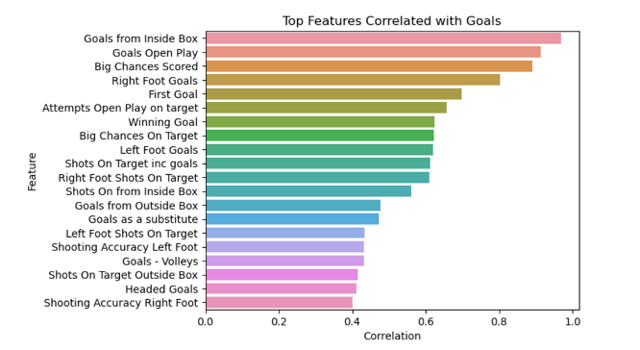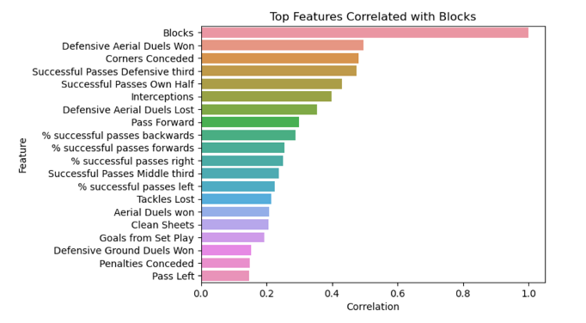

**Figure 1.** Top features Correlated with Goals and Blocks

2.1. Forwards

**Index 1:** This index is designed to emphasize goal-scoring efficiency and offensive contributions, reflecting both a forward’s direct impact on scoring and their role in creating opportunities for the team.

* **Goals from inside box (25%)**Goals scored inside the box are typically the result of more high-quality chances, such as penalties or close-range efforts. This stat is weighted heavily at 25% because converting these chances is crucial in scoring and winning games.
* **Shots on Target inc goals (20%)**Shots on target reflect a forward's ability to consistently challenge goalkeepers. The weighting of 20% signifies its importance but gives slightly less weight than actual goals, as not all shots on target are converted into goals.
* **Big Chances Scored (20%)**Big chances represent high-quality scoring opportunities. A forward’s ability to convert these chances can often be the deciding factor in matches. This stat is highly weighted (20%) because of its direct impact on the outcome of games.
* **Key Passes (15%)**Key passes demonstrate a forward’s ability to assist and set up goal-scoring opportunities for teammates. This stat reflects a more well-rounded offensive role, though it’s secondary to direct goal-scoring contributions, so it’s weighted at 15%.
* **Successful Flick-Ons (10%)**Flick-ons are important for aerial play and for maintaining offensive possession, particularly in link-up play or certain tactical setups. While useful, they are given a lower weight of 10% compared to goal-scoring stats because they don't directly result in goals.
* **Touches open play opp box (5%)**The number of touches a forward has in the opponent’s box highlights how frequently they are involved in dangerous areas, contributing to creating scoring opportunities. However, this stat doesn’t always directly lead to goals, so it is weighted the lowest at 5%.
* **Headed Goals (5%)**The ability to score headers adds an element of versatility to a forward’s skill set. However, since not all forwards are as effective in aerial duels, this stat is weighted at 5%, indicating its relative importance but recognizing that not all forwards may utilize this skill effectively.

**Index 2:** This index emphasizes a forward's ability to create opportunities and contribute to team dynamics, in addition to scoring.

* **Key Passes (25%)**Creating chances for teammates is the most important contribution of a playmaker-forward, which is why this metric receives the highest weighting. It reflects a player's ability to set up scoring opportunities.
* **Assists (20%)**Assists provide a direct measure of a forward's contribution to team goals. This is a key indicator for team-oriented forwards.
* **Big Chances Scored (20%)**The ability to convert high-quality chances is crucial for a forward. This metric highlights their effectiveness and vision in capitalizing on critical opportunities.
* **Shots Off from Inside Box (15%)**Maximizing opportunities from inside the penalty box is vital, as these chances are the most common and high-percentage scoring situations.
* **Touches open play final third (10%)**Touches in the attacking third demonstrate a forward's involvement in offensive build-up play and transitions, highlighting their overall activity in dangerous areas.
* **Successful Dribbles (5%)**This measures a forward's ability to take on defenders and create space. While it enhances versatility, it is secondary to direct goal involvement.
* **Successful Passes Final Third (5%)**Completing passes in the attacking third reflects a player's role in maintaining possession and facilitating creativity. However, its indirect impact on scoring gives it a lower weighting.

|  | **Strength** | **weakness** |
| --- | --- | --- |
| **Index 1** | This index heavily prioritizes goal-scoring and offensive efficiency, selecting forwards who are pure goal-getters and finishers. | May overlook creative forwards who contribute more indirectly (e.g., playmakers or those involved in build-up play). |
| **Index 2** | This index balances goal-scoring with creativity, selecting forwards who contribute to both goals and assists, making them versatile. | May undervalue pure finishers who rely on teammates to create chances. |

**Table 1.** Index 1 Comparisons

As shown in **Table 1**, Index 1 is more effective as it focuses on pure goal-scorers, ensuring that the team has players capable of directly contributing to the scoreboard, making them more effective in terms of tangible output.

2.2. Central Midfielders

**Index 1:** This index evaluates balanced contributions across attack, defense, and transitions.

* **Total Successful Passes All (20%)**Passing accuracy is essential for maintaining possession and controlling the tempo of the game, making it the highest-weighted stat.
* **Key Passes (15%)**A midfielder’s ability to move the ball forward effectively is crucial in supporting offensive transitions and creating scoring opportunities.
* **Interceptions (15%)**Defensive contributions are vital, and interceptions demonstrate a midfielder’s ability to read the game and break up opposition attacks.
* **Tackles Won (15%)**Tackling reflects a midfielder’s work rate and ability to win the ball, which is essential for breaking up opposition play and winning midfield battles.
* **Recoveries (15%)**Ball recovery highlights a midfielder’s role in regaining possession and recycling play, crucial for maintaining control and setting up offensive moves.
* **Total Clearance (10%)**
* Clearances are important for reducing the risk of conceding goals. By clearing the ball before an attempt on goal, the team alleviates pressure on the goalkeeper and defensive line.
* **Touches (10%)**A high number of touches indicates active involvement in the game, although its impact is less direct compared to other stats like passing or tackling.

**Index 2:** This index prioritizes defensive contributions and possession retention.

* **Tackles Won (25%)**Tackling is essential for defensive midfielders to disrupt opposition play and regain possession, so it is given the highest weight.
* **Interceptions (20%)**Interceptions reflect defensive intelligence and the ability to anticipate the opponent's moves, which is key for breaking up attacks.
* **Defensive Ground Duels Won (20%)**Ground duels measure effectiveness in one-on-one defensive battles, crucial for stopping advancing players.
* **Recoveries (15%)**Recoveries represent the effort to regain possession, important but slightly less impactful than tackles and interceptions.
* **Total Successful Passes All (10%)**

Passing accuracy is essential for maintaining possession and controlling the game, contributing to overall team stability.

* **Blocks (5%)**Blocking is situational but valuable for defensive midfielders who drop deep to protect the goal.
* **Successful Passes Defensive Third (5%)**Passing safely in the defensive third is critical, but it is secondary to directly disrupting opposition play.

|  | **Strength** | **weakness** |
| --- | --- | --- |
| **Index 1** | Selects midfielders who contribute across all phases of play, offering balanced defense, offense, and transitions. | May undervalue specialists (e.g., defensive midfielders or advanced playmakers) in favor of balanced players. |
| **Index 2** | This index balances goal-scoring with creativity, selecting forwards who contribute to both goals and focuses on defensive contributions and possession retention, selecting midfielders suited for defensive roles or breaking up opposition play. assists, making them versatile. | Overlooks offensive and creative contributions, favoring a narrower skill set. |

**Table 2.** Index 2 Comparisons

As shown in **Table 2**, Index 1 is more effective, as Index 2 may overlook a well-rounded midfielder's ability to contribute across all phases of play in favor of players with a narrower skill set.

2.3. Central Defenders

**Index 1:** It measures defensive reliability and stopping power.

* **Interceptions (20%)**Interceptions highlight a defender's ability to read the game and neutralize threats, making it a high-priority stat.
* **Tackles Won (20%)**Tackling is crucial for directly halting attacking players and regaining possession.
* **Blocks (15%)**Blocking reflects a defender's ability to prevent shots and crosses, particularly in high-pressure situations.
* **Aerial Duels Won (15%)**Success in aerial duels is important for defending set pieces and long balls, especially for central defenders.
* **Total Clearances (15%)**Clearances are vital for eliminating danger, particularly when the defense is under pressure.
* **Last Man Tackle (10%)**This stat emphasizes a defender's ability to perform under high-pressure situations, given its occasional but crucial nature.
* **Defensive Ground Duels Won (5%)**While important, ground duels are less impactful compared to aerial duels and tackling.

**Index 2:**  This index evaluates defenders' contributions to possession and attacking transitions.

* **Successful Passes Defensive Third (25%)**Effective ball retention and passing from the back are essential for ball-playing defenders, making this the highest-weighted stat.
* **Total Successful Passes All (20%)**Passing accuracy is crucial for maintaining possession and controlling the game, reinforcing its importance in the overall index.
* **Key Passes (15%)**For defenders, moving the ball forward effectively is vital to supporting offensive transitions and initiating attacks.
* **Aerial Duels Won (15%)**Winning aerial duels is important, as defenders often play a key role in set-piece defense and clearing long balls.
* **Tackles Won (10%)**Tackling is important but less central than passing in this index, as it supports defensive and transitional play.
* **Interceptions (10%)**Reading the game and intercepting passes remain valuable but are secondary to passing ability in this context.
* **Touches (5%)**High touch numbers indicate involvement in build-up play, although it’s a less direct measure of effectiveness compared to other stats.

|  | **Strength** | **weakness** |
| --- | --- | --- |
| **Index 1** | Prioritizes defensive reliability, selecting players strong in tackling, interceptions, aerial duels, and clearances. | May undervalue defenders who contribute to ball progression and build-up play. |
| **Index 2** | Focuses on passing and progression, selecting defenders who are comfortable on the ball and contribute to transitions. | May overlook defensive solidity, favoring defenders with good ball skills but weaker defensive stats. |

**Table 3.** Index 3 Comparisons

As shown in **Table 3**, Index 2 is more effective because it prioritizes defenders who contribute to both defensive solidity and offensive play, focusing on passing, ball progression, and transitions, while Index 1 might focus too narrowly on traditional defensive attributes, which could limit the team's ability to transition and build up play effectively from the back.

**3. Data preprocessing**

The following steps involved four main sheets, which contained team and player statistics from 2017 and 2018. To begin with, we extracted players from the player pool and integrated their statistics into a new file to simplify the analysis process. Using the developed index, we then calculated the index for each player and added a new column to assess players’ contributions to their teams in 2017 and 2018. This allowed us to identify any trends or improvements, enabling us to factor these considerations into the player selection process.

For player contribution, we customized the calculations based on different positions:

* **Forward**This calculation directly measures how much a forward contributes to their team's scoring output by combining both goals and assists.  
  *Contribution = (Individual Goals + Individual Assists) / Team Total Goals*
* **Central Midfielder**Midfielders often drive creativity and playmaking. Key passes and assists effectively indicate their role in facilitating scoring opportunities.  
  *Contribution = (Individual Key Passes + Individual Assists) / Team Key Passes*
* **Central Defender**This metric evaluates how much a defender's tackling efficiency contributes to the team’s overall defensive effort. It emphasizes net tackles, making it a fair measure of defensive success.  
  *Contribution = (Individual Tackles Won - Individual Tackles Lost) / (Team Tackles Won - Team Tackles Lost)*

**4. Step 1**

As shown in **Figure 2**, theTop 3 Tier 1 playerswere selected based on a thorough analysis. In addition to the columns for position, player surname, and team, six additional columns were created for evaluation: the 2017 and 2018 indexes, the percentage difference in the index, the player's total contribution to team goals in 2017 and 2018, and the percentage difference in their contribution.

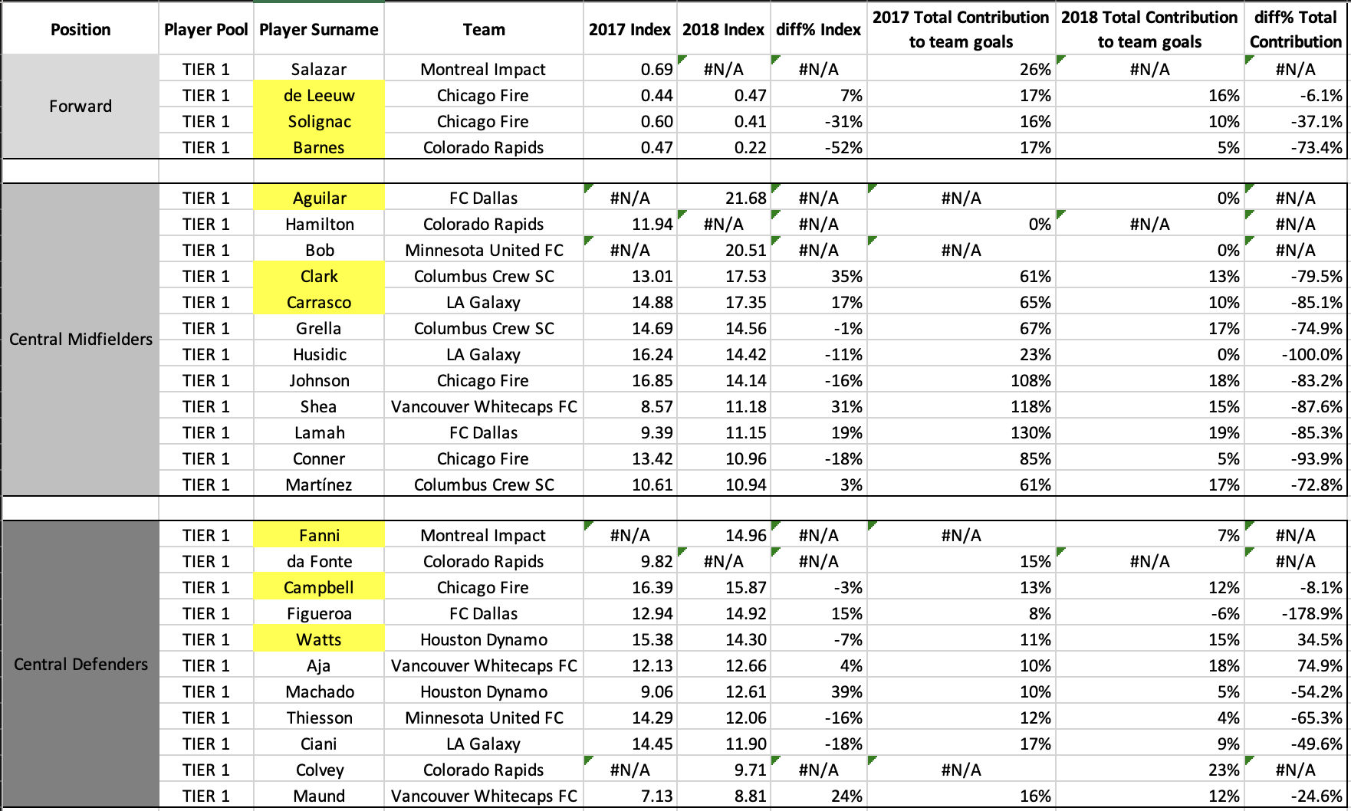

**Figure 2.** Tier 1 Players Comparison

The index was used as an objective criterion to select the top three players for each position. Players without available data for 2018 were excluded from consideration to ensure consistency and reliability in the evaluation.

* **Forward**

Michael de Leeuw, Luis Solignac, and Giles Barnes were selected based on their higher index values in 2018 compared to other forwards. While these players had varying contributions to team goals between 2017 and 2018, their overall performances, as reflected by their indexes, made them the most qualified candidates.

* **Central Midfielder**

Abel Aguilar and Ricardo Clark were selected due to their higher index scores in 2018. Although Fernando Bob had a high 2018 index, he was not selected because he lacked data for 2017 and contributed nothing to his team in 2018. This suggests he might be a rookie with limited impact. Instead, Servando Carrasco was chosen for his experience and demonstrated contributions to his team.

* **Central Defender**

Jonathan Campbell and Rod Fanni were selected based on their high 2018 index scores. Although Fanni may also be considered a rookie, he showed significant contribution to his team in 2018, justifying his inclusion. Additionally, Jared Watts was selected over Maynor Figueroa, despite Figueroa having a higher 2018 index. This decision was due to Figueroa’s extremely negative contribution to his team (-178.9%), which outweighed his index performance.

**5. Step 2**

The top three Tier 1 players selected in Step 1 are now being evaluated against Tier 2 players to determine if any substitutions would result in improved performance.

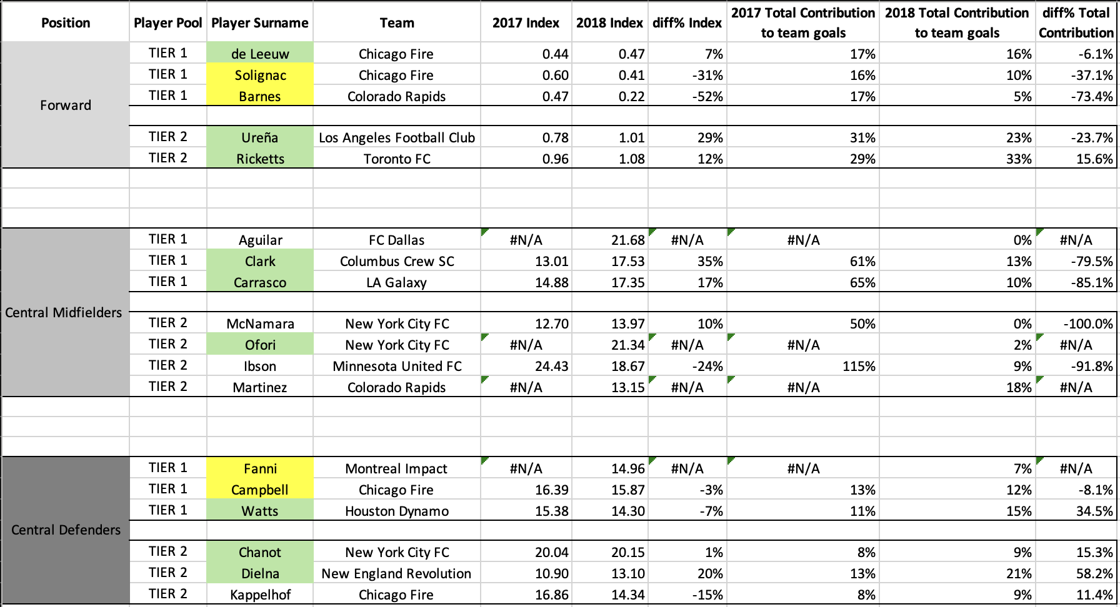

**Figure 3.** Tier 1 and Tier 2 Players Comparison

The arrangement is organized by position, with players previously selected in Step 1 highlighted in yellow, as shown in **Figure 3**. Newly selected players after the Step 2 comparison are highlighted in green, overlapping the yellow for updated selections.

* **Forward**

Tosaint Ricketts and Marco Ureña were newly selected to replace Luis Solignac and Giles Barnes, while Michael de Leeuw was retained. Ricketts demonstrated a strong improvement in 2018, with an index of 1.08 and a positive 15.6% difference in total contribution, reflecting his significant impact on his team. Ureña, with a 2018 index of 1.01 and a smaller negative difference in total contribution (-23.7%) compared to Solignac and Barnes, offered better overall performance and reliability. In contrast, Solignac and Barnes had steep declines in total contribution, with differences of -37.1% and -73.4%, respectively, justifying their replacement.

* **Central Midfielder**

Clark and Carrasco were retained from Tier 1 due to their stronger 2018 performances, including improvements in their indices from 2017 to 2018, and their contributions compared to Tier 2 players. However, Aguilar was replaced by Ebenezer Ofori. While Aguilar and Ofori had only 2018 indices (21.68 and 21.34, respectively), Ofori contributed to the team (2%) more than Aguilar(0%). Furthermore, Clark demonstrated consistency with a 2018 index of 17.53 and a 35% positive difference in index improvement, showing a strong upward trend in his performance. Carrasco, with a slightly lower in the 2018 index at 17.35, showed a 17% improvement in index, indicating his steady performance. In comparison, Tier 2 players like McNamara and Ibson had steep declines in total contribution (-100% and -91.8%, respectively), while others lacked significant positive impact, making Clark, Carrasco, and Ofori the clear choices for retention.

* **Central Defender**

Maxime Chanot and Claude Dielna were newly selected from Tier 2, while Jared Watts was the only player retained from Tier 1. Chanot delivered a strong 2018 performance with an index of 20.15 and a 1% index improvement, outperforming Tier 1 defenders. Dielna demonstrated a strong improvement in total contribution, with a 20% positive difference and a solid 2018 index of 13.1, indicating both consistency and a growing impact on his team. Watts, while retained, showed a slight decline in performance with a 2018 index of 14.3 but a positive 34.5% difference in total contribution. His overall metrics still outperformed those of Fanni and Campbell. These results justify the selection of Chanot and Dielna, along with the retention of Watts.

**6. Step 3**

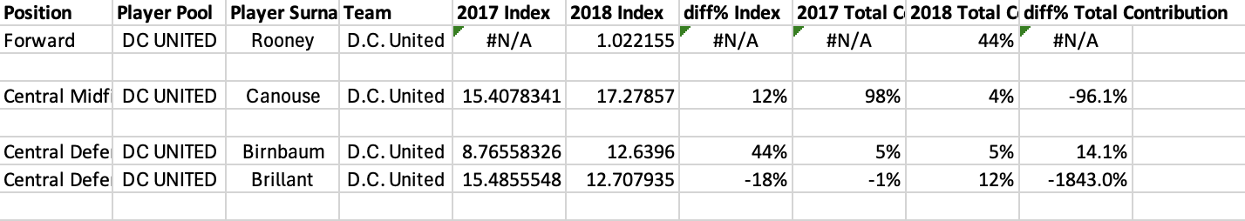

**Figure 4.** DC United Players

* **Forwards**

Michael de Leeuw, Marco Ureña, and Tosaint Ricketts demonstrated varying levels of impact over the two years analyzed. Ricketts emerged as a standout performer in 2018 with an Index of 0.96, reflecting a 12% growth, and an impressive 15.6% increase in total contribution. His consistency and improvement highlighted his significance to the team. Ureña also showcased strong performance metrics, improving his Index by 29% to 1.006, although his contribution declined by 23.7%. De Leeuw remained a reliable player with a modest 7% Index growth to 0.47, but his contributions saw a slight dip of 6.1%. In comparison to D.C. United’s Wayne Rooney, whose 2018 Index of 1.02 was competitive but he is a rookie in 2018 as he just joined the team, the trio of forwards offered better consistency and team impact. But, his impressive team contribution of 44% in 2018 suggests he was carrying the team on his shoulders and could use some help at the front.

* **Midfielders**

Clark, Carrasco and Ofori delivered commendable performances, setting them apart as pivotal midfielders. Clark demonstrated steady growth with a 35% improvement in Index, reaching 17.53, although his total contribution dropped significantly (-79.5%). Carrasco followed closely with a 17% Index increase to 17.35 but faced a similar steep contribution decline (-85.1%). Ofori started in 2018 with an impressive index of 21.34 which was much better than the other Central Midfielders during the season. Compared to D.C. United’s Russell Canouse, whose contributions fell drastically (-96.1%) despite a respectable 2018 Index of 17.28, Ofori, Clark, and Carrasco maintained stronger influence and potential.

* **Defenders**

Jared Watts, Claude Dielna, and Maxime Chanot showcased strong defensive capabilities and consistent improvement. Dielna led with a significant 20% Index growth to 13.09 and the largest contribution increase among defenders (+58.2%), solidifying his rising impact. Watts, while maintaining steady performance, achieved an Index of 10.5 with a 16.7% growth in contribution. Chanot from New York FC showed great consistency in both the seasons with 20.04 and 20.15 indexes respectively with a 15.3% growth to team contributions . In contrast, D.C. United’s defenders, Steven Birnbaum and Frederic Brillant, showed mixed results. While Birnbaum improved his Index to 12.63 with a 14.1% contribution growth, Brillant’s contributions plummeted (-1843%) despite a competitive Index of 12.70. Overall, Watts, Dielna, and Chanot offered stronger consistency and impact over two years.

**7. Step 4**

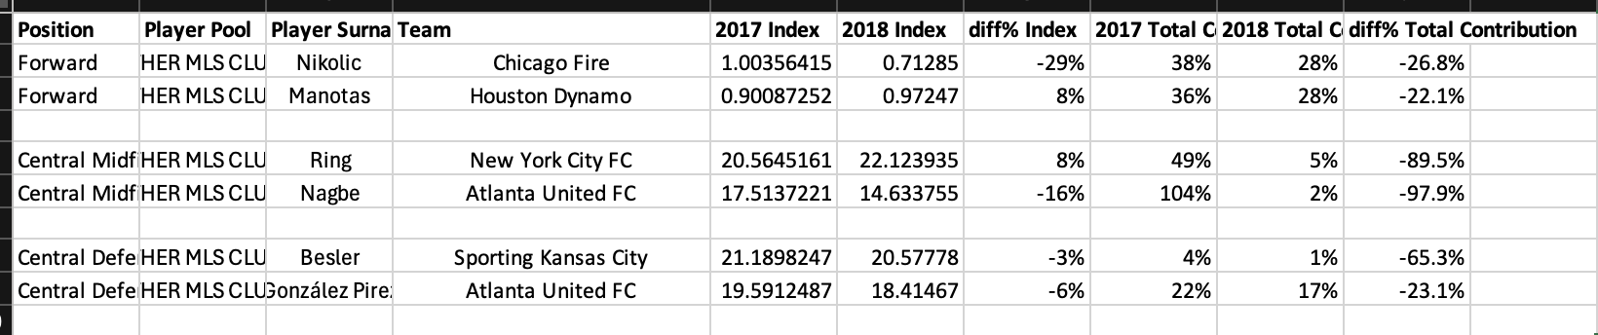

**Figure 5.** Other MLS Clubs Players

* **Forwards**

Among the forwards, Nikolic (Chicago Fire) had a strong start with a 2017 Index of 1.00 but experienced a steep decline (-29%) in 2018, dropping to 0.71 and seeing a significant reduction in total contribution (-26.8%). Similarly, Manotas (Houston Dynamo) improved his Index by 8% to 0.97 but faced a contribution decline of -22.1%. In contrast, Ricketts, Ureña, and de Leeuw demonstrated greater consistency and reliability. Ricketts stood out with a strong 2018 Index (1.08, +12%) and a positive contribution growth (+15.6%). Ureña also showed a significant Index improvement (+29%) to 1.01, though his contributions dropped (-23.7%). De Leeuw remained consistent with a modest 7% Index growth and only a slight dip in contributions (-6.1%). Given the greater consistency and impact of the selected forwards, there is no need for D.C. United to consider trading for Nikolic or Manotas.

* **Midfielders**

The midfield comparison includes Ring (New York City FC) and Nagbe (Atlanta United FC). Ring demonstrated steady Index improvement (+8%) to 22.12 but suffered a dramatic decline in contributions (-89.5%). Nagbe, in contrast, faced a significant Index drop (-16%) to 14.63 and a sharp decline in contributions (-97.9%). In comparison, the selected midfielders Ofori, Carrasco, and Clark offer better overall performance trends. Ofori impressed with a 2018 Index of 21.34, highlighting his potential despite missing contribution data. Carrasco showed steady Index growth (+17%) to 17.35, though his contributions dropped significantly (-85.1%). Clark outperformed Nagbe and Ring with a 35% Index improvement to 17.53, despite his own contribution challenges (-79.5%). The selected midfielders provide a more balanced and promising option compared to Ring and Nagbe, reducing the need for trades.

* **Defenders**

The comparison in defense includes Besler (Sporting Kansas City) and González Pirez (Atlanta United FC). Besler maintained a stable Index (-3%) at 20.57 but saw a sharp contribution decline (-65.3%). González Pirez experienced both an Index decline (-6%) to 18.41 and a contribution drop (-23.1%). In contrast, the selected defenders Chanot, Dielna, and Watts showed stronger performance trends. Chanot maintained a high Index of 20.15 (+1%) with modest contribution growth (+15.3%). Dielna stood out with significant Index improvement (+20%) to 13.10 and exceptional contribution growth (+58.2%). Watts, while showing a slight Index decline (-7%) to 14.30, demonstrated consistent contribution growth (+34.5%). The selected defenders provide more consistent and impactful performances, making them better options than Besler or González Pirez.

D.C. United should carefully evaluate whether trading for the selected players aligns with their strategic priorities and team goals. In the forward position, players like Ricketts and Ureña from the selected pool have demonstrated consistent performances with steady Index improvements and contributions. However, Wayne Rooney remains a critical asset for D.C. United. Despite his declining contributions, his leadership, experience, and potential for a rebound make him a key figure for the team. Instead of pursuing trades for forwards like Nikolic or Manotas, D.C. United should focus on building around Rooney and providing him with better support to maximize his impact.

In the midfield, the selected players—Ofori, Carrasco, and Clark—bring a mix of potential and consistent performance trends. Ofori stands out with a high 2018 Index and promising metrics, while Carrasco and Clark showed steady Index improvements despite notable declines in contributions. Compared to Canouse from D.C. United, who experienced a solid Index improvement (+12%) to 17.28 but a steep drop in contributions (-96.1%), the gap between Canouse and the selected players is not significant enough to justify a trade. Instead, D.C. United should focus on further developing Canouse and addressing his contribution challenges internally, while building tactical strategies around him to enhance midfield performance.

In defense, there is a stronger case for making changes. The selected defenders—Chanot, Dielna, and Watts—offer consistent growth and reliable contributions. Chanot’s stability and contribution improvement, Dielna’s exceptional growth in both Index and contributions, and Watts’ steady positive trends make them attractive options. Compared to D.C. United’s Brillant, who has suffered a steep contribution decline and limited impact, trading for a defender like Dielna or Chanot could provide a meaningful upgrade and address defensive vulnerabilities. Birnbaum, however, has shown consistent improvements and should remain part of the defensive core.

Overall, D.C. United should focus on internal growth and team cohesion in the forward and midfield positions, with no pressing need for trades in those areas. However, addressing defensive weaknesses by replacing Brillant with a consistent and impactful player like Dielna or Chanot would align with the team’s long-term goals and enhance their competitiveness.

**8. Tableau Visualizations:**

8.1. Difference % Total Contribution of Top Players

* Players are categorized by positions (e.g., Central Defenders, Central Midfielders, Forwards).
* Central Defenders such as Chanot show a positive difference in contribution, while players like Carrasco (Midfielder) have a significant negative difference**.**

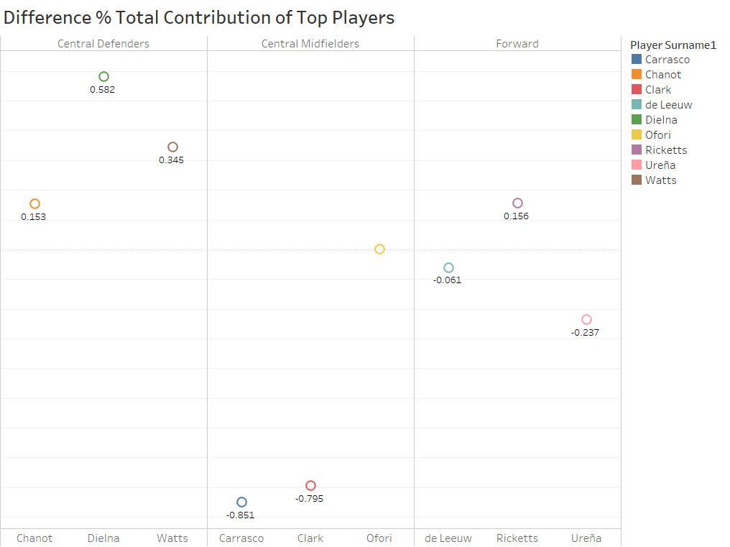

**Figure 6.** Difference % Total Contribution of Top Players

8.2. Difference % Index for Top Players

* A bubble chart indicates contribution indices by player and position.
* All the players show positive indices, except for Defender Watts is negative and a Central Midfielder is missing as the index for one of the years is missing.

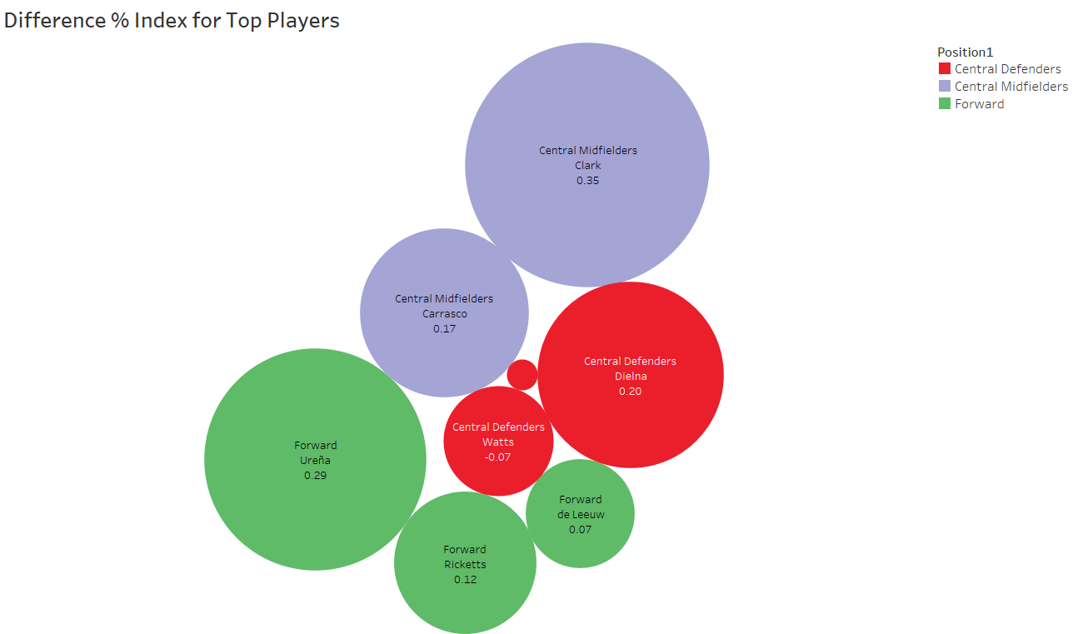

**Figure 7.** Difference % Index for Top Players

8.3. DC United Players’ Contribution

* Brillant (Central Defender) has a significant negative difference in contribution, whereas Birnbaum and Canouse have minor differences.
* Rooney’s difference in index could not be measured as he started only in the year 2018 for DC United.

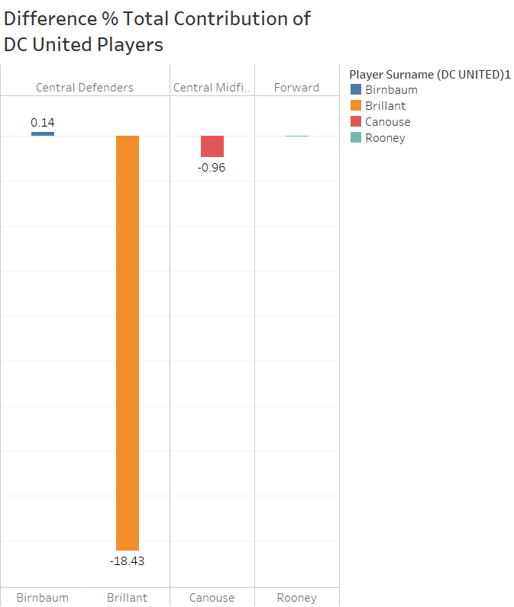

**Figure 8.** Difference % Total Contribution of DC United Players

8.4. Comparison with Other MLS Clubs

Differences in contributions and indices across players from other clubs are shown, with varied positive and negative impacts (e.g., Manotas has a positive difference, while Nikolic and others show negatives).

* Majority of the players had negative indices and contributions which shows the decline in their form for 2018 season.

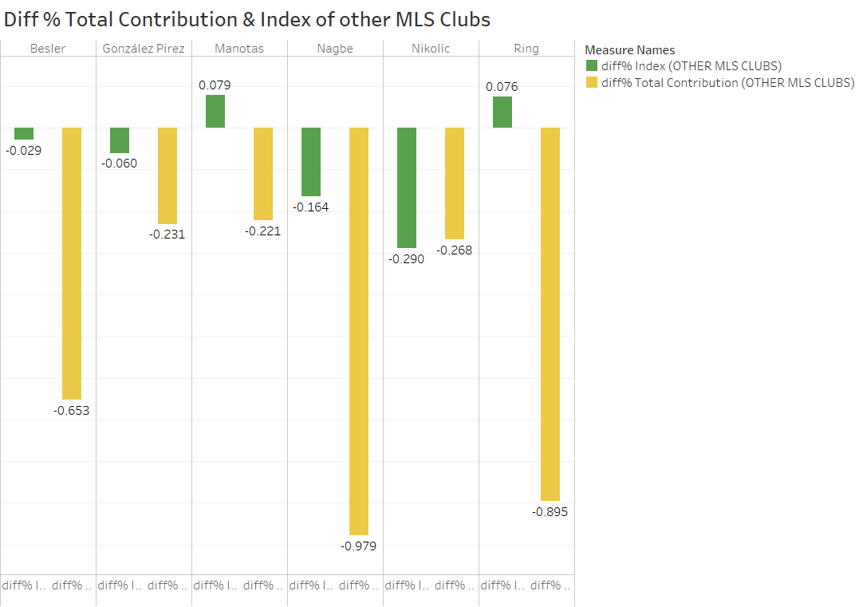

**Figure 9.** Diff % Total Contribution & Index of other MLS Clubs

The dashboard for "MLS Re-Entry Draft – Top Prospects & Analysis" provides a comprehensive visual representation of player performance metrics, focusing on their contributions and indices.

8.5. Dashboard Layout

* **Multiple Visuals**: The dashboard consists of scatter plots, bar charts, and bubble charts, providing varied perspectives on the data.
* **Filters**: Users can filter data by player surnames, positions, and contribution measures, offering customization and deeper insights.
* **Interactive Features**: Hovering over data points reveals detailed metrics for each player, including their contribution percentages and indices.

8.6. Functionality & Usability

* **Dynamic Data Exploration**:
  + Users can interactively explore how contributions vary across positions and clubs.
  + The dashboard facilitates informed decision-making in player evaluation and team-building strategies.
* **Customizable Views**:
  + Filters and tooltips allow users to tailor their focus to specific players or teams.
  + Provides both high-level overviews and detailed breakdowns.

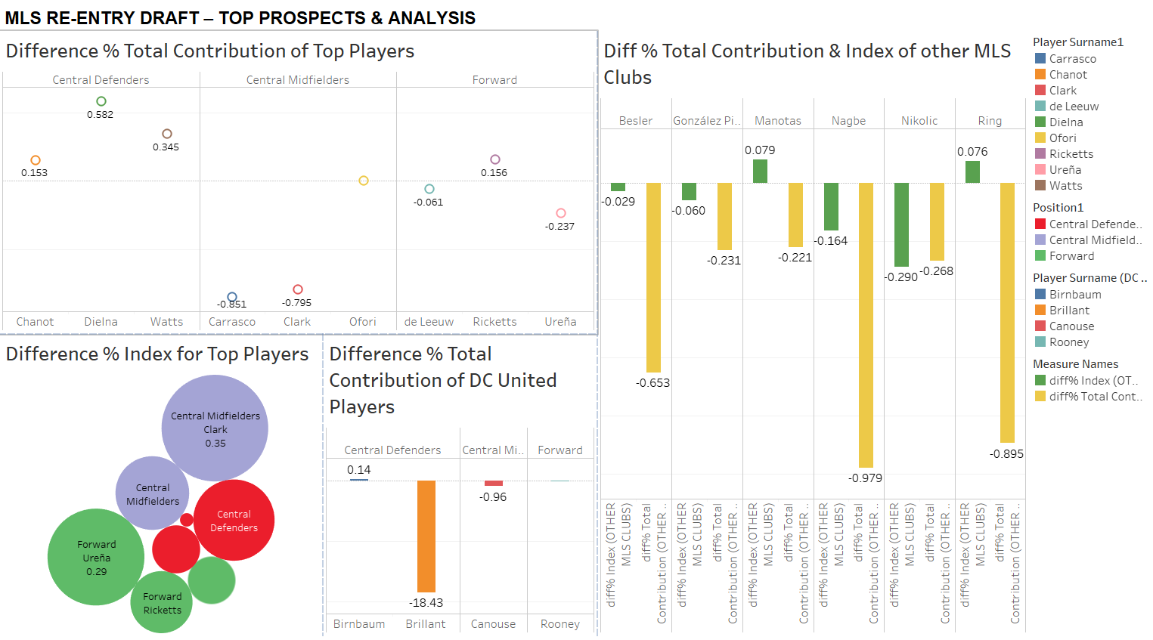

**Figure 10.** Dashboard