**9.FILE READING AND WRITING IN PHP**

**CODE:**

<!DOCTYPE html>

<html>

<head>

<title>Read and Write File</title>

</head>

<body>

<?php

// Specify the path to the file in your Downloads directory

$filename = "C:\Users\haris\Downloads\a.txt";

// Check if the file exists

if (!file_exists($filename)) {

echo "File '$filename' does not exist.";

exit();

}

// Reading from file

$file = fopen($filename, "r");

if ($file == false) {

echo ("Error in opening file");

exit();

}

$filesize = filesize($filename);

$filetext = fread($file, $filesize);

fclose($file);

echo ("File size: $filesize bytes <br>");

echo ("<pre>$filetext</pre>");

// Writing to file

$file = fopen($filename, "w");

if ($file == false) {

echo ("Error in opening file for writing");

exit();

}

$text_to_write = "This is a simple test";

fwrite($file, $text_to_write);

fclose($file);

// Reading from the same file again to display changes

$file = fopen($filename, "r");

if ($file == false) {

echo ("Error in opening file for reading");

exit();

}

$filesize = filesize($filename);

$filetext = fread($file, $filesize);

fclose($file);

echo ("<br> File size after writing: $filesize bytes <br>");

echo ("Content after writing: $filetext");

echo ("<br> File name: $filename");

?>

</body>

</html>

**OUTPUT:**

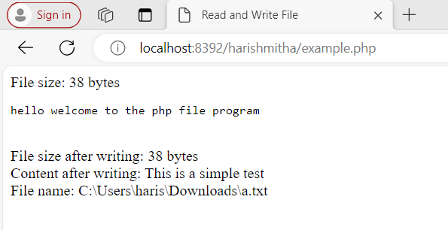

**11.EXCEPTIONS IN PHP**

**CODE:**

<!DOCTYPE html>

<html lang="en">

<head>

<meta charset="UTF-8">

<meta name="viewport" content="width=device-width, initial-scale=1.0">

<title>Division Form</title>

</head>

<body>

<form method="post">

<label for="dividend">Enter dividend:</label>

<input type="number" id="dividend" name="dividend" required><br><br>

<label for="divisor">Enter divisor:</label>

<input type="number" id="divisor" name="divisor" required><br><br>

<button type="submit">Divide</button>

</form>

<?php

class DivideByZeroException extends Exception { }

class DivideByNegativeNoException extends Exception { }

function checkdivisor($dividend, $divisor){

// Throw exception if divisor is zero or negative

try {

if ($divisor == 0) {

throw new DivideByZeroException;

}

else if ($divisor < 0) {

throw new DivideByNegativeNoException;

}

else {

$result = $dividend / $divisor;

echo "Result of division = $result </br>";

}

}

catch (DivideByZeroException $dze) {

echo "Divide by Zero Exception! </br>";

}

catch (DivideByNegativeNoException $dnne) {

echo "Divide by Negative Number Exception </br>";

}

catch (Exception $ex) {

echo "Unknown Exception";

}

}

// Check if form is submitted

if ($_SERVER["REQUEST_METHOD"] == "POST") {

$dividend = $_POST["dividend"];

$divisor = $_POST["divisor"];

checkdivisor($dividend, $divisor);

}

?>

</body>

</html>

**OUTPUT:**

