Week-1

Code:

<!DOCTYPE html>

<html lang="en">

<head>

    <meta charset="UTF-8">

    <meta name="viewport" content="width=device-width, initial-scale=1.0">

    <title>Rithwik Marpally - Portfolio</title>

</head>

<body>

    <nav>

        <a href="#">Home</a> |

        <a href="#">Signup</a> |

        <a href="#">Login</a> |

        <input type="text" placeholder="Search..." />

        <button>Search</button>

    </nav>

    <br/>

    <header>

        Rithwik Marpally - Portfolio

    </header>

    <section >

        <h2>About Me</h2>

        <p>I am a passionate and dedicated individual with a strong desire to explore and learn various technologies. I specialize in AI, Web Development, and Blockchain solutions.</p>

    </section>

    <section>

        <h2>Skills</h2>

        <ul>

            <li>C++, C, Java, SQL, Python, Motoko</li>

            <li>MERN Stack (MongoDB, Express.js, React.js, Node.js)</li>

            <li>Operating Systems: Windows, Linux</li>

            <li>Database Management: MySQL, PostgreSQL, MongoDB</li>

            <li>Machine Learning, Web Scraping, LLM</li>

        </ul>

    </section>

    <section>

        <h2>Projects</h2>

        <ul>

            <li><strong>LAW Assistance</strong> - <i>A website for legal knowledge and case materials.</i> <br> Tools: MERN, Python, LLM.</li>

            <li><strong>Heart Health Monitoring</strong> - <i>Evaluates heart disease risk based on vital signs.</i> <br> Tools: React.js, Flask, Python, Machine Learning.</li>

        </ul>

    </section>

    <section>

        <h2>Education</h2>

        <ul>

            <li><strong>B.Tech in Computer Science</strong> - Keshav Memorial Institute Of Technology (CGPA: 8.06) [2022-2026]</li>

            <li><strong>MPC</strong> - Deeksha (Percentage: 97.5%) [2022]</li>

            <li><strong>CBSE</strong> - Pioneer’s School (CGPA: 9.26) [2020]</li>

        </ul>

    </section>

    <section>

        <h2>Contact Information</h2>

        <ul>

            <li>Email: <a href="mailto:marpallyrithwik8@gmail.com">rithwik@example.com</a></li>

            <li>Phone: <a href="tel:+918143962706">+91 8143962706</a></li>

            <li>LinkedIn: <a href="https://www.linkedin.com/in/rithwik-marpally-31751625b/" target="_blank">LinkedIn Profile</a></li>

            <li>GitHub: <a href="https://github.com/Rithwik-Projects" target="_blank">GitHub Profile</a></li>

        </ul>

    </section>

</body>

</html>

Screenshot:

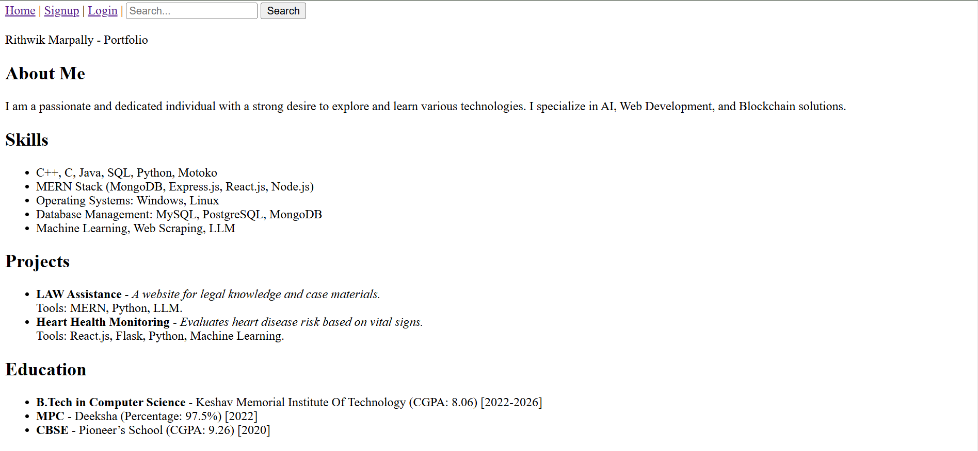

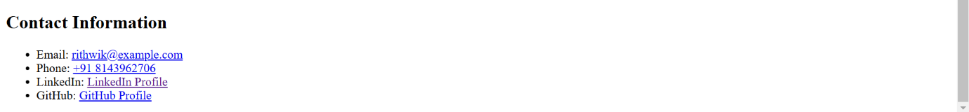

Link: <https://github.com/rithu453/FEWD/tree/main/week1>