Week-3:

First-code:

<!DOCTYPE html>

<html lang="en">

<head>

    <meta charset="UTF-8">

    <meta name="viewport" content="width=device-width, initial-scale=1.0">

    <title>Feedback Form</title>

    <!-- Bootstrap CSS CDN -->

    <link href="https://cdn.jsdelivr.net/npm/bootstrap@5.3.0-alpha3/dist/css/bootstrap.min.css" rel="stylesheet">

</head>

<body>

    <div class="container mt-5">

        <h2 class="text-center mb-4">Feedback Form</h2>

        <div class="card shadow-sm p-4">

            <form>

                <div class="mb-3">

                    <label for="name" class="form-label">Your Name</label>

                    <input type="text" class="form-control" id="name" placeholder="Enter your name" required>

                </div>

                <div class="mb-3">

                    <label for="email" class="form-label">Email Address</label>

                    <input type="email" class="form-control" id="email" placeholder="Enter your email" required>

                </div>

                <div class="mb-3">

                    <label for="phone" class="form-label">Phone Number</label>

                    <input type="tel" class="form-control" id="phone" placeholder="Enter your phone number" required>

                </div>

                <div class="mb-3">

                    <label for="rating" class="form-label">Rating</label>

                    <select class="form-select" id="rating" required>

                        <option selected disabled value="">Choose...</option>

                        <option value="1">1 </option>

                        <option value="2">2 </option>

                        <option value="3">3 </option>

                        <option value="4">4</option>

                        <option value="5">5</option>

                    </select>

                </div>

                <div class="mb-3">

                    <label for="questions" class="form-label">Questions regarding product or service</label>

                    <textarea class="form-control" id="questions" rows="3" placeholder="Your questions..."></textarea>

                </div>

                <div class="mb-3">

                    <label for="comments" class="form-label">Additional Comments</label>

                    <textarea class="form-control" id="comments" rows="3" placeholder="Your comments..."></textarea>

                </div>

                <div class="d-grid">

                    <button type="submit" class="btn btn-primary">Submit</button>

                </div>

            </form>

        </div>

    </div>

    <!-- Bootstrap JS CDN -->

    <script src="https://cdn.jsdelivr.net/npm/bootstrap@5.3.0-alpha3/dist/js/bootstrap.bundle.min.js"></script>

</body>

</html>

Site:

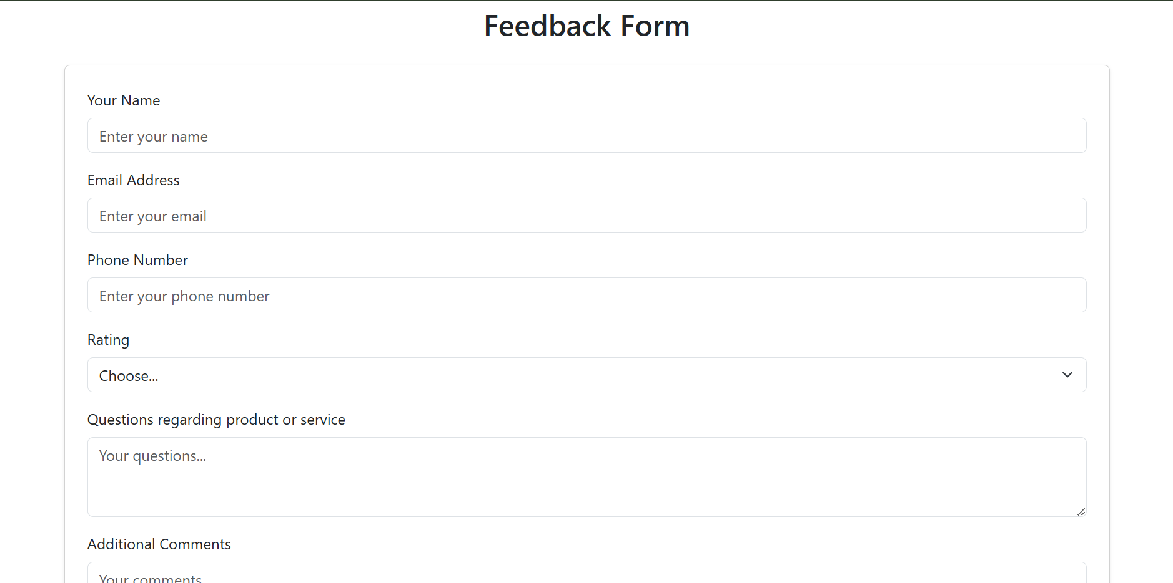

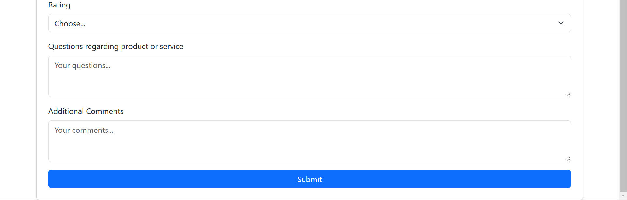

Link: <https://github.com/rithu453/FEWD/tree/main/week3>

Second:Portfolio:code-

<!DOCTYPE html>

<html lang="en">

<head>

    <meta charset="UTF-8">

    <meta name="viewport" content="width=device-width, initial-scale=1.0">

    <title>Rithwik Marpally - Portfolio</title>

    <link href="https://cdn.jsdelivr.net/npm/bootstrap@5.3.0-alpha3/dist/css/bootstrap.min.css" rel="stylesheet">

</head>

<body>

    <nav class="navbar navbar-expand-lg navbar-dark bg-dark fixed-top">

        <div class="container">

            <a class="navbar-brand" href="#">Rithwik Marpally</a>

            <button class="navbar-toggler" type="button" data-bs-toggle="collapse" data-bs-target="#navbarNav" aria-controls="navbarNav" aria-expanded="false" aria-label="Toggle navigation">

                <span class="navbar-toggler-icon"></span>

            </button>

            <div class="collapse navbar-collapse" id="navbarNav">

                <ul class="navbar-nav ms-auto">

                    <li class="nav-item">

                        <a class="nav-link" href="#home">Home</a>

                    </li>

                    <li class="nav-item">

                        <a class="nav-link" href="#about">About Me</a>

                    </li>

                    <li class="nav-item">

                        <a class="nav-link" href="#projects">Projects</a>

                    </li>

                    <li class="nav-item">

                        <a class="nav-link" href="#contact">Contact</a>

                    </li>

                </ul>

            </div>

        </div>

    </nav>

    <section id="home" class="vh-100 d-flex align-items-center justify-content-center text-white bg-dark">

        <div class="text-center">

            <h1>Hi, I'm Rithwik Marpally</h1>

            <p>AI Developer | Web Designer | Blockchain Enthusiast</p>

            <a href="#contact" class="btn btn-primary">Get in Touch</a>

        </div>

    </section>

    <section id="about" class="py-5">

        <div class="container">

            <h2 class="text-center mb-4">About Me</h2>

            <p class="text-center">I am passionate about exploring and learning various technologies. I specialize in AI, Web Development, and Blockchain solutions.</p>

            <div class="row text-center mt-4">

                <div class="col-md-4">

                    <h5>Skills</h5>

                    <p>C++, Java, Python, MERN Stack, Machine Learning</p>

                </div>

                <div class="col-md-4">

                    <h5>Technologies</h5>

                    <p>React, Node.js, FastAPI, Blockchain (Ethereum, Solana)</p>

                </div>

                <div class="col-md-4">

                    <h5>Interests</h5>

                    <p>AI Development, Web Design, Blockchain Solutions</p>

                </div>

            </div>

        </div>

    </section>

    <section id="projects" class="py-5 bg-light">

        <div class="container">

            <h2 class="text-center mb-4">Projects</h2>

            <div class="row">

                <div class="col-md-4">

                    <div class="card mb-4 shadow-sm">

                        <div class="card-body">

                            <h5 class="card-title">LAW Assistance</h5>

                            <p class="card-text">A website for legal knowledge and case materials.</p>

                        </div>

                    </div>

                </div>

                <div class="col-md-4">

                    <div class="card mb-4 shadow-sm">

                        <div class="card-body">

                            <h5 class="card-title">Heart Health Monitoring</h5>

                            <p class="card-text">Evaluates heart disease risk based on vital signs.</p>

                        </div>

                    </div>

                </div>

                <div class="col-md-4">

                    <div class="card mb-4 shadow-sm">

                        <div class="card-body">

                            <h5 class="card-title">Mayabazar</h5>

                            <p class="card-text">A Smart AI site for easy shopping experience</p>

                        </div>

                    </div>

                </div>

            </div>

        </div>

    </section>

    <!-- Contact Section -->

    <section id="contact" class="py-5">

        <div class="container">

            <h2 class="text-center mb-4">Contact Me</h2>

            <form>

                <div class="row">

                    <div class="col-md-6 mb-3">

                        <input type="text" class="form-control" placeholder="Your Name" required>

                    </div>

                    <div class="col-md-6 mb-3">

                        <input type="email" class="form-control" placeholder="Your Email" required>

                    </div>

                </div>

                <div class="mb-3">

                    <textarea class="form-control" rows="4" placeholder="Your Message" required></textarea>

                </div>

                <div class="text-center">

                    <button type="submit" class="btn btn-primary">Send Message</button>

                </div>

            </form>

        </div>

    </section>

    <!-- Footer -->

    <footer class="bg-dark text-white text-center py-3">

        <p>&copy; 2025 Rithwik Marpally | Follow me on

            <a href="https://www.linkedin.com/in/rithwik-marpally-31751625b/" target="_blank" class="text-light">LinkedIn</a> |

            <a href="https://github.com/Rithwik-Projects" target="_blank" class="text-light">GitHub</a>

        </p>

    </footer>

    <!-- Bootstrap JS -->

    <script src="https://cdn.jsdelivr.net/npm/bootstrap@5.3.0-alpha3/dist/js/bootstrap.bundle.min.js"></script>

</body>

</html>

Site:

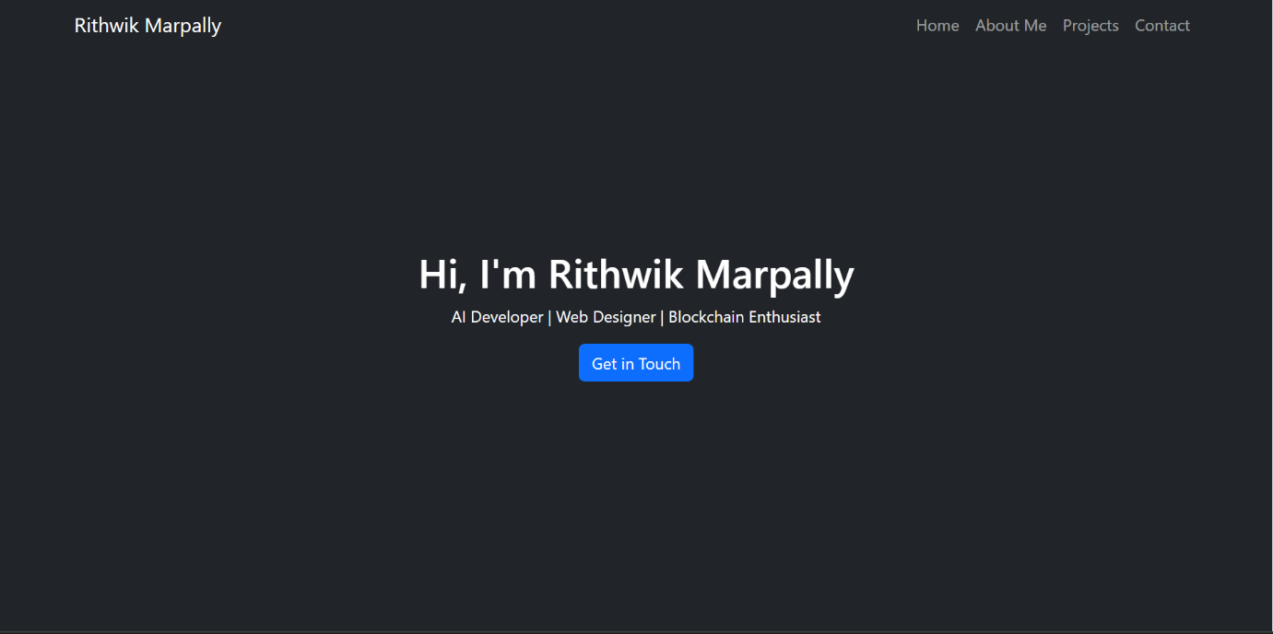

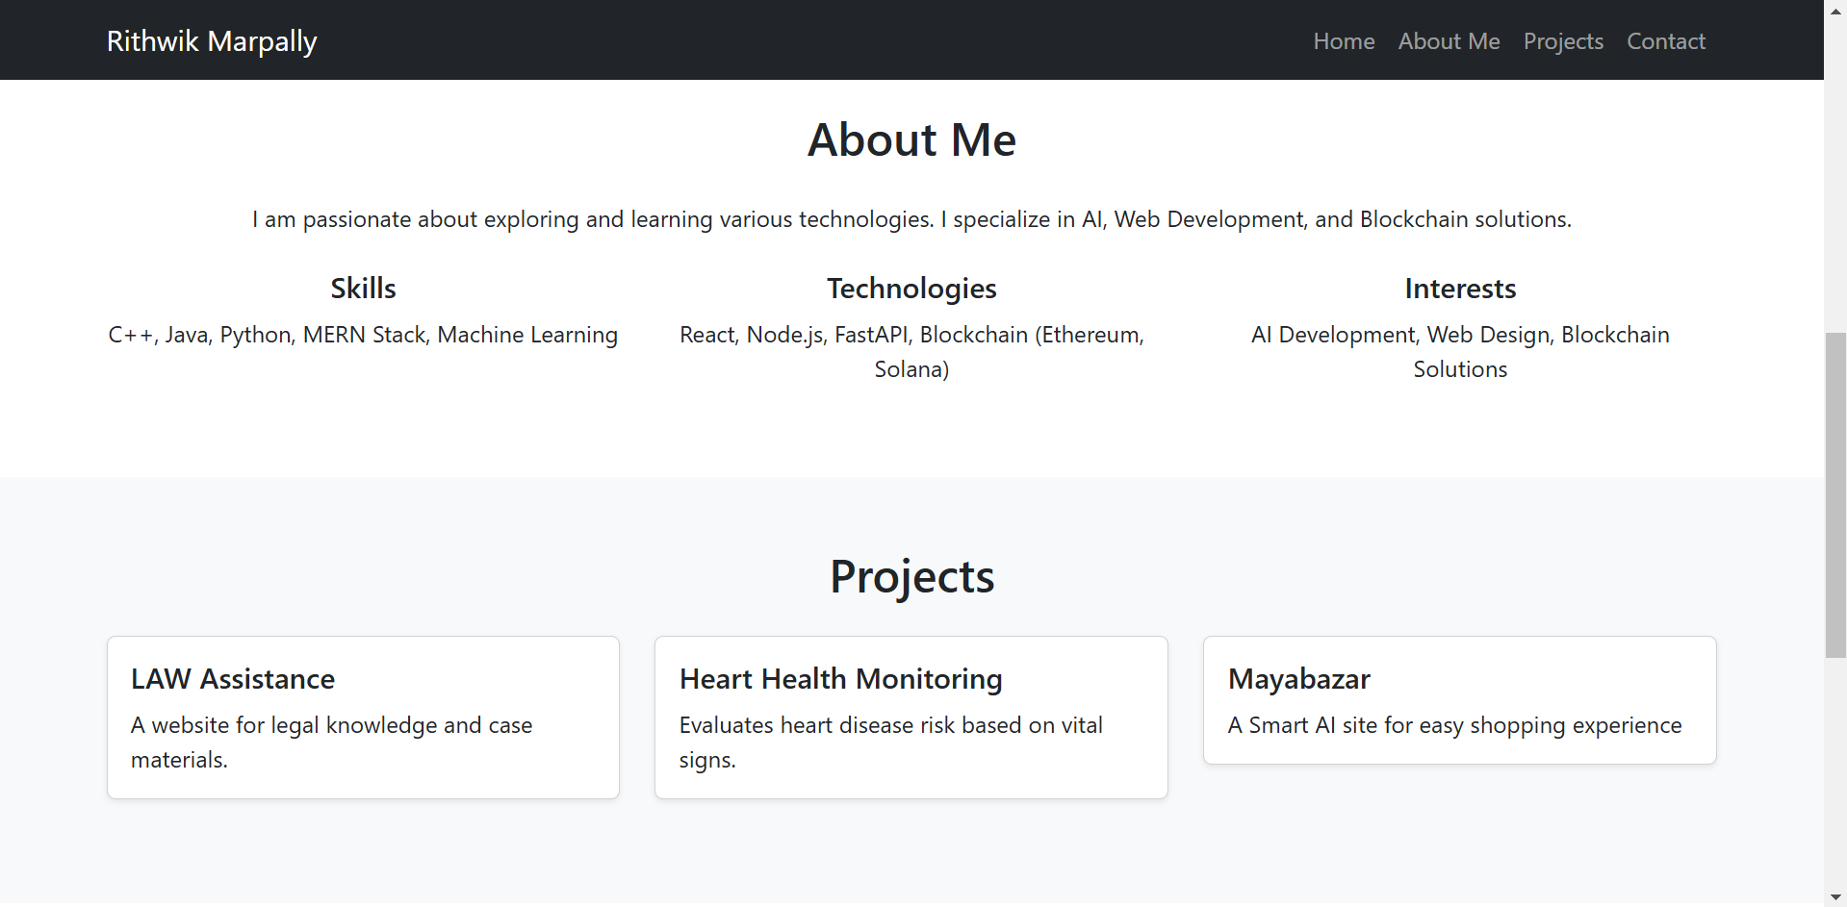

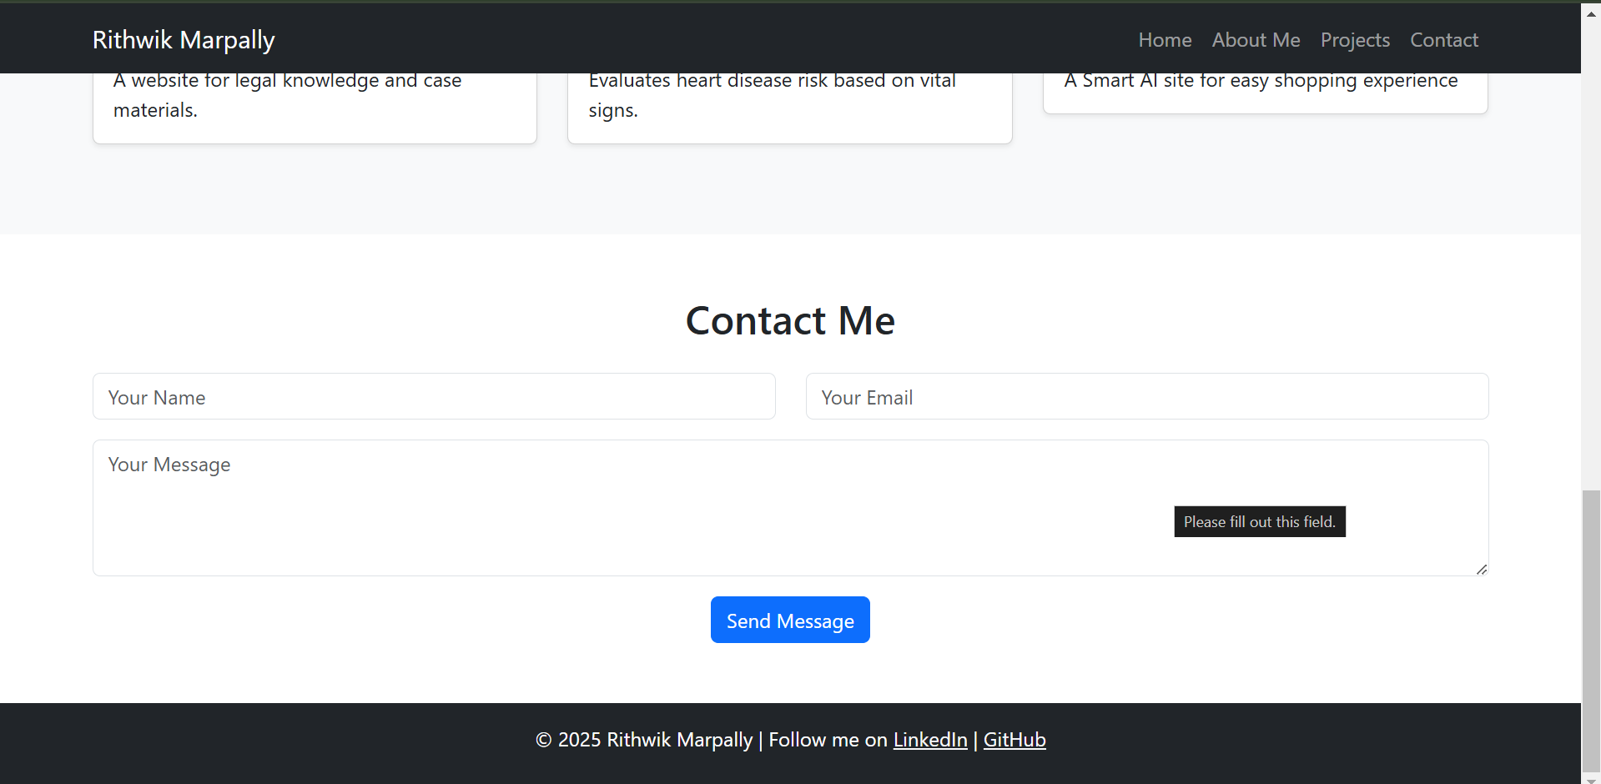

Link: : <https://github.com/rithu453/FEWD/tree/main/week3>