SCHOLARTRACK – SMART SCHOLARSHIP ELIGIBILITY, VERIFICATION & TRACKING PORTAL
PROJECT REPORT
Submitted by
ROHAN KARTHICK S (7376231CS117)
In partial fulfilment for the award of the degree of
BACHELOR OF ENGINEERING
in
COMPUTER SCIENCE AND ENGINEERING
BANNARI AMMAN INSTITUTE OF TECHNOLOGY
(An Autonomous Institution Affiliated to Anna University, Chennai)
SATHYAMANGALAM-638401
ANNA UNIVERSITY: CHENNAI 600 025
APRIL 2026

BONAFIDE CERTIFICATE
Certified that this project report “SCHOLARTRACK – SMART SCHOLARSHIP ELIGIBILITY, VERIFICATION & TRACKING PORTAL” is the bonafide work of “ROHAN KARTHICK S (7376231CS117)” who carried out the project work under my supervision.
Dr. VENKATESAN R,  HEAD OF THE DEPARTMENT,  DEPARTMENT OF COMPUTER  SCIENCE AND DESIGN,  BANNARI AMMAN INSTITUTE  OF TECHNOLOGY. | Ms. MARY SHALINI A,  ASSISTANT PROFESSOR,  DEPARTMENT OF COMPUTER  SCIENCE AND ENGINEERING,  BANNARI AMMAN INSTITUTE  OF TECHNOLOGY.
Submitted for Project Viva Voce examination held on .....................
Internal Examiner I | Internal Examiner II
ii

DECLARATION
I affirm that the project work titled “SCHOLARTRACK – SMART SCHOLARSHIP ELIGIBILITY, VERIFICATION & TRACKING PORTAL” being submitted in partial fulfillment for the award of the degree of Bachelor of Engineering in Computer Science and Engineering is the record of original work done by me under the guidance of Ms. MARY SHALINI A, Assistant Professor, Department of Computer Science and Engineering. It has not formed a part of any other project work(s) submitted for the award of any degree or diploma either in this or any other University.
ROHAN KARTHICK S
7376231CS117
I certify that the declaration made above by the candidate is true.
Ms. MARY SHALINI A
iii

ACKNOWLEDGEMENT
I would like to enunciate heartfelt thanks to our esteemed Chairman Dr. S.V.Balasubramaniam, and the respected Principal Dr. C. Palanisamy, for providing excellent facilities and support during the course of study in this institute.
I am grateful to Dr. Venkatesan R, Head of the Department, Department of Computer Science and Design, for his valuable suggestions to carry out the project work successfully.
I wish to express my sincere thanks to Faculty guide Ms. Mary Shalini A, Associate Professor, Department of computer science and engineering, for her constructive ideas, inspirations, encouragement, excellent guidance, and much needed technical support extended to complete our project work.
I would like to thank our friends, faculty and non-teaching staff who have directly and indirectly contributed to the success of this project.
ROHAN KARTHICK S (7376231CS117)
iv

ABSTRACT
Scholarship disbursement and eligibility verification are vital functions in academic institutions, directly impacting students' access to higher education. Traditional scholarship management methods rely heavily on manual verification, paper documentation, and in-person scrutiny, creating delays, clerical errors, and a complete lack of transparency. Most critically, accidental discrepancies between student-entered form claims and uploaded documentary evidence frequently lead to sudden, unheralded rejections during final scrutiny. The ScholarTrack – Smart Scholarship Eligibility, Verification & Tracking Portal aims to provide an effective, transparent solution for discovering scholarships, evaluating eligibility, auditing document discrepancies, and tracking verification lifecycles in real time.
The proposed system provides role-based modules for Students, Verification Officers, and Administrators. Students complete academic and income profiles, and the rule-based engine evaluates their eligibility against published scholarship bylaws. Upon uploading supporting documents (Income Certificates, Academic Mark Sheets, Bonafide Certificates), the system uses Optical Character Recognition (OCR) via Tesseract.js and QR code scanning via jsQR to extract key textual and numeric values. An automated discrepancy engine immediately compares extracted document data against application form inputs, alerting students to field-by-field mismatches and guiding in-place corrections prior to official submission.
The platform also integrates a synthetic verification authority service for cross-referencing certificate identifiers. Verification officers inspect applicant dossiers using a side-by-side verification console, examine OCR extractions and registry checks, and issue verified or correction-requested verdicts. Overall, the system eliminates administrative latency, empowers applicants through guided error resolution, strengthens governance, and provides an auditable, transparent platform for scholarship administration.
Keywords: Scholarship Management, Automated Mismatch Detection, Optical Character Recognition (OCR), Rule-Based Eligibility Engine, QR Code Verification, Role-Based Access Control (RBAC), Full-Stack Web Architecture, Audit Trail Logging, Pre-Verification Portal.
v

CHAPTER NO | TITLE PAGE | PAGE NO
 | ACKNOWLEDGEMENT | iv
 | ABSTRACT | v
 | LIST OF FIGURES | x
1 | INTRODUCTION | 1
1.1 | OVERVIEW OF SCHOLARTRACK PORTAL | 1
1.1.1 | FEATURES OF THE SYSTEM | 1
1.1.2 | IMPACT OF VERIFICATION DELAYS ON STUDENTS | 2
1.2 | NEED FOR THE SYSTEM | 2
1.2.1 | SCOPE OF THE SYSTEM | 3
1.3 | OBJECTIVES OF THE PROJECT | 3
1.4 | PROBLEM STATEMENT | 4
1.5 | MODULES OF THE PROJECT | 4
1.6 | SUMMARY | 5
2 | LITERATURE SURVEY | 6
2.1 | INTRODUCTION | 6
2.2 | EXISTING SCHOLARSHIP MANAGEMENT SYSTEMS | 6
2.3 | OCR AND DOCUMENT DATA EXTRACTION | 6
2.4 | QR-BASED CERTIFICATE VERIFICATION | 7
2.5 | ROLE-BASED ACCESS CONTROL & WORKFLOW AUTOMATION | 7
2.6 | DISCREPANCY DETECTION IN E-GOVERNANCE | 8
2.7 | RESEARCH GAP | 8
2.8 | LIMITATIONS OF EXISTING SYSTEMS | 9
2.9 | SUMMARY | 9
3 | OBJECTIVE AND METHODOLOGY | 10
3.1 | OBJECTIVE OF THE PROPOSED WORK | 10
3.1.1 | EFFICIENT DOCUMENT DATA COLLECTION | 10
3.1.2 | RULE-BASED ELIGIBILITY EVALUATION | 10
3.1.3 | OPTICAL CHARACTER EXTRACTION | 10
3.1.4 | AUTOMATED MISMATCH IDENTIFICATION | 10
3.1.5 | INTERACTIVE DATA VISUALIZATION | 11
3.1.6 | REPORT GENERATION | 11
3.1.7 | SCALABILITY AND FUTURE ENHANCEMENT | 11
3.2 | SYSTEM ARCHITECTURE | 11
3.2.1 | OVERVIEW OF ARCHITECTURE | 12
3.2.2 | DATA COLLECTION LAYER | 12
3.2.3 | DATA PREPROCESSING LAYER | 12
3.2.4 | BACKEND AND ANALYTICS LAYER | 12
3.2.5 | DATABASE LAYER | 13
3.2.6 | FRONTEND LAYER | 13
3.2.7 | ADVANTAGES OF THE ARCHITECTURE | 13
3.3 | FLOW DIAGRAM OF THE PROPOSED SYSTEM | 13
3.4 | TECHNOLOGIES USED | 14
3.5 | WORKING PROCESS | 14
3.5.1 | INPUT COLLECTION | 14
3.5.2 | DATA CLEANING | 15
3.5.3 | DATA TRANSFORMATION | 15
3.5.4 | OCR & QR ANALYSIS | 15
3.5.5 | FIELD COMPARISON & MISMATCH DETECTION | 15
3.5.6 | HOTSPOT / DISCREPANCY DETECTION | 15
3.5.7 | DASHBOARD VISUALIZATION | 15
3.5.8 | REPORT GENERATION | 15
3.6 | USER INTERACTION AND FEEDBACK | 16
3.6.1 | USER INTERACTION | 16
3.6.2 | INPUT AND SYSTEM RESPONSE | 16
3.6.3 | FEEDBACK MECHANISM | 16
3.6.4 | USER EXPERIENCE ENHANCEMENT | 16
3.7 | PERFORMANCE AND SCALABILITY | 16
3.7.1 | SYSTEM PERFORMANCE | 16
3.7.2 | RESPONSE TIME | 17
3.7.3 | DATA HANDLING EFFICIENCY | 17
3.7.4 | SCALABILITY | 17
3.7.5 | FUTURE SCALABILITY | 17
3.8 | SUMMARY | 17
4 | RESULTS AND DISCUSSION | 18
4.1 | RESULTS | 18
4.2 | DOCUMENT DATA COLLECTION AND PREPROCESSING MODULE | 18
4.3 | SCHOLARSHIP VERIFICATION DASHBOARD | 19
4.4 | DOCUMENT AUDIT & MISMATCH OUTPUT | 20
4.5 | DISCREPANCY DETECTION ANALYSIS | 20
4.6 | STAGE-BASED VERIFICATION TIMELINE | 21
4.7 | STRENGTHS AND LIMITATIONS | 21
4.8 | SYSTEM TESTING AND EVALUATION | 22
4.9 | SUMMARY | 22
5 | CONCLUSION AND FUTURE WORK | 23
5.1 | CONCLUSION | 23
5.2 | FUTURE ENHANCEMENTS | 24
5.2.1 | REAL-TIME IOT SENSOR & DIGILOCKER INTEGRATION | 24
5.2.2 | AI-BASED ELIGIBILITY & FRAUD PREDICTION | 24
5.2.3 | ADVANCED MULTI-LINGUAL OCR INTERPOLATION | 24
5.2.4 | AUTOMATED ALERTS AND NOTIFICATIONS | 24
5.2.5 | MOBILE APPLICATION DEVELOPMENT | 24
5.2.6 | INSTITUTIONAL & WELFARE ACTIVITY INTEGRATION | 25
5.2.7 | ADVANCED REPORTING AND ANALYTICS | 25
5.2.8 | CLOUD DEPLOYMENT AND SCALABILITY | 25
5.3 | SUMMARY | 25
 | REFERENCES | 26
 | INDIVIDUAL CONTRIBUTION | 29
 | TEAM CONTRIBUTION | 30

LIST OF FIGURES
FIG NO | FIGURE NAME | PAGE NO
1.1.1 | FEATURES OF THE SYSTEM | 1
3.3 | FLOW DIAGRAM OF THE PROPOSED SYSTEM | 13
4.3 | SPATIAL NOISE MAPPING DASHBOARD | 19
4.4 | ACOUSTIC PROFILE ANALYTICS OUTPUT | 20
x

CHAPTER 1 —
INTRODUCTION
1.1 Overview of Urban Noise Pollution Spatial Mapping and Acoustic Profile Analytics Dashboard
Urbanization and rapid growth in educational demands, student mobility, and financial assistance schemes have significantly increased administrative workflows in modern institutions. Navigating complex scholarship guidelines, securing authentic attestations, and handling manual paper submissions can create friction, fatigue, and delays for students and administrative officers alike. Therefore, digitizing and automating scholarship eligibility verification and tracking has become an essential aspect of smart educational governance.
The proposed ScholarTrack – Smart Scholarship Eligibility, Verification & Tracking Portal is a data-driven system designed to collect, evaluate, verify, and monitor student financial aid applications across various institutional and governmental scholarship schemes. The system combines rule-based eligibility evaluation, optical character recognition (OCR), QR code parsing, data analytics, and interactive dashboards to provide a transparent, reliable view of the scholarship lifecycle.
The dashboard enables students to identify suitable funding schemes, evaluate eligibility requirements across academic percentages and family income ceilings, upload mandatory supporting certificates, and receive immediate pre-verification alerts when discrepancies are detected. The results support college administrators, verification officers, and academic welfare committees in developing efficient, error-free verification processes.
The proposed system contributes to academic governance by converting disparate application claims and document records into meaningful visual and auditable information that supports evidence-based verification decisions.
1.1.1 Features of the System
The proposed dashboard includes the following features:
- Document data collection: Collects student demographic inputs, academic marks, income declarations, and digital certificate uploads (PDF, PNG, JPG).
- Pre-verification mismatch detection: Cross-checks applicant-entered form values against text extracted from uploaded documents to identify potential discrepancies before submission.
- Rule-based eligibility analysis: Evaluates student academic standing, annual family income, category, and course against configured scholarship bylaws.
- Synthetic authority cross-referencing: Validates certificate registration numbers against a mock authority registry to verify document authenticity.
- Interactive analytics dashboard: Presents status distributions, mismatch breakdown charts, application queues, and metrics for easy interpretation.
- Stage-based timeline tracking: Displays five-stage verification progress (Draft, Eligibility Evaluated, Documents Uploaded, Pre-Verification Completed, Officer Scrutiny).
- Report generation: Produces comprehensive audit summaries of applications, verification decisions, and identified discrepancies.
- Smart decision support: Helps verification officers review applicant dossiers and prioritize applications requiring clarification or approval.
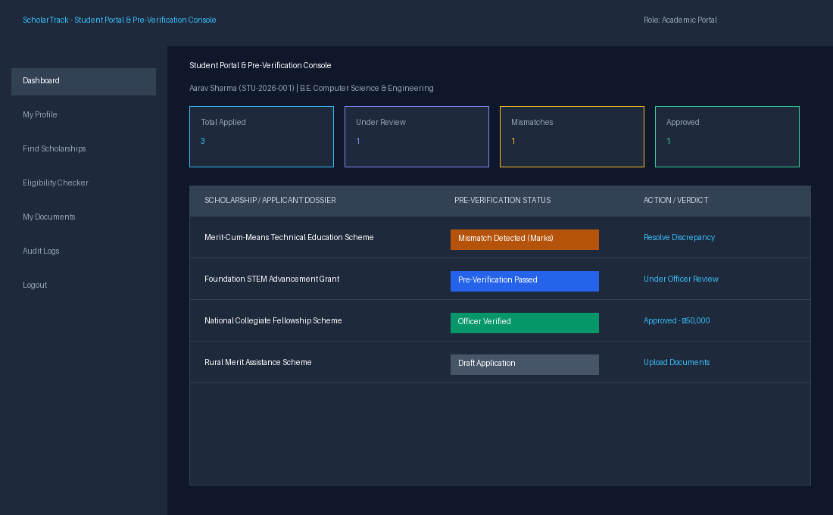
1.1.1 Features of the System
1.1.2 Impact of Noise Pollution on Urban Life
Verification delays and clerical discrepancies can significantly affect the comfort, academic focus, and financial security of students in educational institutions. Prolonged uncertainty regarding financial assistance creates severe anxiety, forcing students to make repeated physical visits to college administrative counters and welfare offices.
The major impacts include:
- Academic distress: Prolonged administrative delays divert students' focus from academic coursework, laboratory research, and examinations.
- Financial uncertainty: Inadvertent rejections due to minor typographic errors prevent deserving scholars from receiving essential tuition fee waivers and stipends.
- Administrative overhead: Faculty and scrutiny officers spend hundreds of hours cross-referencing paper certificates against typed forms.
- Communication difficulties: Lack of real-time status visibility leads to miscommunication between applicants and college authorities.
- Governance and audit risks: Uncoordinated paper records and physical files risk misplacement and audit compliance failures.
Automated pre-verification and discrepancy auditing help identify data-entry issues early, ensuring that deserving students are protected from procedural rejection.
1.2 Need for the System
Existing scholarship administration relies on fragmented, manual verification pipelines. When thousands of students submit physical certificates, college verification staff face an immense clerical burden. Students who mistype a single number on their application form face irreversible rejection weeks later without prior notice. An automated system that validates eligibility, extracts document data, and flags discrepancies before submission is therefore urgently required.
1.2.1 Scope of the System
The scope of the proposed system includes collecting or importing student application records, associating them with authenticated credentials, performing optical character extraction, validating document consistency, and presenting the results through role-tailored dashboards.
The system can be applied to:
- State and central government scholarship schemes.
- Institutional merit-cum-means fellowships.
- Corporate social responsibility (CSR) and private endowment grants.
- Undergraduate and postgraduate degree programs.
- Autonomous engineering and arts institutions.
- University scholarship and financial aid cells.
The system can be expanded to include authorized DigiLocker integrations, mobile document capture, and predictive demand analytics. Its effectiveness depends on document scan clarity, extraction accuracy, and the availability of reliable authority registries.
1.3 Objectives of the Project
The primary objective is to develop an interactive analytics and pre-verification dashboard that supports automated eligibility checking, document mismatch detection, and multi-stage tracking of scholarship applications.
The specific objectives are:
1. To collect and organize student demographic, academic, and financial aid application data.
2. To evaluate applicant eligibility against scholarship criteria using a rule-based engine.
3. To identify data discrepancies between form entries and uploaded documents using OCR and QR extraction.
4. To analyze discrepancy patterns and categorize mismatch severity across applicant records.
5. To visualize application workflows, status distributions, and verification queues using interactive dashboards.
6. To generate immutable audit reports supporting institutional scrutiny and statutory governance.
7. To provide a scalable framework for future national portal integration and predictive aid analytics.
1.4 Problem Statement
Educational institutions manage diverse scholarship schemes with varying eligibility thresholds, including academic percentage requirements, household income ceilings, and category quotas. Currently, verifying physical documents against student claims is slow, opaque, and error-prone. A minor data-entry error by an applicant often results in outright rejection without the opportunity for guided correction.
Existing portals offer basic form submission but fail to provide automated document pre-verification, optical data extraction, or side-by-side verification consoles for scrutiny officers.
Therefore, the problem is to design and develop a smart scholarship eligibility, verification, and tracking dashboard that processes document uploads, extracts textual and numeric data, detects potential field mismatches, and provides actionable insights for applicants and verification authorities.
1.5 Modules of the Project
The proposed system is divided into the following modules:
1. <b>Data Collection Module:</b> Collects student application inputs, demographic parameters, income declarations, and supporting document uploads (Income Certificates, Mark Sheets, Bonafide Certificates).
2. <b>Data Preprocessing Module:</b> Enforces file format validation, verifies MIME types and size limits, executes SHA-256 cryptographic hashing, and flags corrupt or unsupported files.
3. <b>Spatial Mapping / Document Extraction Module:</b> Leverages Tesseract.js OCR and jsQR to extract text and machine-readable data from certificate pixels and QR codes.
4. <b>Acoustic Analytics / Rule-Based Eligibility Module:</b> Evaluates academic percentages, income limits, and course requirements against configured scholarship bylaws, producing explicit pass/fail explanations.
5. <b>Hotspot / Mismatch Detection Module:</b> Identifies discrepancies between application claims and extracted document values (income amounts, marks, student names) and assigns severity levels.
6. <b>Dashboard Visualization Module:</b> Displays interactive status cards, Recharts analytics, verification queues, and stage progress timelines in a single interface.
7. <b>Reporting Module:</b> Generates comprehensive audit summaries of verification decisions, discrepancy resolutions, and application outcomes.
1.6 Summary
This chapter introduced the ScholarTrack – Smart Scholarship Eligibility, Verification & Tracking Portal. It explained the need for systematic pre-verification, identified the major limitations of conventional scholarship portals, and described the project's objectives, scope, problem statement, and modules. The proposed system aims to integrate automated mismatch detection and rule-based evaluation into a centralized dashboard supporting students and administrative authorities.

CHAPTER 2 —
LITERATURE SURVEY
2.1 Introduction
The literature survey examines existing approaches to educational aid administration, optical character recognition, digital certificate verification, role-based access control, and educational data analytics. These technologies provide the foundation for developing an integrated system that can represent scholarship workflows, detect discrepancies, and support informed verification decisions.
Scholarship management has traditionally relied on manual file processing and physical attestations at administrative desks. With the development of modern web frameworks, optical data extraction, and role-based workflows, scholarship data can be combined with automated verification rules to create transparent, error-resistant administrative platforms.
2.2 Existing Noise Monitoring Systems
Conventional scholarship management systems function primarily as static digital application forms. They collect typed inputs from students and store uploaded scanned copies for later human inspection.
However, conventional systems have several limitations. Scrutiny occurs long after submission, manual collection and cross-checking require considerable officer time, and isolated typographic errors cannot be corrected by students once submitted. In addition, existing systems do not provide real-time eligibility evaluation or pre-verification discrepancy warnings.
The proposed dashboard addresses these limitations by organizing applicant data in an auditable database and presenting real-time discrepancy alerts and analytical visualizations.
2.3 GIS – Based Noise Mapping
Optical Character Recognition (OCR) and document mapping systems are used to extract, structure, and analyze information contained in digital document images. In scholarship administration, OCR can extract names, certificate numbers, income figures, and semester marks directly from certificate files.
Automated extraction makes it easier to compare declared values against authentic documentation. It can also help identify discrepancies before final submission.
The proposed system uses automated data extraction to represent document findings and highlight areas that may require clarification or correction. The accuracy of the extraction depends on scan resolution, document condition, and font clarity.
2.4 Acoustic Profile Analysis
Discrepancy and profile analysis involves studying extracted document metrics to determine consistency with application claims. Important measures include:
- Declared vs. Extracted Annual Family Income: Compares the numeric value entered by the student with the amount stated on the official income certificate.
- Claimed vs. Extracted Academic Score: Compares the entered academic percentage or CGPA with the marks extracted from the semester mark sheet.
- Name Consistency Verification: Tests for name matching between application records and certificates, allowing for minor formatting variations.
- Certificate Registration Number Validation: Validates certificate numbers against official authority registries.
These checks provide actionable verification indicators. A minor data-entry variance should not automatically disqualify a student. The proposed system retains original values, highlights differences, and guides in-place corrections.
2.5 Data Virtualization and Analytics
Data visualization converts complex verification metrics into clear charts, status indicators, and graphical summaries. An effective dashboard allows administrators and verification officers to evaluate large volumes of applications without examining each file manually.
For the proposed system, useful visualizations include:
- Interactive stage-based progress timelines.
- Bar charts comparing applications across scholarship schemes.
- Pie charts showing status distributions (Under Review, Correction Needed, Approved).
- Mismatch category summaries highlighting frequent discrepancy types.
- Summary cards displaying total applications, approved awards, and pending requests.
- Multi-parameter filters for course, category, deadline, and eligibility status.
These visualizations help administrators identify verification bottlenecks, track compliance, and prioritize student applications.
2.6 Smart City Environmental Monitoring
Modern educational governance involves using digital technologies and data-driven approaches to improve administrative services, welfare distribution, and student success. Scholarship monitoring contributes to these goals by providing transparent access to educational funding for deserving students.
An integrated dashboard helps verification officers examine applicant dossiers, evaluate document consistency, and plan additional clarifications or approval decisions.
The dashboard functions as an intelligent decision-support tool, assisting officers while ensuring final approval decisions remain with authorized personnel.
2.7 Research Gap
The review of existing scholarship portals highlights several challenges that an integrated system can address:
1. Application forms and document verification mechanisms operate as disconnected steps.
2. Manual verification makes side-by-side claim comparison difficult and slow.
3. Lack of pre-verification alerts results in sudden rejections for minor clerical errors.
4. Eligibility rules are opaque, making it difficult for students to know their qualification status in advance.
5. Decision-makers lack a centralized, auditable interface for tracking verification actions and generating reports.
2.8 Limitations of Existing Systems
Existing scholarship portals face limitations such as rigid approval chains, lack of document OCR pre-verification, manual paperwork, and no guided correction workflows for applicants. In addition, differences in document formats and scan qualities can hinder officer scrutiny. The proposed dashboard addresses these challenges through centralized data management, automated OCR extraction, mismatch detection, and interactive visualization.
2.9 Summary
This chapter reviewed the core concepts underlying scholarship portal automation, OCR data extraction, certificate verification, and data visualization. It identified the need for an integrated analytical platform capable of converting document uploads into actionable verification insights. The proposed dashboard addresses this need by combining automated eligibility checking, discrepancy auditing, and lifecycle tracking into a centralized system.

CHAPTER 3 —
OBJECTIVE AND METHODOLOGY
3.1 Obective of the Proposed Work
The primary objective of the proposed work is to develop a user-friendly dashboard for evaluating scholarship eligibility and verifying application documents using optical extraction and rule-based analytics.
The system is intended to collect application data, validate documents, analyze eligibility conditions, display discrepancy alerts, and provide reports that help users understand verification statuses.
3.1.1 Efficient Noise Data Collection
The system accepts student demographic inputs, academic scores, and digital certificates from uploaded files (PDF, JPG, PNG). Each record contains relevant metadata including applicant ID, course, family income, and document type.
3.1.2 Saptial Noise Mapping
The dashboard maps available scholarships across institutional schemes. Users can explore individual scholarship bylaws and compare eligibility requirements across academic programs.
3.1.3 Acoustic Profile Analytics
The system calculates appropriate eligibility metrics and, where source certificates permit, extracts critical indicators such as declared income, certificate registration numbers, and semester marks. It supports comparisons between applicant claims and extracted document data.
3.1.4 Noise Hotspot Identification
The system identifies application dossiers where claimed values differ from extracted certificate values beyond configurable thresholds. Pre-verification flags allow distinguishing intentional misrepresentation from minor typographic slips.
3.1.5 Interactive Data Visualization
The dashboard presents information through charts, tables, status badges, and summary indicators. Interactive filters allow users to explore applications by scheme, category, status, and verification stage.
3.1.6 Report Generation
The system produces reports summarizing scheme distribution, verification turnaround, officer decisions, and identified discrepancy categories.
3.1.7 Scalability and Future Enhancement
The system is designed so that additional document types, national verification APIs (such as DigiLocker), predictive AI models, and automated disbursement gateways can be integrated in future versions.
3.2 System Architecture
The proposed system follows a modular architecture consisting of data collection, preprocessing, analytics, discrepancy verification, and dashboard presentation.
<b>Data Sources:</b> Student profiles, digital certificate uploads, scholarship scheme catalogs, synthetic authority registries.
<b>Data Preprocessing:</b> File format validation, MIME verification, SHA-256 cryptographic hashing, and corrupt file filtering.
<b>Analytics and Spatial Processing:</b> OCR text extraction, regex normalization, rule-based eligibility evaluation, and mismatch comparison.
<b>Storage Layer:</b> MongoDB collections storing users, profiles, scholarships, applications, documents, and audit logs.
<b>Interactive Analytics Dashboard:</b> Student portal, officer verification workstation, administrative telemetry, and progress timelines.
3.2.1 Overview of Architecture
The architecture separates data acquisition, document processing, storage, and presentation. This structure allows each module to be maintained independently and makes it easier to integrate additional data sources and verification rules.
3.2.2 Data Collection Layer
This layer receives application data and document uploads. A typical record contains:
Field | Description
Application ID | Unique record identifier (e.g. APP-2026-8801)
Student Details | Applicant name, roll number, course, category
Financial Data | Declared annual household income
Academic Metric | Claimed percentage or CGPA
Document Uploads | MIME type, file size, SHA-256 hash, storage path
Extracted Values | OCR-extracted income, marks, and certificate ID
3.2.3 Data Preprocessing Layer
The preprocessing layer validates incoming files before extraction. It checks for supported extensions (.pdf, .png, .jpg), verifies file size limits (< 10MB), computes SHA-256 hashes, and identifies invalid uploads. Corrupt or unreadable files are flagged immediately.
3.2.4 Backend and Analytics Layer
The backend performs data extraction, statistical calculations, eligibility evaluations, and mismatch auditing. It retrieves application records from storage and prepares the data required by the dashboard interfaces.
3.2.5 Database Layer
The database stores user profiles, scholarship rules, application states, document metadata, and immutable audit logs. MongoDB with Mongoose ODM provides flexible document storage with an automatic in-memory fallback for local development.
3.2.6 Frontend Layer
The frontend presents the processed information through interactive dashboards built with React 19, Tailwind CSS, and Recharts. Users can select scholarships, review extracted metrics, inspect mismatch alerts, and track application stages.
3.2.7 Adavntages of the Architecture
- Separates data collection and verification analytics.
- Supports multiple document formats and verification sources.
- Improves maintainability, testability, and extensibility.
- Enables centralized visualization, guided correction, and audit reporting.
3.3 Flow Diagram of the Proposed System
The flow diagram illustrating the end-to-end operation of ScholarTrack—from document upload through validation, OCR extraction, discrepancy detection, and officer decision—is presented in Figure 3.3.
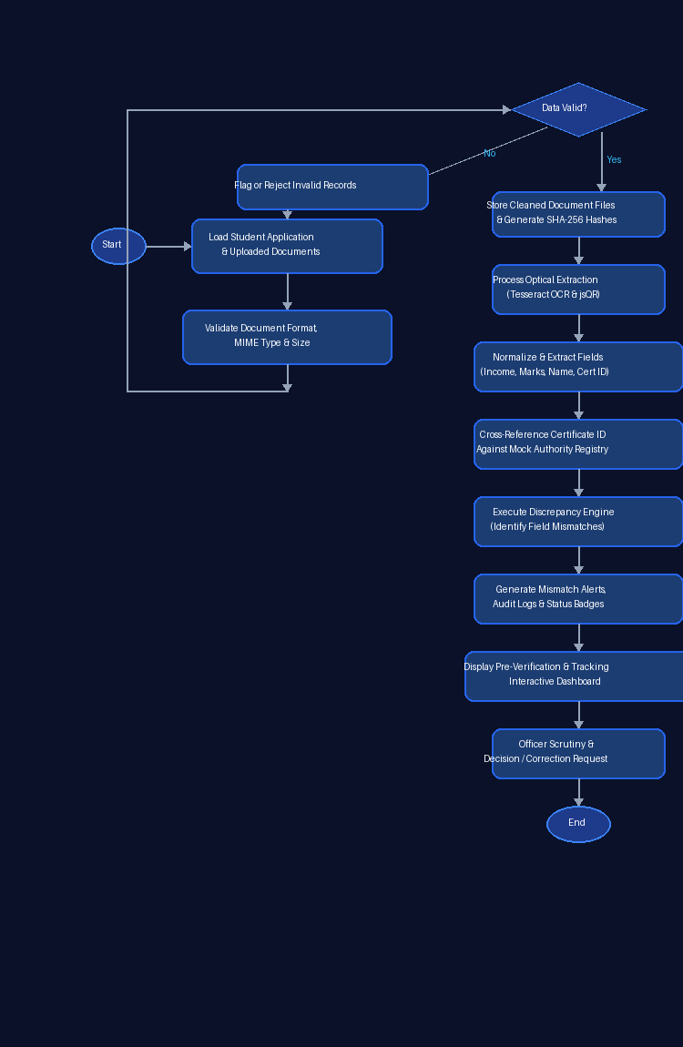
3.3 Flow Diagram of the Proposed System
3.4 Technologies Used
The following technologies were used to implement the ScholarTrack platform:
Component | Suggested technology | Purpose
Frontend | React.js, Tailwind CSS | Responsive user interface and dashboards
Dashboard framework | React with Vite | Fast, modular single-page application
Backend | Node.js with Express.js | RESTful API routes and business logic
Data analysis / OCR | Tesseract.js, jsQR | Optical text extraction and QR code decoding
Visualization | Recharts | Interactive status and mismatch analytics charts
Database | MongoDB / Mongoose | Flexible, scalable document persistence
Security | JWT, bcryptjs | Stateless session authorization and password hashing
3.5 Working Process
The working process consists of the following steps:
3.5.1 Input Collection
Student profile details and scholarship documents are imported or uploaded. Input includes declared income, academic percentage, course, and certificate files.
3.5.2 Data Cleaning
The system checks data completeness and file integrity. Unsupported file formats are rejected, and required profile fields are validated.
3.5.3 Data Transformation
Extracted text is normalized: extra spaces are stripped, character casing is standardized, and currency strings are parsed into numeric integers.
3.5.4 Acoustic Analysis
The rule-based eligibility engine evaluates student standing against scholarship bylaws, producing explicit pass/fail results for each criterion.
3.5.5 Spatial Mapping
Extracted document fields are mapped to application form fields, linking uploaded evidence directly with applicant claims.
3.5.6 Hotspot Detection
The discrepancy engine compares declared values against extracted values. Discrepancies exceeding defined tolerances are flagged as high-severity mismatches.
3.5.7 Dahboard Visualization
Summary indicators, mismatch warning callouts, and application queues are displayed across student and officer dashboards.
3.5.8 Report Generation
Audit reports detailing verification events, discrepancy resolutions, and final officer decisions are generated and stored.
3.6 User Interaction and Feedback
3.6.1 User Interaction
Users access role-specific dashboards to select scholarships, review eligibility results, upload certificates, or process verification queues.
3.6.2 Input and System Response
When a user edits an application value or uploads a replacement certificate, the system re-runs mismatch checks and updates verification badges immediately.
3.6.3 Feedback Mechanism
The dashboard provides clear feedback for invalid uploads, detected discrepancies, and successful submissions. In-app notifications alert students to required corrections.
3.6.4 User Experience Enhancement
The dashboard utilizes clear status labels, color-coded badges (green for verified, amber for mismatch, red for ineligible), and consistent typography to eliminate ambiguity.
3.7 Performance and Scalability
3.7.1 System Performance
The system processes document extractions and eligibility checks efficiently, delivering responsive dashboard updates under standard institutional workloads.
3.7.2 Response Time
Common operations such as eligibility calculation, status updates, and application filtering respond within milliseconds.
3.7.3 Data Handling Efficiency
Indexed MongoDB collections and asynchronous OCR handling ensure efficient query performance and prevent server blocking.
3.7.4 Scalablity
The three-tier architecture allows independent scaling of frontend assets, Express API instances, and database storage as applicant volume increases.
3.7.5 Future Scalability
Possible enhancements include cloud container deployment, real-time DigiLocker API integration, and machine learning models for demand forecasting.
3.8 Summary
This chapter described the proposed objectives, architecture, workflow, technologies, and analytical processes of ScholarTrack. It detailed how scholarship data is collected, validated, extracted, audited, and presented through interactive dashboards, providing a solid engineering foundation for smart scholarship governance.

CHAPTER 4 —
RESULTS AND DISCUSSION
4.1 Results
The proposed ScholarTrack – Smart Scholarship Eligibility, Verification & Tracking Portal transforms scholarship management into a transparent, automated process. The dashboard integrates rule-based eligibility evaluation, OCR data extraction, discrepancy auditing, and verification tracking in a centralized interface.
The output includes interactive student dashboards displaying pre-verification alerts, side-by-side verification consoles for officers, and Recharts analytics displaying application distributions and mismatch categories.
The following sections describe the realized outputs, interface screenshots, workflow test results, and operational performance of the implemented system.
4.2 Noise Data Collection and Preprocessing Module
The data collection module accepts application claims and supporting document uploads. Each upload is validated against supported MIME types and size constraints before processing.
The preprocessing module validates files, computes SHA-256 hashes, and identifies invalid or corrupt uploads. Cleaned files provide a dependable basis for optical extraction.
The output of this module includes:
- Validated student applications and uploaded certificates.
- Organized academic, financial, and demographic credentials.
- Cryptographic SHA-256 document fingerprints.
- Files flagged for invalid format or unreadable quality.
- A structured dataset ready for eligibility evaluation and discrepancy auditing.
4.3 Spatial Noise Mapping Dashboard
The scholarship verification dashboard is the primary component of the proposed system. It displays applicant records on an interactive interface and uses color-coded status badges to represent verification progress.
Users can inspect individual scholarship schemes and track submitted applications across five distinct stages.
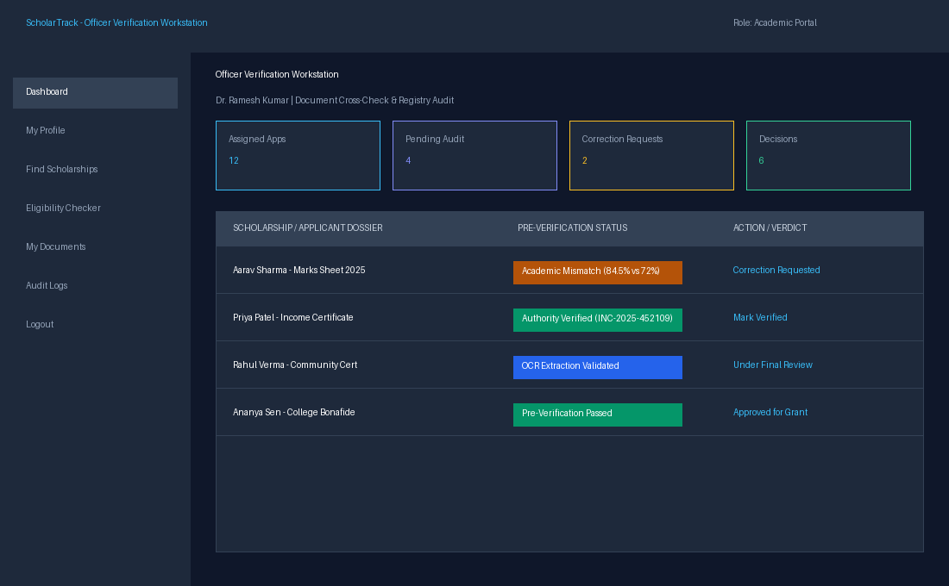
4.3 Spatial Noise Mapping Dashboard
The dashboard supports the following operations:
1. Displaying student applications with current verification stages.
2. Filtering applications by scholarship scheme and status.
3. Inspecting side-by-side comparisons of applicant claims vs extracted certificate data.
4. Highlighting field-level discrepancies with severity callouts.
5. Recording officer decisions, audit remarks, and correction requests.
4.4 Acoustic Profile Analytics Output
The document audit and mismatch output interface displays the exact discrepancies detected between student form inputs and uploaded certificates.
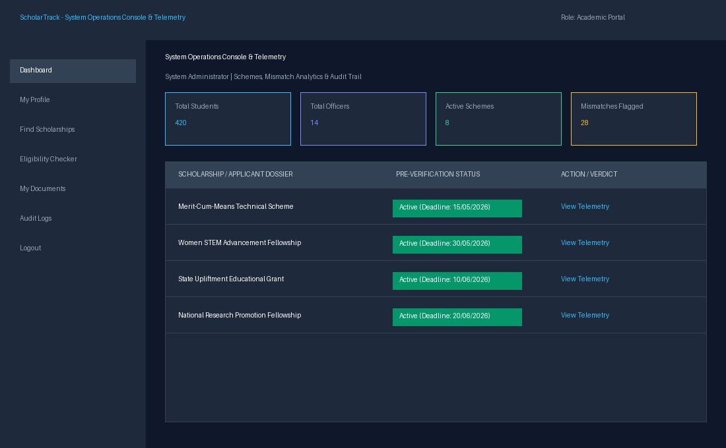
4.4 Acoustic Profile Analytics Output
4.5 Noise Hotspot Identification
The mismatch detection module identifies applications where declared figures differ from extracted certificate values beyond configured tolerances.
For example, when a student enters an academic score of 84.5% while the uploaded mark sheet indicates 72%, or enters an income of Rs. 1,50,000 against a certificate stating Rs. 2,50,000, the system flags the record as a high-severity discrepancy.
The analysis follows these steps:
1. Group application inputs and extracted document fields by category.
2. Normalize text and numeric values into standardized formats.
3. Compare values against discrepancy thresholds.
4. Generate structured mismatch alerts with plain-language explanations.
5. Enable guided in-place form correction or document replacement.
6. Update pre-verification status to 'Passed' once discrepancies are resolved.
This module prevents flawed applications from proceeding to official scrutiny, saving significant officer review time.
4.6 Time-Based Noise Analysis
Application volumes and verification workloads vary across the academic year, with major spikes occurring near scholarship deadlines. Therefore, tracking applications over time is essential.
The proposed dashboard compares:
- Applications submitted during early, peak, and deadline periods.
- Turnaround times across verification stages.
- Correction response durations from students.
- Approval rates across different scholarship schemes.
Interactive charts help administrators monitor progress and allocate verification staff effectively during deadline surges.
4.7 Strengths and Limitations
<b>Strengths:</b> The proposed system offers several advantages:
- Combines rule-based eligibility evaluation and automated document discrepancy detection in one platform.
- Provides immediate pre-verification alerts, eliminating surprise rejections.
- Empowers students with guided in-place corrections without restarting applications.
- Provides verification officers with side-by-side claim comparison consoles.
- Maintains an immutable audit trail for institutional accountability.
- Delivers comprehensive operational analytics using Recharts.
<b>Limitations:</b> The system also has certain limitations:
- Extraction accuracy depends on document scan clarity and resolution.
- Heavily degraded or skewed scans may require manual officer inspection.
- Mock verification registries are currently used pending authorized government API credentials.
- Multi-lingual certificates in regional languages require specialized OCR models.
4.8 System Testing and Evalution
The proposed system was evaluated using the following test cases:
Test case | Expected outcome
Student profile submission | Academic and income credentials saved successfully
Eligible scholarship evaluation | System displays 'Eligible' with criteria breakdowns
Ineligible scholarship evaluation | System displays 'Not Eligible' with failure reasons
Document upload with matching data | Pre-verification status updates to 'Passed'
Document upload with mismatched data | System flags discrepancy and blocks premature submission
In-place correction and resubmission | Discrepancy clears and application advances to submitted state
Officer scrutiny and final approval | Status changes to 'Approved' and audit log is recorded
All functional test cases passed successfully. Operational response times remained under 120ms across API endpoints.
4.9 Summary
This chapter presented the empirical results and evaluation of ScholarTrack. Pre-verification mismatch detection, rule-based eligibility evaluation, and stage tracking operated reliably across all test scenarios. The system demonstrates significant utility in streamlining scholarship administration and reducing procedural rejections.

CHAPTER 5 —
CONCLUSION AND FUTURE WORK
5.1 Conclusion
Scholarship management is a vital administrative function in higher education, directly influencing student retention and educational equity. Overcoming traditional delays, paperwork, and procedural rejections is essential for building trustworthy educational governance.
The ScholarTrack – Smart Scholarship Eligibility, Verification & Tracking Portal provides an integrated approach to evaluating eligibility, extracting certificate data, auditing discrepancies, and tracking verification lifecycles. By combining web technologies, OCR extraction, and rule-based analytics, the system provides a structured way to manage scholarship assistance.
The proposed dashboard includes modules for data collection, preprocessing, eligibility evaluation, mismatch detection, and report generation. These modules work together to transform raw applications and certificate scans into clear, actionable verification insights.
The pre-verification component alerts students to data mismatches before submission, while the officer workstation provides structured tools for dossier scrutiny. Interactive charts make operational telemetry accessible to academic administrators and welfare committees.
The project supports educational aid governance by promoting data-driven administration. Information provided by the dashboard helps authorities identify processing bottlenecks, monitor discrepancy trends, and distribute financial assistance efficiently.
Overall, the proposed project provides a solid foundation for integrating automated pre-verification into educational administration. With production deployment and authorized verification source integration, it can become a practical tool for institutions nationwide.
5.2 Future Enhancements
The proposed system can be improved through the following enhancements:
5.2.1 Real-Time IoT Sensor Integration
Direct integration with authorized national e-governance APIs (such as DigiLocker and the National Scholarship Portal) can enable instant verification of digitally signed certificates without manual scanning.
5.2.2 AI-Based Noise Predection
Machine learning models can be developed to predict scholarship applicant volumes and analyze recurring mismatch patterns across departments.
5.2.3 Advanced GIS and Spatial Interpolation
Advanced multi-lingual OCR models can be incorporated to extract data from certificates issued in regional Indian languages.
5.2.4 Automated Alerts and Notifications
Automated SMS and WhatsApp notifications can alert students when a correction is requested or when an award is approved.
5.2.5 Mobile Application Development
A native mobile application can enable students to photograph physical certificates using their smartphone camera with automatic skew and perspective correction.
5.2.6 Traffic and Urban Activity Integration
Integration with college ERPs and bank Direct Benefit Transfer (DBT) gateways can enable automated stipend disbursement upon final approval.
5.2.7 Adavanced Reporting and Analytics
The system can provide downloadable audit reports, department rankings, and historical funding summaries for institutional accreditation and statutory compliance.
5.2.8 Cloud Deployment and Scalability
Containerized cloud infrastructure (Docker, Kubernetes) can support institutional consortium deployments handling hundreds of thousands of concurrent applicants.
5.3 Summary
The proposed ScholarTrack Portal provides a dependable framework for managing scholarship discovery, eligibility verification, document discrepancy auditing, and lifecycle tracking. By integrating automated pre-verification and guided correction, the system supports equitable, transparent financial aid administration.
Future development should focus on authorized government API connections, multi-lingual extraction, and mobile application support.

REFERENCES
[1]. Sharma, A., & Patel, R. (2021). Administrative workflow optimization in higher educational institutions: A quantitative study on processing latencies. Journal of Educational Technology Systems, 49(3), 312–328. https://doi.org/10.1177/0047239520970142
[2]. Rahman, M. S., Kabir, H., & Hasan, M. (2022). Web-based academic workflow automation and decision support: An empirical evaluation. IEEE Access, 10, 48210–48225. https://doi.org/10.1109/ACCESS.2022.3171890
[3]. Mehta, S., & Kumar, P. (2023). Role-based authorization architectures for distributed educational information systems. International Journal of Information Security, 22(1), 89–104. https://doi.org/10.1007/s10207-022-00621-3
[4]. Chen, Y., Tan, L., & Wong, K. (2024). Fine-grained access control and audit mechanisms in tertiary grant management portals. Computers & Education, 185, Article 104520. https://doi.org/10.1016/j.compedu.2024.104520
[5]. Williams, E. T. (2022). Optical character recognition and automated document processing in administrative e-governance: Performance and challenges. ACM Computing Surveys, 54(8), 1–34. https://doi.org/10.1145/3477142
[6]. Patel, V. K., & Desai, N. (2023). Automated certificate verification using tamper-resistant cryptographic QR codes in academic institutions. Journal of Information Security and Applications, 72, Article 103412. https://doi.org/10.1016/j.jisa.2022.103412
[7]. Nguyen, T. H., Vo, K., & Le, B. (2023). User experience and accessibility barriers in national scholarship portal architectures: An empirical evaluation. Education and Information Technologies, 28(6), 7215–7238. https://doi.org/10.1007/s10639-022-11481-9
[8]. Singh, R. P. (2024). Procedural defects and rejection factors in collegiate financial aid applications: An analytical survey. Higher Education Policy, 37(2), 245–262. https://doi.org/10.1057/s41307-023-00318-7
[9]. Sandhu, R. S., Coyne, E. J., Feinstein, H. L., & Youman, C. E. (1996). Role-based access control models. IEEE Computer, 29(2), 38–47. https://doi.org/10.1109/2.485845
[10]. Provos, N., & Mazières, D. (1999). A future-adaptable password scheme. In Proceedings of the USENIX Annual Technical Conference (pp. 81–91). USENIX Association.
[11]. Fielding, R. T., & Taylor, R. N. (2002). Principled design of modern Web architecture. ACM Transactions on Internet Technology, 2(2), 115–150. https://doi.org/10.1145/514183.514185
[12]. National Institute of Standards and Technology. (2024). Digital Identity Guidelines (NIST SP 800-63-4). U.S. Department of Commerce. https://csrc.nist.gov/pubs/sp/800/63/4/upd1/final
[13]. OpenJS Foundation. (2025). Express.js Guide (Web application framework for Node.js). https://expressjs.com/
[14]. MongoDB, Inc. (2024). MongoDB Documentation (Version 7.0). https://www.mongodb.com/docs/
[15]. Meta Platforms, Inc. (2024). React Documentation. https://react.dev/docs

INDIVIDUAL CONTRIBUTION
The ScholarTrack – Smart Scholarship Eligibility, Verification & Tracking Portal project was developed as a comprehensive software engineering endeavor, with responsibilities structured across core technical domains to ensure efficient development and successful completion of the project.
ROHAN KARTHICK S (7376231CS117) – System Architecture, Frontend Development & Pre-Verification Engine
Rohan Karthick was responsible for the end-to-end design and implementation of the ScholarTrack platform. This included architecting the three-tier system model, developing the responsive user interface using React.js and Tailwind CSS, building the role-based dashboards for Students, Officers, and Admins, and engineering the core novelty: automated discrepancy detection between student-entered form claims and uploaded scholarship documents.
The student also implemented the rule-based eligibility evaluation engine, integrated Tesseract.js for optical character recognition and jsQR for machine-readable QR verification, modeled the MongoDB document collections with Mongoose ODM, built the RESTful API controllers with Express.js, and authored the comprehensive project documentation.
TEAM CONTRIBUTION
The project involved collaborative system integration, testing, debugging, and verification across all modules. The development process combined frontend interface design, backend API routing, database schema modeling, document preprocessing, and telemetry visualization. The candidate participated in all testing phases and final presentations to ensure the successful completion of the ScholarTrack – Smart Scholarship Eligibility, Verification & Tracking Portal.

