Project-2 : Databricks

Architecture Diagram-
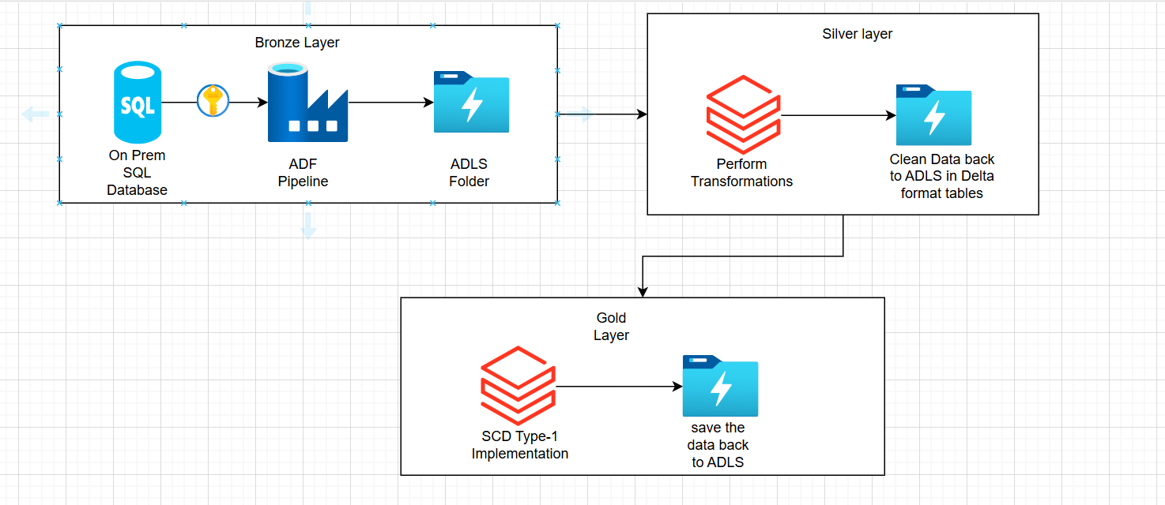

Create a cluster-
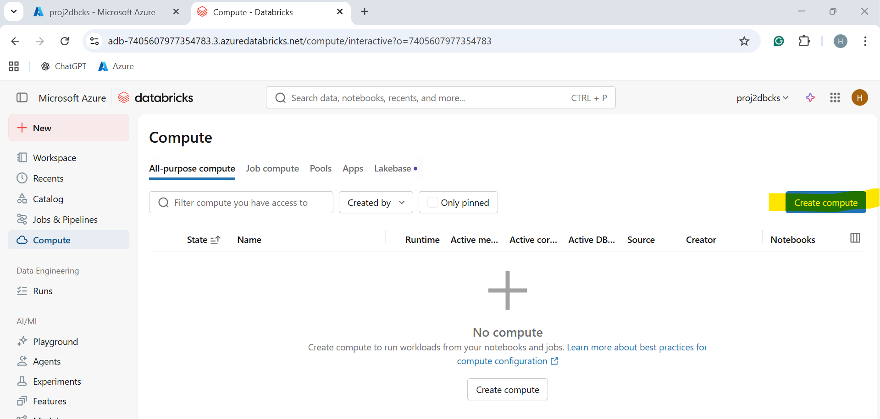
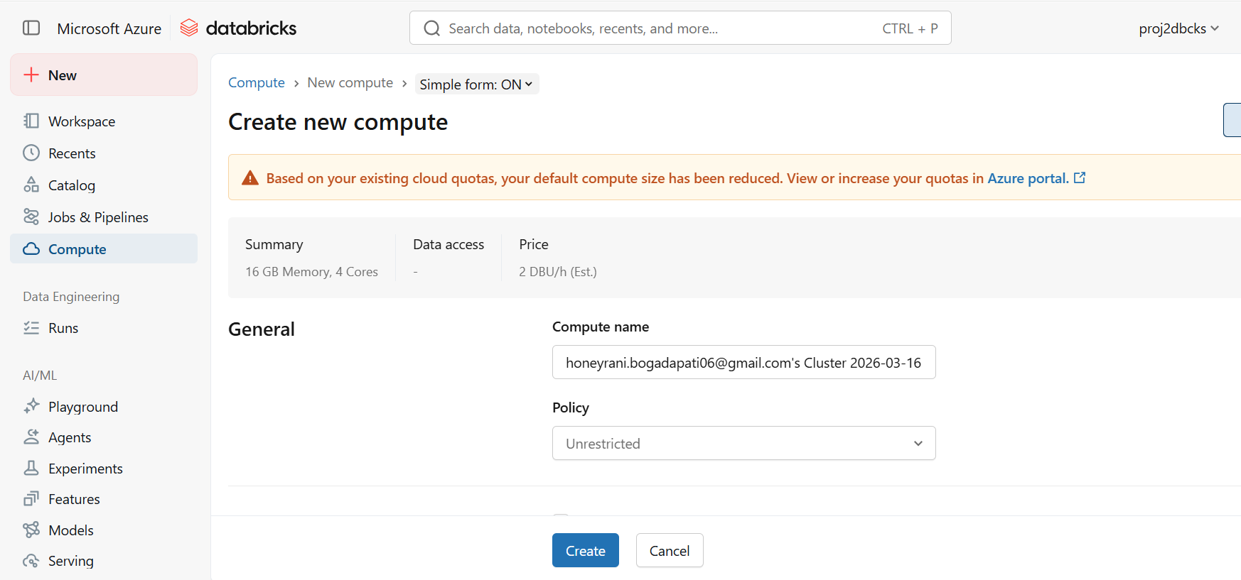
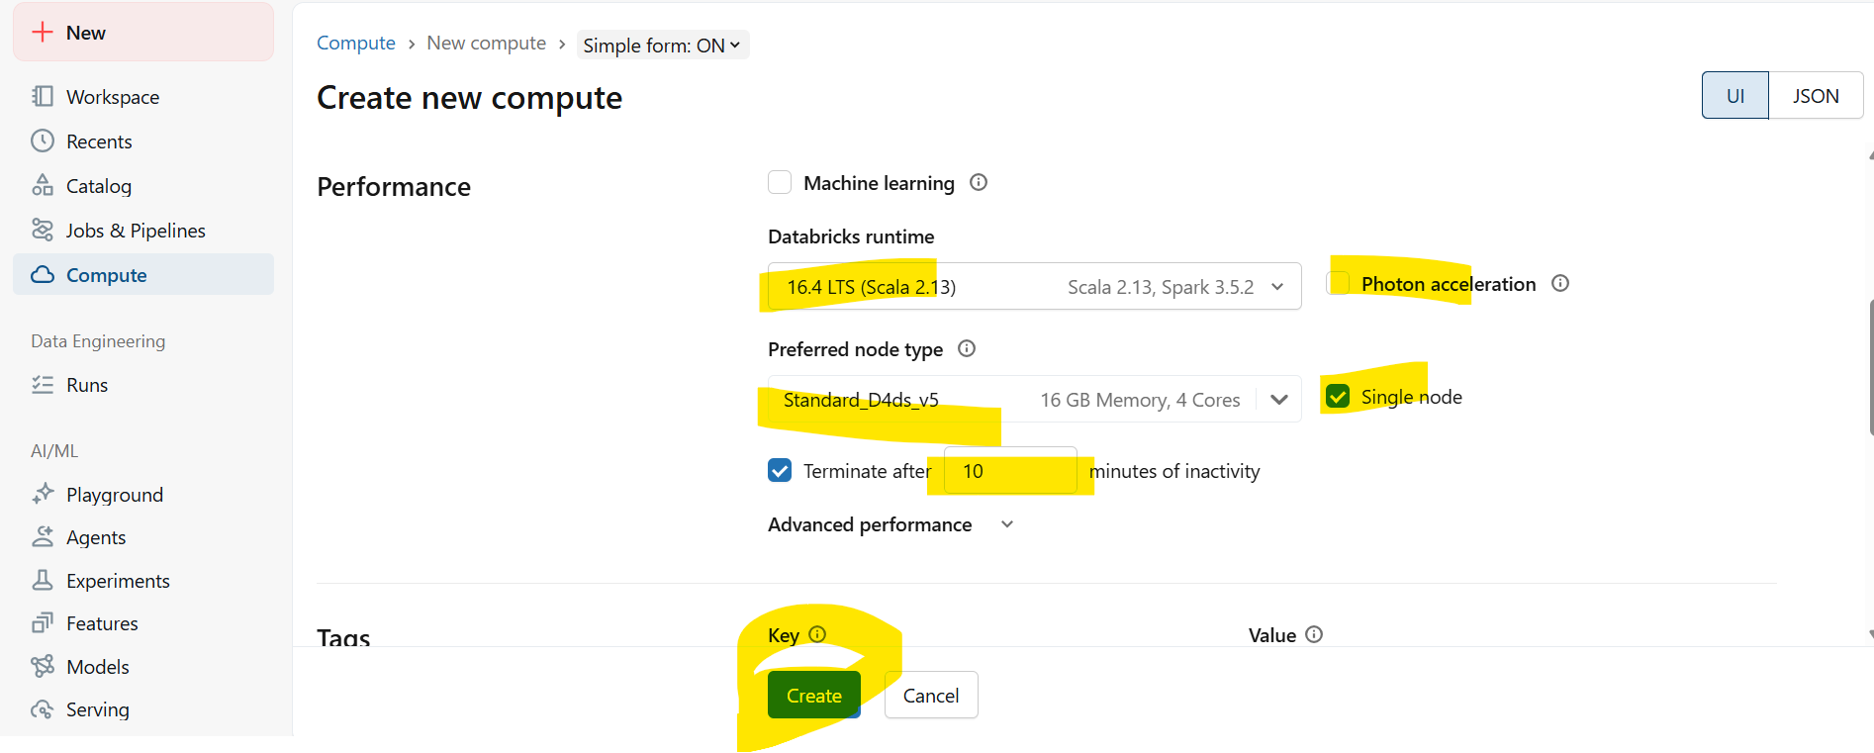
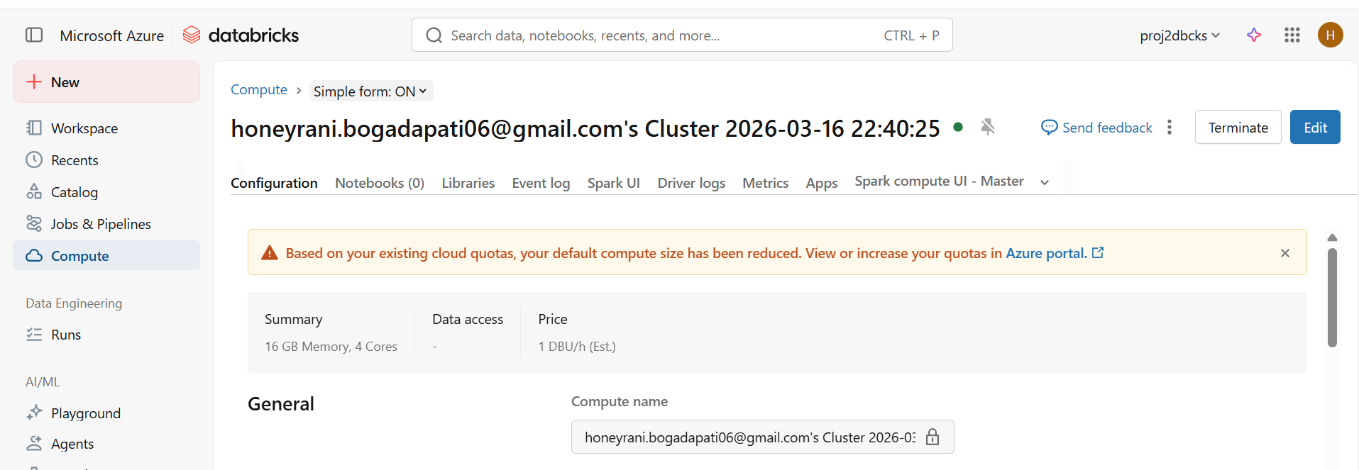
Access Keys-
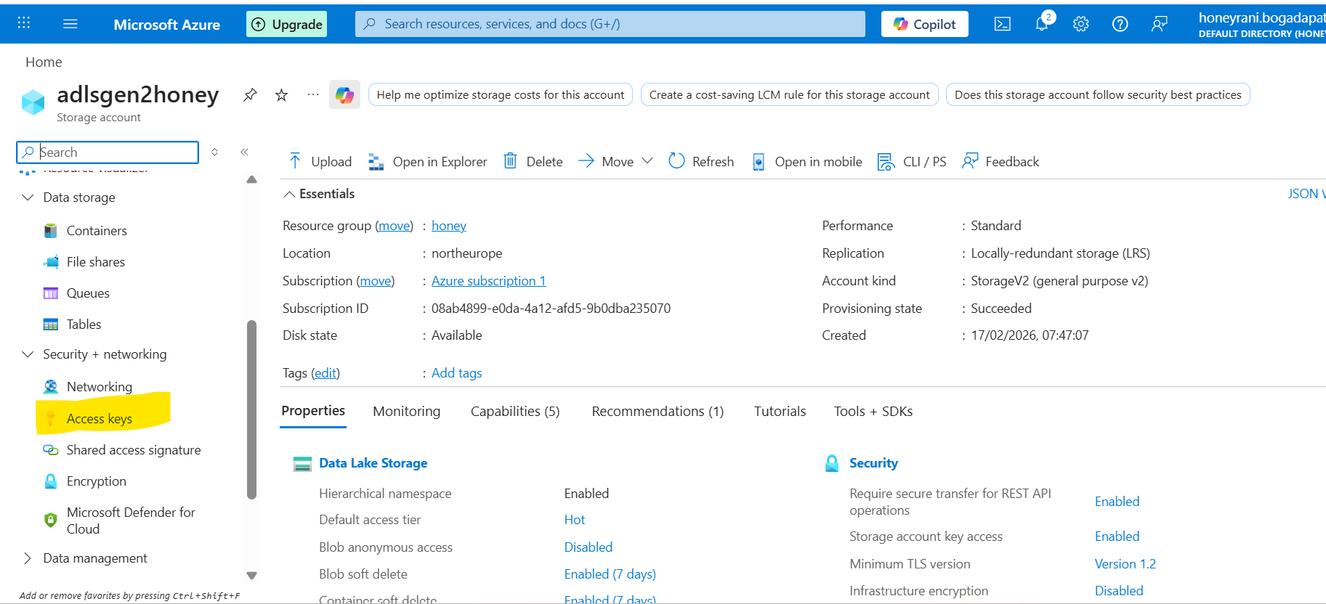
Customer Notebook:
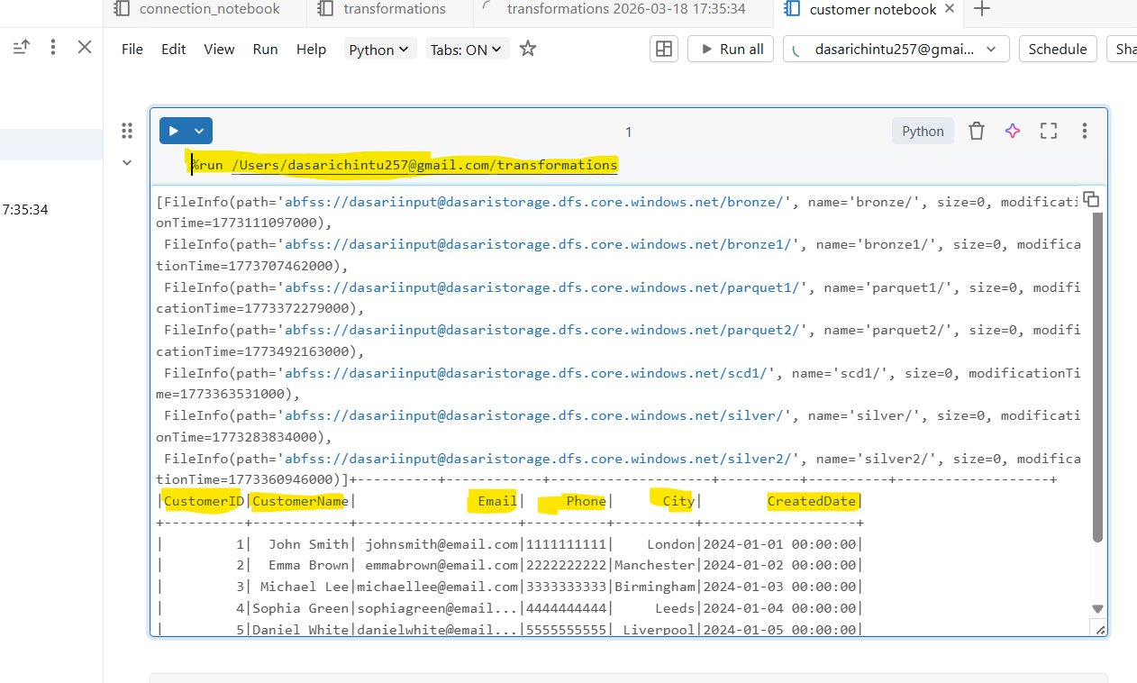

- %run is a magic command it will take the one notebook data to another notebook
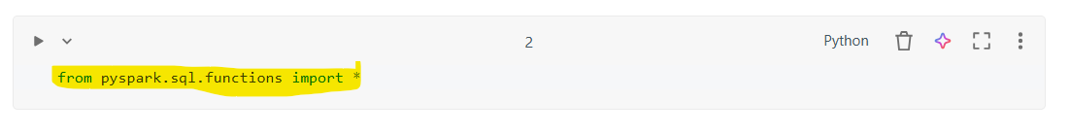
- This statement imports all built-in Spark SQL functions so you can use them directly in your PySpark code
- pyspark.sql.functions → module that contains many Spark SQL functions
- * → imports all functions from that module
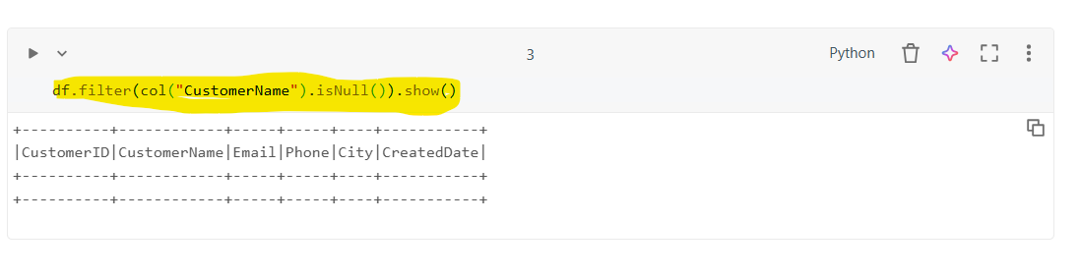
- df.filter(col("CustomerID").isNull()).show()
- filters the DataFrame and displays rows where the CustomerID column contains NULL values.
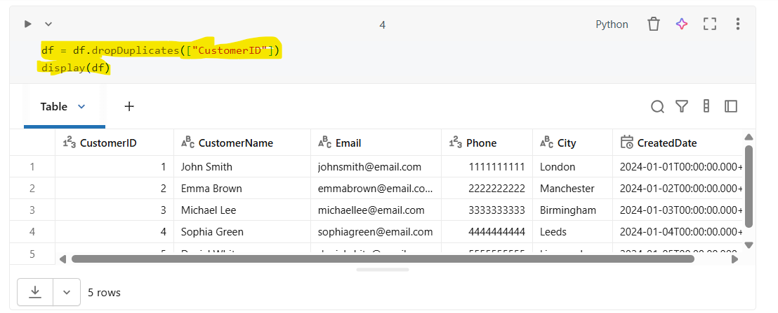
dropDuplicates()
- Used to remove duplicate records from a Spark DataFrame based on one or more columns.
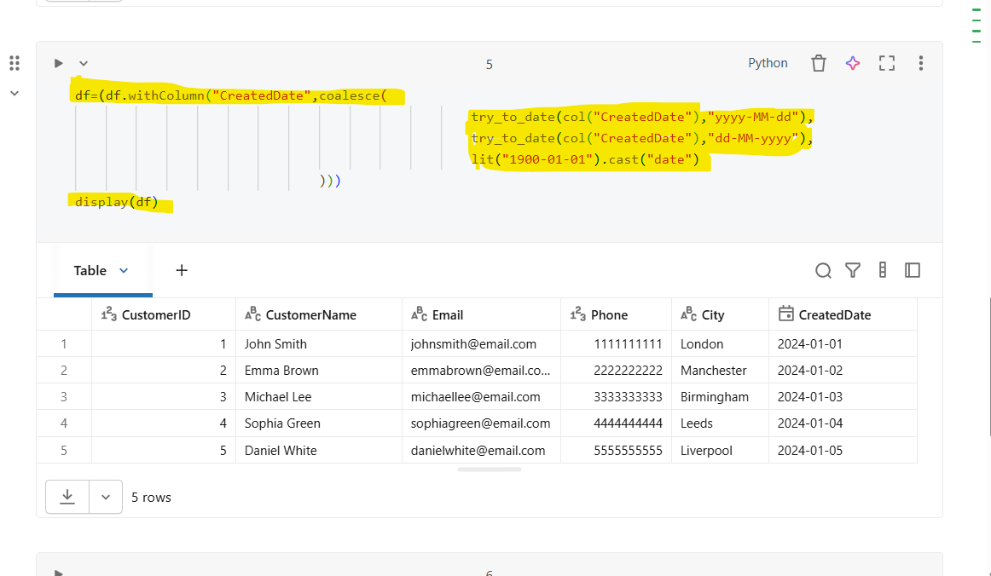

- withColumn() is used to create a new column or replace an existing column.
- Here it replaces the existing CreatedDate column with a cleaned date value.
- try_to_date() attempts to convert a string into a date format.
- If conversion fails, it returns NULL instead of throwing an error.
- coalesce() returns the first non-NULL value from the list.
- lit() creates a constant value.
This acts as a default fallback date when parsing fails.
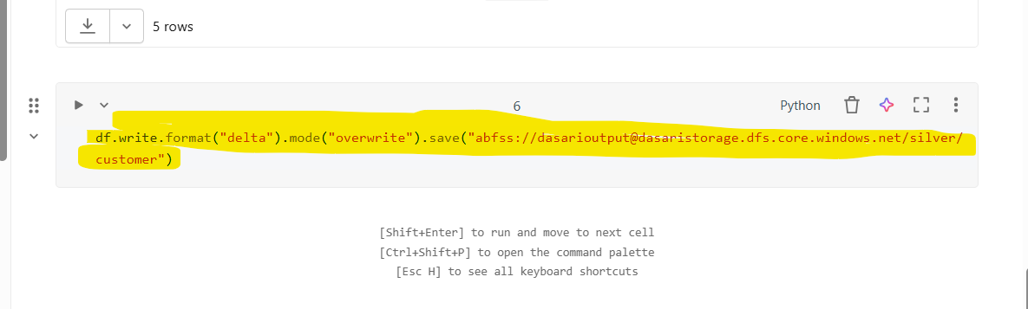

- It will be save in a delta format in a adls gen2
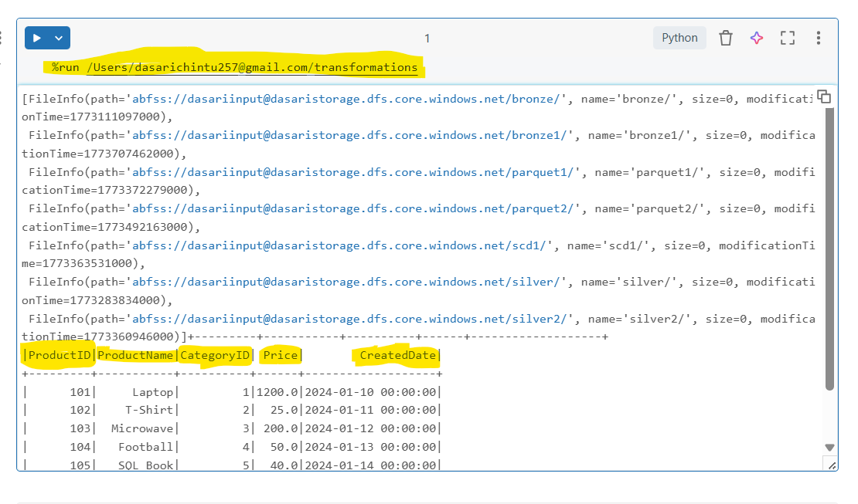
- %run is a magic command it will take the one notebookn data to another notebook

- This statement imports all built-in Spark SQL functions so you can use them directly in your PySpark code
- pyspark.sql.functions → module that contains many Spark SQL functions
- * → imports all functions from that module
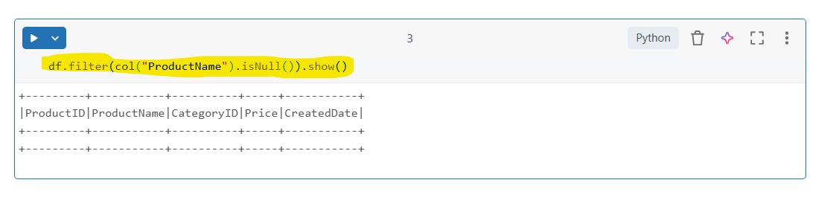
- df.filter(col("ProductID").isNull()).show()
- filters the DataFrame and displays rows where the ProductID column contains NULL values.
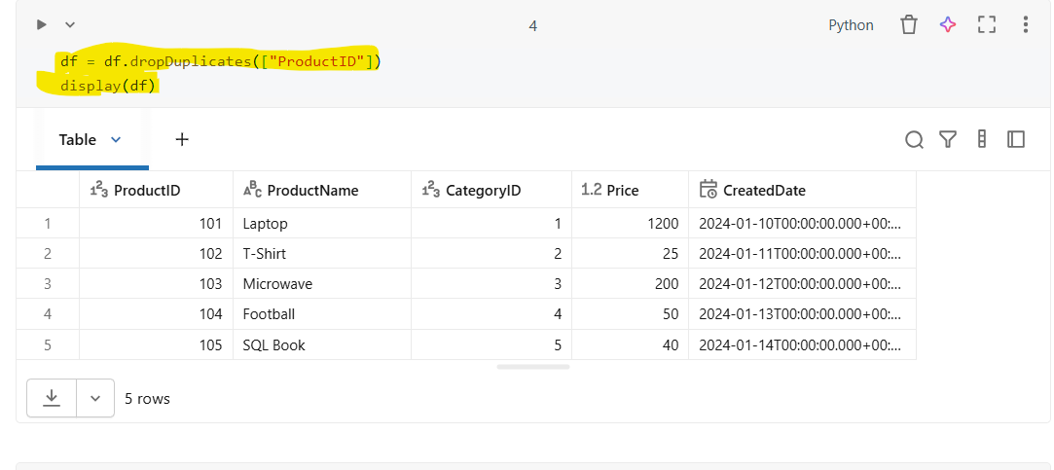

dropDuplicates()
- Used to remove duplicate records from a Spark DataFrame based on one or more columns.
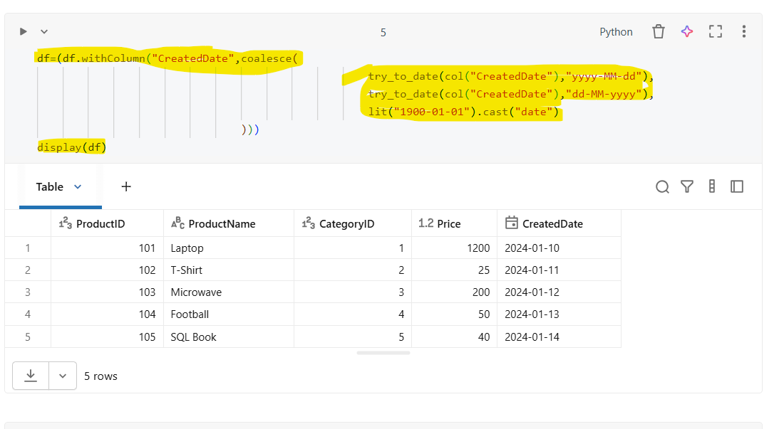
- withColumn() is used to create a new column or replace an existing column.
- Here it replaces the existing CreatedDate column with a cleaned date value.
- try_to_date() attempts to convert a string into a date format.
- If conversion fails, it returns NULL instead of throwing an error.
- coalesce() returns the first non-NULL value from the list.
- lit() creates a constant value.
- This acts as a default fallback date when parsing fails.

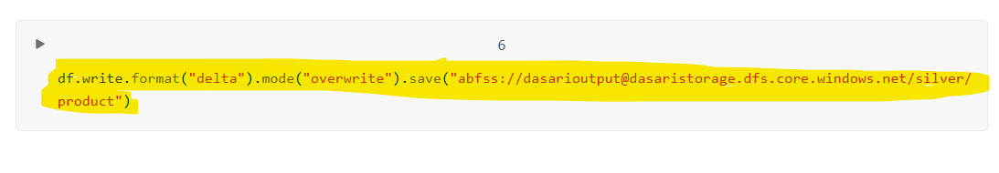
- It will be save in a delta format in a adls gen2

Category Notebook:
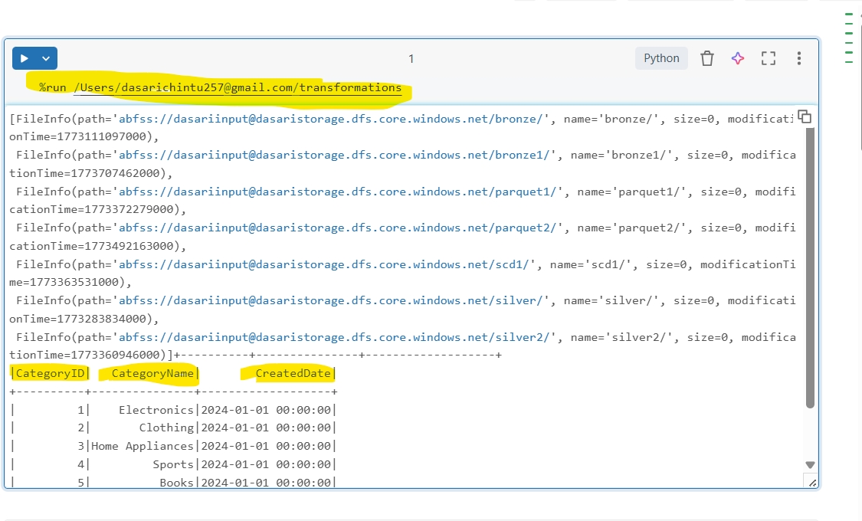
- %run is a magic command it will take the one notebookn data to another notebook

- This statement imports all built-in Spark SQL functions so you can use them directly in your PySpark code
- pyspark.sql.functions → module that contains many Spark SQL functions
- * → imports all functions from that module
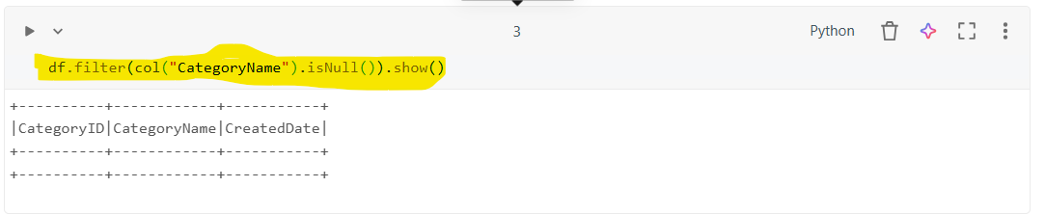

- df.filter(col("CategoryID").isNull()).show()
- filters the DataFrame and displays rows where the CategoryID column contains NULL values.
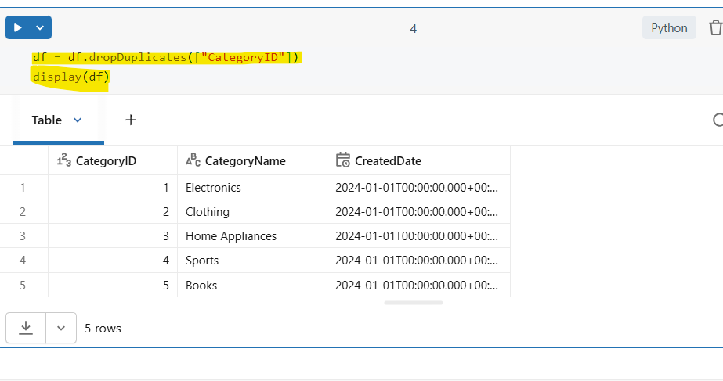
dropDuplicates()
- Used to remove duplicate records from a Spark DataFrame based on one or more columns.
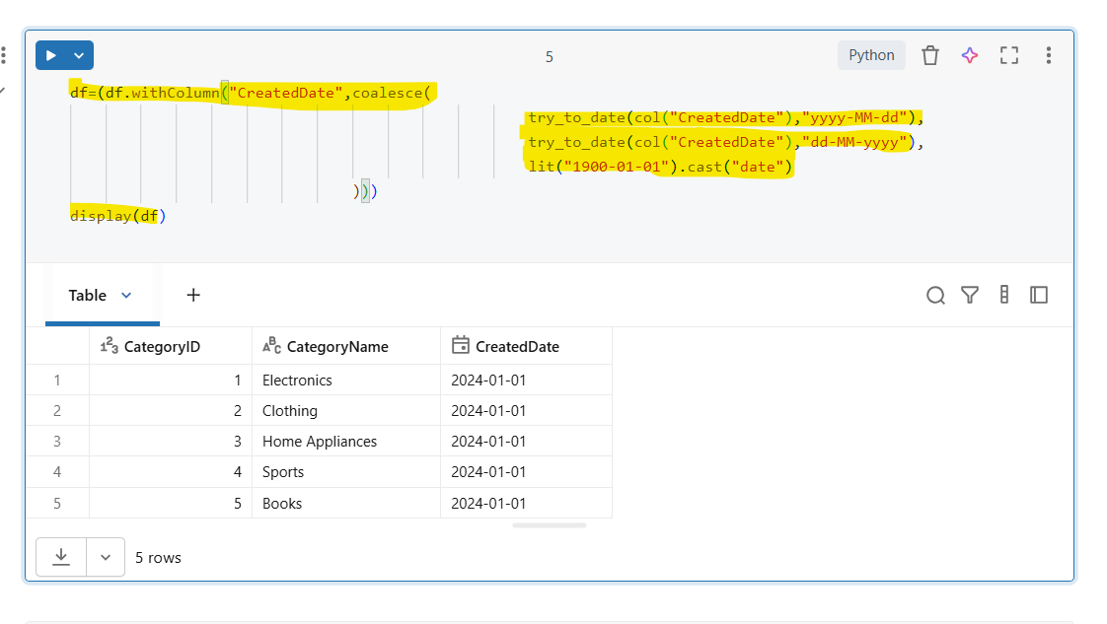
- withColumn() is used to create a new column or replace an existing column.
- Here it replaces the existing CreatedDate column with a cleaned date value.
- try_to_date() attempts to convert a string into a date format.
- If conversion fails, it returns NULL instead of throwing an error.
- coalesce() returns the first non-NULL value from the list.
- lit() creates a constant value.
This acts as a default fallback date when parsing fails.
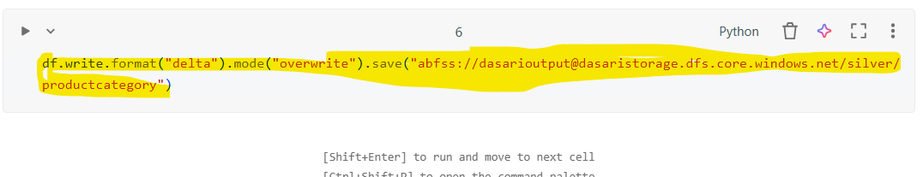

- It will be save in a delta format in a adls gen2
Sales Notebook
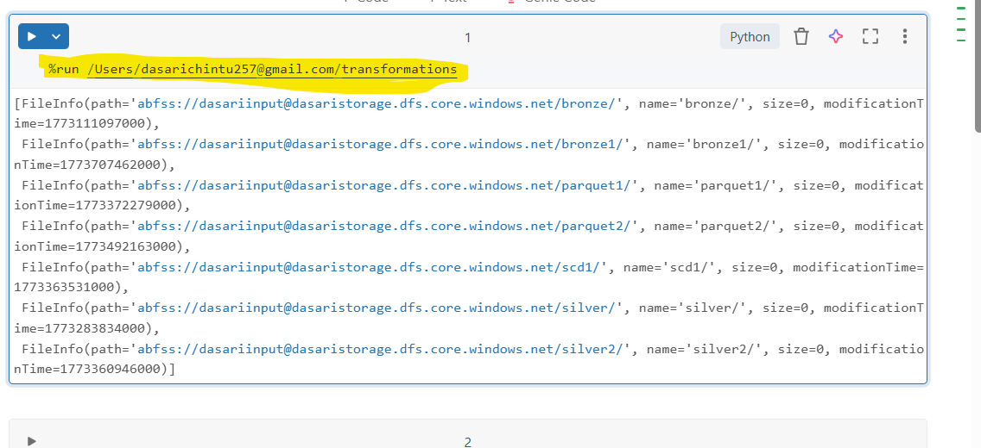
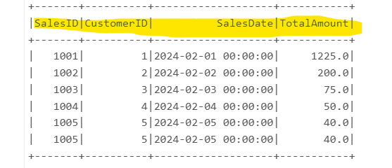
%run is a magic command it will take the one notebookn data to another notebook

- This statement imports all built-in Spark SQL functions so you can use them directly in your PySpark code
- pyspark.sql.functions → module that contains many Spark SQL functions
- * → imports all functions from that module
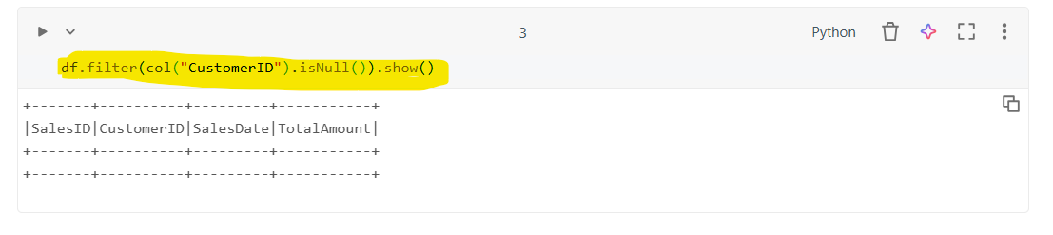
- df.filter(col("ProductID").isNull()).show()
- filters the DataFrame and displays rows where the ProductID column contains NULL values.
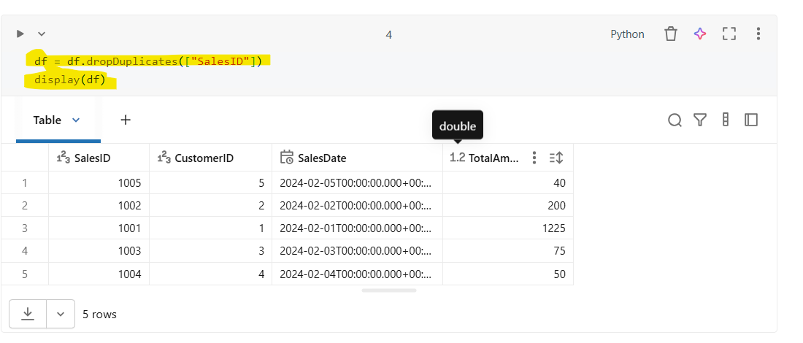
- df.filter(col("CustomerID").isNull()).show()
- filters the DataFrame and displays rows where the CustomerID column contains NULL values.
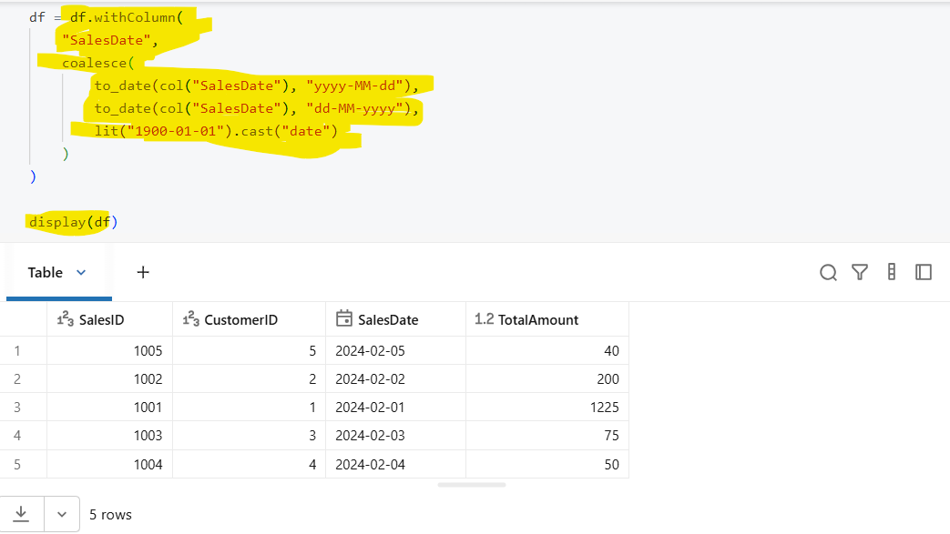
- withColumn() is used to create a new column or replace an existing column.
- Here it replaces the existing CreatedDate column with a cleaned date value.
- try_to_date() attempts to convert a string into a date format.
- If conversion fails, it returns NULL instead of throwing an error.
- coalesce() returns the first non-NULL value from the list.
- lit() creates a constant value.
This acts as a default fallback date when parsing fails.
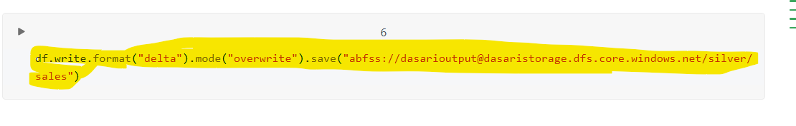
- It will be save in a delta format in a adls gen2
Salesdetails notebook

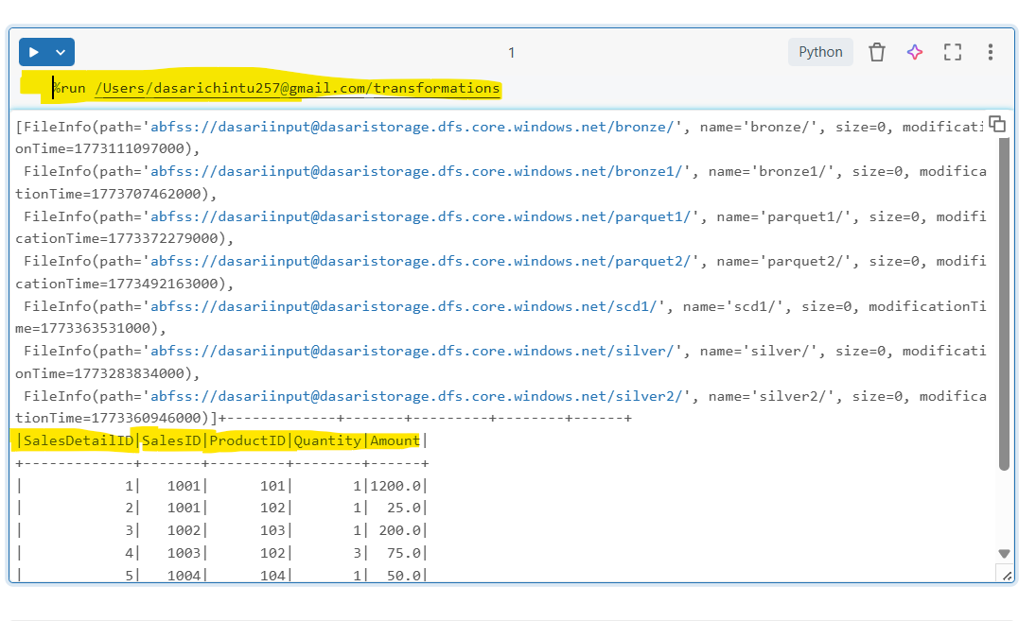

- %run is a magic command it will take the one notebookn data to another notebook


- This statement imports all built-in Spark SQL functions so you can use them directly in your PySpark code
- pyspark.sql.functions → module that contains many Spark SQL functions
- * → imports all functions from that module
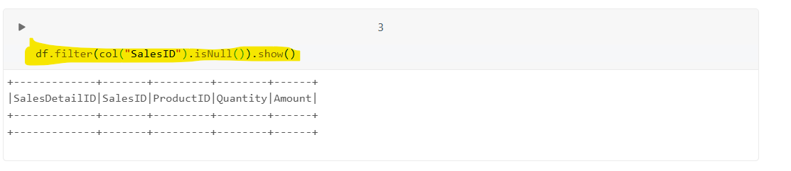
- df.filter(col("SalesID").isNull()).show()
- filters the DataFrame and displays rows where the SalesID column contains NULL values.
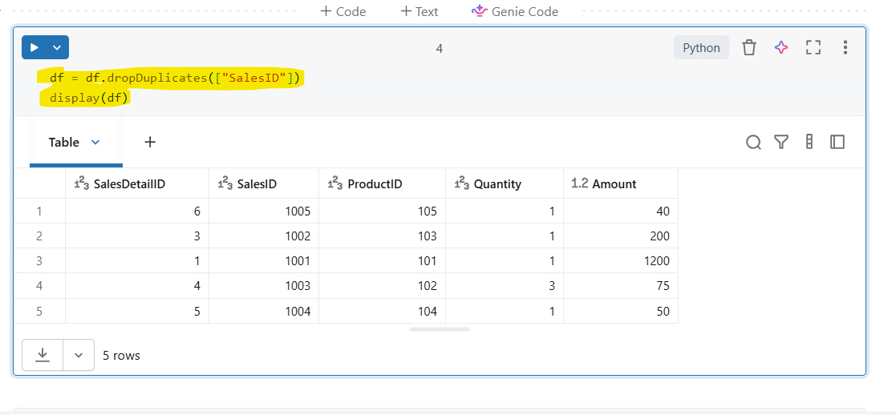
- dropDuplicates()
- Used to remove duplicate records from a Spark DataFrame based on one or more columns.
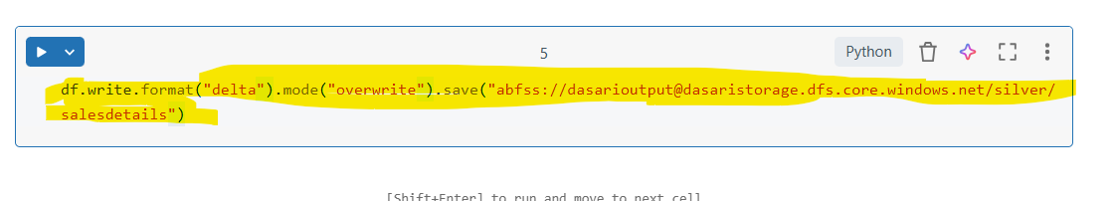

- It will be save in a delta format in a adls gen2

Task-3 SCD TYPE-1

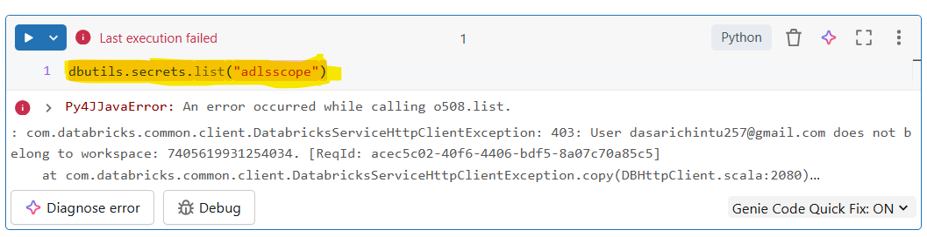
- dbutils.secrets.list(scope) is a Databricks utility command used to list all secret keys stored within a specified secret scope.
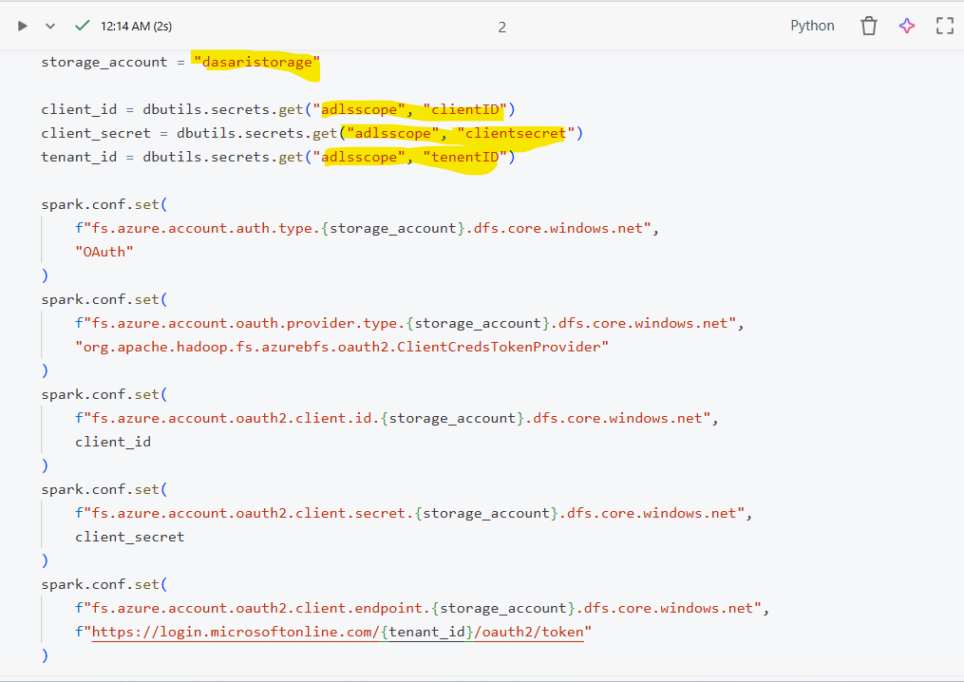

- This code configures secure access from Databricks to Azure Data Lake Storage Gen2 (ADLS Gen2) using a Service Principal with OAuth 2.0 authentication.
Sensitive credentials are retrieved securely from Databricks Secret Scope instead of hardcoding.
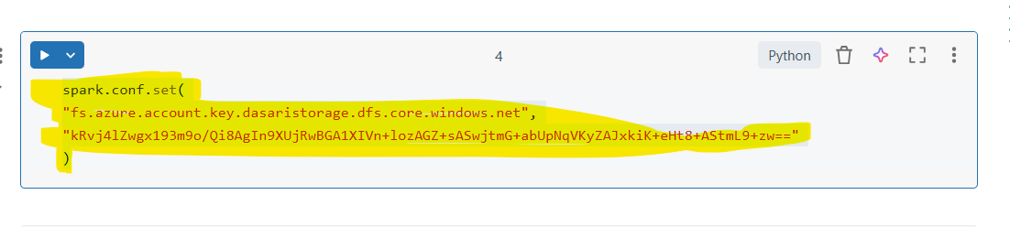
- This configuration enables Databricks (or Spark) to access Azure Data Lake Storage Gen2 (ADLS Gen2) using a Storage Account Access Key.
- It is a key-based authentication method, where full access to the storage account is granted using a secret key.
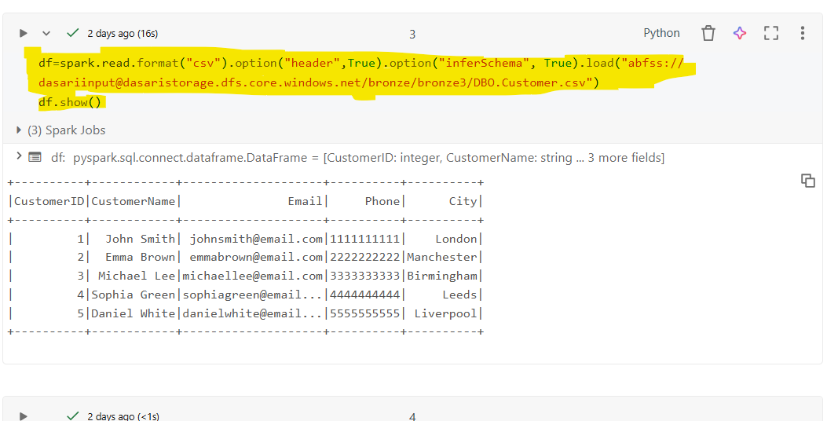

- This command is used in Databricks to list all files and folders available in a specified Azure Data Lake Storage Gen2 (ADLS Gen2) container path.
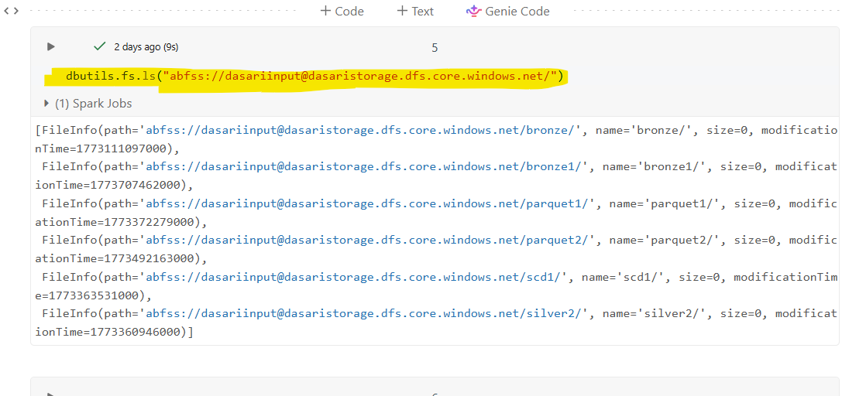
- Lists all files and directories in the specified Azure Data Lake Storage Gen2 (ADLS Gen2) path from a Databricks notebook.
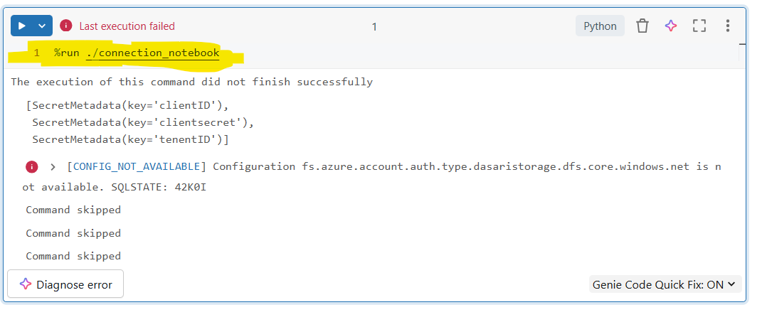
- %run is a Databricks magic command used to execute another notebook within the current notebook.
It allows you to reuse code such as configurations, functions, or connection setup
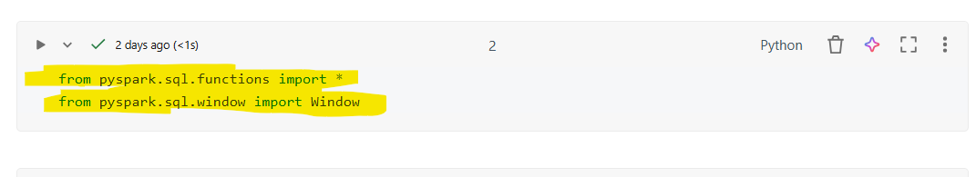

- These statements import built-in PySpark functions and windowing capabilities used for data transformation and analytical operations in Spark DataFrames.

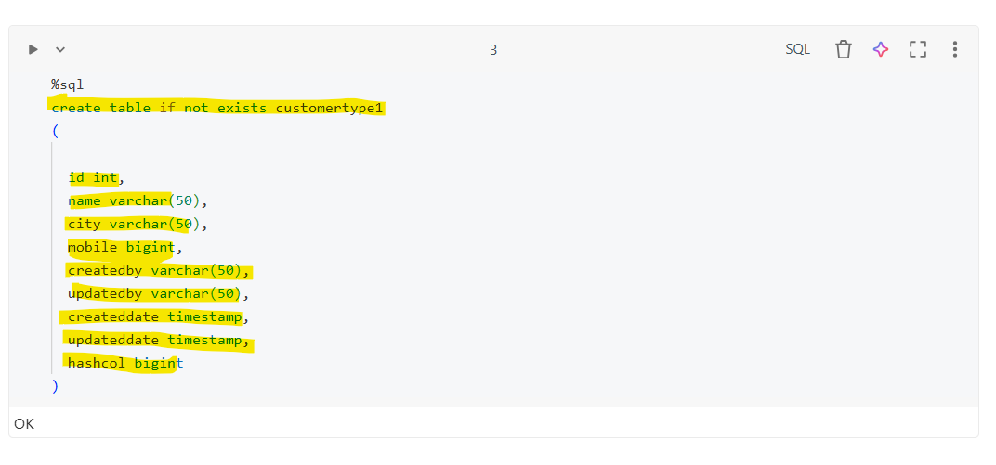

- This command creates a table in Databricks (or Spark SQL) to store in table using SCD Type 1 methodology.
- The table stores latest customer records only
- Existing records are overwritten when changes occur
- No historical tracking is maintained
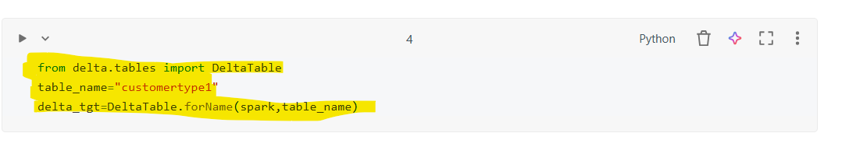
- This code is used to reference an existing Delta table in Databricks using the Delta Lake API.
It allows you to perform operations like MERGE (upsert), UPDATE, DELETE, and more
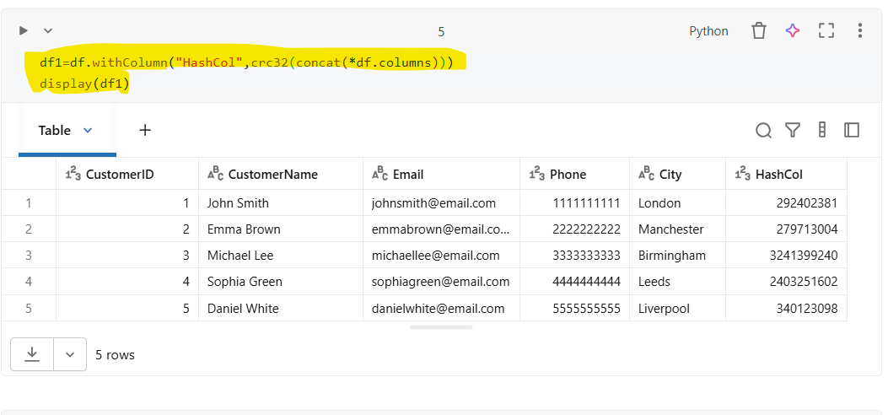
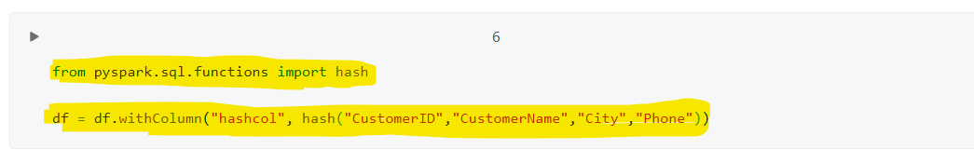
- This any one code creates a new DataFrame by adding a hash column (HashCol) generated from all existing columns.
The hash is used to detect changes in records, commonly in SCD Types implementations
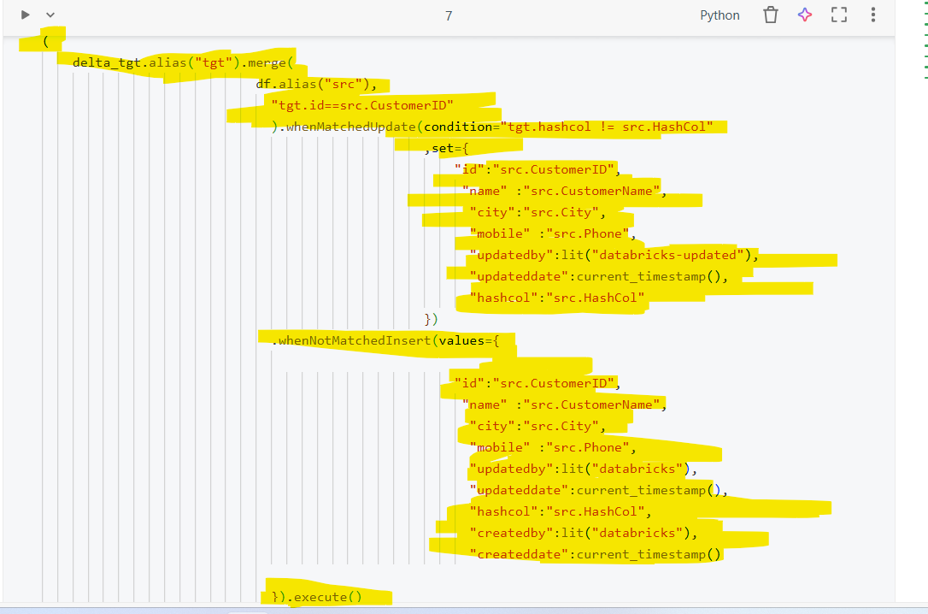

- This code performs a MERGE (UPSERT) operation using Delta Lake to implement SCD Type 1 logic:
- Update existing records when data changes
- Insert new records when they do not exist
- It uses a hash column (hashcol) to detect changes efficiently.
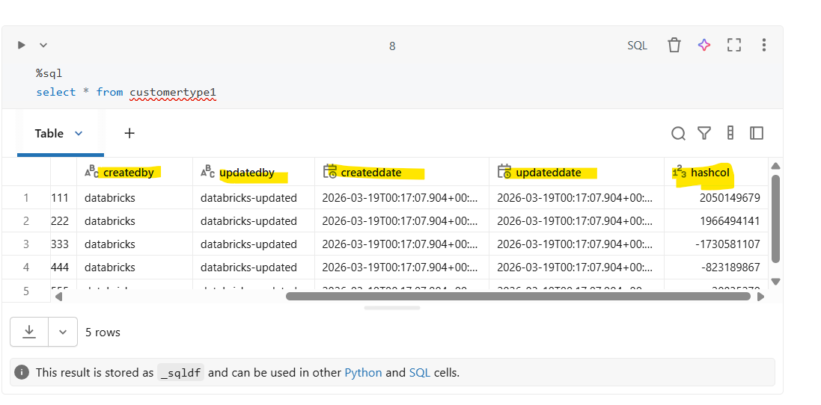
- This code shows the whole table with the updated columns and updated results

