Project -4 : ADF, Databricks and Unity Catalog

Architecture Diagram-
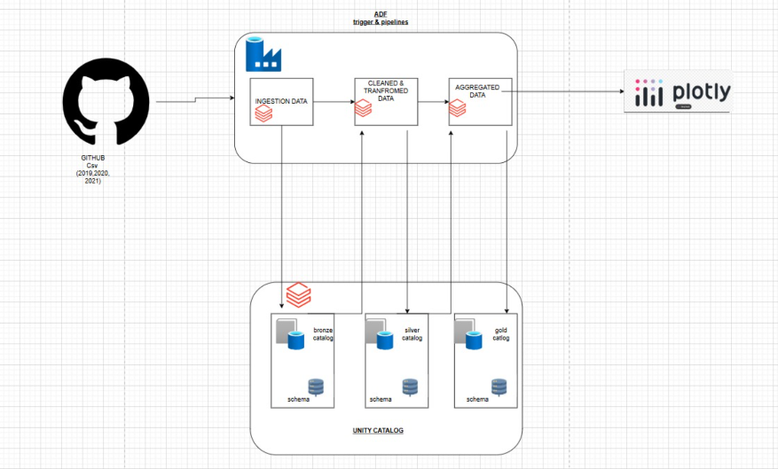

To create a catalog-

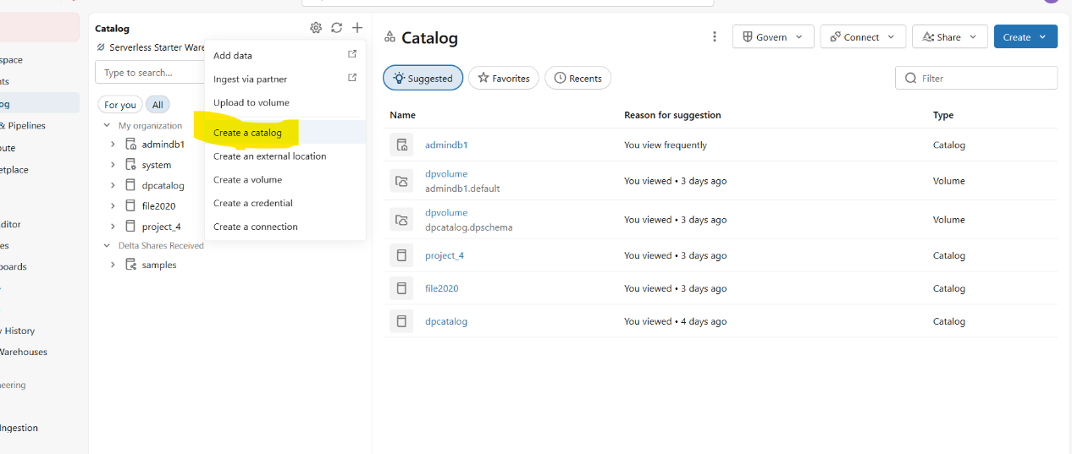
- Go to azure databricks and go to catalogs and
- Click on new
- Create a new catalog
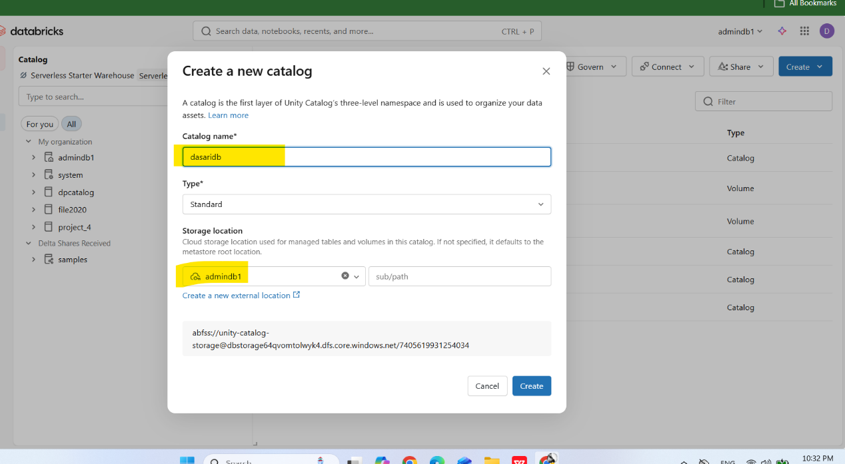

- Give a catalog name
- Choose a storage locations
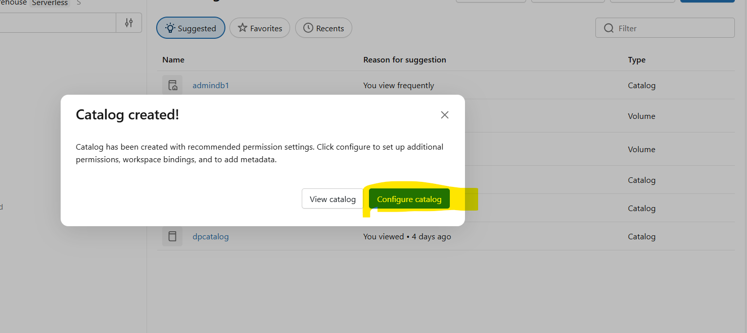

- Click on configure catalog

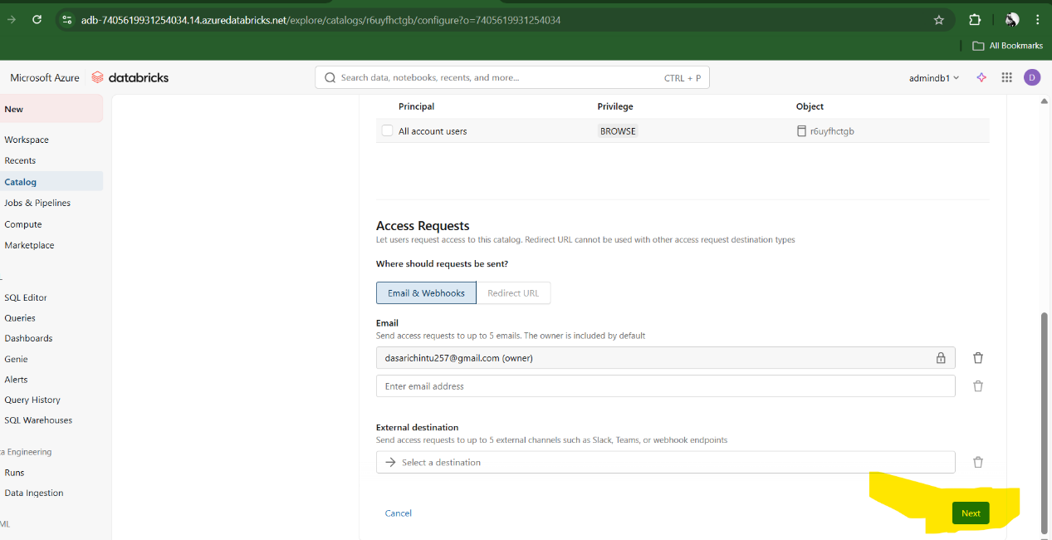
- Give a email and click on next
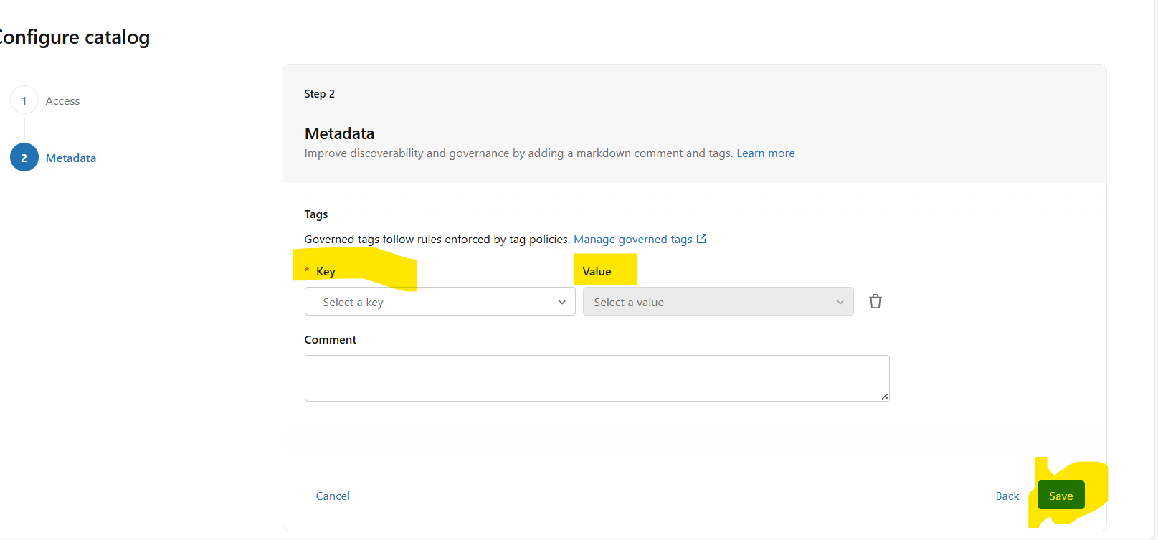
- click on save
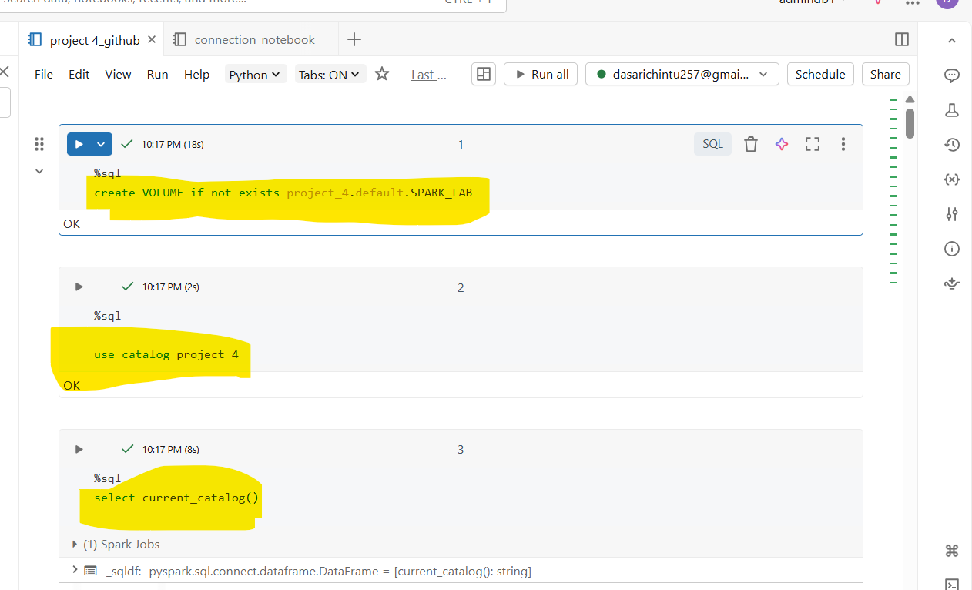

- 1) create volume creates a new volume in catalog
- 2) use catalog = its use the catalog for saving
- 3) current_catalog() = use for selectinmg the existing catalog

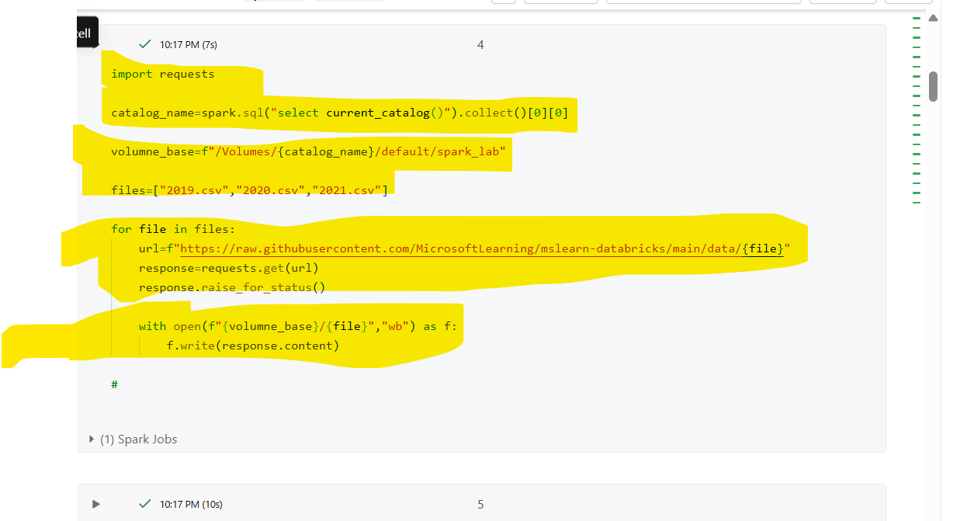

- “I used the requests library to fetch raw CSV data from GitHub and dynamically stored it into a Databricks Unity Catalog volume using the current catalog path.”
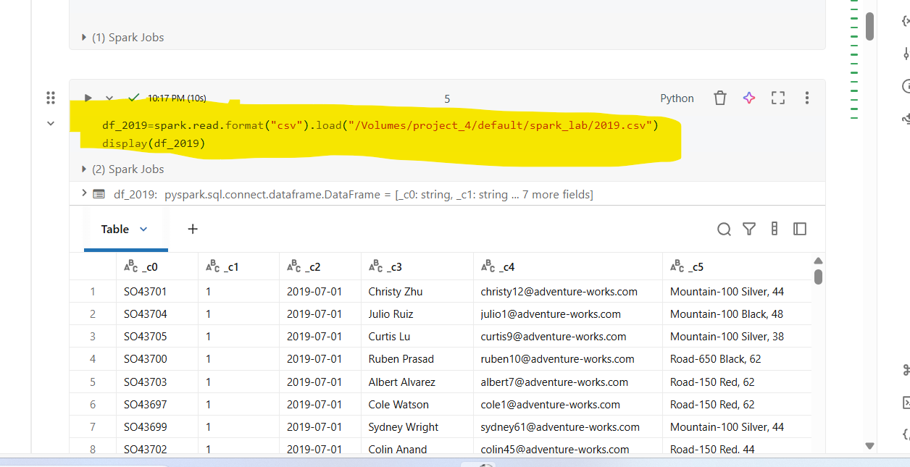

- “I used spark.read with CSV format to load raw data from a Unity Catalog volume into a Spark DataFrame and used display() to visualize it in Databricks.”

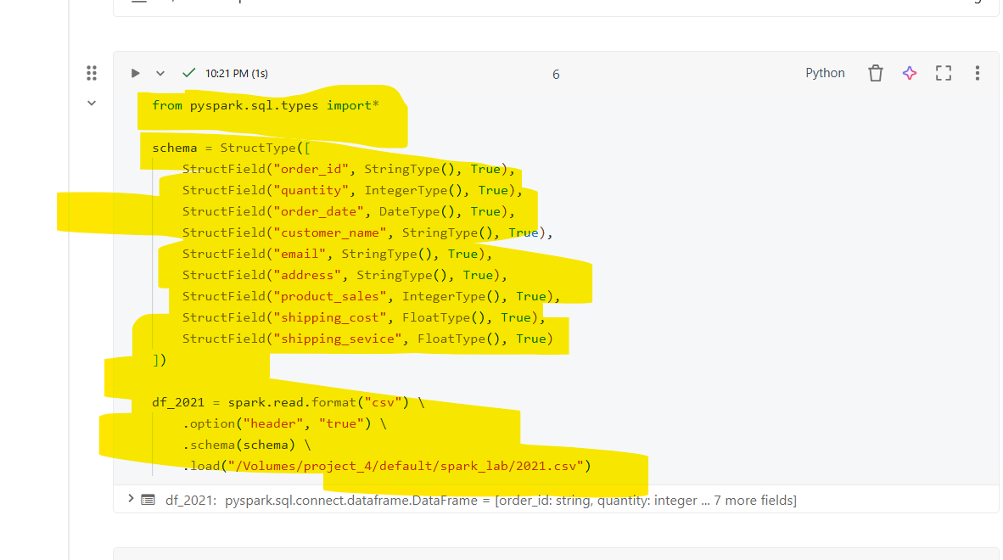

- · StructType represents the entire schema of your DataFrame.
- · StructField defines each column:
- "column_name" → name of the column
- DataType() → type of data (String, Integer, Date, Float, etc.)
- True → allows null values in that column
- df_2021 = spark.read.format("csv") \
.option("header", "true") \
.schema(schema) \
.load("/Volumes/project_4/default/spark_lab/2021.csv")
- spark.read.format("csv") → tells Spark to read a CSV file.
- .option("header", "true") → first row of the CSV is treated as column headers.
- .schema(schema) → use the schema you defined above.
- .load(path) → the path to the CSV file.

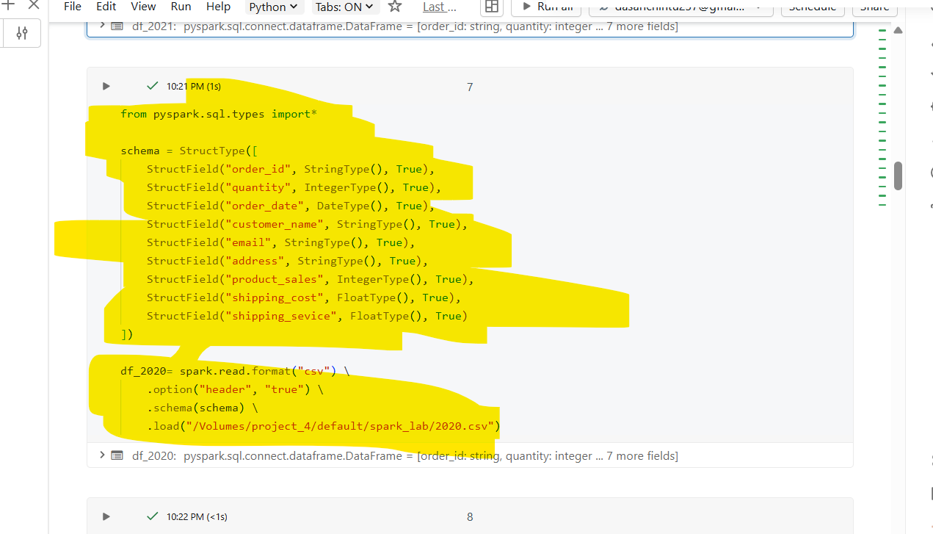

- · StructType represents the entire schema of your DataFrame.
- · StructField defines each column:
- "column_name" → name of the column
- DataType() → type of data (String, Integer, Date, Float, etc.)
- True → allows null values in that column
- df_2020 = spark.read.format("csv") \
.option("header", "true") \
.schema(schema) \
.load("/Volumes/project_4/default/spark_lab/2021.csv")
- spark.read.format("csv") → tells Spark to read a CSV file.
- .option("header", "true") → first row of the CSV is treated as column headers.
- .schema(schema) → use the schema you defined above.
- .load(path) → the path to the CSV file.
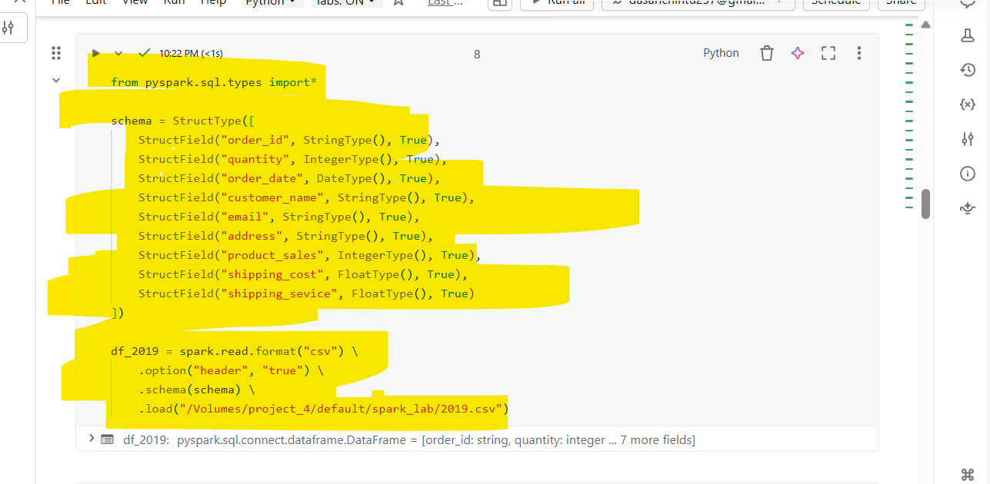
- · StructType represents the entire schema of your DataFrame.
- · StructField defines each column:
- "column_name" → name of the column
- DataType() → type of data (String, Integer, Date, Float, etc.)
- True → allows null values in that column
- df_2019= spark.read.format("csv") \
.option("header", "true") \
.schema(schema) \
.load("/Volumes/project_4/default/spark_lab/2021.csv")
- spark.read.format("csv") → tells Spark to read a CSV file.
- .option("header", "true") → first row of the CSV is treated as column headers.
- .schema(schema) → use the schema you defined above.
- .load(path) → the path to the CSV file.
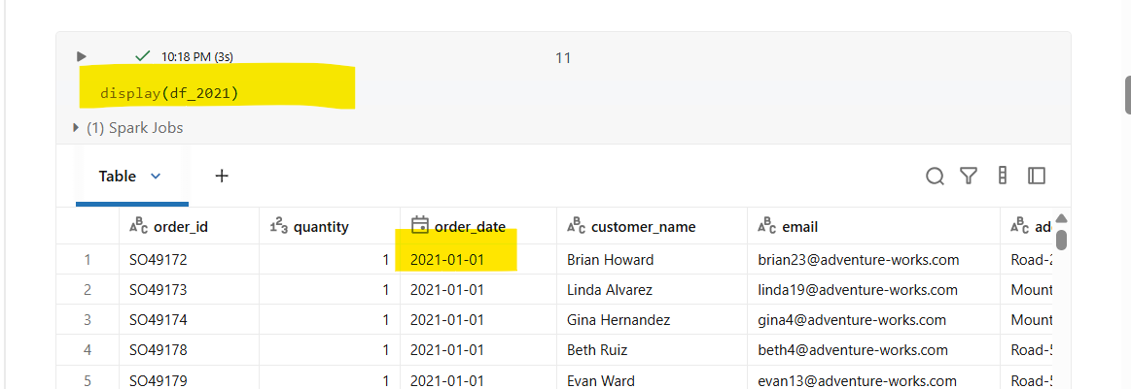

- It will shows the df_2021
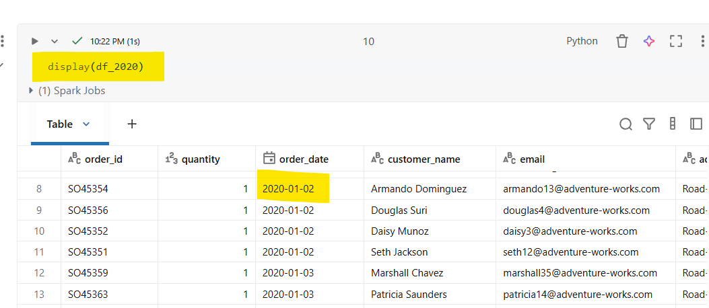
- It will shows the df_2020
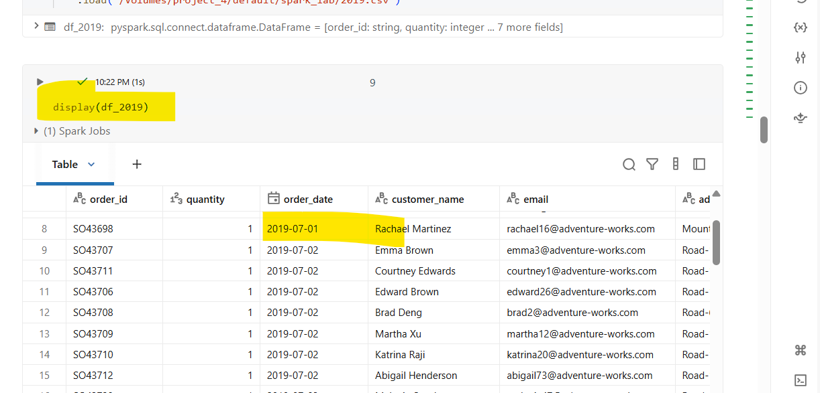
- It will shows the df_2019
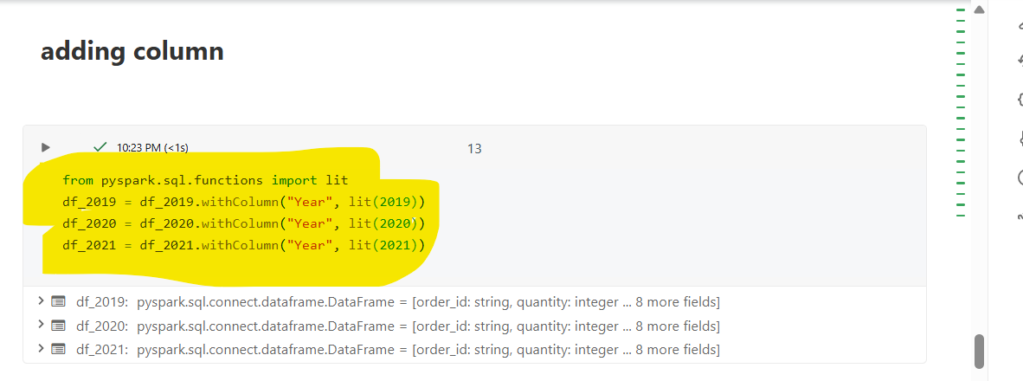
- lit() → add a fixed value column
withColumn() → add/update column
This pattern is very common when you need to tag data with its source year before merging datasets.

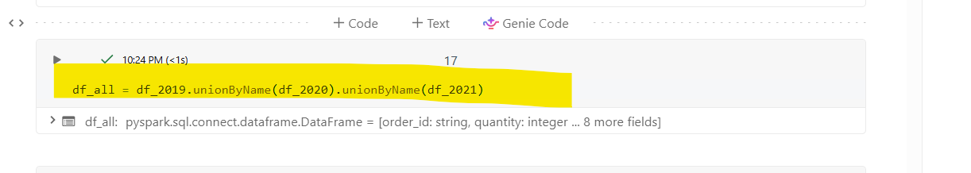
- · unionByName() merges two DataFrames column by column based on column names, not their position.
- · This is safer than union() because it ensures the columns align correctly, even if the order is different in the original DataFrames.
- · Both DataFrames must have the same column names and compatible data types for this to work.
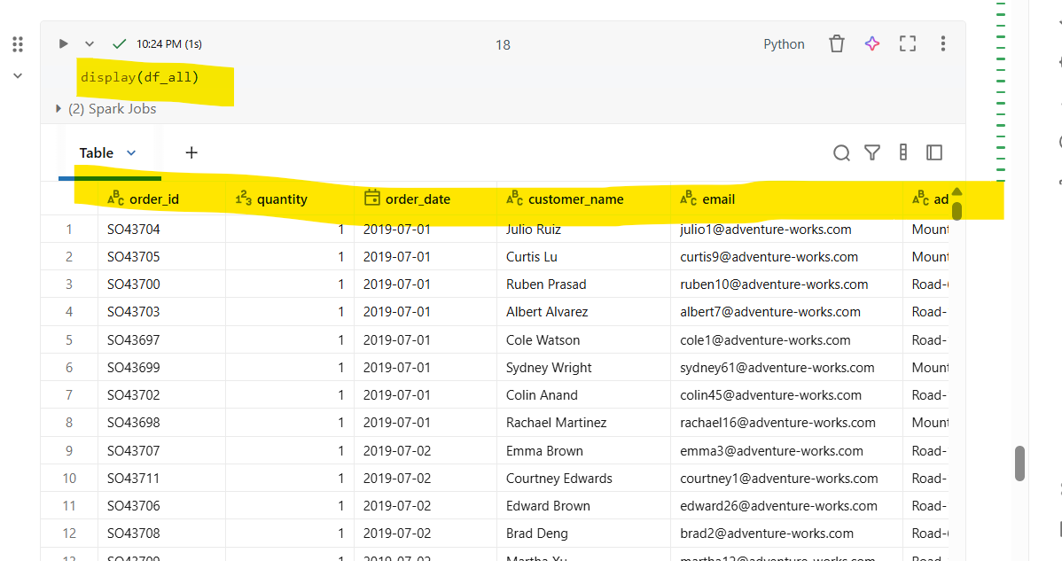

- It will shows the all three files of git hub(2019, 2020, 2021)
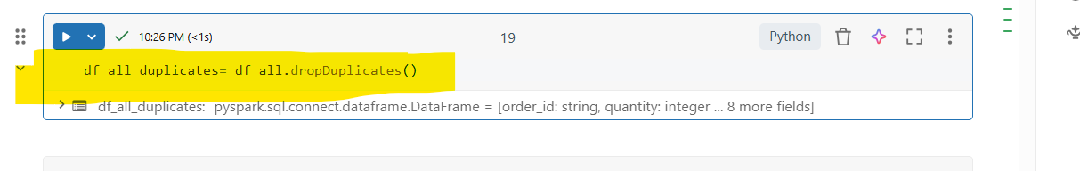
- · dropDuplicates() is a PySpark DataFrame method that removes rows that are exactly identical across all columns.
- · After this operation, df_all_duplicates will only contain unique rows.

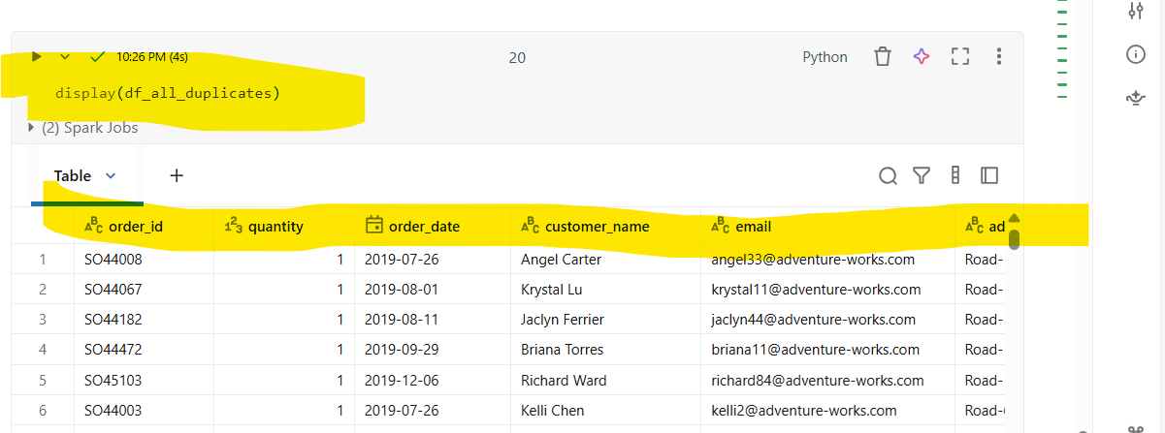
- Its shows the clean data of the three files
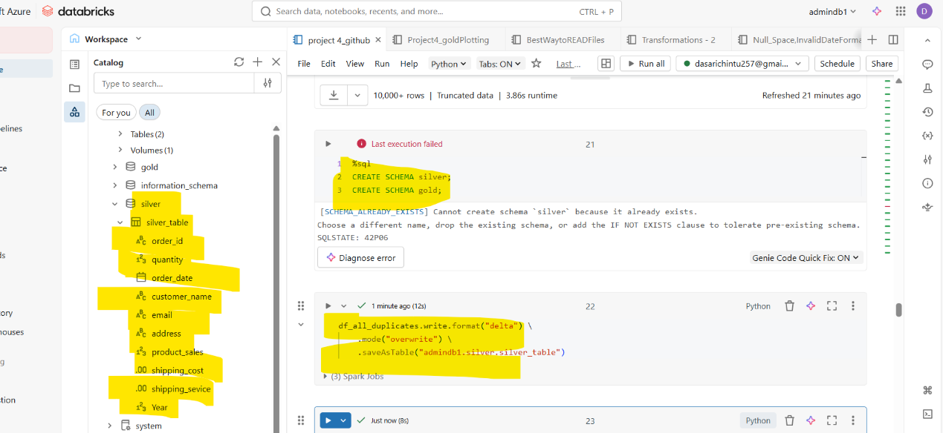
- This query is used for save the table of clean data in silver schema, silver table (SILVER LAYER)

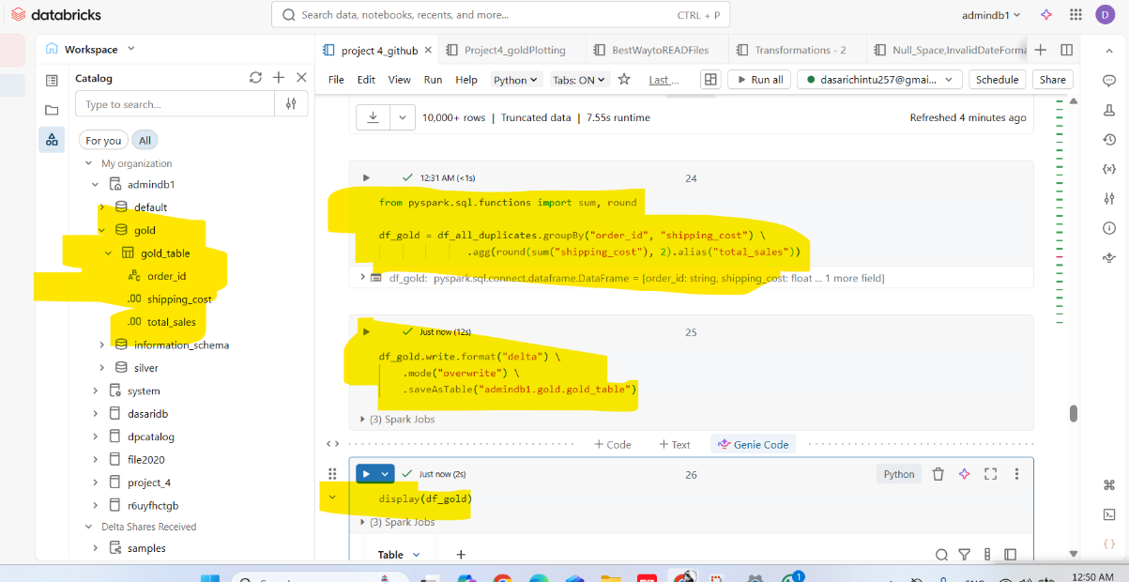
- · sum() → used to calculate the sum of a column.
- · round() → rounds a numeric column to the specified number of decimal places.
- · groupBy() groups the DataFrame by the columns you specify.
- · Here, you are grouping by order_id and shipping_cost.
- · This means that all rows with the same combination of order_id and shipping_cost will be aggregated together.
- · sum("shipping_cost") → calculates the sum of shipping_cost for each group.
- · round(..., 2) → rounds the sum to 2 decimal places.
- · .alias("total_sales") → renames the resulting column to total_sales.

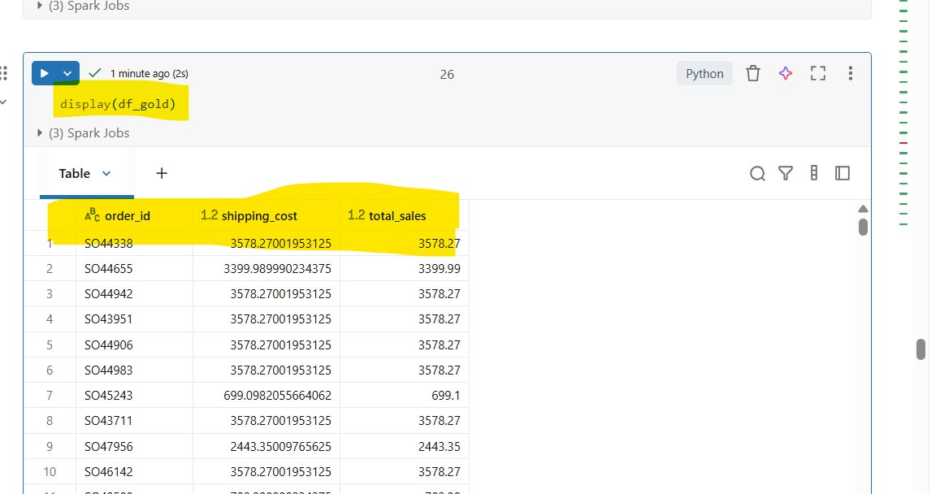
- It will shows the gold schema, as gold layer cleaned table
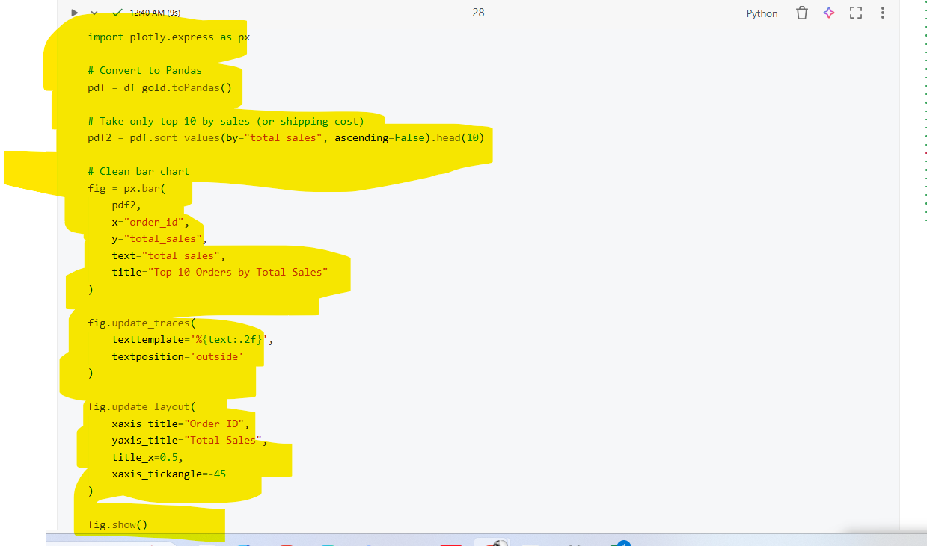
- Imports Plotly Express, a high-level library for creating interactive charts بسهولة.
- Alias px is used for convenience.
- Converts the PySpark DataFrame (df_gold) into a Pandas DataFrame (pdf).
- Required because Plotly works directly with Pandas data.
- Note: This step loads data into memory, so it’s suitable for smaller datasets.
- pdf → Input dataset
- x="order_id" → X-axis represents order IDs
- y="total_sales" → Y-axis represents total sales values
- color="shipping_cost" → Bars are colored based on shipping cost categories
- barmode="group" → Displays bars side-by-side (not stacked)
- text="total_sales" → Shows sales values on top of bars
- title → Chart title
- xaxis_title → Sets X-axis label
- yaxis_title → Sets Y-axis label
- title_x=0.5 → Centers the title
- uniformtext_minsize=8 → Minimum text size for labels
- uniformtext_mode='hide' → Hides overlapping text labels

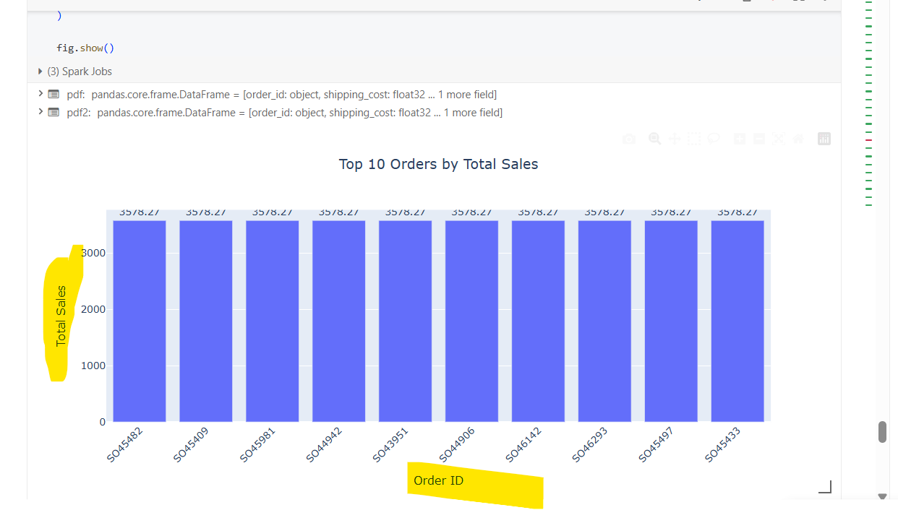

Its shows the top 10 of the total sales
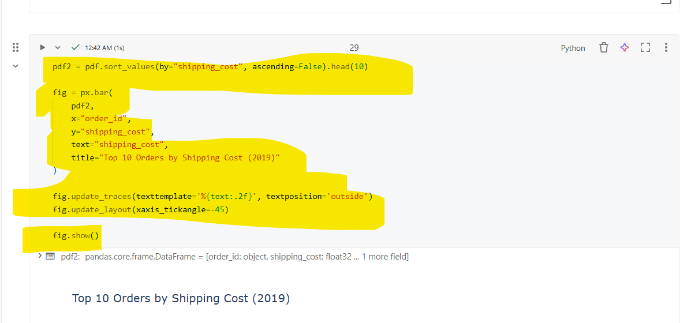
- sort_values(by="shipping_cost", ascending=False)
- Sorts the dataset in descending order based on shipping_cost.
- Highest shipping cost appears first.
- .head(10)
- Selects the top 10 rows after sorting.
- pdf2 → Filtered dataset (top 10 records)
- x="order_id" → X-axis shows order IDs
- y="shipping_cost" → Y-axis shows shipping cost values
- text="shipping_cost" → Displays values on bars
- title → Chart title
- Formats values to 2 decimal places
- Places labels above each bar for better readability
- Rotates X-axis labels by -45 degrees
- Prevents overlapping when order IDs are long or many
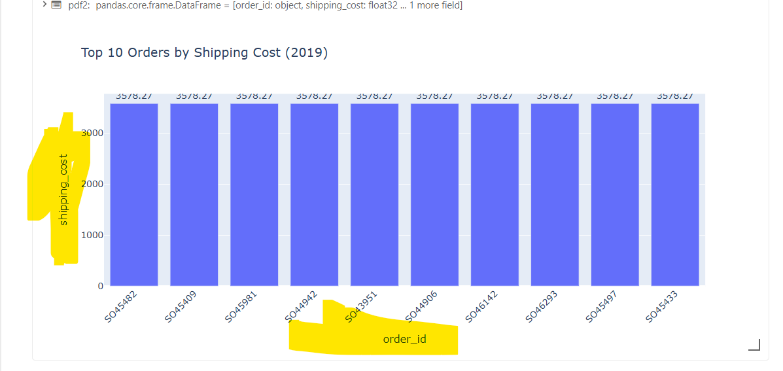
- Its shows the top 10 of the shipping cost
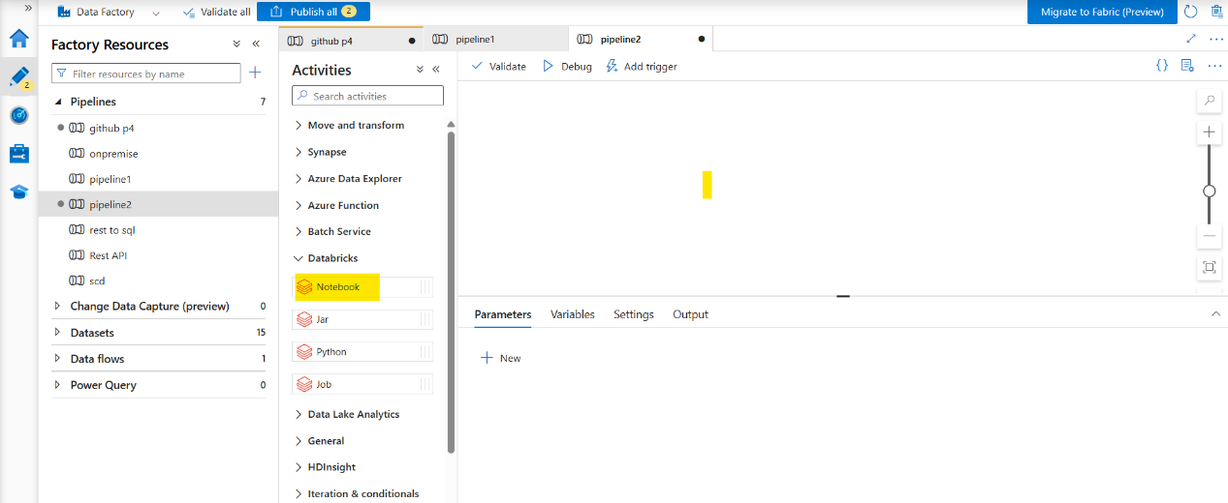
- Go to azure databricks and create a pipeline and drag a pipeline into activity
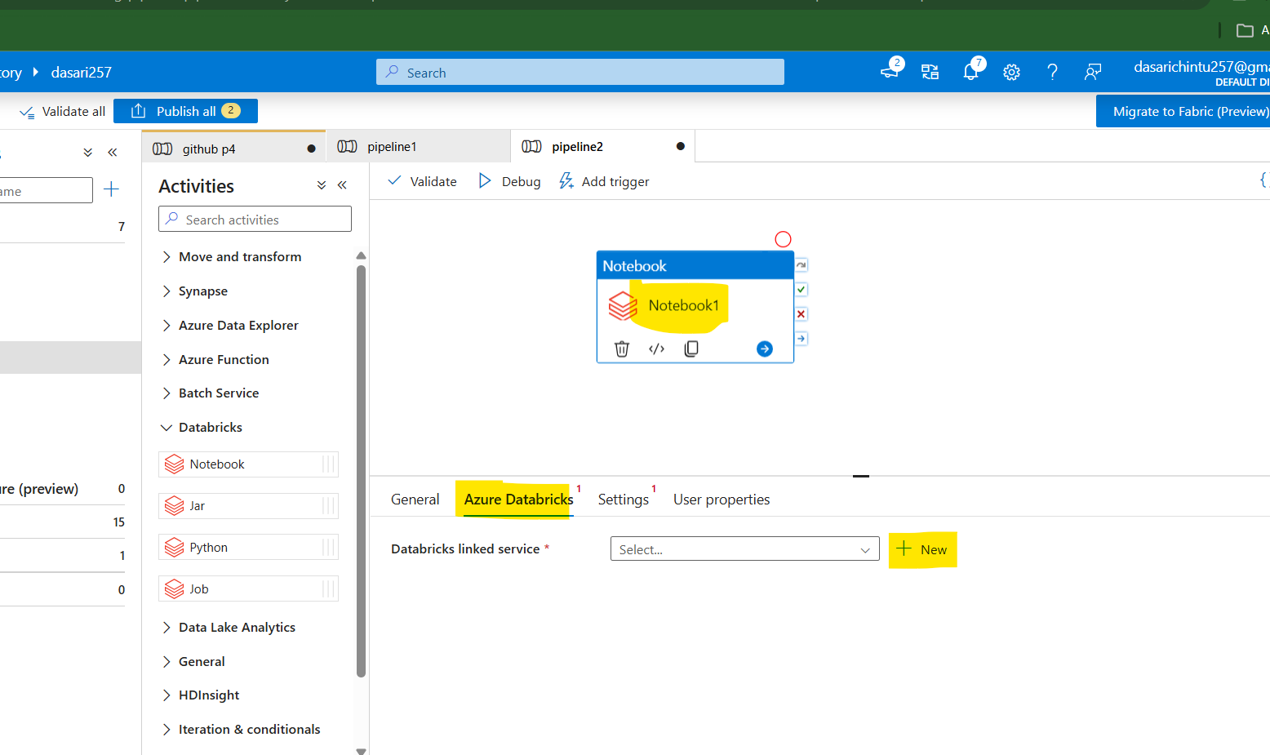
- Go to azure databricks in notebooks
- Click on new
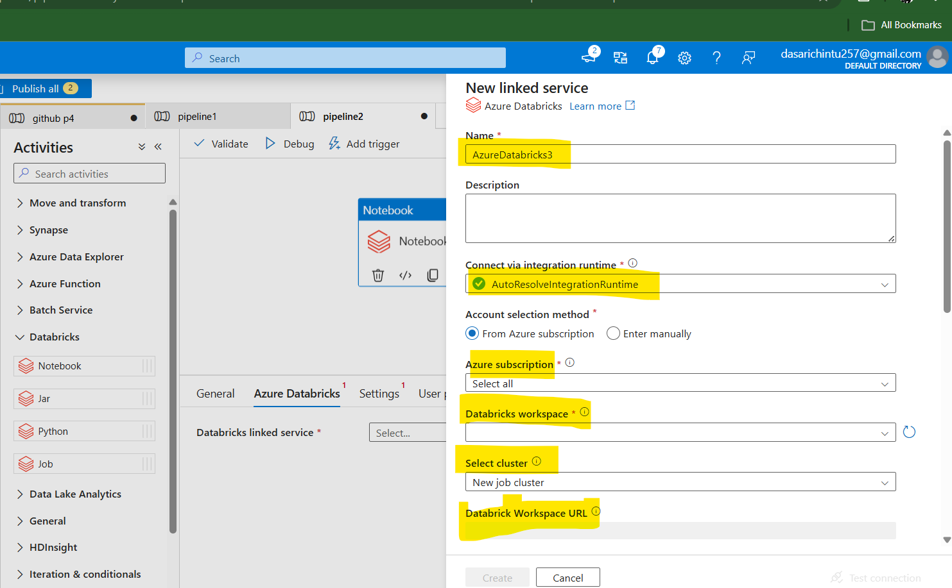
- Create a new linked service and give all the data like azure subscription, databricks workspace, select cluster(existing interactive cluster)
- Access token (it will be available in databricks settings- development-access key)
- Existing cluster ID -will be automatically generated
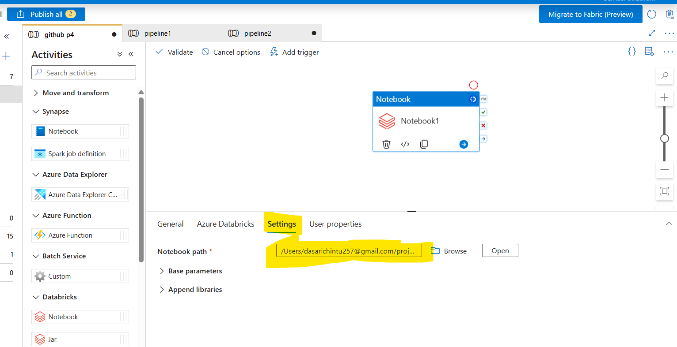

- And go to the settings in notenbook and give a notebook path by using browse

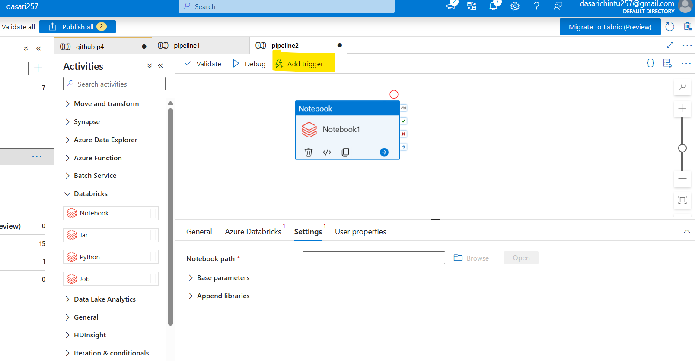
- Publish the notebook and click on triggers
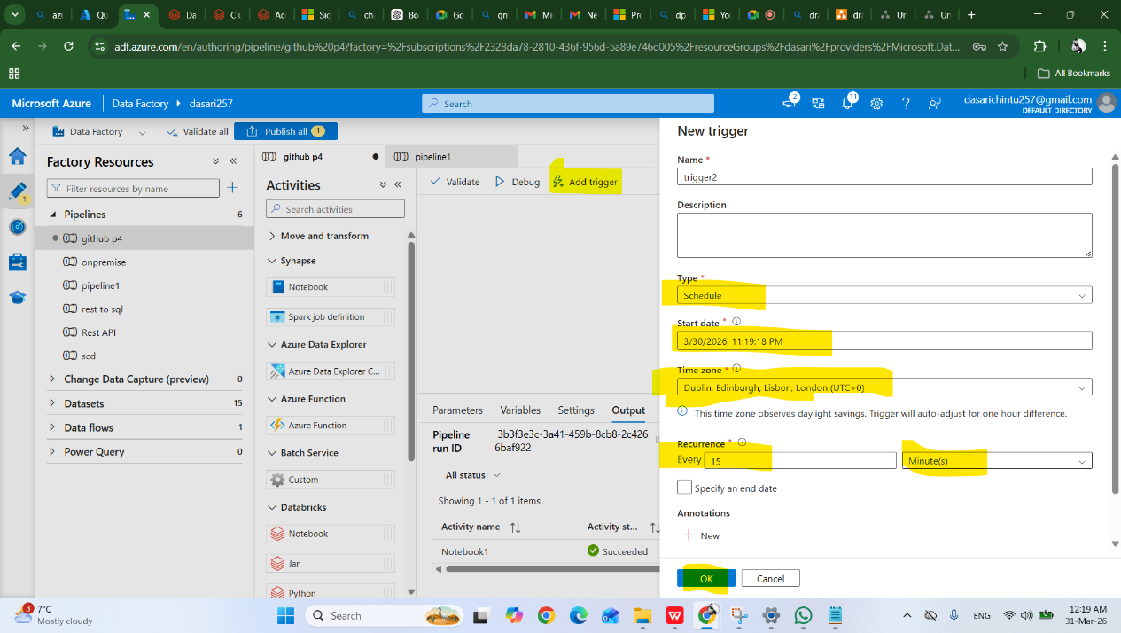
- Here we can choose the triggertype, start date, timezone
- And also we can choose the recurrence with specify the end date of the activity and click on OK
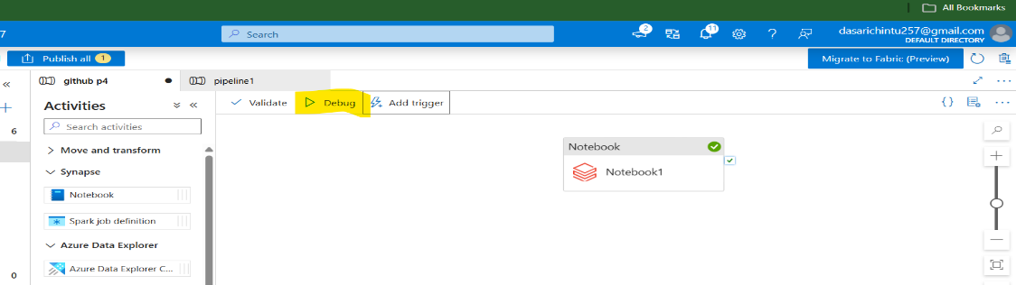

- Debug the activity

