Project-5 : Microsoft Fabric

ARCHITECTURE DIAGRAM:
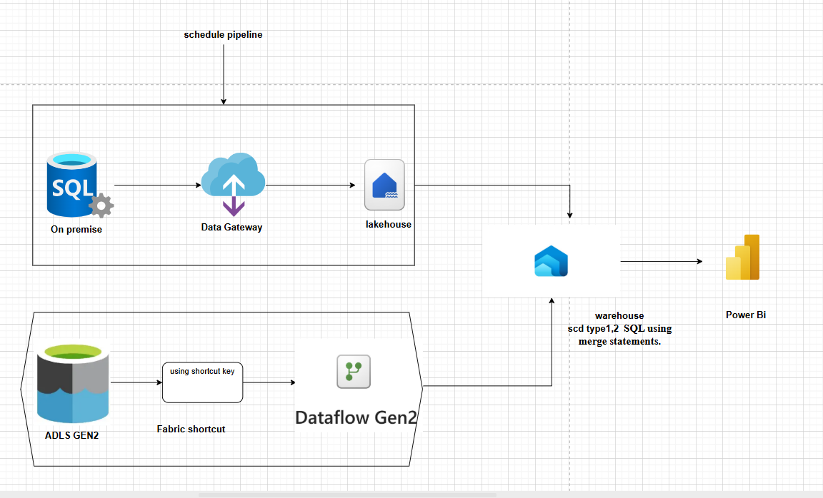

Sample table in SQL:
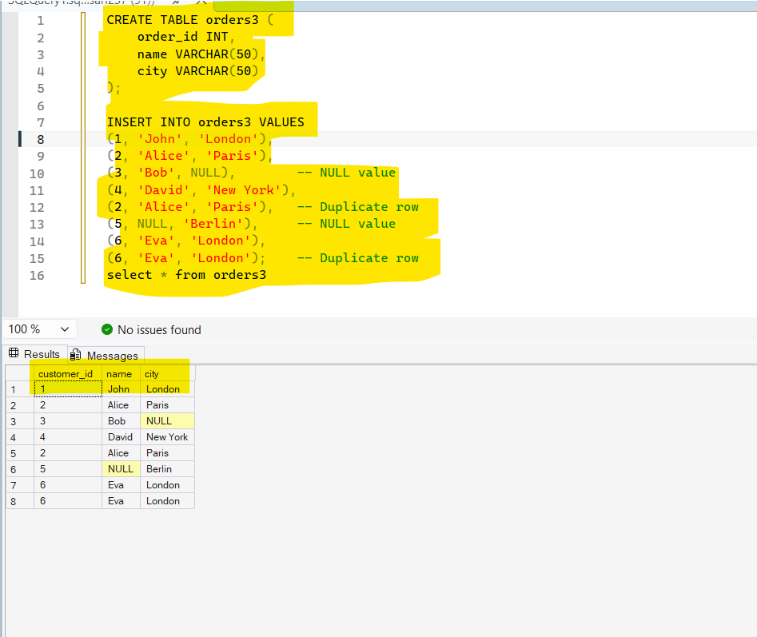
- Create a table in Sql with duplicates and null values ( this nulls and duplicates are use in tranformations)
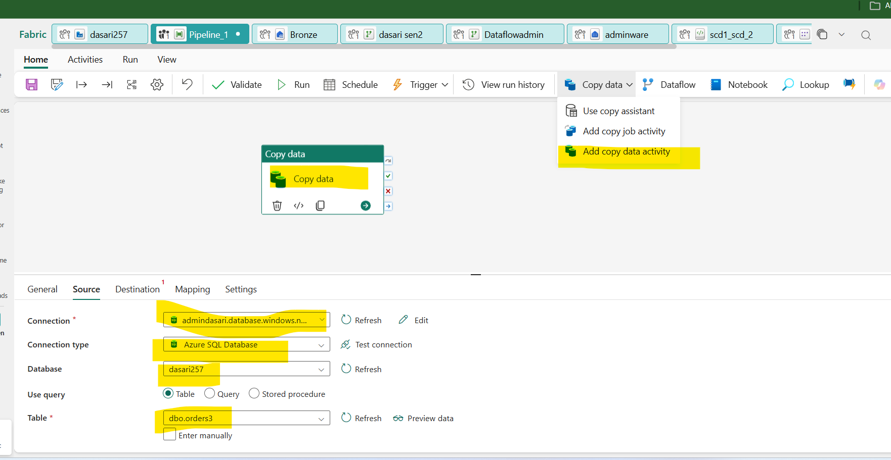
- Open fabric account and create a workspace
- In workspace add a pipeline
- In pipeline drag a copy data
- In copydata: go to source and give connection with SSMS by using the username and password and servername
- Give connection type = azure sql database
- Database= ssms database
- Table = table name ( sql table name)
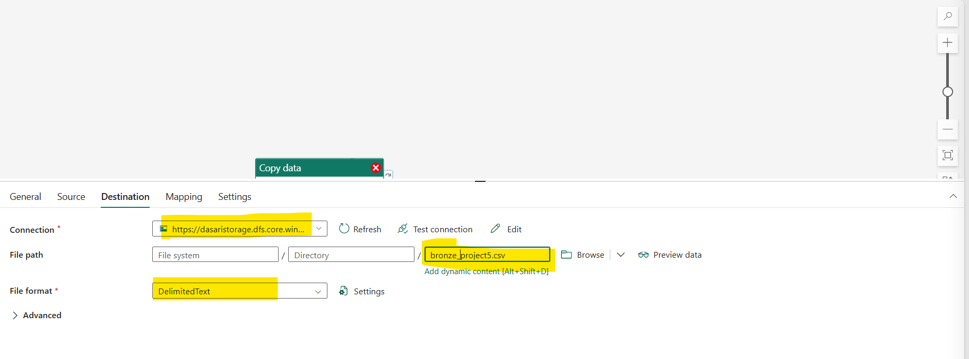
- In source : connection = adls gen2
- File path: select the container and folder by using browse
Connecting Adls to lakehouse

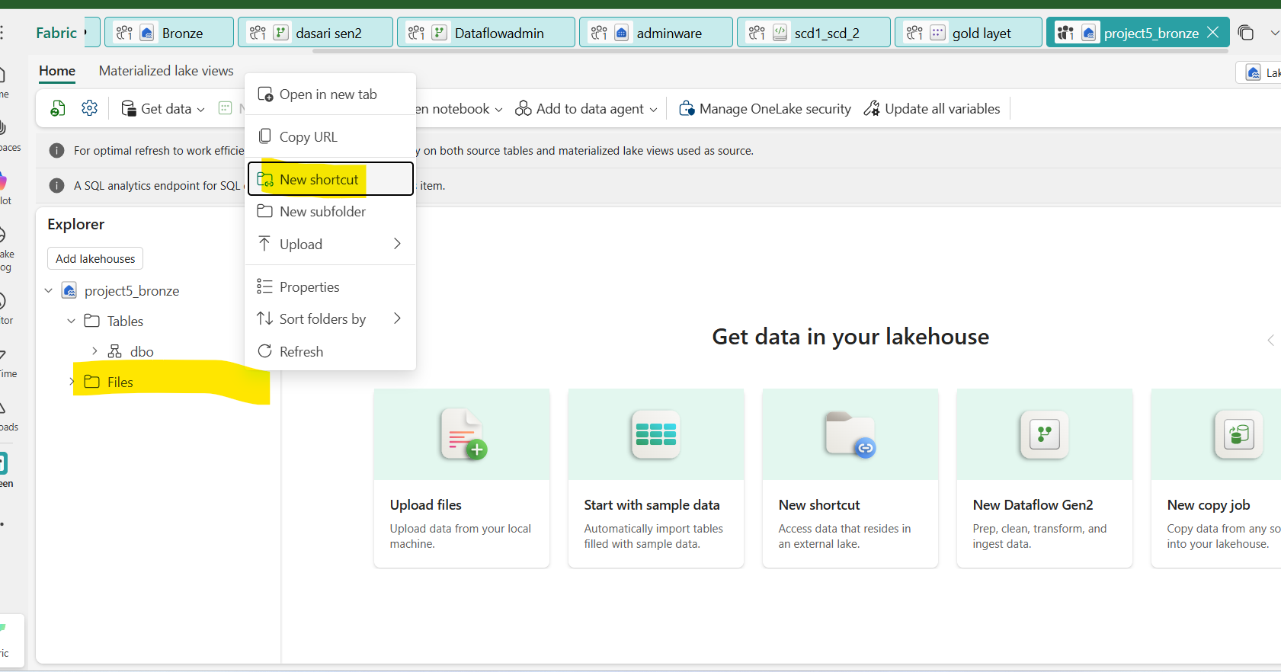
- Go to lakehouse
- right click on files
- Click on the new shortcut
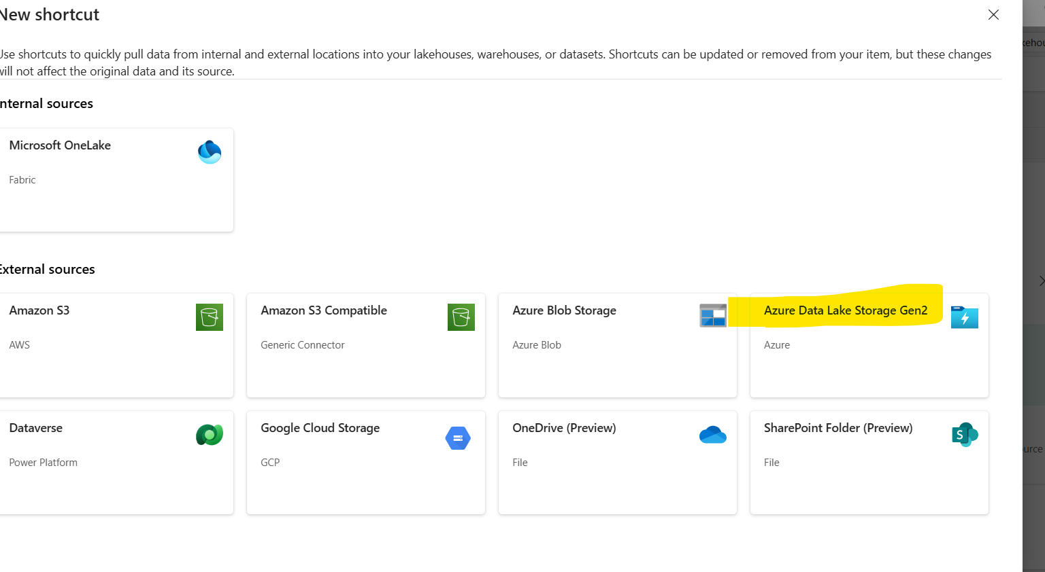Select ADls gen2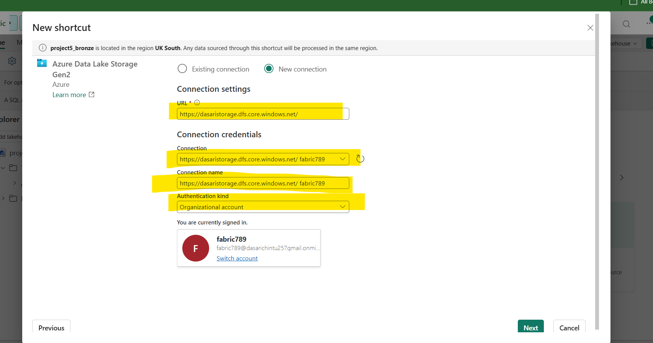
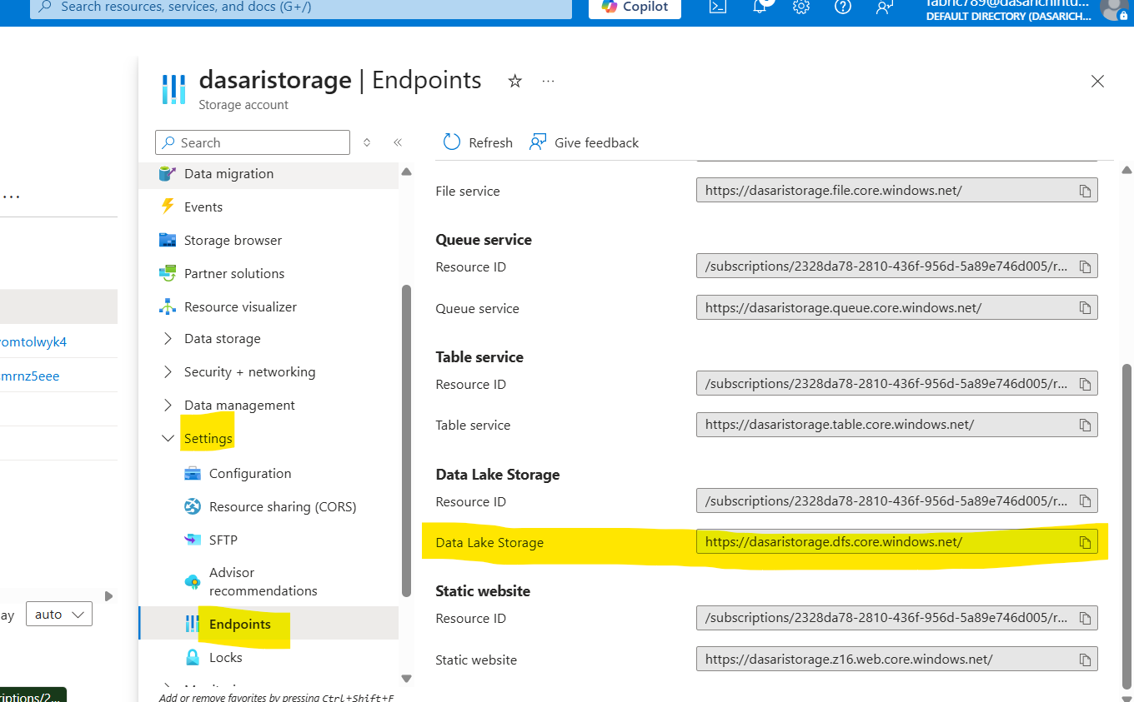

- Select the new connection
Give the URl (the URl will be availbe in the adls storage account → settings → endpoints → Datalake storage
- Give connection credentials
- (Connection and connection name will auto select)
- Give authentication kind = Organizational account
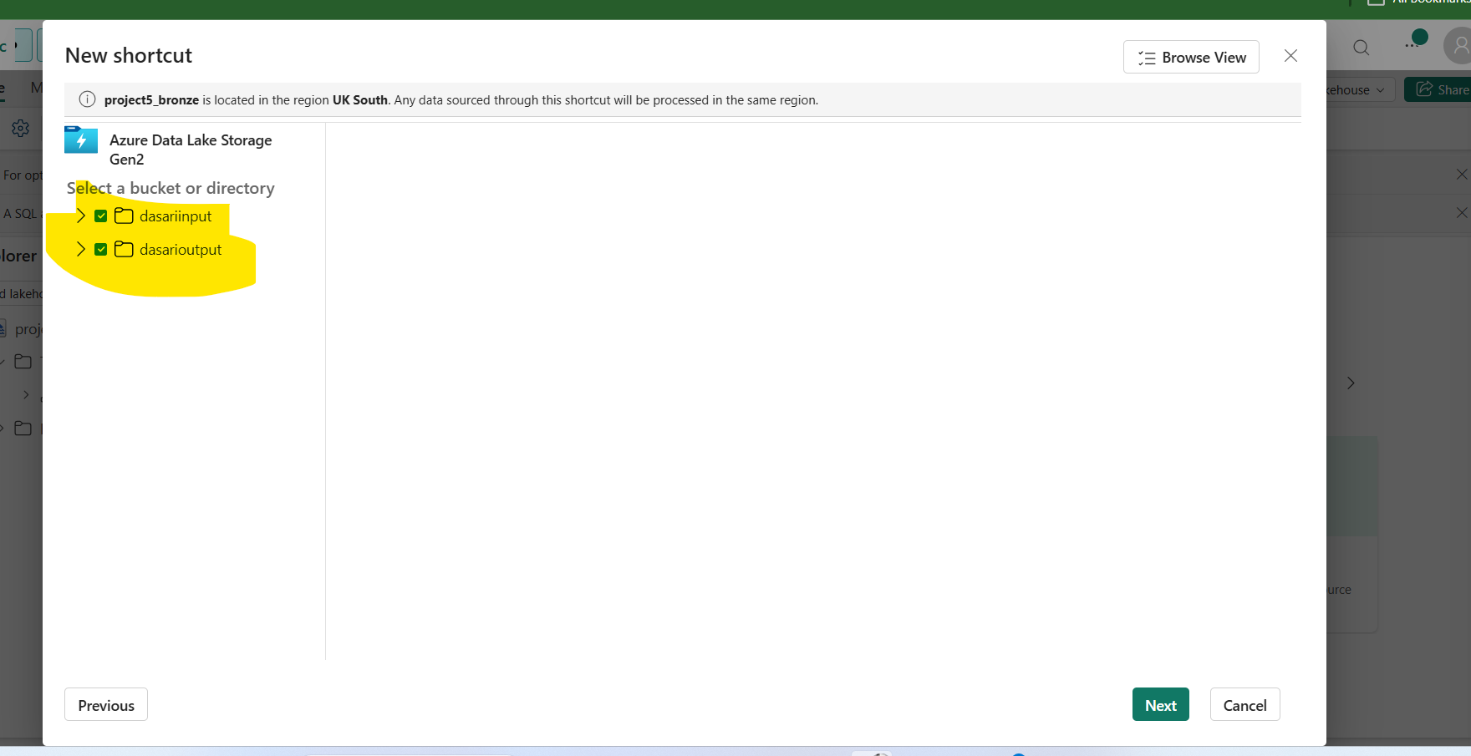
- Select the storage account containers and click on next
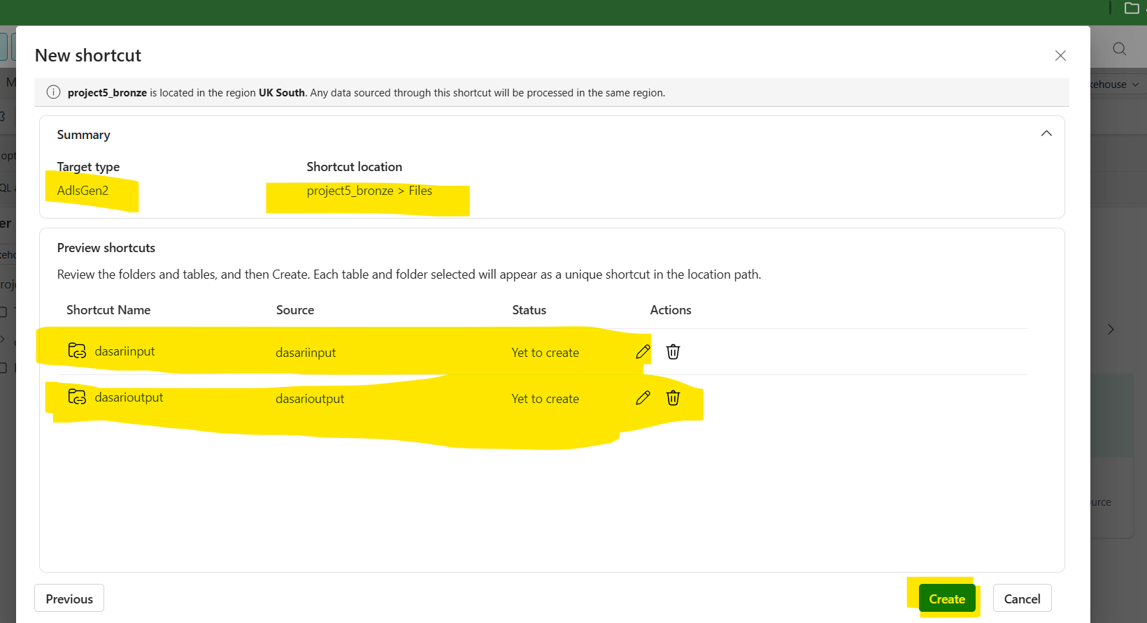
- Verify the the storage account and containers and create
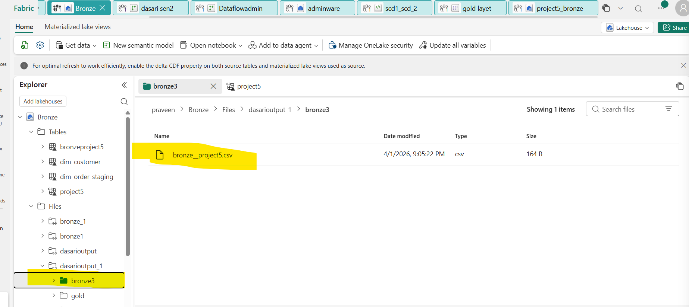
- The file will be appear in lake house
(Errors faced while connecting the adls)

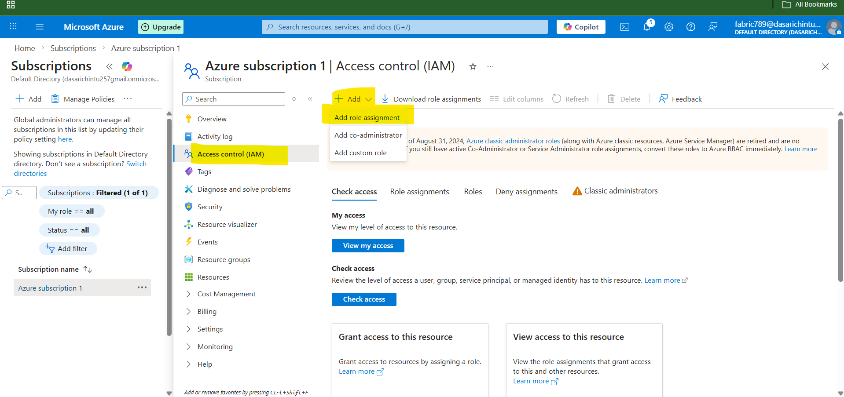

- Go to microsoft azure go to subscriptions
- Go to access control IAM and open add role assignment
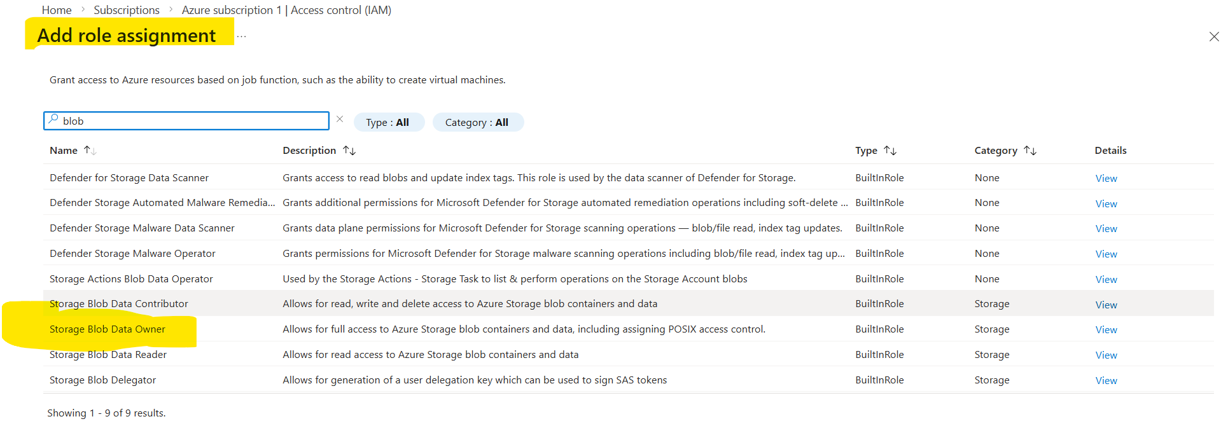
In ROLE:
- Grant the access to the storage blob data owner in job functions
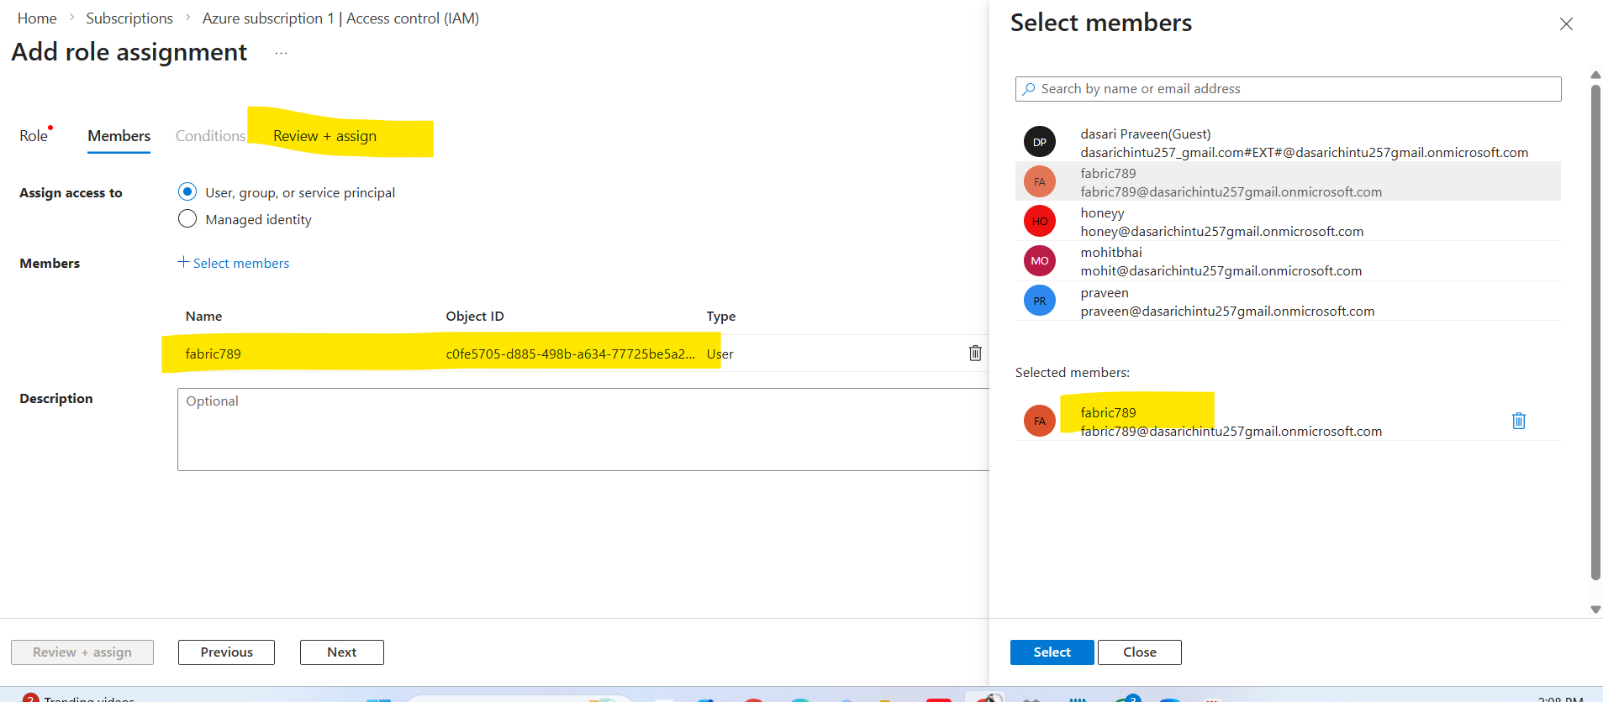
- Go to members and select the members (select the fabric account)
- Review and assign

Using dataflow gen 2 to clean the data which we brought from sql

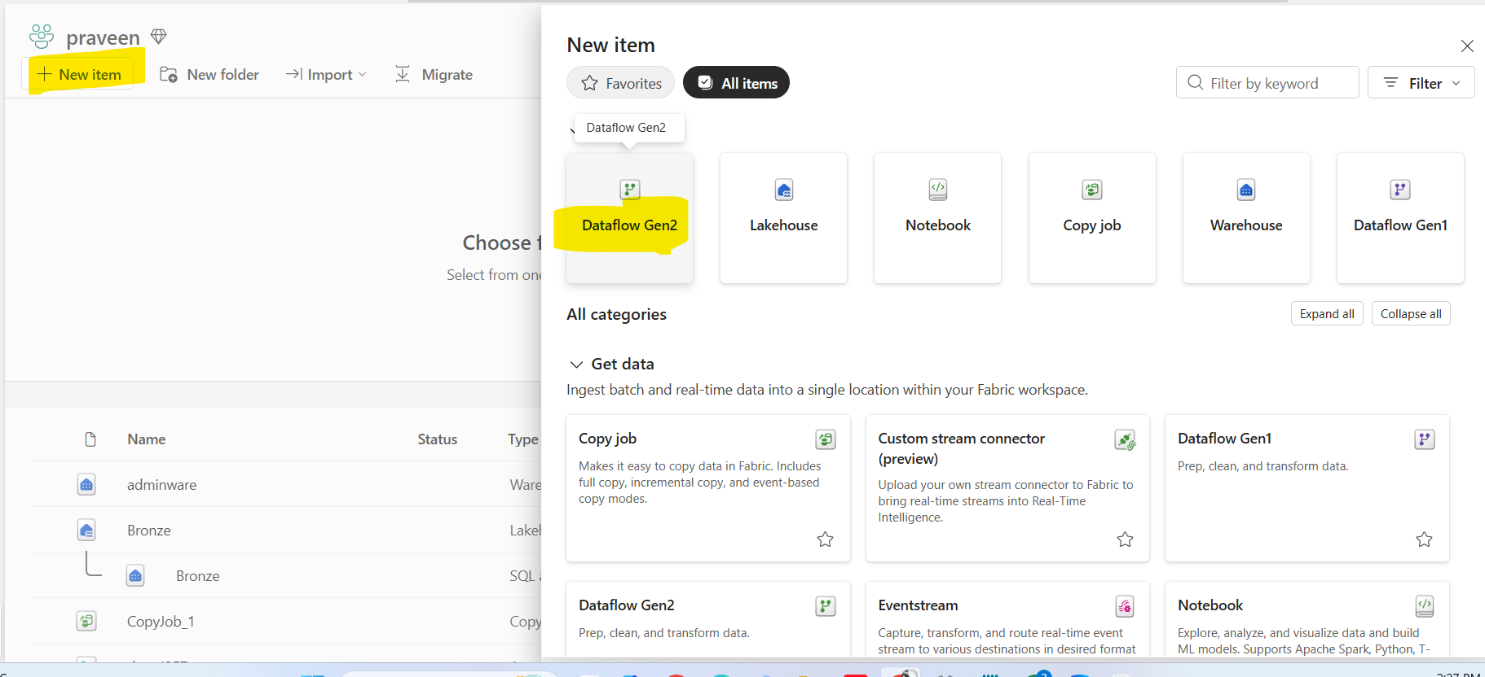
- Go to workspace and add dataflow gen2 into items

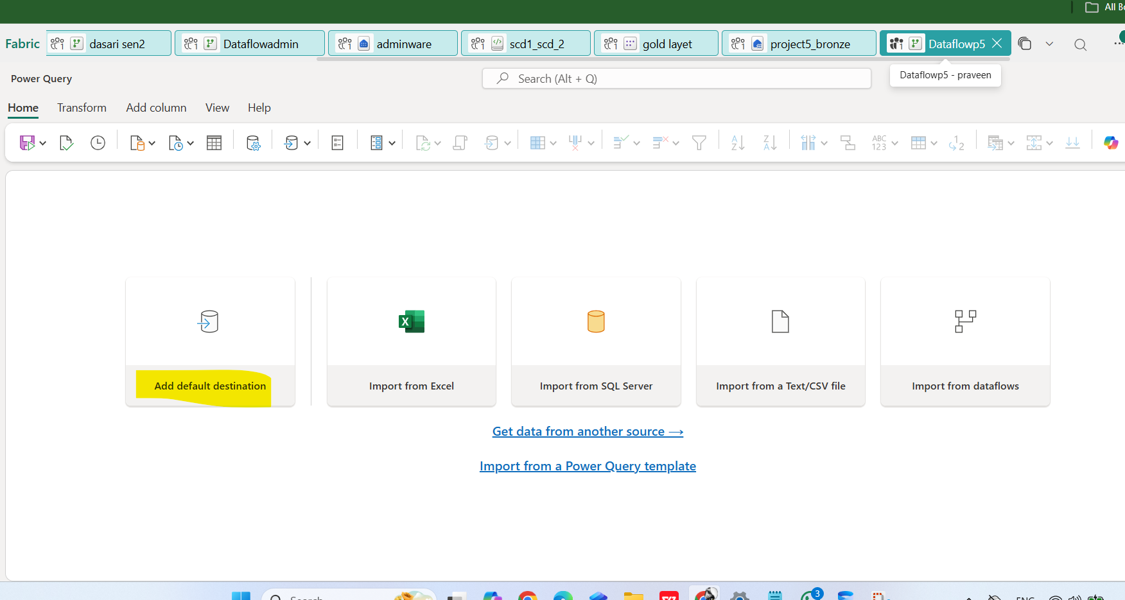

- Click on add default destination ( selecting the destination )
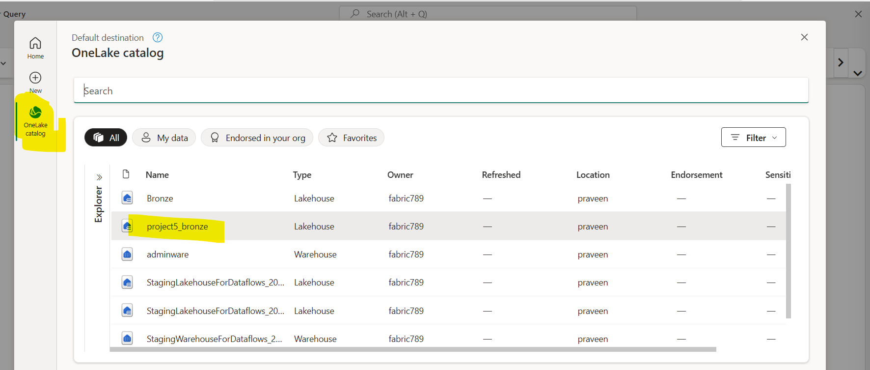
- Click on the onelake catalog
- Select the lakehouse ( we can select warehouse as well to store the cleaned data )
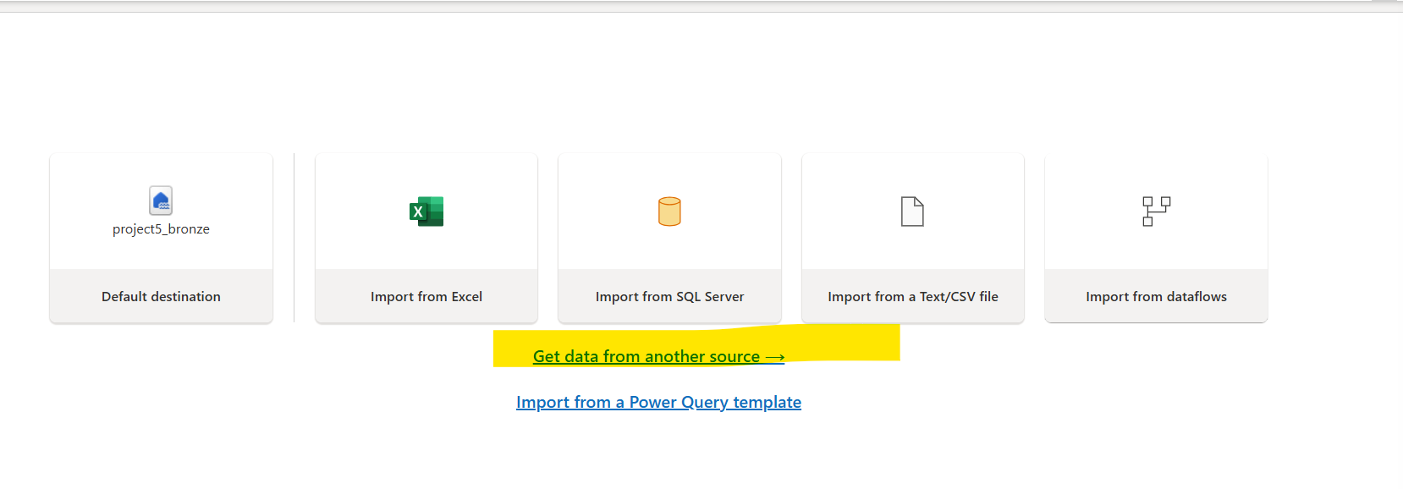
- After Selecting the destination and
Get the data from the source by selecting the option of get data from another source

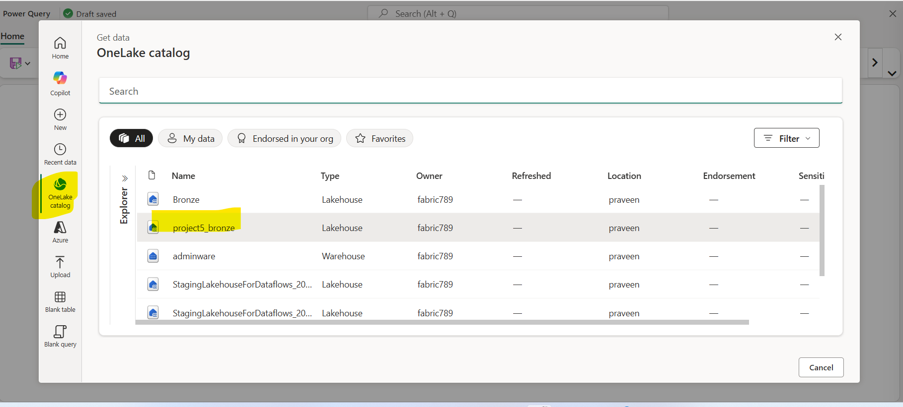
- Click on one lake catalog
- Select the lakehouse( where the file would stored)
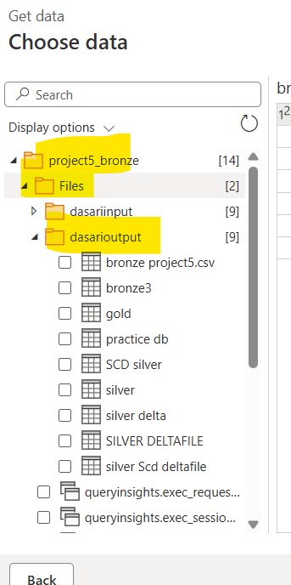

- Dropdown the lakehouse, files and container and the select the data file

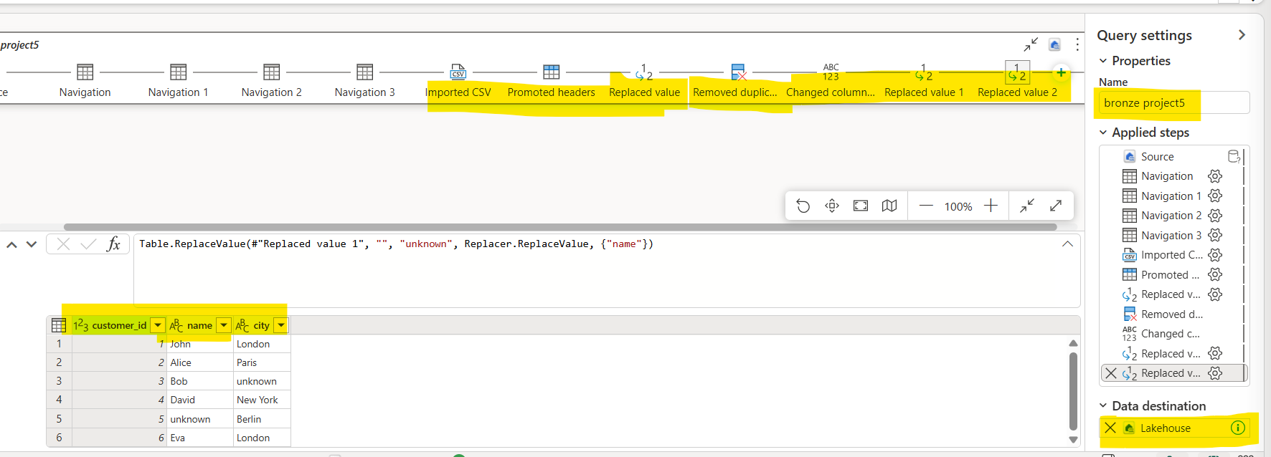
In dataflow gen2 the tranformations need to be apply
- Promoted headers = it will promote the first row as the headers
- Remove duplicates = it will remove the duplicates from the selected column
- Replace value = it will be replace the existing value to new given value
- In data flow gen2 we can change the column names, etc.….

SCD type 1 and SCD type 2 must done in SQL using merge statements.
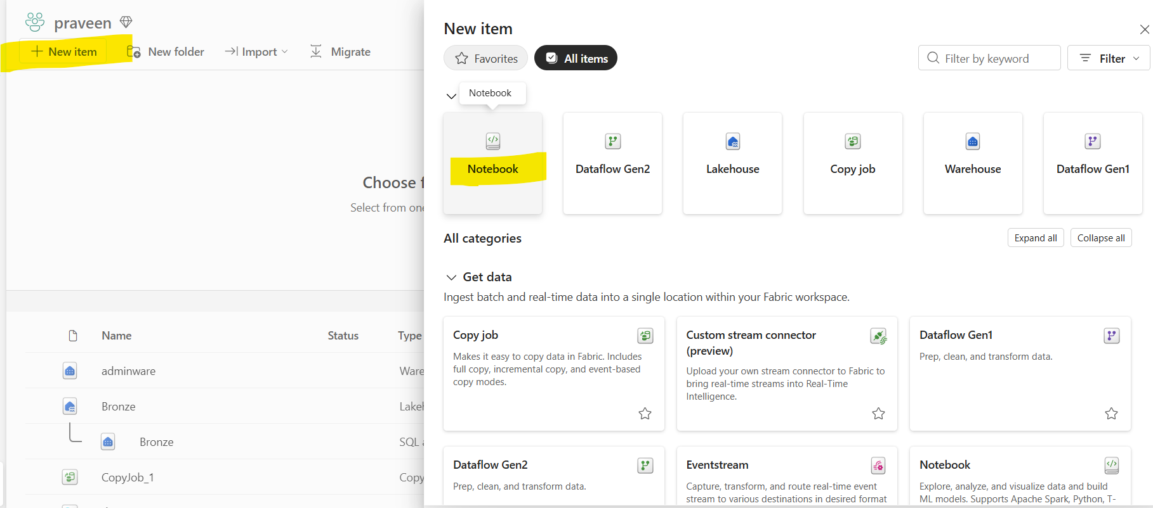
- Go to fabric workspace and search for notebook and
- open the notebook
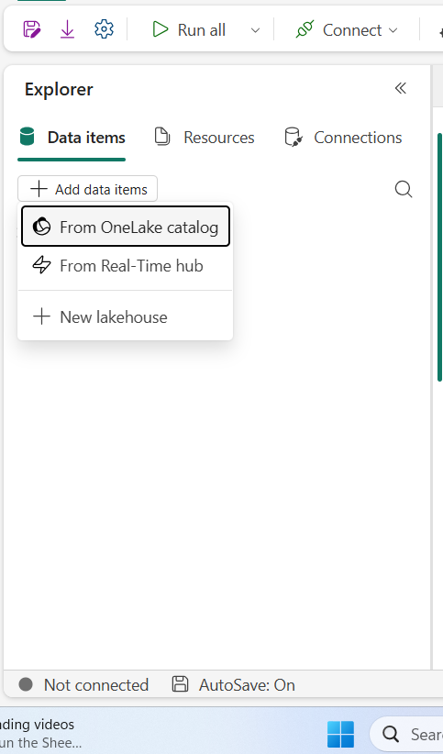
- In notebook go to add data items and
- select the onelake catalog
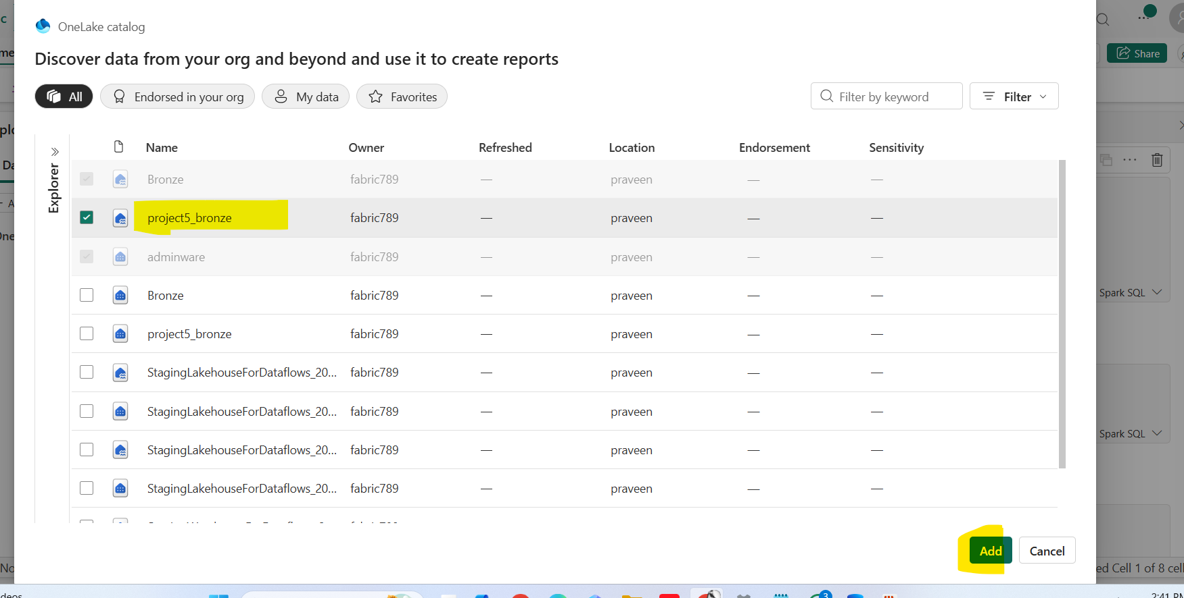
- Select the lake house ( we can select the warehouse as well instead of the lakehouse)

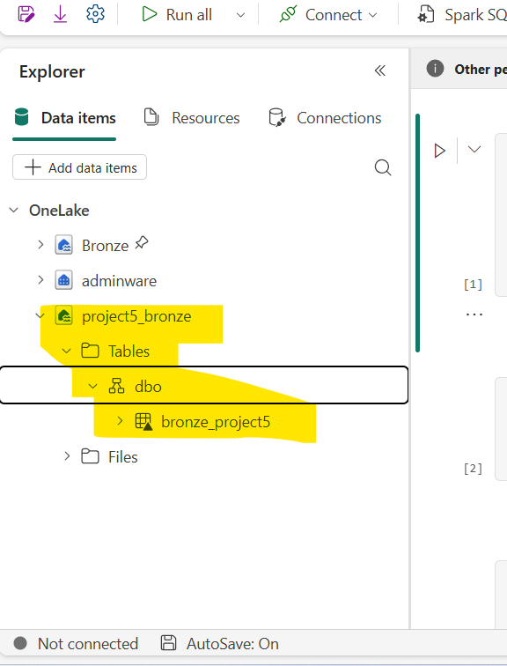

- The catalog will be appear in the note book
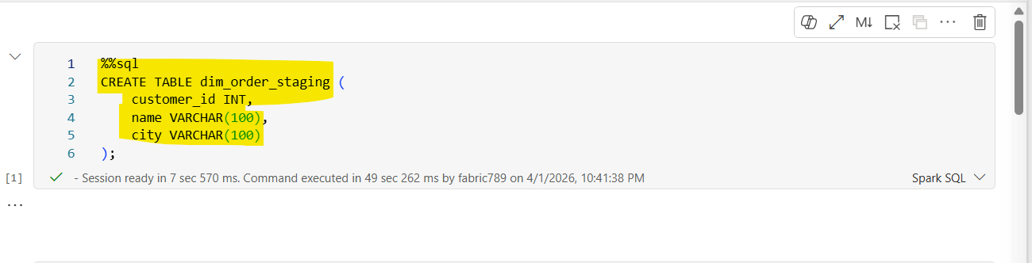
- Creating a new table name of dim_order_stagging
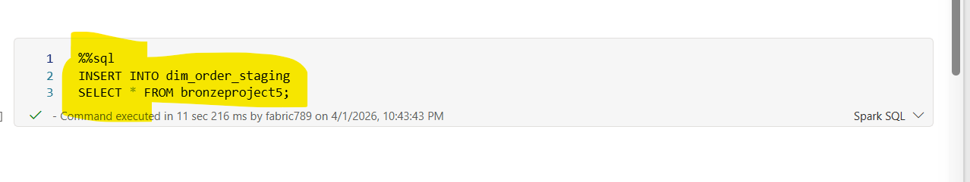
· The statement inserts all records from the source table bronzeproject5 into the target table dim_order_staging.
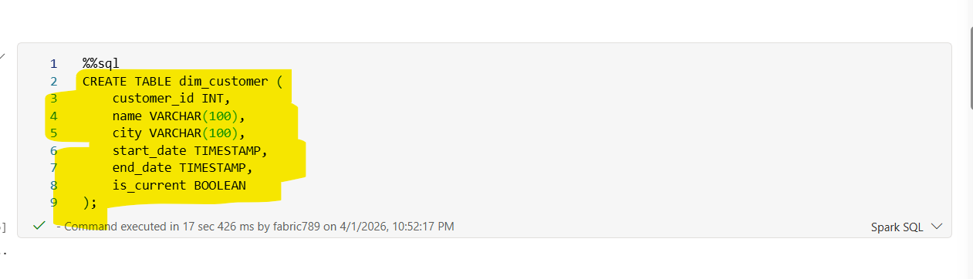
· customer_id INT
- Unique identifier for each customer.
- Used to track and link customer records.
· name VARCHAR(100)
- Stores the customer’s name.
- Variable-length string up to 100 characters.
· city VARCHAR(100)
- Stores the customer’s city or location.

· start_date TIMESTAMP
- Indicates when the record became effective.
- Marks the beginning of the record’s validity period.
· END_DATE TIMESTAMP
- Indicates when the record expired.
- Typically set to NULL or a future date for active records.
· IS_CURRENT BOOLEAN
- Flag to indicate the current active record:
- TRUE → Active/current record
- FALSE → Historical/expired record
SCD TYPE-1
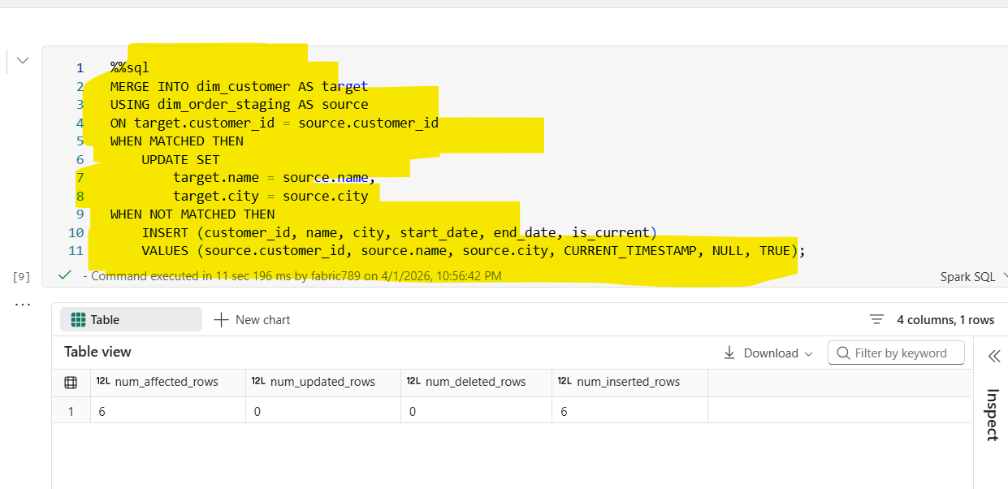
- · The MERGE statement data between:
- Target table → dim_customer
- Source table → dim_order_staging
It compares records based on:
- customer_id
- WHEN MATCHED (Record Exists)
- If a matching customer_id is found in both tables:
- The existing record in dim_customer is updated
Columns updated: Name, city
Ensures latest customer details are reflected
WHEN NOT MATCHED (New Record)
- If a customer_id exists in source but not in target:
- A new record is inserted into dim_customer
- Inserted values:
  - customer_id, name, city → from source
  - start_date → current timestamp
  - end_date → NULL (active record)
  - is_current → TRUE

SCD TYPE-2
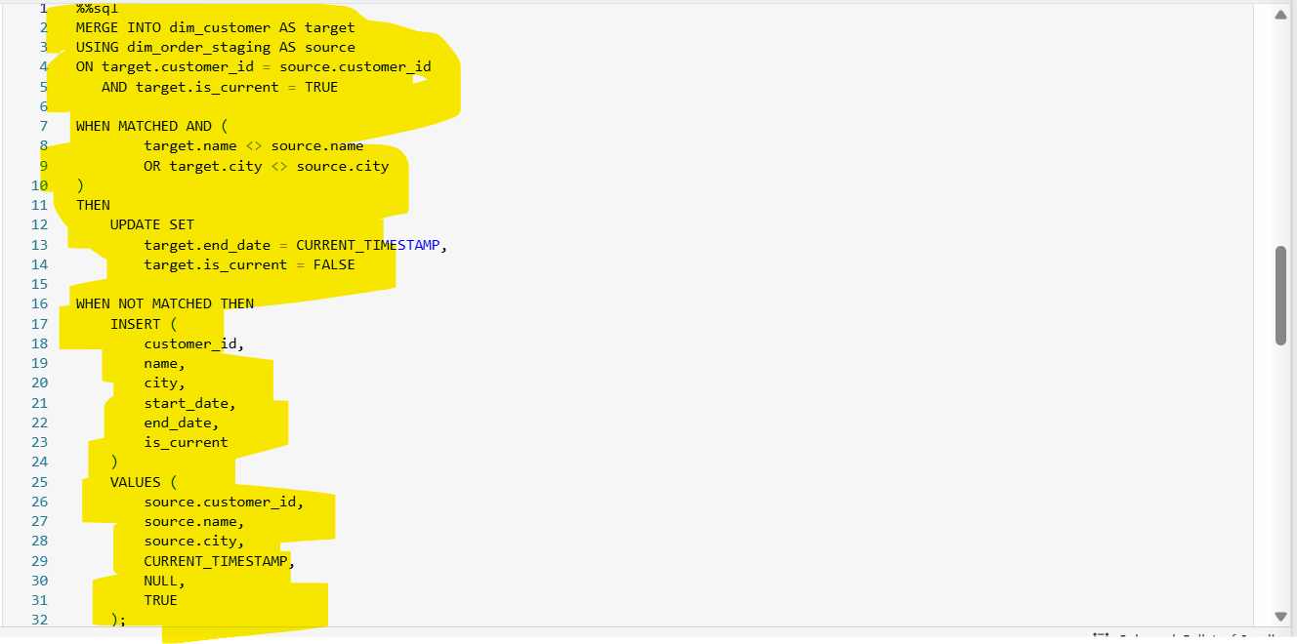
- The MERGE statement data between:
- Target table → dim_customer (dimension table)
- Source table → dim_order_staging (staging table)
- Matching condition:
- Records are matched on customer_id
- Only current active records are considered (is_current = TRUE)

- target.customer_id = source.customer_id
- AND target.is_current = TRUE
Ensures only the latest active record for each customer is evaluated.

- target.name <> source.name
- OR target.city <> source.city
If a match is found and data has changed
The existing record is expired

- end_date → set to current timestamp
- is_current → set to FALSE
Marks the old record as historical

- WHEN NOT MATCHED (New or Changed Record)
If:
- No matching current record exists, or
- A record was just expired in the previous step

Then:
- A new record is inserted

Inserted values:
- Business data → from source (customer_id, name, city)
- start_date → current timestamp
- end_date → NULL (active record)
- is_current → TRUE
- Creates a new current version of the record

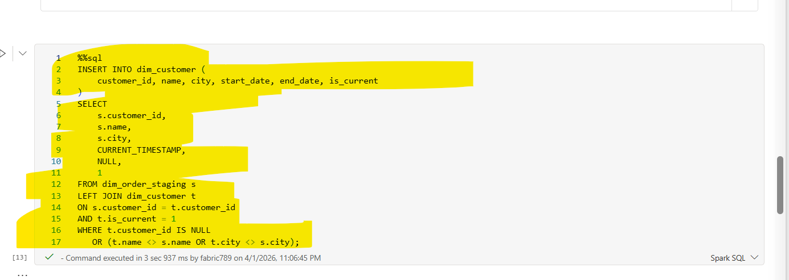
ON s.customer_id = t.customer_id
AND t.is_current = 1
· Joins staging data with only the current active records in the dimension table.
· Ensures comparison is done against the latest version of each customer.
t.customer_id IS NULL
OR (t.name <> s.name OR t.city <> s.city)
This condition selects:
New Records
- t.customer_id IS NULL
- Customer does not exist in the target table
Changed Records
- t.name <> s.name OR t.city <> s.city
- Customer exists but attribute values have changed
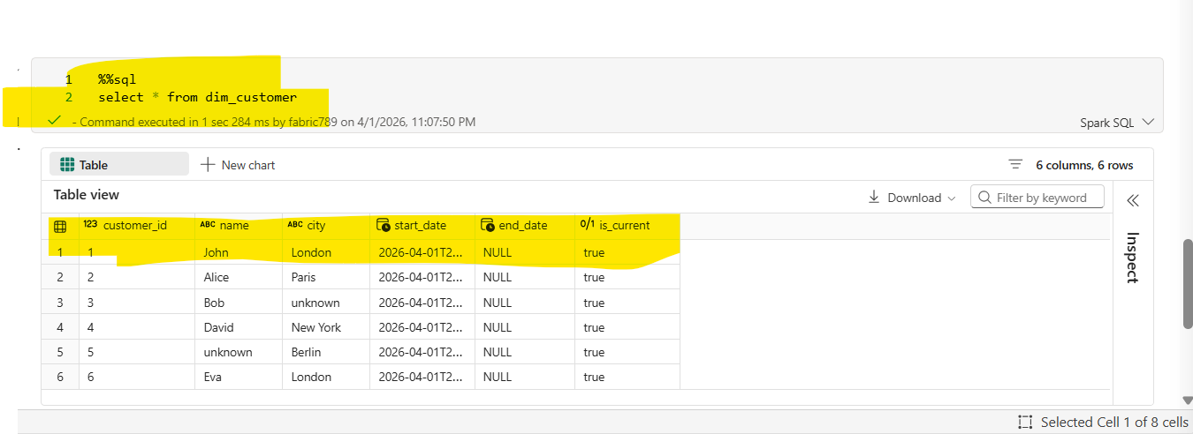
- The query retrieves all columns and all rows from the dim_customer table.
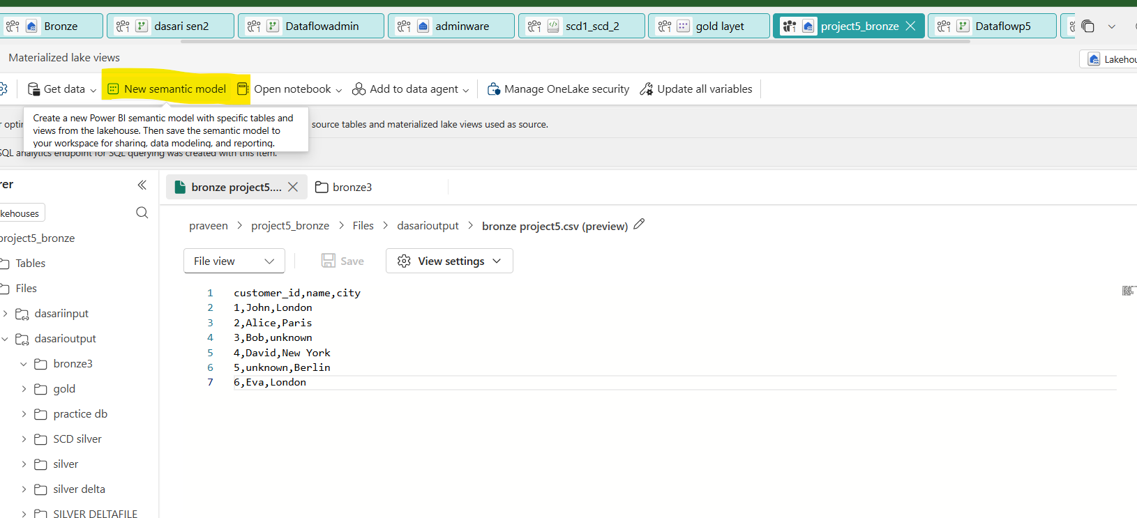
- Go to the lakehouse and open updated file and click on new semantic model
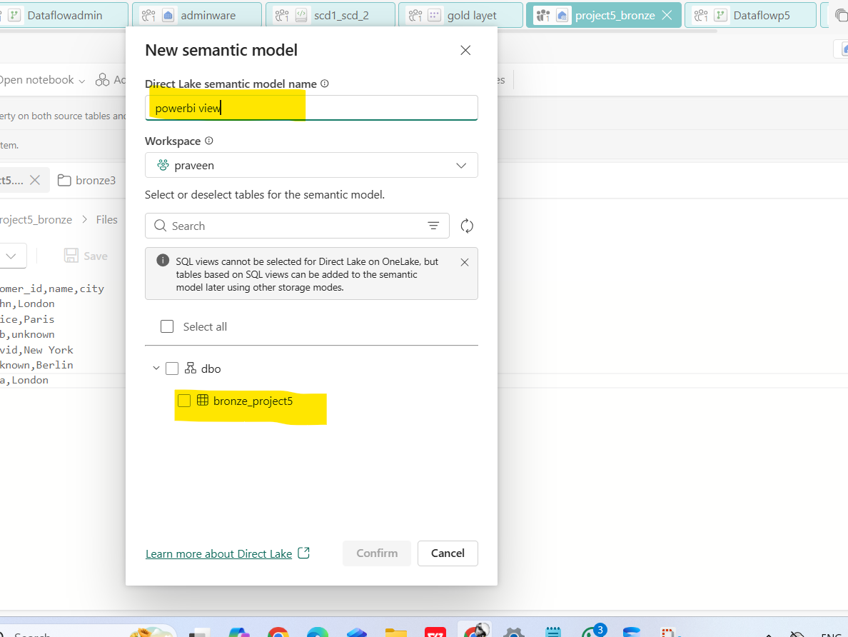
- Give the semantic model name and select the updated file
- And click on confirm

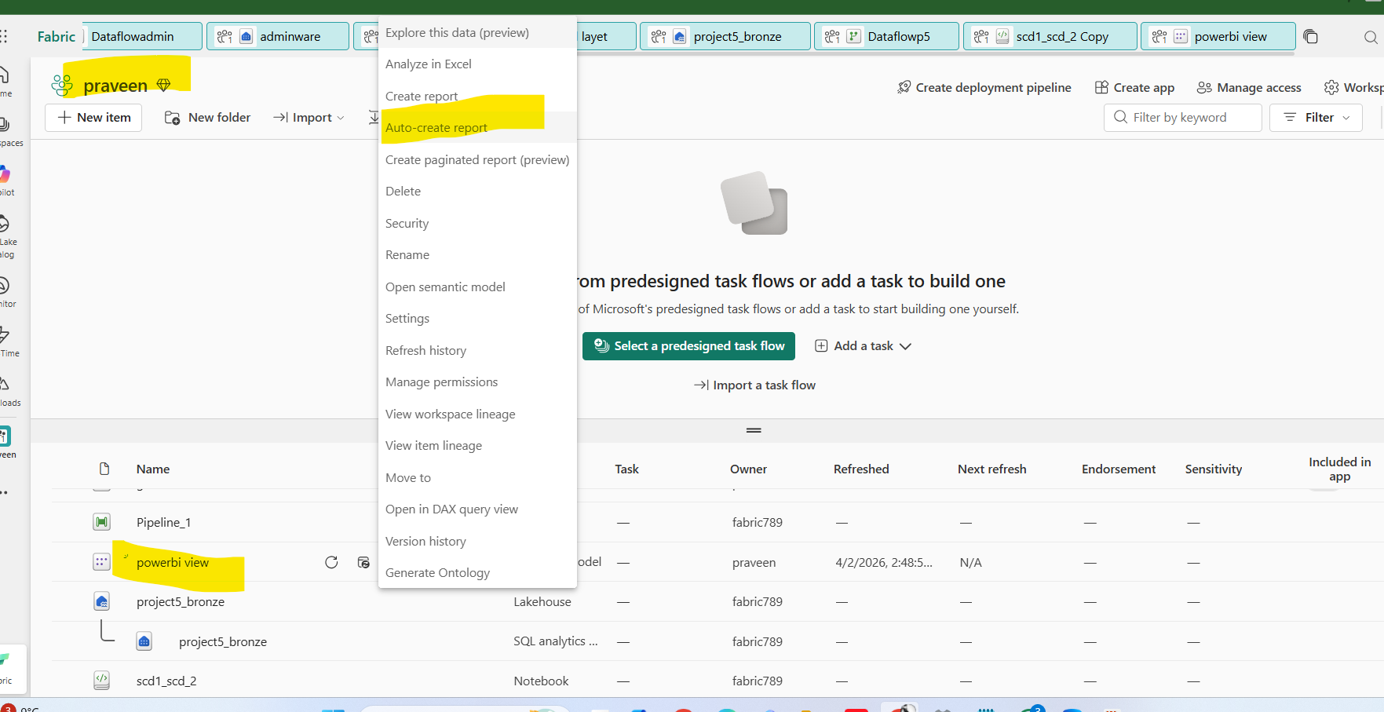
- Go to the workspace and click on three dots on selected file and choose the auto create table

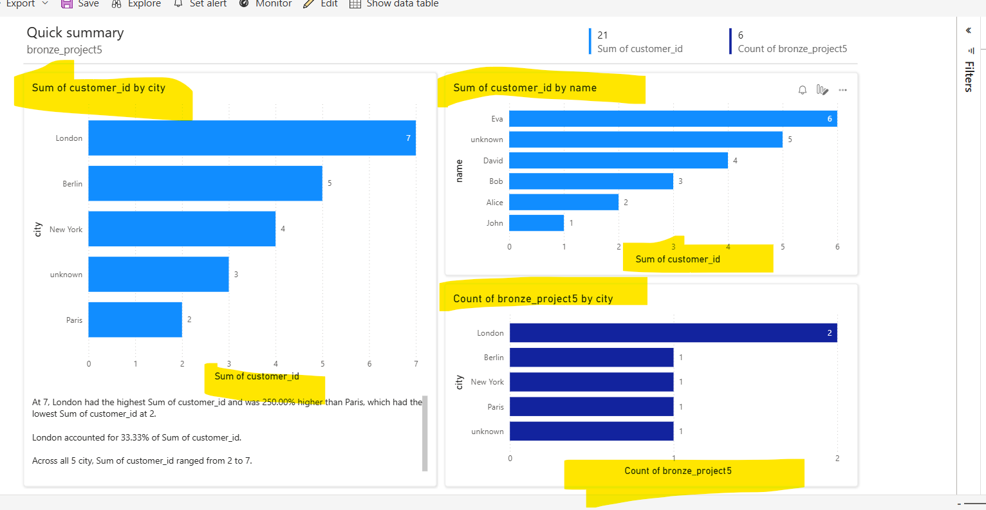

- the table will be generated in this format

