Project-5:

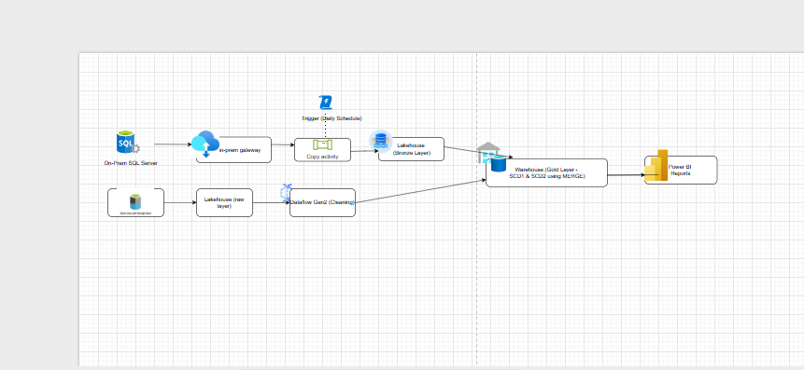
Overview:
This project demonstrates an end-to-end data engineering solution using Microsoft Fabric, where data is ingested from two sources—an on-premises SQL Server and ADLS Gen2—using a gateway, pipelines, and shortcuts. The raw data is stored in the Lakehouse (Bronze layer), then cleaned and transformed using Dataflow Gen2 before being loaded into a Warehouse (Gold layer). In the warehouse, Slowly Changing Dimensions (SCD Type 1 and Type 2) are implemented using SQL MERGE statements to manage data updates and history. The entire process is automated using scheduled pipeline triggers, and finally, the processed data is visualized through Power BI reports to generate business insights.
Create the workspace

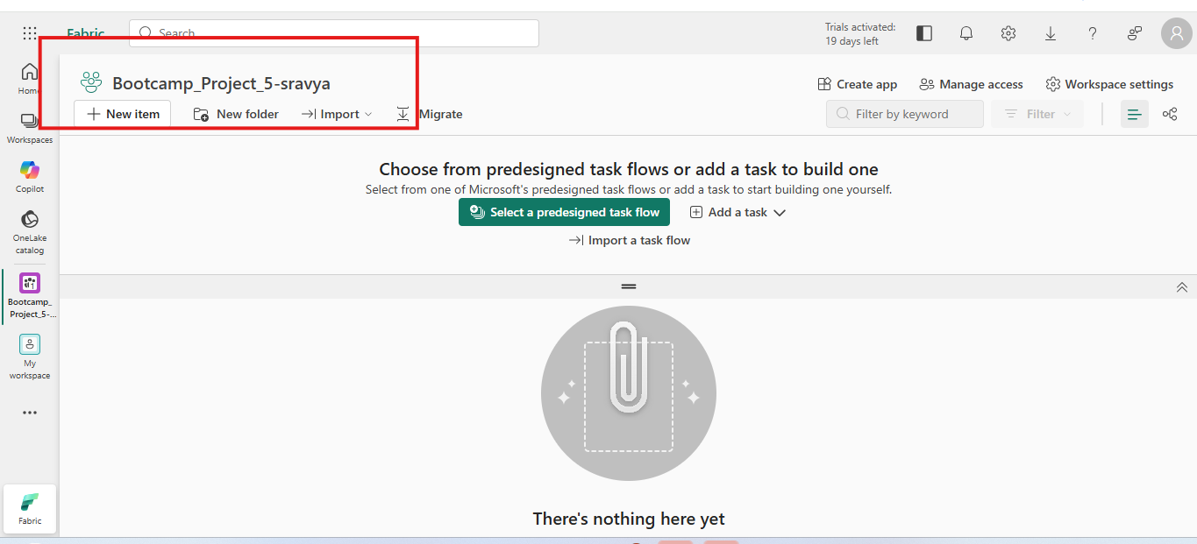
2. Created Lakehouse
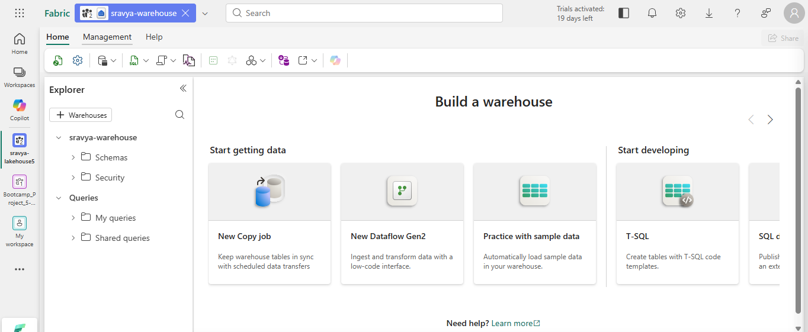
Created warehouse
- 

Step 1: Load On-Prem SQL → Lakehouse (Bronze)

