Automated Retail Data Warehouse (Synapse Data Flow Edition)
Architecture
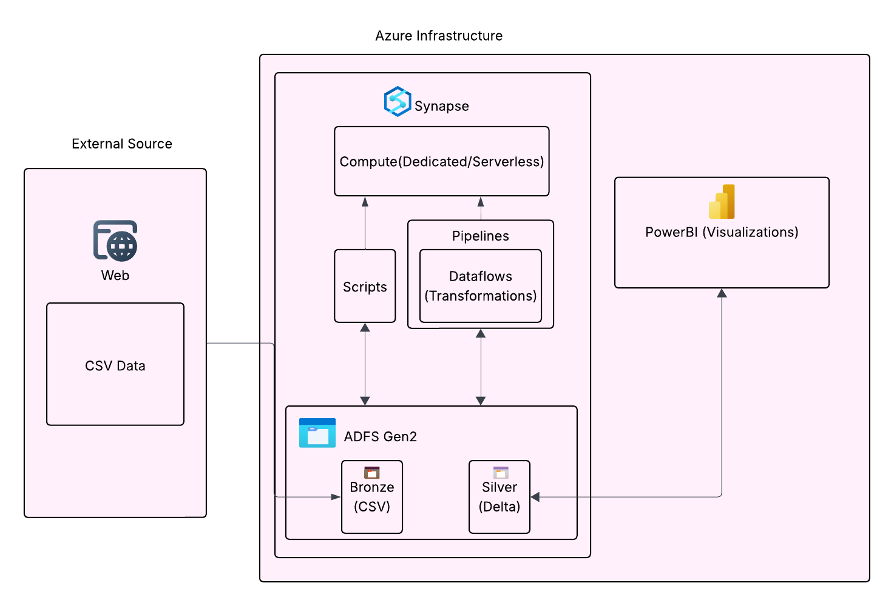
Objective: Transform raw sales data into a high-performance Star Schema in a Dedicated SQL Pool.
Phase 1: Environment Setup
- Storage Permissions: * In Azure Portal, assign Storage Blob Data Contributor to your Synapse Workspace Managed Identity.
- Dedicated SQL Pool: * Ensure your pool is created and running.
  - Create the 3 tables (DimProduct, DimGeography, FactSales) using the DDL provided previously (ensure Product_ID and Geography_ID match your intended types).
- Data Flow Debug: * Turn on Data flow debug in Synapse Studio.

Phase 2: Silver Layer (Cleansing)
Data Flow: DF_Bronze_to_Silver
- Source: sales_data.csv from Bronze.
- Transformation (Derived Column): Force types to match your SQL schema (e.g., toDecimal(Sales_Amount, 18, 2)).
- Transformation (Aggregate): Remove duplicates by grouping by all columns.
- Sink: Inline Delta format in SilverLayer/SalesDelta.

Phase 3: Gold Layer - Dimension Loading
We will now create two separate Data Flows to feed your Dimension tables in the SQL Pool.
1. Product Dimension (SCD Type 1)
Data Flow: DF_Load_DimProduct_SQL
- Source: SilverLayer/SalesDelta (Delta).
- Aggregate: Group by Product_ID. Use first() for Category, Cost, and Price.
- Alter Row: Set Upsert if to true().
- Sink: * Sink Type: Azure Synapse Analytics.
  - Dataset: Point to your Dedicated SQL Pool DimProduct table.
  - Settings: * Check Allow Insert and Allow Upsert.
    - Key Columns: Product_ID.
    - Enable Staging: Check this box (uses the COPY command internally for speed).
2. Geography Dimension
Data Flow: DF_Load_DimGeography_SQL
- Source: SilverLayer/SalesDelta (Delta).
- Aggregate: Group by Region and Sales_Channel.
- Surrogate Key: Add a column Geography_ID starting from 1.
- Sink: * Sink Type: Azure Synapse Analytics.
  - Dataset: Point to DimGeography table.
  - Settings: Select Truncate Table (for full reload) or Allow Insert.

Phase 4: Gold Layer - Fact Table Loading
This is the most complex flow as it requires "Looking up" IDs from the dimensions you just created.
Data Flow: DF_Load_FactSales_SQL
- Source 1: SilverLayer/SalesDelta (Cleaned Transactions).
- Source 2 (Lookup): DimGeography (The SQL Pool Table).
- Join: Join Source 1 and Source 2 on Region == Region and Sales_Channel == Sales_Channel.
- Derived Column: Generate a unique Transaction_ID using the expression uuid().
- Sink: * Sink Type: Azure Synapse Analytics.
  - Dataset: Point to FactSales table.
  - Mapping: Ensure Geography_ID from the Join is mapped to the Sink, and Product_ID from the Sales source is mapped.

Phase 5: Orchestration & Reporting
- Master Pipeline: * Add 4 Data Flow activities in sequence: 1. DF_Bronze_to_Silver 2. DF_Load_DimGeography_SQL (Required for Fact lookup) 3. DF_Load_DimProduct_SQL 4. DF_Load_FactSales_SQL
- Power BI: * Connect to the Dedicated SQL Pool endpoint.
  - Import the tables and create relationships.
  - Visuals: Category Sales (Bar Chart), Regional Distribution (Map), and Sales Trends (Line Chart).

{
"name": "DF_SCD1_Product",
"properties": {
"type": "MappingDataFlow",
"typeProperties": {
"sources": [
{
"linkedService": {
"referenceName": "AzureDataLakeStorage",
"type": "LinkedServiceReference"
},
"name": "IncomingCleanSales"
}
],
"sinks": [
{
"linkedService": {
"referenceName": "AzureDataLakeStorage",
"type": "LinkedServiceReference"
},
"name": "Sink"
}
],
"transformations": [
{
"name": "Aggregate"
},
{
"name": "AlterRow"
},
{
"name": "DerivedColumn"
}
],
"scriptLines": [
"source(output(",
" Sale_Date as string,",
" Sales_Rep as string,",
" Region as string,",
" Sales_Amount as double,",
" Quantity_Sold as string,",
" Product_Category as string,",
" Unit_Cost as string,",
" Unit_Price as string,",
" Customer_Type as string,",
" Discount as string,",
" Payment_Method as string,",
" Sales_Channel as string,",
" Region_and_Sales_Rep as string,",
" Product_ID as integer",
" ),",
" allowSchemaDrift: true,",
" validateSchema: false,",
" ignoreNoFilesFound: false,",
" format: 'delta',",
" fileSystem: 'project3',",
" folderPath: 'SilverLayer/SalesDelta') ~> IncomingCleanSales",
"DerivedColumn aggregate(groupBy(Product_ID),",
" Product_Category = first(Product_Category),",
" Unit_Cost = first(Unit_Cost),",
" Unit_Price = first(Unit_Price)) ~> Aggregate",
"Aggregate alterRow(upsertIf(true())) ~> AlterRow",
"IncomingCleanSales derive(Unit_Price = toDecimal(Unit_Price, 18, 2),",
" Unit_Cost = toDecimal(Unit_Cost, 18, 2),",
" Product_ID = toInteger(Product_ID)) ~> DerivedColumn",
"AlterRow sink(allowSchemaDrift: true,",
" validateSchema: false,",
" format: 'delta',",
" fileSystem: 'project3',",
" folderPath: 'SilverLayer/DimsProduct',",
" mergeSchema: false,",
" autoCompact: false,",
" optimizedWrite: false,",
" vacuum: 0,",
" deletable: false,",
" insertable: true,",
" updateable: false,",
" upsertable: true,",
" keys:['Product_ID'],",
" umask: 0022,",
" preCommands: [],",
" postCommands: [],",
" skipDuplicateMapInputs: true,",
" skipDuplicateMapOutputs: true) ~> Sink"
]
}
}
}
{
"name": "DF_Bronze_to_Silver_Delta",
"properties": {
"type": "MappingDataFlow",
"typeProperties": {
"sources": [
{
"dataset": {
"referenceName": "DS_Bronze_Sales_CSV",
"type": "DatasetReference"
},
"name": "SourceSalesCSV"
}
],
"sinks": [
{
"linkedService": {
"referenceName": "AzureDataLakeStorage",
"type": "LinkedServiceReference"
},
"name": "SinkSilverDelta"
}
],
"transformations": [
{
"name": "AggregateUniques"
},
{
"name": "DerivedColumn"
}
],
"scriptLines": [
"source(output(",
" Product_ID as string,",
" Sale_Date as string,",
" Sales_Rep as string,",
" Region as string,",
" Sales_Amount as string,",
" Quantity_Sold as string,",
" Product_Category as string,",
" Unit_Cost as string,",
" Unit_Price as string,",
" Customer_Type as string,",
" Discount as string,",
" Payment_Method as string,",
" Sales_Channel as string,",
" Region_and_Sales_Rep as string",
" ),",
" allowSchemaDrift: true,",
" validateSchema: false,",
" ignoreNoFilesFound: false) ~> SourceSalesCSV",
"SourceSalesCSV aggregate(groupBy(Sale_Date,",
" Sales_Rep,",
" Region,",
" Sales_Amount,",
" Quantity_Sold,",
" Product_Category,",
" Unit_Cost,",
" Unit_Price,",
" Customer_Type,",
" Discount,",
" Payment_Method,",
" Sales_Channel,",
" Region_and_Sales_Rep),",
" Product_ID = first(Product_ID)) ~> AggregateUniques",
"AggregateUniques derive(Sales_Amount = iif(isNull(Sales_Amount), 0.0, toFloat(Sales_Amount)),",
" Region = upper(Region)) ~> DerivedColumn",
"DerivedColumn sink(allowSchemaDrift: true,",
" validateSchema: false,",
" format: 'delta',",
" fileSystem: 'project3',",
" folderPath: 'SilverLayer/SalesDelta',",
" mergeSchema: false,",
" autoCompact: false,",
" optimizedWrite: false,",
" vacuum: 0,",
" deletable: false,",
" insertable: true,",
" updateable: false,",
" upsertable: false,",
" umask: 0022,",
" preCommands: [],",
" postCommands: [],",
" skipDuplicateMapInputs: true,",
" skipDuplicateMapOutputs: true) ~> SinkSilverDelta"
]
}
}
}
-- =========================================================================
-- TABLE 1: DimProduct (Target for SCD Type 1)
-- Distribution: REPLICATE (Small table, copy to all 60 compute nodes)
-- Index: CLUSTERED COLUMNSTORE INDEX
-- =========================================================================
CREATE TABLE [dbo].[DimProduct]
(
[Product_ID] INT NOT NULL,
[Product_Category] VARCHAR(100) NULL,
[Unit_Cost] DECIMAL(18,2) NULL,
[Unit_Price] DECIMAL(18,2) NULL,

CONSTRAINT PK_DimProduct PRIMARY KEY NONCLUSTERED ([Product_ID]) NOT ENFORCED
)
WITH
(
DISTRIBUTION = REPLICATE,
CLUSTERED COLUMNSTORE INDEX
);
GO

-- =========================================================================
-- TABLE 2: DimGeography
-- Distribution: ROUND_ROBIN (Dealt evenly across nodes like a deck of cards)
-- Index: CLUSTERED COLUMNSTORE INDEX
-- =========================================================================
CREATE TABLE [dbo].[DimGeography]
(
[Geography_ID] INT NOT NULL,
[Region] VARCHAR(50) NULL,
[Sales_Channel] VARCHAR(50) NULL,

CONSTRAINT PK_DimGeography PRIMARY KEY NONCLUSTERED ([Geography_ID]) NOT ENFORCED
)
WITH
(
DISTRIBUTION = ROUND_ROBIN,
CLUSTERED COLUMNSTORE INDEX
);
GO

-- =========================================================================
-- TABLE 3: FactSales
-- Distribution: HASH (Massive table, group records by Product_ID across nodes)
-- Index: CLUSTERED COLUMNSTORE INDEX
-- =========================================================================
CREATE TABLE [dbo].[FactSales]
(
[Transaction_ID] VARCHAR(100) NOT NULL,
[Product_ID] INT NOT NULL,
[Geography_ID] INT NOT NULL,
[Sale_Date] DATE NULL,
[Sales_Amount] DECIMAL(18,2) NULL,
[Quantity_Sold] INT NULL,
[Discount] DECIMAL(5,2) NULL,

-- Primary Key
CONSTRAINT PK_FactSales PRIMARY KEY NONCLUSTERED ([Transaction_ID]) NOT ENFORCED

-- Note: Synapse Dedicated SQL Pools do NOT support FOREIGN KEY constraints.
-- Referential integrity must be handled upstream in your Data Flows!
)
WITH
(
DISTRIBUTION = HASH([Product_ID]),
CLUSTERED COLUMNSTORE INDEX
);
GO
COPY INTO [dbo].[DimProduct]
FROM 'https://project1adlsgagan.dfs.core.windows.net/project3/SilverLayer/DimsProduct/*.parquet'
WITH (
FILE_TYPE = 'PARQUET',
CREDENTIAL = (IDENTITY = 'Managed Identity') -- Uses Synapse's own permission to read the lake
);

SELECT *
FROM OPENROWSET(
BULK 'https://project1adlsgagan.blob.core.windows.net/project3/SilverLayer/DimsProduct/',
FORMAT = 'DELTA'
) AS [result];
-- Load DimGeography and generate a unique ID using ROW_NUMBER()
INSERT INTO [dbo].[DimGeography] (Geography_ID, Region, Sales_Channel)
SELECT
ROW_NUMBER() OVER(ORDER BY Region, Sales_Channel) AS Geography_ID,
CAST(Region AS VARCHAR(50)),
CAST(Sales_Channel AS VARCHAR(50))
FROM (
-- Get only the unique combinations from your Silver Delta files
SELECT DISTINCT Region, Sales_Channel
FROM OPENROWSET(
BULK 'https://project1adlsgagan.blob.core.windows.net/project3/SilverLayer/SalesDelta/',
FORMAT = 'DELTA'
) AS [raw_sales]
) AS distinct_geography;
-- Load FactSales by joining the raw data with our new DimGeography table
INSERT INTO [dbo].[FactSales] (
Transaction_ID, Product_ID, Geography_ID, Sale_Date,
Sales_Amount, Quantity_Sold, Discount
)
SELECT
CAST(NEWID() AS VARCHAR(100)) AS Transaction_ID, -- Auto-generate a unique transaction ID
CAST(s.Product_ID AS INT),
g.Geography_ID, -- Grab the generated ID from the dimension table
CAST(s.Sale_Date AS DATE),
CAST(s.Sales_Amount AS DECIMAL(18,2)),
CAST(s.Quantity_Sold AS INT),
CAST(s.Discount AS DECIMAL(5,2))
FROM OPENROWSET(
BULK 'https://your_storage_account.dfs.core.windows.net/your_container/SilverLayer/SalesDelta/',
FORMAT = 'DELTA'
) AS s
-- Match the raw text to the Dimension table to get the integer ID!
JOIN [dbo].[DimGeography] g
ON CAST(s.Region AS VARCHAR(50)) = g.Region
AND CAST(s.Sales_Channel AS VARCHAR(50)) = g.Sales_Channel;

