End-to-End Data Lakehouse Pipeline using Medallion Architecture
Architecture
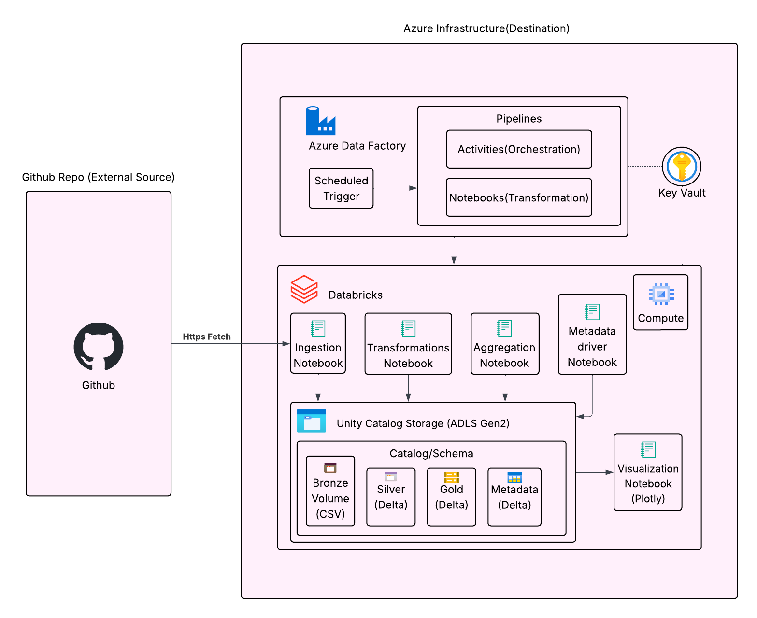
Project Overview
This project builds a fully automated, enterprise-grade data pipeline utilizing the Medallion Architecture (Bronze, Silver, Gold). It uses Azure Databricks (with Unity Catalog) for compute, storage, and governance, and Azure Data Factory (ADF) for orchestration. It also includes an advanced, metadata-driven dynamic loading framework.
Prerequisites
- An Azure Subscription.
- An Azure Databricks Workspace (Premium Tier to support Unity Catalog).
- An Azure Data Factory (ADF) instance.
- A Databricks Cluster configured with Databricks Runtime 11.3 LTS or higher, with Access Mode set to Single User or Shared (to enable Unity Catalog).

Phase 1: Storage and Governance Setup (Unity Catalog)
Before ingesting data, we must create the logical containers to govern our data assets.
- Open your Databricks Workspace and create a new notebook.
- Set the default language to SQL.
- Execute the following commands to build the hierarchy:
SQL
-- 1. Create the overarching project catalog
CREATE CATALOG IF NOT EXISTS bootcamp_catalog;

-- 2. Create the schema to hold our sales data assets
CREATE SCHEMA IF NOT EXISTS bootcamp_catalog.sales_schema;

-- 3. Create the Bronze Volume for raw, unstructured file storage
CREATE VOLUME IF NOT EXISTS bootcamp_catalog.sales_schema.bronze_raw_data;

Phase 2: Data Ingestion (The Bronze Layer)
Fetch raw CSV files from an external GitHub repository and save them directly into the Unity Catalog Volume.
- Create a new notebook (or add a cell) and set the language to Python.
- Execute the following code to download the 2019, 2020, and 2021 datasets:
Python
import requests

urls = [
"https://raw.githubusercontent.com/MicrosoftLearning/mslearn-databricks/main/data/2019.csv",
"https://raw.githubusercontent.com/MicrosoftLearning/mslearn-databricks/main/data/2020.csv",
"https://raw.githubusercontent.com/MicrosoftLearning/mslearn-databricks/main/data/2021.csv"
]

volume_path = "/Volumes/bootcamp_catalog/sales_schema/bronze_raw_data/"

for url in urls:
filename = url.split("/")[-1]
response = requests.get(url)

if response.status_code == 200:
file_destination = f"{volume_path}{filename}"
with open(file_destination, "w") as file:
file.write(response.text)
print(f"✅ Successfully saved {filename} to Bronze Volume.")
else:
print(f"❌ Failed to download {filename}.")

Phase 3: Transformation and Cleaning (The Silver Layer)
Read the raw files, enforce a strict data schema, apply cleaning transformations, and save as a managed Delta Table.
- In a Python notebook, execute the following script to enforce data types and standardize column names:
Python
from pyspark.sql.types import StructType, StructField, StringType, IntegerType, DoubleType, DateType
from pyspark.sql.functions import col

# 1. Define strict schema rules
sales_schema = StructType([
StructField("order_number", StringType(), True),
StructField("line_number", IntegerType(), True),
StructField("order_date", DateType(), True),
StructField("customer_name", StringType(), True),
StructField("email_address", StringType(), True),
StructField("product_name", StringType(), True),
StructField("order_quantity", IntegerType(), True),
StructField("unit_price", DoubleType(), True),
StructField("tax_amount", DoubleType(), True)
])

# 2. Read all CSVs from the Bronze Volume simultaneously
df_raw = spark.read.csv(
"/Volumes/bootcamp_catalog/sales_schema/bronze_raw_data/*.csv",
header=True,
schema=sales_schema
)

# 3. Clean data (Drop rows missing critical identifiers)
df_silver = df_raw.dropna(subset=["order_number", "order_date"])

# 4. Save to Silver Layer as a Delta Table
silver_table_name = "bootcamp_catalog.sales_schema.silver_sales"
df_silver.write.format("delta").mode("overwrite").saveAsTable(silver_table_name)

Phase 4: Business Aggregation and Visualization (The Gold Layer)
Summarize the clean historical data to generate business insights, and visualize the results.
- Execute the following Python code to calculate total revenue by year and product:
Python
from pyspark.sql.functions import year, sum, round, col

df_silver = spark.read.table("bootcamp_catalog.sales_schema.silver_sales")

# 1. Aggregate the data
df_gold = df_silver \
.withColumn("order_year", year(col("order_date"))) \
.groupBy("order_year", "product_name") \
.agg(
sum("order_quantity").alias("total_units_sold"),
round(sum(col("order_quantity") * col("unit_price")), 2).alias("total_revenue")
)

# 2. Save to Gold Layer
gold_table_name = "bootcamp_catalog.sales_schema.gold_product_revenue"
df_gold.write.format("delta").mode("overwrite").saveAsTable(gold_table_name)
- Generate an interactive visual using Plotly:
Python
import plotly.express as px

# Convert Gold table to Pandas for Plotly
pdf_gold = spark.read.table("bootcamp_catalog.sales_schema.gold_product_revenue").toPandas()

# Generate stacked bar chart
fig = px.bar(
pdf_gold,
x="order_year",
y="total_revenue",
color="product_name",
title="Total Revenue by Year and Product",
labels={"order_year": "Order Year", "total_revenue": "Total Revenue ($)"},
barmode="stack"
)
fig.show()

Phase 5: Orchestration (Azure Data Factory)
Automate the execution of the Databricks notebooks.
- Create a Linked Service:
  - In ADF, navigate to Manage > Linked services > + New.
  - Select Azure Databricks.
  - Authenticate using a Databricks Personal Access Token and select your existing interactive cluster.
- Create the Pipeline:
  - Navigate to Author > Pipelines > New pipeline.
  - Drag a Notebook Activity onto the canvas.
  - In the Azure Databricks tab, select your Linked Service.
  - In the Settings tab, browse and select your Databricks processing notebook.
- Schedule the Trigger:
  - Click Add trigger > New/Edit.
  - Create a new Schedule trigger (e.g., daily at 2:00 AM).
- Publish: Click Publish all to deploy the automated pipeline.

Phase 6: Advanced Metadata-Driven Execution (Optional Work)
Implement a dynamic framework to scale the pipeline without altering code.
- Create the Metadata Configuration Table (SQL):
SQL
CREATE TABLE IF NOT EXISTS bootcamp_catalog.sales_schema.pipeline_metadata (
source_system STRING, file_name STRING, source_path STRING,
destination_table STRING, load_type STRING, is_active BOOLEAN
) USING DELTA;

INSERT INTO bootcamp_catalog.sales_schema.pipeline_metadata VALUES
('GitHub', '2019.csv', '/Volumes/bootcamp_catalog/sales_schema/bronze_raw_data/2019.csv', 'bootcamp_catalog.sales_schema.silver_2019', 'overwrite', true),
('GitHub', '2020.csv', '/Volumes/bootcamp_catalog/sales_schema/bronze_raw_data/2020.csv', 'bootcamp_catalog.sales_schema.silver_2020', 'overwrite', true),
('GitHub', '2021.csv', '/Volumes/bootcamp_catalog/sales_schema/bronze_raw_data/2021.csv', 'bootcamp_catalog.sales_schema.silver_2021', 'overwrite', true);
- Create the Driver Notebook to execute loads dynamically (Python):
Python
# 1. Fetch active pipeline configurations
df_metadata = spark.read.table("bootcamp_catalog.sales_schema.pipeline_metadata").filter("is_active == True")
configs = df_metadata.collect()

# 2. Loop through configurations and load dynamically
for row in configs:
try:
# Read from dynamic source path (assuming 'sales_schema' struct is pre-defined)
df_raw = spark.read.csv(row['source_path'], header=True, schema=sales_schema)

# Write to dynamic destination table
df_raw.dropna(subset=["order_number"]).write.format("delta").mode(row['load_type']).saveAsTable(row['destination_table'])
print(f"✅ Successfully processed {row['file_name']}")
except Exception as e:
print(f"❌ Error processing {row['file_name']}: {str(e)}")

{
"name": "pipeline1",
"properties": {
"activities": [
{
"name": "Ingestion",
"type": "DatabricksNotebook",
"dependsOn": [],
"policy": {
"timeout": "0.12:00:00",
"retry": 0,
"retryIntervalInSeconds": 30,
"secureOutput": false,
"secureInput": false
},
"userProperties": [],
"typeProperties": {
"notebookPath": "/Users/pingmething@outlook.com/Project4/Ingestion Script"
},
"linkedServiceName": {
"referenceName": "DatabricksLS",
"type": "LinkedServiceReference"
}
},
{
"name": "Transformation",
"type": "DatabricksNotebook",
"dependsOn": [
{
"activity": "Ingestion",
"dependencyConditions": [
"Succeeded"
]
}
],
"policy": {
"timeout": "0.12:00:00",
"retry": 0,
"retryIntervalInSeconds": 30,
"secureOutput": false,
"secureInput": false
},
"userProperties": [],
"typeProperties": {
"notebookPath": "/Users/pingmething@outlook.com/Project4/Transformation Script"
},
"linkedServiceName": {
"referenceName": "DatabricksLS",
"type": "LinkedServiceReference"
}
},
{
"name": "Aggregation",
"type": "DatabricksNotebook",
"dependsOn": [
{
"activity": "Transformation",
"dependencyConditions": [
"Succeeded"
]
}
],
"policy": {
"timeout": "0.12:00:00",
"retry": 0,
"retryIntervalInSeconds": 30,
"secureOutput": false,
"secureInput": false
},
"userProperties": [],
"typeProperties": {
"notebookPath": "/Users/pingmething@outlook.com/Project4/Aggregation Script"
},
"linkedServiceName": {
"referenceName": "DatabricksLS",
"type": "LinkedServiceReference"
}
}
],
"annotations": []
}
}

