Project Overview:
ETL Pipeline for Healthcare Data using Azure Databricks
This project focuses on building an end-to-end ETL pipeline to process large-scale healthcare data using Azure cloud services. The pipeline ingests raw patient data, cleans and transforms it using PySpark in Azure Databricks, and stores the processed data in Azure SQL Database for analytics and reporting. The system also optionally incorporates machine learning models to predict patient health risks and improve healthcare insights.
Architecture Diagram:
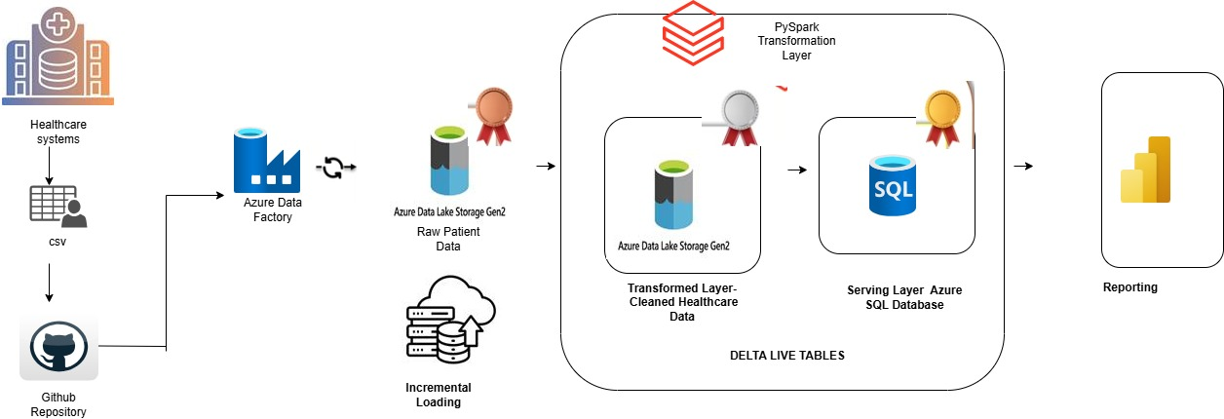

Step-1: Downloading the dataset from Kaggle:
https://www.kaggle.com/datasets/kanakbaghel/hospital-management-dataset?select=treatments.csv

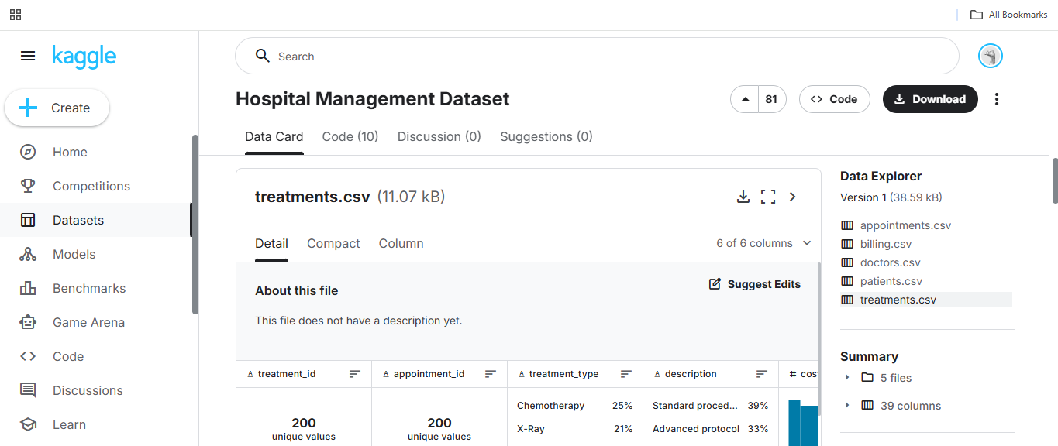
Now, create the repo in GitHub, and upload the files
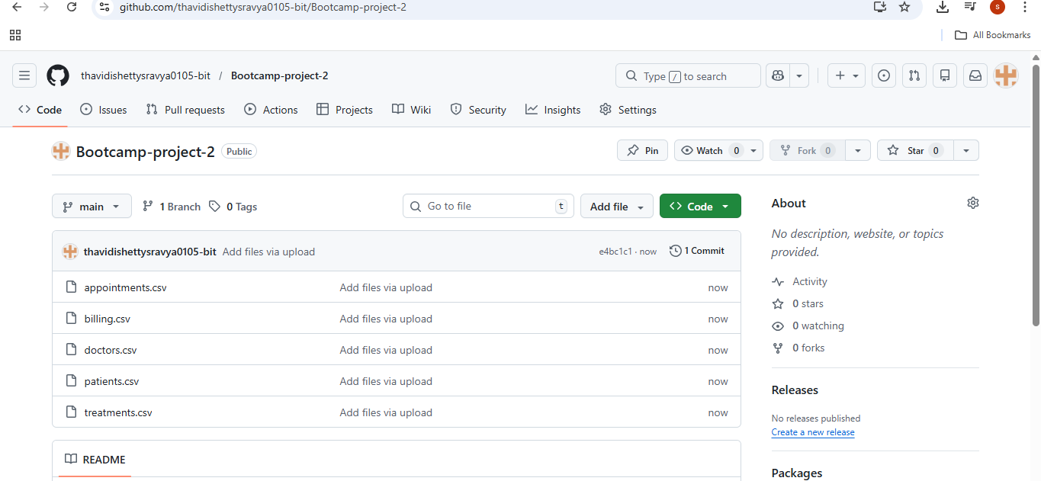
Step-1: Getting the data from GitHub
Dynamically getting data from GitHub
Creating the linked service for HTTP
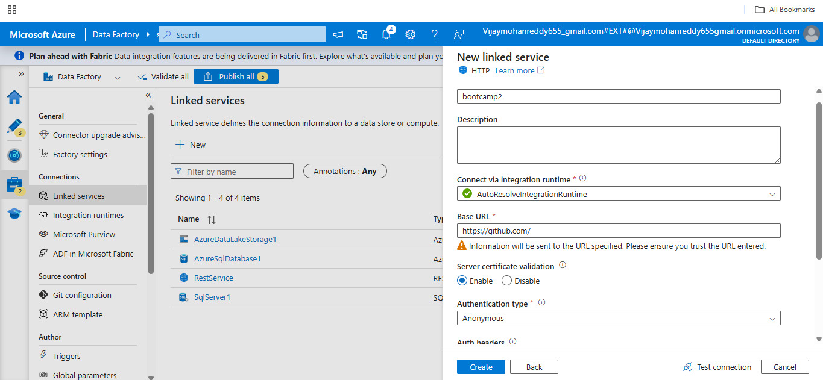
Linked service has been created
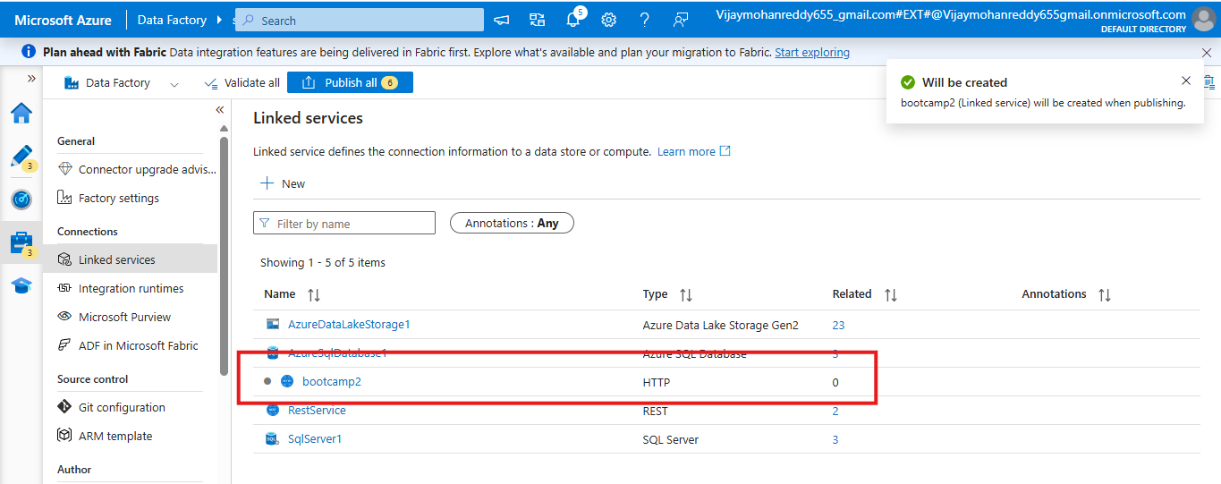

Create the pipeline and drag the copy activity
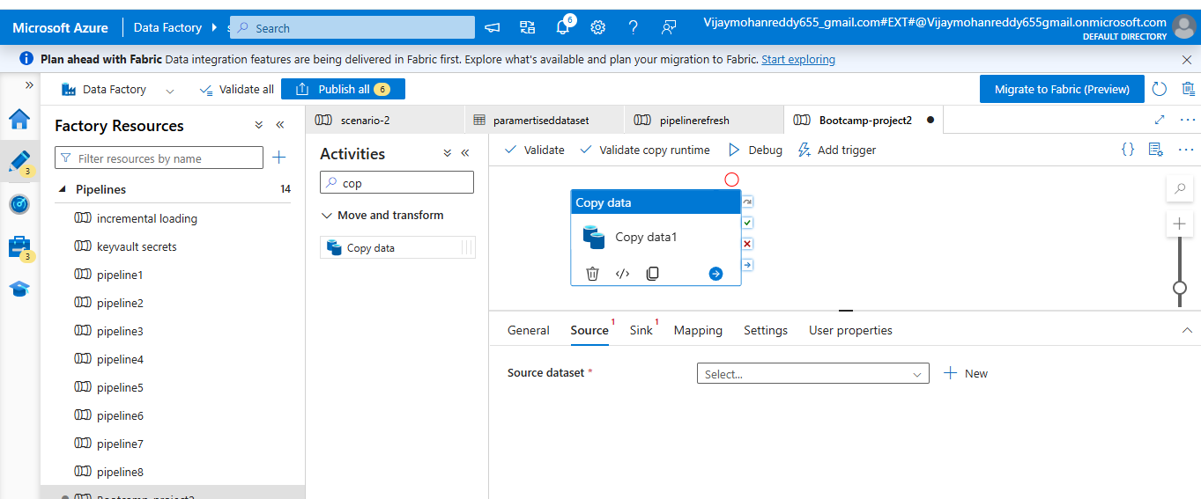
Create the dataset
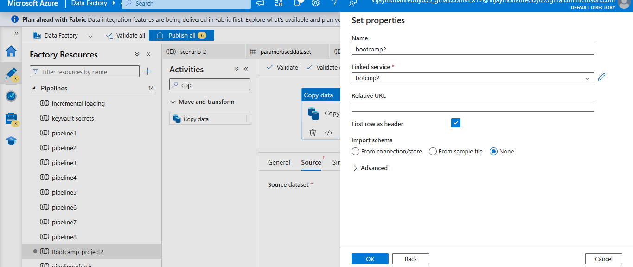
Create parameters for the dataset
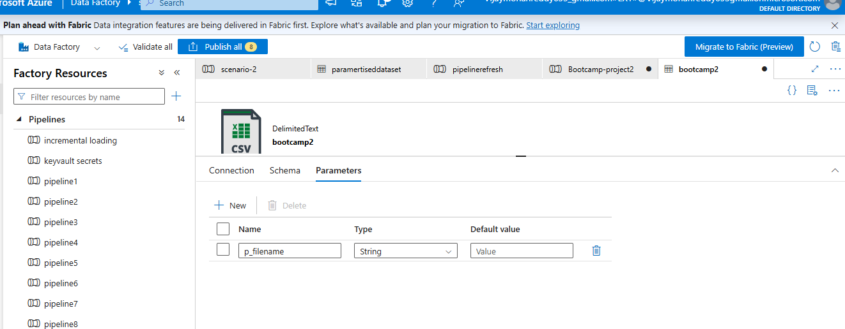

Create an expression like the one below
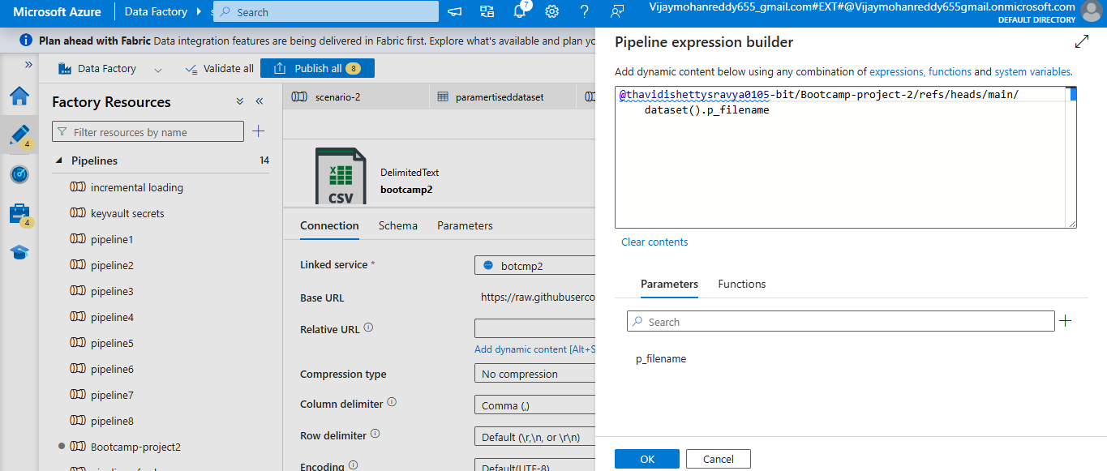
Need to use the expression below to treat it as a string
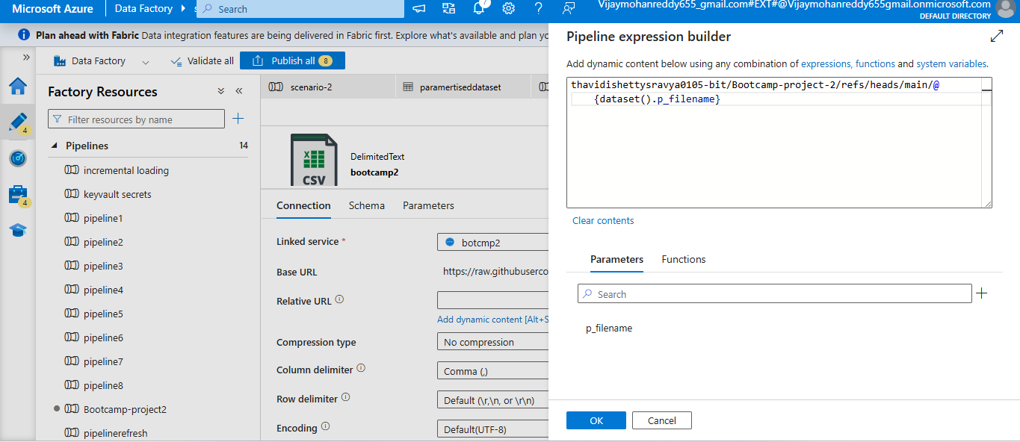
Creating the sink dataset
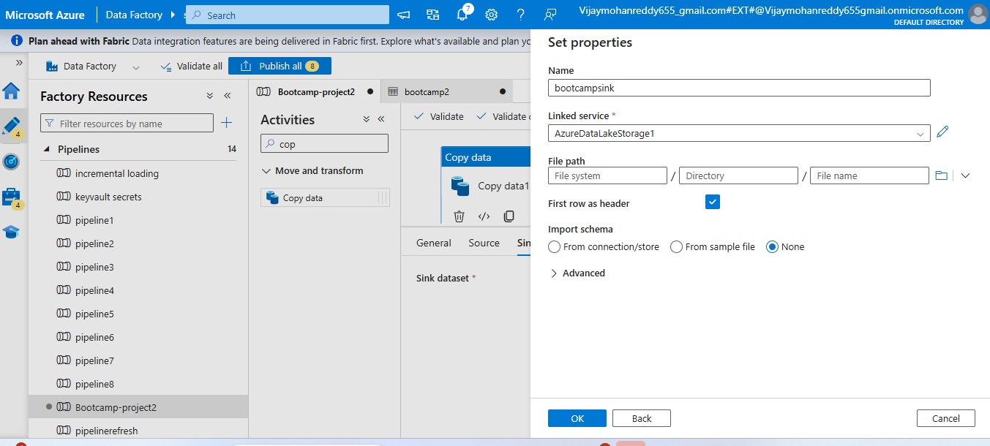
Creating the parameters
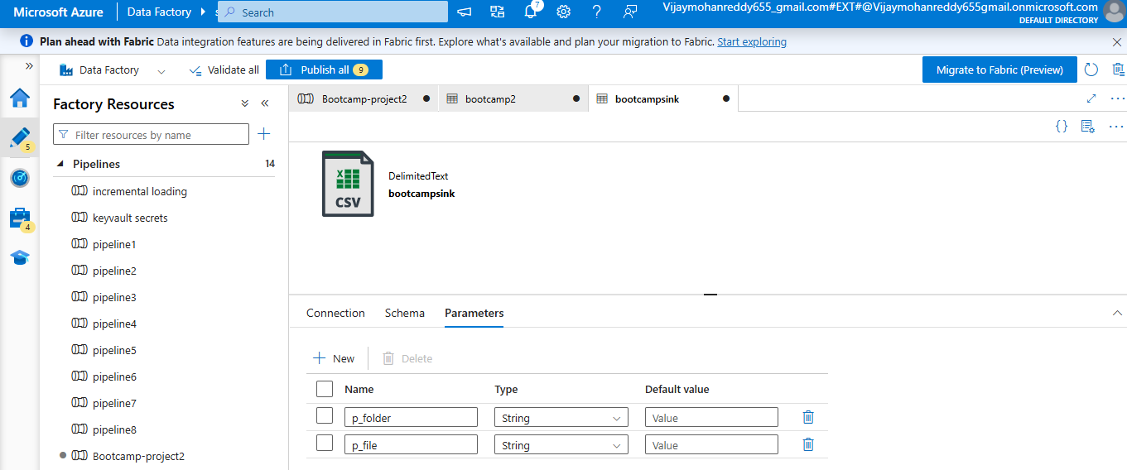
Now dragging for each activity
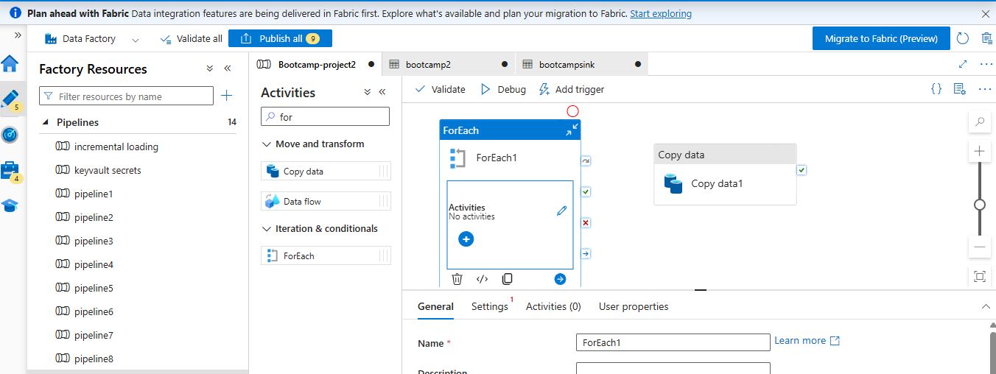
Create a array
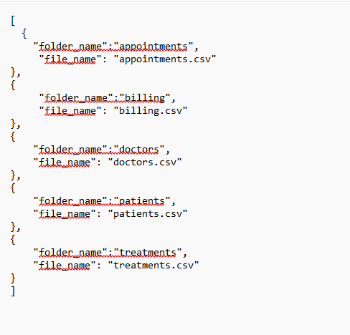
If u create array then no need to use json

Create the parameter and assign the array
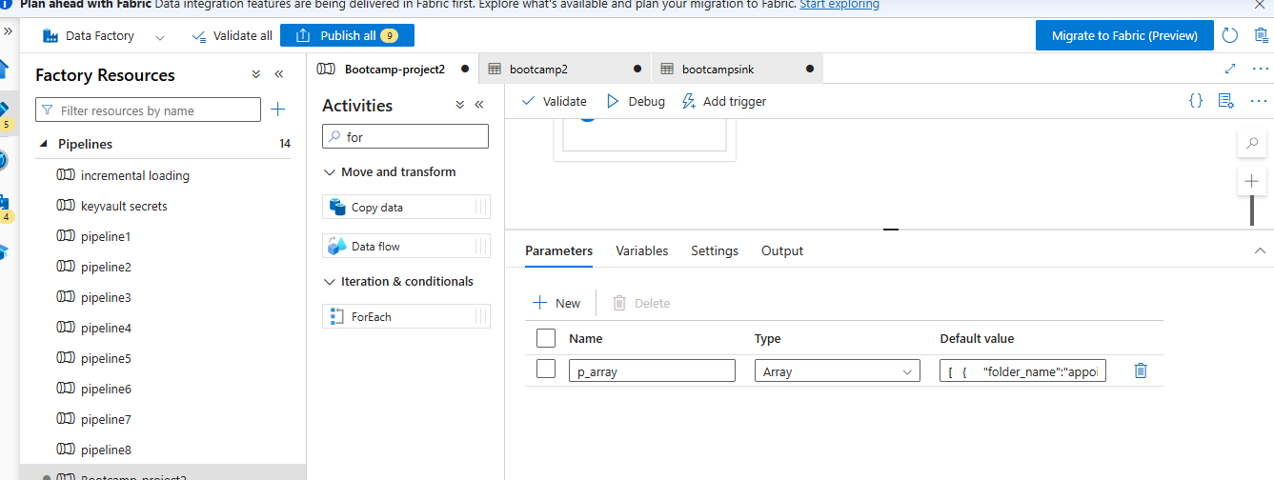
Assign the parameter to that
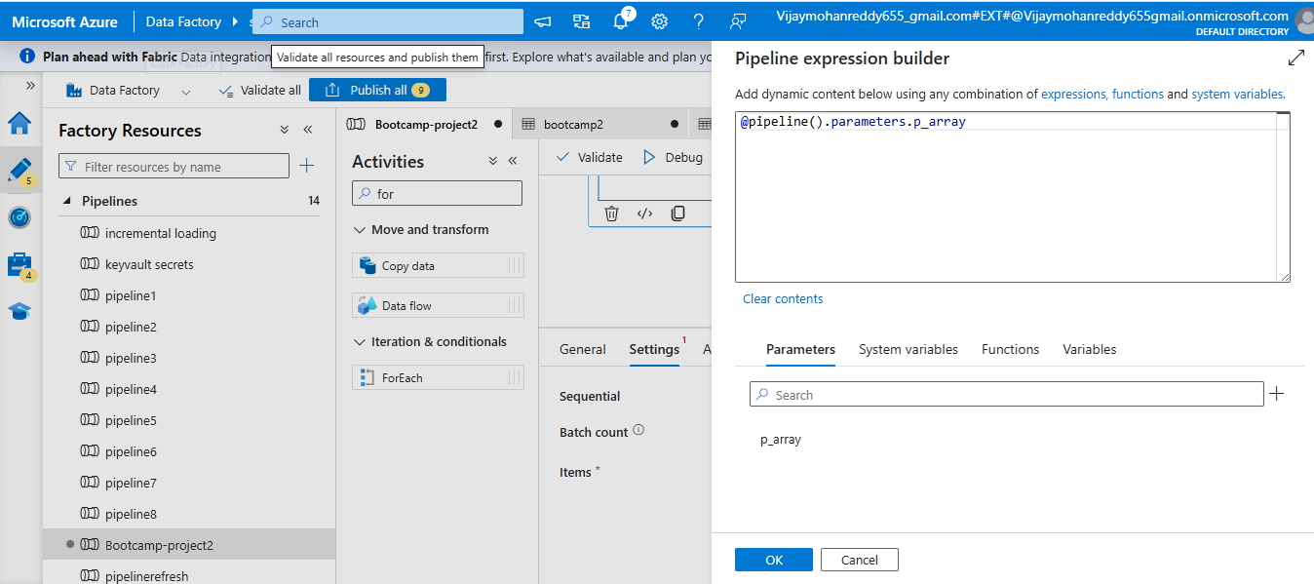
Assign the values like this
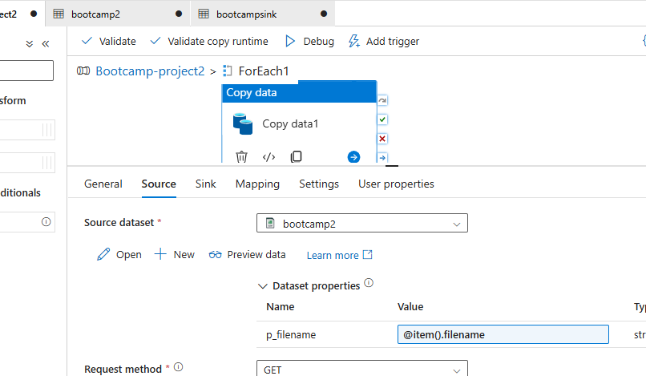
Assign the parameters in sink as well
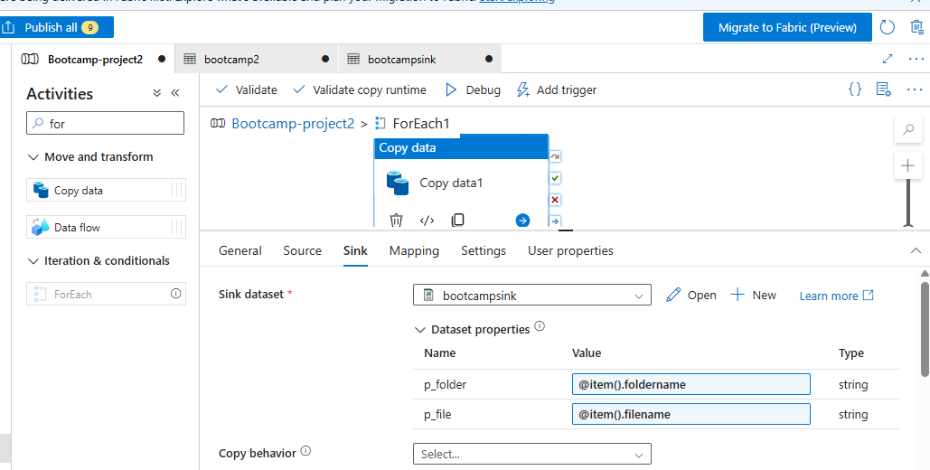
To make the pipeline dynamic, I will use the webactivity

