**ARKA HALDI**

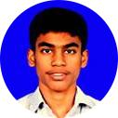

**An Aspiring Computer Engineer, at Sardar Patel Institute of Technology**

|  |  |  |  |  |
| --- | --- | --- | --- | --- |
| [ **arka.haldi@spit.ac.in** | Ó **9497327717** | | ½ **Mumbai, India** | ‡ **https://github.com/Arka-h** |
| ¯ **www.linkedin.com/in/arkahaldi** | | 7 **@Arkah68569353** | |

**MOTIVATION**

A Second Year S.E student with a good academic background with the ability to think through a problem, and come up with a good solution. I have worked with teams before, but only in a college level. I always try to participate in events, and contribute to the community of developers to solve the problems of today. To realise this, and to work together with a team, and come up with feasible solutions to the problems that NGOs face everyday, is my motivation for this application .

**AREAS OF INTEREST**

Software Development

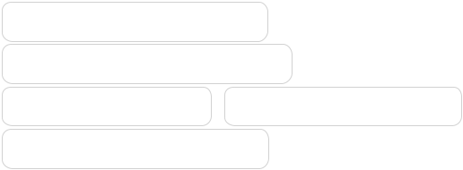

Application Development

Machine Learning Artificial Intelligence

BlockChain Technology

**PROJECTS**

K.B.C

**https://github.com/Arka-h/kbc**

Apr 2019

This Project was a mock-Kaun Banega Crorepati game (with graphics) fully written in C, and my first CS project.

Tools - C & Photoshop.

lref

**https://github.com/Arka-h/lref**

June 2019

This Project was a simple vacation project to edit a webpage from terminal commands !

Tools - Python Jinja2, click modules

**TECHNICAL SKILLS**

Problem Solving Competitive Coding Basics Of Data Structures Interest in UI/UX design

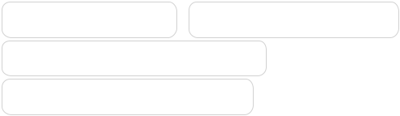

**PERSONAL SKILLS**

Self Starter Flexible&Adaptable Communication Motivator Team Worker

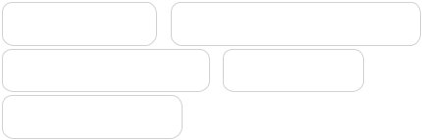

**LANGUAGES**

**C&C++** ○○○○○

**Python** ○○○○○

**Java** ○○○○○

NoteAble

**https://github.com/Arka-h/Noteable**

Oct 2019

This project was a team eﬀort to make an Android app for note making. Tools - Java, Android Studio, FireBase etc

**ACHIEVEMENTS**

* **IEEE Web Development Competition**

Got first position for web development competition, conducted at our college

**EDUCATION**

B.Tech in Computer Science and En-gineering

2016 – present½ Sardar Patel Institute of Tech

HSC (12th)

**91.6%**

2016 ½ PACE Junior College, Dadar

CBSE (10th)

**96.6%**

2014 ½ Navy Children School, Kochi

**CERTIFICATIONS**

**Harvardx: Introduction to Computer Sci-**

**ence** ○○○○

○