HOUSEBOAT MANAGEMENT SYSTEM

DONE BY

ER DIAGRAM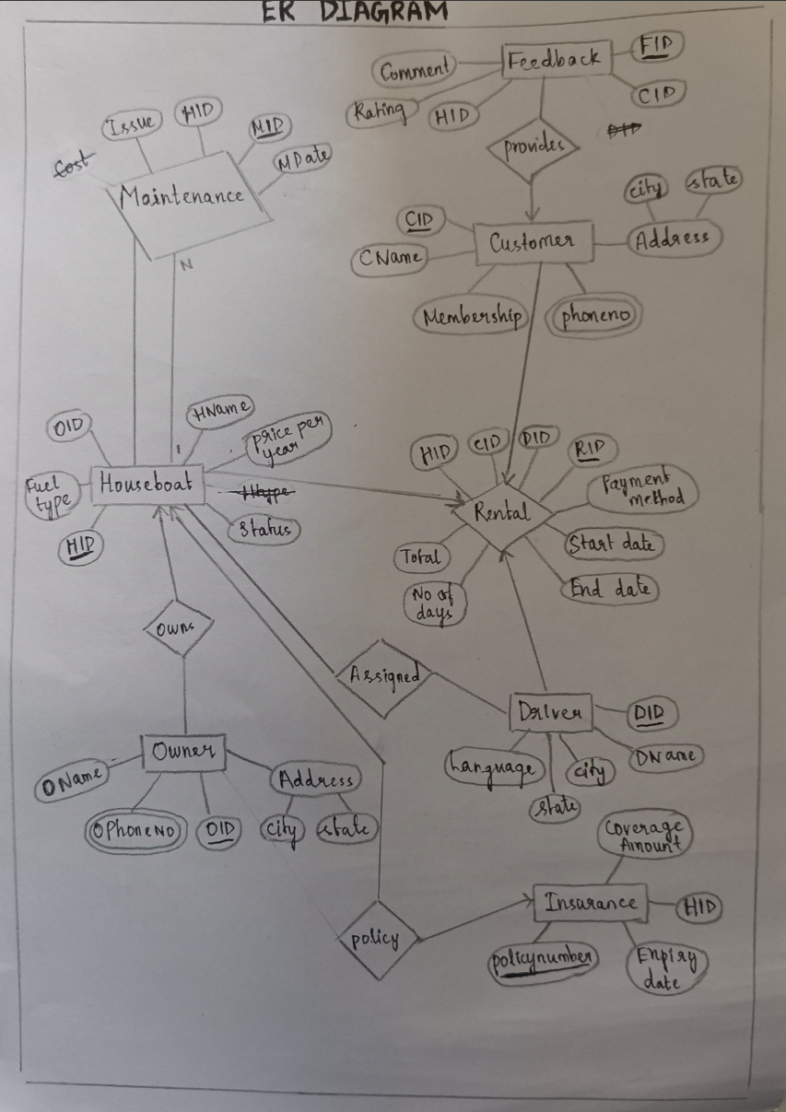

RELATIONAL SCHEMA

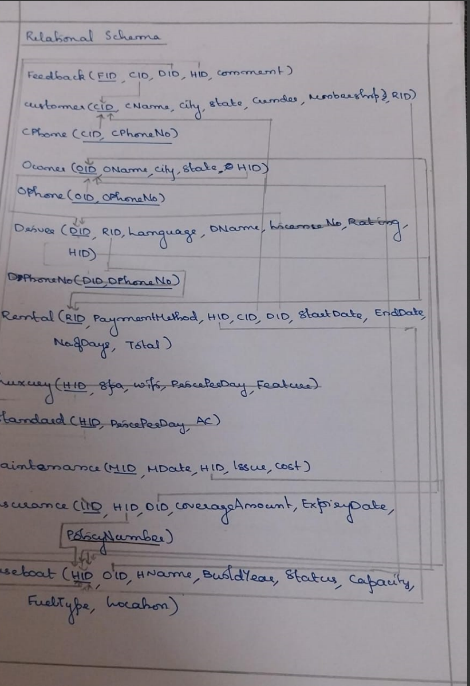

CARDINALITY

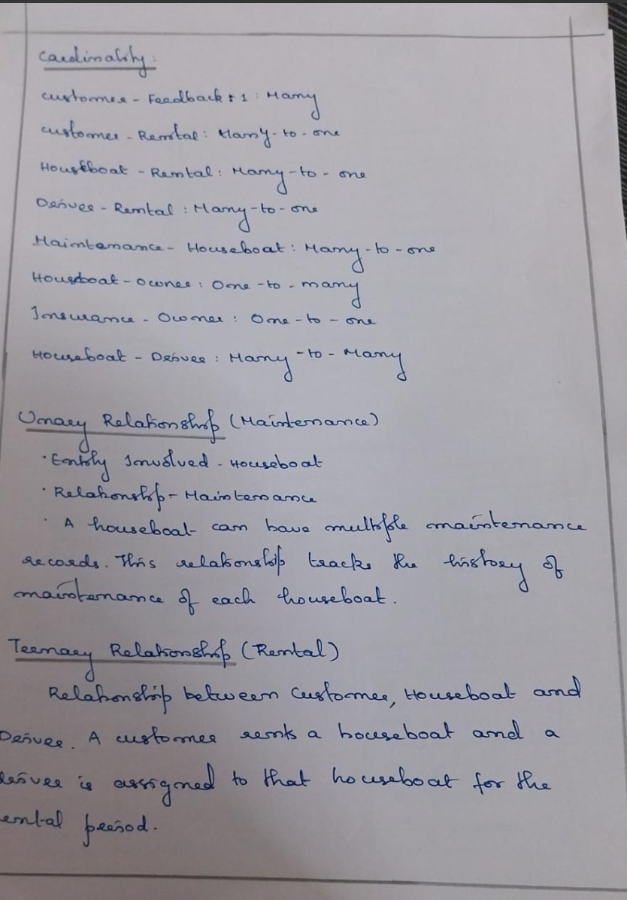

SCHEMA DIAGRAM

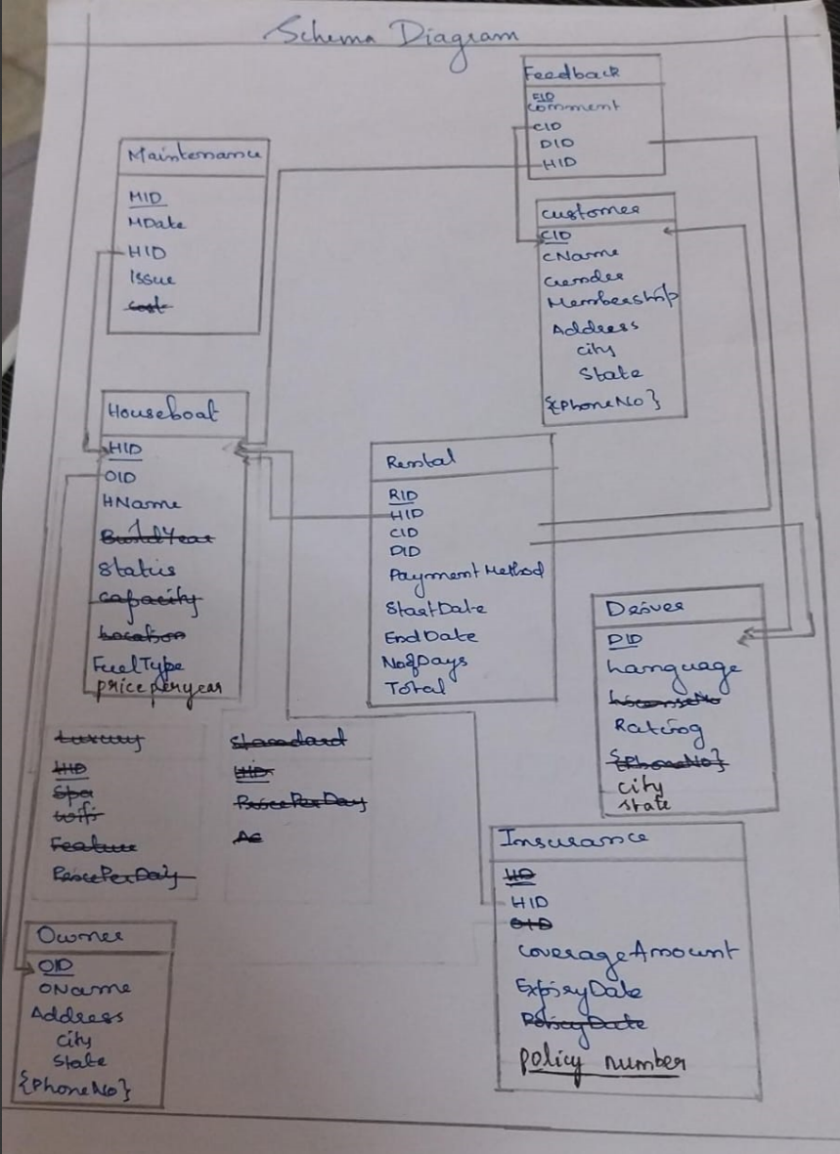

NORMALISATION

1NF

Customer

|  |  |  |  |  |
| --- | --- | --- | --- | --- |
| CID | CName | Membership | Ciy | State |
| 1 | Ajith Nair | Premium | Kochi | Kerala |
| 2 | Deepa Menon | Regular | Alappuzha | kerala |
| 3 | Suresh Kumar | Regular | Ernakulam | Kerala |
| 4 | Rekha Pillai | Premium | Kozhikode | Kerala |
| 5 | Maria Thoma | Regular | Thrissur | Kerala |

Customer Phone Number

|  |  |
| --- | --- |
| CID | CPhoneNO |
| 1 | 9301658742 |
| 2 | 9876543210 |
| 3 | 9876432110 |
| 4 | 9876543210 |
| 5 | 9123456789 |

Owner

|  |  |  |  |
| --- | --- | --- | --- |
| OID | OName | City | State |
| 1 | John Doe | Kozhikode | Kerala |
| 2 | Jane Smith | Alappuzha | Kerala |
| 3 | Mark Lee | Ernakulam | Kerala |
| 4 | Helen Nair | Kozhikode | Kerala |
| 5 | Sophia ROy | Alappuzha | Kerala |

Owner Phone Number

|  |  |
| --- | --- |
| OID | OphoneNo |
| 1 | 123456778 |
| 2 | 88999355 |
| 3 | 999999 |
| 4 | 4398948 |
| 5 | 3489456 |

Driver

|  |  |  |  |
| --- | --- | --- | --- |
| DID | DName | Language | Rating |
| 1 | Micheal Scott | English,Malayalam | 4.5 |
| 2 | John Smith | Hindi,English | 4.2 |
| 3 | Arun Raj | Malayalam | 4.7 |
| 4 | Rajeev Nair | Hindi,Malayalam | 4.9 |
| 5 | Vikram Singh | Tamil,English | 4.4 |

Feedback

|  |  |  |  |  |
| --- | --- | --- | --- | --- |
| FID | CID | DID | HID | Comment |
| 1 | 1 | 1 | 1 | good |
| 2 | 2 | 2 | 2 | Very good |
| 3 | 3 | 3 | 3 | Awsome |
| 4 | 4 | 4 | 4 | Very good |
| 5 | 5 | 5 | 5 | good |

Maintenance

|  |  |  |  |  |
| --- | --- | --- | --- | --- |
| MID | HID | Issue | Cost | MDate |
| 1 | 1 | Engine Service | 100 | 15-11-2023 |
| 2 | 2 | Electrical Issue | 250 | 10-12-2023 |
| 3 | 3 | Propeller Repaie | 500 | 08-12-2023 |
| 4 | 4 | Hull Repair | 400 | 05-12-2023 |
| 5 | 5 | Engine Repair | 300 | 03-12-2023 |

Houseboat

|  |  |  |  |  |  |  |
| --- | --- | --- | --- | --- | --- | --- |
| HID | HName | OID | Fuel Type | Status | Capacity | Build Year |
| 1 | Sea Breeze | 1 | Diesel | Available | 10 | 2015 |
| 2 | Ocean Pearl | 2 | Petrol | Rented | 8 | 2010 |
| 3 | Serene Waters | 3 | Diesel | Available | 12 | 2018 |
| 4 | Golden Horizon | 4 | Petrol | Available | 14 | 2015 |
| 2 | Ocean Pearl | 2 | Petrol | Rented | 8 | 2010 |

Rental

|  |  |  |  |  |  |  |  |
| --- | --- | --- | --- | --- | --- | --- | --- |
| RID | DID | CID | HID | StartDate | EndDate | No.ofDays | Total |
| 101 | 1 | 1 | 1 | 01-12-2023 | 05-12-2023 | 5 | 5000 |
| 102 | 2 | 2 | 2 | 05-12-2023 | 07-12-2023 | 2 | 6000 |
| 103 | 3 | 3 | 3 | 05-12-2023 | 08-12-2023 | 3 | 7000 |
| 104 | 4 | 4 | 4 | 06-12-2023 | 08-12-2023 | 2 | 10000 |
| 105 | 5 | 5 | 2 | 06-12-2023 | 08-12-2023 | 2 | 5500 |

Insurance

|  |  |  |  |  |
| --- | --- | --- | --- | --- |
| PolicyNo | Expiry Date | Coverage Amount | OID | HID |
| POL12345 | 01-12-2024 | 10000 | 1 | 1 |
| POL67890 | 15-12-2023 | 15000 | 2 | 2 |
| POL12346 | 01-06-2024 | 12000 | 3 | 3 |
| POL14445 | 01-12-2024 | 20000 | 4 | 4 |
| POL67890 | 15-12-2023 | 15000 | 2 | 2 |

Functional Dependencies

1.CID -> Cname,Membership,City,State

2.OID -> Oname,City,State

3.DID -> DName,Rating,Language

4.FID -> CID,DID,HID,comment

5.MID -> HID,Issue,Cost,Mdate

6. HID -> Hname,OID,FuelType,Status,Capacity,BuildYear

7.RID -> DID,CID,HID,StartDate,EndDate,No.ofDays,Total

8.PolicyNo -> ExpiryDate,CoverageAmount,OID,HID

2NF and 3NF

Same as 1NF

Why the Schema is the Same Across 1NF, 2NF, and 3NF?

Adherence to Normalization Principles

The schema is designed to minimize redundancy and ensure data integrity from the start. Each table:

Contains atomic values (1NF compliance).

Has attributes fully dependent on the primary key (2NF compliance).

Has no transitive dependencies (3NF compliance).

Since there are no partial or transitive dependencies in the original schema, the progression from 1NF to 3NF results in no changes to the structure of the tables.

Careful Design of Relationships

Tables like Customer, Owner, and Driver use single-column primary keys (CID, OID, DID), ensuring straightforward dependency management.

Composite attributes (e.g., in Feedback and Rental tables) are already decomposed into atomic values, ensuring normalization principles are respected at the initial stage.

The relationships between tables (e.g., foreign key references) are also structured to avoid redundancy or unnecessary dependencies.

Absence of Partial and Transitive Dependencies

All non-prime attributes are directly related to the table's primary key.

There are no attributes indirectly dependent on the primary key through other attributes, meaning transitive dependencies are inherently avoided.

Normalization in Real-World Applications

The schema reflects a real-world use case, where:

Data is logically grouped and inherently normalized.

There are clear distinctions between entity types, reducing the likelihood of anomalies (update, insert, or delete).

Reason for Keeping 1NF, 2NF, and 3NF the Same

Efficiency in Design

Designing a schema to directly conform to 3NF eliminates the need for further modifications during the normalization process. This approach:

Saves time and effort.

Reduces the risk of introducing errors during the decomposition process.

Scalability

A schema already in 3NF is more scalable and ready for integration with additional features, such as advanced querying or complex relationships, without requiring further structural changes.

Data Integrity and Accuracy

Starting with a 3NF-compliant design ensures:

No redundancy in data storage.

Accurate representation of relationships between entities.

Real-World Suitability

Many real-world database systems, like the one here, naturally comply with 3NF due to the logical and functional dependencies between attributes. Maintaining this structure reduces anomalies and improves overall database performance.

By carefully adhering to normalization principles from the beginning, the schema is inherently efficient, eliminating the need for additional steps to achieve 3NF while ensuring high data quality and performance.

QUERIES

1.HOUSEBOATS TABLE INSERTION



2.CUSTOMERS TABLE INSERTION



3.CUSTOMERS TABLE DELETION



4.CUSTOMERS TABLE UPDATION

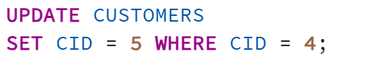

5.OWNER TABLE INSERTION

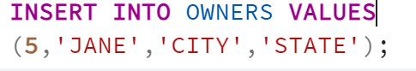

6.OWNERS TABLE UPDATION

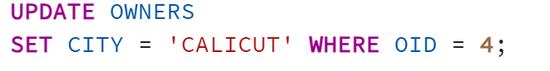  
7.OWNERS TABLE DELETION



8.DRIVERS TABLE INSERTION

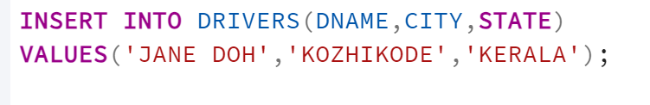

9.DRIVERS TABLE UPDATION

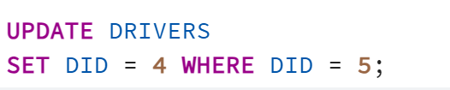

10.DRIVERS TABLE DELETION



11.RENTALS TABLE INSERTION

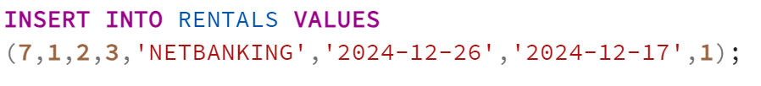

12.RENTALS TABLE DELETION



13.RENTALS TABLE RETREIVAL



14.RENTALS TABLE TOTAL REVENUE



15.FEEDBACK TABLE INSERTION

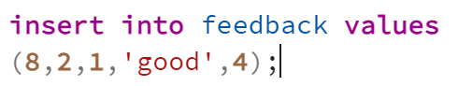

16.FEEDBACK TABLE RETREIVAL



17.CALCULATE AVERAGE RATING



18.FEEDBACK TABLE UPDATE COMMENT



19.INSURANCE TABLE INSERTION

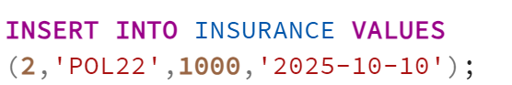

20. INSURANCE TABLE RETREIVAL

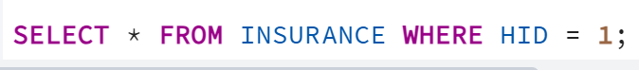

21.INSURANCE TABLE UPDATE COVERAGE AMOUNT



22.MAINTENANCE TABLE INSERTION

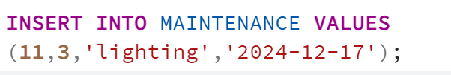

23.MAINTENANCE TABLE RETREIVAL BASED ON HID(DESCENDING)

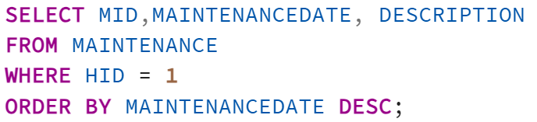

24.MAINTENANCE TABLE DELETION

