Docker

Docker image

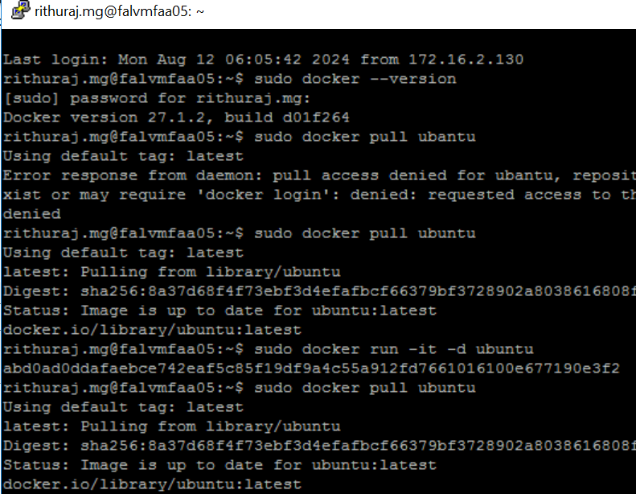

Running docker

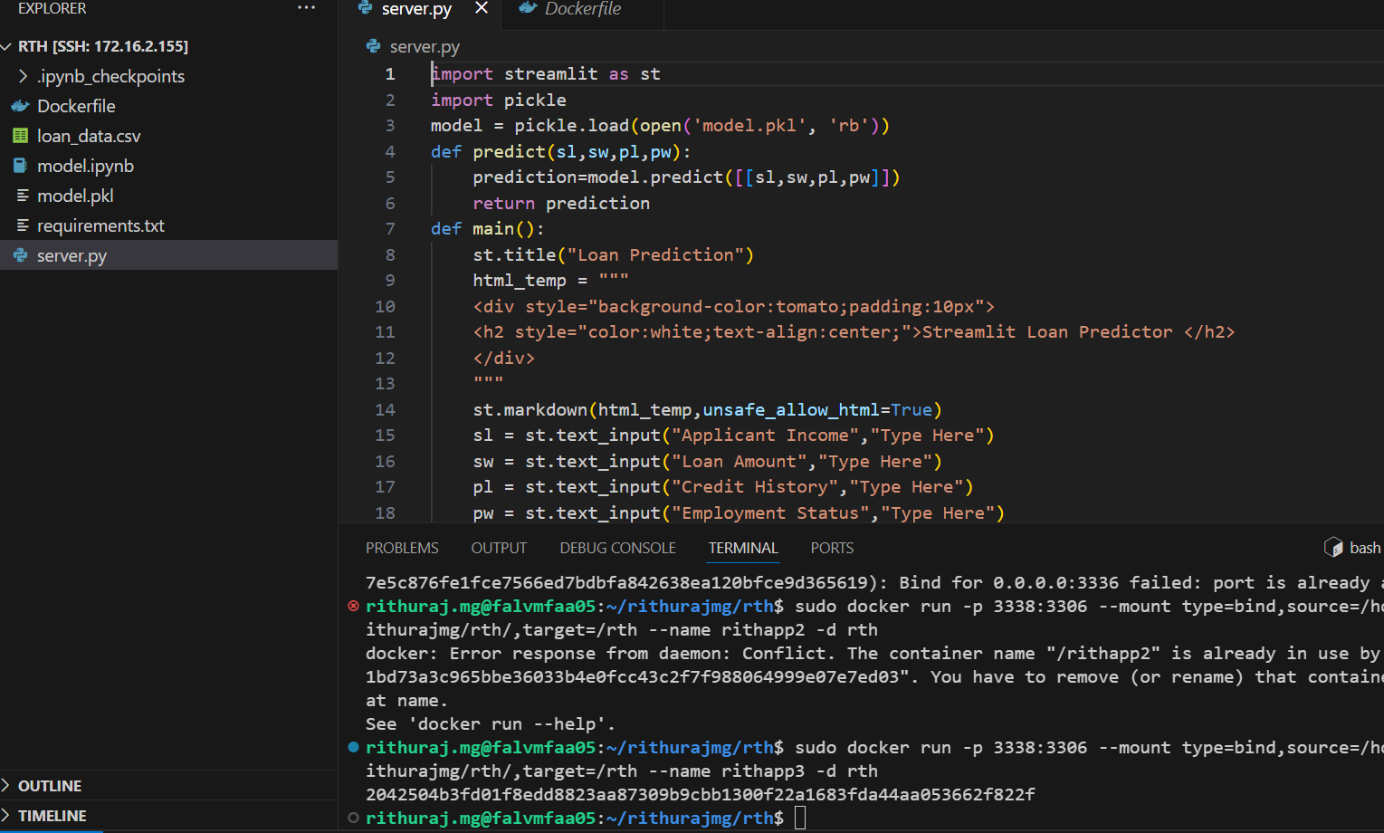Running URL

Jupyter note book

