**SkillMatch Resume Matcher and Skill Recommender**

*Milestone-1 ~Rithvik Goud Mushkam*

**Machine Learning**

Machine Learning (ML) is a branch of Artificial Intelligence (AI) that enables computers to learn from data and improve their performance on tasks without being explicitly programmed. In traditional programming, humans write rules for the computer to follow. In contrast, ML systems learn patterns and relationships directly from data, allowing them to make predictions, classifications, or decisions autonomously.

**How It Works**

The general workflow of a machine learning system involves:

1. **Data Collection** – Gathering relevant data from sensors, files, databases, or user interactions.
2. **Data Preprocessing** – Cleaning, normalizing, and converting data into a usable format.
3. **Model Selection** – Choosing an appropriate algorithm (e.g., decision tree, neural network).
4. **Training** – Feeding data to the model so it learns underlying patterns.
5. **Testing & Evaluation** – Measuring the model’s performance on unseen data.
6. **Deployment & Maintenance** – Integrating the model into real-world applications and updating it as new data becomes available.

**Applications of Machine Learning**

Machine Learning has revolutionized several industries, including:

* **Healthcare:** Disease prediction, drug discovery, medical imaging.
* **Finance:** Fraud detection, algorithmic trading, credit scoring.
* **Marketing:** Customer behavior prediction, recommendation systems.
* **Transportation:** Traffic prediction, autonomous vehicles.
* **Education:** Personalized learning systems, plagiarism detection.
* **Cybersecurity:** Intrusion detection, malware classification.

**NumPy**

Used numpy for numerical operations like array creation (np.array()), reshaping into stack (horizontal and column), and mathematical functions.

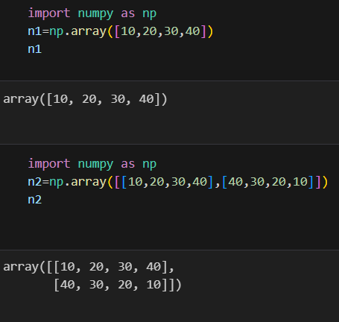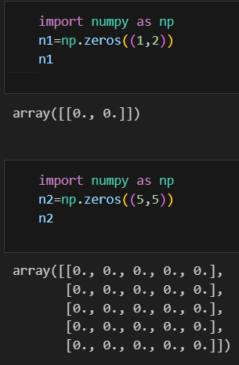

**Pandas**

Uses pandas for data manipulation and analysis through DataFrame and Series.

Functions like pd.read_csv(), df.head(), and df.describe() are used for reading, viewing, and summarizing data.

**IRIS Dataset**

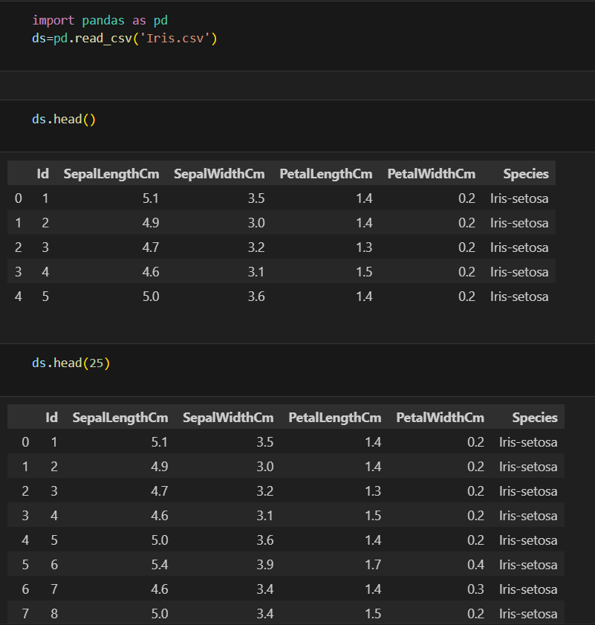

**Matplot and Seaborn**

Uses matplotlib.pyplot for visualizing data through plots (plt.plot(), plt.bar(), plt.scatter()).

Parameters like color, label, linewidth, and marker define chart appearance.

