PROBLEM SOLVING AND TESTING

NAME: L.RITHVIKA REDDY

VTU NO:29439

COURSE CODE:10211CS227

WEEK 1 PROBLEMS
SESSION 1
1.1-Java Lambda Expressions - https://www.hackerrank.com/challenges/java-lambda-expressions/problem
CODE:
import java.io.*;
import java.util.*;
interface PerformOperation {
boolean check(int a);
}
class MyMath {
public static boolean checker(PerformOperation p, int num) {
return p.check(num);
}
public PerformOperation isOdd() {
return num -> num % 2 != 0;
}

public PerformOperation isPrime() {
return num -> {
if (num <= 1) return false;
for (int i = 2; i * i <= num; i++) {
if (num % i == 0) return false;
}
return true;
};
}

public PerformOperation isPalindrome() {
return num -> {
String original = String.valueOf(num);
String reversed = new StringBuilder(original).reverse().toString();
return original.equals(reversed);
};
}
}
public class Solution {

public static void main(String[] args) throws IOException {
MyMath ob = new MyMath();
BufferedReader br = new BufferedReader(new InputStreamReader(System.in));
int T = Integer.parseInt(br.readLine());
PerformOperation op;
boolean ret = false;
String ans = null;
while (T--> 0) {
String s = br.readLine().trim();
StringTokenizer st = new StringTokenizer(s);
int ch = Integer.parseInt(st.nextToken());
int num = Integer.parseInt(st.nextToken());
if (ch == 1) {
op = ob.isOdd();
ret = ob.checker(op, num);
ans = (ret) ? "ODD" : "EVEN";
} else if (ch == 2) {
op = ob.isPrime();
ret = ob.checker(op, num);
ans = (ret) ? "PRIME" : "COMPOSITE";
} else if (ch == 3) {
op = ob.isPalindrome();
ret = ob.checker(op, num);
ans = (ret) ? "PALINDROME" : "NOT PALINDROME";

}
System.out.println(ans);
}
}
}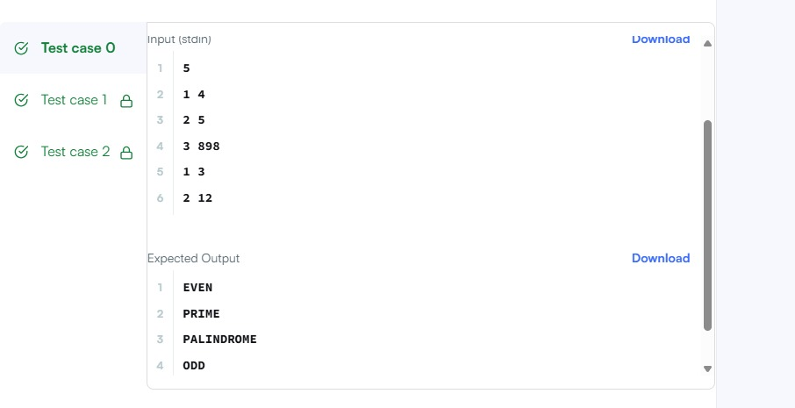SESSION 2
2.1 - Java Sort – https://www.hackerrank.com/challenges/java-sort/problem
CODE:
import java.util.ArrayList;
import java.util.Comparator;
import java.util.List;
import java.util.Scanner;

class Student {
private int id;
private String fname;
private double cgpa;

public Student(int id, String fname, double cgpa) {
this.id = id;
this.fname = fname;
this.cgpa = cgpa;
}

public int getId() {
return id;
}

public String getFname() {
return fname;
}

public double getCgpa() {
return cgpa;
}
}

public class Solution {
public static void main(String[] args) {
Scanner in = new Scanner(System.in);
int testCases = Integer.parseInt(in.nextLine());

List<Student> studentList = new ArrayList<Student>();

while (testCases > 0) {
int id = in.nextInt();
String fname = in.next();
double cgpa = in.nextDouble();

Student st = new Student(id, fname, cgpa);
studentList.add(st);

testCases--;
}

// Sorting using Java 8 Comparator methods
studentList.sort(
Comparator.comparing(Student::getCgpa).reversed()
.thenComparing(Student::getFname)
.thenComparing(Student::getId)
);

// Printing the sorted student first names
for (Student st : studentList) {
System.out.println(st.getFname());
}

in.close();
}
}
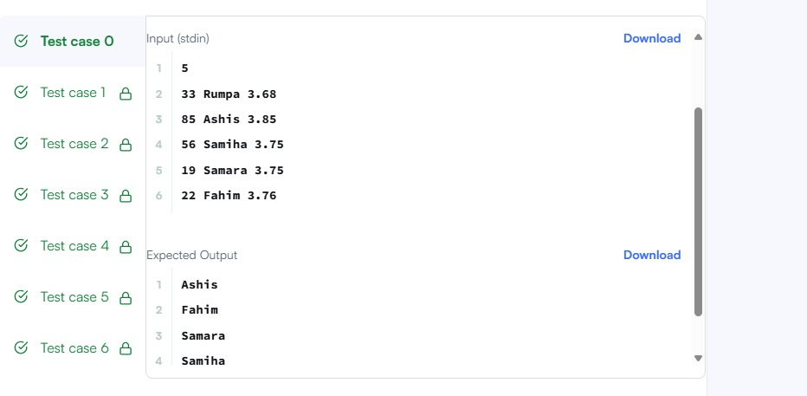
2.2-. Sort Array By Parity https://leetcode.com/problems/sort-array-by-parity/
CODE:
import java.io.*;
import java.util.*;
interface PerformOperation {
boolean check(int a);
}
class MyMath {
public static boolean checker(PerformOperation p, int num) {
return p.check(num);
}
public PerformOperation isOdd() {
return num -> num % 2 != 0;
}

public PerformOperation isPrime() {
return num -> {
if (num <= 1) return false;
for (int i = 2; i * i <= num; i++) {
if (num % i == 0) return false;
}
return true;
};
}

public PerformOperation isPalindrome() {
return num -> {
String original = String.valueOf(num);
String reversed = new StringBuilder(original).reverse().toString();
return original.equals(reversed);
};
}
}
public class Solution {

public static void main(String[] args) throws IOException {
MyMath ob = new MyMath();
BufferedReader br = new BufferedReader(new InputStreamReader(System.in));
int T = Integer.parseInt(br.readLine());
PerformOperation op;
boolean ret = false;
String ans = null;
while (T--> 0) {
String s = br.readLine().trim();
StringTokenizer st = new StringTokenizer(s);
int ch = Integer.parseInt(st.nextToken());
int num = Integer.parseInt(st.nextToken());
if (ch == 1) {
op = ob.isOdd();
ret = ob.checker(op, num);
ans = (ret) ? "ODD" : "EVEN";
} else if (ch == 2) {
op = ob.isPrime();
ret = ob.checker(op, num);
ans = (ret) ? "PRIME" : "COMPOSITE";
} else if (ch == 3) {
op = ob.isPalindrome();
ret = ob.checker(op, num);
ans = (ret) ? "PALINDROME" : "NOT PALINDROME";

}
System.out.println(ans);
}
}
}
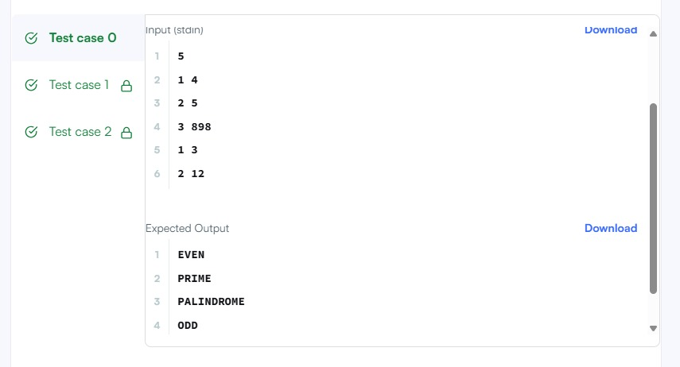
SESSION 3
3.1-. Sorting: Comparator – https://www.hackerrank.com/challenges/ctci-comparator-sorting/problem
CODE:
import java.util.*;

class Player {
String name;
int score;

Player(String name, int score) {
this.name = name;
this.score = score;
}
}
class Checker implements Comparator<Player> {
@Override
public int compare(Player a, Player b) {
if (a.score != b.score) {
// Sort descending by score
return Integer.compare(b.score, a.score);
}
// If scores are equal, sort ascending by name alphabetically
return a.name.compareTo(b.name);
}
}

public class Solution {

public static void main(String[] args) {
Scanner scan = new Scanner(System.in);
int n = scan.nextInt();

Player[] player = new Player[n];
Checker checker = new Checker();

for(int i = 0; i < n; i++){
player[i] = new Player(scan.next(), scan.nextInt());
}
scan.close();

Arrays.sort(player, checker);
for(int i = 0; i < player.length; i++){
System.out.printf("%s %s\n", player[i].name, player[i].score);
}
}
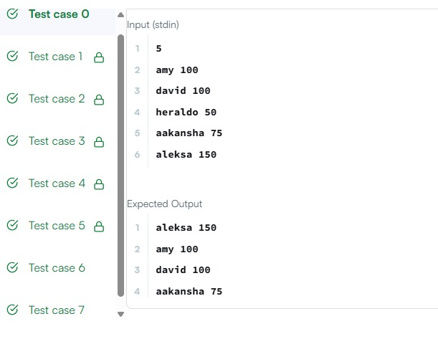

3.2-.Java Comparator – https://www.hackerrank.com/challenges/java-comparator/problem
CODE:
import java.util.*;
class Checker implements Comparator<Player> {
@Override
public int compare(Player a, Player b) {
// Primary sort: decreasing score
if (a.score != b.score) {
return b.score - a.score;
}

// Secondary sort: alphabetical order by name
return a.name.compareTo(b.name);
}
}
class Player{
String name;
int score;

Player(String name, int score){
this.name = name;
this.score = score;
}
}

class Solution {

public static void main(String[] args) {
Scanner scan = new Scanner(System.in);
int n = scan.nextInt();

Player[] player = new Player[n];
Checker checker = new Checker();

for(int i = 0; i < n; i++){
player[i] = new Player(scan.next(), scan.nextInt());
}
scan.close();

Arrays.sort(player, checker);
for(int i = 0; i < player.length; i++){
System.out.printf("%s %s\n", player[i].name, player[i].score);
}
}
}
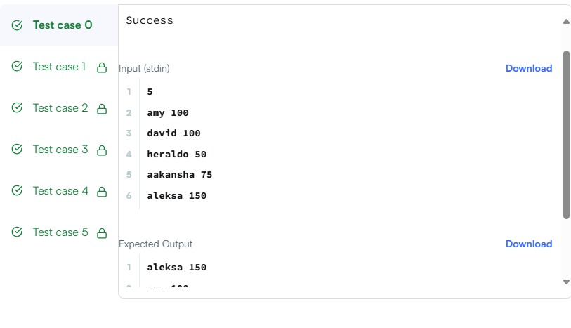
SESSION 4
4.1- Running Sum of 1D Array – https://leetcode.com/problems/running-sum-of-1d-array/
CODE:
public class Solution {
public int[] runningSum(int[] nums) {
for (int i = 1; i < nums.length; i++) {
nums[i] += nums[i - 1];
}
return nums;
}
}
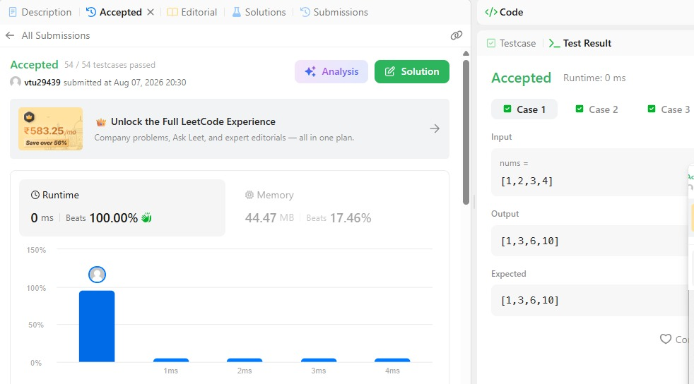

4.2- Richest Customer Wealth – https://leetcode.com/problems/richest-customer-wealth/
CODE:
class Solution {
public int maximumWealth(int[][] accounts) {
int maxWealth = 0;

// Iterate through each customer (row)
for (int[] customer : accounts) {
int currentWealth = 0;

// Sum the money across all banks (columns) for this customer
for (int bank : customer) {
currentWealth += bank;
}

// Update maxWealth if the current customer is richer
maxWealth = Math.max(maxWealth, currentWealth);
}

return maxWealth;
}
}
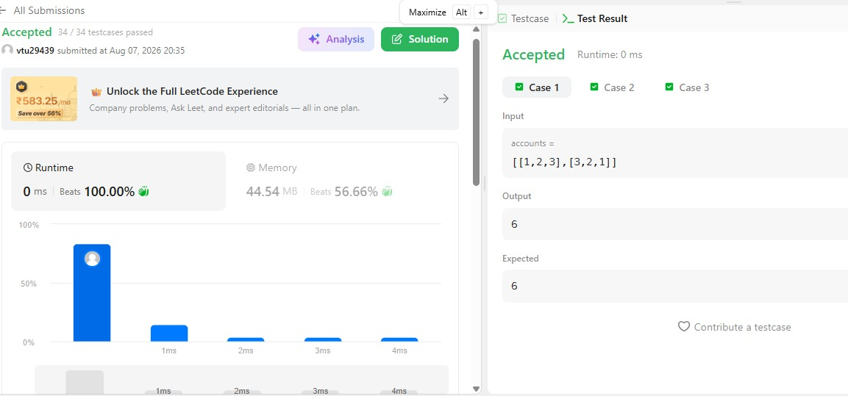
SESSION 5
5.1-Squares of a Sorted Array – https://leetcode.com/problems/squares-of-a-sorted-array/
CODE:
class Solution {
public int[] sortedSquares(int[] nums) {
int n = nums.length;
int[] result = new int[n];

int left = 0;
int right = n - 1;
int index = n - 1; // Start filling from the largest value (end of array)

while (left <= right) {
int leftSquare = nums[left] * nums[left];
int rightSquare = nums[right] * nums[right];

if (leftSquare > rightSquare) {
result[index] = leftSquare;
left++;
} else {
result[index] = rightSquare;
right--;
}
index--;
}

return result;
}
}
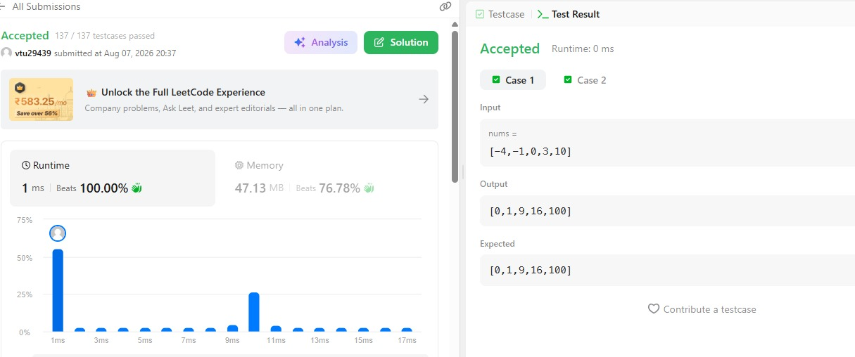

5.2-Find Pivot Index – https://leetcode.com/problems/find-pivot-index/
CODE:
class Solution {
public int pivotIndex(int[] nums) {
int totalSum = 0;
for (int num : nums) {
totalSum += num;
}

int leftSum = 0;
for (int i = 0; i < nums.length; i++) {
// rightSum = totalSum - leftSum - nums[i]
if (leftSum == totalSum - leftSum - nums[i]) {
return i;
}
leftSum += nums[i];
}

return -1;
}
}
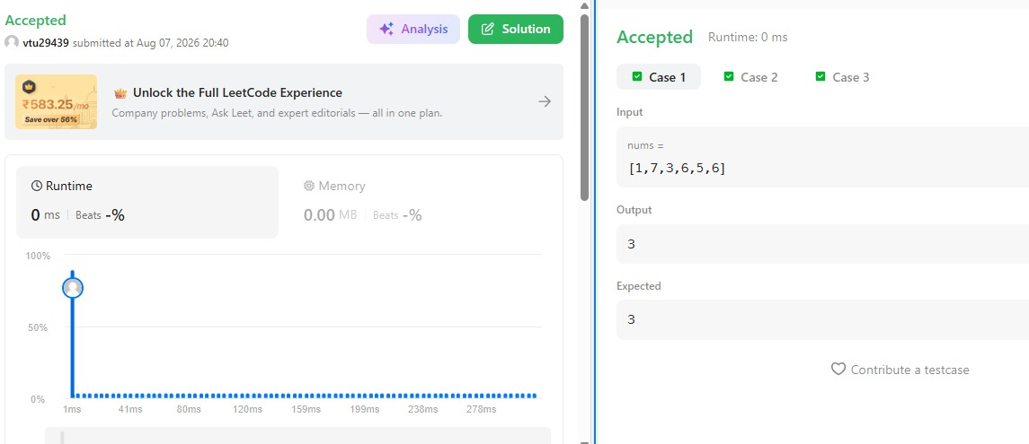

THANK YOU

