PERSONAL BANK LEDGER
AND STATEMENT GENERATOR
Project Abstract • Smart records. Clear insights. Better financial control.
TRACK  Every transaction | ANALYZE  Spending patterns | GENERATE  Professional statements

Abstract
The Personal Bank Ledger and Statement Generator is a practical digital solution designed to transform everyday financial record-keeping into a simple, organized, and insightful experience. It enables users to capture income and expenditure details—including transaction date, description, category, payment mode, debit, credit, and balance—in a centralized ledger. By automatically calculating running balances and organizing transaction history, the system helps users maintain accurate and up-to-date financial records.
Beyond basic data entry, the application converts raw transactions into meaningful financial insights. Users can search, filter, edit, and review records by date range, category, or transaction type. Summary views and visual charts highlight spending patterns, helping users understand where their money goes and make more informed budgeting decisions. The system can also generate professional statements for selected periods and export them in formats such as PDF or CSV.
The proposed solution reduces manual effort, minimizes calculation errors, and improves financial transparency while following essential practices such as input validation, authentication, and secure handling of personal data. With a user-friendly interface and reporting-focused design, the Personal Bank Ledger and Statement Generator serves as a reliable personal finance companion for tracking transactions, monitoring balances, and planning future spending.
Illustrative dashboard view
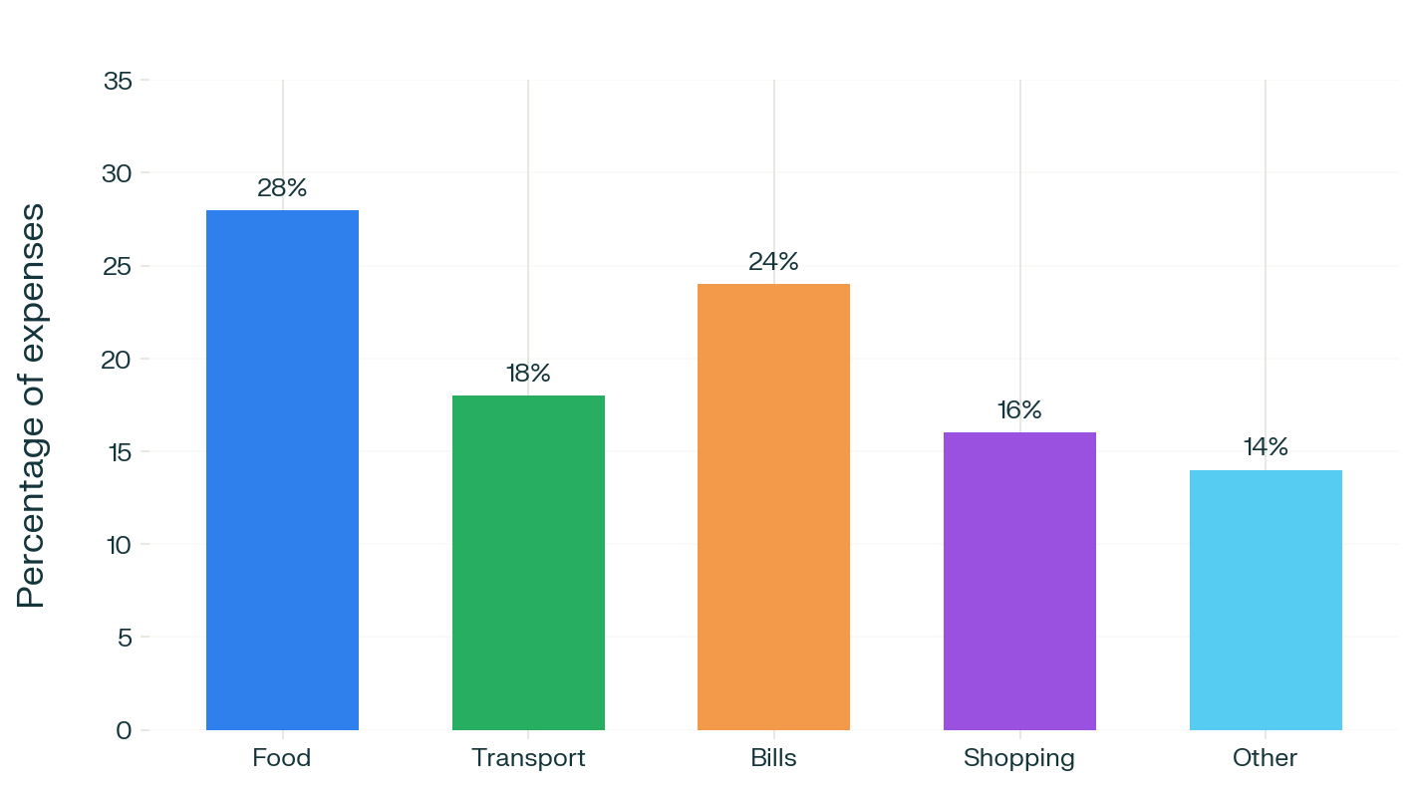
Figure 1. Example of a visual expense summary generated from ledger data.
Core capabilities
Capability | Value to the user
Transaction ledger | Stores income, expenses, categories, notes, and running balances.
Smart search and filters | Finds records quickly by date, type, category, or amount.
Visual analytics | Presents spending trends through charts and summaries.
Statement generation | Creates readable statements for selected periods.
Export and security | Supports reporting formats and protects sensitive financial data.
A clean ledger today creates confident financial decisions tomorrow.

