PRODUCT REQUIREMENTS DOCUMENT
CUSTOM RESUME GENERATOR
A web-based platform for creating professional, customizable resumes
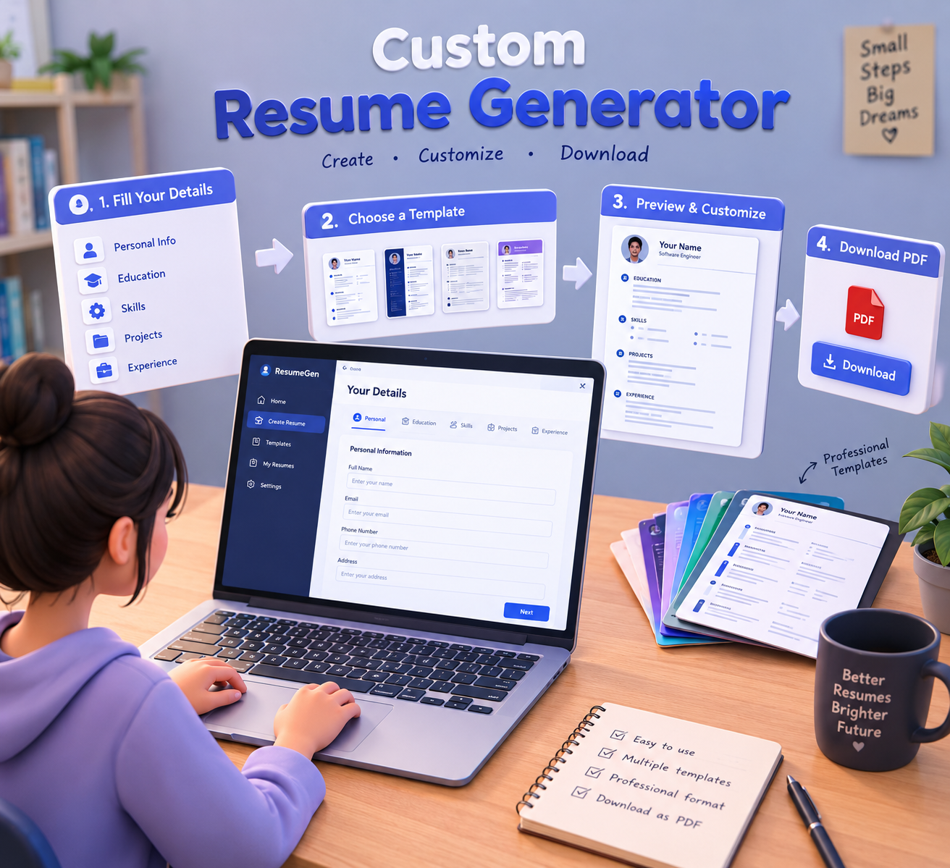
3D concept visualization — Custom Resume Generator
Project Documentation | Version 1.0

1. Project Overview
Custom Resume Generator is a web-based application that helps students, fresh graduates, and job seekers create professional resumes without manually designing a document. The user enters structured information, selects a template, previews the resume, customizes supported sections, and generates a final PDF.

2. Problem Statement
Many users spend significant time manually formatting resumes and may find it difficult to maintain a consistent professional layout. Creating different versions for internships, placements, and job applications can also require repeated editing. This project aims to simplify resume creation through guided data entry and reusable templates.

3. Project Objectives
- Provide a simple interface for entering resume information.
- Offer multiple professional resume templates.
- Allow users to customize and edit resume sections.
- Provide a clear resume preview before final export.
- Generate a downloadable PDF resume.
- Reduce the time and effort required for manual resume formatting.

4. Target Users
- College students applying for internships and placements.
- Fresh graduates preparing entry-level job applications.
- Job seekers who need professionally formatted resumes.
- Users who want to maintain more than one version of a resume.

5. Key Features
Feature | Description
Personal Information | Name, email, phone number, address, LinkedIn and GitHub links.
Education | Add degree, institution, branch, academic year and CGPA/percentage.
Skills | Add technical skills and soft skills.
Projects | Add project title, description, technologies and links.
Experience | Add internships, work experience, role and responsibilities.
Certifications | Add certificates, issuing organization, date and credential link.
Templates | Select from multiple professional resume designs.
Preview | View the formatted resume before downloading.
PDF Export | Generate and download the final resume as a PDF.

6. User Workflow
- Open the Custom Resume Generator.
- Create a new resume.
- Enter personal and contact details.
- Add education, skills, projects, certifications and experience.
- Choose a resume template.
- Preview the generated resume.
- Make required changes or corrections.
- Generate the final PDF.
- Download the completed resume.

7. Functional Requirements
ID | Requirement | Description
FR-01 | User Data Entry | The system shall allow users to enter and edit resume information.
FR-02 | Education | The system shall support one or more education records.
FR-03 | Skills | The system shall allow users to add and remove skills.
FR-04 | Projects | The system shall allow users to add project details.
FR-05 | Experience | The system shall support internship/work experience entries.
FR-06 | Templates | The system shall provide multiple resume templates.
FR-07 | Preview | The system shall display a formatted resume preview.
FR-08 | PDF Export | The system shall generate a downloadable PDF.
FR-09 | Editing | The system shall allow users to modify entered information before export.

8. Non-Functional Requirements
- Usability: The application should be easy to understand for first-time users.
- Performance: Preview and PDF generation should respond quickly under normal usage.
- Reliability: Resume information should be preserved during normal editing.
- Security: Personal information should be protected from unauthorized access.
- Responsiveness: The interface should work on common desktop and mobile screen sizes.
- Maintainability: New templates and resume sections should be easy to add.

9. System Modules
1. User Interface Module — Provides forms, navigation, buttons and visual controls.
2. Resume Data Module — Collects and validates personal, academic and professional information.
3. Template Module — Manages available resume templates and their layouts.
4. Resume Builder Module — Combines user data with the selected template.
5. Preview Module — Displays the generated resume before export.
6. PDF Generator Module — Converts the final resume into a downloadable PDF.
7. Storage Module — Stores resume data when save functionality is implemented.

10. Suggested Technology Stack
Layer | Technology | Purpose
Frontend | HTML, CSS, JavaScript / React | User interface and resume preview
Backend | Python Flask / Node.js | Application logic and APIs
Database | SQLite / MySQL | Resume and user data storage
PDF Generation | ReportLab / jsPDF / HTML-to-PDF | Final PDF creation
Development Tools | VS Code, Git | Development and version control

11. Proposed Data Structure
- User: user_id, name, email, password_hash (if authentication is implemented).
- Resume: resume_id, user_id, title, template_id, created_at, updated_at.
- Education: education_id, resume_id, institution, degree, branch, year, grade.
- Skill: skill_id, resume_id, skill_name, category.
- Project: project_id, resume_id, title, description, technologies, link.
- Experience: experience_id, resume_id, organization, role, dates, description.
- Certification: certification_id, resume_id, name, issuer, date, credential_link.
- Template: template_id, template_name, description, preview_reference.

12. System Flow
User Input → Data Validation → Resume Data → Template Selection → Resume Rendering → Preview → Editing → PDF Generation → Download

13. User Interface Requirements
- Dashboard with Create Resume, Templates and My Resumes options.
- Clear sections for Personal Details, Education, Skills, Projects, Experience and Certifications.
- Template cards with visual previews.
- Easy Add, Edit, Delete and Save controls.
- Preview area that reflects the selected template.
- Prominent Download PDF action.
- Validation messages for missing or invalid information.

14. Minimum Viable Product (MVP)
- Personal details form
- Education section
- Skills section
- Projects section
- At least two resume templates
- Resume preview
- Basic validation
- PDF download

15. Future Scope
- AI-assisted resume content suggestions.
- ATS-oriented formatting and keyword checks.
- Job-description-based customization.
- Multiple language support.
- Cloud storage and synchronization.
- Shareable online resume links.
- Resume version history.
- Optional portfolio or professional-profile integration.

16. Success Criteria
- A user can create a complete resume without manually designing the document.
- The selected template is retained in the generated PDF.
- Users can edit information and regenerate the resume.
- The application clearly identifies incomplete required information.
- The system can support multiple resume templates.

17. Risks and Mitigation
Risk | Mitigation
PDF layout errors | Test templates with different amounts of content and use controlled page-break rules.
Data loss | Use save/autosave mechanisms where persistent storage is available.
Long resumes | Handle overflow and page breaks during preview and PDF generation.
Personal-data exposure | Apply authentication and secure data-handling practices.
Template inconsistencies | Test every template using common and edge-case resume data.

18. Project Deliverables
- Working Custom Resume Generator application.
- Source code and database/schema documentation.
- At least two professional resume templates.
- Resume preview and PDF generation.
- Test cases with sample resume data.
- Project report / PRD.
- Project presentation and demonstration.

19. Conclusion
The Custom Resume Generator is designed to make professional resume creation simpler and faster. By combining structured data entry, reusable templates, live preview and PDF generation, the project provides a practical solution for students and job seekers. The architecture also leaves room for future enhancements such as AI assistance, ATS-oriented checks and cloud-based resume management.

