**Subject: English**

Term 1 – Week 8

Topic: Similes and Metaphors

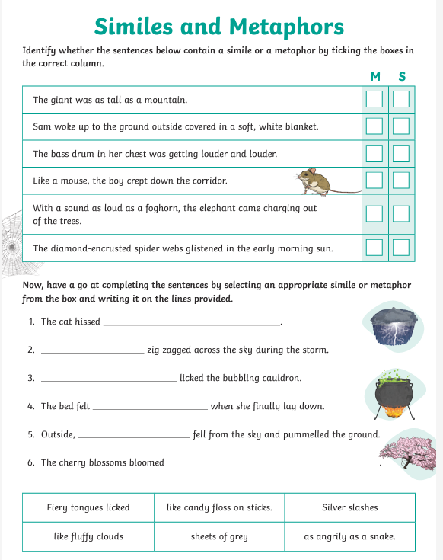

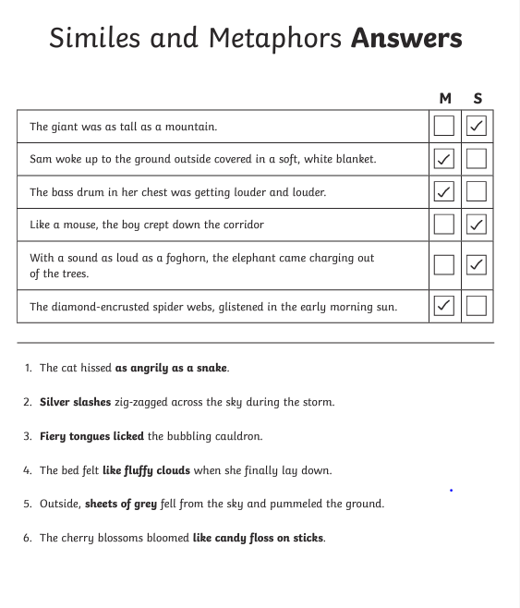

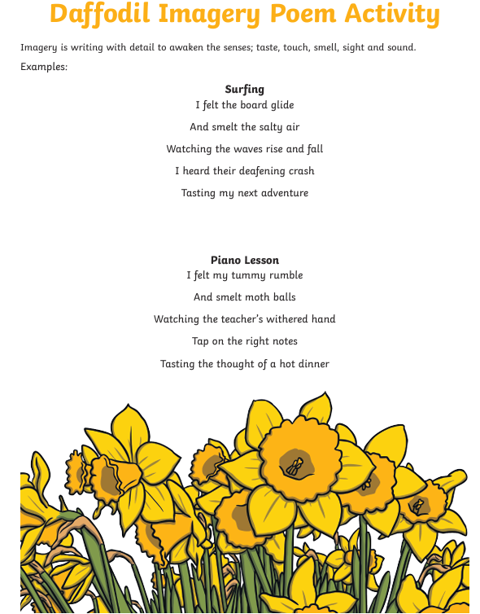

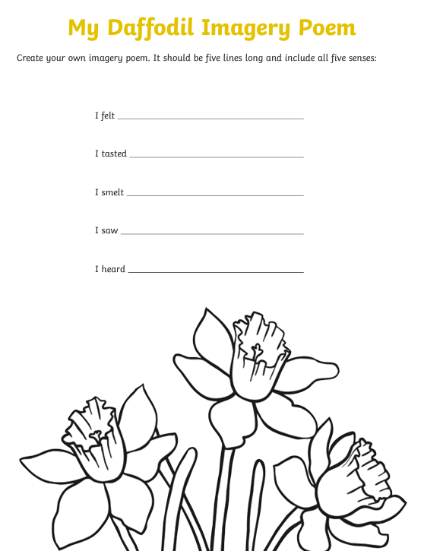

Answers : Students can create their own poem using all the five senses .