**Year 4**

**Microsoft Word Worksheet**

**Create a menu card for a restaurant to display the items and their prices. Use textbox to display heading, names of the dishes.**

**Apply page border, display the contents in two columns, apply formatting features to fit the contents in the columns.**

**(Restaurant menu)**

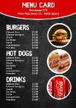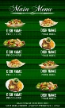

**Create a poster for a food deal offer by adding textboxes and pictures as shown in the below sample poster.**

