**Subject: Mathematics**

Term 1 – Week 5

Topic: Addition and Subtraction

Few links to help:

<https://www.youtube.com/watch?v=9yKnVa-Xvqc>

<https://www.youtube.com/watch?v=7rLFrT2BQ00>

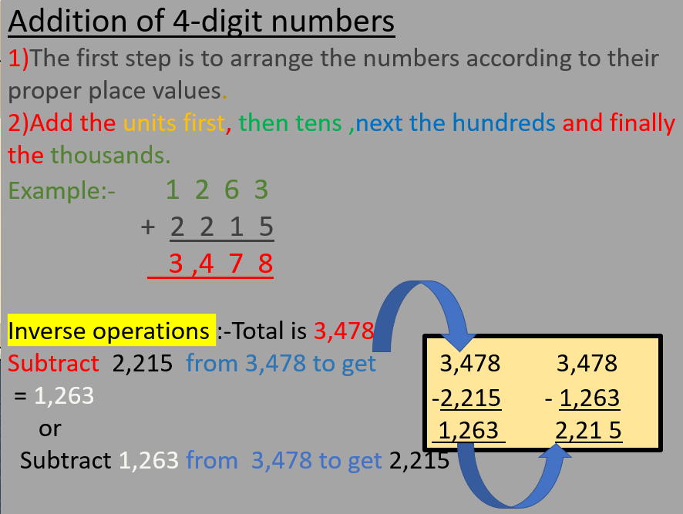

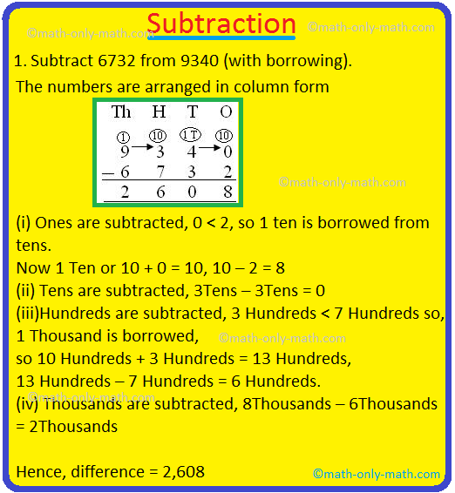

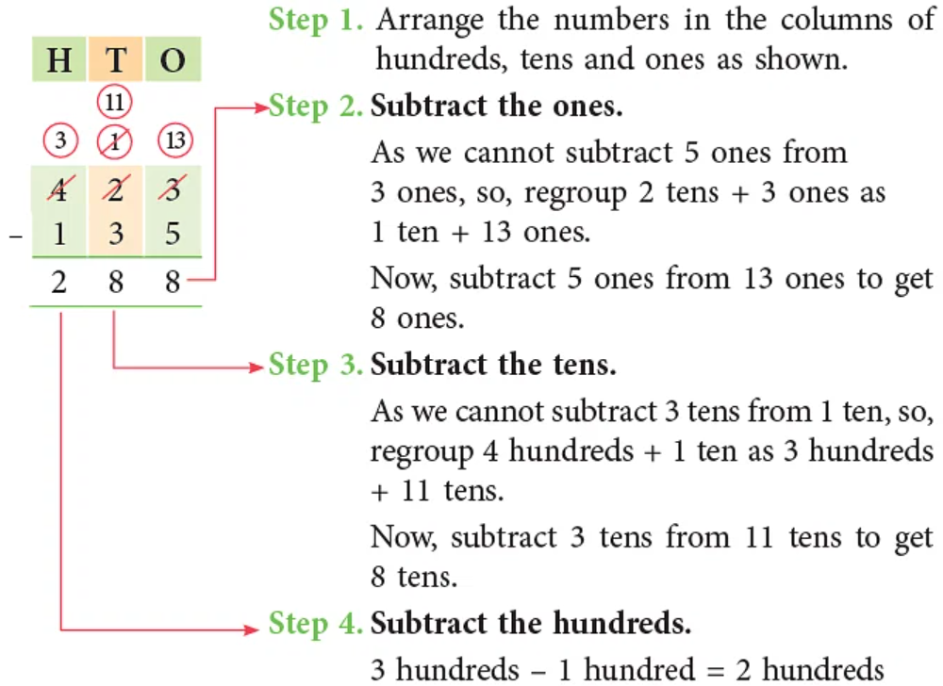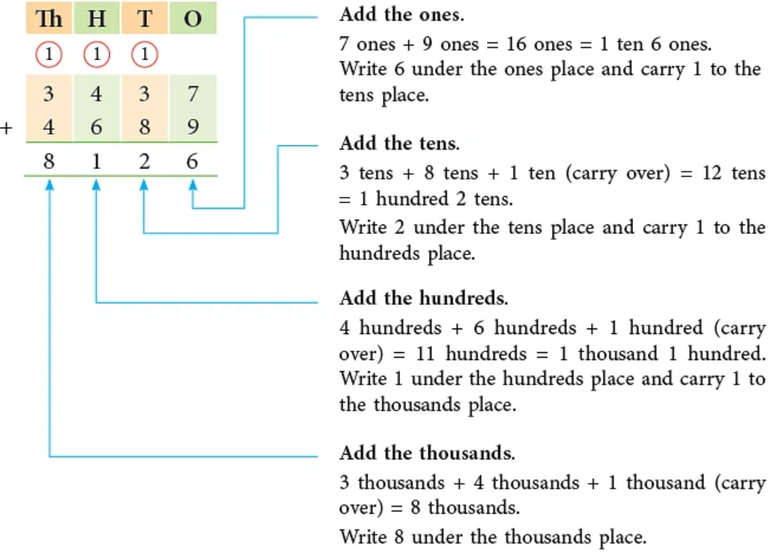

Add the numbers given below using written columnar method:

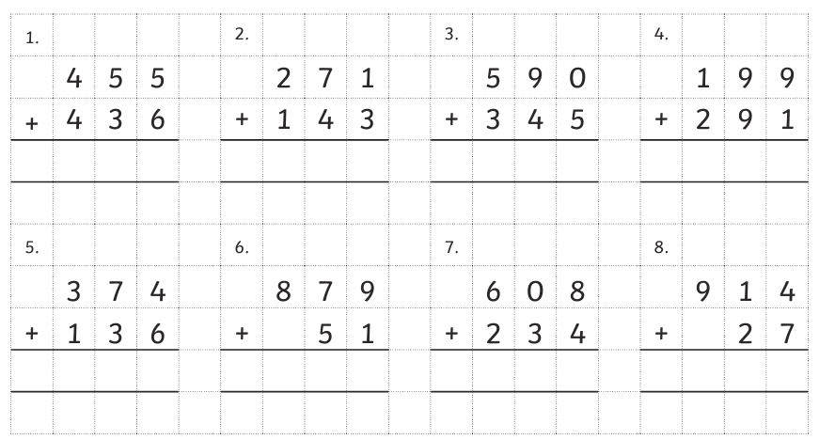

Subtract the numbers given below using written columnar method:

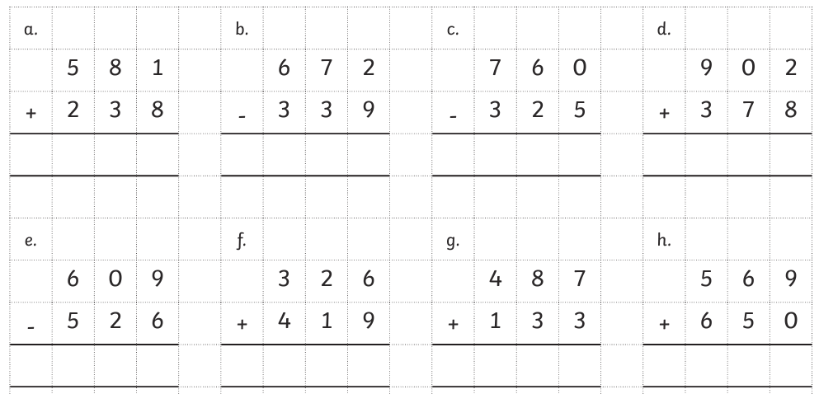

Add /subtract the numbers given below using written columnar method:

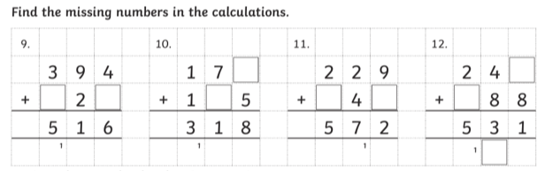

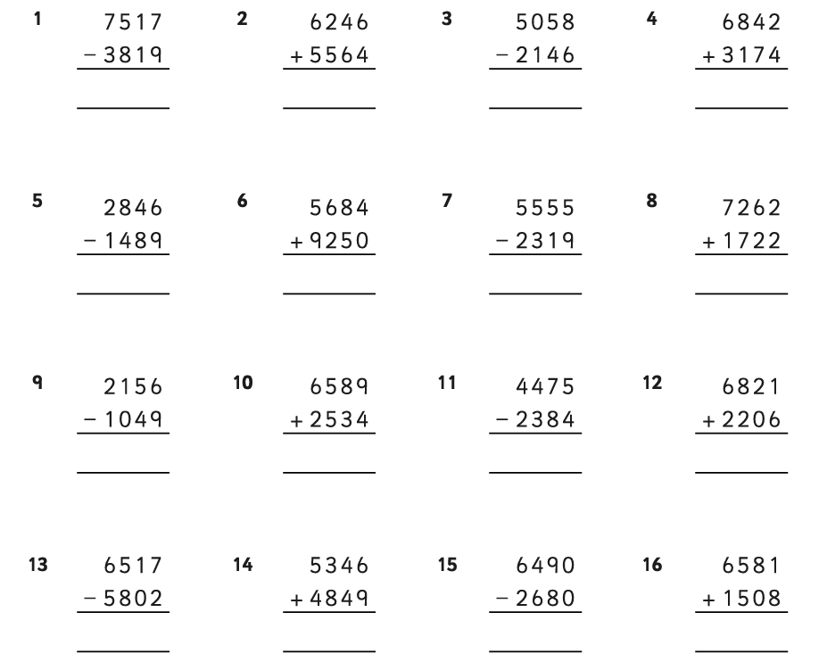

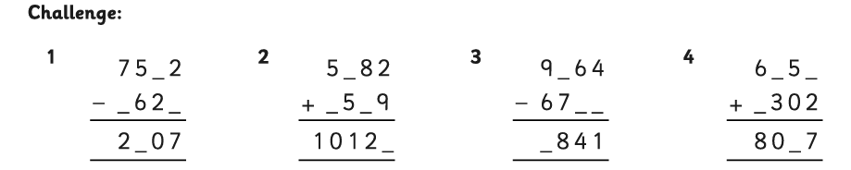

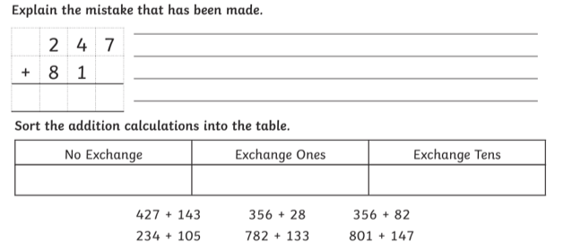

**Let’s check the answers:**

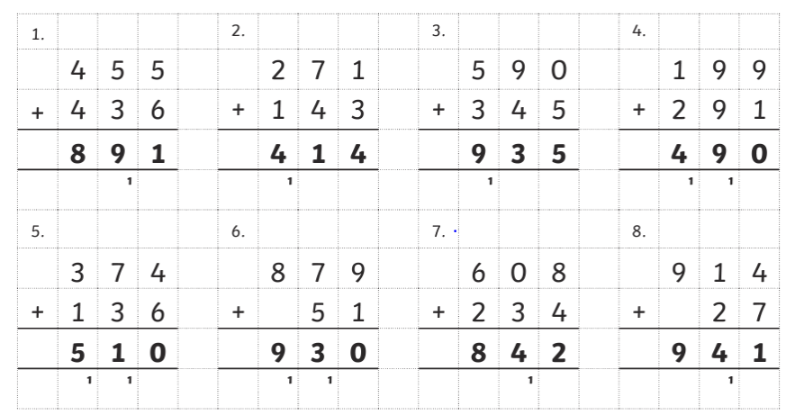Addition

Subtraction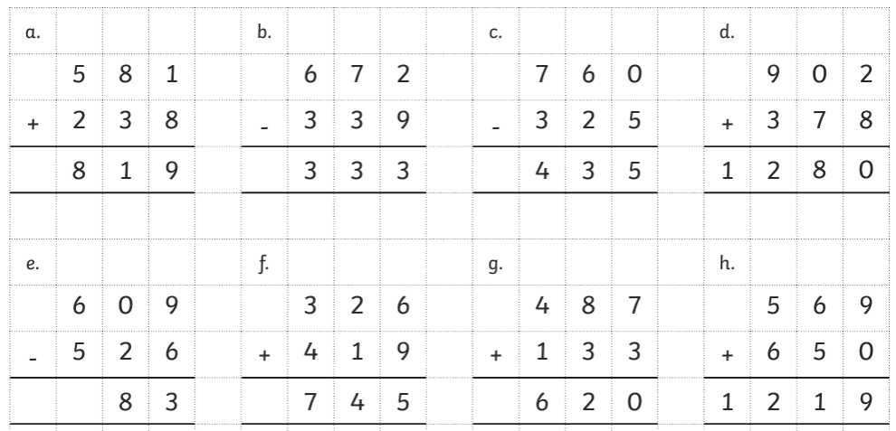

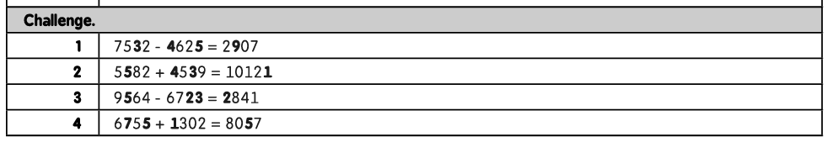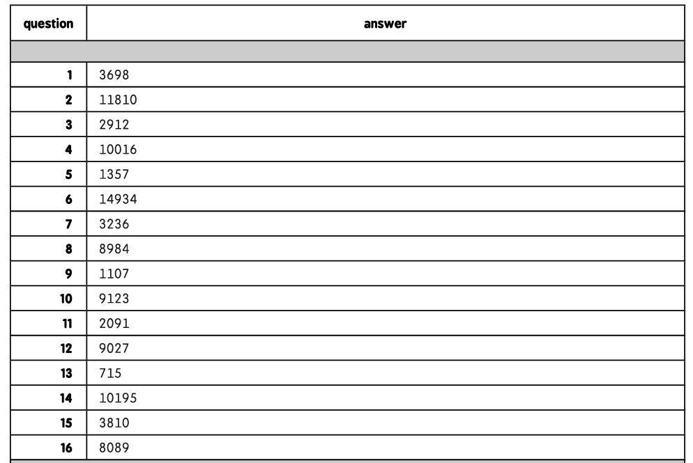Adding and Subtracting:

