**Subject: Mathematics**

Term 1 – Week 6

Topic: Solving Word Problems - Addition and Subtraction

Few links to help:

<https://www.youtube.com/watch?v=HvqCgKxsoIQ>

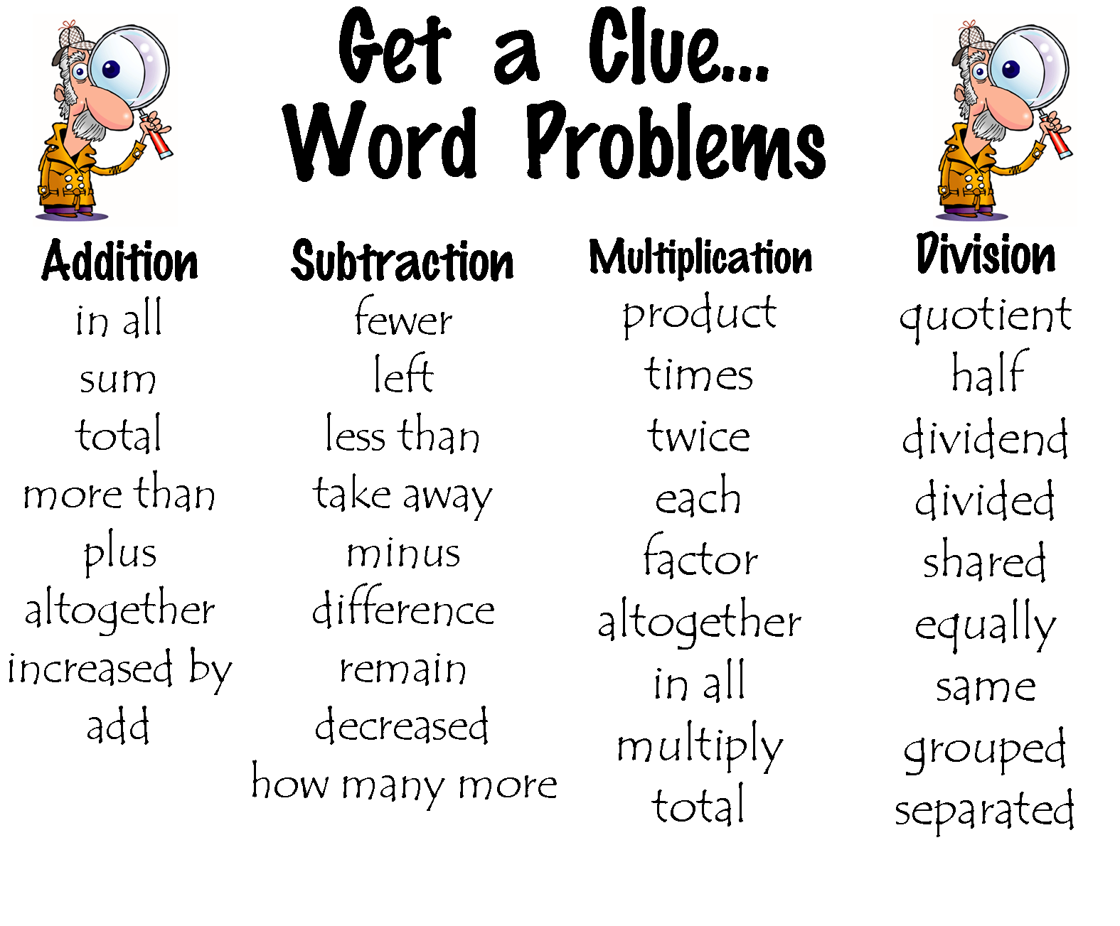

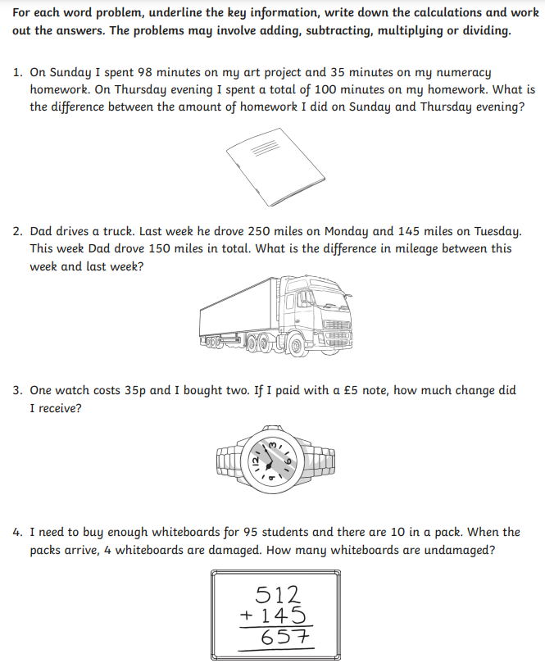

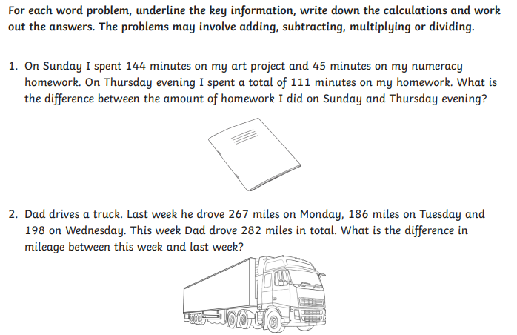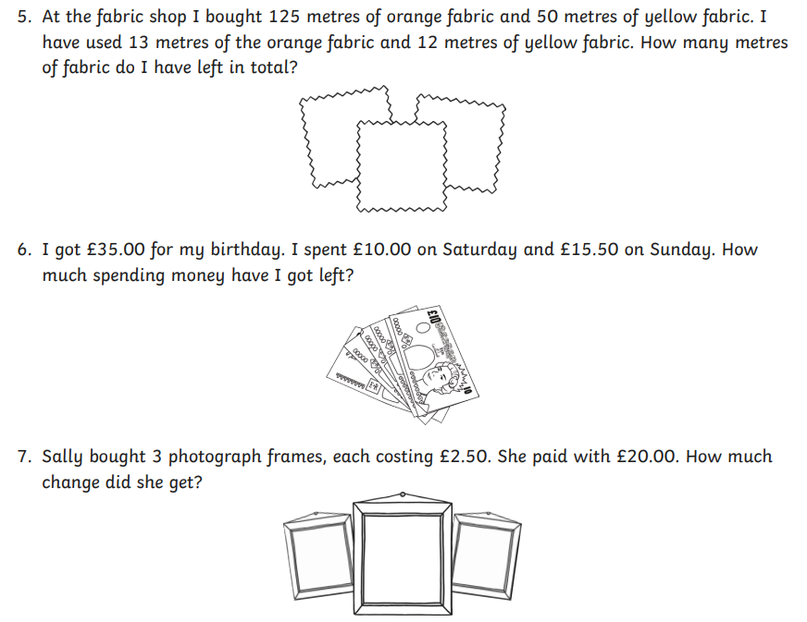**Challenge:**

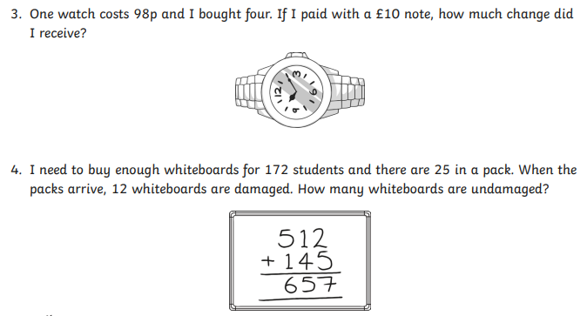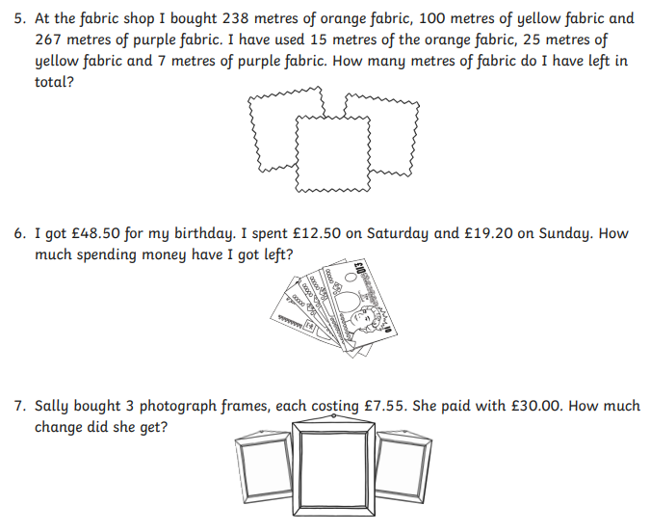

**Let’s check the answer: Challenge:**

