**Subject: Science**

**Term 1 – Week 3**

**Topic: Human digestive system**

# Match the words provided to the letters in the diagram of the digestive system. Put your answer in the table:

|  |  |  |  |  |  |
| --- | --- | --- | --- | --- | --- |
| Liver | Stomach | Salivary glands | Pancreas | Rectum | Mouth |
| Esophagus | Gall Bladder | Small intestines | Large intestines |  |  |

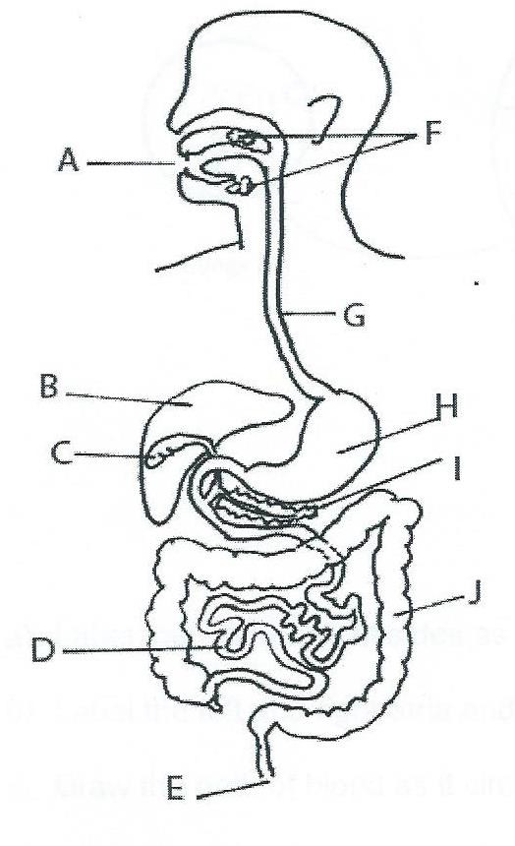

|  |  |
| --- | --- |
| **Letter** | **Part of Digestive System** |
| **A** | Mouth |
| **B** | Liver |
| **C** | Gall bladder |
| **D** | Small intestine |
| **E** | Anus |
| **F** | Salivary gland |
| **G** | esophagus |
| **H** | Stomach |
| **I** | pancreas |
| **J** | Large intestine |

1. **Which of the following gives the correct order for food as it passes through the organs of the digestive system?**
   1. Mouth, esophagus, stomach, gall bladder, pancreas, large intestines, small intestines
   2. Esophagus, epiglottis, stomach, liver, small intestines, large intestines, anus
   3. Mouth esophagus, stomach, small intestines, large intestines, anus



* 1. Mouth, liver, gall bladder, stomach, large intestines, small intestines, anus.

# Which part of the digestive system contains Hydrochloric acid and is coated with mucus for its protection:

1. Rectum
2. Small intestines
3. Stomach



1. Esophagus



# The esophagus connects the mouth to the ?

* 1. Small intestines
  2. Liver
  3. Stomach



# Which of the following are NOT a part of the digestive system?

* 1. Esophagus
  2. Kidneys



* 1. Anus
  2. Liver

# Which of the following best describes the role of the oesophagus in the digestive system:

* 1. Mucus is secreted to protect stomach
  2. Sends food from mouth the stomach



* 1. Helps absorb nutrients

# Digestion beings in the mouth. Which of the following statement is INCORRECT?

* 1. The tongue helps absorb nutrients



* 1. The saliva helps break down food
  2. The tongue keeps food in place in the mouth while the food is being chewed
  3. Teeth help chew food into smaller pieces

# The main function of the stomach is to:

* 1. Store food
  2. Produce hydrochloric acid
  3. Break down food
  4. All of the above



# Complete the cloze passage about the digestive system, with the words in the box below.

|  |  |  |  |  |  |  |
| --- | --- | --- | --- | --- | --- | --- |
| Mouth | nutrients | absorb |  |  |  |  |
|  |  | hydrochloric |  | mucus | Saliva |  |
|  | esophagus |  |  | stomach |  |  |

The human digestive system is a group of organs that break down food, absorb nutrients and remove

unused waste out of the body. Digestion begins in the mouth, where saliva starts to

break food down. Chewed food then travels down the esophagus into the stomach. The

stomach produces hydrochloric acid to help break down food. Hydrochloric acid is

dangerous, as it can burn the stomach. To prevent this, the stomach is coated in a slimy substance called

mucus.

.