VARIABLE POWER SUPPLY

A project Report

Submitted to

Dr.D.Subbulekshmi

Submitted by

RITHVIK NISHAD 19BEE1050

KARTHIK P AJITHKUMAR 19BEE1216

**EEE 2002 – Semiconductor Devices and Circuits**



April 2020

**Contents**

|  |  |  |
| --- | --- | --- |
| S. No | Chapter Title | Page No |
| 1 | Abstract | 3 |
| 2 | Introduction | 4 |
| 3 | Description | 5 |
| 4 | Schematic | 6 |
| 5 | Block Diagram | 7 |
| 6 | Component Explanation | 7 |
| 7 | Working Principle | 9 |
| 8 | Results and Inference | 10 |
| 9 | Conclusion and Future Scope | 10 |
| 10 | References | 10 |

**Abstract**

In this project we attempted to build a power supply unit, with adjustable output voltage (CV Constant voltage mode) from 3V to 45V and adjustable max output current from 100 mA to 30 A (CC constant current mode) setting. Other safety features would include Programmable Input UVLO (Under Voltage Lockout) Protection, Thermal Overload Protection and over current protection. The power supply is flexible with the inputs and accepts both DC (9V to 26V) and AC (110V or 220V). If the input source is AC, the system converts it to a constant 12V DC via a SMPS and is then fed to the system. The system bucks or boosts the input DC voltage according to user control parameters.

**Introduction**

Power supply is an electrical device that supplies electric power to an electrical load. The primary function of a power supply is to convert electric current from a source to an appropriate voltage, current and frequency to power the load. Other functions the power supplies facilitates may include limiting the current drawn by the load to safe and appropriate levels, shutting off the current in the event of an electrical fault, power conditioning to prevent electronic noise or voltage surges on the input from reaching the load, power factor correction and storing energy so it can continue to power the load in event of a temporary interruption from the source power.

An adjustable power supply is generally used by electrical engineers to test circuits which are being or have been developed so that faults in the test circuits would not lead to huge current spikes and damage the input source. Also power drawn by the load can be monitored for analysing the test circuit with the instruments connected to the power supply.

**Description**

The variable power supply is designed to convert a range of input sources to a fixed desired output source for testing and diagnosing electrical appliances and circuits. Our power supply supports both AC and DC input. AC input is fed into an SMPS to get a DC voltage which is then fed to our power supply system to be converted to desired output.

The power supply either bucks or boosts the DC voltage to the desired output level, depending on input voltage and output voltage and current.

If the input voltage is higher than the output voltage and output current is not limited, the power is fed to the buck converter in order to get desired voltage. If the input voltage is lower than the desired output voltage and the output current isn’t limited, the power is fed to the boost converter to get desired output. In both the cases if the current is limited, it tries to automatically lower the output voltage to limit the current from going higher than the desired limit.

The microcontroller and other semiconductor devices can either be powered externally such as it can operate from the power derived from the USB lines for software based serial display. This helps in preventing damage to the semiconductor devices such as the microcontroller and the MOSFETs in case of regulator failure as the regulator can often get warm during operation. Also in case of short circuits and external faults on the load side, the microcontroller will still stay active as its power is no longer derived from the input source. The only potential risk in such a setup is, the load side ground and USB ground should not be shorted. As it can lead to damage to the computer and also the power supply.

Output voltage and current can be monitored and logged via the software serial display for analysing the load later on.

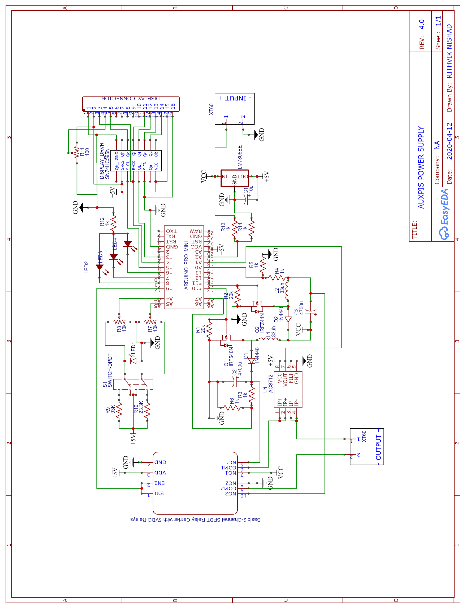

**SCHEMATIC**

**Block Diagram**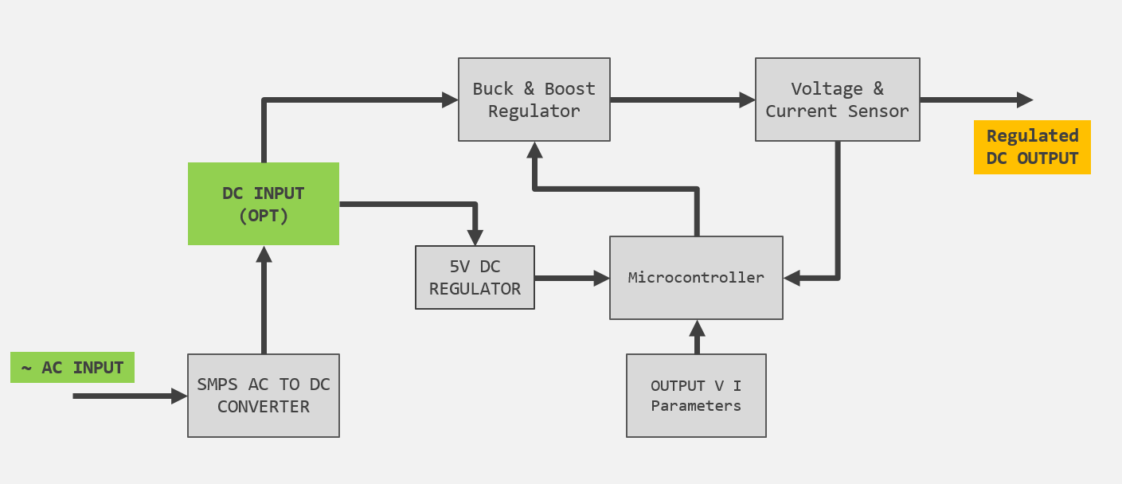

**Component Explanation**

SMPS AC to DC converter is used to convert input AC source to 12V DC efficiently.

This is then fed to LM7805 5V regulator and also to the buck and boost converter.

The LM7805 regulator powers the microcontroller, current sensor, control panel, display and relay module.

The buck converter and boost converter is driven separately depending on whether the output has to be bucked or boosted depending on the input voltage and user control parameters.

IRFZ44N MOSFET is used to drive the buck converter. The MOSFET acts as a high frequency switch. When the gate is biased to 0V, the MOSFET does not conduct any current from Drain to Source, whereas when the gate is biased to 5V, the MOSFET conducts from Drain to Source.

When the MOSFET in the buck converter conducts, the capacitor gets charged higher and tries to achieve the input voltage, but once the microcontroller senses that the capacitor has charged to the user defined voltage level (below input voltage), the microcontroller sets the gate to 0V, and stops the MOSFET from conducting, and while the load tries to discharge the capacitor the voltage across capacitor starts to gradually drop, once it drops below the user defined voltage the microcontroller again sets the gate to 5V in order to charge the capacitor higher to attain the user defined voltage. The N Channel MOSFET sits on the LOW side and hence regulates the LOW side of the capacitor. Hence the voltage across the bucked capacitor is the Positive input voltage, and elevated ground voltage. The negative of the capacitor gets elevated close to the positive voltage of the capacitor as the load discharges the capacitor when not powered from the input voltage, and the negative of the capacitor tries to drop to ground (0) voltage when its powered form the input source.

IRF540N MOSFET is used to drive the boost converter. The N Channel MOSFET acts as a high frequency switch on the low side. It tries to energize and de-energize the inductor at a very high frequency. The inductor gets energized when the MOSFET is closed and stores the energy as a magnetic field. Once the MOSFET opens, just before the inductor reaches saturation point, the magnetic energy stored in the inductor collapses and creates high voltage across the inductor. This boosted voltage is used to charge a capacitor to a higher level than of the input voltage.

The microcontroller facilitates the control of the Buck and Boost MOSFETS, drives the display, takes input from the potentiometer for voltage and current setting, and monitors the input voltage, output voltage and current in order to safely operate the power supply.

ACS712 E30A Current sensor is used to measure output current and is capable of measuring bidirectional current up to 30 A.

**Working Principle**

Buck-Boost converters mainly uses the properties of linear energy storage devices to efficiently step down (buck) and step up (boost) voltage. As we know, when we pass current through an inductor, it stores its energy as magnetic field (B field). After energizing the inductor, and then opened, the B field collapses as electrical energy by producing a back EMF, and creates a high voltage.

The capacitor can be charged to a certain required voltage by a fast switch. Since the capacitor takes a specific amount of time to get charged to a certain level of voltage, we can cut of the input to the capacitor as soon as it reaches the desired output voltage. And across the capacitor we’ll have the desired output voltage. Once the load starts to drain the capacitors charge, voltage across the capacitor starts to drop, and we’ll again charge the capacitor using the input voltage to raise the voltage across the capacitor.

In a buck boost converter, a MOSFET is used to act as a fast switch to control the current flowing to the inductor and effectively charging the capacitor as needed. The PWM duty cycle for the MOSFET is incremented and decremented according to the output voltage and desired voltage.

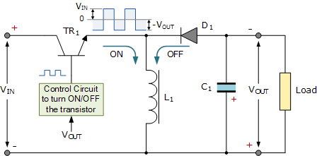

**Results and Inference**

The power supply is able to output 3V to 40V DC. If the input is an AC source, maximum power the power supply can output is 60W at peak performance and with efficient cooling. That is 1.5A at 40V max.

Although when operating at voltages higher than 30V, the system is bound to be unstable, we have software limited the max output voltage to 26V.

**Conclusion and Future Scope**

Although the power supplies intention is to drive the load, in future we could add features like, software controlled automated power control where output voltage can be automatically varied by pre-programming it based on time, or some external parameter. Also wireless control and wireless web based monitoring could be adopted for making the power supply even more capable.

**References:**

Buck And Boost: <https://www.electronics-tutorials.ws/power/switch-mode-power-supply.html>

IRFZ44N: <https://www.infineon.com/dgdl/irfz44npbf.pdf?fileId=5546d462533600a40153563b3a9f220d>

IRF540N: <https://media.digikey.com/pdf/Data%20Sheets/Fairchild%20PDFs/IRF540N.pdf>

ATMEGA328P: <http://ww1.microchip.com/downloads/en/DeviceDoc/Atmel-7810-Automotive-Microcontrollers-ATmega328P_Datasheet.pdf>

LM7805: <http://ee-classes.usc.edu/ee459/library/datasheets/LM7805.pdf>