

UID ASSIGNMENT

SUBMITTED BY
NAME | ORAM RITHVIK REDDY
ROLL NO | AV.SC.U4CSE25136
YEAR/SEM/SECTION | 1ST YEAR/ SEM-2/CSE-B
CREDITS | 03

SUBMITTED TO
NAME | DR. RAJ KUMAR BATCHU
DESIGNATION | ASST.PROFFESSOR (Sl. Grade)
DEPARTMENT | SCHOOL OF COMPUTING

AIM :
Create a responsive frontend clone of SSCRICKET (https://www.sstoncricket.com/) using the concepts with separate index.html, style.css, and script.js files

CODE :

HTML CODE :

<!DOCTYPE html>
<html lang="en">
<head>
<meta charset="UTF-8">
<meta name="viewport" content="width=device-width, initial-scale=1.0">
<title>SS Cricket - Forging Legends Since 1969</title>
<link rel="stylesheet" href="style.css">

</head>
<body>

<header class="header" id="header">
<nav class="navbar">
<div class="logo">
<span class="logo-red">SS</span> Cricket
</div>
<ul class="nav-links" id="navLinks">
<li><a href="#home" class="nav-link">Home</a></li>
<li><a href="#products" class="nav-link">Bats</a></li>
<li><a href="#products" class="nav-link">Kit Bags</a></li>
<li><a href="#products" class="nav-link">Balls</a></li>
<li><a href="#products" class="nav-link">Protectives</a></li>
<li><a href="#about" class="nav-link">About</a></li>
<li><a href="#contact" class="nav-link">Contact</a></li>
</ul>
<div class="hamburger" id="hamburger">
<span class="bar"></span>
<span class="bar"></span>
<span class="bar"></span>
</div>
</nav>
</header>

<section class="hero" id="home">
<div class="hero-content">
<p class="hero-pill">Premium Cricket Equipment</p>
<h1 class="hero-title">Forging Legends<br>Since 1969</h1>
<p class="hero-sub">Trusted by champions across the globe. Handcrafted with passion, from Meerut to international grounds.</p>
<div class="hero-actions">
<a href="#products" class="btn btn-red">Shop Now</a>
<a href="#about" class="btn btn-ghost">Our Story</a>
</div>

</div>
</section>

<div class="promo-strip">
<div class="container promo-flex">
<div class="promo-item">
<strong>Free Shipping</strong>
<span>On orders above Rs.999</span>
</div>
<div class="promo-item">
<strong>Easy Returns</strong>
<span>7-day return policy</span>
</div>
<div class="promo-item">
<strong>Secure Payment</strong>
<span>100% safe checkout</span>
</div>
<div class="promo-item">
<strong>Quality Assured</strong>
<span>Trusted since 1969</span>
</div>
</div>
</div>

<section class="section white-bg" id="products">
<div class="container">
<div class="sec-head">
<h2>Bestsellers</h2>
<p>Our most loved products by cricketers worldwide</p>
</div>
<div class="card-grid">

<div class="p-card">
<div class="img-box">
<span class="tag discount">-15%</span>
<img src="images/bat.jpg" alt="SS Ton Player Bat">
</div>
<div class="p-info">
<h3>SS Ton Player Edition</h3>
<div class="stars">&#9733;&#9733;&#9733;&#9733;&#9733;</div>
<div class="price-wrap">
<span class="p-new">Rs.4,250</span>
<span class="p-old">Rs.5,000</span>
</div>
<button class="cart-btn" onclick="addToCart(this)">Add to Cart</button>
</div>
</div>

<div class="p-card">
<div class="img-box">
<img src="images/helmet.jpg" alt="SS Cricket Helmet">
</div>
<div class="p-info">
<h3>SS Cricket Helmet Pro</h3>
<div class="stars">&#9733;&#9733;&#9733;&#9733;&#9734;</div>
<div class="price-wrap">
<span class="p-new">Rs.2,800</span>
<span class="p-old">Rs.3,200</span>
</div>
<button class="cart-btn" onclick="addToCart(this)">Add to Cart</button>
</div>
</div>

<div class="p-card">
<div class="img-box">
<span class="tag discount">-13%</span>
<img src="images/bag.jpg" alt="SS Duffle Kit Bag">
</div>
<div class="p-info">
<h3>SS Duffle Kit Bag</h3>
<div class="stars">&#9733;&#9733;&#9733;&#9733;&#9733;</div>
<div class="price-wrap">
<span class="p-new">Rs.1,700</span>
<span class="p-old">Rs.1,950</span>
</div>
<button class="cart-btn" onclick="addToCart(this)">Add to Cart</button>
</div>
</div>

<div class="p-card">
<div class="img-box">
<img src="images/ball.jpg" alt="SS Leather Ball">
</div>
<div class="p-info">
<h3>SS Leather Match Ball</h3>
<div class="stars">&#9733;&#9733;&#9733;&#9733;&#9734;</div>
<div class="price-wrap">
<span class="p-new">Rs.550</span>
<span class="p-old">Rs.650</span>
</div>
<button class="cart-btn" onclick="addToCart(this)">Add to Cart</button>
</div>
</div>

<div class="p-card">
<div class="img-box">
<span class="tag discount">-10%</span>
<img src="images/gloves.jpg" alt="SS Batting Gloves">
</div>
<div class="p-info">
<h3>SS Batting Gloves</h3>
<div class="stars">&#9733;&#9733;&#9733;&#9733;&#9733;</div>
<div class="price-wrap">
<span class="p-new">Rs.900</span>
<span class="p-old">Rs.1,000</span>
</div>
<button class="cart-btn" onclick="addToCart(this)">Add to Cart</button>
</div>
</div>

<div class="p-card">
<div class="img-box">
<img src="images/pads.jpg" alt="SS Batting Pads">
</div>
<div class="p-info">
<h3>SS Batting Pads</h3>
<div class="stars">&#9733;&#9733;&#9733;&#9733;&#9734;</div>
<div class="price-wrap">
<span class="p-new">Rs.1,500</span>
<span class="p-old">Rs.1,800</span>
</div>
<button class="cart-btn" onclick="addToCart(this)">Add to Cart</button>
</div>
</div>

<div class="p-card">
<div class="img-box">
<span class="tag discount">-12%</span>
<img src="images/shoes.jpg" alt="SS Cricket Shoes">
</div>
<div class="p-info">
<h3>SS Premium Cricket Shoes</h3>
<div class="stars">&#9733;&#9733;&#9733;&#9733;&#9733;</div>
<div class="price-wrap">
<span class="p-new">Rs.2,200</span>
<span class="p-old">Rs.2,500</span>
</div>
<button class="cart-btn" onclick="addToCart(this)">Add to Cart</button>
</div>
</div>

<div class="p-card">
<div class="img-box">
<img src="images/Thigh.jpg" alt="SS Thigh Guard">
</div>
<div class="p-info">
<h3>SS Thigh Guard</h3>
<div class="stars">&#9733;&#9733;&#9733;&#9734;&#9734;</div>
<div class="price-wrap">
<span class="p-new">Rs.400</span>
<span class="p-old">Rs.480</span>
</div>
<button class="cart-btn" onclick="addToCart(this)">Add to Cart</button>
</div>
</div>

</div>
</div>
</section>

<section class="section grey-bg" id="arrivals">
<div class="container">
<div class="sec-head">
<h2>New Arrivals</h2>
<p>Fresh from our factory, just for you</p>
</div>
<div class="card-grid">

<div class="p-card">
<div class="img-box">
<span class="tag new-tag">New</span>
<img src="images/probat.jpg" alt="SS Pro Player Bat">
</div>
<div class="p-info">
<h3>SS Pro Player Bat</h3>
<div class="stars">&#9733;&#9733;&#9733;&#9733;&#9733;</div>
<div class="price-wrap">
<span class="p-new">Rs.6,500</span>
</div>
<button class="cart-btn" onclick="addToCart(this)">Add to Cart</button>
</div>
</div>

<div class="p-card">
<div class="img-box">
<span class="tag new-tag">New</span>
<img src="images/tball.jpg" alt="SS T20 Ball">
</div>
<div class="p-info">
<h3>SS T20 Match Ball</h3>
<div class="stars">&#9733;&#9733;&#9733;&#9733;&#9734;</div>
<div class="price-wrap">
<span class="p-new">Rs.750</span>
</div>
<button class="cart-btn" onclick="addToCart(this)">Add to Cart</button>
</div>
</div>

<div class="p-card">
<div class="img-box">
<span class="tag new-tag">New</span>
<img src="images/kit.jpg" alt="SS Premium Kit Bag">
</div>
<div class="p-info">
<h3>SS Premium Kit Bag</h3>
<div class="stars">&#9733;&#9733;&#9733;&#9733;&#9733;</div>
<div class="price-wrap">
<span class="p-new">Rs.3,200</span>
</div>
<button class="cart-btn" onclick="addToCart(this)">Add to Cart</button>
</div>
</div>

<div class="p-card">
<div class="img-box">
<span class="tag new-tag">New</span>
<img src="images/wkgloves.jpg" alt="SS WK Gloves">
</div>
<div class="p-info">
<h3>SS WK Keeping Gloves</h3>
<div class="stars">&#9733;&#9733;&#9733;&#9733;&#9734;</div>
<div class="price-wrap">
<span class="p-new">Rs.1,200</span>
</div>
<button class="cart-btn" onclick="addToCart(this)">Add to Cart</button>
</div>
</div>

<div class="p-card">
<div class="img-box">
<span class="tag new-tag">New</span>
<img src="images/jersey.jpg" alt="SS Cricket Jersey">
</div>
<div class="p-info">
<h3>SS Cricket Jersey</h3>
<div class="stars">&#9733;&#9733;&#9733;&#9733;&#9734;</div>
<div class="price-wrap">
<span class="p-new">Rs.850</span>
</div>
<button class="cart-btn" onclick="addToCart(this)">Add to Cart</button>
</div>
</div>

<div class="p-card">
<div class="img-box">
<span class="tag new-tag">New</span>
<img src="images/elbow.jpg" alt="SS Elbow Guard">
</div>
<div class="p-info">
<h3>SS Elbow Guard</h3>
<div class="stars">&#9733;&#9733;&#9733;&#9734;&#9734;</div>
<div class="price-wrap">
<span class="p-new">Rs.350</span>
</div>
<button class="cart-btn" onclick="addToCart(this)">Add to Cart</button>
</div>
</div>

</div>
</div>
</section>

<section class="section white-bg" id="about">
<div class="container about-layout">
<div class="about-img">
<img src="images/legacy.jpg" alt="SS Cricket Legacy">
</div>
<div class="about-text">
<p class="sec-pill">Our Story</p>
<h2>Crafted With Passion,<br>Trusted by Champions</h2>
<p>SS Cricket was founded in 1969 in Meerut, Uttar Pradesh — the cricket equipment capital of the world. For over five decades, we have been handcrafting bats, pads, gloves, and protective gear for cricketers at all levels.</p>
<p>From gully cricket to Test matches, SS Cricket has been the trusted companion of players who dream big. Our artisans bring decades of experience to every piece they make.</p>
<a href="#products" class="btn btn-red">Explore Products</a>
</div>
</div>
</section>

<section class="newsletter-section">
<div class="container newsletter-wrap">
<div class="nl-text">
<h2>Stay in the Game</h2>
<p>Subscribe for exclusive deals, new arrivals, and cricket tips delivered to your inbox.</p>
</div>
<form class="nl-form" onsubmit="handleSubscribe(event)">
<input type="email" id="emailInput" class="nl-input" placeholder="Enter your email address">
<button type="submit" class="btn btn-red">Subscribe</button>
</form>
</div>
</section>

<footer class="footer" id="contact">
<div class="container footer-grid">
<div class="f-col">
<h3><span class="logo-red">SS</span> Cricket</h3>
<p>Premium cricket equipment since 1969. Made in Meerut, loved worldwide by cricketers at every level.</p>
<div class="socials">
<a href="#" class="soc-btn">FB</a>
<a href="#" class="soc-btn">TW</a>
<a href="#" class="soc-btn">IG</a>
<a href="#" class="soc-btn">YT</a>
</div>
</div>
<div class="f-col">
<h4>Products</h4>
<ul>
<li><a href="#">Cricket Bats</a></li>
<li><a href="#">Kit Bags</a></li>
<li><a href="#">Helmets</a></li>
<li><a href="#">Gloves &amp; Pads</a></li>
<li><a href="#">Balls</a></li>
<li><a href="#">Shoes</a></li>
</ul>
</div>
<div class="f-col">
<h4>Support</h4>
<ul>
<li><a href="#">Shipping Policy</a></li>
<li><a href="#">Return &amp; Refund</a></li>
<li><a href="#">Order Tracking</a></li>
<li><a href="#">Bulk Enquiry</a></li>
<li><a href="#">Store Locator</a></li>
</ul>
</div>
<div class="f-col">
<h4>Contact Us</h4>
<p>Meerut, Uttar Pradesh<br>India - 250001</p>
<p>info@sscricket.com</p>
<p>+91 98765 43210</p>
<p>Mon - Sat: 9am to 6pm</p>
</div>
</div>
<div class="footer-bar">
<p>&copy; 2024 SS Cricket. All Rights Reserved.</p>
</div>
</footer>

<div class="toast" id="cartToast">&#10003; Added to cart!</div>

<script src="script.js"></script>
</body>
</html>

CSS CODE:

* {
margin: 0;
padding: 0;
box-sizing: border-box;
}
body {
font-family: 'Segoe UI', Tahoma, Geneva, sans-serif;
color: #333333;
line-height: 1.6;
background-color: #f9f9f9;
}
a { text-decoration: none; color: inherit; }
ul { list-style: none; }
img { max-width: 100%; display: block; }

.container {
max-width: 1200px;
margin: 0 auto;
padding: 0 20px;
}
.section { padding: 70px 0; }
.white-bg { background-color: #ffffff; }
.grey-bg { background-color: #f4f4f4; }

.btn {
display: inline-block;
padding: 12px 28px;
border-radius: 4px;
font-size: 15px;
font-weight: 600;
cursor: pointer;
border: 2px solid transparent;
transition: background-color 0.3s, color 0.3s, border-color 0.3s;
}
.btn-red {
background-color: #d62828;
color: #ffffff;
border-color: #d62828;
}
.btn-red:hover {
background-color: #b71c1c;
border-color: #b71c1c;
}
.btn-ghost {
background-color: transparent;
color: #ffffff;
border-color: #ffffff;
}
.btn-ghost:hover {
background-color: #ffffff;
color: #1a1a2e;
}

.sec-head {
text-align: center;
margin-bottom: 40px;
}
.sec-head h2 {
font-size: 2rem;
color: #1a1a2e;
margin-bottom: 8px;
}
.sec-head p {
color: #777777;
font-size: 1rem;
}
.sec-pill {
display: inline-block;
background-color: #d62828;
color: #ffffff;
font-size: 0.78rem;
padding: 4px 14px;
border-radius: 20px;
letter-spacing: 1px;
text-transform: uppercase;
margin-bottom: 12px;
}

.header {
position: fixed;
top: 0;
left: 0;
width: 100%;
z-index: 999;
background-color: #1a1a2e;
box-shadow: 0 2px 8px rgba(0, 0, 0, 0.3);
transition: box-shadow 0.3s;
}
.navbar {
display: flex;
justify-content: space-between;
align-items: center;
padding: 16px 24px;
max-width: 1200px;
margin: 0 auto;
}
.logo {
font-size: 1.5rem;
font-weight: 700;
color: #ffffff;
letter-spacing: 1px;
}
.logo-red { color: #d62828; }
.nav-links {
display: flex;
gap: 26px;
}
.nav-links a {
color: #cccccc;
font-size: 0.92rem;
font-weight: 500;
transition: color 0.2s;
}
.nav-links a:hover,
.nav-links a.active { color: #d62828; }

.hamburger {
display: none;
flex-direction: column;
gap: 5px;
cursor: pointer;
}
.bar {
display: block;
width: 25px;
height: 3px;
background-color: #ffffff;
border-radius: 2px;
transition: transform 0.3s, opacity 0.3s;
}

.hero {
min-height: 100vh;
background: linear-gradient(rgba(10, 10, 30, 0.72), rgba(10, 10, 30, 0.55)),
url('images/.jpg') center / cover no-repeat;
display: flex;
align-items: center;
justify-content: center;
padding: 100px 20px 60px;
text-align: center;
}
.hero-content { max-width: 640px; }
.hero-pill {
display: inline-block;
background-color: rgba(214, 40, 40, 0.85);
color: #ffffff;
padding: 5px 18px;
border-radius: 20px;
font-size: 0.82rem;
letter-spacing: 1.5px;
text-transform: uppercase;
margin-bottom: 20px;
}
.hero-title {
font-size: 3rem;
color: #ffffff;
font-weight: 800;
line-height: 1.2;
margin-bottom: 18px;
}
.hero-sub {
color: #cccccc;
font-size: 1.05rem;
margin-bottom: 32px;
line-height: 1.75;
}
.hero-actions {
display: flex;
gap: 16px;
justify-content: center;
flex-wrap: wrap;
}

.promo-strip {
background-color: #1a1a2e;
padding: 22px 0;
border-top: 1px solid rgba(255, 255, 255, 0.08);
}
.promo-flex {
display: flex;
justify-content: space-around;
align-items: center;
flex-wrap: wrap;
gap: 20px;
}
.promo-item {
display: flex;
flex-direction: column;
align-items: center;
text-align: center;
}
.promo-item strong {
font-size: 0.95rem;
color: #ffffff;
margin-bottom: 2px;
}
.promo-item span {
font-size: 0.82rem;
color: #aaaaaa;
}

.card-grid {
display: grid;
grid-template-columns: repeat(4, 1fr);
gap: 24px;
}
.p-card {
background-color: #ffffff;
border-radius: 8px;
overflow: hidden;
box-shadow: 0 2px 10px rgba(0, 0, 0, 0.08);
transition: transform 0.3s, box-shadow 0.3s;
}
.p-card:hover {
transform: translateY(-6px);
box-shadow: 0 8px 24px rgba(0, 0, 0, 0.14);
}
.img-box {
position: relative;
overflow: hidden;
background-color: #f0f0f0;
}
.img-box img {
width: 100%;
transition: transform 0.4s;
}
/* Zoom on card hover */
.p-card:hover .img-box img { transform: scale(1.06); }
.tag {
position: absolute;
top: 10px;
left: 10px;
font-size: 0.74rem;
font-weight: 700;
padding: 3px 9px;
border-radius: 4px;
z-index: 1;
}
.tag.discount { background-color: #d62828; color: #ffffff; }
.tag.new-tag { background-color: #2a9d8f; color: #ffffff; }
.p-info { padding: 14px 16px 18px; }
.p-info h3 {
font-size: 0.93rem;
color: #222222;
margin-bottom: 6px;
font-weight: 600;
}
.stars {
color: #f4a261;
font-size: 0.85rem;
margin-bottom: 8px;
}
.price-wrap {
display: flex;
align-items: center;
gap: 10px;
margin-bottom: 12px;
}
.p-new { color: #d62828; font-size: 1.05rem; font-weight: 700; }
.p-old { color: #aaaaaa; font-size: 0.85rem; text-decoration: line-through; }
.cart-btn {
width: 100%;
padding: 9px 0;
background-color: #1a1a2e;
color: #ffffff;
border: none;
border-radius: 4px;
font-size: 0.88rem;
font-weight: 600;
cursor: pointer;
transition: background-color 0.3s;
}
.cart-btn:hover { background-color: #d62828; }

.about-layout {
display: flex;
align-items: center;
gap: 60px;
}
.about-img { flex: 1; }
.about-img img {
border-radius: 8px;
box-shadow: 0 4px 20px rgba(0, 0, 0, 0.12);
width: 100%;
}
.about-text { flex: 1; }
.about-text h2 {
font-size: 2rem;
color: #1a1a2e;
margin-bottom: 16px;
line-height: 1.3;
}
.about-text p {
color: #555555;
margin-bottom: 14px;
font-size: 0.97rem;
line-height: 1.75;
}

.footer {
background-color: #1a1a2e;
color: #cccccc;
padding: 60px 0 0;
}
.footer-grid {
display: grid;
grid-template-columns: 2fr 1fr 1fr 1fr;
gap: 40px;
padding-bottom: 40px;
}
.f-col h3 { font-size: 1.4rem; color: #ffffff; margin-bottom: 14px; }
.f-col h4 {
font-size: 0.95rem;
color: #ffffff;
margin-bottom: 16px;
text-transform: uppercase;
letter-spacing: 0.5px;
}
.f-col p { font-size: 0.87rem; line-height: 1.8; margin-bottom: 6px; }
.f-col ul li { margin-bottom: 9px; }
.f-col ul li a { color: #aaaaaa; font-size: 0.87rem; transition: color 0.2s; }
.f-col ul li a:hover { color: #d62828; }
.socials { display: flex; gap: 10px; margin-top: 16px; }
.soc-btn {
display: inline-block;
padding: 6px 12px;
background-color: rgba(255, 255, 255, 0.1);
color: #ffffff;
border-radius: 4px;
font-size: 0.78rem;
font-weight: 600;
transition: background-color 0.2s;
}
.soc-btn:hover { background-color: #d62828; }
.footer-bar {
border-top: 1px solid rgba(255, 255, 255, 0.1);
text-align: center;
padding: 18px 24px;
font-size: 0.84rem;
color: #777777;
}

.newsletter-section {
background-color: #d62828;
padding: 50px 0;
}
.newsletter-wrap {
display: flex;
justify-content: space-between;
align-items: center;
gap: 30px;
flex-wrap: wrap;
}
.nl-text h2 {
font-size: 1.7rem;
color: #ffffff;
margin-bottom: 6px;
}
.nl-text p {
color: rgba(255, 255, 255, 0.85);
font-size: 0.97rem;
}
.nl-form {
display: flex;
gap: 12px;
flex-wrap: wrap;
}
.nl-input {
padding: 12px 18px;
border-radius: 4px;
border: none;
font-size: 0.95rem;
width: 280px;
outline: none;
}
.nl-input:focus {
box-shadow: 0 0 0 3px rgba(255, 255, 255, 0.4);
}

.toast {
position: fixed;
bottom: 30px;
right: 30px;
background-color: #2a9d8f;
color: #ffffff;
padding: 12px 22px;
border-radius: 6px;
font-size: 0.9rem;
font-weight: 600;
opacity: 0;
pointer-events: none;
transition: opacity 0.4s;
z-index: 9999;
}
.toast.show { opacity: 1; }

/* ===== RESPONSIVE ===== */
@media (max-width: 1024px) {
.card-grid { grid-template-columns: repeat(3, 1fr); }
}
@media (max-width: 768px) {
.hamburger { display: flex; }
.nav-links {
position: absolute;
top: 64px;
left: 0;
width: 100%;
flex-direction: column;
background-color: #1a1a2e;
padding: 20px 24px;
gap: 16px;
display: none;
border-top: 1px solid rgba(255, 255, 255, 0.1);
}
.nav-links.open { display: flex; }
.hero-title { font-size: 2.2rem; }
.card-grid { grid-template-columns: repeat(2, 1fr); }
.about-layout { flex-direction: column; gap: 32px; }
.footer-grid { grid-template-columns: 1fr 1fr; gap: 30px; }
}
@media (max-width: 480px) {
.hero-title { font-size: 1.8rem; }
.hero-sub { font-size: 0.95rem; }
.hero-actions { flex-direction: column; align-items: center; }
.card-grid { grid-template-columns: 1fr; }
.footer-grid { grid-template-columns: 1fr; }
.sec-head h2 { font-size: 1.6rem; }
}

JAVASCRIPT CODE:

let hamburger = document.getElementById('hamburger');
let navLinks = document.getElementById('navLinks');

hamburger.addEventListener('click', function() {
navLinks.classList.toggle('open');
});

let navItems = document.querySelectorAll('.nav-link');
for (let i = 0; i < navItems.length; i++) {
navItems[i].addEventListener('click', function() {
navLinks.classList.remove('open');
});
}

let header = document.getElementById('header');

window.addEventListener('scroll', function() {
if (window.scrollY > 60) {
header.style.boxShadow = '0 4px 16px rgba(0, 0, 0, 0.45)';
} else {
header.style.boxShadow = '0 2px 8px rgba(0, 0, 0, 0.3)';
}
});

let toast = document.getElementById('cartToast');
let toastTimer;

function addToCart(btn) {

clearTimeout(toastTimer);

toast.classList.add('show');

let originalText = btn.textContent;
btn.textContent = 'Added!';
btn.style.backgroundColor = '#2a9d8f';

toastTimer = setTimeout(function() {
toast.classList.remove('show');
btn.textContent = originalText;
btn.style.backgroundColor = '';
}, 2200);
}

let anchorLinks = document.querySelectorAll('a[href^="#"]');

for (let j = 0; j < anchorLinks.length; j++) {
anchorLinks[j].addEventListener('click', function(e) {
let targetId = this.getAttribute('href');
let targetEl = document.querySelector(targetId);

if (targetEl) {
e.preventDefault();
targetEl.scrollIntoView({ behavior: 'smooth' });
}
});
}

function handleSubscribe(e) {
e.preventDefault();
let emailInput = document.getElementById('emailInput');
let val = emailInput.value.trim();
if (val === '') return;

clearTimeout(toastTimer);
toast.textContent = '&#10003; Subscribed successfully!';
toast.classList.add('show');

emailInput.value = '';

toastTimer = setTimeout(function() {
toast.classList.remove('show');
toast.textContent = '&#10003; Added to cart!';
}, 2500);
}

let sections = document.querySelectorAll('section[id]');

window.addEventListener('scroll', function() {
let scrollPos = window.scrollY + 80;

for (let k = 0; k < sections.length; k++) {
let sec = sections[k];
let secTop = sec.offsetTop;
let secHeight = sec.offsetHeight;

if (scrollPos >= secTop && scrollPos < secTop + secHeight) {

for (let m = 0; m < navItems.length; m++) {
navItems[m].classList.remove('active');
}

let match = document.querySelector('.nav-link[href="#' + sec.id + '"]');
if (match) {
match.classList.add('active');
}
}
}
});

OUTPUT :

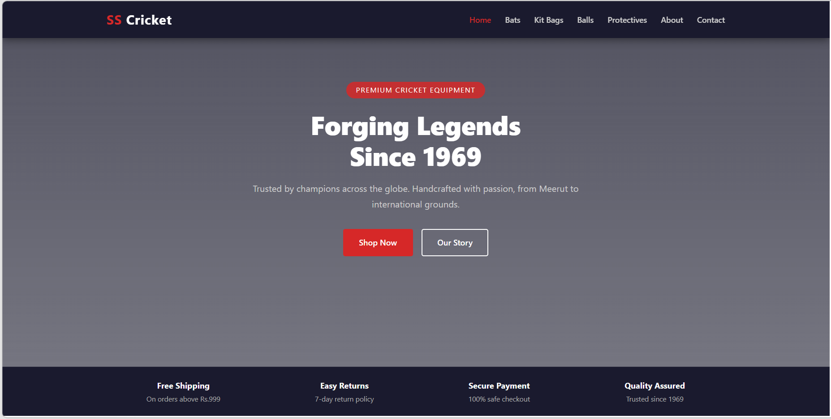

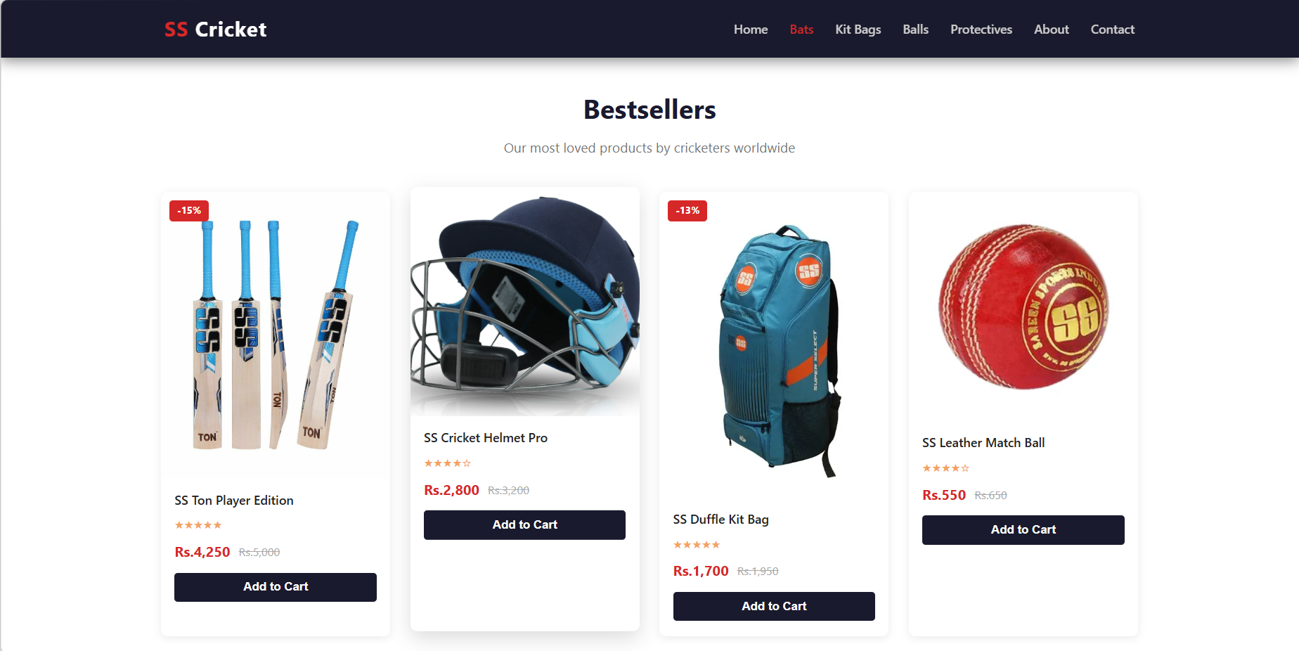

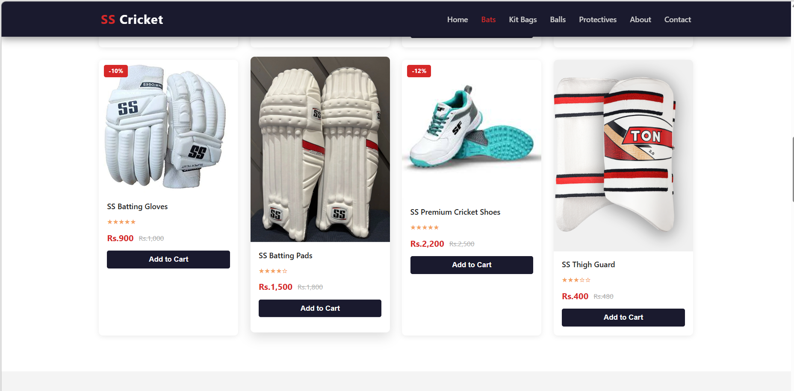

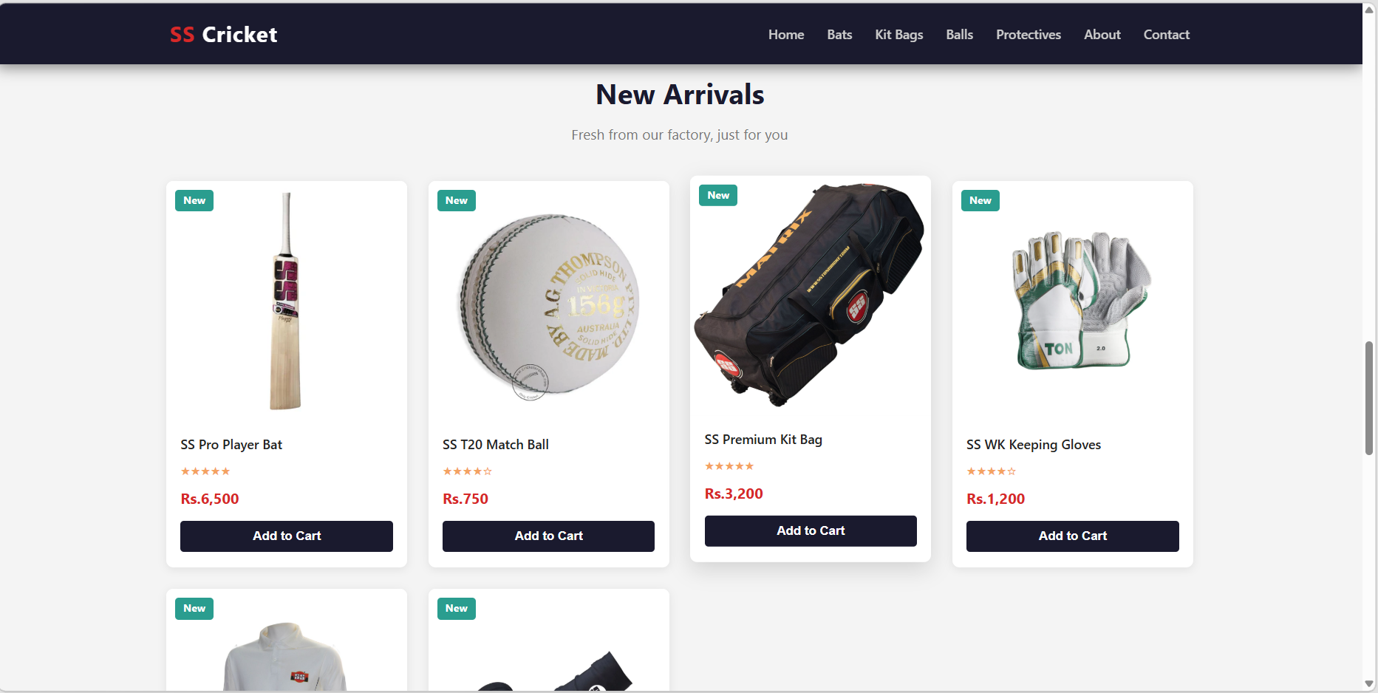

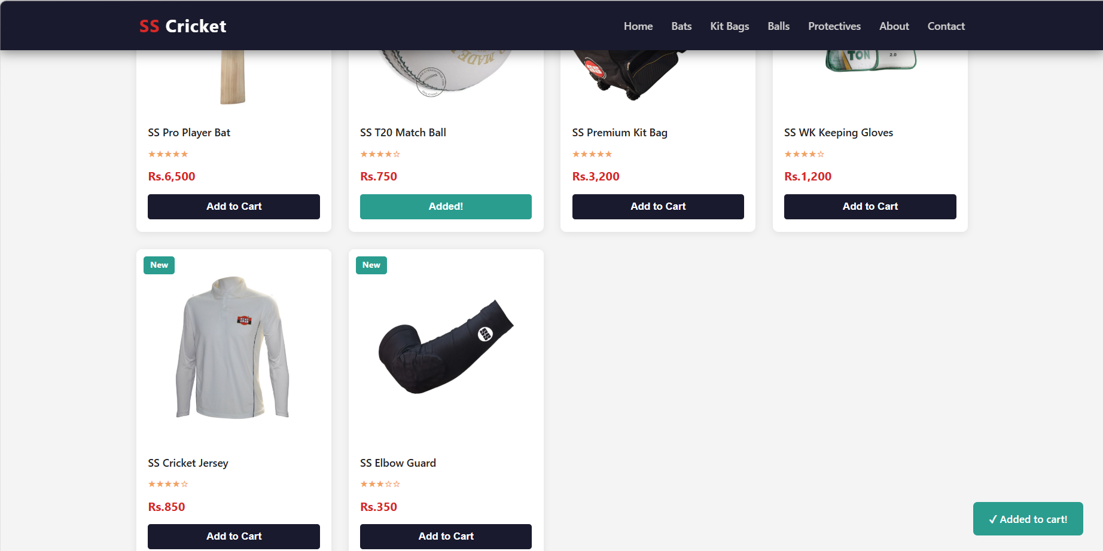

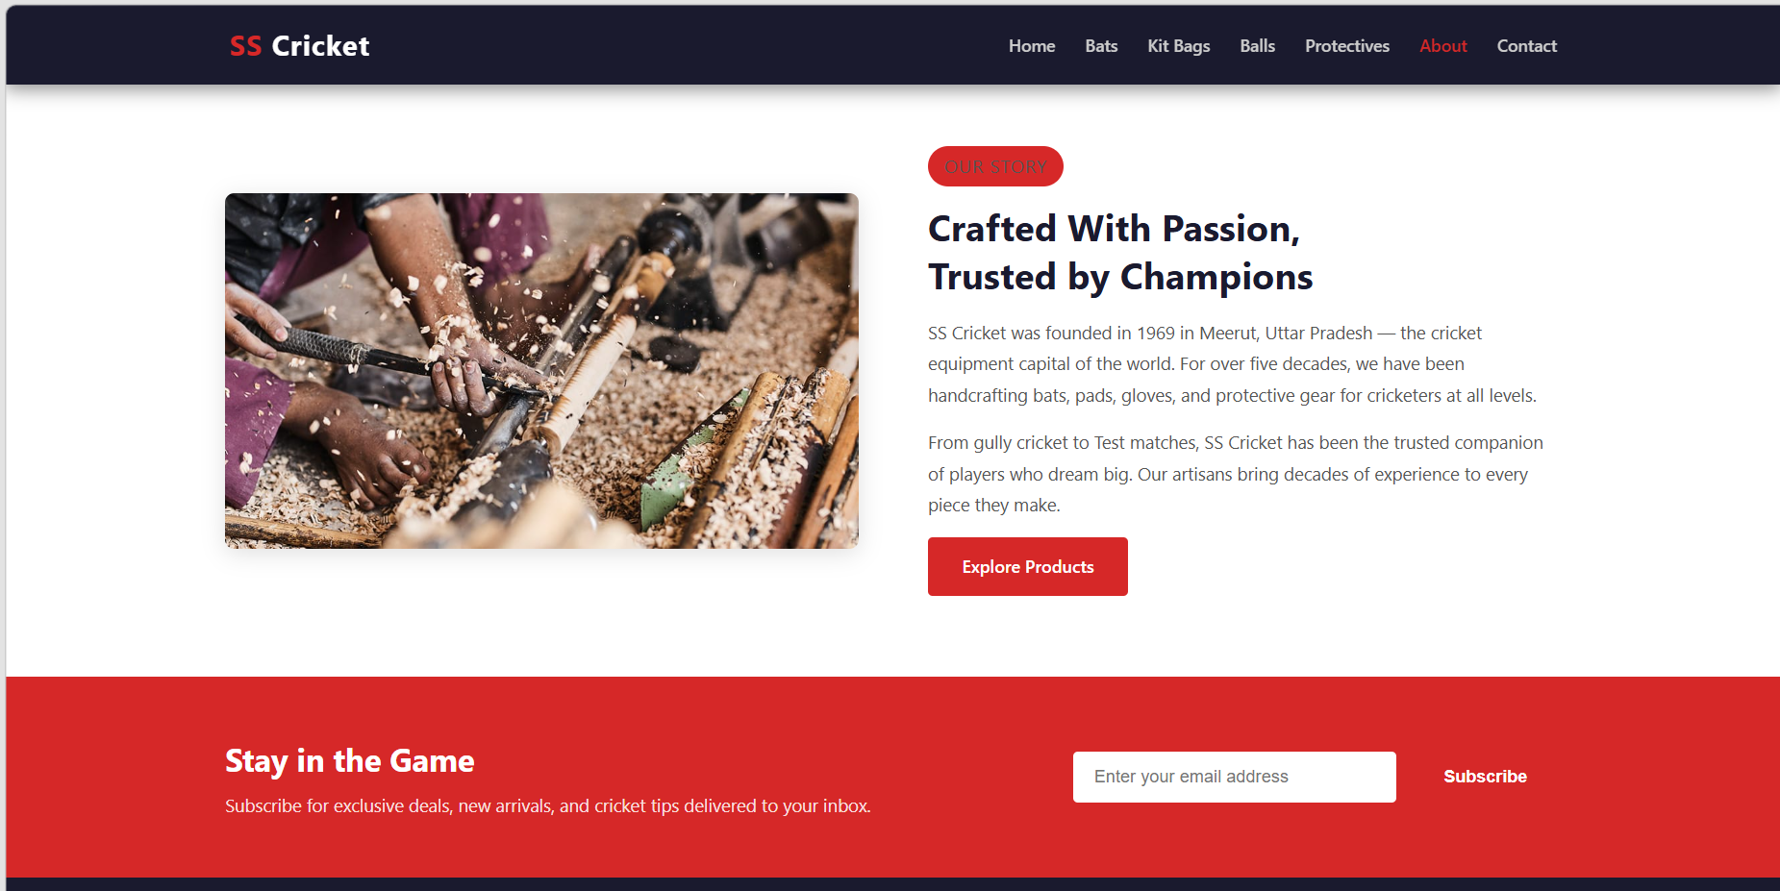

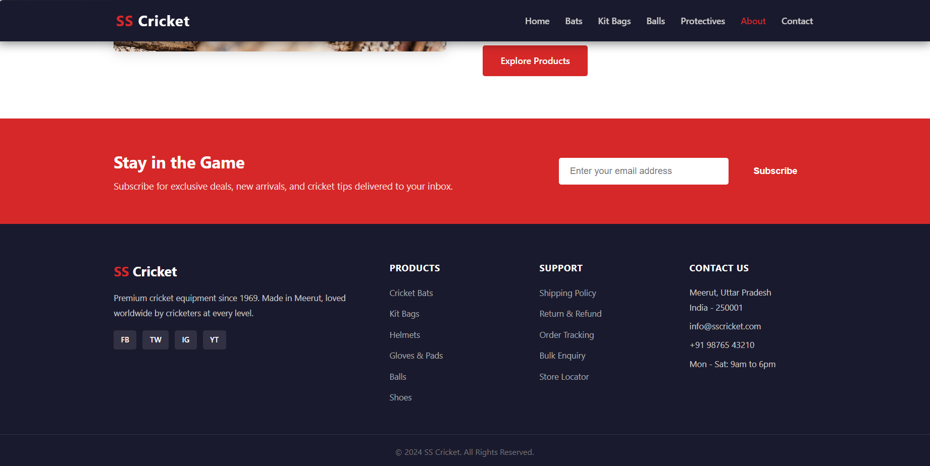

EXPLANATION:

SS Cricket Website — File Explanation

📄 index.html — Page Structure

- Standard HTML5 document with UTF-8 charset, viewport meta tag, and linked style.css
- Fixed header with logo ("SS Cricket") and 7 navigation links for in-page scrolling
- Hamburger icon (3 <span> bars) included for mobile menu toggle
- Hero section covers full viewport with a pill badge, main heading, subtitle, and two CTA buttons
- Promo strip below hero shows 4 trust badges: Free Shipping, Easy Returns, Secure Payment, Quality Assured
- Bestsellers section has 8 product cards — each with image, name, star rating, price, and Add to Cart button
- Some cards have red discount tags (e.g. -15%), others have no tag
- New Arrivals section has 6 cards with green "New" tags and single prices (no strikethrough)
- About section uses a two-column layout — legacy image on left, brand story text on right
- Newsletter section has an email input form with a Subscribe button calling handleSubscribe()
- Footer has 4 columns: brand info + socials, Products list, Support links, Contact details
- A hidden toast <div> sits at bottom-right to show cart and subscription feedback messages

style.css — Styling & Layout

- CSS reset on * clears margin/padding and sets box-sizing: border-box globally
- Body uses Segoe UI font, dark gray text, and light #f9f9f9 background
- .container centers content at max 1200px width with auto margins
- .section gives consistent 70px vertical padding; .white-bg and .grey-bg alternate section colors
- Two button styles: .btn-red (solid red, darkens on hover) and .btn-ghost (transparent, fills white on hover)
- Header is position: fixed, dark navy #1a1a2e, always on top with z-index: 999
- Nav links are gray by default, turn red on hover or when .active class is applied
- Hamburger is hidden by default (display: none), only appears on screens below 768px
- Hero uses min-height: 100vh with a dark gradient overlay on a background image
- Product cards have white background, rounded corners, and lift up with shadow on hover
- Card images zoom in slightly (scale(1.06)) when the parent card is hovered
- Discount/New tags are absolutely positioned on the top-left of each card image
- Cart button spans full card width, turns red on hover
- About section uses flexbox with 60px gap between image and text
- Footer is a 4-column CSS grid (2fr 1fr 1fr 1fr) with dark navy background
- Newsletter section has a solid red background with a white email input field
- Toast notification is fixed bottom-right, starts invisible, fades in when .show class is added
- Media queries: ≤1024px → 3-column grid; ≤768px → 2-column grid, stacked nav, stacked about layout; ≤480px → single column everything

script.js — Behaviour & Interactivity

- Hamburger click toggles .open class on nav links, showing/hiding the mobile menu
- Clicking any nav link removes .open to auto-close the mobile menu after selection
- Scroll listener deepens the header shadow after 60px scroll, lightens it when back at top
- addToCart(btn) shows the toast, changes button text to "Added!" and color to teal
- After 2200ms, button text and color are restored and toast fades out automatically
- clearTimeout is called before each toast action to prevent overlapping timers
- All href="#..." anchor links use scrollIntoView({ behavior: 'smooth' }) for smooth scrolling
- e.preventDefault() stops default anchor jump and form submission behaviors
- handleSubscribe() validates the email field is not empty before showing success toast
- Toast text is updated to "Subscribed successfully!" then reset to cart message after 2500ms
- Scroll spy loop checks all <section id> elements on every scroll event
- Compares scrollY + 80 against each section's offsetTop and offsetHeight range
- Matching section removes .active from all nav links, then adds it to the correct one
- This turns the matching nav link red, visually indicating the current section in view

