{{ dc_title }}
WATER WORKS ENGINEERING
#65-B, GURUSAMY NAGAR, THANNEERPANDAL, PEELAMEDU,
COIMBATORE-641 004
TELE NO.: 0422 2511139  CELL : 98650 13676/ 99427 44822  E mail :waterworksengineeringcbe@gmail.com |  | D.C No. : {{ dc_no }}  DATE : {{ date }}
CONSIGNER' S NAME & ADDRESS:  WATER WORKS ENGINEERING  #65-B, GURUSAMY NAGAR, THANNEERPANDAL, PEELAMEDU,  COIMBATORE-641 004. |  | DELIVER TO:  {{ deliver_to }}  {{ deliver_to }}
 | DESCRIPTION | QTY
{{ item.description }} |  | {{ item.qty }}
PARTY GST NO.:

Received the above on goods condition  Signature of the party |  | For WATER WORKS ENGINEERING  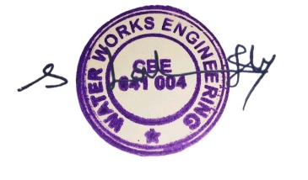  AUTHORIZED SIGNATORY

