STUDENT LAB ALLOCATOR
Project Report submitted for the partial fulfilment of grade for the course

Data Structures and Algorithms -3 (25CS2103E)
in

A.Y. 2026-2027

Submitted by
M. Yashwanth Raj (2520030181)
V. Karthik (2520030053)
K. Rithwik (2520030428)
Team Number: 5
Section: 1

Under the guidance of

Dr. CH Anuradha

Professor, Computer Science and Engineering
Hyderabad-500090, Telangana, India.

K L (Deemed to be) University
DEPARTMENT OF COMPUTER SCIENCE ENGINEERING



DECLARATION

The Mini Project Report entitled “Student Lab Allocator” is a record of Bonafide work of M. Yashwanth Raj – 2520030181, V. Karthik – 2520030053, K. Rithwik – 2520030428 submitted in partial fulfillment for the award of B. Tech in Computer Science and Engineering to the K L University. The results embodied in this report have not been copied from any other departments/University/Institute.

M. Yashwanth Raj – 2520030181
V. Karthik – 2520030053
K. Rithwik – 2520030428

K L (Deemed to be) University
DEPARTMENT OF COMPUTER SCIENCE ENGINEERING
CERTIFICATE

This is to certify that the mini project based report entitled “Student Lab Allocator” is a bonafide work done and submitted by M. Yashwanth Raj – 2520030181, V. Karthik – 2520030053, K. Rithwik – 2520030428 in partial fulfillment of the requirements for the award of the degree of BACHELOR OF TECHNOLOGY in Department of Computer Science and Engineering, K L (Deemed to be University), during the academic year 2026-2027.

Signature of the Supervisor

Signature of the HOD Signature of the External Examiner

ACKNOWLEDGEMENT

The success in this project would not have been possible but for the timely help and guidance rendered by many people. We wish to express our sincere thanks to all those who have assisted us in one way or the other for the completion of our project.

Our greatest appreciation to our guide, Dr. CH Anuradha, Professor, Computer Science and Engineering , which cannot be expressed in words, for his/her tremendous support, encouragement and guidance for this project.

We express our gratitude to Dr. P. Venkateshwar Rao, Head of the Department of Computer Science and Engineering, for providing us with adequate facilities, ways and means by which we were able to complete this project.

We thank all the members of the teaching and non-teaching staff, and also all those who have assisted us directly or indirectly for the successful completion of this project. Finally, we sincerely thank our parents, friends and classmates for their kind help and cooperation during our work.

M. Yashwanth Raj – 2520030181
V. Karthik – 2520030053
K. Rithwik – 2520030428

TABLE OF CONTENTS

S.No. | Contents | Page no.
1. | Abstract | 6
2. | Introduction | 7
3. | Literature survey | 8
4. | Problem Statement and Objectives | 9
5. | Hardware and Software requirements | 9
6. | Implementation | 11
7. | Results & Discussion | 14
8. | Conclusion & Future Scope | 18
9. | References | 19

1.ABSTRACT

Allocating students to laboratory sessions by hand is slow, error-prone and often leaves some students without a seat while other seats remain empty. This project, Student Lab Allocator, automates the process by modelling it as a maximum bipartite matching problem. Students form one vertex set and individual laboratory seats (a seat is identified by lab, time slot and seat number) form the other; an edge connects a student to every seat whose time slot equals the student’s preferred slot. A Kuhn-style augmenting-path algorithm then finds a matching of maximum size, so that every student receives at most one seat, no seat is given to two students, and the number of successful allocations is the largest possible. The system is written in Java with a Swing graphical interface. It reads student and laboratory data from CSV files or accepts manual and randomly generated input, runs the allocation, and produces reports: a searchable allocation table, lab-wise and slot-wise statistics, and an exportable CSV file. On the supplied dataset of 50 students and 3 laboratories (165 seat-slots) all 50 students were allocated (100% allocation rate), and in an over-subscribed test of 60 students requesting the same slot the system allocated exactly the 55 seats available. The project demonstrates how graph matching algorithms solve real-world scheduling problems.
Team Name: 4
Team Members:
- M. Yashwanth Raj, 2520030181
- V. Karthik, 2520030053
- K. Rithwik, 2520030428

- INTRODUCTION
Every semester, colleges must distribute hundreds of students across a limited number of laboratories and time slots. Each laboratory has a fixed number of seats and each student wants a particular session. When this is done manually with spreadsheets, clashes, double bookings and unused seats are common, and re-doing the schedule after a small change takes a long time. The problem is therefore a natural candidate for automation.
Student Lab Allocator treats the allocation as a graph problem. The students are placed on the left side of a bipartite graph and the laboratory seats on the right side. A seat is one chair in one laboratory during one time slot, for example “LAB01, 09:00-10:00, Seat 7”. A student is connected to every seat in his or her preferred time slot. A matching is a set of edges in which no student and no seat appears twice, which is exactly the rule that each student gets at most one seat and each seat serves at most one student. The best possible schedule is therefore a maximum matching, the matching with the largest number of edges.
The maximum matching is computed with the augmenting-path method (Kuhn’s algorithm). If a student’s preferred seats are all taken, the algorithm tries to move a student who already holds one of those seats to another compatible seat, and repeats this recursively. Because of this re-arrangement, the result is never worse than a simple first-come first-served assignment, and no student is left unallocated while a feasible arrangement exists.
The application is built in Java. A Swing dashboard lets the user view students and laboratories, run the allocation, see statistics, enter data manually or generate random data, and export the result as a CSV report. The rest of this document is organised as follows: Section 3 reviews related work, Section 4 states the problem and objectives, Section 5 lists the hardware and software used, Section 6 presents the main code modules, Section 7 discusses the results, and Section 8 gives the conclusion and future scope.
- LITERATURE SURVEY
Maximum bipartite matching with augmenting paths. The standard textbook treatment of matching in bipartite graphs is given by Cormen et al. in the chapter on maximum flow, where matching is reduced to a flow problem and solved with the Ford–Fulkerson method. Kuhn’s algorithm, explained on CP-Algorithms, is the simplified depth-first form of the same idea and runs in O(V·E) time. The GeeksforGeeks tutorial on maximum bipartite matching uses a job-assignment example that is almost identical to student-to-seat allocation. These sources form the basis of our matching module.
Hopcroft–Karp algorithm. Hopcroft and Karp (1973) improved the running time of bipartite matching to O(E√V) by finding many shortest augmenting paths in each phase. It is the preferred method when the number of vertices is very large, and it is a natural upgrade path for this project if it is used for thousands of students.
Hungarian algorithm and weighted assignment. Kuhn’s Hungarian method (1955) solves the assignment problem when edges carry costs or weights, for example when each student ranks the laboratories. It produces a minimum-cost perfect matching in polynomial time. Our project uses the unweighted version because only slot compatibility is modelled, but the weighted version is the correct extension for ranked preferences.
Stable matching. Gale and Shapley (1962) introduced the stable marriage problem, in which both sides have ranked preferences and the goal is a matching with no “blocking pair”. Variants of it are used in school admission and medical residency allocation. Stable matching optimises fairness of preferences, whereas our system optimises the number of students served, which is the more important criterion when laboratory capacity is limited.
Hall’s marriage theorem. Hall’s theorem states when a bipartite graph has a matching that covers every vertex of one side. It explains the behaviour of our over-subscription test: when more students request a slot than there are seats in that slot, a complete matching is impossible, and the maximum matching equals the number of seats.
Timetabling and seat-allocation tools. Institutional timetable and lab-booking tools commonly rely on spreadsheets, or on greedy first-come first-served rules that never re-arrange earlier bookings. In contrast, Student Lab Allocator re-arranges existing assignments through augmenting paths and provides a desktop interface, data import and export, and statistics in one package.
The URLs and publications consulted are listed in the References section.
- Problem Statement and Objectives
Problem Statement:
To design and implement an automated system that allocates each student to at most one laboratory seat in a preferred time slot while maximizing the total number of successful allocations.
Problem Description:
Manual lab allotment causes slot clashes, double bookings and idle seats; the task is modelled as a bipartite graph of students and lab seats and solved as a maximum bipartite matching problem.
Objectives:
1. To model students and laboratory seats as the two vertex sets of a bipartite graph, with an edge wherever a seat’s time slot matches the student’s preferred slot.
2. To guarantee that each student receives at most one allocation and that no seat is assigned to more than one student.
3. To maximize the total number of successful assignments using the augmenting-path (Kuhn) maximum matching algorithm.
4. To accept input from CSV files, manual entry and random generation, so that the system can be tested with different data sizes.
5. To generate allocation reports: an allocation table, lab-wise and slot-wise statistics, a list of unallocated students and an exported CSV file.
6. To provide an easy-to-use Java Swing interface that demonstrates graph matching in a real-world scheduling task.
- HARDWARE AND SOFTWARE REQUIREMENTS
Hardware Requirements:
- Processor: Intel Core i3 (or equivalent) or higher
- Memory: 4 GB RAM minimum (8 GB recommended)
- Storage: 500 MB of free disk space
- Display: 1280 × 720 resolution or higher, with keyboard and mouse
Software Requirements:
- Operating System: Windows 10/11, Linux or macOS
- Programming Language: Java (JDK 17 or later; built and tested with JDK 21)
- GUI Toolkit: Java Swing / AWT (part of the JDK, no external library needed)
- Data Format: CSV files for students, laboratories and exported results
- Development Tools: VS Code / Eclipse / IntelliJ IDEA, Command Prompt or Terminal (javac and java)
- IMPLEMENTATION
The system is organised around a small set of Java classes. Student, Lab, LabSeat and Allocation are plain data classes; CSVReader loads the input files; the four modules below form the allocation engine. The full pipeline in Main is: read CSV → generate seats → build bipartite graph → maximum matching → create result → statistics → write CSV.
Module 1: Seat Generation (LabSeatGenerator.java)
Each laboratory is expanded into individual seats, one for every available time slot and seat number. For the dataset (capacities 20, 20 and 15, three slots each) this gives (20 + 20 + 15) × 3 = 165 seats. Treating every seat as its own vertex is what lets plain matching enforce the capacity of a laboratory.
public static List<LabSeat> generateSeats(List<Lab> labs) {
List<LabSeat> seats = new ArrayList<>();
for (Lab lab : labs) {
String[] slots = lab.getAvailableSlots().split(";");
for (String slot : slots) {
for (int seatNumber = 1;
seatNumber <= lab.getCapacity();
seatNumber++) {
LabSeat seat = new LabSeat(lab.getLabId(), lab.getLabName(), slot.trim(), seatNumber);
seats.add(seat);
}
}
}
return seats;
}

Module 2: Bipartite Graph Construction (SeatBipartiteGraph.java)
The left vertices are students and the right vertices are seats. A student is connected to a seat only when the seat’s slot equals the student’s preferred slot, and the graph is stored as an adjacency list. Construction takes O(S × K) time for S students and K seats.
public void buildGraph() {
for (int i = 0; i < students.size(); i++) {
Student student = students.get(i);
for (int j = 0; j < seats.size(); j++) {
LabSeat seat = seats.get(j);
if (student.getPreferredSlot() .equals(seat.getSlot())) {
adjacencyList.get(i).add(j);
}
}
}
}

Module 3: Maximum Bipartite Matching (MaximumBipartiteMatching.java)
This is the core of the project. For each student a depth-first search looks for an augmenting path: if a compatible seat is free it is taken, otherwise the student who currently holds that seat is asked to move to another seat. The visited array is reset for every student. The search for each student starts at a different offset (studentIndex % connections), which spreads students across laboratories without changing the maximum matching. Worst-case time is O(V × E).
public boolean findAugmentingPath(int studentIndex, boolean[] visited) {
List<Integer> connections = graph.getConnections(studentIndex);
if (connections.isEmpty()) {
return false;
}
int startPosition = studentIndex % connections.size();
for (int offset = 0;
offset < connections.size();
offset++) {
int position = (startPosition + offset) % connections.size();
int seatIndex = connections.get(position);
if (visited[seatIndex]) {
continue;
}
visited[seatIndex] = true;
if (seatMatch[seatIndex] == -1 || findAugmentingPath(seatMatch[seatIndex], visited)) {
studentMatch[studentIndex] = seatIndex;
seatMatch[seatIndex] = studentIndex;
return true;
}
}
return false;
}

public int maximumMatching() {
matchingCount = 0;
for (int studentIndex = 0;
studentIndex < studentMatch.length;
studentIndex++) {
boolean[] visited = new boolean[
seatMatch.length
];
if (findAugmentingPath(studentIndex, visited)) {
matchingCount++;
}
}
return matchingCount;
}

Module 4: Allocation Result and Main Pipeline (AllocationManager.java, Main.java)
The matching arrays are converted into Allocation objects (student, lab, slot, seat number) and a list of unallocated students; Main wires all modules together, prints the summary and statistics, and writes output/allocation_result.csv.
public AllocationResult createResult() {
AllocationResult result = new AllocationResult();
int[] studentMatch = matching.getStudentMatch();
for (int i = 0; i < students.size(); i++) {
Student student = students.get(i);
if (studentMatch[i] != -1) {
LabSeat seat = seats.get(studentMatch[i]);
Allocation allocation = new Allocation(student, seat);
result.addAllocation(allocation);
} else {
result.addUnallocatedStudent(student);
}
}
return result;
}

// Main.java - pipeline of main()
List<Student> students = CSVReader.readStudents(studentFile);
List<Lab> labs = CSVReader.readLabs(labFile);
List<LabSeat> seats = LabSeatGenerator.generateSeats(labs);

SeatBipartiteGraph graph = new SeatBipartiteGraph(students, seats);
graph.buildGraph();

MaximumBipartiteMatching matching = new MaximumBipartiteMatching(graph);
matching.maximumMatching();

AllocationManager manager = new AllocationManager(students, seats, matching);
AllocationResult result = manager.createResult();

Statistics statistics = new Statistics(result);
statistics.displaySummary();
statistics.displayLabWiseStatistics();
AllocationCSVWriter.write(result, outputFile);

Other classes: MainFrame (dashboard and actions), InputFrame and ManualStudentFrame (data entry), RandomStudentGenerator, DataTableFrame (searchable tables), StatisticsFrame and AllocationCSVWriter (reports).
- RESULTS & DISCUSSION
The application was compiled and run on the supplied dataset (50 students from CSE and ECE, 3 laboratories, 3 time slots, 165 seats). Screenshots of the running application and their explanation follow.
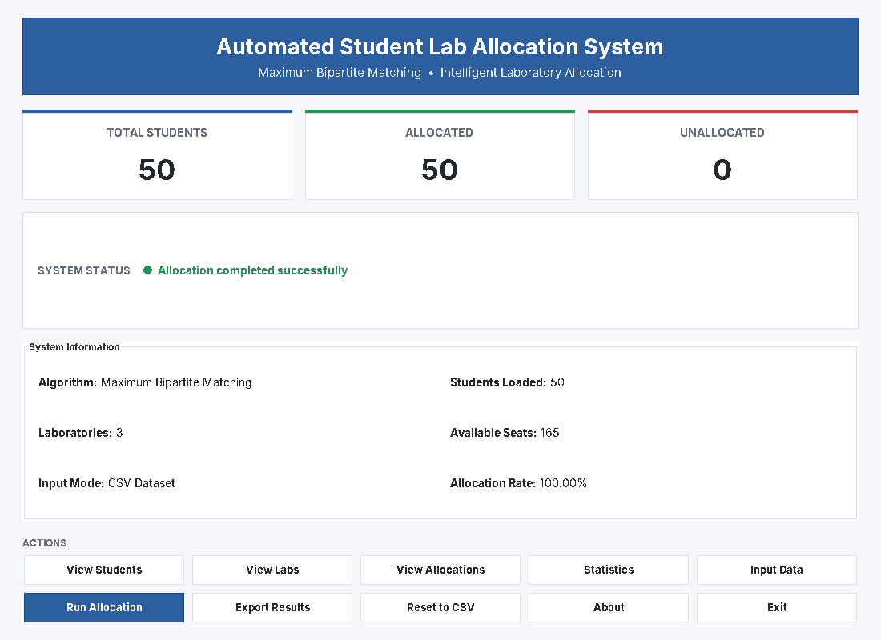
Fig 7.1: Dashboard
The dashboard shows 50 students, 50 allocated and 0 unallocated, with the algorithm name, 3 laboratories, 165 available seats and a 100.00% allocation rate.
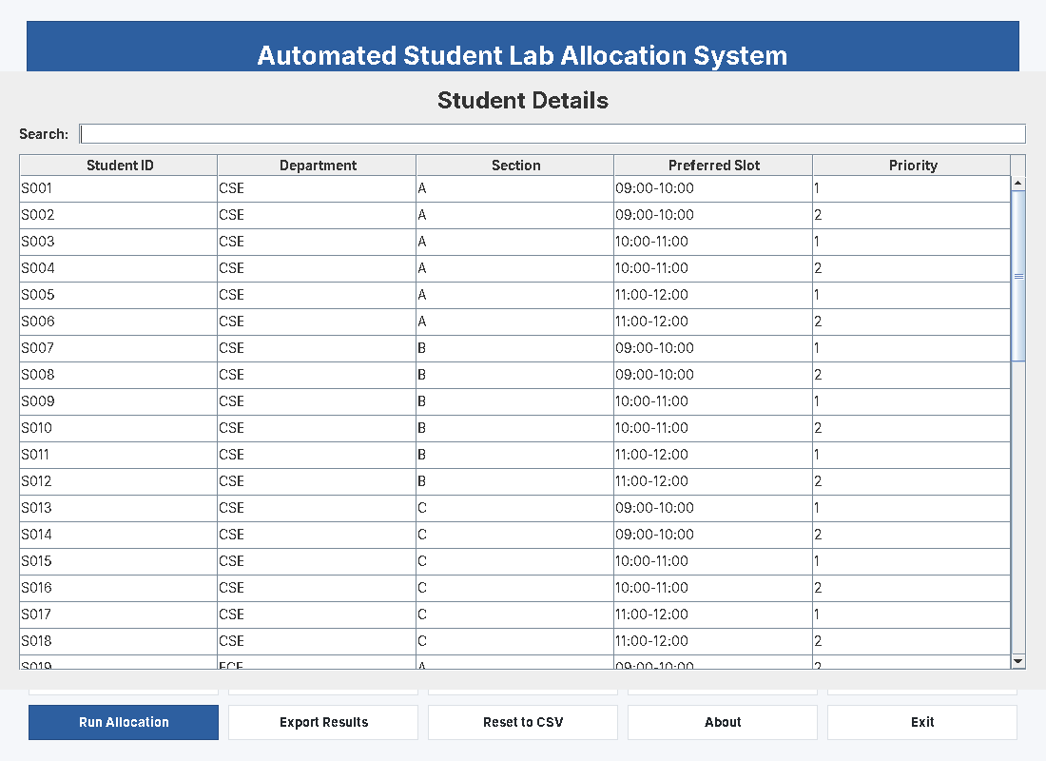
Fig 7.2: Student Details
The input table lists each student’s ID, department, section, preferred slot and priority, loaded from the CSV file. A search box filters the rows.
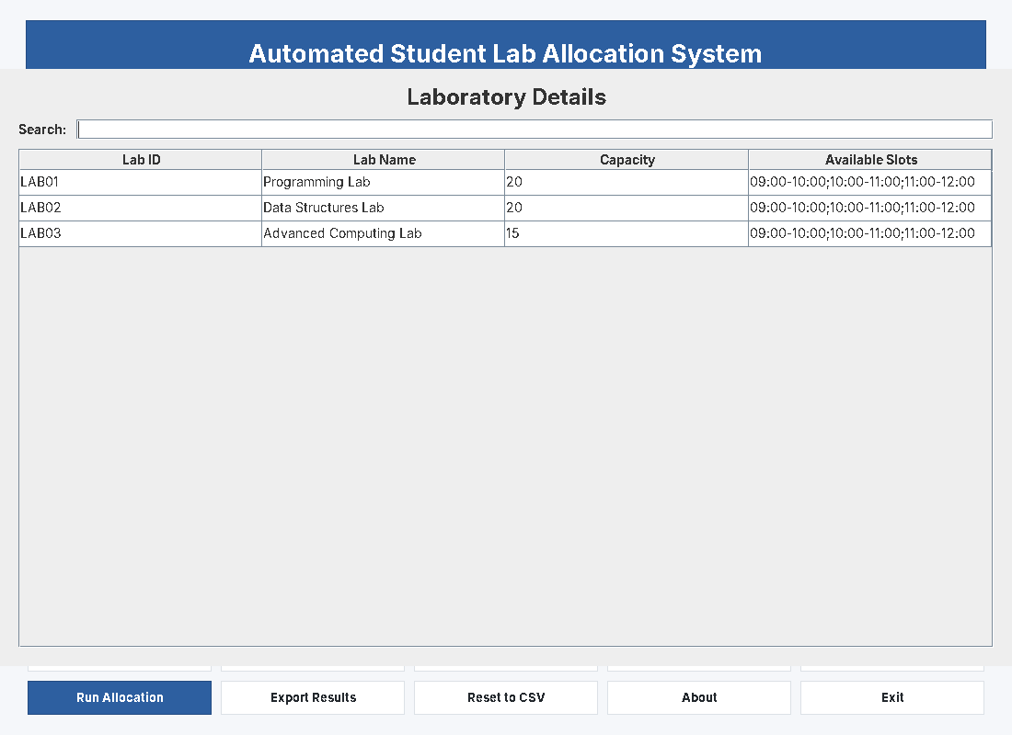
Fig 7.3: Laboratory Details
Three laboratories are loaded: Programming Lab (20), Data Structures Lab (20) and Advanced Computing Lab (15), each available in three one-hour slots.
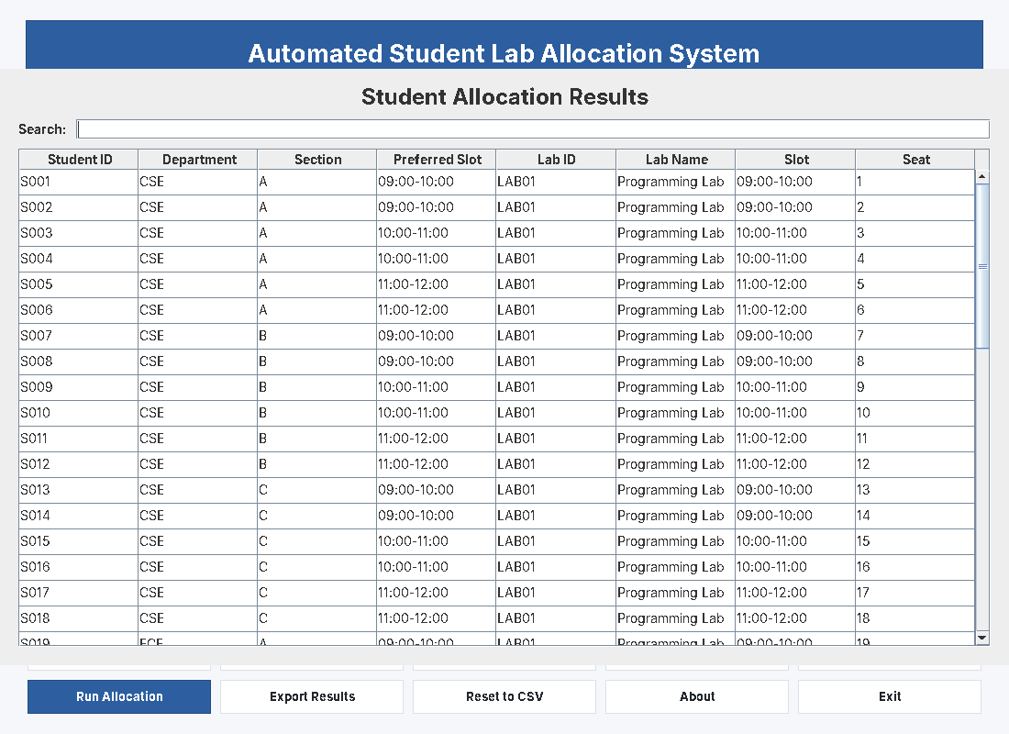
Fig 7.4: Student Allocation Results
Every student is shown with the lab, slot and seat assigned by the matching. In every row the allocated slot equals the preferred slot and no seat appears twice.
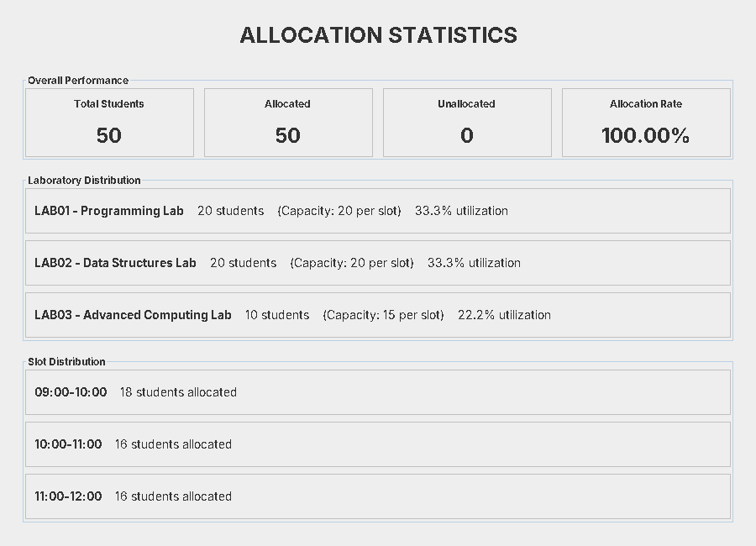
Fig 7.5: Allocation Statistics
LAB01 and LAB02 receive 20 students each and LAB03 receives 10. The slot distribution is 18, 16 and 16 students, equal to the number requested for each slot.
Test results
Test case | Students | Seats | Allocated | Unallocated | Rate
1. Supplied dataset (balanced slots) | 50 | 165 | 50 | 0 | 100.00%
2. Over-subscribed (60 students, all 09:00-10:00) | 60 | 165 | 55 | 5 | 91.67%

Discussion. In test 1 the demand per slot (18, 16, 16) is below the 55 seats available in each slot, so a complete matching exists and all students are allocated. The result file contained 50 distinct seats, so no seat was shared, and every student received his or her preferred slot. Lab-wise counts were 20, 20 and 10 because students are spread across labs and fill LAB01 and LAB02 first.
In test 2 only 55 seats exist in the 09:00-10:00 slot (20 + 20 + 15), so at most 55 of the 60 students can be served. The algorithm allocated exactly 55 (all three laboratories filled to capacity) and listed the remaining 5 students (S056 to S060) as unallocated. This confirms that the matching is maximum and that the system reports shortages instead of double-booking seats. Note that the current graph uses slot compatibility only; the priority column is stored and displayed but is not yet used to decide who is left out.
- CONCLUSION & FUTURE SCOPE
The project set out to build an automated student-to-laboratory allocation system based on maximum bipartite matching, and this was achieved. Students and laboratory seats were modelled as a bipartite graph, and the augmenting-path algorithm produced allocations in which every student receives at most one seat, no seat is shared, and the number of assignments is the largest possible. The system allocated all 50 students of the supplied dataset (100%), correctly allocated 55 of 60 students in an over-subscribed case, and produced allocation tables, statistics and a CSV report through a Java Swing interface. The project shows that graph matching algorithms can be applied directly to real scheduling problems.
Future Scope
• Near term: use the Priority field and a ranked list of preferred slots and labs, so that students who cannot get their first choice receive the next best one; add input validation and a printable PDF report.
• Medium term: replace the unweighted matching with weighted matching (Hungarian algorithm or min-cost max-flow) and switch to Hopcroft–Karp for O(E√V) performance on large student populations; add constraints such as department-specific labs and section-wise batches.
• Long term: provide a web-based version with a database, student login and e-mail/SMS notifications, and integrate with the university timetable so that allocations are re-computed automatically when labs or slots change.
- REFERENCES
1. T. H. Cormen, C. E. Leiserson, R. L. Rivest and C. Stein, Introduction to Algorithms, 4th ed., MIT Press, 2022 (chapter on Maximum Flow, maximum bipartite matching).
2. “Matching (graph theory)”, Wikipedia. https://en.wikipedia.org/wiki/Matching_(graph_theory)
3. “Kuhn’s Algorithm – Maximum Bipartite Matching”, CP-Algorithms. https://cp-algorithms.com/graph/kuhn_maximum_bipartite_matching.html
4. “Maximum Bipartite Matching”, GeeksforGeeks. https://www.geeksforgeeks.org/maximum-bipartite-matching/
5. J. E. Hopcroft and R. M. Karp, “An n^5/2 algorithm for maximum matchings in bipartite graphs”, SIAM Journal on Computing, 2(4), 225–231, 1973. Overview: https://en.wikipedia.org/wiki/Hopcroft%E2%80%93Karp_algorithm
6. H. W. Kuhn, “The Hungarian method for the assignment problem”, Naval Research Logistics Quarterly, 2(1–2), 83–97, 1955. Overview: https://en.wikipedia.org/wiki/Hungarian_algorithm
7. D. Gale and L. S. Shapley, “College admissions and the stability of marriage”, American Mathematical Monthly, 69(1), 9–15, 1962. Overview: https://en.wikipedia.org/wiki/Stable_marriage_problem
8. “Ford–Fulkerson algorithm”, Wikipedia. https://en.wikipedia.org/wiki/Ford%E2%80%93Fulkerson_algorithm
9. “Hall’s marriage theorem”, Wikipedia. https://en.wikipedia.org/wiki/Hall%27s_marriage_theorem
10. “Creating a GUI with Swing”, The Java Tutorials, Oracle. https://docs.oracle.com/javase/tutorial/uiswing/

