INTER VISION
NETWORK RECONNAISSANCE AND
FOOTPRINTING FRAMEWORK

TECHNICAL REPORT

Prepared by
M RITHWIK KUMAR

Project Domain:
Cyber Security / Ethical Hacking / Network Security

Tools & Technologies Used:
Kali Linux, Nmap, WHOIS, DIG, NSLOOKUP,
Sublist3r, CURL, Ping, Traceroute

Date: May 2026

FOR EDUCATIONAL AND AUTHORIZED SECURITY RESEARCH PURPOSES ONLY

ABSTRACT

Reconnaissance and footprinting are essential phases in cybersecurity assessment and ethical hacking. These processes involve gathering publicly accessible information about a target system, domain, or network in order to understand its infrastructure, services, and potential exposure to security threats.

This project, titled “INTER VISION: Network Reconnaissance and Footprinting Framework”, focuses on performing ethical and controlled information gathering using open-source cybersecurity tools available in Kali Linux. The project demonstrates how network intelligence can be collected using techniques such as WHOIS enumeration, DNS analysis, subdomain discovery, Google Dorking, network connectivity testing, traceroute analysis, web server fingerprinting, and port scanning.

Various tools including WHOIS, DIG, NSLOOKUP, Sublist3r, cURL, Ping, Traceroute, and Nmap were used to identify domain registration details, DNS records, publicly accessible resources, active services, and web server information related to the authorized target system.

The findings obtained during the reconnaissance process were analyzed and documented to understand how exposed network information may contribute to cybersecurity risks if not responsible security assessment methodologies.

This framework is intended strictly for educational and authorized cybersecurity research purposes only.

TABLE OF CONTENTS

Abstract ii
Table of Contents iii
List of Figures vi

1. Introduction 7
1.1 Overview 7
1.2 Background of the Study 8
1.3 Need for the Project 9
1.4 Objectives of the Project 9
1.5 Scope of the Project 10

2. Tools and Technologies Used 11
2.1 Kali Linux 11
2.2 Nmap 11
2.3 WHOIS 11
2.4 DIG 11
2.5 NSLOOKUP 12
2.6 Sublist3r 12
2.7 cURL 12
2.8 Ping 12
2.9 Traceroute 13
2.10 Google Dorking 13

3. Methodology 14
3.1 Methodology Overview 14
3.2 Reconnaissance Workflow 14
3.3 Passive Reconnaissance 16
3.4 Active Reconnaissance 16
3.5 Information Analysis 17
3.6 Ethical Consideration 17

4. System Architecture 18
4.1 Architecture Overview 18
4.2 Reconnaissance Architecture 18
4.3 Network Topology 19
4.4 Information Flow 21
4.5 Architecture Advantages 21

5. Reconnaissance and Findings 22
5.1 WHOIS Enumeration 22
5.2 DNS Enumeration 23
5.3 MX Record Enumeration 24
5.4 NS Record Enumeration 25
5.5 Subdomain Enumeration 26
5.6 Google Dorking 27
5.7 Ping Analysis 29
5.8 Traceroute Analysis 30
5.9 Web Server Fingerprinting 31
5.10 Nmap Port Scanning 32

6. Results and Analysis 34
6.1 Result Overview 34
6.2 Information Gathered 34
6.3 Service Detection Results 34
6.4 Analysis 35
6.5 Summary 35

7. Conclusion 36

8. References 37

LIST OF FIGURES

Figure 3.1 Reconnaissance Workflow Diagram 15
Figure 4.1 System Architecture Diagram 19
Figure 4.2 Network Topology Diagram 20
Figure 5.1 WHOIS Enumeration Output 22
Figure 5.2 DNS Enumeration Output 23
Figure 5.3 MX Record Lookup Output 24
Figure 5.4 NS Record Lookup Output 25
Figure 5.5 Subdomain Enumeration Output 26
Figure 5.6.1 Google Dorking Result 27
Figure 5.6.2 Google Dorking Login Page Result 28
Figure 5.6.3 Google Dorking Directory Listing Result 29
Figure 5.7 Ping Analysis Output 30
Figure 5.8 Traceroute Analysis Output 31
Figure 5.9 Web Fingerprinting Output 32
Figure 5.10 Nmap Scan Output 33

CHAPTER 1
INTRODUCTION
1.1 Overview
In the modern digital era, computer networks and internet-based services play a critical role in communication, business operations, cloud computing, and information exchange. As organizations increasingly rely on interconnected systems, the exposure of network infrastructure to cyber threats has also increased significantly. Attackers often gather publicly available information about a target before launching cyber attacks. This initial phase is known as reconnaissance or footprinting.
Reconnaissance is one of the most important stages in cybersecurity assessment and ethical hacking. It involves collecting information related to domains, IP addresses, servers, services, DNS records, operating systems, and publicly accessible resources. By performing reconnaissance, security professionals can identify exposed services, weak configurations, and publicly available sensitive information before malicious attackers exploit them.
Footprinting helps organizations understand how much information about their infrastructure is publicly accessible on the internet. This information may include domain registration details, DNS records, subdomains, server details, login portals, exposed documents, and open network services. If such information is not properly secured, it can increase the attack surface of the organization.
The project “INTER VISION: Network Reconnaissance and Footprinting Framework” focuses on performing ethical and controlled information gathering on a publicly approved target using open-source cybersecurity tools available in Kali Linux. The project demonstrates how attackers and security analysts collect network intelligence using passive and active reconnaissance techniques.
The project includes multiple stages such as WHOIS enumeration, DNS analysis, subdomain discovery, Google Dorking, network connectivity testing, traceroute analysis, web server fingerprinting, and port scanning. These techniques help in understanding the network structure, identifying publicly exposed services, and analyzing the security posture of the target system.
The implementation uses tools such as Nmap, WHOIS, DIG, NSLOOKUP, cURL, Sublist3r, Ping, and Traceroute within a Kali Linux virtual environment. The gathered information is analyzed and documented to understand how reconnaissance activities contribute to cybersecurity assessments and penetration testing methodologies.
This project is performed strictly in a legal and ethical environment using publicly accessible and authorized targets. The primary objective is educational and security-oriented analysis rather than unauthorized intrusion or exploitation.

1.2 Background of the Study
Cybersecurity threats have evolved rapidly over the past decade due to the widespread adoption of internet technologies, cloud services, and remote connectivity. Organizations continuously face risks such as unauthorized access, data breaches, phishing attacks, ransomware, and network intrusions. Before performing advanced attacks, cyber attackers typically conduct reconnaissance to gather intelligence about the target environment.
Reconnaissance is generally categorized into passive reconnaissance and active reconnaissance. Passive reconnaissance involves collecting information without directly interacting with the target systems, such as using WHOIS records, DNS information, search engines, and publicly indexed documents. Active reconnaissance involves direct interaction with the target using tools such as ping, traceroute, and network scanners to identify active hosts, open ports, and running services.
Ethical hackers and penetration testers use reconnaissance techniques to evaluate the security posture of organizations and identify vulnerabilities before they can be exploited by malicious actors. Network scanning and footprinting also help administrators understand the visibility of their infrastructure on the internet and implement better security controls.
Open-source tools available in Kali Linux provide powerful capabilities for reconnaissance and network analysis. Tools such as Nmap and Sublist3r allow cybersecurity professionals to gather detailed information about systems, services, and domains. Understanding these tools and techniques is essential for students and professionals working in cybersecurity and network security domains.

1.3 Need for the Project
Many organizations unknowingly expose sensitive information through publicly accessible services, DNS records, misconfigured servers, and indexed web content. Attackers can utilize this information to plan cyber attacks, identify weak entry points, and exploit vulnerable services. The need for this project arises from the importance of identifying publicly available information before attackers can misuse it. By performing ethical reconnaissance and footprinting, organizations can:
- Identify exposed network services
- Detect unnecessary open ports
- Discover publicly accessible resources
- Analyze server information leakage
- Improve overall network security posture
This project also provides practical exposure to real-world cybersecurity methodologies and helps in understanding how information gathering forms the foundation of penetration testing and security assessment processes.

1.4 Objectives of the Project
The primary objectives of this project are:
- To perform ethical reconnaissance on an authorized target
- To gather publicly accessible domain and DNS information
- To identify subdomains and server-related information
- To perform network connectivity and latency analysis
- To identify active services and open ports using Nmap
- To perform web server fingerprinting using HTTP headers
- To understand the importance of reconnaissance in cybersecurity
- To document and analyze all findings in a structured format
1.5 Scope of the Project
The scope of this project is limited to authorized and non-intrusive reconnaissance activities performed on publicly accessible targets. The project focuses only on information gathering and analysis techniques without performing exploitation, privilege escalation, or malicious activities.
The project includes:
- WHOIS enumeration
- DNS and MX record analysis
- Subdomain enumeration
- Google Dorking
- Ping and traceroute analysis
- Web server fingerprinting
- Port scanning and service detection
The project does not include:
- Unauthorized exploitation
- Malware deployment
- Credential attacks
- Denial of Service attacks
- Data modification or destruction
The framework is intended purely for educational purposes, ethical hacking practice, and cybersecurity awareness.

CHAPTER 2
TOOLS AND TECHNOLOGIES USED

2.1 Kali Linux
Kali Linux is a Debian-based Linux distribution designed specifically for penetration testing, ethical hacking, and cybersecurity research. It provides a large collection of pre-installed security tools used for reconnaissance, network analysis, vulnerability assessment, and digital forensics. In this project, Kali Linux was used as the primary operating environment for performing all reconnaissance and footprinting activities.

2.2 Nmap
Nmap (Network Mapper) is an open-source network scanning tool widely used for network discovery, service detection, port scanning, and operating system fingerprinting. In this project, Nmap was used to identify open ports, active services, and basic information about the target host.

2.3 WHOIS
WHOIS is a protocol and command-line utility used to retrieve domain registration information from WHOIS databases. It provides details such as registrar information, domain creation date, expiry date, administrative contacts, and name servers. WHOIS was used in this project to gather public information related to the target domain.

2.4 DIG
DIG (Domain Information Groper) is a command-line DNS lookup utility used for querying DNS servers and retrieving DNS records. It supports advanced DNS analysis including A records, MX records, and NS records. In this project, DIG was used for DNS enumeration and domain analysis.

2.5 NSLOOKUP
NSLOOKUP is a network administration utility used for querying domain name servers and obtaining DNS-related information. It helps identify IP addresses, mail servers, and authoritative name servers associated with a domain. The tool was used to perform DNS resolution and record analysis.

2.6 Sublist3r
Sublist3r is an open-source subdomain enumeration tool used for discovering publicly accessible subdomains through passive reconnaissance methods. It utilizes search engines and online sources to identify subdomains related to a target domain. The tool was used in this project for subdomain discovery and reconnaissance.

2.7 cURL
cURL is a command-line utility used for transferring data using various network protocols including HTTP and HTTPS. It can retrieve HTTP response headers and web server information. In this project, cURL was used for web server fingerprinting and identifying server-related information.

2.8 Ping
Ping is a network diagnostic utility used to test connectivity between systems and measure network latency. It sends ICMP echo requests to the target system and analyzes the responses. Ping was used in this project to verify connectivity and analyze response times.

2.9 Traceroute
Traceroute is a network diagnostic tool used to identify the path taken by packets between the source and target systems. It displays intermediate network hops and routing information. In this project, traceroute was used to analyze the network path to the target system.

2.10 Google Dorking
Google Dorking is an advanced search technique used to identify publicly accessible resources, login pages, files, and sensitive information indexed by search engines. In this project, Google Dorking was used for passive reconnaissance and publicly exposed resource discovery.

CHAPTER 3
METHODOLOGY

3.1 Methodology Overview
The methodology followed in this project focuses on ethical reconnaissance and footprinting techniques used to gather publicly accessible information about an authorized target system. The project was performed using open-source cybersecurity tools available in the Kali Linux environment. The methodology was divided into multiple phases, including domain information gathering, DNS enumeration, subdomain discovery, network analysis, web fingerprinting, and port scanning. Each phase was performed systematically to collect and analyze information related to the target infrastructure.

3.2 Reconnaissance Workflow
The reconnaissance workflow followed in this project begins with target identification and proceeds through multiple stages of information gathering and analysis. The workflow includes both passive and active reconnaissance techniques.
The major stages involved in the workflow are:
• Target Selection
• WHOIS Enumeration
• DNS Enumeration
• Subdomain Discovery
• Google Dorking
• Ping and Traceroute Analysis
• Web Fingerprinting
• Nmap Port Scanning
• Result Analysis and Documentation
The collected information from each phase was carefully analyzed and documented to understand the security exposure and publicly accessible information related to the target system.
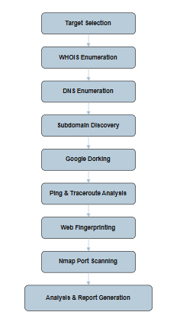
Figure 3.1: Reconnaissance Workflow Diagram

The above workflow diagram represents the overall reconnaissance and footprinting process followed in the project. The process begins with target selection and continues through multiple stages including WHOIS enumeration, DNS analysis, subdomain discovery, Google Dorking, network analysis, web fingerprinting, and Nmap port scanning. The collected information is finally analyzed and documented in the generated technical report.

3.3 Passive Reconnaissance
Passive reconnaissance involves gathering information without directly interacting with the target system. This technique minimizes detection while collecting publicly available information.
In this project, passive reconnaissance techniques included:
• WHOIS Enumeration
• DNS Record Analysis
• Google Dorking
• Subdomain Enumeration
WHOIS enumeration was used to obtain domain registration details, registrar information, and name servers. DNS analysis helped identify A records, MX records, and NS records associated with the target domain. Google Dorking techniques were used to locate publicly indexed resources and login pages. Subdomain enumeration helped identify additional publicly accessible services.

3.4 Active Reconnaissance
Active reconnaissance involves direct interaction with the target system to collect network-related information. These techniques provide more accurate results but may generate detectable traffic.
The active reconnaissance techniques used in this project include:
• Ping Analysis
• Traceroute Analysis
• Web Server Fingerprinting
• Nmap Port Scanning
Ping analysis was used to verify target availability and measure network latency. Traceroute analysis helped identify intermediate network hops and routing paths. cURL was used for web server fingerprinting through HTTP header analysis. Nmap scanning was performed to identify open ports and active services running on the target system.

3.5 Information Analysis
The information gathered during reconnaissance was analyzed to understand the target’s network exposure, publicly accessible resources, and active services.
The collected data included:
• Domain registration details
• DNS records
• Subdomains
• HTTP server information
• Network routing details
• Open ports and services
The findings were documented systematically to understand how publicly exposed information may contribute to cybersecurity risks if not properly secured.

3.6 Ethical Considerations
All reconnaissance activities performed in this project were conducted strictly in an ethical and authorized environment. Only publicly accessible and approved targets were used during the implementation process.

No exploitation, unauthorized access, denial of service, credential attacks, or malicious activities were performed during this project. The framework was developed purely for educational purposes, cybersecurity awareness, and ethical security research.

CHAPTER 4
SYSTEM ARCHITECTURE

4.1 Architecture Overview
The system architecture of the project represents the overall structure and interaction between the attacker machine, reconnaissance tools, internet infrastructure, and the target system. The architecture demonstrates how information is collected, analyzed, and documented during the reconnaissance and footprinting process.
The project was implemented using a Kali Linux virtual machine containing various open-source cybersecurity tools. These tools interact with publicly accessible internet services and authorized target systems to gather network-related information.

4.2 Reconnaissance Architecture
The reconnaissance architecture consists of the following major components:
• Kali Linux Environment
• Reconnaissance Tools
• Internet Infrastructure
• Target System
• Analysis and Reporting Module
The Kali Linux environment acts as the primary platform for executing reconnaissance activities. Various tools such as WHOIS, DIG, NSLOOKUP, Sublist3r, cURL, Ping, Traceroute, and Nmap are used to collect information related to the target system.

The target system responds to DNS queries, HTTP requests, ICMP packets, and scanning operations, allowing the collection of publicly accessible information. The gathered information is then analyzed and documented in the final technical report.

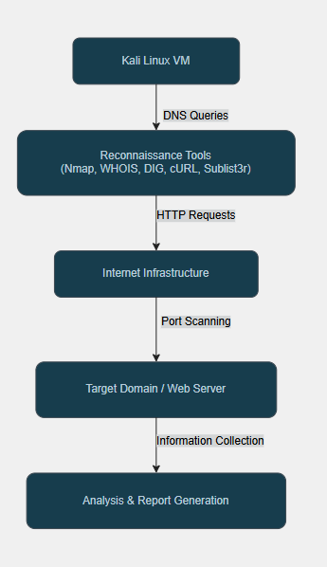
Figure 4.1: System Architecture Diagram

The above diagram represents the overall architecture of the reconnaissance framework used in the project. It illustrates the interaction between the Kali Linux environment, reconnaissance tools, internet infrastructure, and the target system during the information gathering process.

4.3 Network Topology
The network topology used in this project represents a basic reconnaissance communication model between the attacker machine and the authorized target system through the internet.
The topology includes:
• Kali Linux Virtual Machine
• Local Network/Router
• Internet
• Target Domain/Web Server
The reconnaissance tools communicate with the target through standard internet protocols such as DNS, HTTP, HTTPS, and ICMP. The responses obtained from the target are analyzed to identify publicly exposed services and network-related information.

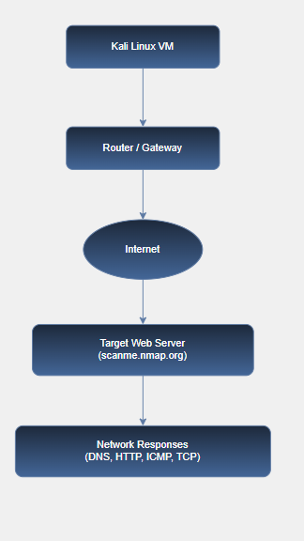
Figure 4.2: Network Topology Diagram

The above diagram illustrates the network topology used during the reconnaissance and footprinting process. The Kali Linux virtual machine communicates with the target web server through the router and internet infrastructure. Various network protocols such as DNS, HTTP, ICMP, and TCP are used to collect publicly accessible information from the target system.

4.4 Information Flow
The information flow in the system begins with target selection and continues through multiple phases of information gathering and analysis.
The major stages of information flow include:
1. Domain Information Gathering
2. DNS Enumeration
3. Subdomain Discovery
4. Public Resource Identification
5. Network Connectivity Analysis
6. Web Server Fingerprinting
7. Port and Service Detection
8. Result Analysis and Documentation
Each stage contributes additional information related to the target infrastructure and helps in building a complete reconnaissance profile of the system.

4.5 Architecture Advantages
The proposed reconnaissance architecture provides multiple advantages including:
• Modular reconnaissance workflow
• Easy integration of additional tools
• Structured information gathering
• Efficient network analysis
• Ethical and controlled implementation
• Improved understanding of target exposure
The architecture is lightweight, flexible, and suitable for educational cybersecurity research and ethical hacking practice.

CHAPTER 5
RECONNAISSANCE AND FINDINGS

5.1 WHOIS Enumeration
Objective: To gather publicly accessible domain registration information related to the target domain.
Command Used:
- whois nmap.org
Observations :
• Registrar information was identified
• Domain creation and expiry details were obtained
• Configured name servers were discovered

Findings: Public domain registration information associated with the target domain was successfully identified through WHOIS enumeration.

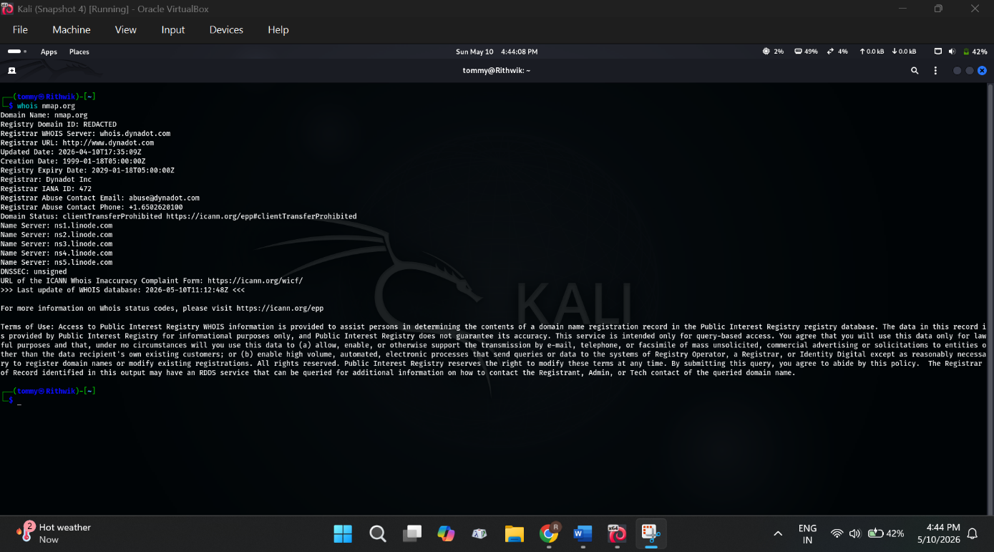
Figure 5.1: WHOIS Enumeration Output

The above figure shows the WHOIS enumeration performed on the target domain using Kali Linux. The output reveals publicly accessible information such as registrar details, domain dates, and name server information associated with the target domain.

5.2 DNS Enumeration
Objective : To identify DNS records and IP address information associated with the target domain.
Commands Used :
- nslookup scanme.nmap.org
- dig scanme.nmap.org
Observations :
• IPv4 and IPv6 addresses were identified
• DNS resolution was successful
• DNS infrastructure details were obtained

Findings : DNS enumeration successfully revealed network-related information associated with the target system.

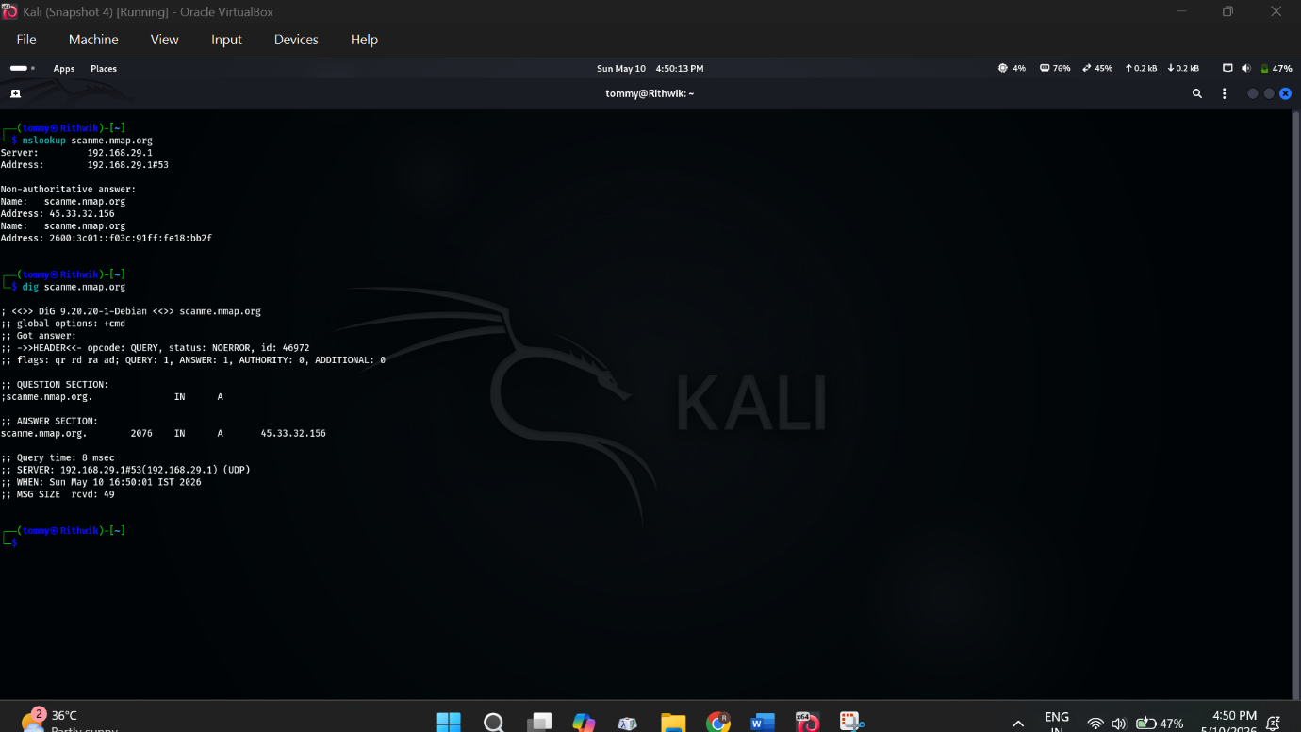
Figure 5.2: DNS Enumeration Output
The above figure shows the DNS enumeration performed using NSLOOKUP and DIG utilities in Kali Linux. The output reveals the IPv4 and IPv6 addresses associated with the target domain and confirms successful DNS resolution.

5.3 MX Record Enumeration
Objective : To identify mail servers associated with the target domain.
Commands Used :
- nslookup -type=mx nmap.org
- dig mx nmap.org
Observations :
• Multiple mail exchange servers were identified
• Email infrastructure information was obtained

Findings : MX record analysis revealed publicly accessible mail server information related to the target domain.

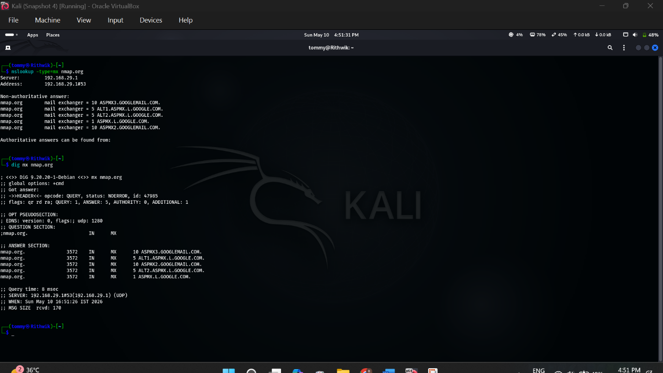
Figure 5.3: MX Record Enumeration Output

The above figure shows the MX record enumeration performed on the target domain using NSLOOKUP and DIG utilities in Kali Linux. The output reveals multiple mail exchange servers associated with the domain and provides information about the email infrastructure configuration.
5.4 NS Record Enumeration
Objective : To identify authoritative name servers configured for the target domain.
Commands Used :
- nslookup -type=ns nmap.org
- dig ns nmap.org
Observations :
• Authoritative name servers were identified
• DNS hosting infrastructure was analyzed

Findings : NS record enumeration successfully identified DNS server information associated with the target domain.

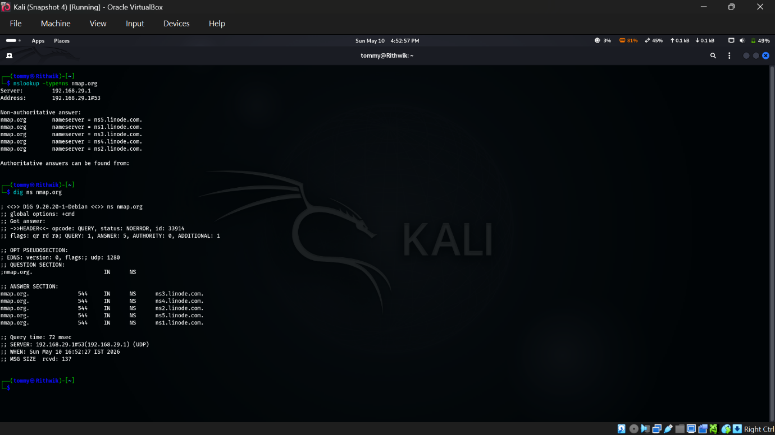
Figure 5.4: NS Record Enumeration Output

The above figure shows the NS record enumeration performed using NSLOOKUP and DIG utilities in Kali Linux. The output reveals the authoritative name servers associated with the target domain and provides information about its DNS infrastructure.

5.5 Subdomain Enumeration
Objective : To identify publicly accessible subdomains related to the target domain.
Command Used :
- sublist3r -d nmap.org
Observations :
• Multiple subdomains were discovered
• Additional publicly accessible services were
identified

Findings : Subdomain enumeration revealed additional attack surface information related to the target domain.

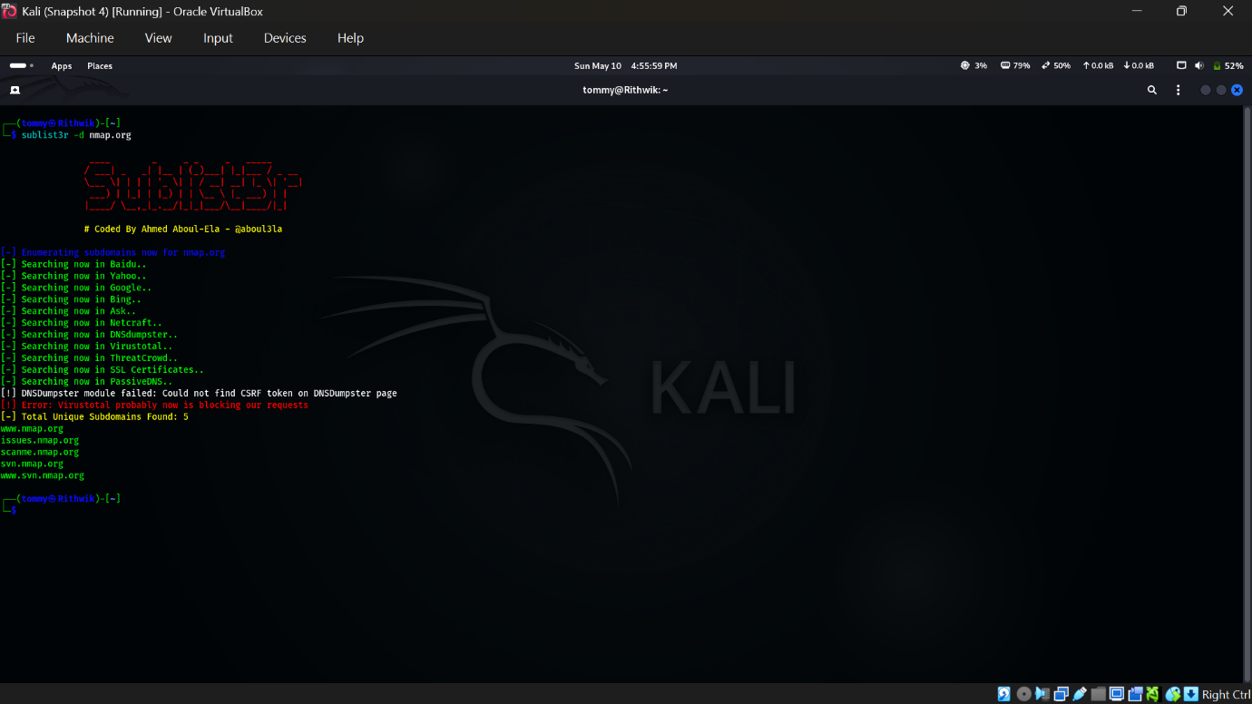
Figure 5.5: Subdomain Enumeration Output

The above figure shows the subdomain enumeration performed using the Sublist3r tool in Kali Linux. The output reveals multiple publicly accessible subdomains associated with the target domain and helps identify additional exposed services.

5.6 Google Dorking
Objective : To identify publicly indexed resources and web content associated with the target domain.
Queries Used :
- site:nmap.org filetype:pdf
- site:nmap.org login
- site:nmap.org intitle:"index of"
Observations :
• Publicly accessible files were identified
• Login-related pages were discovered
• Indexed web resources were analyzed

Findings : Google Dorking techniques successfully identified publicly indexed resources associated with the target domain.


Figure 5.6.1: Google Dorking Results
The above figure shows the Google Dorking process performed on the target domain using advanced search queries. The search results revealed publicly indexed PDF documents and web resources associated with the target domain.

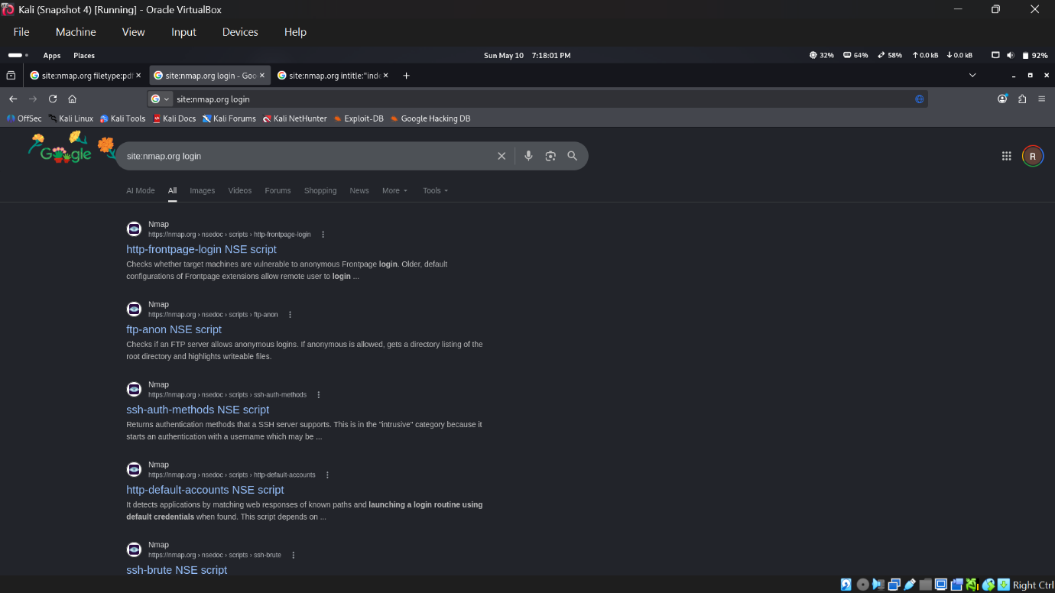
Figure 5.6.2: Google Dorking Login Page Results

The above figure shows the Google Dorking results obtained using login-related search queries on the target domain. The search results reveal publicly indexed login pages and web resources associated with the target website.


Figure 5.6.3: Google Dorking Directory Listing Results

The above figure shows the Google Dorking results obtained using the “intitle:index of” query on the target domain. The search results reveal publicly indexed directory listings and accessible web resources associated with the target website.

5.7 Ping Analysis
Objective : To verify target connectivity and analyze network latency.
Command Used :
- ping -c 4 scanme.nmap.org
Observations :
• Target host responded successfully
• Network latency information was obtained
• ICMP connectivity was verified
Findings : Ping analysis confirmed network connectivity and basic communication with the target host.

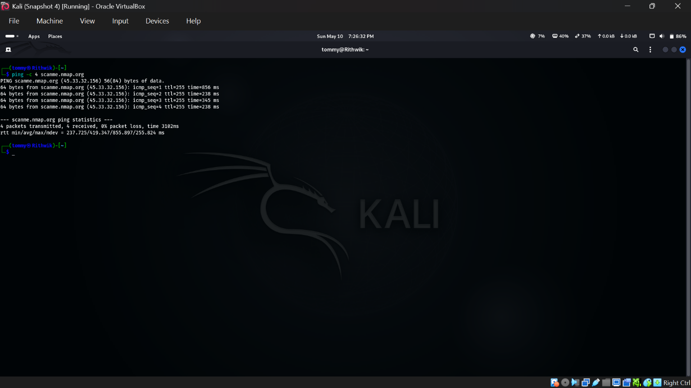
Figure 5.7: Ping Analysis Output

The above figure shows the ping analysis performed on the target domain using the Ping utility in Kali Linux. The output confirms successful network connectivity and provides round-trip time statistics between the local system and the target host.

5.8 Traceroute Analysis
Objective : To identify the network path between the local system and the target host.
Command Used :
- traceroute scanme.nmap.org
Observations :
• Multiple network hops were identified
• Routing path information was analyzed

Findings : Traceroute analysis successfully revealed the routing path to the target system.

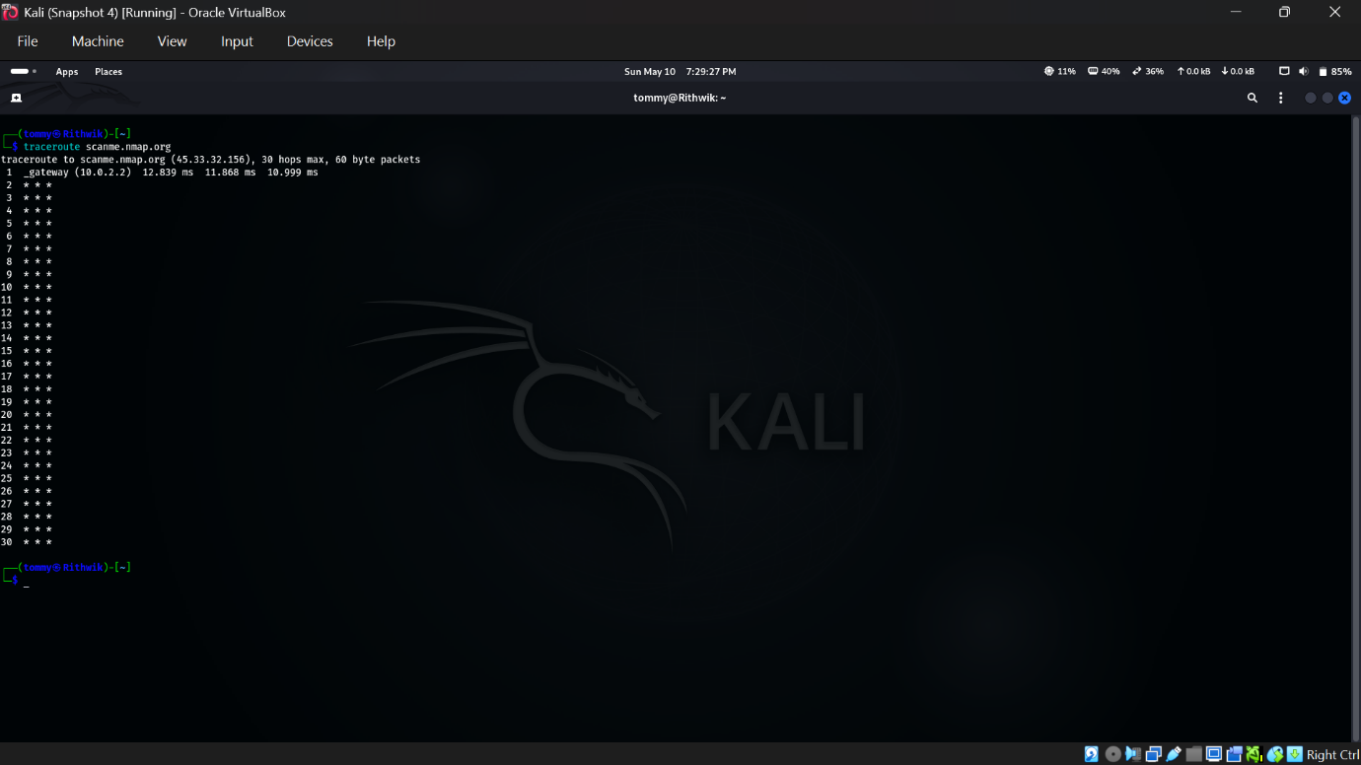
Figure 5.8: Traceroute Analysis Output

The above figure shows the traceroute analysis performed on the target domain using the Traceroute utility in Kali Linux. The output displays the network path and intermediate hops between the local system and the target host.

5.9 Web Fingerprinting
Objective : To identify web server technologies and HTTP header information associated with the target.
Command Used :
- curl -I http://scanme.nmap.org
Observations :
• HTTP response headers were retrieved
• Web server information was identified

Findings : Web fingerprinting revealed publicly accessible server-related information associated with the target web server.

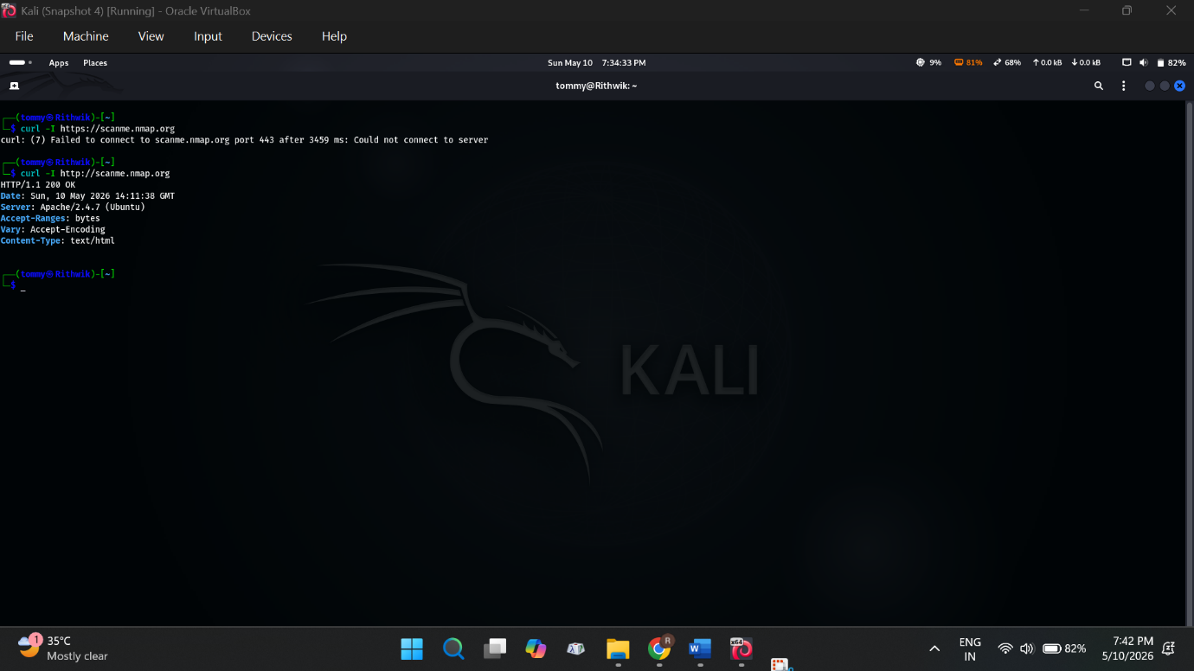
Figure 5.9: Web Fingerprinting Output

The above figure shows the web fingerprinting performed using the cURL utility in Kali Linux. The output reveals HTTP response headers and web server information associated with the target website.

5.10 Nmap Port Scanning
Objective : To identify open ports and active services running on the target host.
Command Used :
- nmap -F scanme.nmap.org
Observations:
• Open ports were identified
• Active network services were detected
• Service accessibility was analyzed

Findings : Nmap scanning successfully identified publicly accessible services running on the target system.

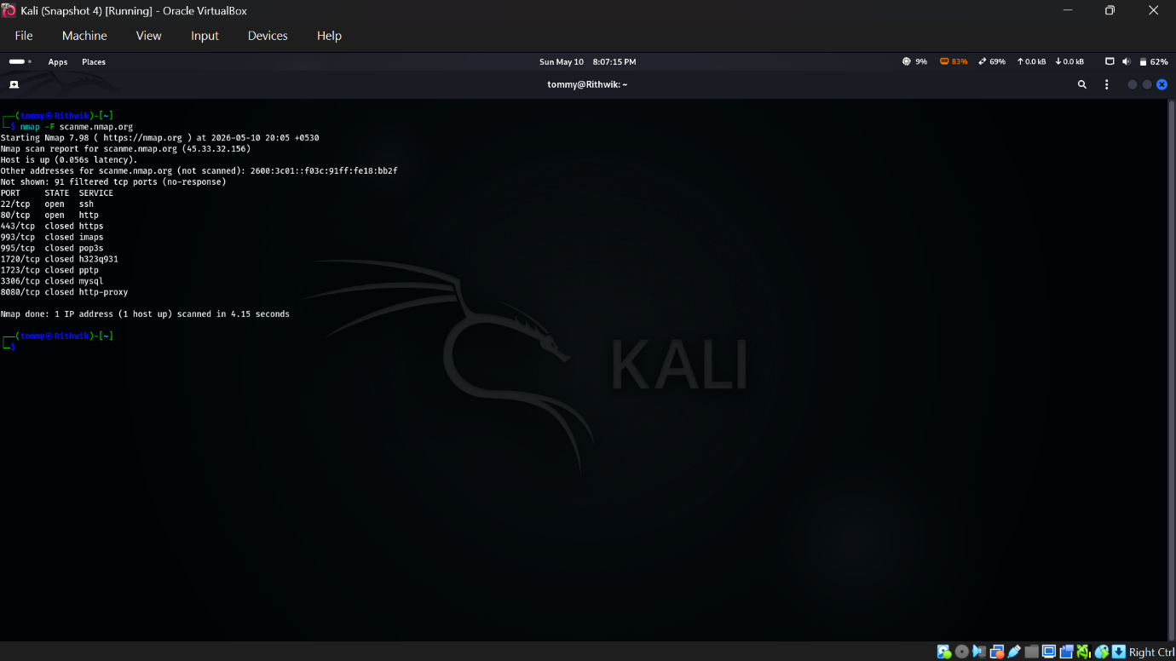
Figure 5.10: Nmap Port Scanning Output

The above figure shows the Nmap port scanning performed on the target host using Kali Linux. The output reveals open and closed TCP ports along with the active network services running on the target system.

CHAPTER 6
RESULTS AND ANALYSIS

6.1 Results Overview
The reconnaissance and footprinting activities performed during the project successfully identified multiple publicly accessible details related to the target domain and network infrastructure. The collected information included domain registration details, DNS records, subdomains, network routing information, HTTP server details, and active network services.

6.2 Information Gathered

The following table summarizes the information obtained during the reconnaissance process.

Reconnaissance Activity | Information Obtained
WHOIS Enumeration | Registrar details, domain information
DNS Enumeration | IPv4 and IPv6 addresses
MX Record Analysis | Mail server information
NS Record Analysis | Authoritative name servers
Subdomain Enumeration | Publicly accessible subdomains
Google Dorking | Indexed files and login pages
Ping Analysis | Connectivity and latency details
Traceroute Analysis | Network routing path
Web Fingerprinting | HTTP server information
Nmap Scanning | Open ports and active services

6.3 Service Detection Results
The Nmap scanning process identified multiple active services running on the target system.

The following table summarizes the detected ports and associated services.
Port Number | Protocol | Service
22 | TCP | SSH
80 | TCP | HTTP

6.4 Analysis
The reconnaissance process demonstrated how publicly accessible information can reveal important details about network infrastructure and exposed services. The identified DNS records, server information, subdomains, and open ports highlight the importance of properly securing internet-facing systems and minimizing unnecessary public exposure. The project also demonstrated the effectiveness of open-source reconnaissance tools available in Kali Linux for ethical cybersecurity assessments.

6.5 Summary
The reconnaissance activities performed during the project successfully gathered publicly accessible information related to the authorized target system. The findings demonstrate the importance of reconnaissance in cybersecurity assessment and ethical hacking methodologies.

CHAPTER 7

CONCLUSION

The project “INTER VISION: Network Reconnaissance and Footprinting Framework” successfully demonstrated ethical reconnaissance and information gathering techniques using open-source cybersecurity tools available in Kali Linux.

Various reconnaissance activities including WHOIS enumeration, DNS analysis, subdomain discovery, Google Dorking, network analysis, web server fingerprinting, and Nmap scanning were performed on an authorized public target. The collected information provided insights into publicly exposed network infrastructure and active services.

The project highlighted the importance of reconnaissance in cybersecurity assessments and ethical hacking methodologies. It also demonstrated how publicly accessible information may contribute to potential security risks if not properly secured.

The implementation was performed strictly in an ethical and controlled environment for educational and cybersecurity research purposes only.

REFERENCES

[1] Gordon Lyon, “Nmap Network Scanning,” Official Nmap Documentation.
Available: https://nmap.org/book/
[2] Kali Linux Documentation,
Available: https://www.kali.org/docs/
[3] Internet Corporation for Assigned Names and Numbers (ICANN), WHOIS Protocol Information.
Available: https://whois.icann.org/
[4] Linux Manual Pages, DIG Command Documentation.
Available: https://linux.die.net/man/1/dig
[5] Linux Manual Pages, NSLOOKUP Command Documentation.
Available: https://linux.die.net/man/1/nslookup
[6] OWASP Foundation, “Information Gathering and Reconnaissance.”
Available: https://owasp.org/
[7] Sublist3r GitHub Repository.
Available: https://github.com/aboul3la/Sublist3r
[8] cURL Documentation.
Available: https://curl.se/docs/
[9] Wireshark Foundation, Network Analysis Documentation.
Available: https://www.wireshark.org/docs/
[10] RFC 1035, Domain Names - Implementation and Specification.
Available: https://datatracker.ietf.org/

