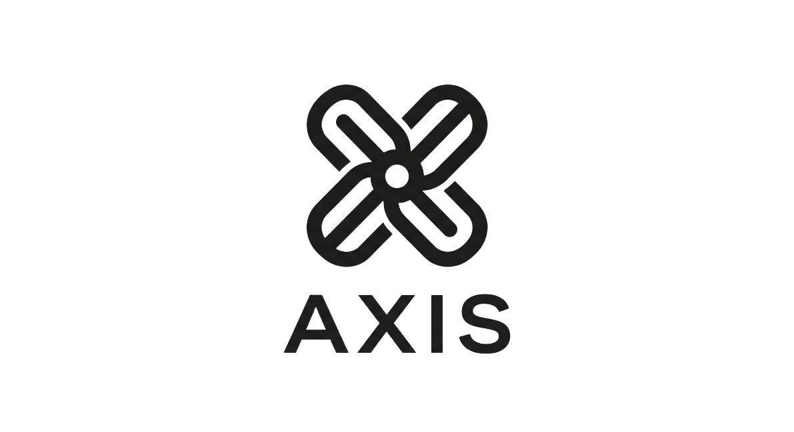

Vision
Axis is a unified organizational ecosystem for IB schools focused on seamless operational workflows, contextual collaboration, and reduced friction across educational environments.
Axis aims to replace fragmented school software experiences with one connected system built around communication, coordination, organization, and workflow continuity.

Core principles
Seamlessness
Integration
Reduced friction
Contextual workflows
One identity system
Modular environments
Shared infrastructure
Workflow-first design
Organizational coherence
Smart organization
Low cognitive load
Operational simplicity
Adaptive experiences
User-first ecosystem

Problem statement
Schools operate through fragmented software ecosystems that force teachers, students, and administrators to constantly switch between disconnected platforms for communication, assignments, collaboration, scheduling, organization, and resource management. This software directly tackles every single possible discrepancy and utilizes it for the most optimal benefit of the user.

This fragmentation creates:
- workflow interruption
- duplicated effort
- communication breakdowns
- operational inefficiency
- cognitive overload
- poor coordination
- weak organizational visibility
Current systems prioritize isolated features instead of unified operational flow.

Current school workflow problems
Multiple disconnected platforms
Repeated app switching
Fragmented communication
Poor teacher coordination
Weak scheduling visibility
Scattered academic resources
Inefficient attendance workflows
Reactive operational management
Poor contextual organization
Confusing UI systems
Notification overload
Weak collaboration environments
Inconsistent workflow continuity
Lack of operational awareness
Poor cross-department coordination
Delayed substitute planning
Resource discoverability issues

User Types
Primary Users
Teachers
Coordinators
Students
Secondary Users
Administrators
Parents/Guardians
Counselors
Nurses
Support staff

Module Structure
Axis Core
Identity system
Permissions
Workspaces
Communication
Notifications
Tasks
Smart organization
Search
Contextual workflows
Workplace Module
Teacher collaboration
Exam paper collaboration
Internal communication
Resource sharing
Scheduling coordination
Operational planning
Teacher Module
Assignments
Uploads
Attendance
Student communication
Timetable access
Workflow coordination

Communication Module
Messaging
Channels
Announcements
Calling (With requests)
Organization Layer
Resource indexing
Contextual retrieval
Workflow linking
Smart search

MVP Scope
Included
Unified login
Role-based workspaces
Teacher workplace
Messaging
Notifications
Task system
Attendance system
Teacher status system
Scheduling visibility
Smart organization
Resource indexing
Interactive annotatable timetable
Cross-module navigation

Excluded
Advanced AI systems
Mobile apps
OCR systems
Community extensions
3D school rendering
Ecosystem automation
Large-scale analytics
Advanced curriculum adaptation

Feature Hierarchy
Core Features
Identity system
Communication
Workspaces
Tasks
Attendance
Scheduling
Permissions
Notifications

Workflow Features
Teacher coordination
Status visibility (You’re able to see if a specific student or teacher is present that day)
Resource organization
Exam collaboration
Timetable interaction
Contextual search

Differentiation Features
Essential Space
Smart organization
Operational awareness
Contextual workflows
Adaptive UI layers

Long-Term Ideas
Handwriting intelligence
OCR systems
Educational AI
Pattern recognition
Contextual memory
Community extensions
Curriculum adaptation
Workflow orchestration
Knowledge graph
Organization-trained AI
Resource relationship mapping
Ecosystem automation
Spatial school intelligence
UX Philosophy
Minimize clicks
Reduce context switching
Keep workflows continuous
Prioritize operational clarity
Surface contextual information
Reduce mental overhead
Keep interactions adaptive
Make systems feel connected
Make communication contextual
Design around workflows, not pages
Prioritize visibility and coordination
Build around operational flow
Make the platform feel supportive, not corporate
Keep interfaces clean and predictable
Ensure modules feel like one ecosystem

