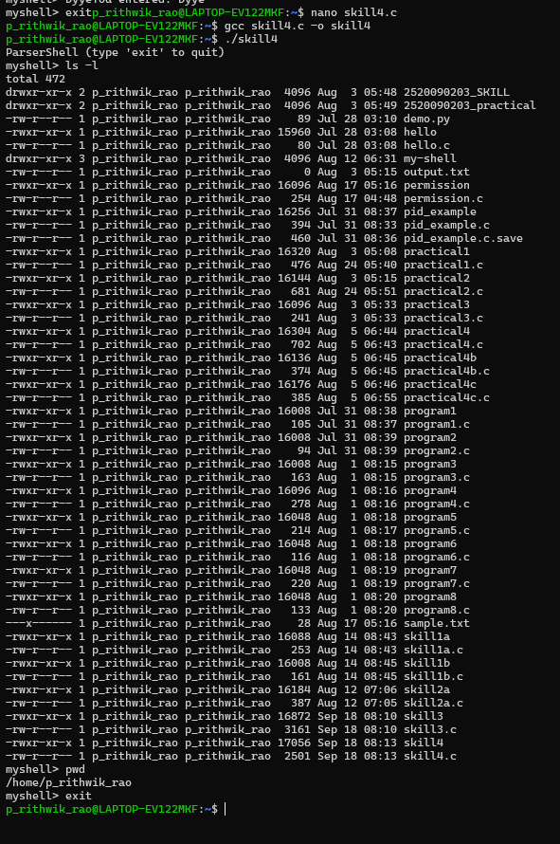
#include <stdio.h>
#include <stdlib.h>
#include <string.h>
#include <unistd.h>
#include <sys/wait.h>

// Token structure
typedef struct {
char **args;
int argc;
} Command;

// Split input into tokens
Command parse_input(char *input) {
Command cmd;
cmd.args = malloc(sizeof(char*) * 64);
cmd.argc = 0;

char *token = strtok(input, " \t\n");
while (token) {
cmd.args[cmd.argc++] = strdup(token);
token = strtok(NULL, " \t\n");
}
cmd.args[cmd.argc] = NULL; // execvp needs NULL terminator
return cmd;
}

// Free command structure
void free_command(Command cmd) {
for (int i = 0; i < cmd.argc; i++) {
free(cmd.args[i]);
}
free(cmd.args);
}

// Execute a single command
void execute_command(Command cmd) {
if (cmd.argc == 0) return; // empty command

pid_t pid = fork();
if (pid == 0) {
execvp(cmd.args[0], cmd.args);
perror("execvp failed");
exit(1);
} else if (pid > 0) {
wait(NULL);
} else {
perror("fork failed");
}
}

// Handle pipeline: cmd1 | cmd2
void execute_pipeline(char *input) {
char *pipe_pos = strchr(input, '|');
if (!pipe_pos) {
Command cmd = parse_input(input);
execute_command(cmd);
free_command(cmd);
return;
}

// Split into two parts
*pipe_pos = '\0';
char *left = input;
char *right = pipe_pos + 1;

Command cmd1 = parse_input(left);
Command cmd2 = parse_input(right);

int fd[2];
pipe(fd);

pid_t pid1 = fork();
if (pid1 == 0) {
dup2(fd[1], STDOUT_FILENO);
close(fd[0]);
close(fd[1]);
execvp(cmd1.args[0], cmd1.args);
perror("execvp failed");
exit(1);
}

pid_t pid2 = fork();
if (pid2 == 0) {
dup2(fd[0], STDIN_FILENO);
close(fd[0]);
close(fd[1]);
execvp(cmd2.args[0], cmd2.args);
perror("execvp failed");
exit(1);
}

close(fd[0]);
close(fd[1]);
waitpid(pid1, NULL, 0);
waitpid(pid2, NULL, 0);

free_command(cmd1);
free_command(cmd2);
}

int main() {
char input[256];

printf("ParserShell (type 'exit' to quit)\n");
while (1) {
printf("myshell> ");
fflush(stdout);

if (!fgets(input, sizeof(input), stdin)) break;
if (strcmp(input, "\n") == 0) continue; // empty command
if (strncmp(input, "exit", 4) == 0) break;

execute_pipeline(input);
}
return 0;
}

