#include <stdio.h>
#include <unistd.h>
int main()
{ pid_t pid = fork();
if(pid == 0)
{ printf("Child Process\n")
; printf("PID = %d\n", getpid())
; } else
{ printf("Parent Process\n");
printf("PID = %d\n", getpid());
} return 0;
}
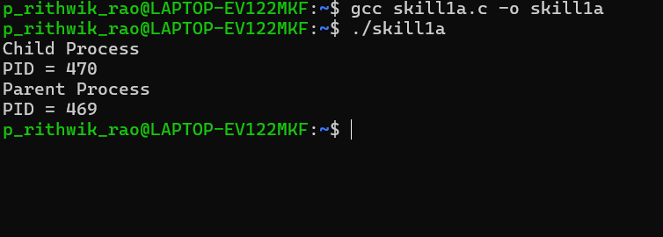
#include <stdio.h>
#include <unistd.h>
int main() {
printf("Before exec()\n");
execlp("date","date",NULL);
p rintf("After exec()\n");
return 0;
}