
Department | FED
Subject | DSA-2
Academic Year
Faculty Name | SUREKHA MAM
Student Name | PADAKANTI RITHWIK RAO
Roll Number | 2520090203
Branch | CSIT
Course Outcome

Case Study Topic: IRCTC Fare-Routing using A* Search with Heuristic
Work Done Summary:

In this case study, we analyzed the cheapest train route from Mumbai to Kolkata using Dijkstra and A* Search.
Dijkstra was used as the baseline algorithm without any heuristic.
A* Search used the formula f(v) = g(v) + h(v), where g(v) is the fare from source and h(v) is the estimated remaining fare to Kolkata.
The straight-line distance heuristic helped A* reach the goal with fewer node expansions compared to Dijkstra.

Implementation Details:
- Represented each railway station as a node in the graph.
- Represented train fares between stations as weighted edges.
- Ran Dijkstra from MUM to KOL using only cumulative fare g(v).
- Ran A* Search using f(v) = g(v) + h(v).
- Used the given heuristic values:
MUM = 900, NGP = 600, HYD = 750, PAT = 400, BBS = 300, RNC = 350, VSK = 550, KOL = 0.
- Compared number of extracted nodes in Dijkstra and A*.
- Java boilerplate for A* using Priority Queue and stale-skip condition.

Result / Output:
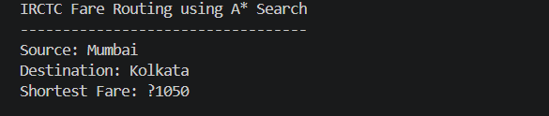

Time Complexity:
Worst Case: O((V + E) log V)

Heuristic Conditions:
Admissibility: h(v) <= true remaining cost
Consistency: h(u) <= w(u,v) + h(v)

GitHub Link: https://github.com/rithwikraopadakanti-03/DSA2_C0_1T06_CASE_STUDY
