
Department | FED
Subject | DSA-2
Academic Year
Faculty Name | SUREKHA MAM
Student Name | PADAKANTI RITHWIK RAO
Roll Number | 2520090203
Branch | CSIT
Course Outcome

Case Study Topic: Coin Change Problem using Dynamic Programming for Indian Currency Denominations
Work Done Summary:

In this case study, we analyzed the coin-change problem for Indian currency denominations using Dynamic Programming (DP).
The vending machine had to dispense exactly ₹43 using the minimum number of coins from the set {₹1, ₹2, ₹5, ₹10, ₹20}.
We first applied the greedy largest-coin-first approach and then verified the optimality using Dynamic Programming.
The DP approach guaranteed the minimum possible number of coins for any coin system.

Implementation Details:
- Coin denominations used: {1, 2, 5, 10, 20}.
- Target amount: ₹43.
- Applied greedy algorithm by selecting the largest possible coin repeatedly.
- Greedy Selection Process:
- ₹20 → Remaining ₹23
- ₹20 → Remaining ₹3
- ₹2 → Remaining ₹1
- ₹1 → Remaining ₹0
- Total coins used by greedy = 4 coins.
- Built DP table dp[0..43] where:
dp[i] = minimum number of coins required to make amount i.
- Recurrence Used:
dp[i] = 1 + min(dp[i - c]) for all c ∈ coins and c ≤ i.
- Constructed choice[] array to recover the coins used in the optimal solution.

Result / Output:
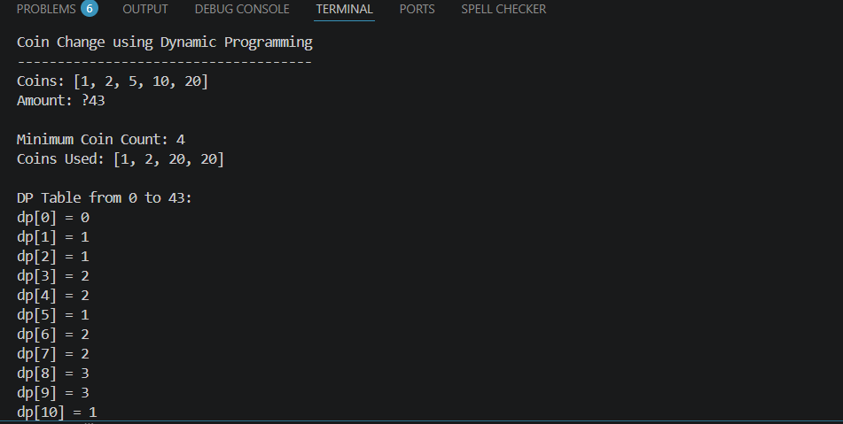

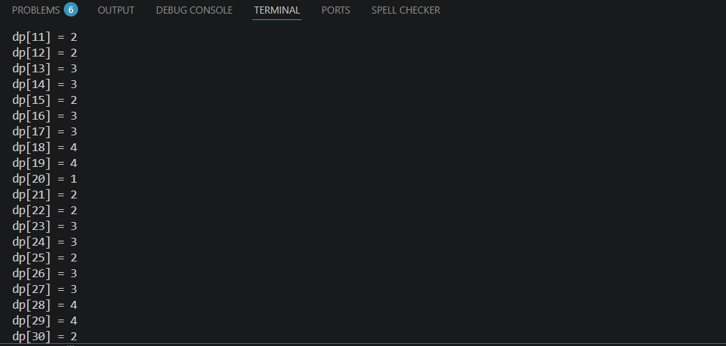

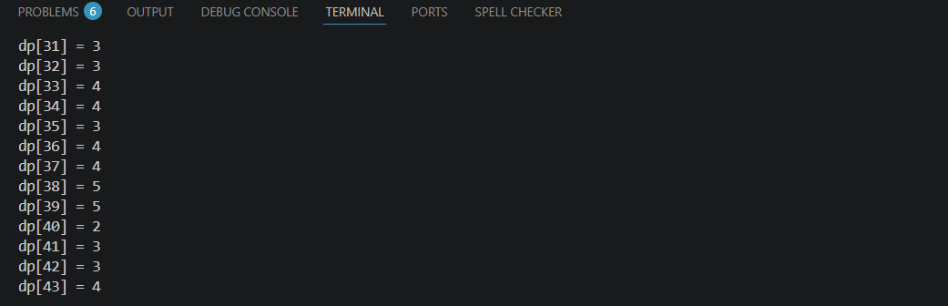
Time Complexity:
O(n ? k), where n = amount and k = number of denominations

Space Complexity:
O(n)

Operation Count for amount = 10000, k = 5:
10000 ? 5 = 50000 operations

GitHub Link: https://github.com/rithwikraopadakanti-03/DSA2_C0_1T06_CASE_STUDY