
Department | FED
Subject | DSA-2
Academic Year
Faculty Name | SUREKHA MAM
Student Name | PADAKANTI RITHWIK RAO
Roll Number | 2520090203
Branch | CSIT
Course Outcome

Case Study Topic: Splunk on-call
Work Done Summary:
An Interval Tree was implemented to store and query Splunk log stream intervals efficiently. The tree was built by inserting eight streams and computing max_end values for each node. Using the overlap query [14:25, 14:50], all matching streams were identified with an optimized search that prunes unnecessary subtrees. The Interval Tree was then compared with a sorted-array approach, showing that it provides efficient overlap queries and dynamic updates, making it suitable for Splunk's large-scale monitoring workload.

Implementation Details:
- Implemented an Interval Tree using a Binary Search Tree (BST) keyed by interval start times.
- .Inserted the eight log stream intervals in the specified order: S1, S2, S3, S4, S5, S6, S7, and S8.
- Stored each stream as a node containing start time, end time, stream ID, and max_end value.
4. Computed max_end for every node as the maximum end time present in its subtree.
5. Constructed the final interval tree by updating max_end values from leaf nodes to the root.
6. Applied the interval overlap condition (a ≤ d AND c ≤ b) to identify streams overlapping the query window.
7. Implemented the findOverlapping() function to search for all intervals that overlap the query range.
8. Used the pruning rule (lo > max_end) to skip subtrees that cannot contain valid overlaps.
9. Returned all matching stream IDs that overlap the incident window [14:25, 14:50].
10. Compared the Interval Tree approach with a sorted arrays + binary search method based on build cost, query performance, update cost, and memory usage.
- b9 → [91]
- Sorted each bucket independently using insertion sort.
- Concatenated all buckets sequentially to obtain the final sorted array.

Result/output: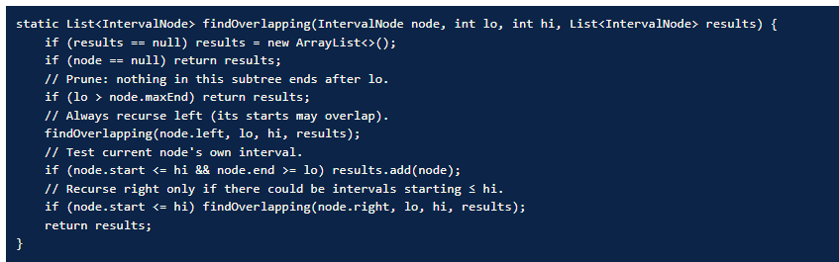
Time Complexity:
1. Build Interval Tree: O(n log n)
2. Overlap Query: O(log n + k)
3. Insertion: O(log n)
4. Deletion: O(log n)
5. Space Complexity: O(n)

GitHub Link: https://github.com/rithwikraopadakanti-03/DSA2_C0_1T06_CASE_STUDY