
EXPO PROJECT DOSSIER
ONLINE EXAMINATION &
AI-ASSISTED PROCTORING PLATFORM
Secure exam delivery • Automated evaluation • Browser-based AI-assisted monitoring
TEAM | Team 7 • Section 12 • CSIT
MEMBERS | M. Sai Ajith Reddy – 2520090186  P. Likith Kumar – 2520090084  P. Rithwik Rao – 2520090203
GUIDE | Dr. Khaja Shareef
COURSE | Database Systems Engineering and Distributed Backend Development (25CS1302E)
INSTITUTION | KLH Bachupally Campus • Academic Year 2026–27
JUDGE QUICK VIEW A complete web examination workflow with backend-authoritative scoring and browser-based AI indicators for session monitoring. AI events support review; they are not an automatic cheating verdict.

01 | Executive Overview
Online Examination & AI-Assisted Proctoring Platform is a full-stack web application that manages the complete examination lifecycle: authentication, exam creation, question delivery, timed attempts, answer submission, automated evaluation, proctoring-event capture and administrator review.
The implementation uses React + Vite on the frontend, FastAPI for REST services, MongoDB for persistence, JWT + bcrypt for authentication, and TensorFlow.js with COCO-SSD for browser-side object detection.
THE CORE IDEA Integrate examination management and evaluation with AI-assisted session monitoring in a single workflow, while keeping final review under administrator control.

Capability | What the platform provides
Authentication | JWT-based login, bcrypt password hashing and active-user validation.
Exam management | Centralized exam metadata, timing, marks and status.
Question security | Student-facing question API does not expose correct_option.
Automated evaluation | FastAPI compares answers with stored answer keys.
AI monitoring | Browser camera + object detection for configured session indicators.
Review | Submission, score, risk and unlock-request workflows.

02 | System Architecture
The architecture separates frontend presentation, backend business logic, persistent data and browser-based AI inference.
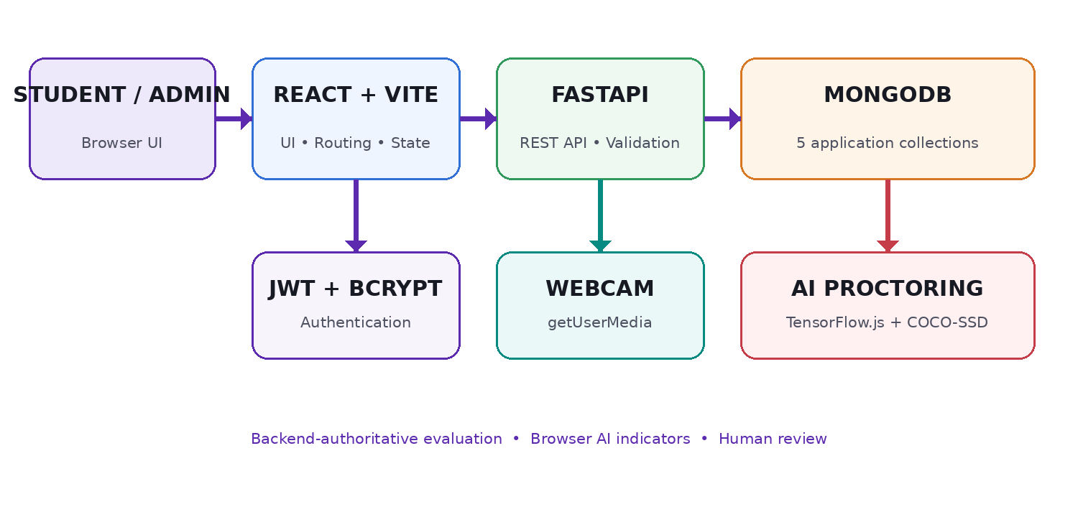
Figure 1. High-level architecture of the implemented platform.
Layer | Technology | Responsibility
Frontend | React 19 • Vite • React Router • Tailwind CSS | Student/admin UI and examination experience
Backend | Python FastAPI | REST API, validation and business logic
Database | MongoDB / PyMongo | Application persistence
Security | JWT + bcrypt | Authentication and password hashing
AI | TensorFlow.js + COCO-SSD | Browser object detection
Browser | getUserMedia + Page Visibility API | Camera access and visibility events

03 | Functional Modules
Module | Current implementation
Authentication & Access | Registration, login, JWT, active-user checks and protected routes.
Exam Management | Create/retrieve/delete exams; validate timing/marks; calculate exam status.
Question Management | Create questions, validate answer indexes and return student-safe question data.
Examination Engine | Timer, question navigation, answer capture, violation tracking and submission.
Evaluation Engine | Backend answer-key comparison; correct/incorrect/skipped counts, marks and percentage.
AI-Assisted Proctoring | Camera access plus no-person, multiple-person and cell-phone indicators.
Unlock Workflow | Student request → administrator approval → approval consumption.
Administrative Review | Dashboard analytics, submissions, risk information and review.

04 | End-to-End Examination Workflow
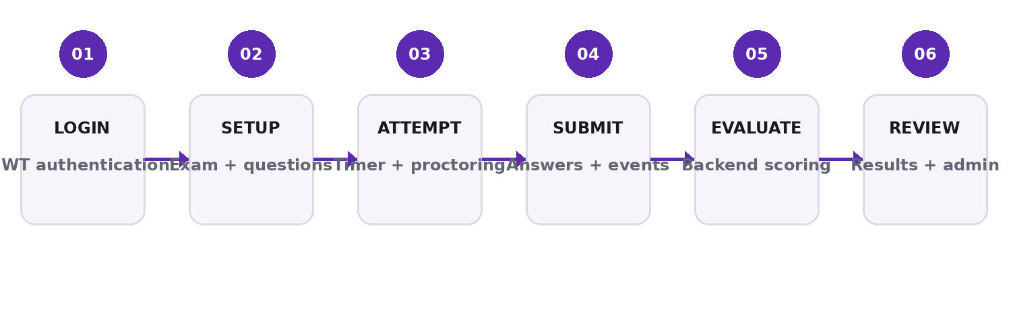
Figure 2. Examination lifecycle.
- Administrator authenticates and creates/schedules an examination.
- Questions are associated with the exam; answer keys remain server-side.
- Student authenticates and opens an active examination.
- Browser camera permission is requested and proctoring starts when enabled.
- Student answers questions while timer and configured monitoring indicators operate.
- Submission sends answers, violation information and risk information to FastAPI.
- Backend loads the exam/question records and performs answer-key comparison.
- Result and proctoring information are stored in MongoDB and exposed to the relevant views.

05 | AI-Assisted Proctoring
The current proctoring module runs in the browser. Camera access is obtained through getUserMedia and inference uses TensorFlow.js with the COCO-SSD lite model. The implementation uses temporal confirmation and cooldown logic to reduce transient detections.
Indicator | Current behavior
No person | Generates an event after the configured no-person grace period.
Multiple people | Generates an event when more than one person is detected.
Cell phone | Uses confirmed phone detections before generating an event.
Page visibility | Visibility changes can be recorded as examination violations.
Risk level | Violation counts map to Low / Moderate / High; configured threshold can lock the session.

IMPORTANT BOUNDARY The implementation does not perform facial identity verification, gaze tracking or head-pose analysis. AI output is treated as evidence/indicators for review.

06 | Database Design
Collection | Purpose / important data
users | Identity, student ID, role, active status and password hash.
exams | Title, subject, duration, marks, question count, schedule, status and creator.
questions | Exam reference, text, options, marks, difficulty/category and correct option.
submissions | Answers, score fields, student/exam information, violations and risk level.
requests | Unlock reason, student/exam information and request status.

ANSWER-KEY PROTECTION The student-facing question endpoint omits correct_option, keeping the answer key in the backend evaluation path.

07 | REST API Surface
Method | Endpoint | Purpose
POST | /api/auth/register | Register student
POST | /api/auth/login | Authenticate / issue JWT
GET | /api/auth/me | Authenticated user
GET | /api/exams/ | List exams
POST | /api/exams/ | Create exam
GET | /api/exams/{exam_id} | Get exam
POST | /api/questions/ | Create question
GET | /api/questions/exam/{exam_id} | Student-safe questions
POST | /api/submissions/ | Evaluate/store submission
GET | /api/submissions/my | Student submissions
GET | /api/submissions/all | Admin review
POST | /api/requests/ | Create unlock request
GET | /api/requests/pending | Pending requests
POST | /api/requests/{request_id}/approve | Approve request
POST | /api/requests/{request_id}/consume | Consume approval

08 | Actual Implementation Screens
These are screenshots from the implemented application and are included to demonstrate the working student and administrator interfaces.
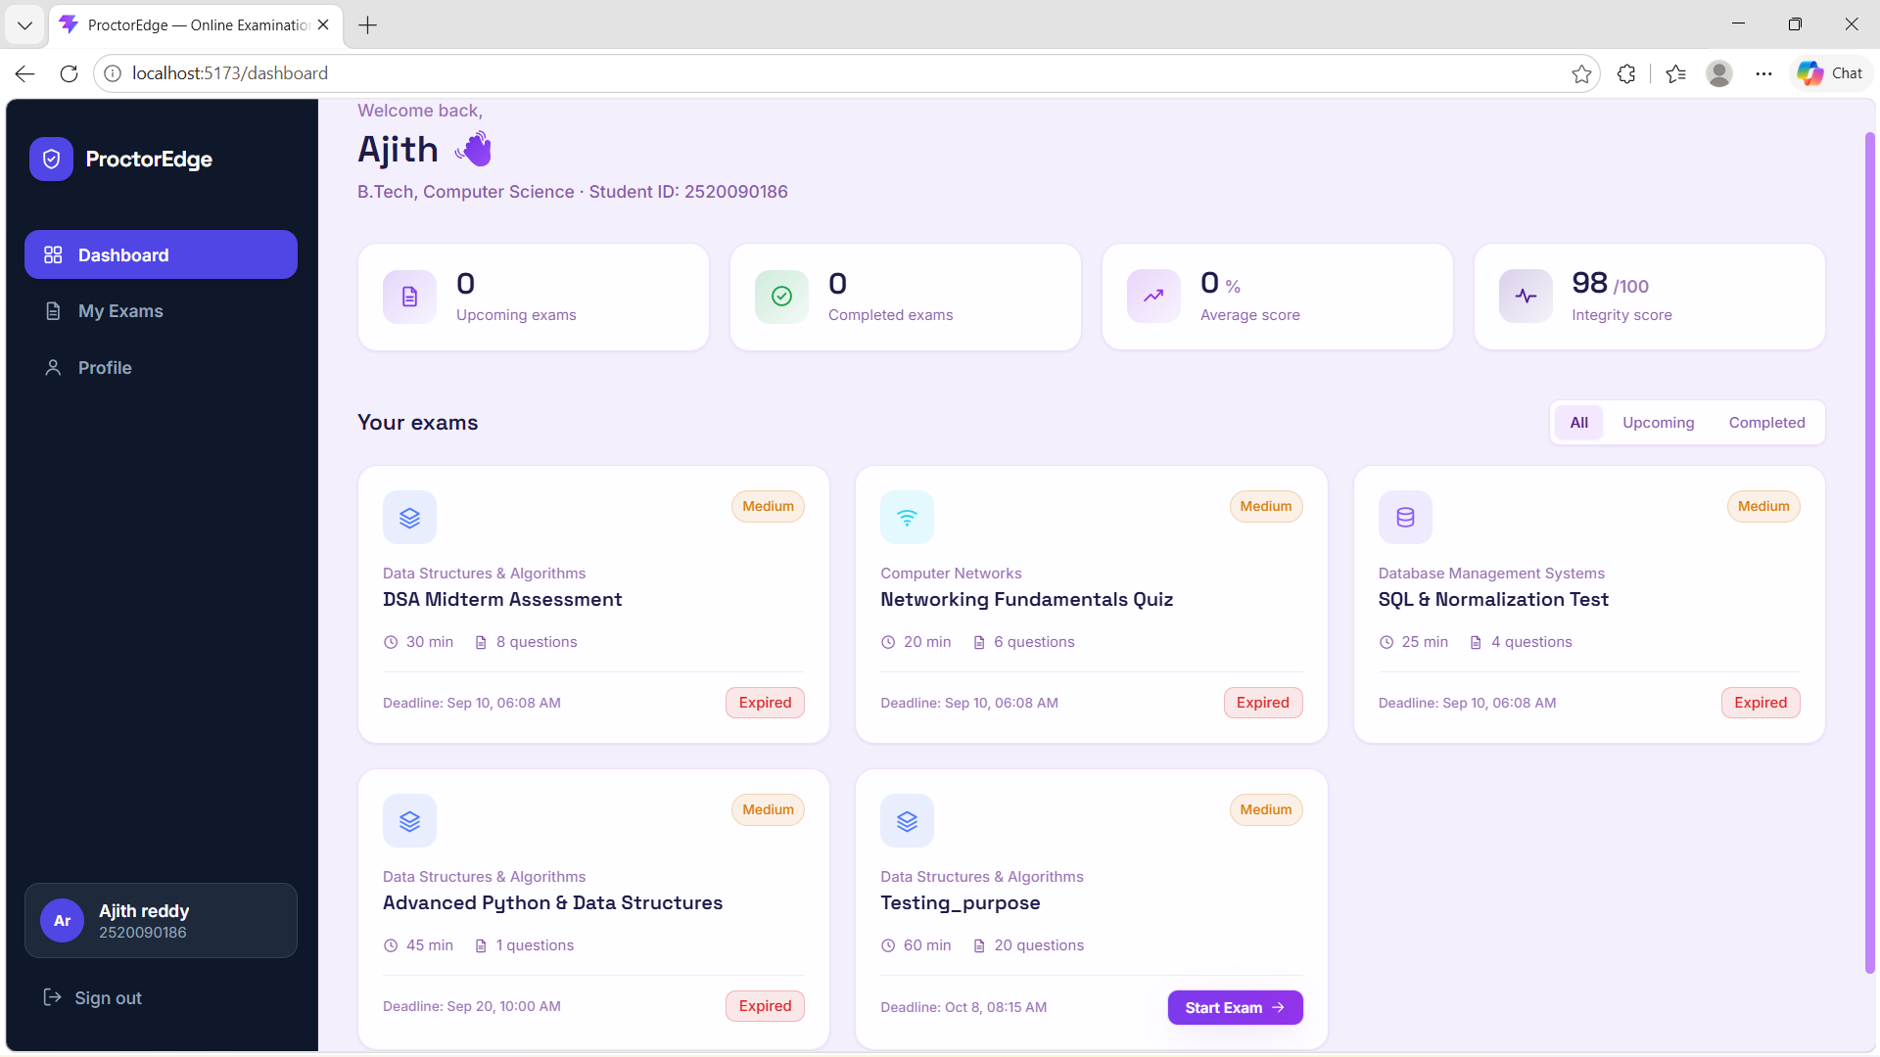
Figure 3. Student dashboard — exam cards, status, duration, questions and attempt access.
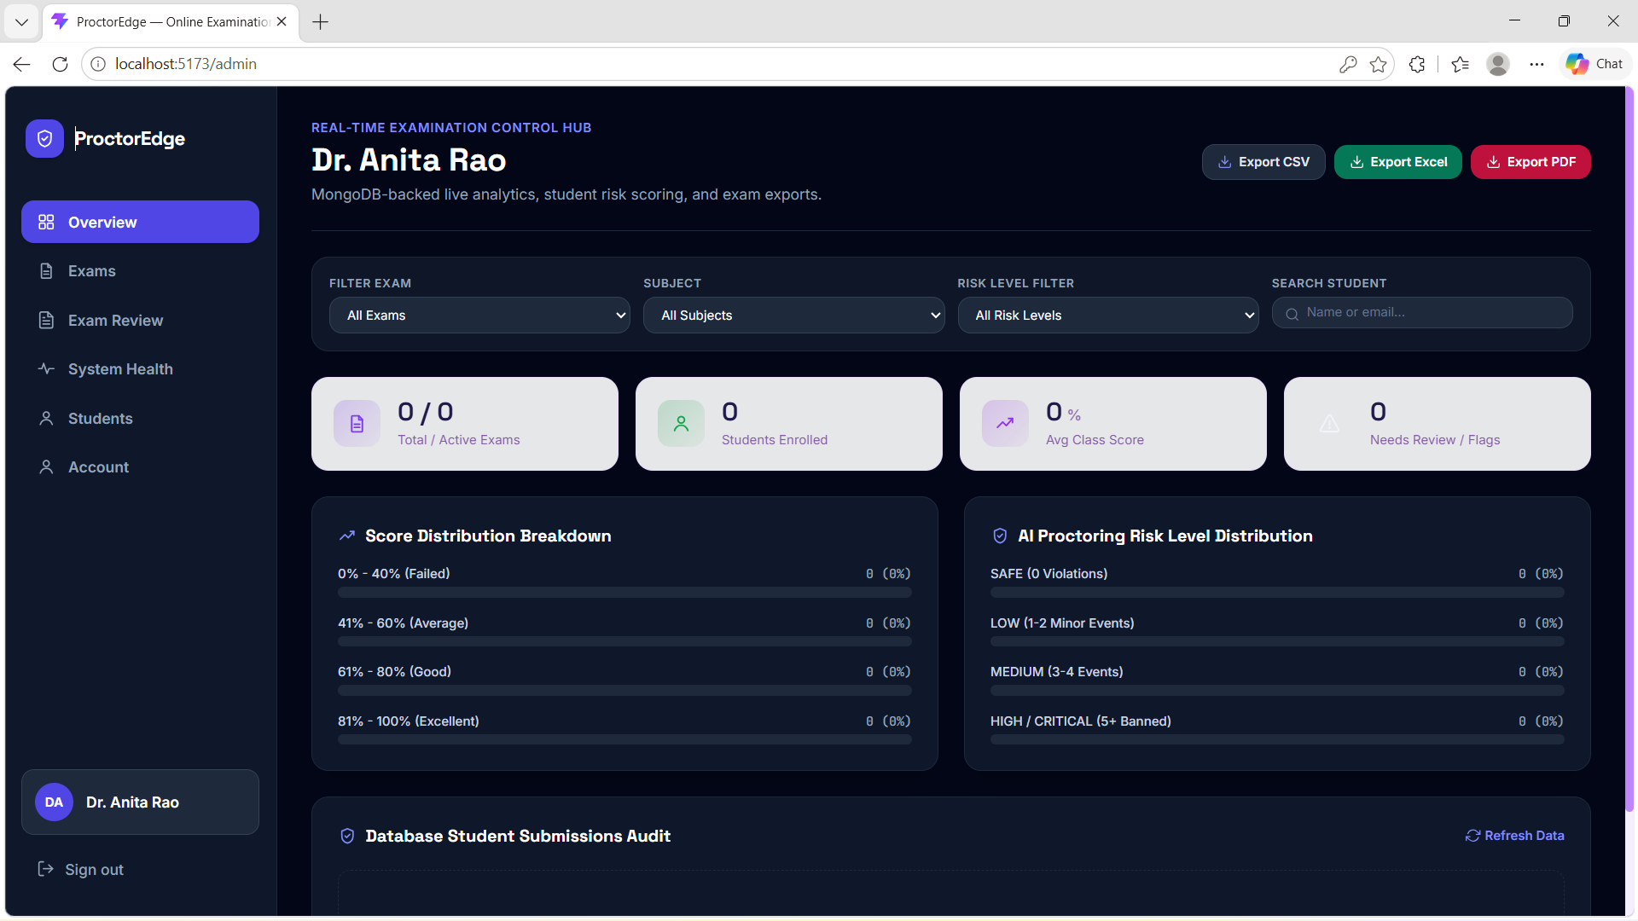
Figure 4. Administrator dashboard — filters, score distribution, proctoring-risk distribution and submission audit.

09 | Validation & Testing
Test area | Validation performed
Backend | Root endpoint and MongoDB health check verified.
Authentication | JWT login and protected API requests exercised.
Exams | Exam creation/retrieval and status logic exercised.
Questions | Question creation and student-safe retrieval exercised.
Submission | Backend answer comparison and score calculation exercised.
Proctoring | Camera flow and COCO-SSD person/phone behavior exercised.
UI | Student and admin dashboard/exam/review workflows exercised.

QUALITY POSITION No fabricated accuracy, latency or benchmark numbers are reported. Any future performance metric should come from a controlled measurement protocol.

10 | Security & Engineering
- Passwords are hashed using bcrypt before storage.
- JWT bearer tokens carry subject, role and expiration information.
- Protected API requests use Bearer authentication.
- Duplicate email/student ID checks are performed during registration.
- Inactive users are prevented from logging in.
- Correct answer keys are not returned by the student-facing question endpoint.
- Frontend protected routes are role-aware.
KNOWN HARDENING ITEM Backend JWT authentication is implemented, but administrative role authorization is not consistently enforced across every administrative route in the reviewed code. This should be strengthened before production deployment.

11 | Implementation Status
Feature | Status | Expo wording
Authentication | Implemented | Demonstrate login and protected navigation.
Exam management | Implemented | Show admin exam workflow.
Question management | Implemented | Show question creation/retrieval.
Backend evaluation | Implemented | Submit an attempt and show calculated result.
MongoDB persistence | Implemented | Explain five collections.
AI-assisted proctoring | Implemented | Demonstrate a controlled monitoring event.
Unlock request workflow | Implemented | Explain request and approval flow.
Question-file import | Enhancement / work in progress | Do not present as fully verified unless tested in final build.
Mobile detection optimization | Enhancement / tuning | Present as planned performance improvement.

12 | Five-Minute Expo Demonstration
Time | Demo action | Judge takeaway
0:00–0:30 | Login | Two-role examination platform.
0:30–1:20 | Admin dashboard | Exam management + monitoring/review.
1:20–2:20 | Student dashboard | Exam availability + attempt access.
2:20–3:20 | Start exam | Timer + questions + proctoring.
3:20–4:10 | Controlled AI event | Browser-based object/event monitoring.
4:10–4:40 | Submit | Backend-authoritative evaluation.
4:40–5:00 | Admin review | Score/risk/submission information.

13 | Current Limitations
- Detection quality depends on camera, lighting, browser and client hardware.
- COCO-SSD is a general object detector and can produce false positives/negatives.
- No facial identity verification is implemented.
- Development mockData fallback remains in the frontend code and is not the MongoDB source of truth.
- Backend scoring is authoritative when submission succeeds; the frontend also has a local fallback for continuity.
- Backend administrative role authorization needs stronger enforcement before production deployment.

14 | Future Roadmap
Priority | Enhancement | Benefit
P1 | Optimize mobile-phone detection and temporal confirmation | Faster, more stable indicators
P1 | Strengthen backend admin authorization | Stronger access control
P1 | Question file import + preview + validation | Less manual question entry
P2 | Auto-save + reconnection recovery | Reduced accidental data loss
P2 | Evidence snapshots linked to events | Better review context
P2 | Real-time participant monitoring | Better administrator visibility
P3 | Analytics and export workflows | Improved reporting

15 | Conclusion
The project demonstrates a complete academic full-stack solution for online examination management. Its value comes from integrating authentication, exam lifecycle management, protected question delivery, backend-authoritative evaluation, MongoDB persistence and browser-based AI-assisted monitoring.
The modular design provides a clear path toward stronger real-time monitoring, question import, evidence handling, analytics and production-grade security.
ONE-LINE PITCH “We built an online examination platform where the backend controls exam data and evaluation, while browser-based AI adds real-time session-level proctoring indicators for administrator review.”

Appendix A | Project Structure
Layer | Representative files
Backend entry | app/main.py
Database | app/database/connection.py
Models | app/models/user.py • exam.py • question.py
Routes | app/routes/auth.py • exams.py • questions.py • submissions.py • requests.py
Frontend | src/App.jsx • src/context/ • src/pages/ • src/components/
API client | src/utils/api.js
Proctoring | src/hooks/useProctoringCamera.js • ProctoringPanel.jsx
Fallback/demo data | src/data/mockData.js — development fallback only

Appendix B | Technology Summary
Technology | Role
React 19 | Frontend application
Vite | Development/build tooling
React Router 7 | Client-side routing
Tailwind CSS | UI styling
FastAPI | REST backend
MongoDB / PyMongo | Database/data access
python-jose | JWT handling
Passlib / bcrypt | Password hashing
TensorFlow.js | Browser inference
COCO-SSD lite_mobilenet_v2 | Object detection
getUserMedia | Camera access
Page Visibility API | Visibility-event monitoring

