OS-LAB-CLASS-ACTIVITY-6
Github URL : https://github.com/rithy-piseth/os-lab-class-activity-06.git
With Deadlock :
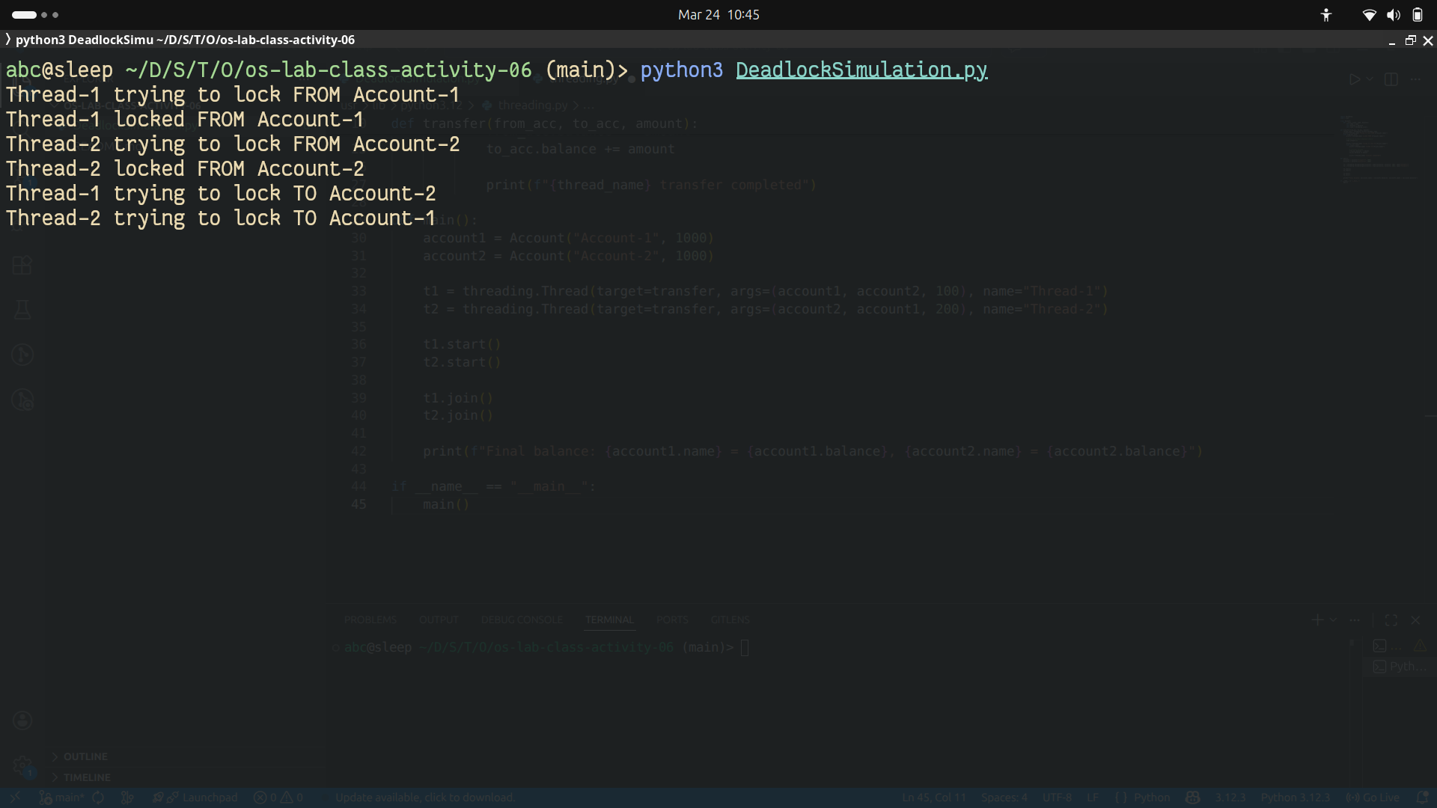
Without Deadlock:
