ADVANCED DATA SCIENCE | FINAL PROJECT REPORT
Who Is at Risk After Four Weeks?
Early-warning analytics on the Open University Learning Analytics Dataset (OULAD)
Detailed, plain-language edition
Programme | Master of AI and Data Science, Term 4
Institution | Cambodia Academy of Digital Technology (CADT)
Course | Advanced Data Science
Instructor | Dr. PHAUK Sokkhey
Author(s) | [add your name(s) and student ID(s) here]
Date | 24 October 2026
Sustainable Development Goal | SDG 4, Quality Education

How to read this report
This report describes a complete data science project, from the first question to the final recommendation. It is written so that a reader who is new to data science can follow it. Every section starts with a short box called In simple words. If you only have ten minutes, read the summary on the next page, the first box of each section, and the conclusions.
Section | What you will learn
Summary | The whole project on one page, with the five numbers that matter.
1. The problem | Why we want to find struggling students early, and the four questions we asked.
2. The data | What OULAD contains, what one row means, and the rules we set before looking at results.
3. Data quality | The problems we found in the data and how each one was handled.
4. Exploring the data | What the data look like and which early signals relate to failing or leaving.
5. Preparing the data | How raw click logs became a clean table the models can use.
6. Methods and results | Choosing features, finding student profiles, finding rules, predicting risk, and checking fairness.
7. Can we trust it? | Imbalance, leakage, drift, forecasting and how to test whether outreach really helps.
8. Conclusions | Decision, limits, ethics and next steps.
Glossary | Every technical word used here, explained in everyday language.
Appendices | Map of the nine notebooks, the data-cleaning log and references.

Three ideas that appear everywhere
1. The cutoff. We pretend it is day 28 of a course and use only what was known by then. Anything that happens later is off limits, because a real early-warning system could not see it.
2. Train on the past, test on the future. The model learns from the 2013 courses and is graded once on the 2014 courses, which it has never seen.
3. Prediction is not a verdict. The model ranks students by risk so that advisers can offer help first to those who need it most. It never decides anything on its own.

Summary
In simple words
Four weeks after a course starts, we can already tell which students are most likely to fail or drop out, and we are right about three times out of four among the students we flag. The strongest warning sign is simple: missing a deadline in the first month. But the tool is only useful if it is fair to every group and if the university tests whether contacting students really helps.
What we did. We studied 27,553 student records from the Open University (UK), covering 22 course runs in 2013 and 2014 and 10.7 million records of clicks on the online learning platform. For each student we used only information from the first 28 days. The goal was to predict who would end the course as Fail or Withdrawn, which we call at risk.
The five numbers that matter.
Number | What it means
0.78 | The model ranks students correctly 78% of the time (AUC) on a year it had never seen. A coin flip would give 0.50 and a perfect model 1.00.
75.7% | Of the 30% of students the model flags as highest risk, three out of four really did end up failing or withdrawing.
87.6% | Of students who missed an assessment due in the first four weeks, this share ended at risk. It is the strongest single warning sign.
13 to 16 points | Students from the most deprived areas are 13 to 16 percentage points more likely to be at risk, even when their platform activity looks the same.
3.7 points | With a randomised trial on all flagged students in a year, we could detect a reduction of 3.7 percentage points in the at-risk rate. A trial on one module could only detect about 10 points.

What we recommend.
- Use the model for supportive triage: contact the flagged students early to offer help, never to penalise anyone.
- Use the version of the model without education and deprivation, because it treats groups more equally and costs only 0.009 of AUC.
- Do not claim that outreach works until a randomised trial shows it. Comparing contacted and not-contacted students would give the wrong answer.
- Monitor the model every week and retrain it if its accuracy drops by 0.03 or more.

1. The problem we want to solve
In simple words
Many students in online courses fail or quietly disappear. If a teacher could see this coming in the first month, they could reach out in time. We test how well that is possible with the data an online platform already collects.

1.1 Background
Distance-learning courses lose a large share of their students to failure and withdrawal. Support teams can only help if they know who is struggling while there is still time. A prediction made at the end of the course is easy, but it is useless, because by then the result is already decided. The challenge is therefore to make a prediction early, using only what is known at that moment.
There are two further worries. A model trained on one group of students may not work on the next group. And a model may work well on average while making more mistakes for some groups of students than for others. This project checks both worries on purpose.
The topic links to United Nations Sustainable Development Goal 4 (Quality Education), which aims for inclusive and equitable education for all.

1.2 Objective
Main objective. To describe and model the risk of ending a course as Fail or Withdrawn using only information available at day 28, and to test whether the findings hold across years and across student groups.

1.3 Research questions
Question | In plain words | Where answered
RQ1 Association | How do early activity, early assessment behaviour and a student's background relate to ending at risk? | Sections 4 and 6.3
RQ2 Structure | Are there distinct types of students (engagement profiles) at day 28, and does their risk differ? | Section 6.2
RQ3 Prediction and stability | How well can day-28 information predict risk, and does a model built on 2013 still work in 2014? | Sections 6.4 and 7
RQ4 Equity | Are risk and prediction mistakes spread unevenly across deprivation, prior education, age, disability and gender? | Sections 6.5 and 7

1.4 Unit of analysis and population
One row in our data is one student in one course run (a course run is called a module-presentation, for example module FFF starting in October 2013). The population is every student who is still registered on day 28: 27,553 rows, which belong to 24,849 different people. Of these, 2,583 people appear in more than one course run, so the rows are not completely independent of each other. We handle this in the way we split the data (see section 2.4).

1.5 Variables at a glance
Role | Variables
Outcome we predict | At risk = final result is Fail or Withdrawn (1); Pass or Distinction (0)
Behaviour (explanatory) | Clicks by week, number of active days, mix of activities, early assessment submissions, timing and scores
Background (explanatory) | Gender, region, prior education, deprivation band (IMD), age band, disability, previous attempts, credits studied
Context | Module, year and start month, course length
Identifiers | Student, site and assessment ids (never used as features)
Leakage risks (forbidden) | Final result, unregistration date, anything recorded after day 28

Ethics in one paragraph
The data are anonymised, but deprivation, disability, age, gender and region are sensitive. A risk model must trigger support, never penalties, and its error rates must be reported for each group.

2. The data
In simple words
OULAD is a free, public collection of records from the Open University, a large distance-learning university in the UK. It tells us who the students are, what they did on the online platform each day, and how their courses ended. Before looking at any result, we wrote down the rules of the experiment so that we could not bend them later.

2.1 Where the data come from
Item | Detail
Creator | The Open University, Knowledge Media Institute
Publication | Kuzilek, Hlosta and Zdrahal (2017), Scientific Data 4, 170171, doi:10.1038/sdata.2017.171
Obtained from | UCI Machine Learning Repository, dataset 349, on 24 October 2026 (the Open University download page now redirects to a new portal)
Licence | CC BY 4.0 as stated by the authors (to be re-confirmed on the source page before submission)
How it was collected | Records of the virtual learning environment (VLE) and the student records system. It is administrative data, not a designed survey.
Coverage | 7 modules, 22 course runs starting in February (B) or October (J) of 2013 and 2014; UK distance learners
Not covered | Other modules and years; study that leaves no trace on the platform; students who left before day 28 (removed by design)

What could limit our conclusions
- Selection. Only 7 modules and 4 start dates. Results may not apply to other courses. Module CCC exists only in 2014.
- Measurement. Clicks measure platform activity, not learning. A student who studies offline looks inactive.
- Repeated students. 12.3% of people appear in more than one run, so rows are not fully independent.
- Leakage. The unregistration date and the final result describe the outcome itself and must not be used as inputs.
- Sensitive attributes. Deprivation, disability and age can act as proxies for each other and need fairness checks.

2.2 The seven tables
OULAD is not one table but seven linked tables. We join them into one analysis table with one row per student per course run.
Table | Rows | One row is | Key
courses | 22 | a course run | module + presentation
assessments | 206 | an assessment of a course run | assessment id
vle | 6,364 | a page or resource on the platform | site id
studentInfo | 32,593 | a student in a course run | module + presentation + student
studentRegistration | 32,593 | registration record of the same | same key
studentAssessment | 173,912 | a submitted assessment | assessment + student
studentVle | 10,655,280 | clicks by one student on one page on one day | none is unique

We checked by assertion that all keys are unique. The official documentation mentions 32,953 students in one place and 32,593 in another; the data contain 32,593, so we used that.

2.3 Why day 28, and why some students are removed
We predict on day 28 (the end of week 4). Half of all withdrawals happen before that day, and 2,676 students leave before the course even starts. For those students the outcome is already known on day 28, so there is nothing to predict, and keeping them would give away the answer. We therefore exclude the 5,040 early leavers from the modelling population and count them openly.
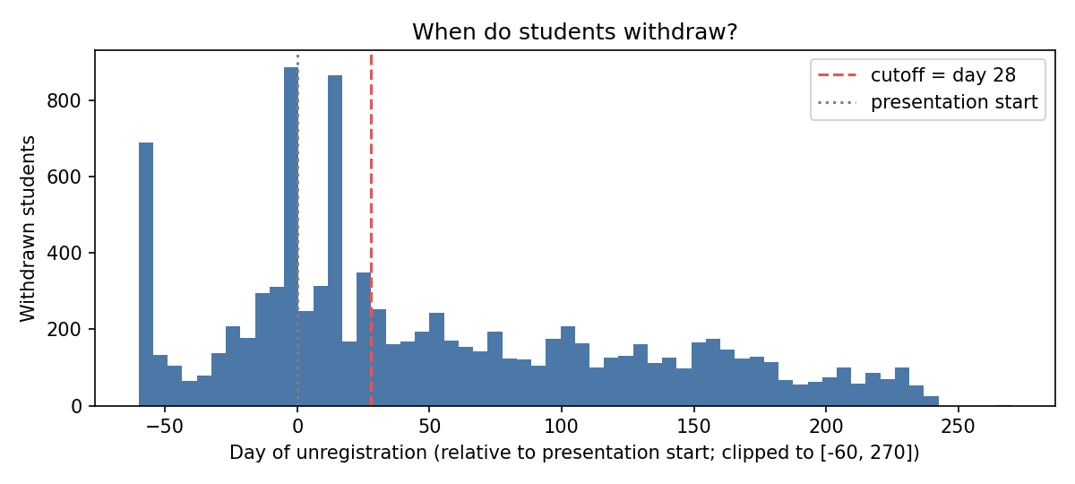
Figure 1. When students withdraw, measured in days from the course start. The red dashed line is our day-28 cutoff. Many withdrawals happen before it, which is why those students are removed from the prediction problem.
The effect of this choice
The at-risk rate in the full data is 52.8%. After removing early leavers it is 44.2%. Our results must therefore never be compared with full-course failure rates.

2.4 Rules fixed before looking at results
Rule | Choice | Why
Prediction day | Day 28 | Early enough to act, late enough to see behaviour
Target | Fail or Withdrawn = at risk (44.2% of rows) | One simple outcome that triggers support
Training data | 2013 course runs: 11,818 rows | The past, used to learn
Test data | 2014 course runs: 15,735 rows | The future, used once to grade the model
Forbidden inputs | final result, unregistration date, anything after day 28 | They would leak the answer
Learned preprocessing | Fitted on training data only | Otherwise test information leaks into training

2.5 Data dictionary (short version)
The master table has 46 columns (58 after feature engineering). The full dictionary is saved in the project as outputs/data_dictionary_master.csv. The main variables are:
Variable | Meaning | Type | Role | Quality note
code_module, code_presentation | Course and run (year + B or J start) | Nominal | Key, context | CCC only in 2014
id_student | Anonymised student | Identifier | Never a feature | 2,583 people in several runs
gender, region, disability | Declared characteristics | Nominal | Predictor, fairness group | Gender has no association with the outcome
highest_education | Education on entry (code 0 to 4) | Ordinal | Predictor, fairness group | No formal 0.9%, postgraduate 1.0%
imd_band | Deprivation of home area (code 0 to 9, 0 = most deprived) | Ordinal | Predictor, fairness group | 3.7% missing and informative; two label styles merged
age_band | 0 to 35, 35 to 55, 55 and over | Ordinal | Predictor, fairness group | 55 and over is only 0.7%
num_of_prev_attempts, studied_credits | Previous attempts, credits studied | Count | Predictor | Skewed; capped at 3 and 360
clicks_total, weekly clicks, active_days | Platform use before day 28 | Count | Predictor | Skewness 3.5; log transform
activity shares | Forum, content, homepage, quiz, subpage, resource | Share | Predictor | Shares sum to 1
n_assess_due, submit_rate_early | Assessments due before day 28; share submitted | Count, ratio | Predictor | Undefined for EEE and GGG (nothing due)
score_pct_mean, days_before_due_mean | Score rank; days submitted before deadline | Numeric | Predictor | 34.5% and 28.2% missing; rebuilt
eng_pct_* | Rank within the same module-presentation | 0 to 1 | Predictor | Derived feature
target_at_risk | Fail or Withdrawn | Binary | Target | 44.2% positive

3. Data quality: what we found and what we did
In simple words
Real data is messy. We looked for problems before modelling and wrote down every fix. One problem would have quietly damaged the test results: an assessment that was recorded as either 100 or 1 instead of a real mark.
The table below lists each finding, why it matters and the action taken. The full audit is saved as outputs/data_quality_audit.csv.
Issue | What we found | Why it matters | What we did
Missing values written as text | A question mark in 6 files, 34,347 cells | Numbers are read as text, so every statistic is wrong | Read the question mark as missing
Missing values | Early score 28.2%, submission rate 18.1% (EEE and GGG have no early assessment), deprivation 3.7% | Missing deprivation is informative (29.1% at risk vs 44.7%); averaging would invent marks | Keep rows, add indicators, fill gaps only inside cross-validated pipelines
Inconsistent coding | Assessment 15020 (module BBB, 2014J) scores only 100 or 1; 671 students have an early mean of exactly 1 | A completion code was averaged as if it were a mark; 34% at risk for a score of 1 vs 85% for genuine low marks | Replace scores by percentile rank within each assessment; exclude coded assessments
Label inconsistencies | 9 students have an unregistration date but are not labelled Withdrawn; 93 Withdrawn students have no date (0.34%) | Exit time is unknown for a few students | Apply the date rule; keep the 93; test the effect in notebook 07b
Label styles | Deprivation band written as 10-20 and 10-20% (23,696 rows) | One band would count as two categories | Harmonised
Duplicates | 787,170 identical click rows (6.2% of the day-28 window) | Could inflate engagement | Sensitivity test: rank order identical (Spearman 0.9996); kept and summed
Keys and repeats | Keys unique; 2,583 people in more than one run | A random split could put one person on both sides | Temporal split and cross-validation grouped by student
Outliers | Clicks: 6.1% above the usual fence, maximum 7,570; 453 credit values not multiples of 30 | Heavy users are plausible (30 to 46 active days); credit values cannot be verified | Keep; log transform; cap credits at 360 and previous attempts at 3
Rare categories | No formal education 0.9%, postgraduate 1.0%, age 55 and over 0.7% | Very wide uncertainty | Ordinal codes; merge only for rule mining
Near-constant variables | Late registration 18 rows, missing registration date 7 rows | No information | Dropped from model features
Imbalance | At risk 44% / 56%; Distinction 11%, Withdrawn 19% | The main target is balanced, the rare outcomes are not | Studied in section 7.1
Leakage and privacy | No post-outcome field in the features; strongest correlation with the target is 0.33 | No leakage alarm; sensitive attributes can stand in for each other | Report errors by group

The most important data-quality finding
Assessment 15020 stores only 100 (done) or 1 (not done). If we had averaged it like a normal mark, 671 students would look like failures with an average of 1. This assessment exists only in 2014, so the model would have been trained without it and tested with it. We replaced scores by percentile ranks, which fixes the problem. Without this fix the 2014 AUC would have been 0.764 instead of 0.780.

4. Exploring the data
In simple words
Before building any model we looked at the data from many sides. The main message: early behaviour and background both relate to risk, but each only moderately, and the signal in the clicks is hidden by the fact that some modules are used ten times more heavily than others.

4.1 One variable at a time
- Platform activity is very uneven. The median student made 221 clicks in the first 28 days but the average is 351, because a few students click a great deal (skewness 3.5). 3.4% of students never opened the platform. We use a log transform so that heavy users do not dominate.
- Early scores have a ceiling. The median score is 78 among scored students and 11.3% average 95 or more.
- Credits and registration are lumpy. 53% of students study 60 credits, and the median student registered 53 days before the start.
- Who the students are. 55% are men, 83% have A level education or less, 70% are under 35, 9.5% declare a disability and 87% have no previous attempt. Module sizes range from 2.6% (AAA) to 24% (FFF).
- The outcome. 44.2% are at risk (Pass 44.9%, Fail 25.6%, Withdrawn 18.6%, Distinction 11.0%). The at-risk rate runs from 26.0% in AAA to 52.4% in CCC. February starts run about 7 points above October starts, and the overall rate is the same in 2013 (44.4%) and 2014 (44.0%).

4.2 Two variables at a time
With about 12,000 students almost every statistical test is “significant”, so we look at the size of each effect, not only at whether it is significant. All findings below are associations, not proof of cause.
Pair | Method | Result | Reading
Clicks and active days | Spearman correlation | 0.885 | Nearly the same information; we keep one of them
Clicks and early score | Spearman correlation | 0.27 (0.10 in EEE to 0.37 in AAA) | Time on the platform is not the same as marks
At risk and each number | AUC of the single feature | Best is 0.67 (early score); active days 0.665; clicks 0.66; registration timing 0.50 | No single signal separates the groups well
Module and clicks | Kruskal-Wallis | Effect size 0.26; median 474 clicks in FFF vs 48 in GGG | Inside one module the clicks AUC is 0.64 to 0.74, against 0.66 pooled
Deprivation and risk | Chi-square, logistic regression | 56.1% at risk in the most deprived band, 34.9% in the least; odds ratio 0.92 per band, still 0.93 after adjustment | A gap that behaviour does not explain
Other background and risk | Chi-square, odds ratio | Education: 60.4% at risk with no formal qualification, 28.8% with postgraduate; previous attempts: 41.8% for none, 69.2% for three or more; disability odds ratio 1.54 (1.37 adjusted); gender 1.14 (1.005 adjusted) | The raw gender gap is only module mix
Clicks per day, by outcome | Time profile | At-risk students click about half as much, already before day 0 (53% as many) and 55% to 64% in each of weeks 1 to 4 | Risk is visible before the course starts

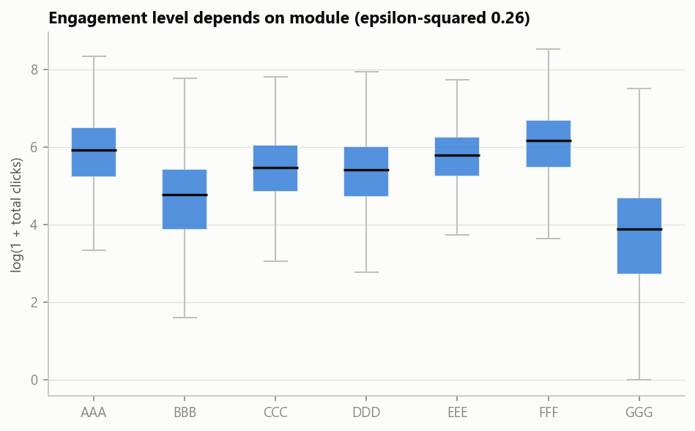
Figure 2. Clicks in the first 28 days differ about ten times between modules (median 474 in FFF, 48 in GGG). This is why we compare each student with others in the same module.
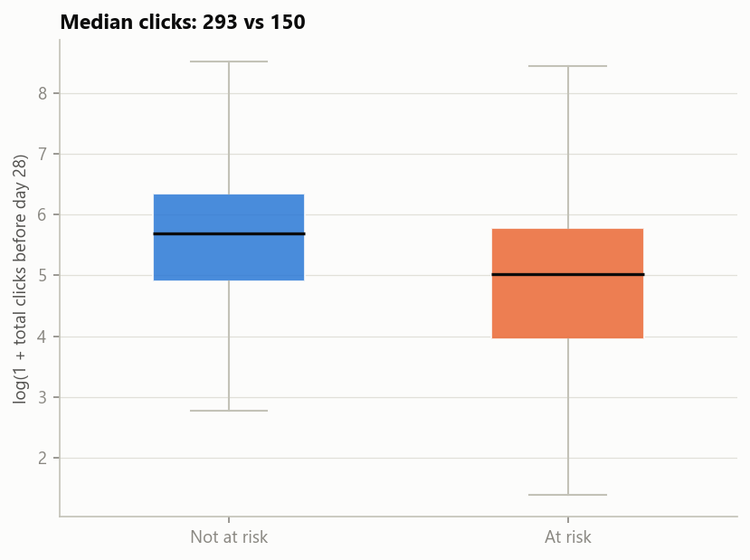
Figure 3. Students who end the course at risk click less in the first four weeks than students who pass.
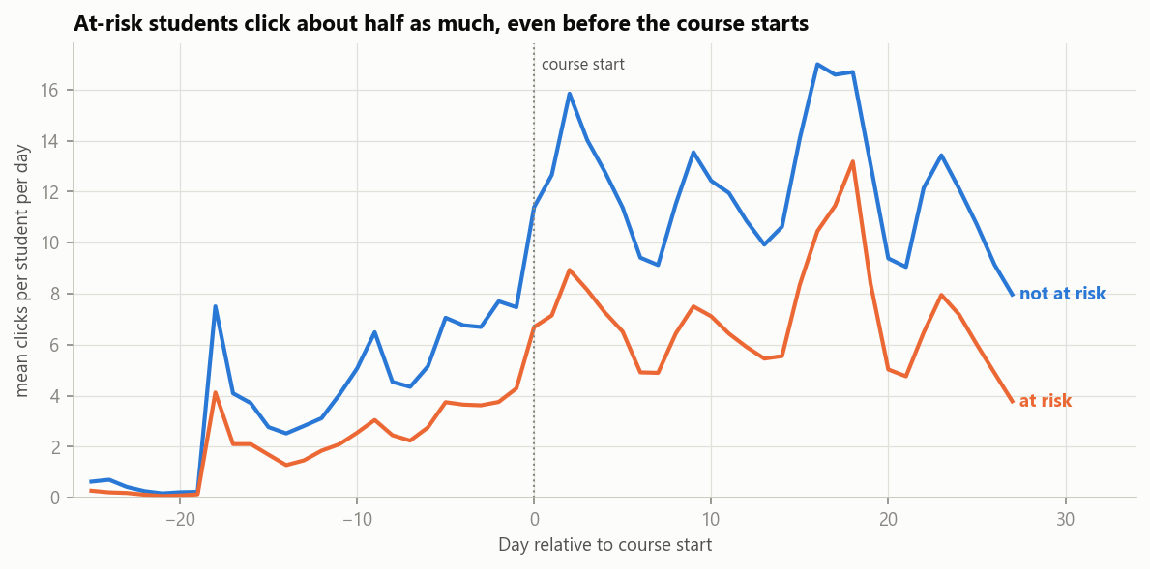
Figure 4. Daily clicks by outcome. At-risk students are already about half as active before the course starts.
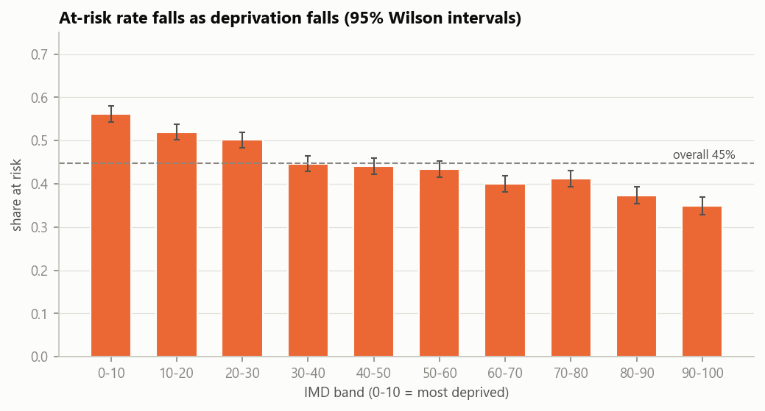
Figure 5. Share of students at risk by deprivation band. The most deprived band has 56.1% at risk, the least deprived 34.9%.
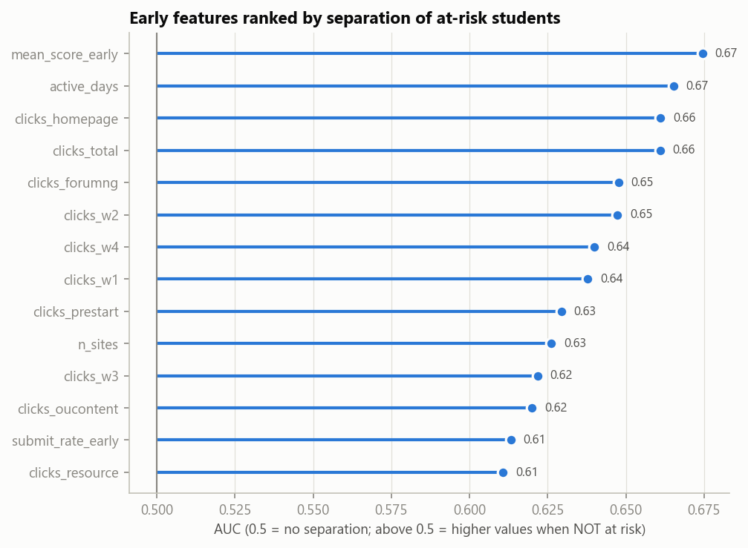
Figure 6. How well each single feature separates at-risk from not-at-risk students (AUC). The best single feature reaches only 0.67, so we need to combine signals.
Engagement explains failing better than leaving
From the lowest to the highest engagement quartile, the share who Fail falls from 40.8% to 13.4%, but the share who Withdraw falls only from 21.7% to 13.7%. Low activity warns us about failing more than about quietly leaving.

5. Preparing the data and building features
In simple words
The raw files are never changed. A notebook turns them into one clean table in 14 logged steps. We then build features, which are numbers that describe a student, such as “how many days did they log in?” or “how active are they compared with others in the same module?”.

5.1 Before and after
Measure | Raw data | Analysis table
Student rows | 32,593 | 27,553 (5,040 early leavers removed)
Distinct students | 28,785 | 24,849
Columns | 12 (studentInfo) | 46 (master), 58 with engineered features
Missing cells | 1,111 + 22,566 + 173 in three tables, coded as text | 15,767, all in documented columns
Rows breaking 12 domain rules | not checked | 0
At-risk rate | 52.8% | 44.2% (early leavers are the clearest withdrawals)

5.2 Features we built
- Rank-based early scores. Each early score becomes a percentile rank within its own assessment (0 means lowest, 1 highest). This fixes the 100-or-1 coding problem and makes hard and easy assessments comparable. We also record how many days before the deadline a student submitted.
- Raw engagement. Log of total clicks, number of active days, the longest stretch without activity, the trend across the four weeks, and the share of clicks on each type of page.
- Relative engagement. The rank of a student’s clicks among students of the same module and year. A student with 100 clicks is active in module GGG but quiet in FFF, so the rank tells us more than the raw count. It lifts the single-feature AUC of clicks from 0.661 to 0.694.
- Tidying. Counts are log transformed, credits capped at 360, previous attempts capped at 3, and near-constant flags dropped. Anything that is fitted (filling gaps, scaling, encoding) happens inside cross-validated pipelines and is fitted on 2013 only.
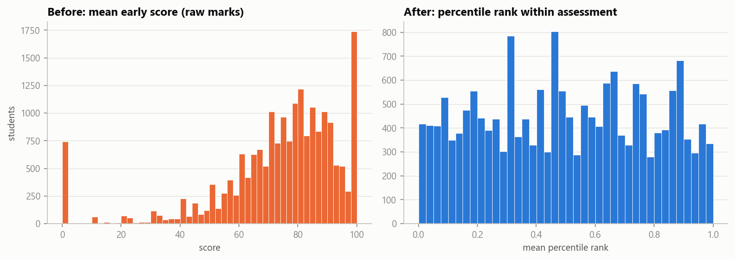
Figure 7. Rebuilding the early score features. Percentile ranks replace averages that were distorted by the 100-or-1 assessment.

5.3 Checks that preparation did not distort the evidence
- The key relationship survives. The at-risk rate still falls with engagement quartile: 62.5%, 48.4%, 38.6%, 27.1%.
- No group disappeared. Every module and cohort keeps 78% to 97% of its students.
- Numbers reconcile. Weekly and activity-type clicks add up to the total, submission counts match for all 27,553 students, and assertions confirm that no feature uses data from day 28 or later.

5.4 Assumptions and open issues
Results hold for the day-28 population only. Modules EEE and GGG have no early assessment. The exit date of 93 Withdrawn students is unknown. The credit-load oddities cannot be verified. Because some students repeat, splits are temporal and grouped by student.

6. Methods and results
In simple words
This is the core of the project. We (1) pick the most useful features, (2) look for types of students, (3) look for simple “if this then that” rules, (4) build a model that predicts risk and test it on 2014, and (5) check that it is fair. Everything is learned from 2013. The 2014 labels are used only for the final test and the checks in section 7.

6.1 Choosing the features
We started with 48 candidate features and kept 18, using the 2013 data only. Four steps did the work:
- A redundancy filter removed 6 features that said almost the same as another (correlation of 0.9 or more).
- Three different rankings (mutual information, the stability of an L1 logistic model over 30 random subsamples, and permutation importance) were combined.
- Cross-validation chose how many features to keep (20).
- A variance-inflation check removed two more that overlapped with others.
The final set has 4 assessment features, 3 relative-engagement, 5 raw-engagement, 4 background and 2 context features.
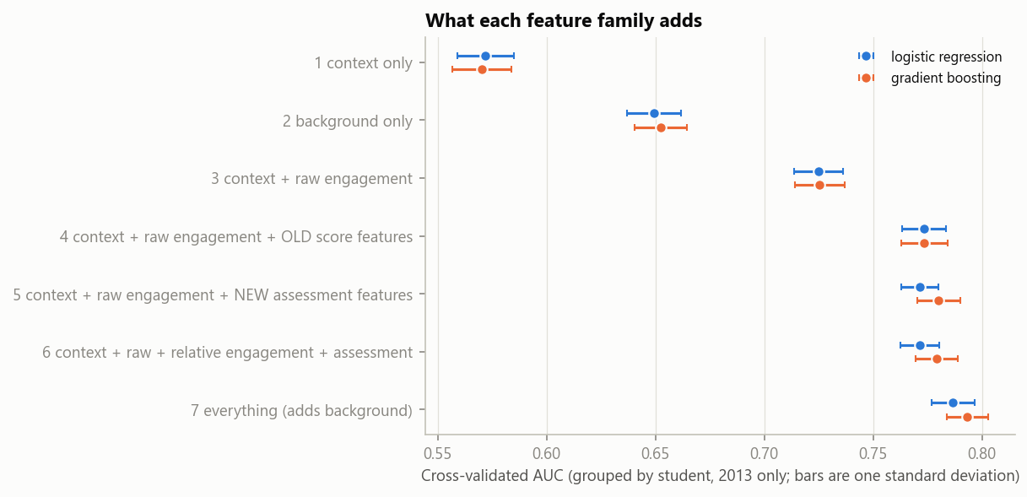
Figure 8. What each family of features adds (cross-validated AUC on 2013, grouped by student). Context alone gives only 0.57, background 0.65, adding raw engagement 0.725, and adding assessment behaviour brings the model to about 0.78.
Reading the figure from top to bottom: module and season alone are almost useless (0.57); background alone is modest (0.65); engagement lifts the model to 0.725; assessment behaviour adds about 0.05 more (0.771 logistic, 0.780 boosting); background adds 0.01 to 0.015 on top. The 18 selected features match all 48 (0.784 and 0.793).
A surprising result
Relative engagement adds nothing when the module is already known. But when the module is hidden (a model meeting a brand-new module), relative engagement predicts better than raw engagement (average AUC 0.738 against 0.728). This is why the model worked well on the new module CCC.

6.2 Engagement profiles (clustering)
Clustering means letting an algorithm group similar students without telling it the outcome. Students with no clicks at all (3.9%) form their own group. The others were clustered on behaviour measured relative to their module, with four methods: k-means, Ward, DBSCAN and a Gaussian mixture.
The structure is weak. Silhouette scores are below 0.25, DBSCAN finds no gaps in the data, and the methods disagree about boundaries (adjusted Rand index 0.3 to 0.6). Engagement is a continuum, like a ruler, not a set of separate types. Three profiles are its most stable regions (stability 0.90, falling to 0.54 with four clusters).
Profile | Share of active students | Behaviour | At risk (2013)
No activity | 3.9% of all students | No clicks before day 28 | 80.7%
Low | 25.6% | About one standard deviation below average, median 75 clicks, longest gap 12.4 days | 62.7%
Intermittent | 30.9% | Slightly below average, gaps of 9.3 days | 46.5%
Sustained | 43.4% | 0.8 standard deviations above average, median 490 clicks, gaps of 3.5 days | 28.8%

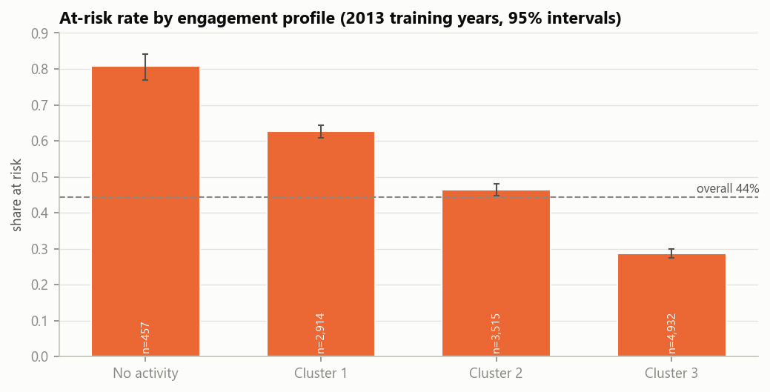
Figure 9. Share of students at risk in each engagement profile. Risk falls steadily from the no-activity group to the sustained group.
A lesson from the first attempt. Clustering on raw behaviour recovered the modules, not student types (Cramér’s V with module 0.52, population shift 0.45). Ranking every behaviour within its own module fixed this (0.17 and 0.01). The effect holds inside each module (odds ratios 4.2 and 2.2 against the sustained profile), and profile shares are the same in 2013 and 2014. Profiles add nothing to prediction beyond the 18 features, so they are a communication tool, useful for explaining students to advisers.

6.3 Rules and categorical associations
Association rules are statements such as “students who missed an early assessment and live in a deprived area are at risk 96% of the time”. We found them with the FP-growth algorithm. We also used chi-square tests with Cramér’s V (a 0 to 1 measure of how strongly two categories are linked).
Factor | Cramér’s V with being at risk
Early assessment behaviour | 0.33
Engagement profile | 0.31
Early score | 0.30
Prior education | 0.17
Deprivation | 0.15
Previous attempts | 0.13
Gender | 0.01 (no association)

- Behaviour matters most, gender not at all. Behaviour is the strongest associate of risk; gender has none.
- Background effects are not a module artefact. Stratifying by module (Mantel-Haenszel) leaves the deprivation effect unchanged (odds ratio 1.99 crude, 2.00 pooled).
- The engagement effect depends on the module. The odds ratio of low against sustained engagement is 11.7 in EEE but only 1.6 in GGG.
- 173 rules survive. FP-growth produced 5,123 candidate rules. With this many students 81% are statistically significant, so we kept only those with a useful lift, enough students and real improvement over simpler rules.
The dominant fact
Missing an assessment due before day 28 goes with 87.6% at risk (1,463 students, lift 1.97). With education below A level it is 92.0%, with high deprivation 90.9%, and with both 96.0% (326 students).
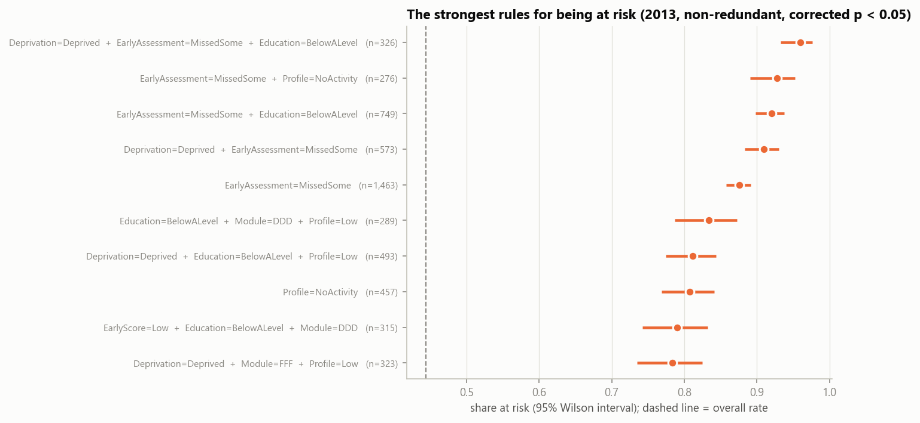
Figure 10. The strongest risk rules found on the 2013 data. Each bar shows how often the students who match the rule end up at risk.
An equity finding. The deprivation gap is 13 to 16 points for students who look fine on the platform, but only 5 points among students who already missed an assessment (90.9% against 85.5%), because their risk is already about 90%. Correspondence analysis, a method that draws a table as a map, reduces each table to a single gradient (91% to 96% of the information) and shows engagement is about four times as strongly tied to the final result as deprivation.

6.4 Prediction and the 2014 test
We compared logistic regression (a simple, transparent model) with gradient boosting (a more flexible model that builds many small decision trees). Gradient boosting wins only if it beats logistic regression by more than 0.003 in cross-validation. It did, by 0.009, so it became the main model. The features, settings, model-choice rule and flagging policy (flag the 30% of students with the highest predicted risk) were fixed before the test. The 2014 data were used for one evaluation.
Method (2014 test) | AUC | PR-AUC | At-risk students found when 30% are flagged
Gradient boosting, 18 features | 0.780 | 0.751 | 51.6%
Logistic regression, 18 features | 0.776 | 0.741 | 51.4%
Logistic regression with module interactions | 0.778 | 0.744 | 51.5%
Baseline: engagement rank within the module | 0.696 | 0.652 | 44.6%
Baseline: early score rank | 0.638 | 0.577 | 37.1%
Baseline: missed an early assessment | 0.589 | 0.524 | 38.1%
Baseline: module average | 0.551 | 0.471 | 31.7%

How to read the numbers. AUC 0.780 (95% confidence interval 0.773 to 0.786) means that if you pick one at-risk and one not-at-risk student at random, the model gives the at-risk student the higher score 78% of the time. The cross-validated value on 2013 was 0.793; the small drop is expected, because the features were selected on the 2013 rows.
Calibration and triage
Calibrated means that the predicted probabilities can be trusted as probabilities: the average predicted risk is 44.3% and the observed risk 44.0% (calibration slope 1.03).
Of the 30% flagged, 75.7% really are at risk (lift 1.72). But the model finds only 51.6% of all at-risk students, so about half are missed. It is a triage tool that tells advisers whom to call first, not a certainty about any one student.
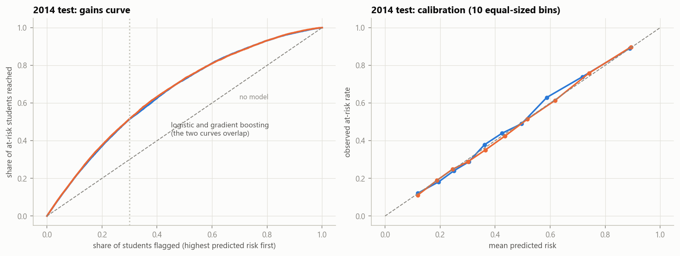
Figure 11. Left: share of at-risk students found as more students are flagged. Right: predicted against observed risk, where points close to the diagonal line mean well-calibrated predictions.

Where the model works best and worst
- By module (AUC): CCC 0.81 (never seen in 2013), DDD 0.80, FFF 0.79, EEE 0.78, BBB 0.74, AAA 0.70 (only 348 students), GGG 0.69.
- By start month: February starts 0.786, October starts 0.772.
- By student type: returning students 0.768, new students 0.775. Both are predicted equally well.

How early can we predict?
Engagement alone gives an AUC of 0.64 before the course starts, 0.67 at day 7, 0.68 at day 14 and 0.70 at day 28. Assessment behaviour and background add about 0.08 on top at day 28. Waiting gives a modest gain, so earlier contact is possible but less accurate.
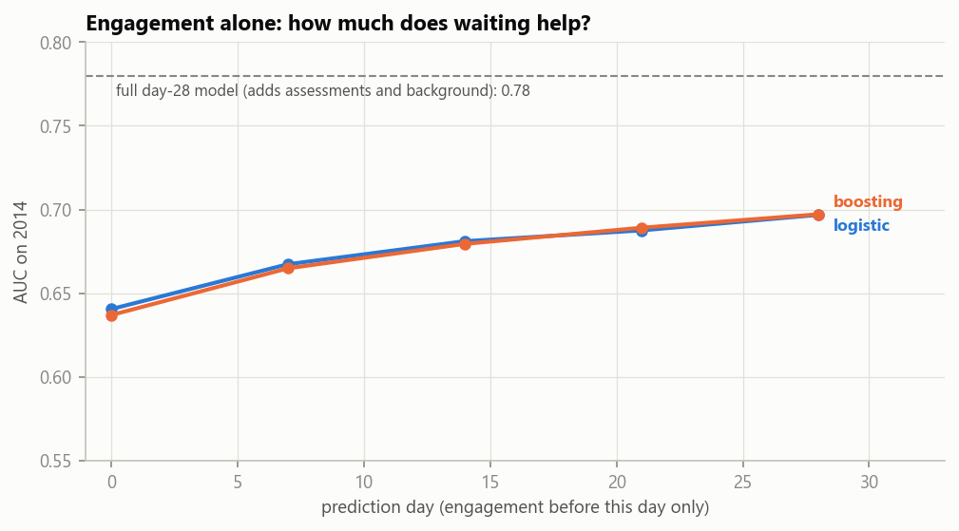
Figure 12. Accuracy of an engagement-only model by prediction day. The dashed line is the full day-28 model.

Do the 2013 findings repeat in 2014?
Yes. The risk of each engagement profile moves by less than 3 points from 2013 to 2014. All 173 rules keep their direction, and 83.8% keep a lift of at least 1.25 (98% of the risk rules, 60% to 71% of the protective ones). A simple rule list tuned for 70% precision flags 30.2% of students with 69.1% precision and finds 47.5% of the at-risk ones; the model at the same flagged share gets 75.6% and 51.9%.

6.5 Fairness
A model can be accurate overall and still treat groups differently. At the fixed policy (flag the top 30%), we compared recall (the share of truly at-risk students who are flagged) and the false-positive rate (the share of not-at-risk students who are flagged by mistake) across groups, with and without education and deprivation as inputs.
Group | At risk | Recall, all features | Recall, no socio-economic | False positives, all features | False positives, no socio-economic
Deprived (bands 1 to 3) | 51.4% | 58.7% | 51.8% | 19.1% | 13.4%
Affluent (bands 8 to 10) | 38.3% | 45.0% | 50.5% | 9.9% | 13.0%
Education below A level | 52.0% | 59.4% | 50.2% | 19.3% | 12.0%
Higher education | 35.7% | 44.5% | 54.0% | 9.0% | 14.4%
Women | 41.3% | 44.2% | 43.0% | 11.6% | 11.0%
Men | 46.0% | 56.6% | 56.7% | 14.1% | 15.1%
Disability | 54.1% | 55.0% | 52.6% | 16.6% | 14.5%
No disability | 42.9% | 51.2% | 51.1% | 12.7% | 13.2%

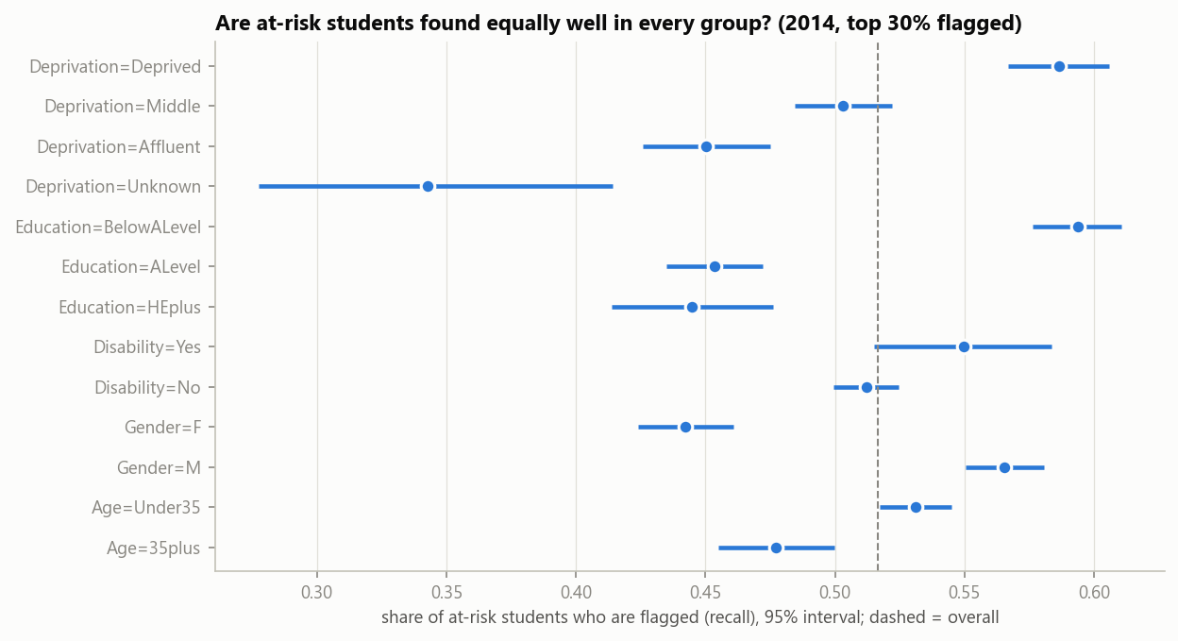
Figure 13. Recall by group, with and without socio-economic features. Removing education and deprivation brings the groups closer together.
- With all features, the model finds more of the at-risk students in disadvantaged groups (58.7% for deprived against 45.0% for affluent) but also flags more of the others wrongly (19.1% against 9.9%, almost twice as often).
- Without education and deprivation, recall and false-positive rates become nearly equal across deprivation and education, at a cost of 0.009 AUC (0.780 to 0.771).
- The apparent gender gap is module mix. AUC is 0.751 for women and 0.797 for men, but women are 88% of the students in BBB and 80% in GGG, the two modules where the model works worst.
- Disability. Risk is under-predicted by about 5 points (49.1% predicted, 54.1% observed).
Recommendation
Use an alert model without education and deprivation, and let advisers use deprivation information separately to decide how much support to offer. This is a policy choice for the university, not a purely technical one.

7. Can we trust it? Imbalance, leakage, drift, forecasting and experiments
In simple words
A good test score can hide problems that matter in real use. We examined five of them on purpose, including by building deliberately wrong versions, to measure how much damage each could do.

7.1 Class imbalance
The main target is nearly balanced (44% against 56%), but the outcomes behind it are not: Withdrawn is 17.0% of students in 2013 and 19.8% in 2014, and Distinction 9.1% and 12.4%. We compared five strategies for the rare outcome Withdrawn inside cross-validation: class weights, random oversampling, random undersampling, SMOTE (written by hand; it creates synthetic examples of the rare class) and threshold tuning.
- Ranking is not helped. ROC-AUC and PR-AUC for Withdrawn are 0.706 and 0.335 with the plain model, 0.706 and 0.336 with class weights, and lower with undersampling (0.699, 0.314) and SMOTE (0.686, 0.310; on 2014, 0.663 against 0.696).
- The default threshold is the real problem. A plain model almost never predicts the rare class at the usual 0.5 cutoff (F1 of 0.08), but moving the threshold of the unchanged model reaches the same F1 as every fix (0.394 against 0.387 to 0.393).
- Fixes spoil the probabilities. Weights and resampling make the average predicted probability 2.1 to 3.2 times the true rate (Brier score 0.146 plain, 0.207 with weights).
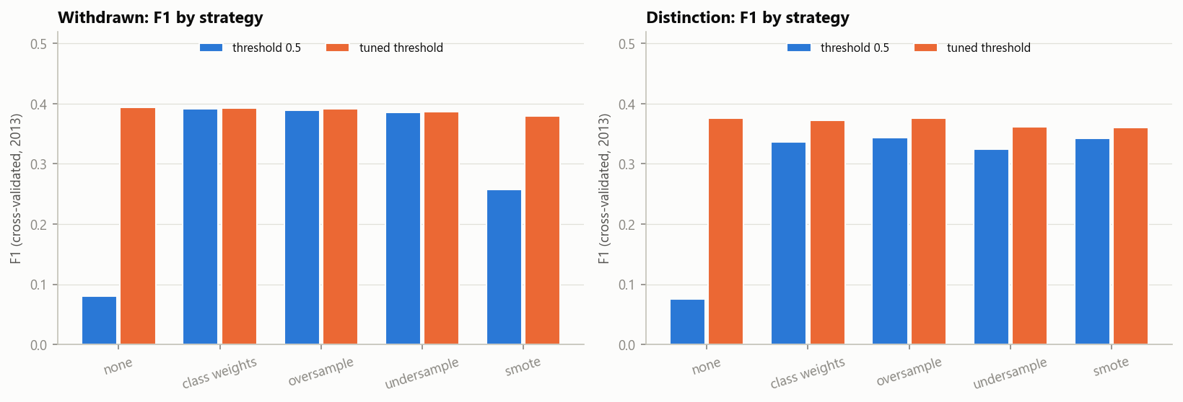
Figure 14. Comparison of imbalance strategies. Tuning the decision threshold of the plain model matches all the other fixes without distorting the probabilities.
Practical advice: keep the plain model, and either tune the threshold or flag a fixed share of students.

7.2 Data leakage
Leakage happens when a model sees information that would not be available in real use, so its score looks better than it deserves. We built seven leaks on purpose and measured how much each inflates the test AUC.
Leak built on purpose | AUC inflation | Caught by a train/test split?
Clicks on days 28 to 55 added as a feature | +0.028 | No, the leak is in the test data too
Scores of assessments submitted after day 28 | +0.079 | No
Unregistered by day 56 (an outcome proxy) | +0.014 | No
All three together (test AUC 0.864 against 0.780) | +0.084 | No
Random-row split instead of a temporal split | +0.009 | Partly
Target encoding of 1,909 fine cells on all rows | +0.175 | No
Choosing features before cross-validation (pure noise) | +0.149 | No
Scaling and imputing on both years | 0.000 | Harmless here

Lesson
Future information is invisible to a train/test split because it sits in both halves. Only a written timeline of when each field becomes known catches it. Everything that is fitted must stay inside the cross-validation pipeline.

7.3 Data drift
Drift means the data change over time. We separate two kinds: data drift (the inputs look different) and concept drift (the link between inputs and outcome changes). Only the second one really breaks a model.
- The inputs moved. Withdrawn rose 2.7 points and Distinction 3.3 points; module CCC went from 0% to 22.4% of students. Behavioural engagement is stable (population stability index, PSI, of 0.02 or less), while course structure shifted: course length PSI 16.1 (values never overlap between years), module 1.8, days before the deadline 0.38.
- The relationship did not move. A model that saw 2014 does no better than the 2013 model (AUC 0.781 against 0.780), and coefficients fitted separately on each year correlate at 0.98. This means there is no concept drift.
- A measurement trap. Adversarial validation (can a model tell the years apart?) first reported 0.89. But percentile ranks sit on a grid whose width depends on group size, and so reveal the course run. Without them the real shift is moderate (0.71, and 0.65 without CCC).
- The 100-or-1 assessment. For the 1,674 affected students (10.6% of 2014) the old raw-score feature predicts 46.5% risk against 31.9% observed (AUC 0.59); the rank-based feature predicts 33.6% (AUC 0.66). Overall AUC would have been 0.764 instead of 0.780.
- Fragile features. Removing the course-length feature and capping days-before-deadline costs about 0.001 AUC, so both should go in the next version.
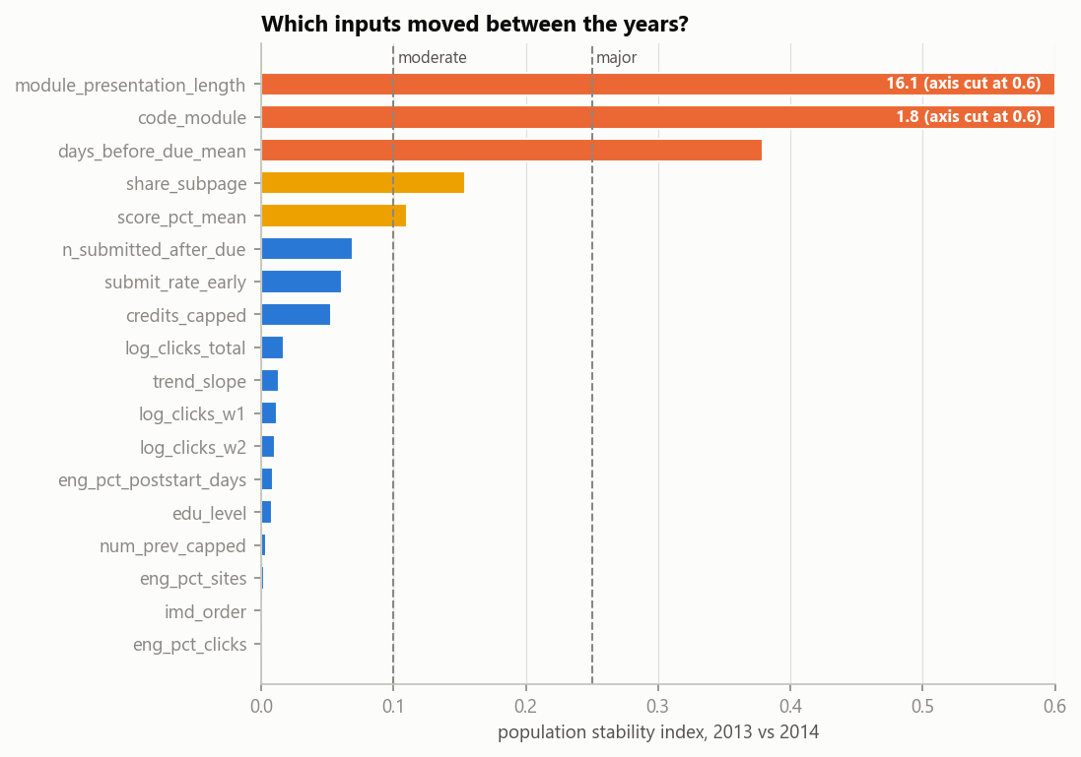
Figure 15. Population stability index (PSI) for each feature between 2013 and 2014. Values above 0.10 deserve attention and above 0.25 mean a major shift.
Monitoring plan
Weekly: PSI of every input (alert at 0.10, major at 0.25), missing share per module, and the distribution of predicted risk.
End of each course run: calibration by module (alert above a 3-point gap), and AUC and group recall (retrain if AUC falls by 0.03 or a group’s recall gap widens by 0.05).

7.4 Time series: forecasting platform activity
The same data can answer a different question: how busy will the platform be? This matters for staffing and server capacity. We studied 22 daily click series, one for each course run.
- Shape of activity. A decaying trend, a modest weekly cycle (median strength 0.23) and a dominant deadline calendar.
- Deadlines matter most. Across 105 tutor-marked and 69 computer-marked assessments, clicks on the day before the due date are 1.9 and 3.2 times the local average, then fall to 0.8 and 0.6 times.
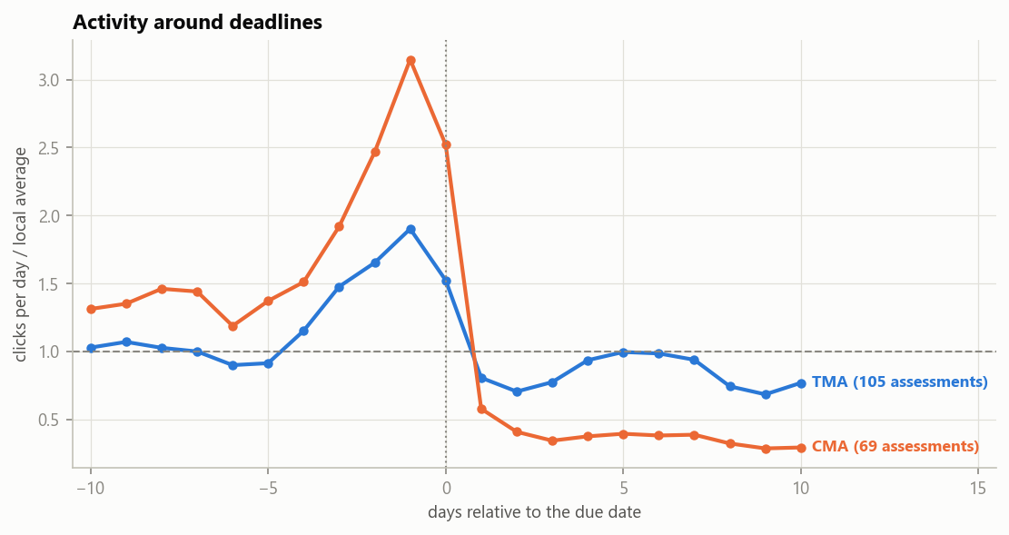
Figure 16. Activity around assessment deadlines. Clicks peak just before the due date and drop right after.
Forecasting. Standing on day 28 (when alerts go out), we forecast days 28 to 55 from days 0 to 27. Simple methods are hard to beat: seasonal naive, naive and Holt-Winters have similar errors, and Holt-Winters over-forecasts by 20% at the median. On the 9 series that have a 2013 twin (the same module a year earlier), last year’s profile rescaled by recent activity is clearly best.
Method (9 series with a twin) | sMAPE (error) | Bias | Mean MASE
Analog profile (last year’s twin) | 17% | -4% | 0.54
Holt-Winters (damped, weekly) | 29% | +12% | 0.73
Naive | 27% | -18% | 0.69
Seasonal naive | 30% | +29% | 1.05

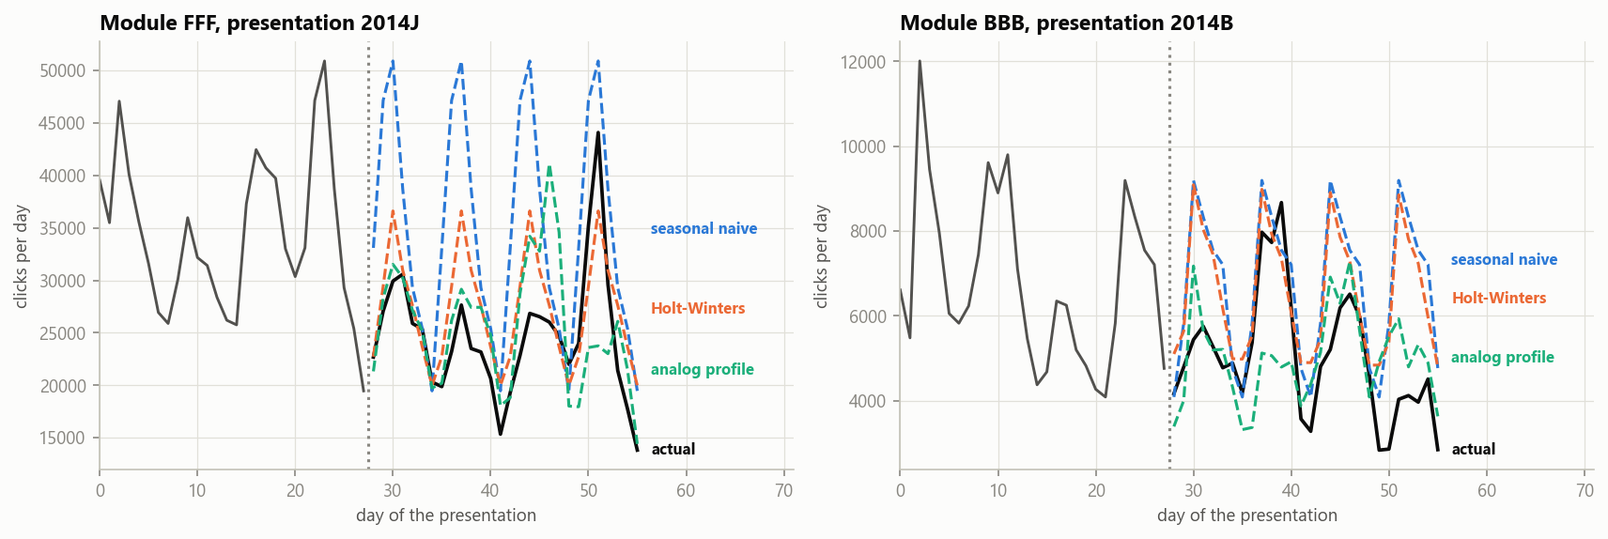
Figure 17. Examples of forecasts for days 28 to 55. The analog profile follows the deadline peaks that the statistical methods miss.
The analog forecast also stays accurate over the whole four-week horizon (sMAPE 13%, 19%, 14% and 22% by week), while Holt-Winters worsens from 17% to 36%. Caveat: only 9 of the 13 course runs of 2014 have a twin, so this is evidence from 22 series and a single holdout window.

7.5 Designing an A/B test of outreach
The model says who is at risk. It does not say whether contacting them helps. Answering that needs an experiment.
Why a simple comparison fails
If we compare contacted with not-contacted students, contact looks harmful. In our simulation, outreach truly lowers the at-risk rate by 5 points, yet the naive comparison reports a 36-point increase. The reason: contact went to the students who were already at the highest risk. A regression discontinuity design around the flagging threshold recovers the effect (-4.6 and -4.7 points) but is four times noisier than a randomised trial (standard deviation 4.8 to 6.3 points against 1.3).
The flagged group (top 30% in 2014) has 4,721 students, 75.1% of whom ended at risk. How big a reduction could a trial detect (80% power)?
Population for the comparison | Students per arm | Smallest reduction detectable
All flagged students in one year | 2,360 | 3.7 points
A median module, both presentations | 306 | 10.5 points
A median module-presentation | 198 | 13.2 points

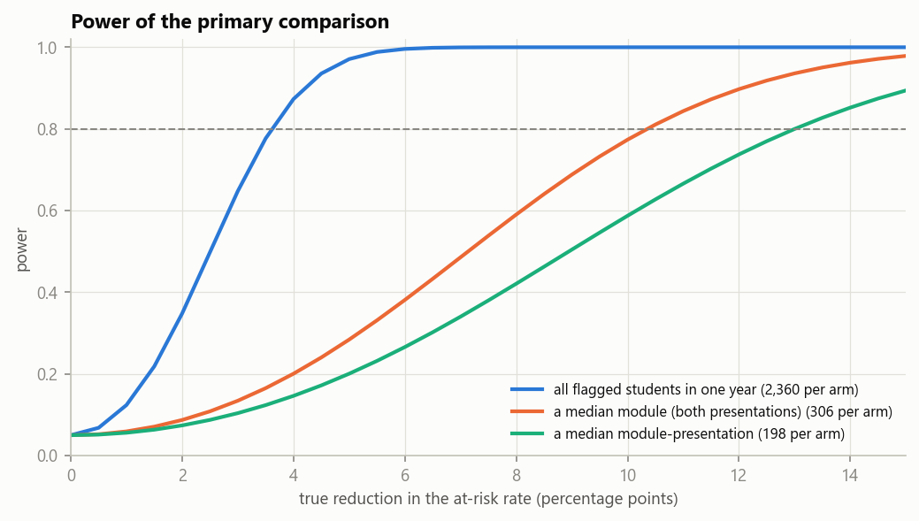
Figure 18. Statistical power against the number of students per arm. More students allow smaller effects to be detected reliably.
Simulated trials keep the test’s size (5.8% to 6.0% false positives at a nominal 5%) and have 69% to 71% power for a 3-point reduction and 97% to 98% for 5 points. Adjusting for the risk score adds at most 2.5 points of power.

The experiment plan
- Randomise individual students 1:1, stratified by module-presentation and risk tercile (by tutor group if tutors would treat both arms).
- Primary outcome: ending the course at risk. Secondary outcomes: the next assessment submitted by day 56, and the final score.
- Guardrails: complaints, tutor workload, and outcomes of the unflagged students.
- Control students receive usual support, and the outreach afterwards if it works.
- Single modules would be inconclusive, so the trial must pool modules and run for two or three course runs.

8. Conclusions, limits and next steps
In simple words
The data are good enough to build an early-warning tool for triage, if we follow five precautions. The tool can say who is likely to struggle. It cannot say why, and it cannot say whether contacting them helps.

8.1 What the data tell us
- Platform data differ hugely between modules (median clicks 474 in FFF, 48 in GGG), so every behaviour is best read relative to the student’s own module.
- Early behaviour carries most of the signal, but no single signal is strong. The best single feature has an AUC of 0.67; combining them reaches 0.78. A missed assessment is the strongest single fact (87.6% at risk), engagement is next, and background last.
- Equity signals survive every control. At-risk falls from 56% in the most deprived band to 35% in the least deprived, and the gap persists after adjusting for module, background and engagement.

8.2 What was relevant and what surprised us
Relevant | Unexpected
An engagement gap that already exists before the course starts | The module never seen in training (CCC) was predicted best (AUC 0.81)
Engagement describes failing better than withdrawing | The gender association vanished after adjusting for module
A deprivation gap that is largest for students who look fine on the platform | Relative engagement adds nothing when the module is known, yet makes unseen modules predictable
 | 2014 inputs shifted a lot but the link with the outcome did not move at all (retraining gain 0.002)
 | An alarming adversarial-validation result was only a rank-grid artefact

8.3 Biggest threats to validity
- The population definition. Results describe students still enrolled at day 28. The 5,040 early leavers are outside them, and the exit date of 93 Withdrawn students is unknown.
- The assessment coding artefact. It is fixed, but it shows how a silent change in one course can break a model.

8.4 What the data can and cannot answer
Question | Answered? | Why
RQ1 association | Well | Effect sizes with intervals; background effects hold within modules; the engagement effect varies by module
RQ2 profiles | Partly | Three stable regions of a continuum, not natural types; no added predictive value
RQ3 prediction and stability | Well | AUC 0.78 on a new year, calibrated, no concept drift; but only two years and seven modules
RQ4 equity | Well for description, partly for remedies | Gaps measured and one variant evaluated; causes unknown; small groups have wide intervals
Does outreach help? | Not at all | Needs a randomised trial; the observational comparison has the wrong sign

8.5 Decision: proceed, with five precautions
- Alerts trigger supportive contact, never penalties.
- Use the alert model without education and deprivation, and keep that information for human decisions about support intensity.
- Drop the course-length feature and cap days-before-deadline in the next version.
- Monitor every input and calibration per module, and retrain if AUC falls by 0.03.
- Test the effect of outreach in a pooled randomised trial before claiming that it works.

8.6 Limitations
- The test is one year ahead. Features were selected on the training rows, which makes cross-validation about 0.013 AUC optimistic; the 2014 result is the unbiased estimate.
- Cut points (score tertiles, the 7-day timing threshold, merged education and age levels) were fixed before looking at outcomes but remain choices.
- The cluster structure is weak, so the number of profiles is partly a convenience choice.
- The forecasting evidence rests on 22 series, 9 of them with a twin, and one holdout window each.
- Risk for disabled students is under-predicted by about 5 points, and groups such as age 55 and over or no formal education are small.
- Two cohort years, seven modules and one institution: the results may not apply elsewhere, and associations cannot show that any intervention works.

8.7 Ethics and privacy
The data are anonymised and no re-identification was attempted. Sensitive attributes (deprivation, disability, age, gender, region) are used to audit fairness and are excluded from the recommended alert model. Alerts should lead to supportive contact, be explained to students, and keep the data minimal. The A/B plan keeps control students on usual support and gives them outreach afterwards if it works.
AI assistance. Code, figures and drafts were produced with AI assistance (Claude Code). The author remains responsible for the correctness, interpretation and reproducibility of everything submitted.

8.8 Next steps
- Run the pooled randomised trial of outreach for two or three course runs.
- Ship the next model version without the course-length feature, with days-before-deadline capped, and without socio-economic features.
- Re-evaluate on later presentations as they become available, consider separate models for GGG and AAA, and add a calendar-aware forecast that uses the known deadlines.

Glossary: technical words in everyday language
Words are listed in the order a beginner is likely to meet them.
Word | Meaning in simple words
At risk | Our label for a student who ends the course as Fail or Withdrawn.
Cutoff (day 28) | The moment we pretend to stand at. We may only use information from before it.
VLE | Virtual learning environment: the online platform where students read, watch and click.
Module-presentation | One run of one course, for example module FFF starting October 2013.
IMD (deprivation band) | A UK measure of how deprived the student’s home area is. Band 1 is the most deprived, band 10 the least.
Feature | A number that describes a student and is fed into the model, such as active days.
Target | The thing we want to predict (here: at risk or not).
Training and test data | Training data is what the model learns from (2013). Test data is used once to grade it (2014).
Cross-validation | Splitting the training data into parts, training on some and testing on the rest, to estimate accuracy without touching the test data.
Percentile rank | A student’s position among others, from 0 (lowest) to 1 (highest). It removes differences in scale between modules.
Log transform | Compressing very large numbers so a few heavy users do not dominate.
Correlation (Spearman) | How closely two numbers rise and fall together, from -1 to 1. It shows association, not cause.
Effect size | How big a difference is, as opposed to whether it is statistically significant. With thousands of students, tiny differences are significant.
Cramér’s V | Strength of the link between two categories, from 0 (none) to 1 (perfect).
Odds ratio | How much more likely something is in one group compared with another. 1 means no difference; 2 means about twice the odds.
Clustering | Letting an algorithm group similar students without telling it the outcome.
Association rule | A statement such as “if A and B then C”, with how often it holds (confidence) and how much better than chance it is (lift).
Lift | How many times more common an outcome is among those who match a rule than among everyone. Lift 2 means twice as common.
Logistic regression | A simple, transparent model that adds up weighted features into a probability.
Gradient boosting | A more flexible model that builds many small decision trees, each correcting the previous ones.
AUC | How well a model ranks students: 0.5 is a coin flip, 1.0 is perfect. 0.78 means the model gives the higher score to the at-risk student 78% of the time.
Precision | Of the students we flag, the share who really are at risk.
Recall | Of the students who really are at risk, the share we manage to flag.
False-positive rate | Of the students who are not at risk, the share we flag by mistake.
Calibration | Whether predicted probabilities match reality. If the model says 40% for many students, about 40% should really be at risk.
Triage | Deciding who gets help first when you cannot help everyone.
Class imbalance | When one outcome is much rarer than another. Then a model can look accurate by always predicting the common one.
SMOTE | A method that creates synthetic examples of the rare class to balance the data.
Leakage | When a model sees information it would not have in real use, so its test score looks better than it deserves.
Data drift | The inputs change over time (for example a new module appears).
Concept drift | The link between the inputs and the outcome changes. This is the kind that breaks models.
PSI | Population stability index: a number that says how much a variable’s distribution changed. Above 0.10 deserves attention, above 0.25 is a major shift.
Fairness (recall and false-positive gaps) | Comparing how often the model finds, or wrongly flags, students from different groups.
Time series | A number recorded over time, such as daily clicks.
Naive forecast | Predicting that the next days will look like the last day.
Seasonal naive | Predicting that the next days will look like the same weekdays last week.
Holt-Winters | A classic forecasting method that follows trend and weekly pattern.
sMAPE and MASE | Two measures of forecast error. Lower is better. sMAPE is a percentage; MASE compares with a simple benchmark.
A/B test (randomised trial) | Randomly splitting people into two groups, giving one the treatment, and comparing outcomes. Randomness makes the groups comparable.
Statistical power | The chance that a trial detects a real effect. 80% is the usual target.
Regression discontinuity | Comparing people just above and just below a cutoff, who are very similar, to estimate an effect without randomising.

Appendix A. Reproducibility and notebook map
The project folder OULAD_Project contains raw files in data/raw/ (never edited), analysis tables in data/processed/, notebooks in notebooks/, tables and figures in outputs/, and shared item definitions in src/items.py. Run the notebooks in order from the notebooks folder. The file studentVle.csv has 10.6 million rows and needs about 1 GB of memory. The README lists package versions and the single key parameter (CUTOFF_DAY = 28).
Notebook | What it does | Main outputs
01 | Framing, provenance, table structure | keys and counts
02 | Master table at day 28, audit trail | oulad_master_day28.csv, data dictionary, transformation log
03 | Exploratory analysis, quality audit, sensitivity checks | audit table, effect sizes
04 | Feature engineering and selection | oulad_features_day28.csv, feature_groups.json
05 | Clustering | oulad_clusters_day28.csv
06 | Association rules, chi-square and trend tests, correspondence analysis | association_rules_2013.csv
07a | Models, 2014 test, fairness, replication, cutoff sensitivity | oulad_predictions_2014.csv, final_model_spec.json
07b | Imbalance, leakage, drift, monitoring plan | ledgers and drift tables
07c | Time series and A/B test design | forecast errors, power simulations, plan

Software: Python 3.13; pandas 2.3.2, numpy 2.2.6, scipy 1.16.3, scikit-learn 1.8.0, statsmodels 0.14.6, matplotlib 3.10.6, mlxtend 0.23.4. Random seed 42 throughout.

Appendix B. Transformation log (notebook 02)
Every change made to the raw data is listed here. Raw files were never edited.
Step | Issue | Action | Rows affected
S1 | Missing values coded with a question mark | Read as missing | 34,347 cells
S2 | Duplicate click rows | Kept and summed (sensitivity tested) | 2,195,960
S3 | Documentation says 32,953 and 32,593 students | Used the observed 32,593 | 360
S4 | Unregistered before day 28 | Removed from the modelling population | 5,040
S4b | Unregistration date but not Withdrawn | Date rule applied | 9
S4c | Withdrawn without exit date | Kept, no flag (a flag would leak) | 93
S5 | Raw click log | Aggregated to student level, days before 28 only | 28,774
S6 | Late and banked submissions | Only submissions before day 28, not banked | 23,439
S7 | Two deprivation label styles | Harmonised | 23,696
S8 | Deprivation missing | Indicator, no imputation | 1,029
S9 | Ordered categories stored as text | Ordinal codes added | 27,553
S10 | Registration date missing | Indicator | 7
S11 | No clicks or submissions after joins | Counts set to 0 with flag; scores left missing | 940
S12 | Unregistration date | Dropped (outcome leakage) | 27,553

References
Kuzilek, J., Hlosta, M. and Zdrahal, Z. (2017). Open University Learning Analytics dataset. Scientific Data 4, 170171. doi:10.1038/sdata.2017.171
Open University Learning Analytics Dataset, UCI Machine Learning Repository, dataset 349 (accessed 24 October 2026).
Benjamini, Y. and Hochberg, Y. (1995). Controlling the false discovery rate. Journal of the Royal Statistical Society B 57(1), 289-300.
Chawla, N. V., Bowyer, K. W., Hall, L. O. and Kegelmeyer, W. P. (2002). SMOTE: synthetic minority over-sampling technique. Journal of Artificial Intelligence Research 16, 321-357.
Cleveland, R. B., Cleveland, W. S., McRae, J. E. and Terpenning, I. (1990). STL: a seasonal-trend decomposition procedure based on loess. Journal of Official Statistics 6(1), 3-73.
Greenacre, M. (2007). Correspondence Analysis in Practice, 2nd edition. Chapman and Hall/CRC.
Hyndman, R. J. and Koehler, A. B. (2006). Another look at measures of forecast accuracy. International Journal of Forecasting 22(4), 679-688.

