Clearing and Settlement System – Team 5
[v0.1]

Document Version History

Version No. | Created/Updated Date | Created/Updated By | Version Change Details
0.1

Document Approval
Approved By:
Approved On:

Contents

Introduction 3
Project Team & Roles 3
Project Background 3
Project Assumptions 3
Requirements Scope 3
In Scope 3
Out of Scope 3
Requirements Description 4
Functional Requirements 4
Scenarios Covered 4
Non-functional Requirements 4
Logical Flow Chart 5
Project Architecture 5
Schematic Project Architecture 5
Data Model (ERD) 5
Testing Approach 5
Test Scenarios 5
Test Cases 5

Introduction

Project Team & Roles
[Note: Write names of team members and the roles they are playing the project]

Role | Name | Remarks
Project Manager | Prateek W
Business Analyst | Avnish Panda
Developer 1 | Hardik
Developer 2 | Riti Agarwal
Developer 3 | Sakshi Patil
Developer 4 | Varsha Deshpande
Developer 5 | Charasmai
Tester 1 | Maria
Tester 2 | Kshiteesh

Project Background
[Note: Give a brief background regarding the software being built e.g. why this software is is needed, which line of business is this software used in, etc.]
Clearing houses are an intermediary between buyers and sellers of financial instruments. Further, it is an agency or separate corporation of an exchange responsible for settling trading accounts, clearing trades, collecting and maintaining margin monies, regulating delivery of the bought/sold instrument, and reporting trading data. Clearing houses act as third parties to all futures and options contracts, as buyers to every clearing member seller, and as sellers to every clearing member buyer.
A clearing and settlement system is built by the clearing house in order to settle up the transactions of a day in an orderly fashion. The system is to built to handle any kind of transactions taking place in the day. It stores the information regarding the companies using the settlement house and the stocks as well as funds associated with the respective company.
The software is needed because there are millions of transactions that occur in a day which are not feasible to be handled by humans with the necessary business knowledge as it creates a large margin for human error which might adversely affect the company associated with the clearing house in a large manner.
This software is in the stock market line of business where the stocks and funds transacted in a day are handled by the clearing house and the necessary funds/equities are assigned to the corresponding companies which are a part of the transaction house.

Project Assumptions
[Note: Assumptions are made when you do not know something, but you still have to proceed with whatever information is available. All such assumptions that you have done for this project should be listed here so that the project and document audience are also aware about them.]

Assumption No. | Assumption | Detail about the assumption & why it was made
1 | Initial Fund and Equities | Initial fund and equities for each custodian is assumed to be 10 lakh and zero respectively for the sake of demonstration of real time system.
2 | Base Cost | No base cost of settlement. Only the interest rate are used to calculate the final cost.
3 | Settlement | Settlement will happen manually after clicking the button.

Requirements Scope

In Scope
The project primarily concentrates on the settling algorithm which considers the balances of the companies till the latest settle up as well as the new transactions that have occurred until the point of the current settle up and generates new balances for the companies based on the transactions. The settling up will occur regularly in a specific time period as well as on invocation of the settle up option. The project assumes that the user of the system can add transactions to the system hence gives the user the option to do the same. It also allows the user of the system to add companies or securities to the system so that they can trade and be traded upon. It also allows to dynamically update the interest rates of each security that is a part of the clearing house and updates the same of user interface of the software.

Out of Scope
[Note: List below requirements that you know are related to the project, but are not included within the project]
The future scope of the project is that the market price of the securities being traded can be dynamically pulled off the internet updating the database so no data has to be hard coded into the database before hand.

Requirements Description

Functional Requirements
[Note: Functional requirements include software features that a user can use, some calculation or information processing. In this section list the functional requirements for the project and describe each requirement in brief.]

FR No. | Requirement | Description
FR1 | Transaction amount Calculation | Each Trade transaction amount is calculated on the basis of funds and equities.
FR2 | Netting | Overall Netting of amount per custodian is calculated.
FR3 | Balance Shortage Check | Depending upon the overall netted amount ,it is checked whether the custodian has balance shortage or not.
FR4 | Borrowing | In case of Shortage, borrowing option on the basis of fund and equities is provided to the client.

Scenarios Covered
[Note: Scenarios mean different permutations, combinations that exist for a requirement. Few scenarios are mentioned in the project documents shared with you, but there could be more scenarios not mentioned in that document. List here a requirement and the related scenarios that you have included in your project.]

FR No. | Scenario | Description
FR1 | No shortage | Enough fund or equities: NO NEED TO BORROW
FR2 | Shortage | Insufficient funds or equities: NEED TO BORROW

Non-functional Requirements
[Note: Non-functional requirements include aspects related to the quality of the system e.g. data security, user/application scalability, speed of processing, system availability, etc. In this section, list quality related aspects of your project. Describe in brief each non-functional requirement.]

NFR No. | Requirement | Description
NFR1 | Accuracy | Correct calculation.
NFR2 | Response Time | Minimum time for connection, calculation and display
NFR3 | Usability | Data presented should be readable. UI should be user-friendly.
NFR4 | Reliability | System should generate reliable data and obligation reports.

Logical Flow Chart
[Note: Include here a logical flow chart explaining the overall flow of the project.]
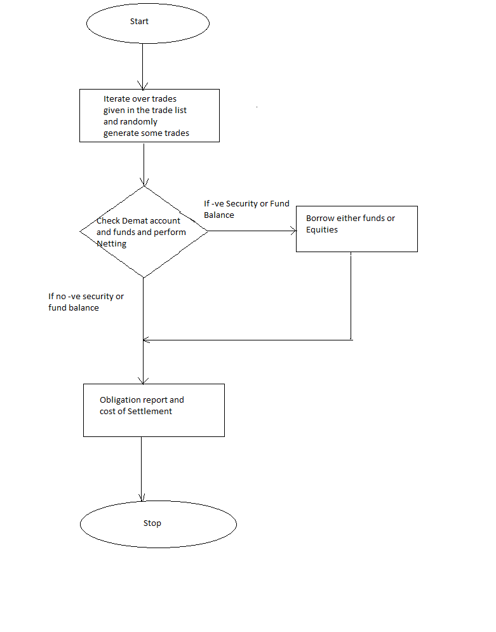

Project Architecture

Schematic Project Architecture
[Note: Include here a picture showing various components of your project and how and why they interact with each other.]

Data Model (ERD)
[Note: Include here a data model showing the key entities, their attributes, and relationships between the entities.]

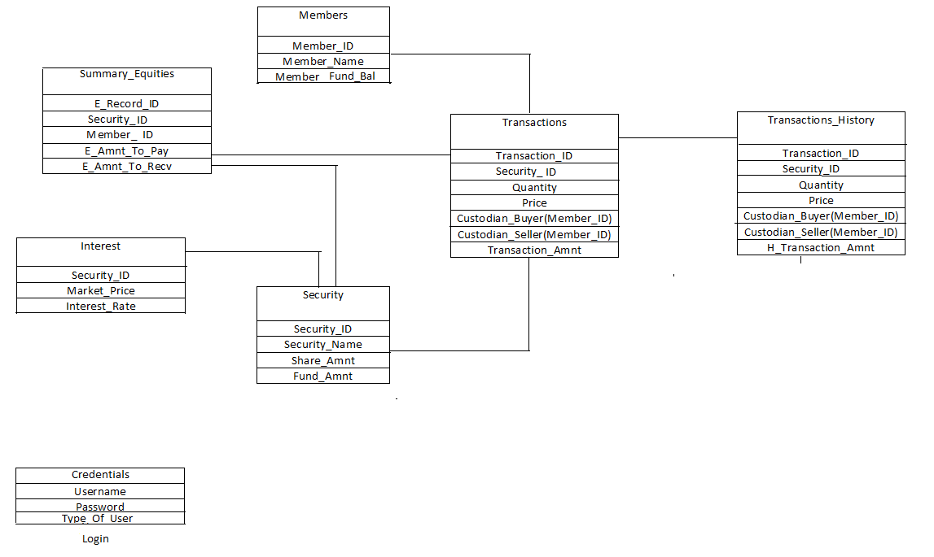

Class Diagram:

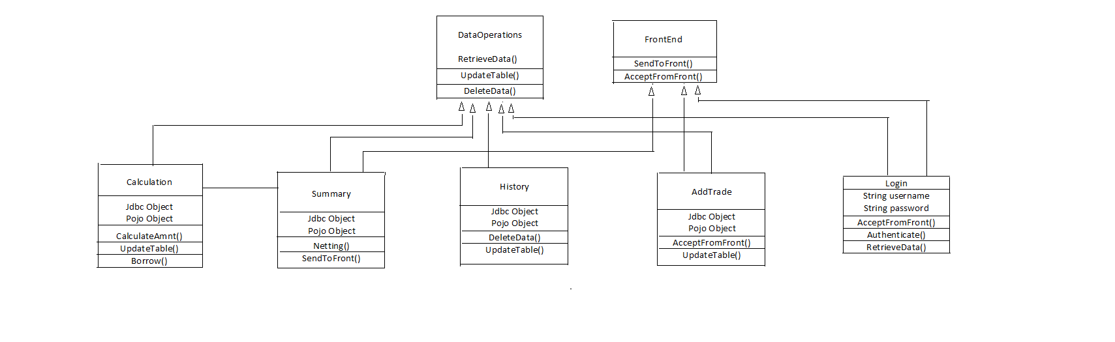

Testing Approach

Test Scenarios
[Note: Include here different scenarios that you are planning to test within the project. Generally there is a direct relation between the requirement and the test scenario.]

Test Cases
1. Incorrect username/ password - block after 3 attempts/ forgot password?
2. Trade done simultaneously at the time of settlement- gets reflected or not?
3. If admin can login through guest login as well (y?) and vice versa(n?)
4. History retrieval- ability to check over all as well as particular date
5. Close option of borrowing funds/ equities after decision is made so that modification is not made
6. Simultaneous trades of same member and correct balance update
7. If option of multiple settling option is given to clearing house and they enter same time in 2 fields- error message?
8. If a custodian presses settlement before the end of the day, then the settlement report produced by clearing house at the end of the day should contain only summary after he pressed settlement

