Care Insurance

API Payload Encryption Design
Direct request encryption, envelope responses
v3.0 · September 2026

Submitted By


The information contained in the document is confidential, privileged and only for the information of the intended recipient and may not be used, published or redistributed without the prior written consent of LUMIQ. This proposal is the property of LUMIQ. No part of this document, including all concepts and ideas contained herein, may be reproduced or transmitted in any form, or by any means, electronic or mechanical, for any purpose without the express written permission of LUMIQ. Any non-consensual use, copying, republication or redistribution of contents contained in this document is expressly prohibited and are protected under applicable law.
All rights reserved.

Document control
Document field | Value
Status | Design for review
Version | v3.0
Date | 25 September 2026
Supersedes | v2.0, where requests carried two fields, request_key and request_value. Responses are unchanged
Audience | Platform engineers, application developers, security reviewers, and vendor integration leads
Scope | Request and response encryption for every Empower Care business API, for internal and external vendors
Companion material | Sample case document, runnable example project, and Postman collection

Summary
Every API request now carries one field, request_value. The vendor encrypts its JSON directly with a shared request encryption key, and a small readable label travels inside the same field. Every response still carries response_key and response_value, exactly as in v2.0.
The request side gets simpler for vendors: one encryption step instead of two. The protections that matter stay in place:
- Every request_value works once. A replayed request is rejected.
- The label is glued to the data. Editing the label, or moving it onto other data, breaks decryption.
- A request built for one API or one vendor cannot be used for another.
- Keys change on their own every day, and can be revoked in seconds.
Decision | Choice
Request body | { request_value }. One field. Nothing else is accepted
request_value | label . iv . ciphertext . tag, four base64url parts joined by dots
Request encryption | AES-256-GCM directly with the request encryption key, fresh random 12 byte iv, label as AAD
Response body | Readable status fields plus { response_key, response_value }, unchanged
Response encryption | New DEK for every reply, locked with kek_response. Unchanged
Keys per vendor | Two: request_encryption_key and kek_response. Derived from a master seed, never stored
Key lifetime | 24 hours by default, 1 hour for high sensitivity vendors, 15 minute overlap
One-time rule | Serial number (jti) in the label, recorded in DynamoDB, first use only
Where it runs | One shared Lambda layer. Each business Lambda adds one decorator line

What changed from v2.0
Area | v2.0 | v3.0
Request body | request_key and request_value | request_value only
How the request is locked | New DEK per request, DEK locked with kek_request | Directly with the request encryption key
Where the label sits | Inside request_key | First part of request_value
Key service fields | kek_request, kek_response | request_encryption_key, kek_response
Vendor work per request | Two AES-GCM steps plus compression | One AES-GCM step, no compression
Response | response_key and response_value | Unchanged
Replay, binding, tamper and rotation rules | In place | In place
A vendor who still sends the v2.0 two-field shape is refused with CRY400, so the old and new formats cannot be mixed by accident.

The terms in plain words
Think of a courier again. Requests now go in a locked envelope that the vendor seals with a key both sides hold. Replies still come back in a locked box, with the box key inside a small safe.
Term | Plain meaning | Who makes it | Lives for
Request encryption key | The key both sides hold for requests. The vendor locks each request with it directly | Platform derives it. Vendor fetches it once a day | 24 hours, or 1 hour
request_value | The locked request. A readable label on the outside, the JSON locked inside, and a tamper seal over both | Vendor | One request, used once
Label | The writing on the envelope: which key, who, which API, when, and a serial number. Anyone can read it. Nobody can change it | Vendor | One request
KEK, kek_response | The key to the small safe. It only ever locks a reply DEK, never data | Platform derives it. Vendor fetches it with the request key | 24 hours, or 1 hour
DEK | The key to the box holding one reply. Brand new every time | Platform | One response
response_key | The reply DEK, locked in the safe with kek_response, plus a label | Platform | One response
response_value | The reply data, locked in the box with the DEK | Platform | One response

Why it holds up
If someone | What happens
Intercepts a request | They can read the label but not the data. Without the request key the rest is noise
Edits the label, or moves it onto other data | The tamper seal covers the label too, so decryption fails
Resends the same request | Every serial number is accepted once. The copy is rejected with CRY409
Sends a request built for another API | The label names the API. It is rejected with CRY412
Steals yesterday's key | It has already expired. Today uses a different key
Leaks today's key | The platform bumps key_version for that vendor. The key stops working on the next call

What travels on the wire
The vendor builds request_value locally. The only network call for keys is the once-a-day fetch.
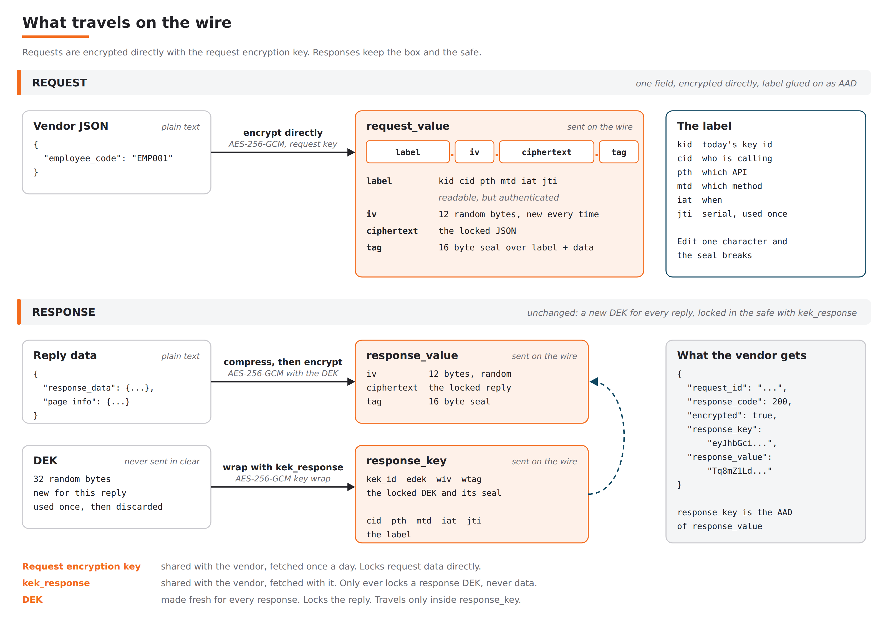
Figure 1. Requests are one field, encrypted directly. Responses keep the box and the safe.

request_value
Four base64url parts joined by dots. For a typical Employee API request it is about 300 characters.
Part | Size | Meaning
label | About 220 characters | The readable envelope writing, see below. It is the AAD, so it is covered by the tag
iv | 12 bytes | Random start value, new for every request
ciphertext | Same as the JSON | The request JSON, locked with the request encryption key
tag | 16 bytes | Tamper seal over the label and the ciphertext together

The label
Field | Meaning | Example
v | Format version | 1
alg | How the data is locked | A256GCM
kid | Which key locked it. Same value as kek_id from the key service | bfp_Gl4ezWPgplI2yEtDYF
cid | Who is calling | MERCH_ENCRYPTED
pth | Which API | /employee
mtd | Which method | POST
iat | When, in epoch seconds | 1790332751
jti | Serial number, never reused | 32 hex characters

response_key and response_value
Unchanged from v2.0. The platform makes a fresh DEK for every reply, locks response_data and page_info with it after compression, and locks the DEK with kek_response. response_key carries the locked DEK and a label, and is the AAD of response_value. Paginated APIs keep their cursors exactly as today, inside the locked part.

End to end flow
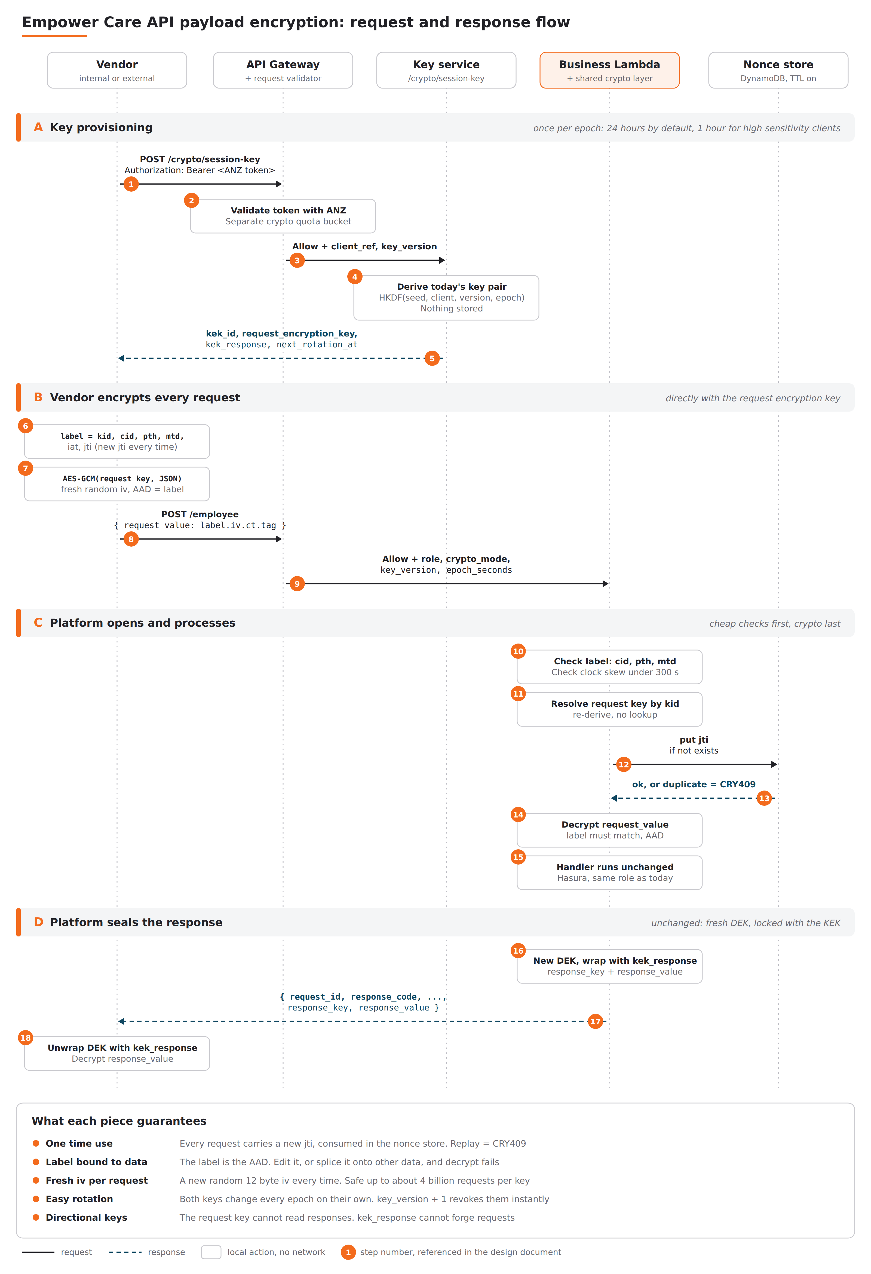
Figure 2. Key provisioning, then every request and response. Step numbers match the table below.
Step | Who | What happens
1 | Vendor | Asks for today's keys. POST /crypto/session-key with its ANZ bearer token
2 | Gateway | Validates the token with ANZ. Counts the call against a separate crypto quota, so it does not use up business calls
3 | Gateway | Allows the call and passes the vendor identity and key_version
4 | Key service | Derives today's key pair from the master seed. Nothing is stored
5 | Key service | Returns kek_id, request_encryption_key, kek_response and the expiry times
6 | Vendor | Writes the label: kid, cid, pth, mtd, iat and a brand new jti
7 | Vendor | Locks the JSON with the request encryption key, a fresh random iv, and the label as AAD
8 | Vendor | Calls the API with { request_value: label.iv.ciphertext.tag }
9 | Gateway | Validates the token as today and passes role, crypto_mode, key_version and epoch length to the Lambda
10 | Lambda | Reads the label. Checks it matches the caller, the API and the method, and that the time is within 5 minutes
11 | Lambda | Finds the request key from kid by deriving it again. No lookup
12 | Lambda | Records the serial number in the nonce store. This only succeeds the first time
13 | Nonce store | Confirms, or reports a duplicate. A duplicate is rejected with CRY409
14 | Lambda | Unlocks request_value. The tag must match both the label and the data
15 | Lambda | The existing business code runs unchanged, with the same Hasura role as today
16 | Lambda | Makes a new DEK, locks the reply, and locks the DEK with kek_response
17 | Lambda | Returns the readable status fields plus response_key and response_value
18 | Vendor | Unlocks the DEK with kek_response and reads the reply
Order matters in steps 10 to 14. Every cheap check runs before any decryption. A stale or mislabelled request is rejected without touching DynamoDB or spending CPU on cryptography.

Keys: where they come from, rotation and revocation

Both keys are derived, never stored
One master seed sits in AWS Secrets Manager, protected by a dedicated KMS key. Each vendor's two keys are computed from it on demand. There is no key table to back up, replicate or leak.
seed = SecretsManager("empower-care-prod-secret-payload-seed-v1")
context = vendor_id + "|" + key_version + "|" + epoch_id
k_epoch = HKDF_SHA256(seed, salt = vendor_id,
info = "empower-payload-v1|" + context)
request_encryption_key = HKDF_SHA256(k_epoch, info = "request")
kek_response = HKDF_SHA256(k_epoch, info = "response")
kek_id = first 22 characters of base64url(SHA256(context))
Property | What it gives you
Vendor id is the salt | One vendor's keys say nothing about another's. A leak affects one vendor only
Epoch in the context | Both keys change on their own every day, or every hour. No rotation job to run or forget
key_version in the context | Revoking a vendor is one number increased by one. The next call with the old key fails
kek_id is a hash | Any Lambda can check any kid by recomputing it. No database call
Two separate keys | The request key cannot read replies, and kek_response cannot forge requests

Lifetime settings
Vendor type | Key lifetime | Notes
Internal services | 24 hours | Already inside the AWS account boundary
Standard external vendor | 24 hours | One key call a day
High sensitivity: claims, CKYC, policy financials | 1 hour | For reviewers who want to see an hour on paper
Very high volume, over 100 million requests a day | 1 hour | Keeps each key far below the AES-GCM message limit
Any vendor during an incident | Unchanged | Increase key_version instead. It takes effect immediately
Overlap. After the keys change, the previous pair is still accepted for 15 minutes, so clocks that drift a few seconds do not cause failures. Vendors should refresh at 80 percent of the lifetime. With a 24 hour lifetime the change happens at 05:30 IST, because the window counts from UTC midnight. A fixed offset can move it to a quieter hour.

Key service contract
POST /crypto/session-key
Authorization: Bearer <ANZ_ACCESS_TOKEN>
{}

200 OK
{
"request_id": "<id>",
"response_code": 200,
"kek_id": "bfp_Gl4ezWPgplI2yEtDYF",
"request_alg": "A256GCM",
"response_alg": "A256GCMKW",
"request_encryption_key": "<base64url, 32 bytes>",
"kek_response": "<base64url, 32 bytes>",
"not_before": "2026-09-25T05:30:00+05:30",
"not_after": "2026-09-26T05:45:00+05:30",
"next_rotation_at": "2026-09-26T05:30:00+05:30",
"epoch_seconds": 86400,
"grace_seconds": 900
}

Protecting the key service
Control | Setting
Login | Same ANZ token validation as every other API
Quota | Separate crypto bucket. A key call never uses up a business call
Gateway rate limit | 2 per second, burst 5, 50 per day per vendor
Issue cap | 10 key issues per vendor per key lifetime
Source IP | Checked against the vendor allowlist on this endpoint
Caching | Off. Cache-Control: no-store
Logging | kek_id only. Never request_encryption_key, kek_response, the seed or the token
Alerting | More than 3 key calls in an hour for one vendor, or a call from a new IP

How each requirement is enforced
Requirement | Mechanism | Error if broken
A request_value is used once | The jti serial in the label is written to DynamoDB only if it does not already exist | CRY409
Nobody can edit the label | The label is the AAD. Changing one character breaks the tag | CRY422
A label cannot be moved onto other data | Same AAD rule. The tag covers label and data together | CRY422
A request for one API cannot be used on another | pth and mtd in the label are compared with the API being called | CRY412
One vendor cannot reuse another vendor's request | cid in the label is compared with the logged-in vendor | CRY412
Old captured requests cannot be replayed later | iat must be within 300 seconds of platform time | CRY413
The same key never repeats an iv | A fresh random 12 byte iv for every request | None
Keys can be changed at will | Keys change every epoch. key_version revokes them instantly | CRY410
No plaintext can slip in beside request_value | Any other field, including the old request_key, is refused | CRY400

API contract

Request
POST /employee
Authorization: Bearer <ANZ_ACCESS_TOKEN>
Content-Type: application/json

{
"request_value":
"eyJhbGciOiJBMjU2R0NNIiwiY2lkIjoiTUVSQ0hfRU5DUllQVEVEIiwiaWF0IjoxNzkwMzMy
...label continues...cCI6MX0",
".IR6V9dOx7wB84H3v" <- iv
".hKRHwFQ5wjoxSwGxB3IbsJoL8wa_-vvz0Bc" <- ciphertext
".vWemmjRCsVBZvgIyk3PReQ" <- tag
}
Shown split for reading. On the wire request_value is one unbroken string.
- request_value is the only field. Anything else, including a v2.0 request_key, is refused with CRY400.
- It must have exactly four parts separated by dots.
- The JSON wrapper keeps the existing API Gateway mapping template working unchanged.

Response
Unchanged from v2.0.
{
"request_id": "<api-gateway-request-id>",
"response_code": 200,
"response_error_code": "",
"response_error_message": "",
"time_taken": 12.4,
"timestamp": "2026-09-25T16:02:11+05:30",
"response_message": "Request Successfully processed",
"encrypted": true,
"response_key": "eyJhbGciOiJBMjU2R0NNS1ciLCJjaWQiOiJNRVJDSF9F...",
"response_value": "Tq8mZ1Ld0pX4wHc9Rb2kVe6Ys3Na7Fu5Gi8Jo1Km4Pq..."
}
response_value unlocks to { "response_data": { ... }, "page_info": { ... } }.

Error response
Errors are always sent readable, with encrypted set to false and no response_key, because a vendor with a broken key still needs to read what went wrong.
{
"request_id": "<id>",
"response_code": 400,
"response_error_code": "CRY409",
"response_error_message": "request_value already used",
"encrypted": false,
"response_data": {}
}

Error codes
Code | HTTP | Meaning | What the vendor does
CRY400 | 400 | request_value missing or not four parts, an extra field such as the old request_key, or over 10 MB | Fix the request
CRY401 | 400 | alg in the label is not A256GCM | Use A256GCM
CRY409 | 400 | request_value already used | Build a new one with a new jti and iv. Never resend
CRY410 | 400 | kid expired, unknown or revoked | Fetch today's keys, then retry once
CRY412 | 400 | Label does not match the vendor, API or method | Build the label for the API being called
CRY413 | 400 | Label time more than 5 minutes from platform time | Sync the clock with NTP
CRY422 | 400 | Could not unlock | Fetch today's keys, retry once, then raise a ticket
CRY426 | 400 | Plain JSON sent while encryption is required | Send request_value
CRY500 | 500 | Platform side failure | Retry with backoff
One code for every unlock failure. CRY422 covers a wrong key, an edited label, a spliced label and tampered data, and never says which. The precise reason goes to CloudWatch only.
Never a silent downgrade. If Secrets Manager, the nonce store or encryption of the reply fails, the platform returns an error. It never falls back to plain JSON.

What this protects, and what it does not
Protects against | Does not protect against
Anyone reading traffic between the vendor and API Gateway, beyond TLS | A stolen ANZ token. A valid token can fetch valid keys
Plain personal data sitting in logs and S3 audit records | A compromised vendor server that already holds the keys
Replay, edited labels, spliced labels and tampered data | Weak Hasura role permissions. Those remain a separate control
A leaked key being useful beyond one day, or seconds after revocation | A leaked master seed. It must be protected like a root key

What the request side gave up in v3.0, and why it is acceptable
Topic | v2.0 requests | v3.0 requests | Practical effect
If today's request key leaks | Every DEK for the day can be unlocked, so every request can be read | Every request for the day can be read | Same. Rotation and revocation are what limit the damage in both
Data under the shared key | The shared key only locked 32 byte DEKs | The shared key locks the request data itself | More data under one key. Bounded by daily or hourly rotation
AES-GCM message limit | Not a concern, a new DEK every time | About 4.29 billion requests per key with random ivs | At 1,000 requests a second a 24 hour key uses 2 percent of the limit
Vendor implementation | Two AES-GCM steps plus compression | One AES-GCM step | Fewer steps means fewer vendor bugs, which is a real security gain
Recommendation: accept the change
The risk added is small and bounded, and the simpler vendor code removes a common source of integration mistakes. The change is safe on four conditions, all built into the layer and the reference libraries: a fresh random iv for every request, the label authenticated as AAD, the one-time jti check, and daily or hourly key rotation. Move any vendor above 100 million requests a day to 1 hour keys.

Is this two layers of security? For responses, the box and safe give per-reply isolation. For requests, there is one layer, the shared key, with rotation and revocation around it. If a future requirement says no secret may be shared with vendors at all, the upgrade is a platform public key for requests. The label already carries alg, so that can be added without changing the one-field format.

Changes to existing components
Component | Change | Size
Request validator Lambda | Adds four values to the authorizer context: client_ref, crypto_mode, key_version, epoch_seconds. Uses a separate quota bucket for /crypto | Small
API Gateway mapping templates | Pass the four new context values. Script it across all 22 APIs | Medium
22 business Lambdas | Attach the crypto layer, pinned to an exact version, and add one decorator line | Small each
keyrolemapping table | Add crypto_mode, key_version, epoch_seconds. Backfill with crypto_mode off | Small
Audit logging Lambda | Store request_value and kid as received. Never a plain body | Medium
Token generator Lambda | Remove client_secret and token logging | Small

New components
Component | Purpose
empower-care-prod-layer-payloadcrypto | Shared layer. Opens request_value, seals replies, checks labels, records serial numbers
empower_care_prod_lambda_cryptokeys | The /crypto/session-key key service
empower_care_prod_dydb_payload_nonce | Serial number store, TTL enabled, 300 second expiry
empower-care-prod-secret-payload-seed-v1 | Master seed, protected by the KMS key empower-care-prod-cmk-payload
Vendor reference libraries | Java, .NET, Python and Node. About 30 lines of crypto each

Rollout
Switch vendors one at a time, not APIs. crypto_mode sits on the vendor record. One change moves a vendor to encrypted on all 22 APIs at once, and one change moves them back.
Phase | Work | Done when
0. Foundations | Remove secret logging. Create KMS key, seed and nonce table. Add fields to keyrolemapping with crypto_mode off. Publish the layer | Layer published, all records backfilled, no vendor affected
1. Key service | Deploy /crypto/session-key with limits and alarms. Publish vendor libraries | A test vendor fetches keys and completes a round trip
2. Pilot | Employee API only, crypto_mode optional, one internal caller | Both encrypted and plain calls succeed. Latency measured
3. Widen | Layer on all 22 APIs, still optional. Paginated APIs last | Seven days without an unlock failure spike
4. Switch vendors | Vendor by vendor, from optional to required | Zero plain calls from that vendor for seven days before switching
5. Tighten | Audit logs switch to encrypted values only. Source IP enforcement widens | No plain bodies in the audit bucket

Open questions
- Does a regulator or internal standard require an HSM or a public key design? If yes, the public key upgrade for requests becomes day one work.
- Does any vendor send more than 100 million requests a day? Those vendors should start on 1 hour keys.
- How do production vendors get ANZ tokens, and how often? This decides how the crypto quota bucket is sized.
- Which internal systems call these APIs directly, not through API Gateway? They need CRYPTO_DEFAULT_MODE set correctly.
- Who can unlock archived audit records? Name the role and approval path before Phase 5.
- Should the daily key change move from 05:30 IST? A fixed offset can move it to a quieter hour.

Reference scope
Built on the Empower Care API Architecture and Developer Guide v1.0 and the payload encryption designs v1.0 and v2.0. Every deployed name and path must be copied from the target environment. The runnable example project implements this document exactly and is covered by 27 unit tests, 22 end to end checks and a Postman collection with 34 assertions.

