Empower Care
API Payload Encryption
Design Document
v1.0 — September 2026
Submitted By

The information contained in the document is confidential, privileged and only for the information of the intended recipient and may not be used, published or redistributed without the prior written consent of LUMIQ. This proposal is the property of LUMIQ. No part of this document, including all concepts and ideas contained herein, may be reproduced or transmitted in any form, or by any means, electronic or mechanical, for any purpose without the express written permission of LUMIQ. Any non-consensual use, copying, republication or redistribution of contents contained in this document is expressly prohibited and are protected under applicable law.
All rights reserved.

1. Summary
Every Empower Care API will carry encrypted payloads in both directions, per vendor, without changing any business logic. A single Python decorator, @secure_api(), is added to each Lambda handler. It decrypts the vendor's request on the way in and encrypts the reply on the way out.
- One field in, two fields out. Vendors send {"request_key": "label.iv.ciphertext.tag"}. They receive {"response_key": "...", "response_value": "..."}.
- One key per vendor. Each of the 36 vendors has its own AES-256 key in AWS Secrets Manager. The X-Vendor-Id header selects it, and the key is cached for 5 minutes in each Lambda.
- No logic change. The handler reads plain JSON from the same place as today and returns what it returns today.
- Built on design v3.0. The request label is authenticated, replays are blocked, each reply uses a fresh one-time key, and errors are returned as fixed CRY codes.
- Proven end to end. A reference API (hello-udit-test, ap-south-1) runs on the layer. 36 unit tests pass, and live calls were checked for success, replay, missing header, unknown vendor and plaintext.

Decisions needed
# | Decision | Recommendation
1 | One secret per vendor, or one secret holding all 36 keys | Per vendor: about USD 14.40 a month. It gives per-vendor rotation, access control and a smaller blast radius
2 | Migration window for vendors that are not ready | Add a per-vendor plaintext allow-list for a fixed window (not built yet, see section 11)
3 | Differences from design v3.0 (section 10) | Approve and fold into v3.1 before external vendors onboard
Table 1. Open decisions

2. Scope and goals

Goals
- Protect request and response bodies end to end between the vendor and the Lambda, beyond TLS, API Gateway logs and intermediaries.
- Bind each message to its vendor, API path, method and time, so a message cannot be replayed, redirected or reused.
- Adopt across 50+ existing APIs with a two-line code change and a template change per API.
- Support 36 vendors with independent keys and rotation without downtime.

Out of scope
- Authentication and authorisation. The existing authorizer stays in front of every API; the vendor header only selects a key.
- Encryption of query strings, path parameters and headers. Only bodies are encrypted.
- Key distribution to vendors. Keys are handed over out of band, through the existing secure channel.

3. Architecture
The decorator sits between API Gateway and the handler. It needs two AWS services: Secrets Manager for vendor keys and DynamoDB for replay protection. API Gateway configuration and business code stay as they are.
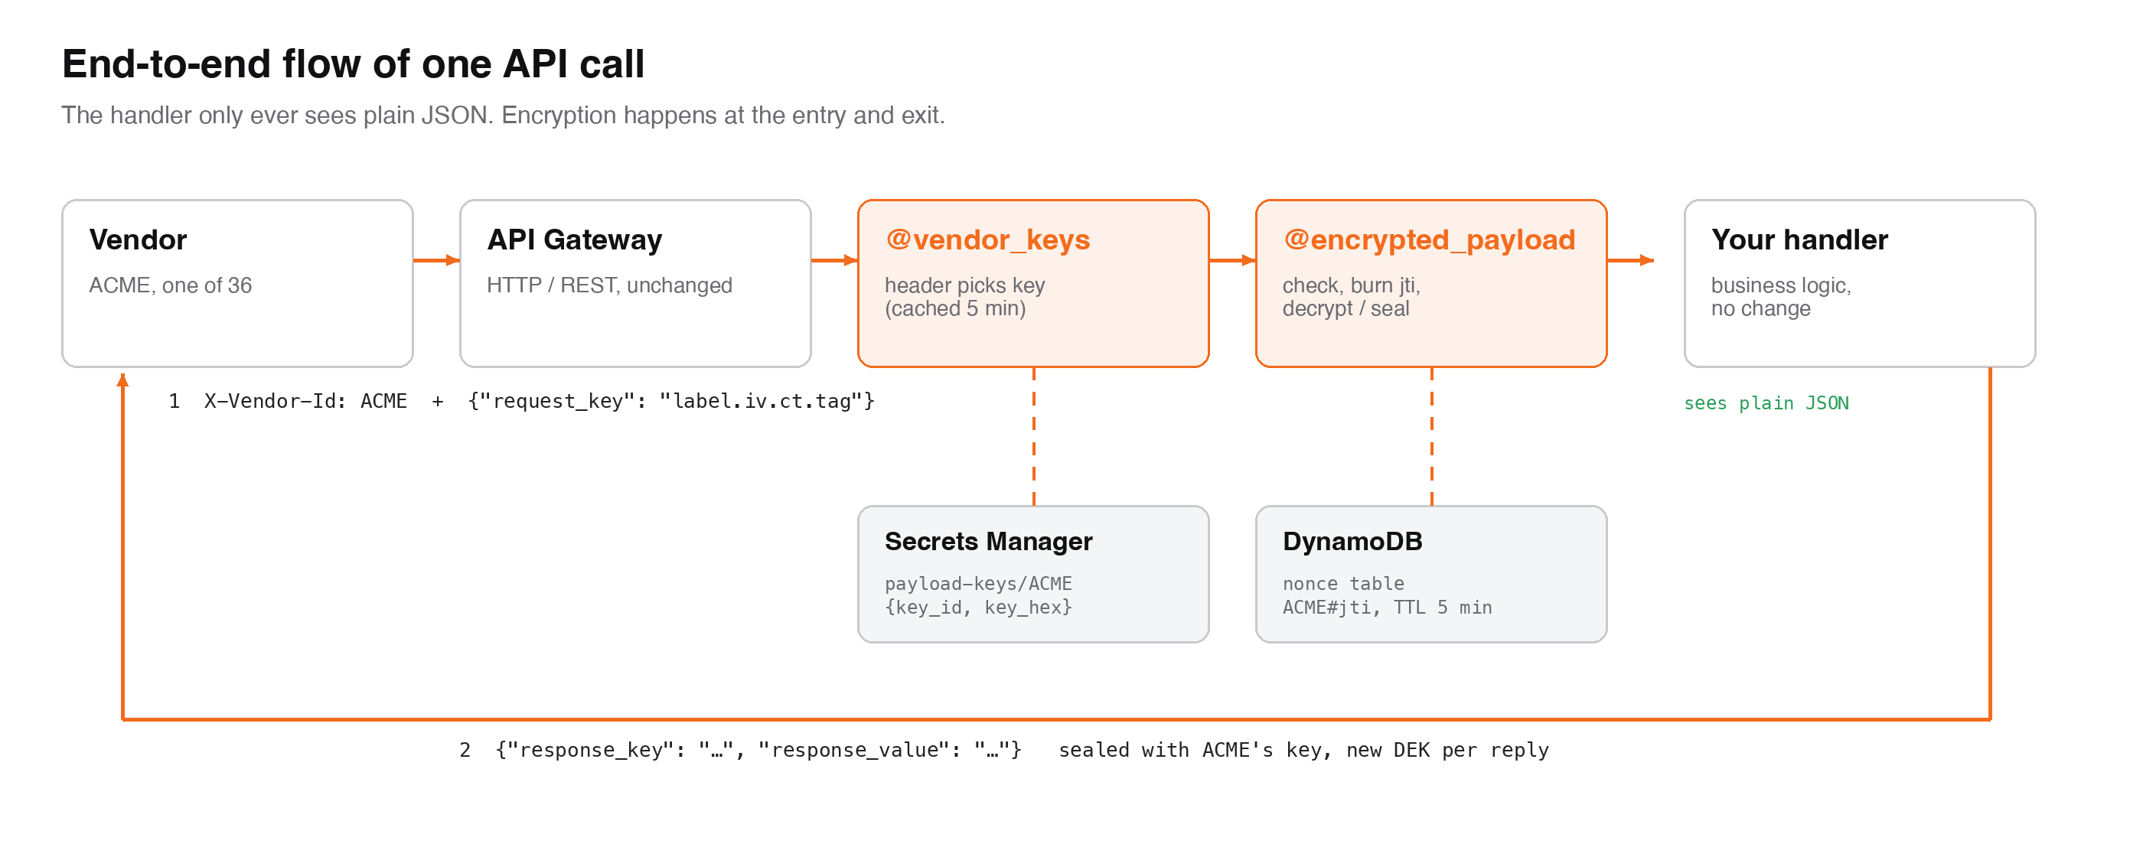
Figure 1. End-to-end flow of one API call
Deployment has two parts. A shared stack is deployed once per account and region. It holds the Lambda layer, the replay table and an IAM policy, and exports all three. Each API stack imports them.
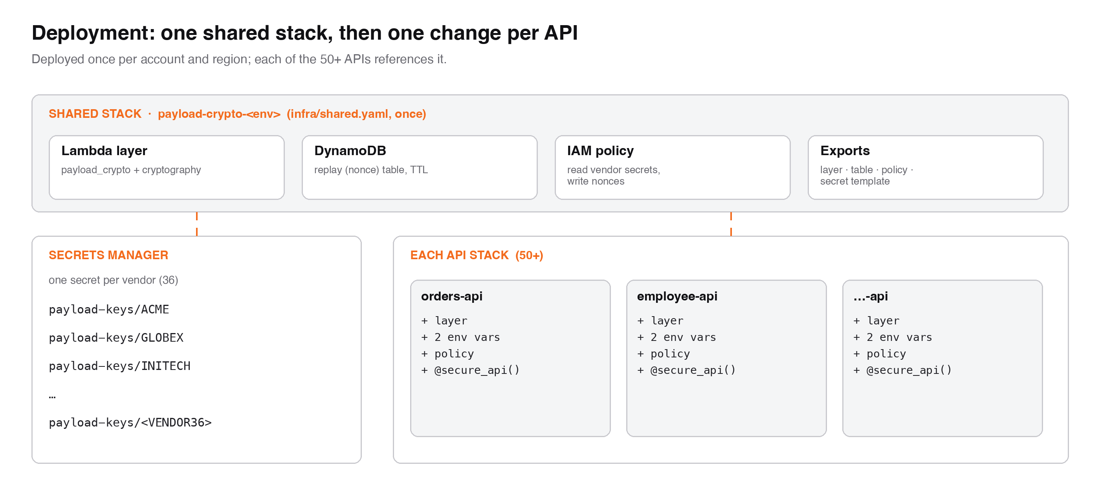
Figure 2. Shared stack, vendor secrets and per-API changes
Component | Type | Deployed | Purpose
payload_crypto layer | Lambda layer (Python 3.12, x86_64) | Once (shared stack) | The decorators plus the cryptography library
Nonce table | DynamoDB, on demand, TTL | Once (shared stack) | Records each request id (jti) for 5 minutes to block replays
payload-crypto policy | IAM managed policy | Once (shared stack) | Read vendor secrets, write nonces
payload-keys/<VENDOR> | Secrets Manager secret | Once per vendor (36) | Vendor AES-256 key, current and previous
@secure_api() | Decorator on the handler | Per API (50+) | Decrypts in, encrypts out
Table 2. Components

4. Wire format

4.1 Request
The vendor sends the header X-Vendor-Id: <VENDOR> and a body with exactly one field, request_key. Its value is four base64url segments joined by dots: label.iv.ciphertext.tag.
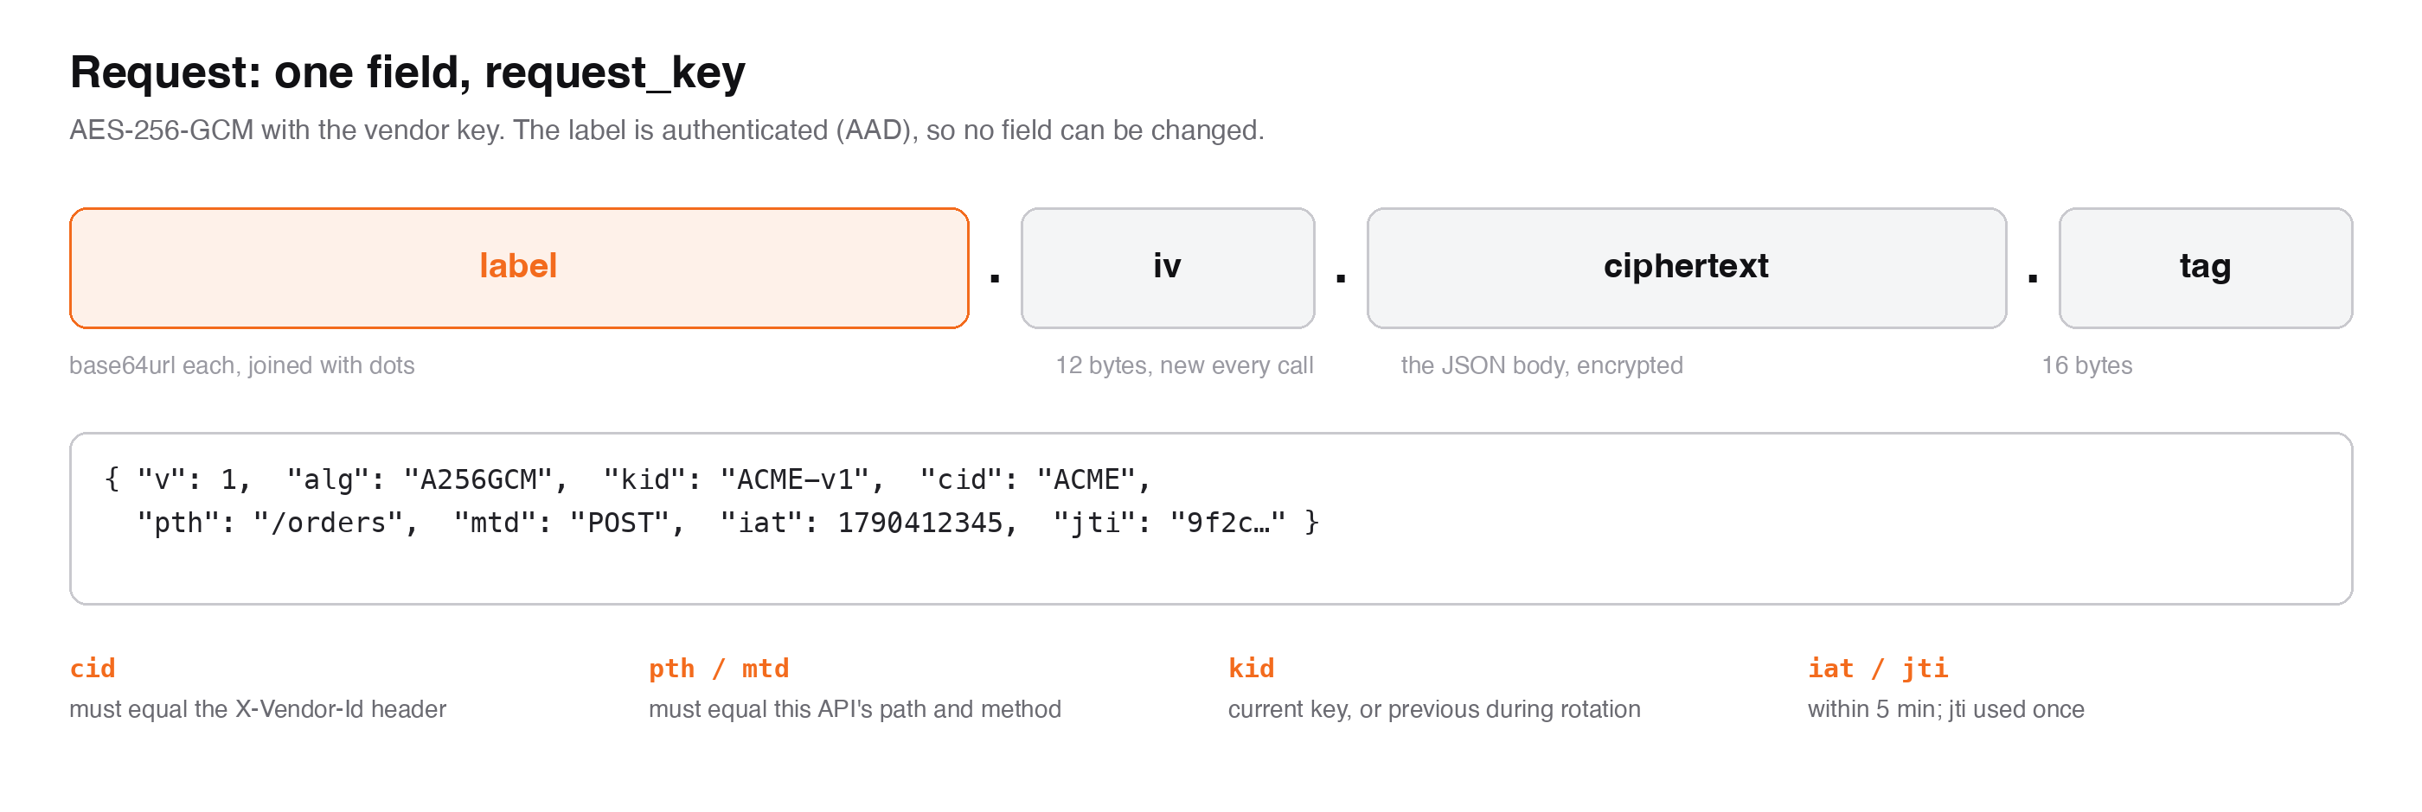
Figure 3. Anatomy of request_key
Label field | Meaning | Server check
v | Format version, always 1 | Must be 1, else CRY400
alg | Always A256GCM | Else CRY401
kid | Key id, e.g. ACME-v1 | Current or previous key id, else CRY410
cid | Vendor id | Must equal the X-Vendor-Id header, else CRY412
pth, mtd | API path (no stage) and HTTP method | Must equal this API, else CRY412
iat | Unix time the request was sealed | Within ±5 minutes, else CRY413
jti | Unique id for this request | First use only, else CRY409
Table 3. Request label
The ciphertext is AES-256-GCM over the UTF-8 JSON body, using the vendor key and a random 12-byte IV. The label segment string is the additional authenticated data (AAD), so changing any label field, or pairing a label with another request's ciphertext, fails decryption.

4.2 Reply
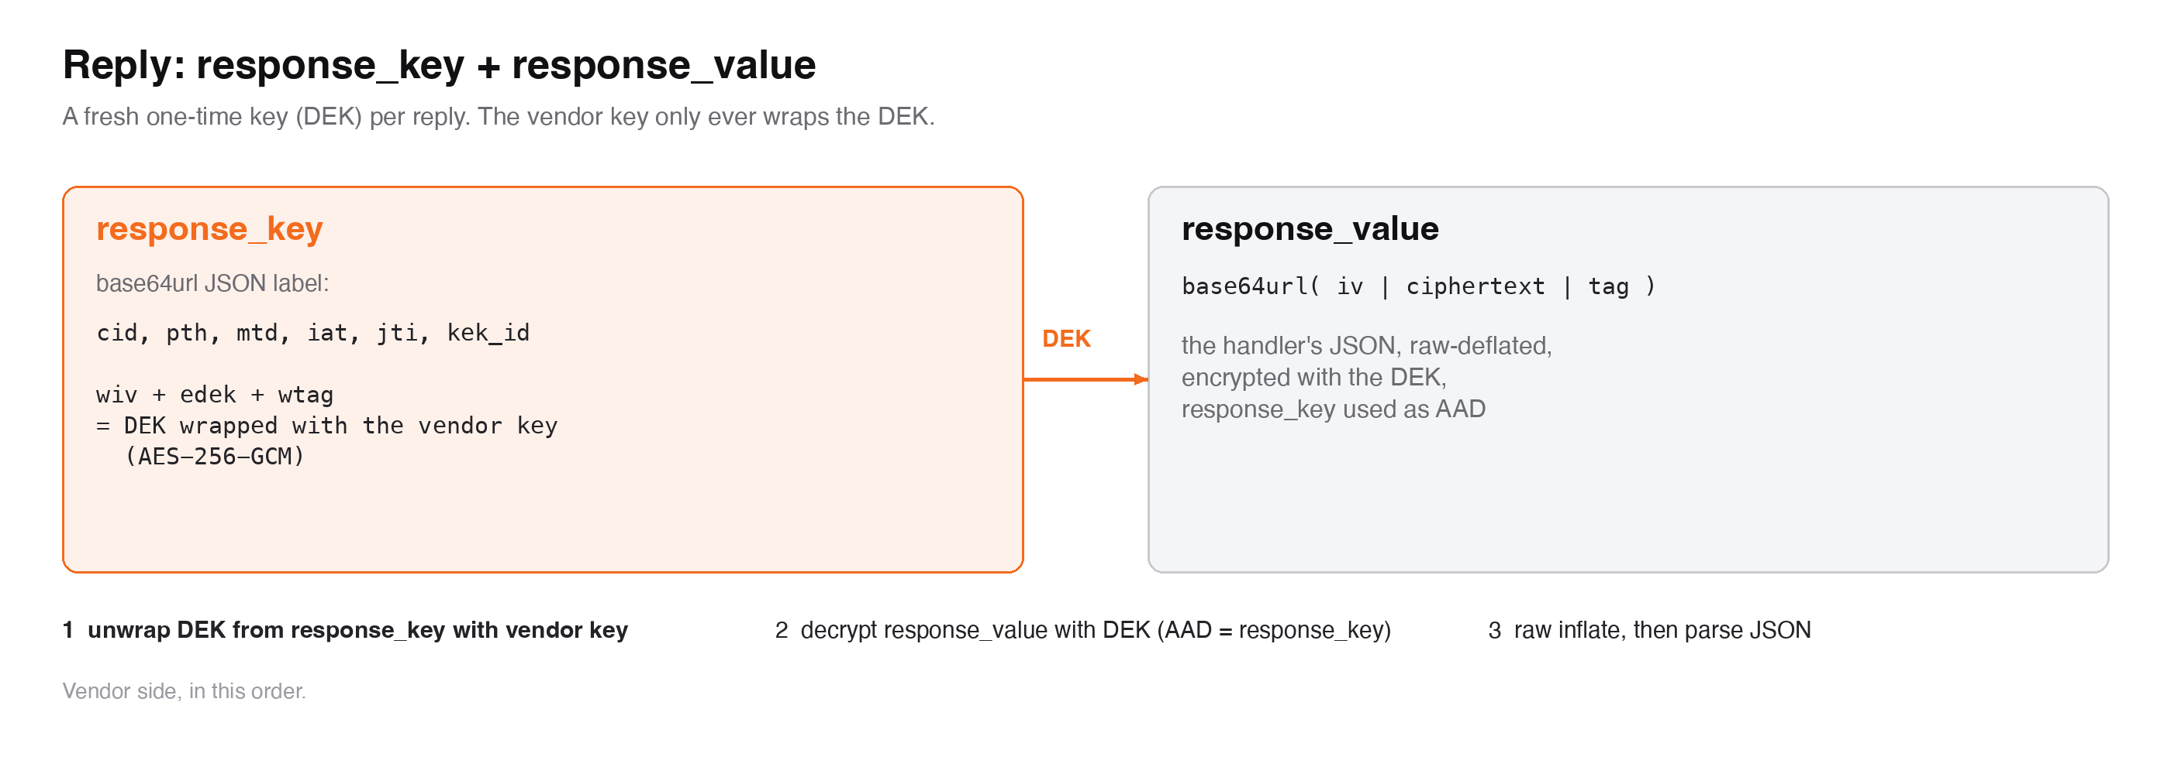
Figure 4. Anatomy of the reply
Each reply gets a fresh random 256-bit data key (DEK). The DEK is wrapped with the vendor key using AES-256-GCM. response_key carries the wrapped DEK plus its own label (cid, pth, mtd, iat, jti, kek_id). response_value is iv | ciphertext | tag of the raw-deflated JSON reply under the DEK, with the response_key string as AAD. The vendor key never encrypts data directly on the reply path.

5. Cryptography
Item | Choice | Notes
Cipher | AES-256-GCM | Authenticated encryption; 128-bit tag
IV | 12 random bytes per message | From the OS secure random source
Request encryption | Direct, vendor key | Label as AAD; no compression
Reply encryption | Envelope: DEK per reply, wrapped with the vendor key | response_key as AAD; raw deflate (RFC 1951) before encryption
Encoding | base64url without padding | JSON with sorted keys and no spaces for labels
Key size | 256-bit, one per vendor | Stored as 64 hex characters
Library | Python cryptography 43.0.1 | Shipped in the layer; no custom crypto on the server
Table 4. Cryptographic choices

6. Key management
Each vendor has one Secrets Manager secret, named payload-keys/<VENDOR> by default (set by PAYLOAD_KEY_SECRET_TEMPLATE):
{"key_id": "ACME-v1", "key_hex": "<64 hex characters>"}

# while rotating, also:
"previous_key_id": "ACME-v1", "previous_key_hex": "<64 hex characters>"
- Creation: scripts/vendor_key.py create ACME GLOBEX ... generates keys from the OS random source and never prints them.
- Caching: keys are cached in each Lambda container for 5 minutes. Unknown vendors are cached as misses for 60 seconds, so random names cannot flood Secrets Manager.
- Access: only the shared IAM policy can read payload-keys/*. Keys are never put in the Lambda event, logged or returned.
- Allow-list (optional): PAYLOAD_ALLOWED_VENDORS refuses unknown vendor names before any AWS call.

Rotation
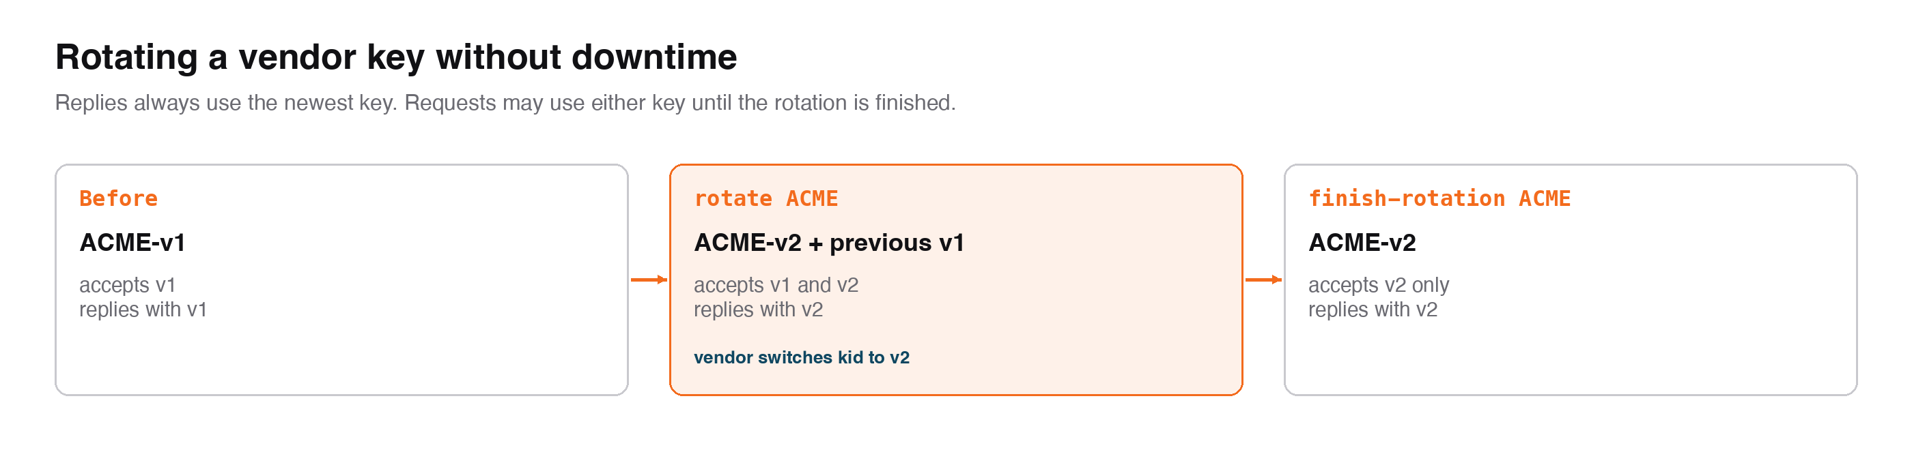
Figure 5. Rotation in three steps, no downtime
vendor_key.py rotate ACME makes a new current key and keeps the old one as previous. Requests sealed with either key are accepted, and replies always use the new key. After the vendor switches, finish-rotation drops the old key. Lambdas pick up a change within 5 minutes. For revocation, rotate and finish immediately.

7. Request validation and errors
Checks run cheapest first, so malformed or unauthorised traffic is rejected before any cryptography or database write. The request id (jti) is recorded before decryption, so a request can never be processed twice.
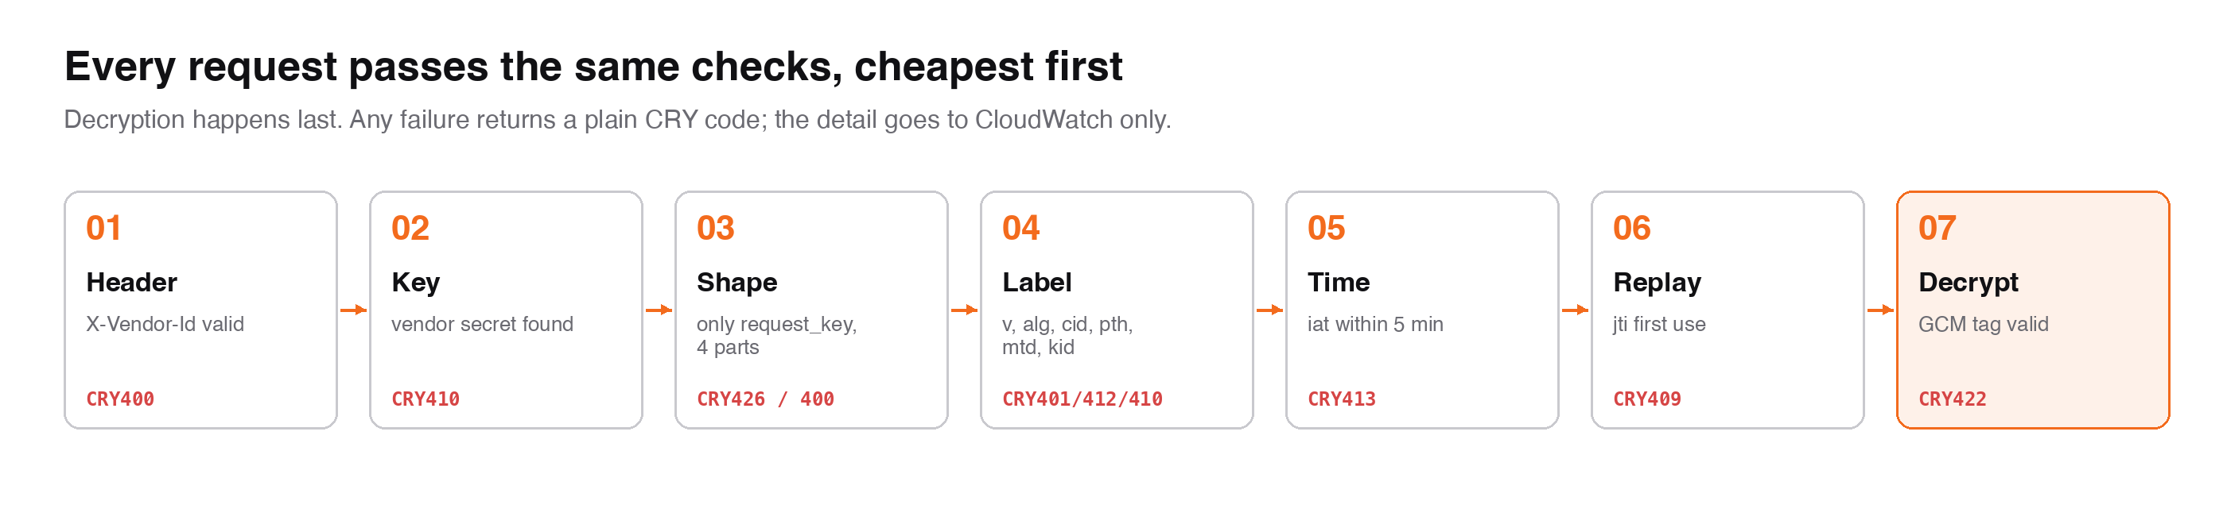
Figure 6. Validation order
Code | HTTP | Message returned | Typical cause
CRY400 | 400 | Malformed encrypted payload / X-Vendor-Id header is required | Missing header, wrong shape, extra field
CRY401 | 400 | Algorithm not permitted for this client | alg is not A256GCM
CRY409 | 400 | request_key already used | Replay, or a retry without resealing
CRY410 | 400 | Key expired or unknown | Unknown vendor, or old kid after rotation
CRY412 | 400 | Payload binding mismatch | Header and label vendor differ; wrong path or method
CRY413 | 400 | Message timestamp outside the accepted window | Vendor clock off by more than 5 minutes
CRY422 | 400 | Payload could not be decrypted | Wrong key or tampered data
CRY426 | 400 | Encryption required for this client | Plain JSON sent
CRY500 | 500 | Platform crypto failure | Secrets Manager or DynamoDB unavailable; malformed secret
Table 5. Error codes
Errors are returned in the clear, so a vendor with a broken key can still see why. The response carries only the code and a fixed message. The detail is written to CloudWatch as payload_crypto rejected <code>: <detail>.

8. Decorator design
@secure_api() combines two decorators, and each can also be used on its own:
Decorator | Does
@vendor_keys | Reads X-Vendor-Id, validates it, loads and caches the vendor keys, and holds them for this call only (Python contextvar, never in event)
@encrypted_payload(path, method, plain_fields) | Works out the route, verifies and decrypts the request, calls the handler, then seals whatever it returns
@secure_api(...) | Both, in the right order. Use this on every API
Table 6. Decorators

Event shapes supported
API Gateway integration | Handler reads | Handler returns | Decorator behaviour
HTTP API, REST proxy, function URL | event["body"] string | {statusCode, headers, body} | Replaces body with the decrypted JSON; seals body; keeps status and headers
REST mapping template (type: aws) | event["body-json"] dict | dict | Replaces body-json; seals the whole dict; plain_fields stay readable (e.g. response_code)
Table 7. Integration types
- GET, HEAD, DELETE and OPTIONS with no body are passed through, and the reply is still sealed.
- The path for the label comes from the event. A named HTTP API stage is stripped. It can be overridden with path=.
- If sealing fails, the caller gets CRY500. The decorator never falls back to plaintext.
- Handler exceptions propagate unchanged. Existing error handling and alarms keep working.

9. Security considerations
Threat | Control
Payload read in transit or in gateway logs | Bodies encrypted with a per-vendor key; replies use a fresh DEK each time
Replay of a captured request | jti recorded in DynamoDB with a conditional write; ±5 minute iat window
Request redirected to another API or method | pth and mtd in the authenticated label must match
Vendor A impersonating vendor B via the header | Header must equal the authenticated cid. A cannot seal for B or read B's replies
Label or ciphertext tampering, splicing | GCM tag over the ciphertext with the label as AAD; response_key as AAD on replies
Key leak through handler logs | Keys never enter the event; key objects hide key bytes from repr
Secret lookups flooded with random vendor names | Name validation, optional allow-list, 60-second miss cache, bounded cache
Crypto dependency outage | Fail closed with CRY500; never plaintext
Table 8. Threats and controls
The vendor header is not authentication. It only picks the key. The existing authorizer must stay in front of every API.

10. Differences from design v3.0
Area | Design v3.0 | This implementation | Why
Request field | request_value | request_key | Agreed with the platform team
Key source | Derived per vendor per 24h epoch from one master seed | One stored key per vendor in Secrets Manager | Key handed to the vendor once; simpler operations
Request vs reply keys | Separate request key and kek_response | One vendor key for both directions | One secret per vendor; replies still use a DEK per message
Vendor identity | From the authorizer context | From the X-Vendor-Id header, bound to the label | Works across all 50+ APIs with no authorizer change
Rotation | Automatic at the epoch boundary | Explicit rotate / finish, previous key accepted | Controlled cut-over per vendor
Table 9. Deviations to fold into v3.1

11. Operations, cost and rollout

Cost (per account and region)
Item | Basis | Approx. monthly
Vendor secrets | 36 × USD 0.40 | USD 14.40
Secrets Manager API calls | At most 1 call per vendor per container per 5 minutes | Under USD 1
DynamoDB nonce table | One write per request, on demand, 5-minute TTL | USD 1.25 per million requests
Layer, IAM policy | No charge | —
Table 10. Running cost

Latency
The added time is one DynamoDB conditional write per request (single-digit milliseconds) plus microseconds of AES. The first call per vendor in a cold container adds one Secrets Manager read.

Rollout and migration
Enabling @secure_api() on an API immediately refuses plain JSON (CRY426). Every vendor calling that API must be ready first. Recommendation: add a time-boxed per-vendor plaintext allow-list (PAYLOAD_PLAINTEXT_VENDORS) for the migration window, then remove it. This is not built yet.
- Pilot: deploy the shared stack, onboard 2 vendors and wrap 1–2 low-risk APIs.
- Waves: wrap APIs in groups of 10, onboarding the vendors that use them.
- Enforce: remove any plaintext allow-list, and alarm on CRY426 and CRY422 rates.

12. Test evidence
The module has 36 unit tests (moto for AWS) covering the three event shapes, three vendors with separate keys, caching, rotation, keys staying out of events, replay, tampering, every label check and every failure mode.
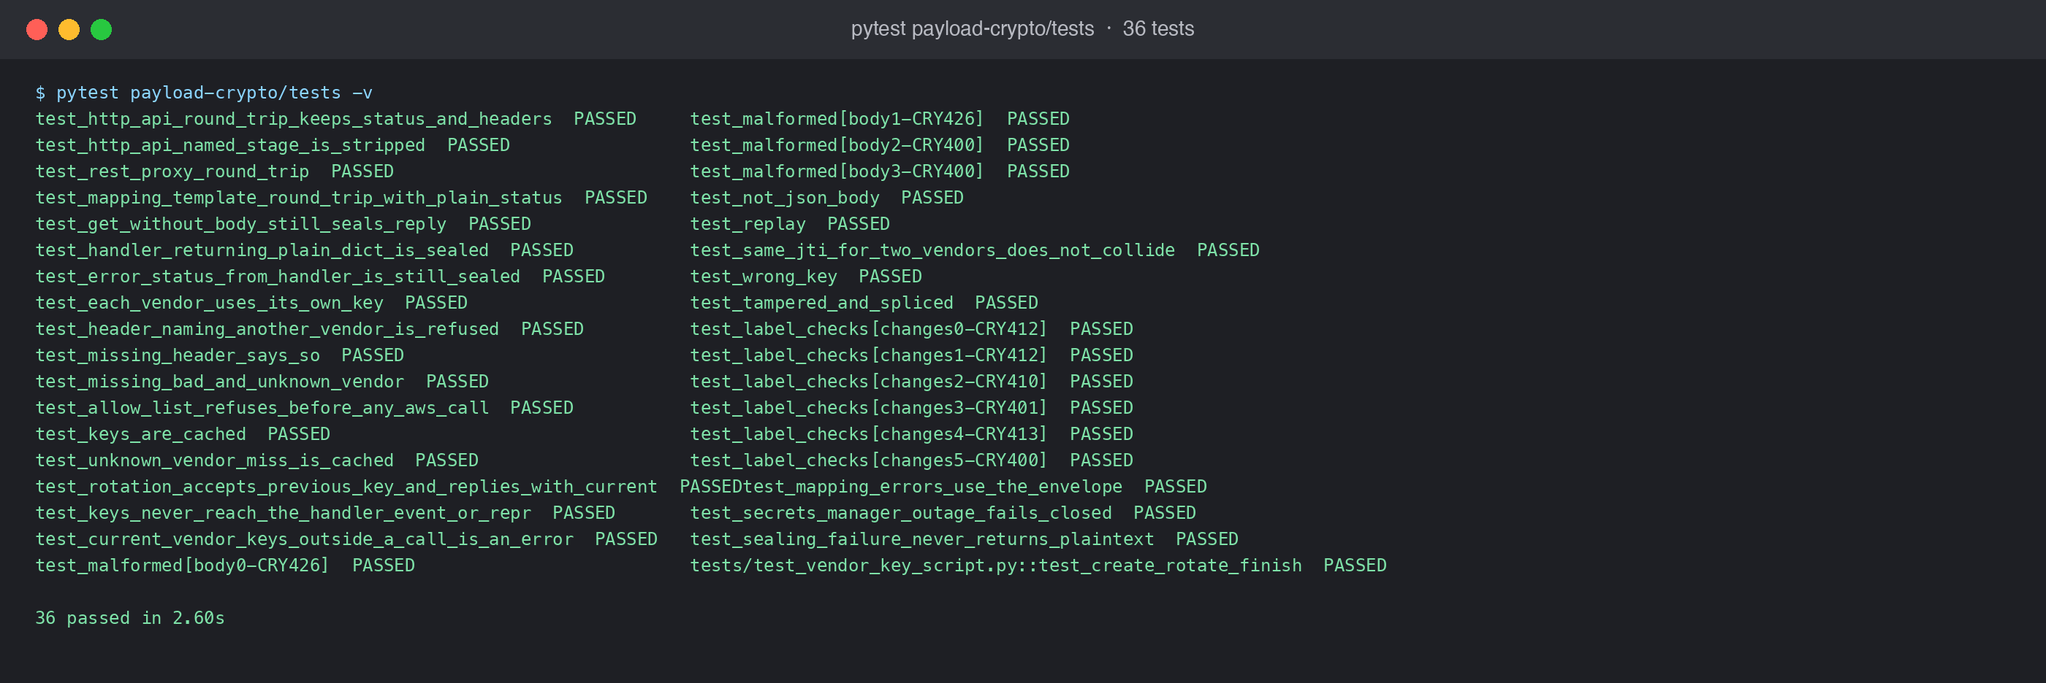
Figure 7. Unit test run: 36 passed
Live checks against the deployed reference API hello-udit-test in ap-south-1:
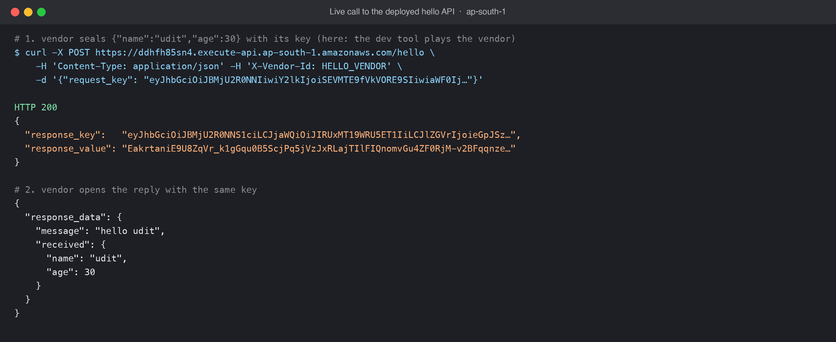
Figure 8. Live: encrypted request in, encrypted reply out, opened by the vendor
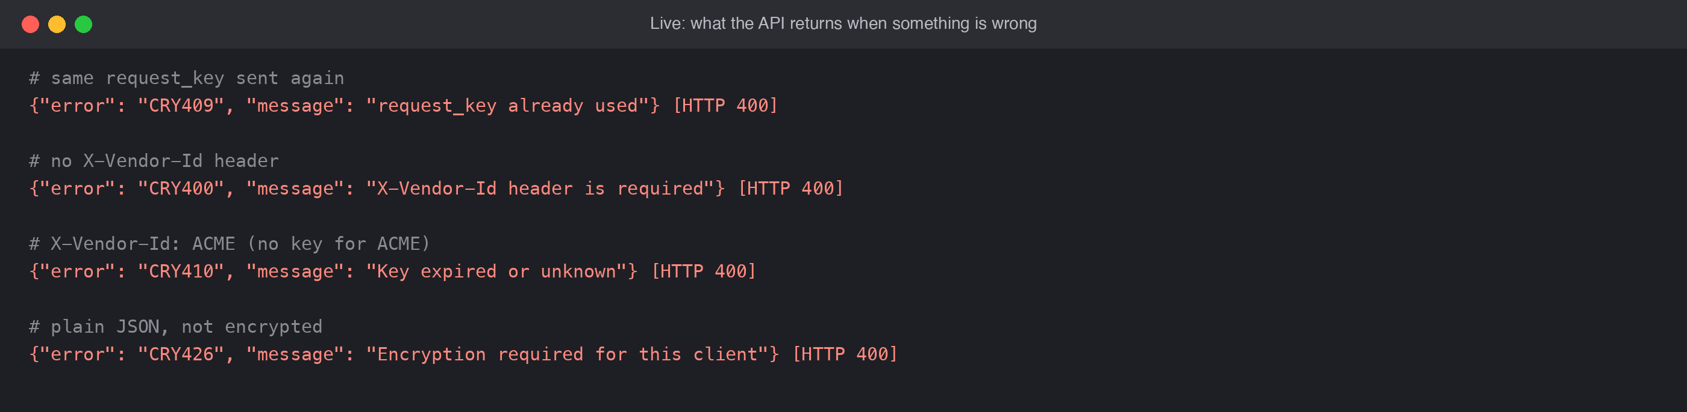
Figure 9. Live: replay, missing header, unknown vendor and plaintext are refused

Appendix A. Configuration
Variable | Default | Meaning
PAYLOAD_KEY_SECRET_TEMPLATE | payload-keys/{vendor} | Secret name per vendor
PAYLOAD_NONCE_TABLE | (required) | Replay table name
PAYLOAD_VENDOR_HEADER | X-Vendor-Id | Header naming the vendor
PAYLOAD_ALLOWED_VENDORS | (none) | Optional comma-separated allow-list
PAYLOAD_KEY_CACHE_SECONDS | 300 | Key cache lifetime per container
Table 11. Environment variables

Source
Path | Contents
payload-crypto/layer/python/payload_crypto.py | The decorators
payload-crypto/infra/shared.yaml | Shared stack: layer, nonce table, IAM policy
payload-crypto/scripts/vendor_key.py | Create / rotate / finish-rotation vendor keys
payload-crypto/vendor/ | Vendor client, example, test vectors
payload-crypto/GUIDE.md | Engineer checklist per API
hello/ | Reference API on the layer
Table 12. Code

