Empower Care
API Payload Encryption
Implementation Guide for Existing Lambdas
v1.0 — September 2026
Submitted By

The information contained in the document is confidential, privileged and only for the information of the intended recipient and may not be used, published or redistributed without the prior written consent of LUMIQ. This proposal is the property of LUMIQ. No part of this document, including all concepts and ideas contained herein, may be reproduced or transmitted in any form, or by any means, electronic or mechanical, for any purpose without the express written permission of LUMIQ. Any non-consensual use, copying, republication or redistribution of contents contained in this document is expressly prohibited and are protected under applicable law.
All rights reserved.

1. What changes, at a glance
Encryption is added at the entry and exit of each Lambda. No business logic changes. Some work is done once per account; the rest is repeated per API.
# | What | Where | How often | Effort
1 | Build the layer | payload-crypto/scripts/build_layer.sh | Once per release | 1 min
2 | Deploy the shared stack (layer, nonce table, IAM policy) | payload-crypto/infra/shared.yaml | Once per account and region | 5 min
3 | Create vendor keys | payload-crypto/scripts/vendor_key.py | Once per vendor (36) | 1 min
4 | Add import + decorator to the handler | <api>/app.py | Per API (50+) | 2 lines
5 | Add layer, 2 env vars and policy to the function | <api>/template.yaml | Per API | 6 lines
6 | CORS: allow the X-Vendor-Id header (if CORS is on) | API Gateway / template | Per API | 1 line
7 | Test, deploy, smoke test | pytest, sam deploy, vendor client | Per API | 10 min
Table 1. Change list
Before switching an API on, every vendor calling it must be able to encrypt. With @secure_api(), plain JSON is refused (CRY426). Plan vendor onboarding with each wave (section 7).

2. Prerequisites
- AWS CLI v2 and AWS SAM CLI, with credentials for the target, non-production account first.
- Python 3.12 and x86_64 Lambdas. The layer is built for this runtime. Tell the platform team about any API on another runtime.
- The repository folder payload-crypto/: layer, infra, scripts, vendor kit and tests.

3. One-time setup

3.1 Build the layer
cd payload-crypto
./scripts/build_layer.sh
# layer built: .build/layer ( 12M)
The script downloads Linux wheels for cryptography, so it works on macOS and Windows without Docker. boto3 comes from the Lambda runtime.

3.2 Deploy the shared stack
aws sts get-caller-identity # confirm the account first
sam deploy --template-file infra/shared.yaml --stack-name payload-crypto-dev \
--region ap-south-1 --capabilities CAPABILITY_NAMED_IAM --resolve-s3 \
--parameter-overrides Env=dev
Export | Used by each API as
payload-crypto-dev-layer | Layers
payload-crypto-dev-nonce-table | PAYLOAD_NONCE_TABLE
payload-crypto-dev-secret-template | PAYLOAD_KEY_SECRET_TEMPLATE
payload-crypto-dev-policy | Policies
Table 2. Shared stack exports

3.3 Create vendor keys
python scripts/vendor_key.py create ACME GLOBEX INITECH # all 36 in one call
# created payload-keys/ACME key_id=ACME-v1 arn:aws:secretsmanager:...
The script never prints a key. Hand each vendor its key over the agreed secure channel (section 8).

4. Changing an existing Lambda

4.1 Handler: two lines
Add the import and the decorator. Everything else stays as it is.
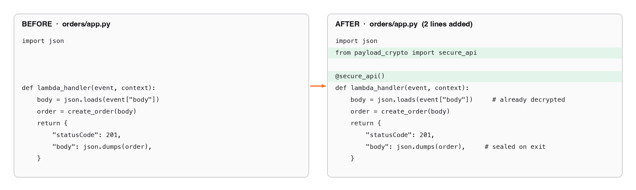
Figure 1. Handler before and after
orders/app.py
import json
from payload_crypto import secure_api # added

@secure_api() # added
def lambda_handler(event, context):
body = json.loads(event["body"]) # already decrypted
order = create_order(body)
return {"statusCode": 201, "body": json.dumps(order)} # sealed on exit

Mapping-template APIs (type: aws), for example Empower employee_api
The handler reads event["body-json"] as a dict and returns a dict. If the API Gateway response template maps response_code to the HTTP status, keep that field readable with plain_fields:
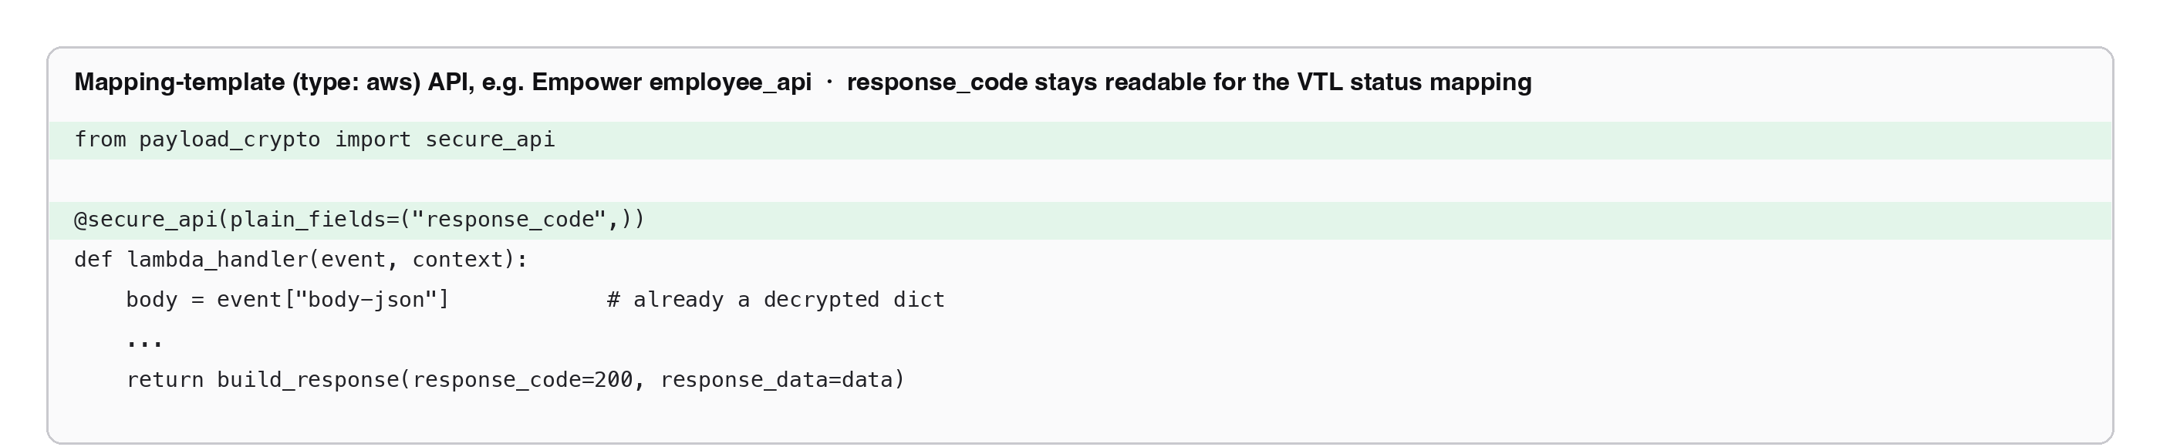
Figure 2. Mapping-template variant
If the handler… | Then
reads event["body"] and returns statusCode/body | @secure_api()
reads event["body-json"] and returns a dict | @secure_api(), or @secure_api(plain_fields=("response_code",)) if the VTL reads response_code
is behind a custom domain with a base path | @secure_api(path="/orders"), the path the vendor puts in the label
already has decorators (validation, logging, metrics) | Put @secure_api() on top (outermost). Decorators below it see the decrypted event and the plain reply, exactly as today
Table 3. Which form to use

4.2 Template: layer, environment, policy
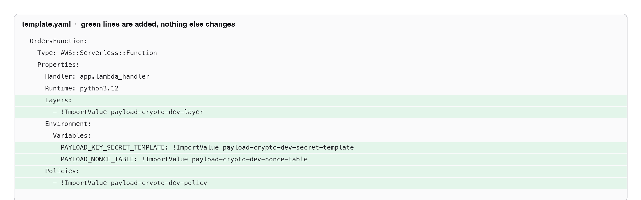
Figure 3. Template change (green lines added)
template.yaml
OrdersFunction:
Type: AWS::Serverless::Function
Properties:
Handler: app.lambda_handler
Runtime: python3.12
Architectures: [x86_64]
Layers:
- !ImportValue payload-crypto-dev-layer
Environment:
Variables:
PAYLOAD_KEY_SECRET_TEMPLATE: !ImportValue payload-crypto-dev-secret-template
PAYLOAD_NONCE_TABLE: !ImportValue payload-crypto-dev-nonce-table
Policies:
- !ImportValue payload-crypto-dev-policy
Templates with many functions can set Layers and Environment once under Globals: Function:.

4.3 API Gateway
Integration | Change
HTTP API, REST proxy, function URL | None. Headers reach the Lambda already
REST with mapping template | None if the template copies headers into params.header (the Empower template does). Otherwise add "params": {"header": {"X-Vendor-Id": "$util.escapeJavaScript($input.params('X-Vendor-Id'))"}}
CORS enabled | Add X-Vendor-Id to the allowed headers
Table 4. Gateway changes

5. Testing before and after deploy

5.1 Unit test (add one per API)
A round trip with moto proves the handler still works behind the decorator:
tests/test_orders_encrypted.py
import json, os, boto3
from moto import mock_aws
import payload_crypto as pc
import app # your handler module

@mock_aws
def test_orders_round_trip(monkeypatch):
monkeypatch.setenv("AWS_DEFAULT_REGION", "ap-south-1")
monkeypatch.setenv("PAYLOAD_NONCE_TABLE", "nonce")
key = os.urandom(32)
boto3.client("secretsmanager").create_secret(
Name="payload-keys/ACME", SecretString=json.dumps({"key_id": "ACME-v1", "key_hex": key.hex()}))
boto3.client("dynamodb").create_table(TableName="nonce", BillingMode="PAY_PER_REQUEST",
AttributeDefinitions=[{"AttributeName": "nonce_id", "AttributeType": "S"}],
KeySchema=[{"AttributeName": "nonce_id", "KeyType": "HASH"}])
pc._clients.clear(); pc.clear_key_cache()

body = pc.seal_request({"sku": "A1"}, key, "ACME-v1", "ACME", "/orders", "POST")
event = {"rawPath": "/orders", "headers": {"x-vendor-id": "ACME"},
"requestContext": {"http": {"method": "POST"}, "stage": "$default"},
"body": json.dumps(body)}
out = app.lambda_handler(event, None)
reply = json.loads(out["body"])
assert pc.open_reply(reply["response_key"], reply["response_value"], key)["sku"] == "A1"

5.2 Deploy and smoke test
sam deploy ... # your usual deploy
export VENDOR_ID=ACME VENDOR_KEY_HEX=<test vendor key>
python payload-crypto/vendor/vendor_client.py https://<api>/orders '{"sku": "A1"}'
Expected result: HTTP 200 and the normal response, decrypted. The screenshots below come from the reference API hello-udit-test (ap-south-1).
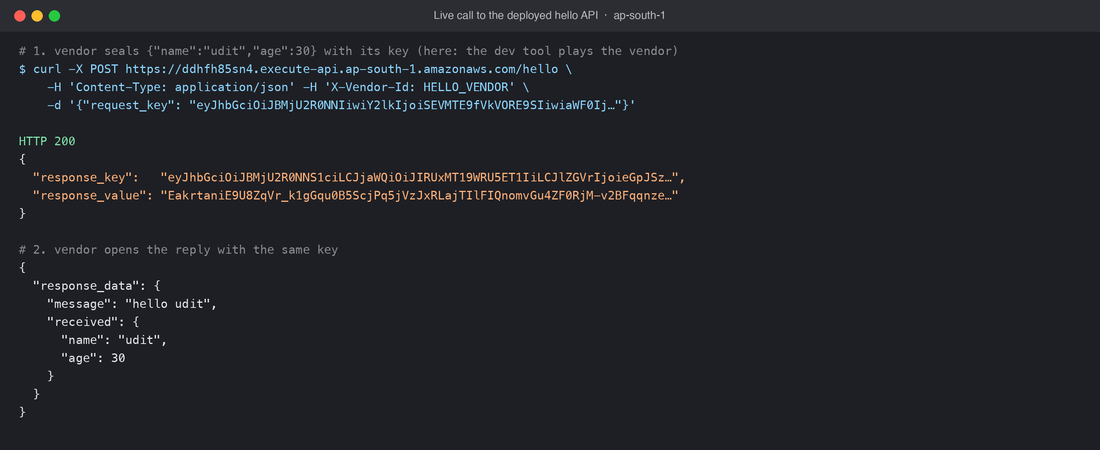
Figure 4. Live: encrypted request, encrypted reply, opened by the vendor
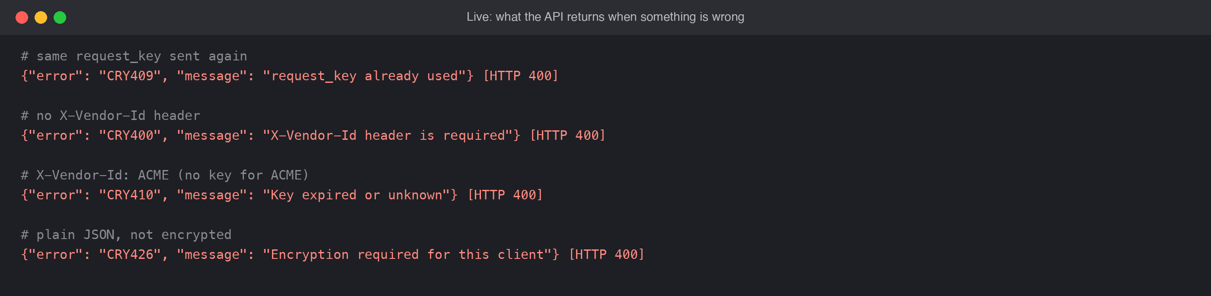
Figure 5. Live: the API must refuse replay, missing header, unknown vendor and plaintext
Why a call failed is logged in CloudWatch, never in the response:
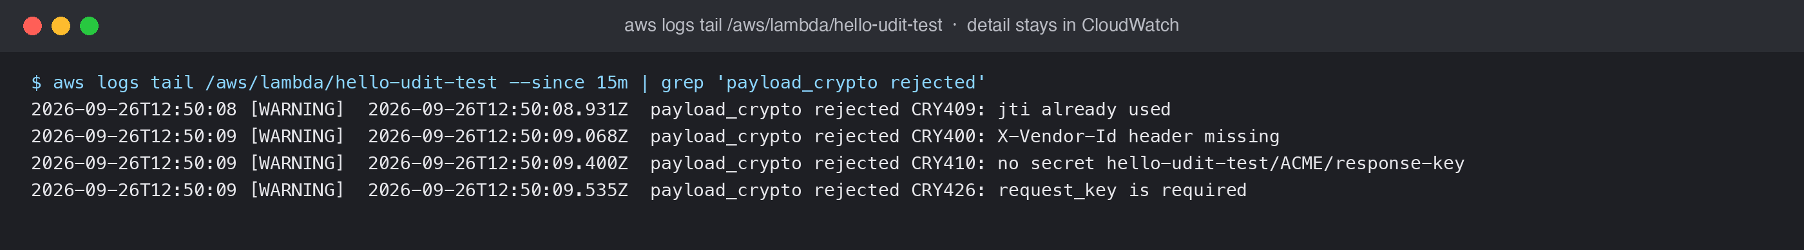
Figure 6. CloudWatch detail for each rejection

5.3 Postman
Import the collection, set the collection variables vendor_id and vendor_key_hex, and send. The Headers tab shows X-Vendor-Id: {{vendor_id}}. The Pre-request script encrypts the body, and the Post-response script decrypts the reply into the Visualize tab. For any API, reuse payload-crypto/postman/payload_crypto.postman.js in both script tabs.
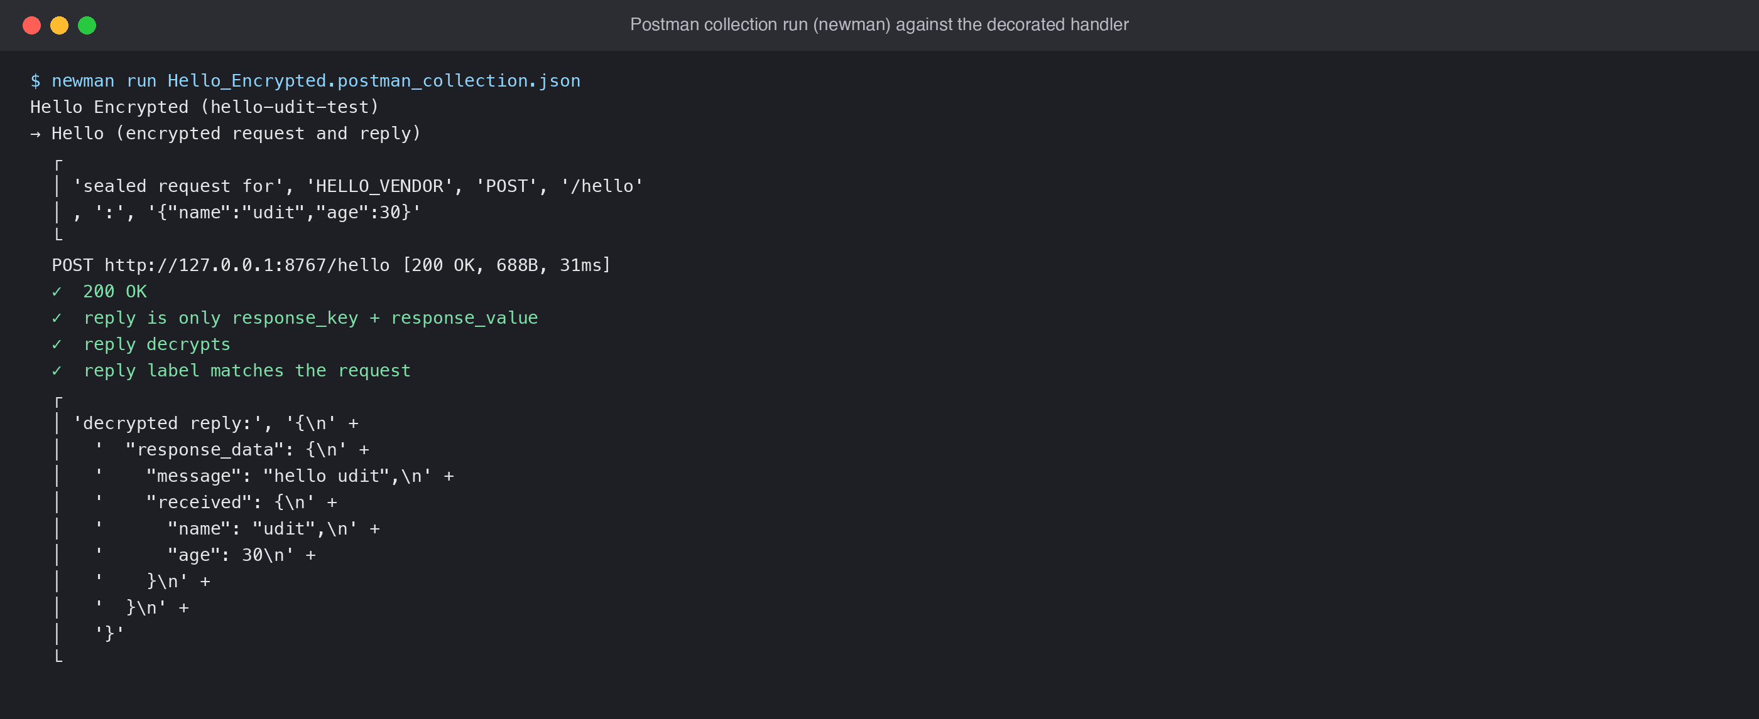
Figure 7. The Postman collection run against the decorated handler

5.4 What gets deployed
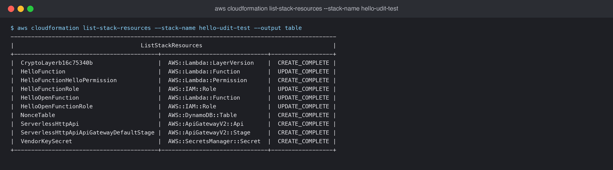
Figure 8. Resources of the reference stack after deploy

6. Per-API checklist
✓ | Item
☐ | from payload_crypto import secure_api and @secure_api() on the handler (outermost decorator)
☐ | Mapping-template API: plain_fields=("response_code",) if the VTL maps status from it
☐ | Template: layer, PAYLOAD_KEY_SECRET_TEMPLATE, PAYLOAD_NONCE_TABLE, policy
☐ | Runtime is python3.12, x86_64
☐ | CORS allows X-Vendor-Id (if CORS is on)
☐ | Unit round-trip test added and passing
☐ | Deployed; vendor client returns 200 with the right body
☐ | Plain JSON returns 400 CRY426; the same request twice returns 400 CRY409
☐ | Every vendor of this API has its key and has tested against non-production
Table 5. Checklist

7. Rollout plan
Wave | Scope | Exit criteria
0 · Pilot | Shared stack in dev; 2 vendors; 1–2 low-risk APIs | Vendors call successfully; no CRY500
1 · First wave | 10 APIs and the vendors that call them | CRY422/CRY413 below 0.1% for a week
2 · Remaining | Other 40+ APIs in groups of 10 | All vendors onboarded
3 · Production | Shared stack in prod; same order | Change approval per wave
Table 6. Waves
Open decision: a time-boxed per-vendor plaintext allow-list would let vendors migrate one at a time on a shared API. It is not built yet; see the design document.

8. Vendor onboarding and key rotation
- Create the key: python scripts/vendor_key.py create <VENDOR>.
- Give the vendor: vendor id, key id (<VENDOR>-v1), the key (secure channel only), the base URLs, and the Vendor Integration Guide with its code kit.
- The vendor runs verify_test_vectors.py, then calls non-production with vendor_client.py.
- Switch the vendor's APIs on in the next wave.

Rotation: vendor_key.py rotate <VENDOR>. Both keys work while the vendor switches to the new key id, then run vendor_key.py finish-rotation <VENDOR>. Changes reach all Lambdas within 5 minutes.
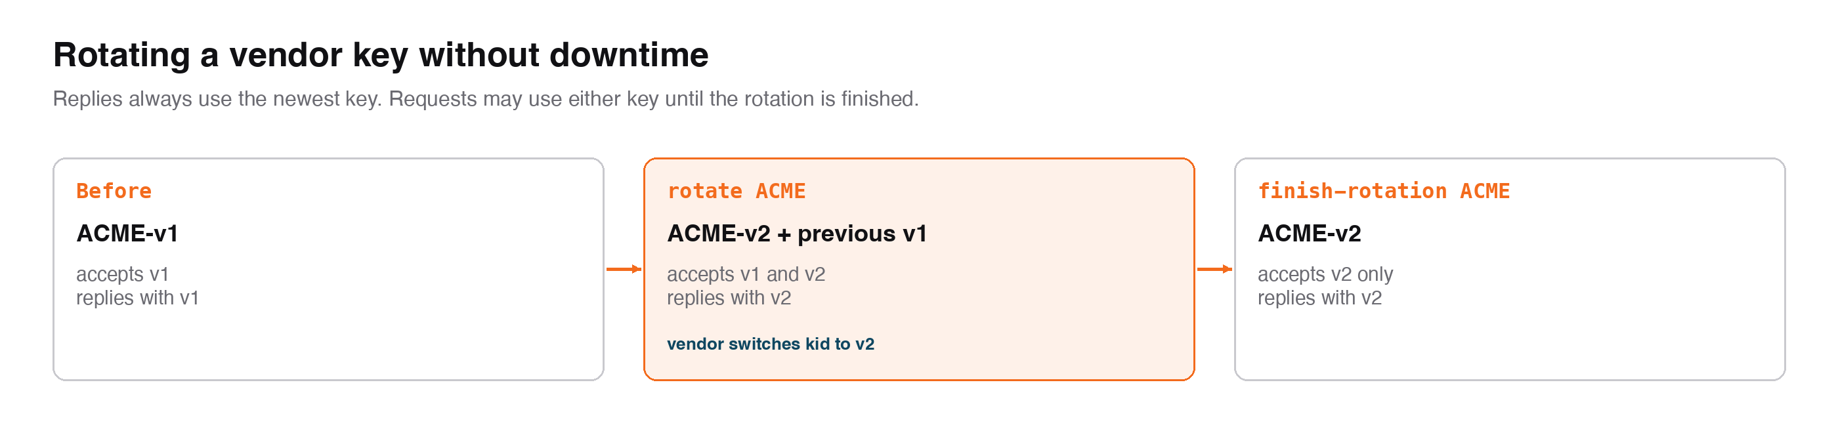
Figure 9. Rotation steps

9. Troubleshooting
Symptom | Check
Every call 400 CRY400 "X-Vendor-Id header is required" | Header not sent, or dropped by CORS or the mapping template
CRY410 | CloudWatch shows no secret payload-keys/<X>: vendor name typo or key not created. After creating a key, allow 60 seconds (miss cache)
CRY412 | Label path differs from the API path: stage included, or a custom-domain base path. Use path=
CRY413 | Vendor clock drift over 5 minutes: vendor to sync with NTP
CRY409 on a retry | Retries must re-encrypt (new jti). The same request_key is never sent twice
CRY422 | Wrong key, key id mismatch after rotation, or the body was changed in transit
CRY500 | Lambda cannot read the secret or write the nonce table: check the policy and env vars
Runtime.ImportModuleError: payload_crypto | Layer missing on the function, or the runtime is not python3.12
Table 7. Troubleshooting

