Empower Care
API Payload Encryption
Vendor Integration Guide
v1.0 — September 2026
Submitted By

The information contained in the document is confidential, privileged and only for the information of the intended recipient and may not be used, published or redistributed without the prior written consent of LUMIQ. This proposal is the property of LUMIQ. No part of this document, including all concepts and ideas contained herein, may be reproduced or transmitted in any form, or by any means, electronic or mechanical, for any purpose without the express written permission of LUMIQ. Any non-consensual use, copying, republication or redistribution of contents contained in this document is expressly prohibited and are protected under applicable law.
All rights reserved.

1. In one page
Every Empower Care API call you make is encrypted end to end with a key only you and Empower Care hold. You do three things differently:
- Send your vendor id in the header X-Vendor-Id on every call.
- Encrypt the request body into one field: {"request_key": "<label>.<iv>.<ciphertext>.<tag>"}.
- Decrypt the reply, which arrives as {"response_key": "...", "response_value": "..."}.

A working Python kit comes with this guide. With it, the three steps are a few lines of code (section 5). For other languages, section 6 gives the exact algorithm and test vectors so you can check your code byte for byte.

What you receive from Empower Care
Item | Example | Notes
Vendor id | ACME | Goes in the header and inside every request
Key id | ACME-v1 | Changes only when your key is rotated
Key | 64 hex characters (256-bit) | Delivered over a secure channel. Store it in your secret store, never in code or logs
Base URLs | non-production and production | Test against non-production first
Code kit | vendor_client.py, example_call.py, verify_test_vectors.py, test_vectors.json | Python 3.8+, needs only cryptography
Table 1. Onboarding package

2. How a call works
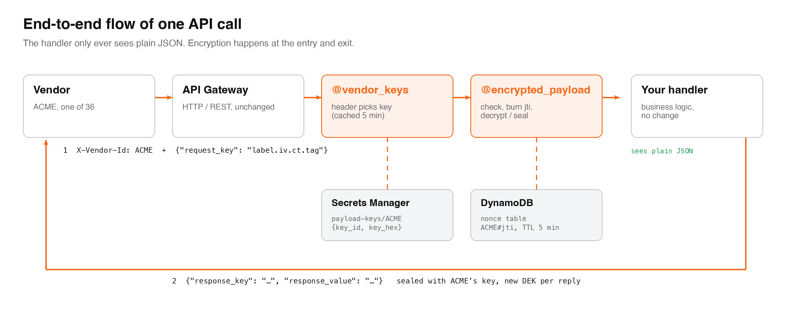
Figure 1. One API call, end to end
Empower Care checks that the header, the encrypted label and your key all agree, that the request is fresh and has not been seen before, and then decrypts it. The reply is encrypted with a new one-time key, which is itself locked with your key.

3. Sending an encrypted request
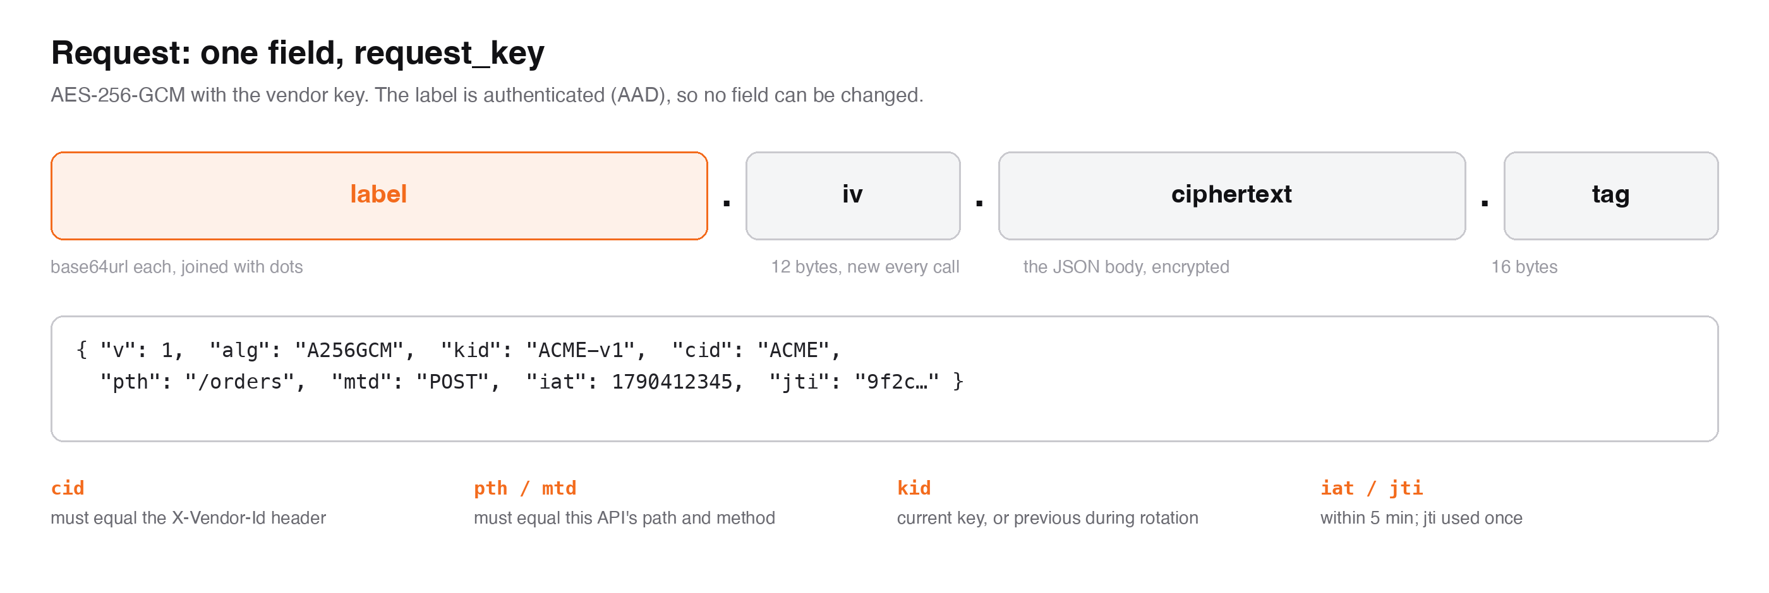
Figure 2. The request_key value
- Build the label JSON with these 8 fields, keys sorted and no spaces: alg = A256GCM, cid = your vendor id, iat = current Unix time in seconds, jti = a new random id (e.g. 32 hex chars), kid = your key id, mtd = HTTP method, pth = the API path with no host and no stage (e.g. /orders), v = 1.
- label segment = base64url (no padding) of the label JSON bytes.
- iv = 12 new random bytes from a secure random source. Never reuse one.
- Encrypt the UTF-8 JSON body with AES-256-GCM, your key and that iv, using the label segment string (ASCII) as the additional authenticated data (AAD). This gives ciphertext plus a 16-byte tag.
- request_key = label_segment + "." + b64url(iv) + "." + b64url(ciphertext) + "." + b64url(tag).
- POST {"request_key": "..."} with headers Content-Type: application/json and X-Vendor-Id: <vendor id>. The body must contain no other field.

GET, HEAD and DELETE calls with no body: send no body, only the header. The reply is still encrypted.
vendor_client.py: seal_request
def seal_request(payload, key: bytes, vendor: str, path: str, method: str = "POST", key_id: str = None):
label = {"v": 1, "alg": "A256GCM", "kid": key_id or f"{vendor}-v1", "cid": vendor, "pth": path,
"mtd": method, "iat": int(time.time()), "jti": uuid.uuid4().hex}
label_seg = b64u(json.dumps(label, sort_keys=True, separators=(",", ":")).encode())
iv = os.urandom(12)
sealed = AESGCM(key).encrypt(iv, json.dumps(payload, separators=(",", ":")).encode("utf-8"),
label_seg.encode("ascii"))
return {"request_key": ".".join([label_seg, b64u(iv), b64u(sealed[:-16]), b64u(sealed[-16:])])}

4. Reading the encrypted reply
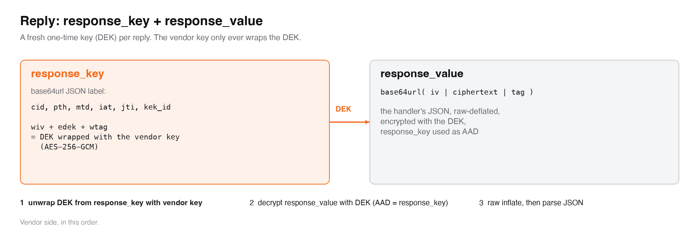
Figure 3. The reply
- base64url-decode response_key and parse it as JSON. It holds wiv, edek, wtag (your one-time key, locked) plus cid, pth, mtd, iat, jti and kek_id.
- Unwrap the DEK: AES-256-GCM decrypt edek + wtag with your key and iv wiv, with no AAD. The result is a 32-byte DEK.
- base64url-decode response_value into iv (first 12 bytes), ciphertext, and tag (last 16 bytes).
- Decrypt with the DEK, that iv, and the response_key string (ASCII) as AAD.
- Inflate the result with raw deflate (RFC 1951, no zlib or gzip header), then parse the UTF-8 JSON.

vendor_client.py: open_reply
def open_reply(response_key: str, response_value: str, key: bytes, vendor: str = None):
label = json.loads(b64u_decode(response_key))
if vendor and label.get("cid") != vendor:
raise ValueError(f"reply is for {label.get('cid')}, not {vendor}")
dek = AESGCM(key).decrypt(b64u_decode(label["wiv"]),
b64u_decode(label["edek"]) + b64u_decode(label["wtag"]), None)
blob = b64u_decode(response_value)
packed = AESGCM(dek).decrypt(blob[:12], blob[12:], response_key.encode("ascii"))
d = zlib.decompressobj(wbits=-15)
plaintext = d.decompress(packed, MAX_PLAINTEXT_BYTES + 1)
if len(plaintext) > MAX_PLAINTEXT_BYTES or d.unconsumed_tail:
raise ValueError("reply over 10 MB")
return json.loads(plaintext)
If any step fails, treat the reply as untrusted and discard it. Error replies (section 7) are not encrypted: they contain error and message, not response_key.

5. Python: complete example
Run
pip install cryptography
export VENDOR_ID=ACME
export VENDOR_KEY_HEX=<your 64 hex character key>
python verify_test_vectors.py # proves your setup, no network
python example_call.py https://<api-host>/orders
example_call.py
"""End-to-end example for a vendor: encrypt a request, send it, decrypt the reply.

pip install cryptography
export VENDOR_ID=ACME
export VENDOR_KEY_HEX=<the 64 hex character key you were given>
python example_call.py https://<api-host>/orders
"""
import json
import os
import sys
import urllib.error
import urllib.request
from urllib.parse import urlparse

from vendor_client import open_reply, seal_request

vendor = os.environ["VENDOR_ID"]
key = bytes.fromhex(os.environ["VENDOR_KEY_HEX"]) # keep it in a secret store, never in code
url = sys.argv[1]
path = urlparse(url).path # the label's pth: the path, no host, no stage

# 1. Encrypt: plain JSON in, one field out.
payload = {"order_id": "ORD-1001", "amount": 2500, "currency": "INR"}
body = seal_request(payload, key, vendor, path, "POST") # {"request_key": "label.iv.ciphertext.tag"}

# 2. Send, with your vendor id in the header.
req = urllib.request.Request(url, data=json.dumps(body).encode(), method="POST",
headers={"Content-Type": "application/json", "X-Vendor-Id": vendor})
try:
with urllib.request.urlopen(req, timeout=15) as resp:
status, reply = resp.status, json.load(resp)
except urllib.error.HTTPError as exc:
status, reply = exc.code, json.load(exc)

# 3. Decrypt: the reply is {"response_key", "response_value"}; errors come back in the clear.
if "response_key" in reply:
print(status, json.dumps(open_reply(reply["response_key"], reply["response_value"], key, vendor), indent=2))
else:
print(status, reply) # e.g. {"error": "CRY413", ...}
Or use the one-line helper: status, reply = call(url, payload, vendor, key) in vendor_client.py. It encrypts, sends and decrypts in one step.
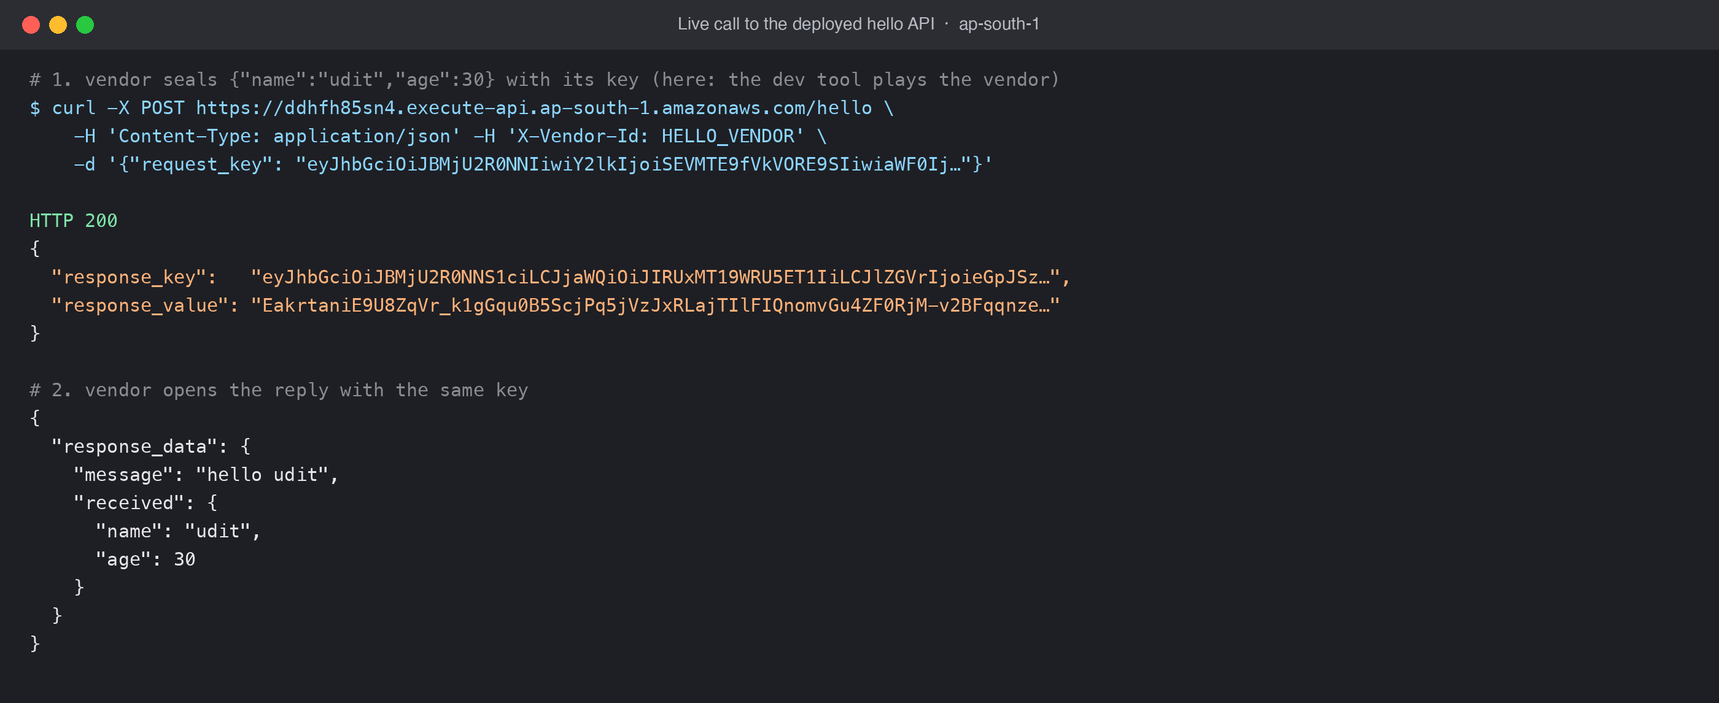
Figure 4. A real call: encrypted request in, encrypted reply out, decrypted by the vendor

6. Other languages: algorithm and test vectors
Item | Value
Cipher | AES-256-GCM, 12-byte IV, 16-byte tag
Encoding | base64url, no padding (- and _, no =)
Label JSON | UTF-8, keys sorted, separators , and : with no spaces
Request AAD | the label segment string (ASCII bytes)
Reply DEK unwrap | AES-256-GCM with your key, iv wiv, no AAD
Reply AAD | the response_key string (ASCII bytes)
Reply compression | raw deflate (RFC 1951). Java: new Inflater(true); Node: zlib.inflateRawSync; .NET: DeflateStream
Table 2. Algorithm summary

Test vectors
These use a public TEST key (bytes 00 to 1f). Never use it for real traffic. Your code must produce the request_key below exactly, and open the reply below to the exact JSON shown.

Request: inputs
Input | Value
key_hex | 000102030405060708090a0b0c0d0e0f101112131415161718191a1b1c1d1e1f
label JSON | {"alg":"A256GCM","cid":"ACME","iat":1790412345,"jti":"0f1e2d3c4b5a69788796a5b4c3d2e1f0","kid":"ACME-v1","mtd":"POST","pth":"/orders","v":1}
iv_hex | a0a1a2a3a4a5a6a7a8a9aaab
payload JSON | {"order_id":"ORD-1001","amount":2500,"currency":"INR"}

Request: expected request_key
eyJhbGciOiJBMjU2R0NNIiwiY2lkIjoiQUNNRSIsImlhdCI6MTc5MDQxMjM0NSwianRpIjoiMGYxZTJkM2M0YjVh
Njk3ODg3OTZhNWI0YzNkMmUxZjAiLCJraWQiOiJBQ01FLXYxIiwibXRkIjoiUE9TVCIsInB0aCI6Ii9vcmRlcnMi
LCJ2IjoxfQ.oKGio6Slpqeoqaqr.nToTXyGucOALAaXpJTWSml2daSCjlW5O_WNJ8xHfVzvgQ3fPgwAwSC3uYaZq
A6HDZVIIGkCt.R7gmmw8dUB-C_o_VrB-4_w

Response: input body
response_key:
eyJhbGciOiJBMjU2R0NNS1ciLCJjaWQiOiJBQ01FIiwiZWRlayI6InNQaVgxOGZJSnU0b2FVMFNnaHhZNXZ6RFU0
LU1VcThLbW5QN3VvZk56d1kiLCJlbmMiOiJBMjU2R0NNIiwiaWF0IjoxNzkwNDEyMzQ2LCJqdGkiOiIxZjJlM2Q0
YzViNmE3OTg4MDc5NmE1YjRjM2QyZTFmMCIsImtla19pZCI6IkFDTUUtdjEiLCJtdGQiOiJQT1NUIiwicHRoIjoi
L29yZGVycyIsInYiOjEsIndpdiI6IndNSEN3OFRGeHNmSXljckwiLCJ3dGFnIjoiRlhqelR2cmFncFhocWRIRlJC
RXdDdyIsInppcCI6IkRFRiJ9

response_value:
0NHS09TV1tfY2drbHQYIhnbZW_uibt-ce1vm3pDUGUPvgv9Xc68Dt40Jp2JO1OxzwxSfmwPqq6LlCpS_iqb9DIZ1
B-WyTWU

Response: expected
Step | Expected
DEK after unwrap (hex) | b0b0b0b0b0b0b0b0b0b0b0b0b0b0b0b0b0b0b0b0b0b0b0b0b0b0b0b0b0b0b0b0
Decrypted, still deflated (hex) | ab56ca2f4a492d8acf4c51b252f20f72d13534303054d2512a2e492c292d068a3907b93a86b8ba28d50200
Final JSON | {"order_id":"ORD-1001","status":"CREATED"}

The Python check is verify_test_vectors.py. Port it to your language and make it part of your build.

7. Errors and what to do
Errors come back as plain JSON: {"error": "CRY4xx", "message": "..."}. They never include details of our side.
Code | HTTP | Meaning | What to do
CRY400 | 400 | Malformed, or header missing | Send X-Vendor-Id; body must be exactly {"request_key": ...} with 4 dot-separated parts
CRY401 | 400 | Algorithm not permitted | Label alg must be A256GCM
CRY409 | 400 | request_key already used | Never resend the same request_key. For retries, encrypt again (new jti and iv)
CRY410 | 400 | Key expired or unknown | Check vendor id spelling and key id; after a rotation, use the new key id
CRY412 | 400 | Binding mismatch | Header vendor id must equal label cid; pth/mtd must match the URL path and method
CRY413 | 400 | Timestamp outside window | Sync your clock with NTP; iat must be within 5 minutes of real time
CRY422 | 400 | Could not decrypt | Wrong key, wrong AAD, or the body was changed; run the test vectors
CRY426 | 400 | Encryption required | You sent plain JSON; encrypt it
CRY500 | 500 | Platform failure | Retry with a newly encrypted request; contact support if it persists
Table 3. Error codes

8. Rules and good practice
- Keep the key secret: store it in a secret manager or HSM, restrict access, and never log it, email it or commit it.
- Fresh every time: new iv and new jti for every request, including retries.
- Clocks: keep servers NTP-synced. Requests older or newer than 5 minutes are refused.
- Paths: pth is the path you call, without host, query string or stage. For example, /orders/7, not https://host/dev/orders/7?x=1.
- Verify replies: a reply that fails to decrypt is not from Empower Care. Discard it.
- Rotation: when we rotate your key you get a new key and key id. Both work for a short window. Switch to the new one, then confirm to us.

9. Testing with Postman
Postman's sandbox has no AES-GCM, so the kit includes a script that implements it: payload_crypto.postman.js. Paste it into both the Pre-request and Post-response script tabs of your request. Set the collection variables vendor_id and vendor_key_hex, and add the header X-Vendor-Id: {{vendor_id}}. Write plain JSON in the Body tab; the script encrypts it on send and shows the decrypted reply in the Visualize tab.
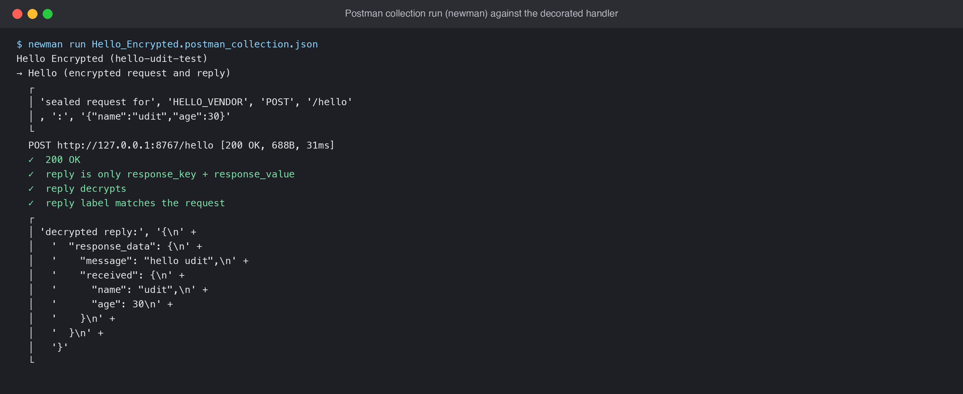
Figure 5. Collection run: request encrypted, reply decrypted by the script
A collection that holds your key can decrypt your traffic. Do not share or export it.

10. Kit contents
File | Purpose
vendor_client.py | seal_request, open_reply and call: everything needed, about 100 lines
example_call.py | End-to-end example: encrypt, send, decrypt
verify_test_vectors.py | Checks the implementation against test_vectors.json
test_vectors.json | Fixed inputs and expected outputs, with a public test key
requirements.txt | cryptography>=42
payload_crypto.postman.js | Postman encrypt and decrypt script
Table 4. Files

