QR-Linked Fragmented Watermarking
for Tamper-Evident Document Authentication
Project Report
A content-fragile watermarking scheme that detects document tampering and localises it to the altered region, anchored to a signed QR commitment.

Submitted by
Ritik Rana
October 2026

Abstract
A digital signature on a document answers one question: has this file changed? It cannot say which part changed, and it does not survive the document being rendered, printed or re-encoded. This project presents QLFW, a watermarking scheme that embeds authentication data into the pixels themselves so that tampering is both detected and located.
The page is partitioned into 32x32 pixel fragments. Each fragment's visual content is reduced to a digest, and that digest is converted into a 64-bit keyed authentication tag bound to the fragment's position. The tag is then hidden not in its own fragment but in a different one, chosen by a key-driven derangement, so that the document is interlocked globally rather than being a collection of independently valid blocks. A Merkle root over all tags is signed with Ed25519 and printed on the page as a QR code, which binds the sheet to one exact set of authenticators and to one issuer.
The implementation provides two carriers: a semi-fragile DCT quantisation-index-modulation carrier that tolerates mild recompression, and a fragile LSB carrier for born-digital documents. On a 1024x1280 certificate the DCT carrier produces 1280 fragments at 29.26 dB PSNR. Across 400 trials with independent keys, a four-fragment edit was never missed, and false positives averaged 0.2 fragments and never exceeded 2. The system is implemented in 1,707 lines of Python with a command-line interface and a suite of 61 tests.
Keywords: fragile watermarking, tamper localisation, document authentication, discrete cosine transform, quantisation index modulation, Merkle tree, Ed25519.
Table of Contents
If the list below is empty, select it and press F9 (Word) or right-click and choose Update Field.
Abstract
1. Introduction
2. Problem Statement
3. Objectives
4. Background and Related Approaches
4.1 Detached digital signatures
4.2 Fragile watermarking
4.3 Semi-fragile watermarking
4.4 Position of this work
5. System Architecture
5.1 Components
5.2 Data flow
6. Methodology
6.1 Fragmentation
6.2 Separating digest from payload
6.3 Tag generation
6.4 Dispersal
6.5 The QR anchor
6.6 Embedding as a fixed-point search
6.7 Handling saturation
6.8 Verification and localisation
7. Implementation
7.1 Technology
7.2 Carriers
7.3 Lossless output
7.4 Command-line interface
8. Results
8.1 Imperceptibility and convergence
8.2 Tamper localisation
8.3 Localisation accuracy
8.4 Robustness
8.5 QR anchor reliability
8.6 Testing
9. Security Analysis
10. Limitations
11. Future Work
12. Conclusion
References

1. Introduction
Documents that carry consequence — academic transcripts, contracts, medical records, land titles — circulate as images and PDFs. Any of them can be opened in an ordinary image editor and altered in seconds. The alteration leaves no trace that an unaided reader can see.
The conventional defence is a detached cryptographic signature. It is effective while the document stays in its original binary form, and useless afterwards. Rendering a signed PDF to an image, printing it, or re-encoding it all discard the signature while preserving everything a human reads. A signature is also binary in its verdict: it reports that the file differs from what was signed, but cannot indicate where, which matters when the question is whether a single figure was altered or the whole document is counterfeit.
Watermarking takes the opposite approach. Authentication data is carried inside the pixels, so it travels with the visual content rather than with the file format. This project builds such a scheme and addresses the two properties that make one useful in practice: it must say where the document was altered, and it must resist a forger who holds the watermarked document and wishes to repair it.

2. Problem Statement
Design and implement a document authentication system that satisfies all of the following simultaneously:
- Tamper detection. Any modification to the document's visual content must be detected.
- Tamper localisation. The system must identify which regions were altered, not merely that an alteration occurred.
- Resistance to repair. An adversary holding the watermarked document, but not the secret key, must be unable to edit a region and restore consistency.
- Resistance to splicing. Genuine content copied from one position to another within the same document must be rejected.
- Origin binding. Re-watermarking an altered document with the adversary's own key must not yield a document that verifies as the issuer's.
- Imperceptibility. The watermark must not interfere with reading the document.
The central technical obstacle is circularity. A fragment's authentication tag is computed from that fragment's content, yet the tag must be stored in the pixels — which changes the content it was computed from. Any workable scheme must break this dependency rather than assume it away.

3. Objectives
- To design a fragment-level authentication scheme in which a fragment's authenticator is stored outside that fragment, so that local forgery propagates into a document-wide inconsistency.
- To separate, in the frequency domain, the coefficients that determine a fragment's digest from those that carry its payload, thereby eliminating the circular dependency between content and tag.
- To bind the document to a compact, signed public commitment carried as a QR code, giving origin attribution independent of the pixel-level watermark.
- To implement both a semi-fragile and a fragile carrier, and to characterise empirically where each one ceases to work.
- To deliver a working command-line tool operating on both images and PDFs, with an automated test suite.

4. Background and Related Approaches

4.1 Detached digital signatures
A signature over the file's bytes gives strong integrity and origin guarantees, but is bound to the container rather than the content. It does not survive format conversion and provides no localisation.

4.2 Fragile watermarking
Classical fragile schemes embed a checksum of each block into the least significant bits of that same block. These detect any change and localise it well, but store each block's evidence inside the block it protects, which leaves the document a collection of independently valid units vulnerable to collage attacks, in which an adversary assembles a new document from authenticated blocks taken from genuine ones.

4.3 Semi-fragile watermarking
Semi-fragile schemes embed in transform coefficients so the watermark tolerates benign processing such as mild recompression while still failing on genuine edits. The difficulty is calibration: the margin that absorbs compression noise is the same margin an attacker can hide a small edit within.

4.4 Position of this work
QLFW combines a keyed, position-bound tag per fragment (defeating splicing), a key-driven dispersal of tags across fragments (defeating local repair and collage), and a signed Merkle anchor carried in a QR code (defeating wholesale re-watermarking). The contribution is the composition and a working, measured implementation rather than any single primitive.

5. System Architecture
The system has two operations, embedding and verification, over six components.
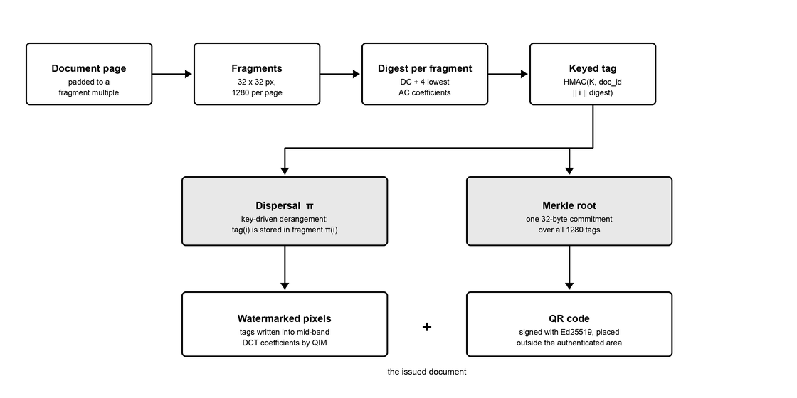
Figure 1 — Embedding pipeline. Tags are dispersed across fragments; only their Merkle root reaches the QR code.

5.1 Components
Module | Responsibility
transform.py | Vectorised 8x8 DCT and fragment tiling
carriers.py | DCT-QIM and LSB carriers; the digest / payload coefficient split
crypto.py | HMAC tags, dispersal derangement, Merkle root, Ed25519 signing
manifest.py | Packed binary QR record and the self-validating QR renderer
pipeline.py | Embedding fixed-point search; verification and localisation
docio.py / pdfwrite.py | Image and PDF input, lossless PDF output, QR attachment
Table 1 — Principal modules and their responsibilities.

5.2 Data flow
- Partition. The page is padded by edge replication to a multiple of the fragment size and divided into N fragments. Padding rather than cropping ensures no original pixel falls outside an authenticated fragment.
- Digest. Each fragment is reduced to a digest over quantised low-frequency DCT coefficients, describing its coarse appearance.
- Tag. Each digest becomes a 64-bit keyed tag bound to the fragment index and document identifier.
- Disperse. A key-driven derangement assigns the tag of fragment i to fragment pi(i).
- Embed. Tags are written into mid-band DCT coefficients by quantisation index modulation.
- Anchor. A Merkle root over all tags is signed and rendered as a QR code placed outside the authenticated region.

6. Methodology

6.1 Fragmentation
The page is divided into non-overlapping square fragments, 32 pixels on a side by default. The size is a direct trade-off: smaller fragments localise more precisely but offer less capacity for a payload, while larger fragments carry more bits but blur the location of an edit. At 32 pixels a fragment spans 16 DCT sub-blocks, and the resulting capacity of 64 bits matches the tag length exactly. A 1024x1280 page yields 1280 fragments.

6.2 Separating digest from payload
The circularity identified in Section 2 is resolved by partitioning each 8x8 DCT sub-block's coefficients into two disjoint sets:
- Digest coefficients — the DC term and four lowest AC terms, at positions (0,0), (0,1), (1,0), (0,2) and (2,0). These describe the fragment's coarse appearance. They are never modified by embedding.
- Payload coefficients — four mid-band terms at (1,2), (2,1), (2,2) and (1,3). These carry tag bits. They are low enough in frequency to survive mild recompression, high enough to remain invisible.
Because the sets are disjoint, writing a payload cannot alter any digest. One residual coupling remains: the inverse transform and rounding back to 8-bit integers perturbs every coefficient slightly. This is removed by snapping each digest coefficient onto a quantisation lattice of step 16 during embedding, so that the measured round-trip drift — at most 1.21 against a tolerance of 8 — cannot move a coefficient into a neighbouring bucket.

6.3 Tag generation
Each fragment's authenticator is a truncated HMAC-SHA256:
tag(i) = HMAC(K_tag, doc_id || i || digest(i)) truncated to 64 bits
Three inputs each serve a purpose. The digest binds the tag to the fragment's content. The index i binds it to a position, so genuine content copied elsewhere on the page carries an authenticator computed for the wrong location and is rejected. The document identifier binds it to one document, preventing fragments from being transplanted between documents issued under the same key.

6.4 Dispersal
The tag for fragment i is embedded into fragment pi(i), where pi is a derangement — a permutation with no fixed points — derived deterministically from the secret key and the document identifier by a keystream-driven Fisher-Yates shuffle.
This is the scheme's central structural decision. Were a tag stored in the fragment it authenticates, every fragment would be a self-contained verifiable unit and the document a bag of interchangeable parts. Under dispersal, altering fragment i is detected through fragment pi(i); repairing that evidence would require modifying pi(i), which invalidates the tag stored in pi(pi(i)), and so on. A local edit therefore propagates into a document-wide inconsistency that cannot be resolved without the key.

6.5 The QR anchor
All N tags are combined into a single 32-byte Merkle root with domain-separated leaf and node prefixes. The root, the scheme parameters, the document identifier and an issue timestamp form a 69-byte record, signed with Ed25519 and encoded as base32 — whose alphabet lies within QR alphanumeric mode, packing 5.5 bits per character against byte mode's 8.
The issuer's public key is deliberately excluded from the record. A key carried by the document it signs attests to nothing, since a forger re-signs with their own key and presents that. The verifier supplies the key it expects, so the question asked becomes whether the document originates from a specific trusted issuer.
The QR is placed on a strip below the document, outside the authenticated region, because overlaying it would overwrite watermarked pixels. A verifier recovers the authenticated region by cropping to the dimensions stated in the manifest.

6.6 Embedding as a fixed-point search
Although the coefficient split makes digests independent of the payload in principle, the implementation does not rely on that assumption. Embedding iterates: a candidate payload is rendered to an 8-bit image, digests are read back from that rendered image, tags are recomputed and dispersed, and the result is compared with the payload that produced it. The process terminates only when the two agree, at which point the document is demonstrably self-consistent. If no fixed point is reached within eight rounds, the tool refuses to write output rather than ship a document that would fail its own verification. In practice convergence occurs in two rounds.

6.7 Handling saturation
A document page is predominantly saturated white with black text. A saturated block has no headroom to be modulated: the clip back to the 8-bit range erases the payload. In the initial implementation this cost 11 percent of all payload bits, concentrated in the background. The tonal range is therefore compressed by one quantisation step at each end before embedding, which restores the headroom. This compression, rather than the watermark itself, accounts for most of the DCT carrier's distortion.

6.8 Verification and localisation
Verification receives only the document and the key. For each fragment it recomputes the digest from the current pixels, recomputes the expected tag, and compares it against the tag extracted from fragment pi(i). A Hamming distance above the tolerance marks a mismatch.
A mismatched fragment is not necessarily an altered one: it also fails when the guardian holding its tag was the region edited. The reported tamper set is therefore refined to those fragments whose own guardian relationship is consistent with them being the edited party, which removes most of this halo. The remainder is reported separately as guardian fallout.

7. Implementation

7.1 Technology
Python 3.14, with NumPy for vectorised transforms, Pillow for image handling, the cryptography library for Ed25519, OpenCV for QR detection, qrcode for QR generation, and pypdfium2 for PDF rasterisation. The 8x8 DCT is implemented directly as a matrix product applied to the whole image at once, which avoids per-block iteration.

7.2 Carriers
Property | DCT carrier (default) | LSB carrier
Domain | Mid-band DCT, QIM | Bit 0 of the last channel
Fragility | Semi-fragile | Fragile
JPEG tolerance | Clean to quality 92 | None; any re-encode fails
Noise tolerance | Sigma approx. 1 | None
Colour | Converts to grayscale | Authenticates all channels
PSNR | 29.26 dB | 63.21 dB
Intended use | Scanned or re-encoded documents | Born-digital documents
Table 2 — Comparison of the two embedding carriers.

7.3 Lossless output
Two output paths were found to destroy the watermark silently and required replacement. Pillow encodes PDF pages with DCTDecode, that is JPEG, so a custom FlateDecode PDF writer was implemented. Separately, PDF rasterisation returns a page one pixel off at densities where the page box is a fractional number of points; rendering density is therefore restricted to 72 x 2^k DPI, where the round-trip is bit-exact.

7.4 Command-line interface
Command | Function
keygen | Create an issuer key file (HMAC key plus Ed25519 pair, mode 0600)
embed | Watermark a document and emit its QR anchor
verify | Authenticate a document, localise tampering, write a tamper map
inspect | Decode and print a QR manifest without the secret key
tamper | Simulate an attack, for demonstration and testing
Table 3 — Command-line operations.
Verification exits with status 0 only for an authentic document, allowing the tool to be used directly in automated pipelines. A machine-readable report naming the tampered fragments is available via a JSON output flag.

8. Results

8.1 Imperceptibility and convergence
On the 1000x1280 test certificate, padded to 1024x1280 and divided into 1280 fragments, the DCT carrier achieves 29.26 dB PSNR and the LSB carrier 63.21 dB. Both reach a self-consistent fixed point in two rounds. Figure 2 shows the watermarked document; the text remains fully legible.

Figure 2 — Watermarked certificate with its QR anchor on the strip below.

8.2 Tamper localisation
The value 9.14 was altered to 9.94 using an ordinary text overlay. Verification, given only the file and the key, reported 13 tampered fragments beginning at row 15, column 10 — precisely the altered region, which begins at pixel coordinates (325, 492) and therefore at fragment (15, 10).
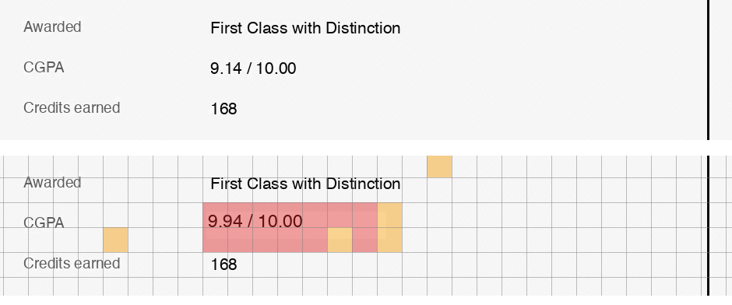
Figure 3 — Detail before (top) and after (bottom) verification. Red marks the located edit; amber marks guardian fallout.
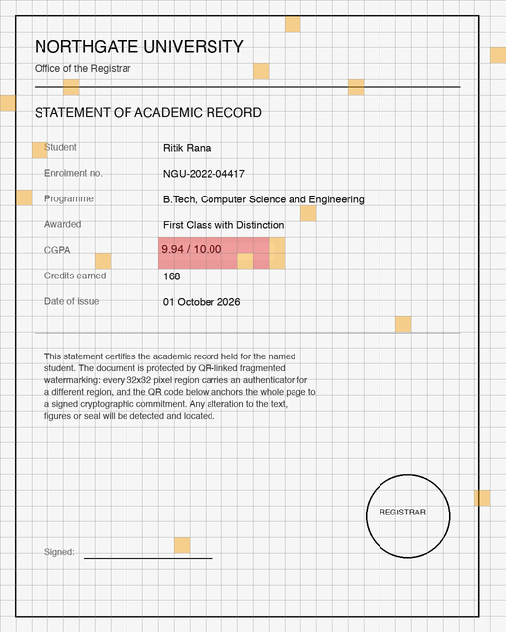
Figure 4 — Full-page tamper map. The scattered amber fragments are those whose authenticators were stored inside the edited region.

8.3 Localisation accuracy
A four-fragment edit was applied under 400 independently generated keys, 200 per carrier, and the reported tamper set compared against ground truth.
Carrier | Trials | Edit missed | Mean false positives | Max false positives
DCT | 200 | 0 | 0.20 | 2
LSB | 200 | 0 | 0.14 | 2
Table 4 — Localisation accuracy over 400 trials with independent keys.
Recall is complete: the edit was never missed. False positives arise from the dispersal itself — when an edited fragment's guardian was also inside the edit, a third fragment is promoted — and are bounded at two.

8.4 Robustness
The DCT carrier was subjected to JPEG recompression and additive Gaussian noise at two strength settings.
Attack | Strength 8 (default) | Strength 16
JPEG quality 95 | Clean | Clean
JPEG quality 92 | Clean | Clean
JPEG quality 90 | 2 of 1280 flagged | Clean
JPEG quality 85 | Total failure | —
Gaussian noise, sigma 0.75 | Clean | Clean
Gaussian noise, sigma 1.0 | 2 of 1280 flagged | 3 of 1280 flagged
Gaussian noise, sigma 1.5 | 1043 of 1280 flagged | —
Gaussian noise, sigma 2.0 | Total failure | 146 of 1280 flagged
PSNR | 29.26 dB | 23.66 dB
Table 5 — Robustness of the DCT carrier, and the cost of raising embedding strength.
Two observations follow. First, tolerance to JPEG does not imply tolerance to additive noise: the carrier is clean through JPEG quality 92 but fails by noise of sigma 1.5. Second, raising the embedding strength buys robustness at a measurable cost in fidelity, and the trade-off is exposed as a parameter rather than fixed. Beyond either limit the system fails loudly rather than producing a plausible but wrong tamper map.

8.5 QR anchor reliability
OpenCV's QR decoder proved unreliable on dense symbols, failing roughly 8 percent of reads even on undamaged images, with failures occurring in decoding rather than detection. Two measures were taken. The manifest was compacted from a JSON representation of 428 characters to a packed binary record of 218, encoded in base32 to exploit QR alphanumeric mode. Second, the rendered QR is decoded from the composed page before the document is written, stepping through error-correction levels until one round-trips.
Configuration | Failures
JSON manifest, single decode attempt | 10 of 40
Packed binary manifest, multi-view decode | 3 of 80
Packed binary, validated on the composed page | 0 of 80
Table 6 — QR anchor read reliability at each stage of refinement.

8.6 Testing
The implementation is covered by 61 automated tests across 559 lines, spanning the cryptographic primitives, the manifest wire format, both carriers, the PDF round-trip and the command-line interface. Several encode claims made in this report, including the JPEG breakdown point, the bit-exactness of the PDF raster round-trip and the bound on false positives, because a regression in any of these would produce incorrect verdicts silently rather than failing visibly.

9. Security Analysis
Attack | Defence
Edit a region | Digest changes; the tag stored in the guardian fragment no longer matches
Repair the edited region | Requires the key; repairing the guardian cascades to its own guardian
Splice content within the page | Tags are bound to the fragment index, so moved content carries the wrong tag
Transplant between documents | Tags are bound to the document identifier
Re-watermark with the attacker's key | The Merkle root in the signed QR no longer matches
Forge the QR anchor | Ed25519 signature over the whole record, verified against an expected issuer key
Substitute the whole document | Document identifier and Merkle root both bind the anchor to one page
Table 7 — Attack surface and corresponding defences.
The security of fragment authentication rests on the secrecy of the HMAC key; forging a single tag without it succeeds with probability 2^-64. The security of origin attribution rests on Ed25519 and is independent of the HMAC key.

10. Limitations
- Verification requires the secret key. The Ed25519 signature provides public attribution of the anchor, but authenticating the pixels requires the HMAC key. Genuine public verifiability would need a different construction.
- Narrow robustness envelope. The DCT carrier tolerates JPEG to quality 92 and noise to sigma 1 at default settings. Beyond that it reports failure rather than a partial result.
- Geometric attacks are out of scope. Rotation, cropping and rescaling destroy fragment alignment; these are reported as unverifiable rather than authentic.
- Print and scan is not supported. The carrier tolerates mild recompression, not a full analogue round trip.
- Localisation is not exact. Recall is complete but precision is bounded rather than perfect, with up to two false positives observed.
- Chroma is unprotected under the DCT carrier. That carrier converts to grayscale so every authenticated byte lies in the plane it controls; the LSB carrier authenticates all channels.

11. Future Work
- Geometric resynchronisation, using registration marks or a template, to recover fragment alignment after rotation or cropping.
- A print-and-scan robust carrier, which would require a substantially lower embedding rate and explicit halftone modelling.
- Self-embedding content recovery, in which each fragment additionally carries a compressed thumbnail of another, allowing the original appearance of an altered region to be approximately reconstructed.
- Public verifiability without a shared secret, for example by committing to per-fragment values in a structure that supports public proofs.
- A graphical interface for non-technical operators in a registrar's office.

12. Conclusion
This project implements a document authentication scheme that detects tampering and localises it to the altered region, resists repair by an adversary who lacks the key, and binds each document to a signed public anchor carried as a QR code. The circular dependency between a fragment's content and its authenticator — the principal obstacle to any such scheme — is resolved by partitioning the DCT coefficients into disjoint digest and payload sets, and the implementation verifies self-consistency by fixed-point iteration rather than assuming it.
The measured results support the design. Localisation recall was complete across 400 trials with a false-positive bound of two fragments. Both carriers converge in two rounds, and the semi-fragile carrier tolerates recompression to JPEG quality 92 at 29.26 dB fidelity.
Equally informative were the failures encountered during development. Saturated document backgrounds silently destroyed 11 percent of payload bits until tonal headroom was introduced; two separate output paths were found to re-encode the document lossily and had to be replaced; and the QR decoder failed on 8 percent of dense symbols until the manifest was compacted and validated on the composed page. Each was invisible in casual testing and would have produced confidently incorrect verdicts in deployment. The system's stated limits are therefore measured rather than assumed, and it is designed to fail audibly where it fails at all.

References
[1] M. Wu and B. Liu, "Watermarking for image authentication," Proceedings of the IEEE International Conference on Image Processing, 1998.
[2] P. W. Wong and N. Memon, "Secret and public key image watermarking schemes for image authentication and ownership verification," IEEE Transactions on Image Processing, vol. 10, no. 10, pp. 1593-1601, 2001.
[3] B. Chen and G. W. Wornell, "Quantization index modulation: a class of provably good methods for digital watermarking and information embedding," IEEE Transactions on Information Theory, vol. 47, no. 4, pp. 1423-1443, 2001.
[4] R. C. Merkle, "A digital signature based on a conventional encryption function," Advances in Cryptology - CRYPTO '87, pp. 369-378, 1988.
[5] D. J. Bernstein, N. Duif, T. Lange, P. Schwabe and B.-Y. Yang, "High-speed high-security signatures," Journal of Cryptographic Engineering, vol. 2, no. 2, pp. 77-89, 2012.
[6] M. Bellare, R. Canetti and H. Krawczyk, "Keying hash functions for message authentication," Advances in Cryptology - CRYPTO '96, pp. 1-15, 1996.
[7] H. He, J. Zhang and F. Chen, "Adjacent-block based statistical detection method for self-embedding watermarking techniques," Signal Processing, vol. 89, no. 8, pp. 1557-1566, 2009.
[8] International Organization for Standardization, ISO/IEC 18004:2015, "Information technology - Automatic identification and data capture techniques - QR Code bar code symbology specification."

