**Eye Movement**

Below is the code which we used for extracting eyes as an object and predicting them as suspicious or clean. For the other parts of the code i.e. for applying model, training and prediction, we have used the same code as we used for head movement.

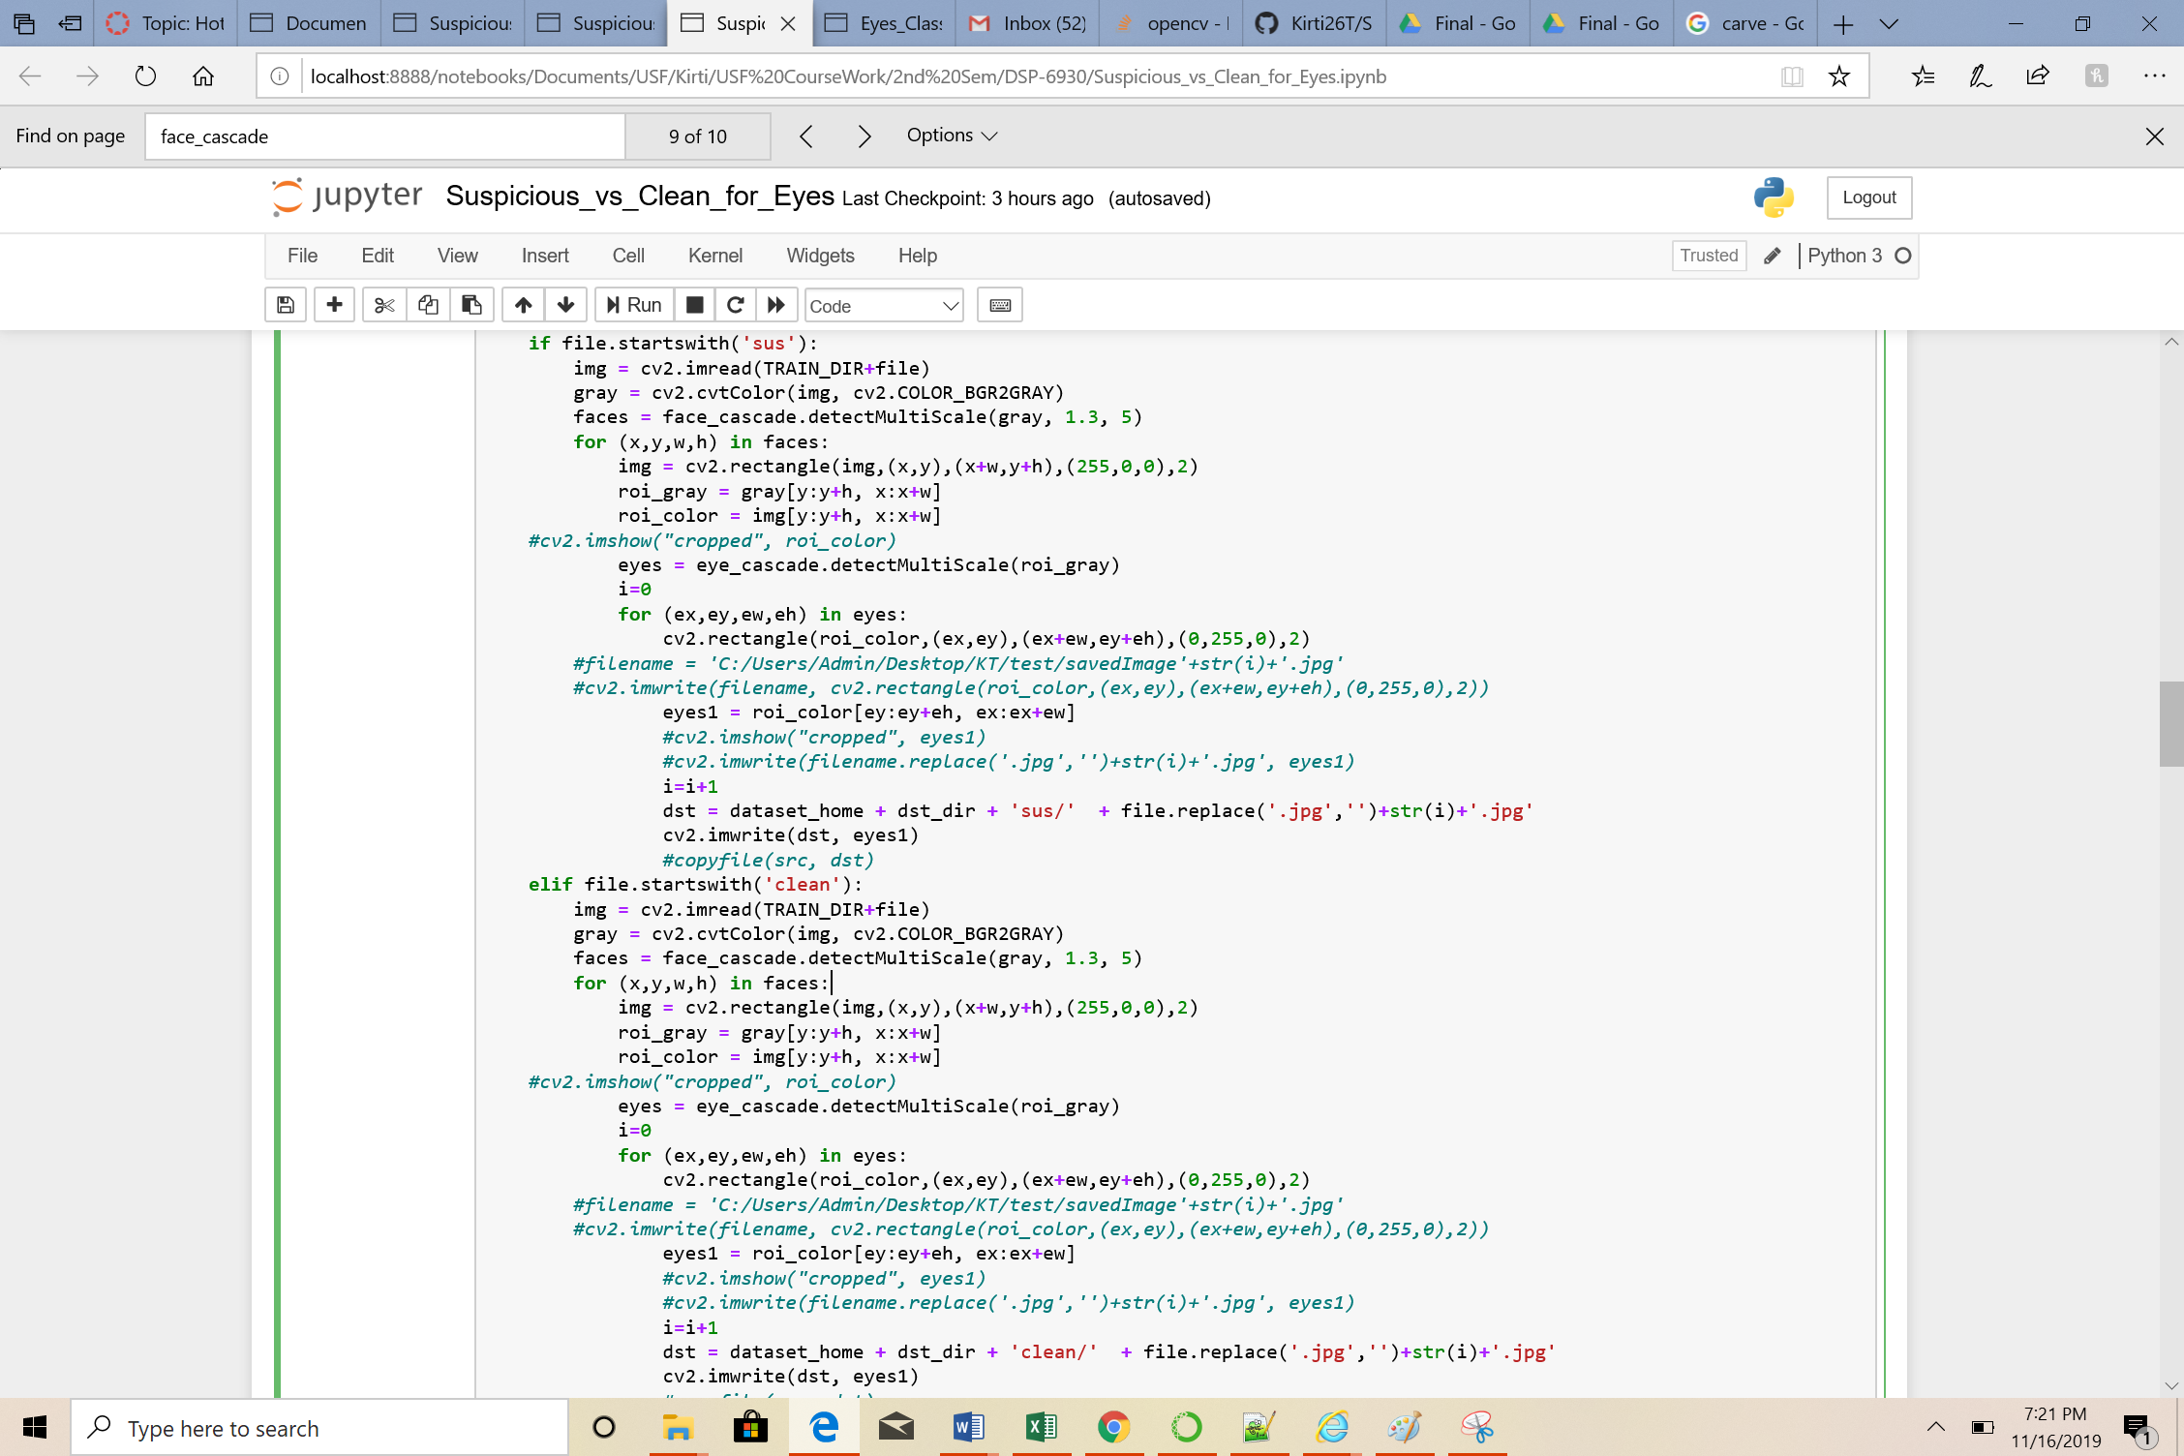

We were able to achieve accuracies for training around 85% and for validation around 60-70%

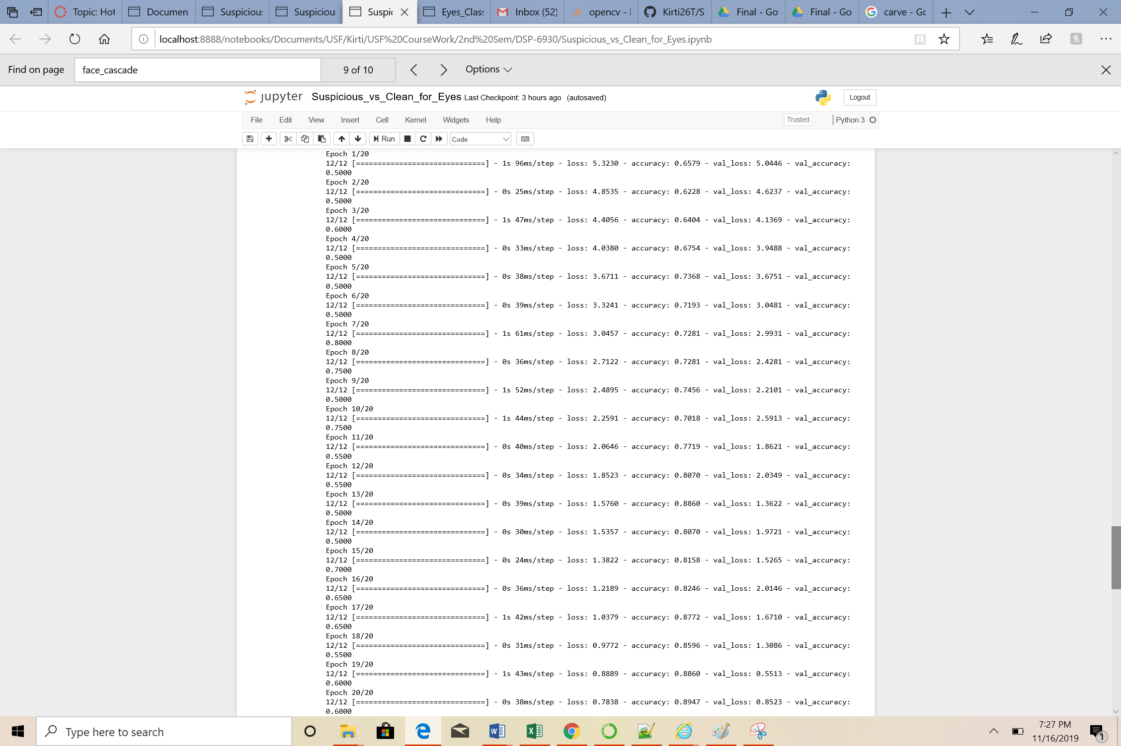

When we applied model on Test data, we got the below results with cutoff of 0.65

