**Read Me**

Below Steps needs to be done before running the codes.All the files are stored in below location in google drive:

<https://drive.google.com/drive/u/0/folders/18Iu67LAg3b0iAjOZtujlxSpnFfNR4C_i>

* **Suspicious Activity Classification using Head Movement (Both for Images and videos).**
* Download the folder “Suspicious_vs_Clean” from above google drive location and “Suspicious_vs_Clean_Activity.ipynb” Juypter Notebook.
* Change the below path for directory to the location where your “Suspicious_vs_Clean” Folder (downloaded above) is available.

directory = 'C:/Users/ktiwari/Documents/USF/Kirti/USF CourseWork/2nd Sem/DSP-6930/Project/' # only have to change this path



Note : Replace the “\” with “/” and provide “ / “ at the end of the path.

* **Suspicious Activity Classification using Eye Movement (Only Images).**
* Download the folder “eye” from above google drive location and “Suspicious_vs_Clean_for_Eyes.ipynb” Juypter Notebook.
* Change the below path for directory to the location where your “eye” Folder (downloaded above) is available.

directory = 'C:/Users/ktiwari/Documents/USF/Kirti/USF CourseWork/2nd Sem/DSP-6930/eye_dataset/eye/' # only have to change this path



Note : Replace the “\” with “/” and provide “ / “ at the end of the path.

* Search for ‘haarcascade_frontalface_default.xml’ in windows search and open the file found.

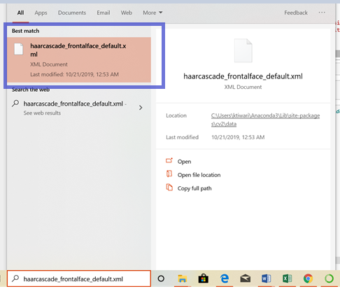



* It will open in explorer and copy the full path from there.



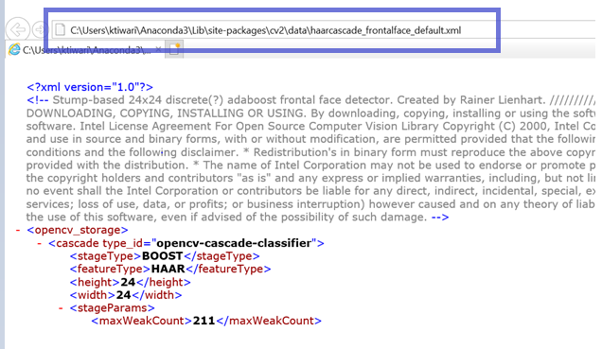

It will be something like this: Copy that path

**C:\Users\ktiwari\Anaconda3\Lib\site-packages\cv2\data\haarcascade_frontalface_default.xml**

* Use this path which you copied above and replace in the face_cascade section in below part of the code, also replace the “\” with “/”



face_cascade = cv2.CascadeClassifier('C:/Users/ktiwari/Anaconda3/Lib/site-packages/cv2/data/haarcascade_frontalface_default.xml')

* Similar activity needs to be done for eye_cascade as well. Search for ‘haarcascade_eye.xml'

eye_cascade = cv2.CascadeClassifier('C:/Users/ktiwari/Anaconda3/Lib/site-packages/cv2/data/haarcascade_eye.xml')