**APIM Integration with PowerApps**

1. **Create Custom Connector to setup connection between APIM and PowerApps**
2. Navigate to Developer Portal and open the API section. Now, click on the API definition icon on the top-right side. Select the OpenAPI specification and copy the content and paste the same in a file and save it in json format.

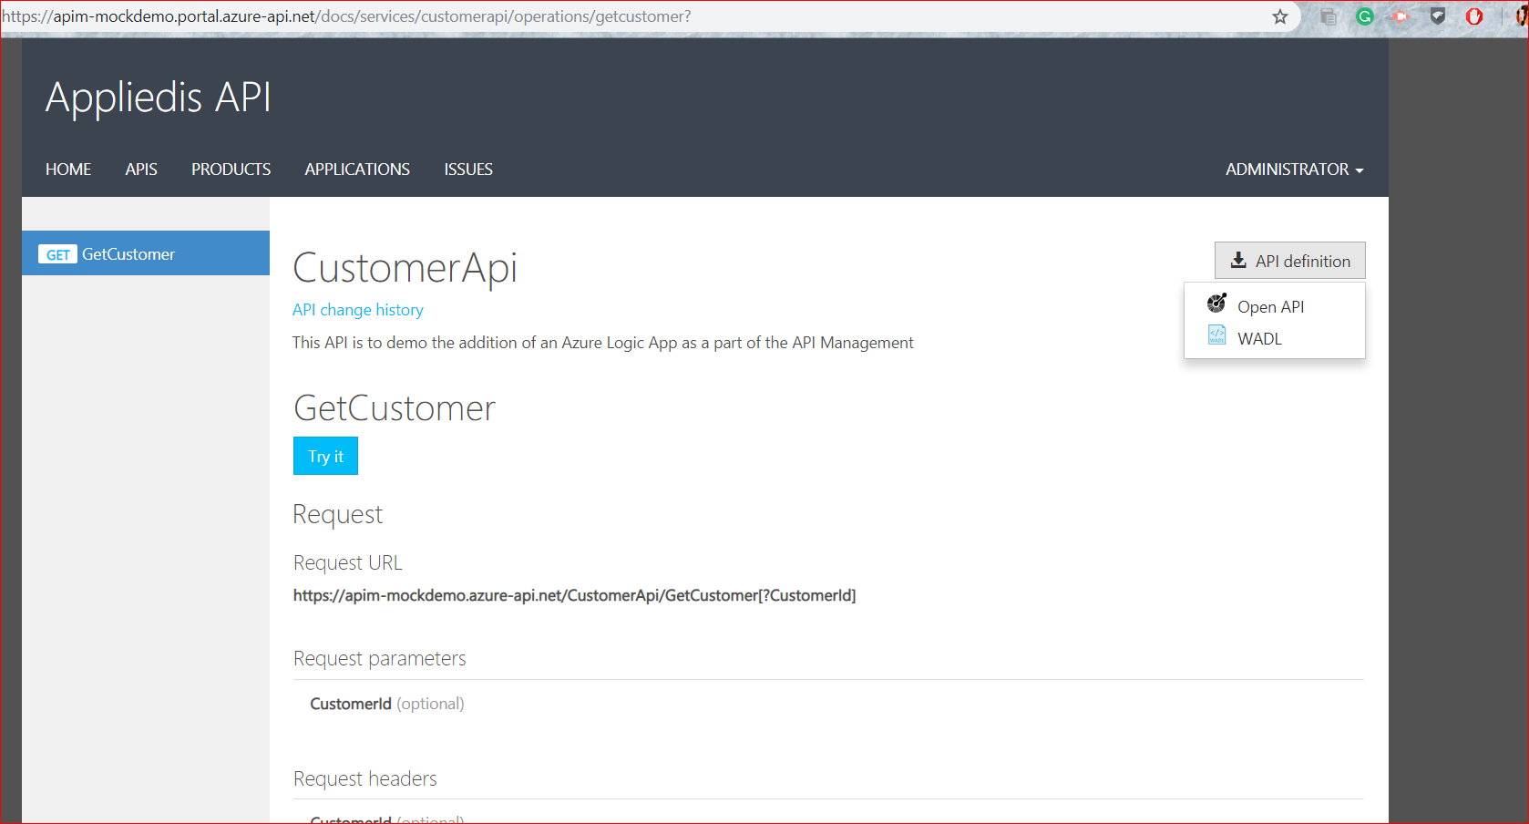

1. Modify few details in the swagger file before uploading it as a custom-connector swagger file.

Change the title tag in info, so that multiple operations from different APIs can be called with the same display name.

Change the base path to / so that PowerApps communicate with the base APIM at / instead of a specific API configured inside APIM.

1. Navigate to PowerApps and select Custom Connection under Data menu item. Create a new Custom Connector and select upload an OpenAPI file. Select the file and create the custom-connector.

After uploading file, user need to verify following sections:

**General:**

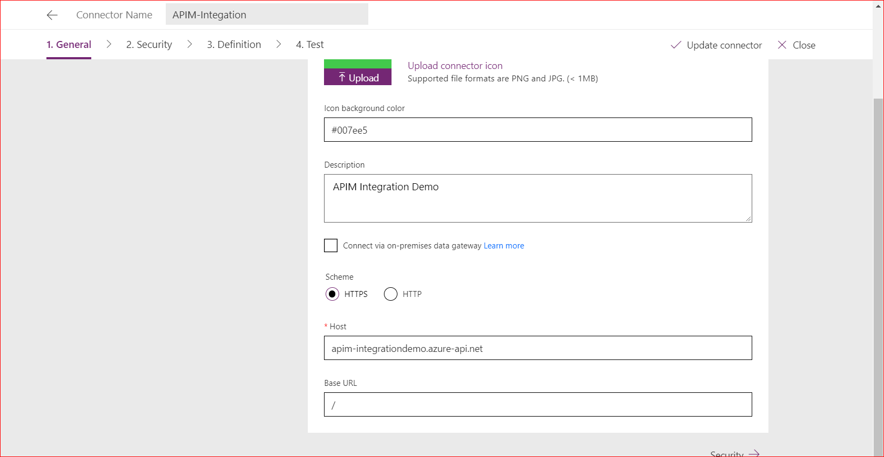

**Security:**

When there are multiple security criteria, then PowerApps selects the first one by default, if this need to be changes then user need to update the same in security section.

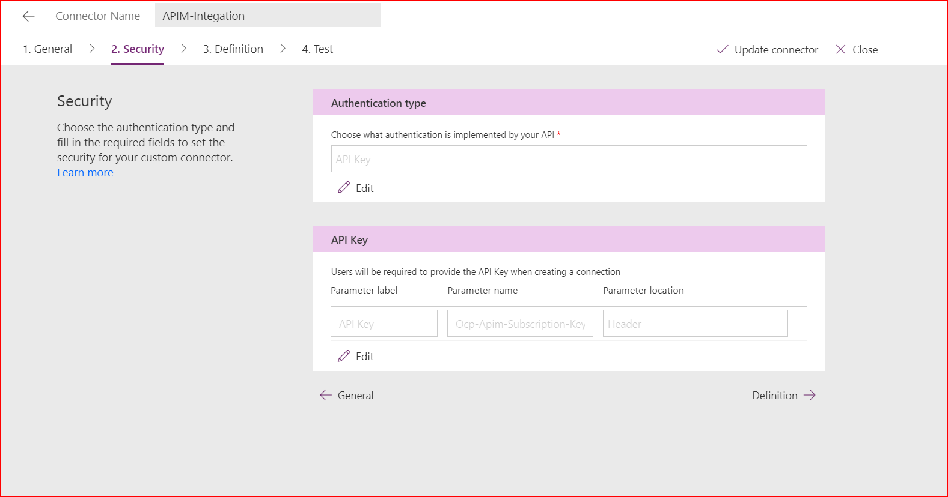

In the OAUTH security criteria, user need to provide certain details regarding the OAuth that are configured after registering the app. Also, Redirect URL is auto-generated once the connector is created.

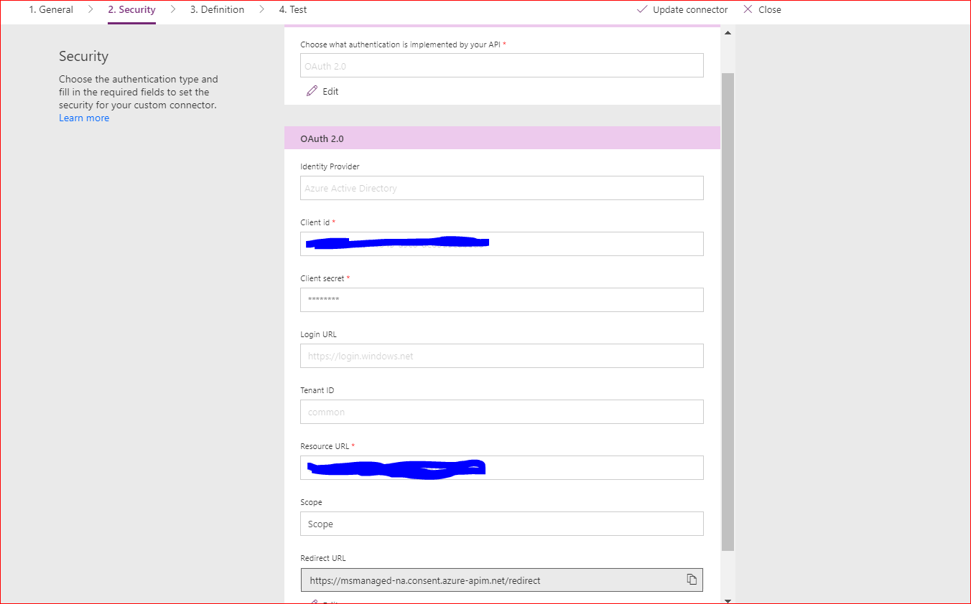

**Definition:**

Define the actions for calling the APIs.

As the base URL is changed to / while creating connector, hence actions for multiple API can be called inside once custom-connector.

User can edit any of the details, and can set the Request and Response formats as well.

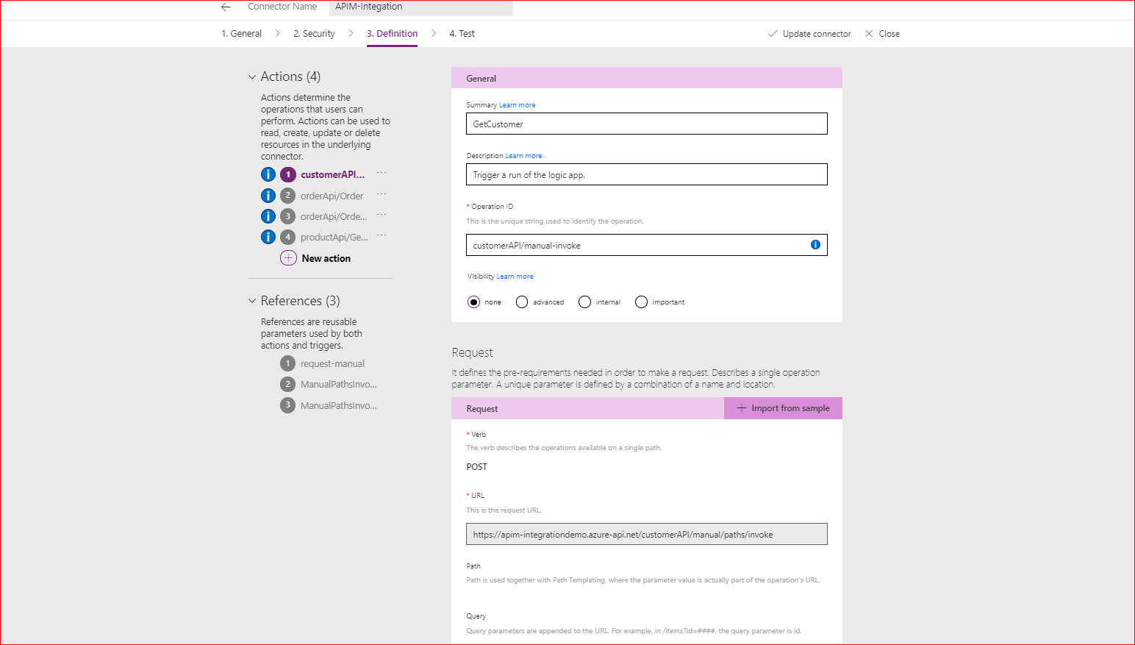

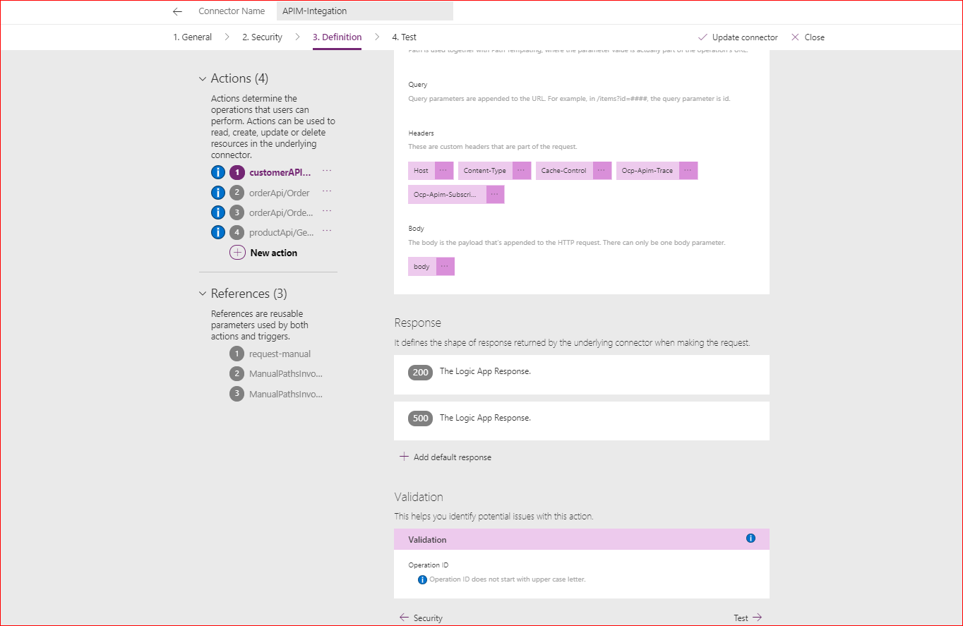

Similarly, multiple actions can be set with their respective request and Response formats.

**Test:**

Here the User needs to create a connection that will be used to connect custom-connector and APIM. In case of API Key, user need to specify the Subscription key of the Product that is generated at the APIM level while for OAuth, user need to authenticate using the Azure account. Later authentication, a connection is created while will be used to send the request.

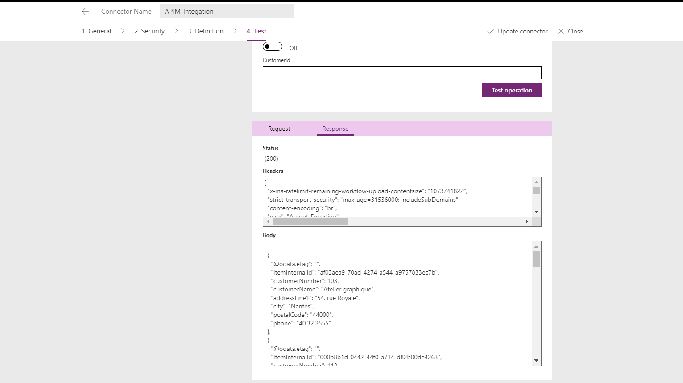

1. **PowerApps Creation**

Create new App in either Phone or Desktop layout and create a custom layout for displaying data as per your needs.

In this case, a phone layout is selected, user input is taken in text box and On Submit button, the request is initiated, and the returned response is stored in a collection and displayed to user in the form of a gallery.

A main page is created to enable navigation between multiple screens.

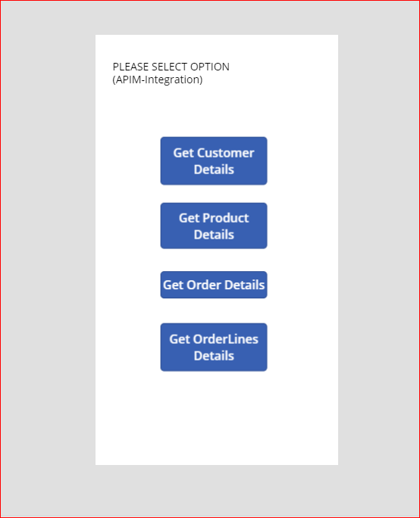

To fetch data, user need to add the data source which will get the connection created previously to come into picture.

To add data source, select View and then click on Data Source, if already created select the connection from displayed values, or else a new connection can be made after authentication.

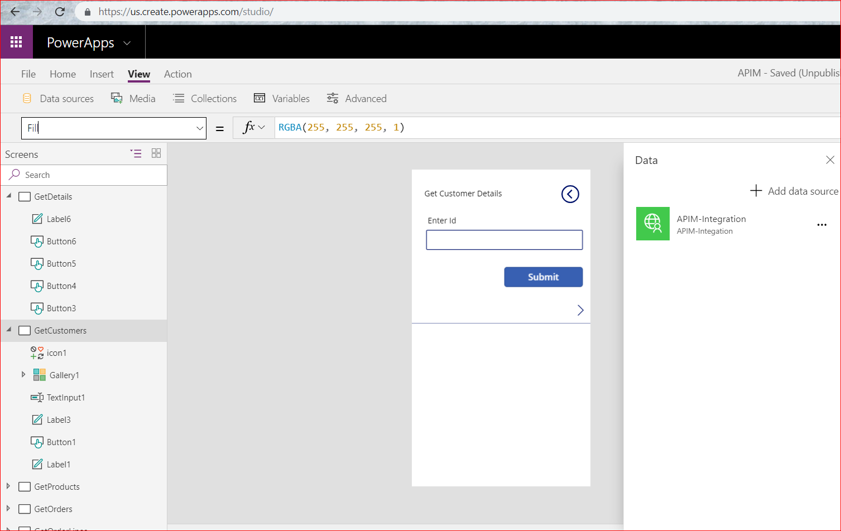

Submit button has a onselect action, which will make the request and the response will be stored in specified collection.



customerDetails is the name of collection.

ClearCollect will clear the collection and will save new data once a request is made.

To display items in gallery, this collection will be added in the items section and for each item, whatever value that will be displayed from the whole collection is selected.

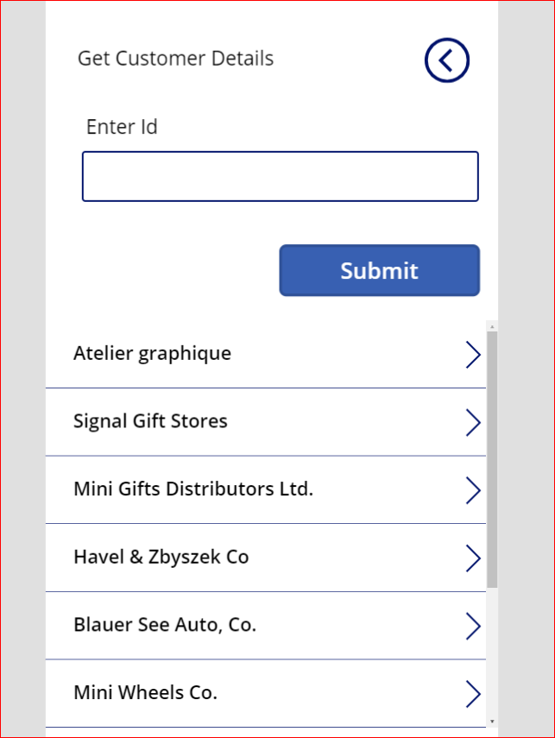

After the app is configured properly and if it is working as Expected then user can publish it. So that it can be played from outside.