# Review report

1. **Formatting issue in Figure:**

Put space after Figure.

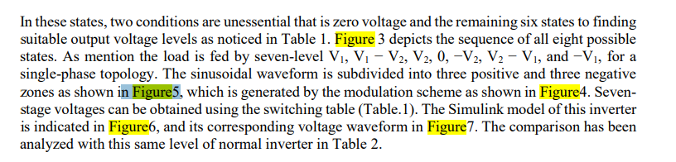

1. **Poor image quality, labels are not readable (Figure 4, 6 & 11).**
2. **References: Authors naming format is not similar in references:**

[27] R. S. Alishah, S. H. Hosseini, E. Babaei, and M. Sabahi, “Optimal design of new cascaded switch-ladder multilevel inverter structure”, IEEE Trans. Ind. Electron., vol. 64, no. 3, pp. 2072 2080, Mar. 2017. [28] Margarita Norambuena, Samir Kouro, Sibylle Dieckerhoff  &  Jose  Rodriguez,  “Reduced  Multilevel  Converter:  A  Novel  Multilevel  Converter  with  a  Reduced  Number  of  Active  Switches”,  IEEE  Transactions on Industrial Electronics, vol. 65, no. 5, pp. 3636-3645. 2018

1. **Could not found the citation of references in the article.**