[1]

**Effect of MgO thickness on magnetic and dielectric properties of Ta/CoFeB/MgO(x) structures**

**Jitendra P. Singh**

Manav Rachna University, Faridbad, India

*Abstract*—Electric field induced changes in coercivity and magnetoresistance has been recently observed by using a dielectric layer like ZrO2 or ITO . In our opinion observation of this effect in MTJ by using these may reduce the magnetoreisistance of the devices. We are looking for the possibility of using MgO layer in these devices to exhibit this effect. Hence, the present work reports the dielectric and magnetic properties of Ta (50)/CoFeB(12)/MgO(x)/Ta(50) structures (values in parenthesis are thickness of layers in Angstrom) . The structure was deposited by using the rf sputtering method in the vacuum better than 3×10-7 Torr and by annealing at 275oC. Out of plane squarness (S) is ~0.15 for as deposited structures and a slight variation of S with MgO thickness is observed. After annealing S reaches to the value of 0.6 for structure with MgO thickness of 20 Å. Rest of the samples, exhibit value of S in the range of 0.24. High value of S and EHE hysteresis for structure Ta (50)/CoFeB(12)/MgO(20)/Ta(50) shows presence of PMA. Dielectric measurement on these structures shows value of decrease in value of dielectric constant with decrease in MgO layer thickness for as deposited and annealed structures. The value of dielectric constant for structure Ta(50)/CoFeB(12)/MgO(500)/Ta(50) changes from 2.5 to 4.3 with annealing, which may be due to improvement in the crystallization structure of the MgO. Less value of dielectric constant of these structures needs detailed investigation.

*Index Terms*—Perpendicular Magnetic Anisotropy, dielectric constant, Anamalous Hall Effect

# INTRODUCTION

M

agnetic tunnel junction with perpendicular magnetic anisotropy has been widely utilized for spin transfer torque and magnetic random access memory applications This orientation of anisotropy is preferred due to reduced switching current densities (Jc) as MTJ cell scale down upto 20 nm in this configuration [3]. Scaling down upto this small scale is not a easy task, so another approaches in this context will be much more informative. .

It has been seen that the assistance of an E-field, the amplitude of Jc can be reduced to the range of 104 A/cm2 in a CoFeB/MgO/CoFeB perpendicular MTJ system [5]. As per application requirements MTJ exhibiting electrical field switching phenomena has been in the process of recent development. Basic mechanism in these developments is the modification of perpendicular magnetic anisotropy under the effect of electrical field. The idea could lead to realization after the observation of electric field induced changes in coercivity in ferromagnetic film [6, 7]. The perpendicular component of magnetic moment also affected by the application of ac electric field and change in interface anisotropy could be observed [8, 9]. We present a model for determining the Rashba spin-orbit coupling (RSOC) at magnetic surfaces or interfaces by explicitly taking into account the interaction between the inversion-symmetry-broken potential and the spin-dependent electric dipoles of the Bloch states. We show that the RSOC alone can generate a perpendicular surface magnetic anisotropy comparable to the observed values in transition metals. When an external electric field is applied across the interface, the induced screening potential modifies the RSOC and thus controls the direction of the magnetization. Our results are consistent with the existing experiments [9]. The changes also exhibit strong dependency on the thickness of magnetic layer. We review the recent developments in the electric field control of magnetism in multiferroic heterostructures, which consist of heterogeneous materials systems where a magnetoelectric coupling is engineered between magnetic and ferroelectric components. The magnetoelectric coupling in these composite systems is interfacial in origin, and can arise from elastic strain, charge, and exchange bias interactions, with different characteristic responses and functionalities. Moreover, charge transport phenomena in multiferroic heterostructures, where both magnetic and ferroelectric order parameters are used to control charge transport, suggest new possibilities to control the conduction paths of the electron spin, with potential for device applications [11]. We have demonstrated purely electrical manipulation of the magnetic anisotropy of a Co0.6Fe0.2B0.2 film by applying only 8 V across the CoFeB/oxide stack. A clear transition from in-plane to perpendicular anisotropy was observed. The quantitative relationship between interface anisotropy energy and the applied electric-field was determined from the linear voltage dependence of the saturation field. By comparing the dielectric stacks of MgO/Al2O3 and MgO/HfO2/Al2O3, enhanced voltage control was also demonstrated, due to the higher dielectric constant of the HfO2. These results suggest the feasibility of purely electrical control of magnetization with small voltage bias for spintronics applications [11].

Since, tailoring interface anisotropy by application of ac electrical field is required for development of these device, hence more information on the ac behavior will be an added advantage.

In the present case, we studied the dielectric and magnetic properties of bottom structure of a typical magnetic tunnel junction stack.

# Experimental Method

## Deposition of multilayer stack

Ta (50)/CoFeB(12)/MgO(x)/Ta(50) structures (values in parenthesis are thickness of layers in Angstrom) been deposited by using the dc/rf sputtering method on Si/SiO2 substrate in vacuum of 4mTorr. The base pressure of the sputtering chamber was better than 3×10-7 Torr. These samples were further annealed at 275oC for 1 hr in vacuum of 2×10-5 Torr [12]. Prior to deposition of these structure Ta layer of ~ 40 nm as bottom electrode have been done. After deposition of this structure top electrode have been deposited for dielectric measurement (Figure 1).



Figure 1: Layer sequence and deposition of Ta/CoFeB/MgO/Ta layers for capacitance measurements (not to scale)

## Characterization

After growth, the magnetic properties of these multilayer stacks were investigated by using vibrating samples magnetometer at room temperature. Dielectric measurements at room temperatures were carried out on LCR meter at 20 mV a.c. voltage.

# Results and Discussion

## Magnetic properties

Figure 1 and 2 shows the hysteresis curves of the as-deposited and annealed stacks. It is clear from Fig. 1 that all deposited stacks are do not exhibit any out of plane orientation of magnetic moment while annealing leads to the presence of this orientation in the stack with MgO thickness of 2 nm.

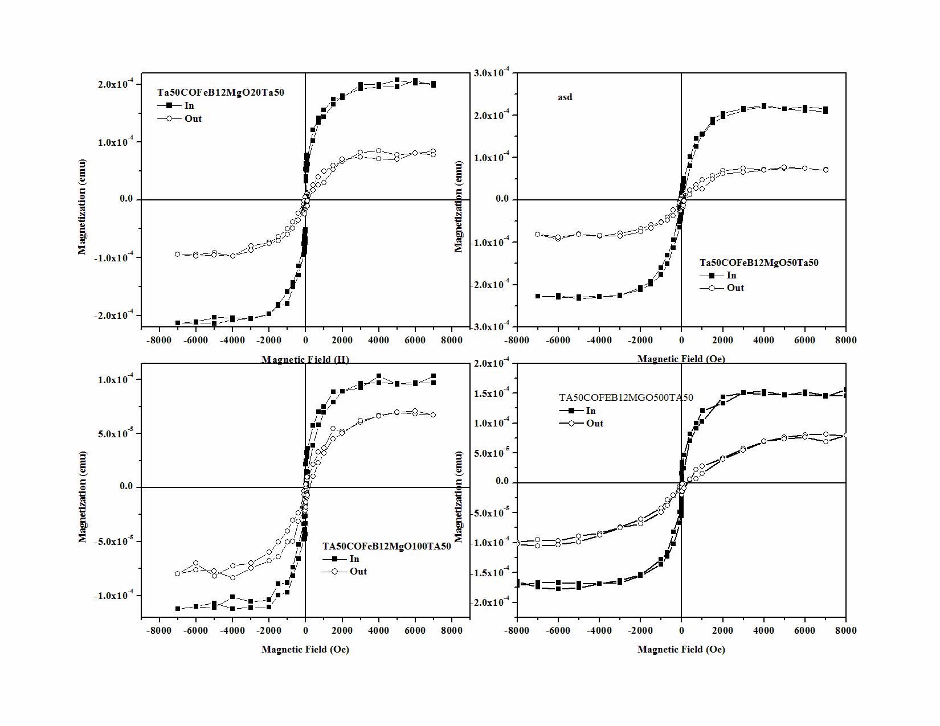

**Fig. 1: Hysteresis loops of as-deposited Ta/CoFeB/MgO (x)**

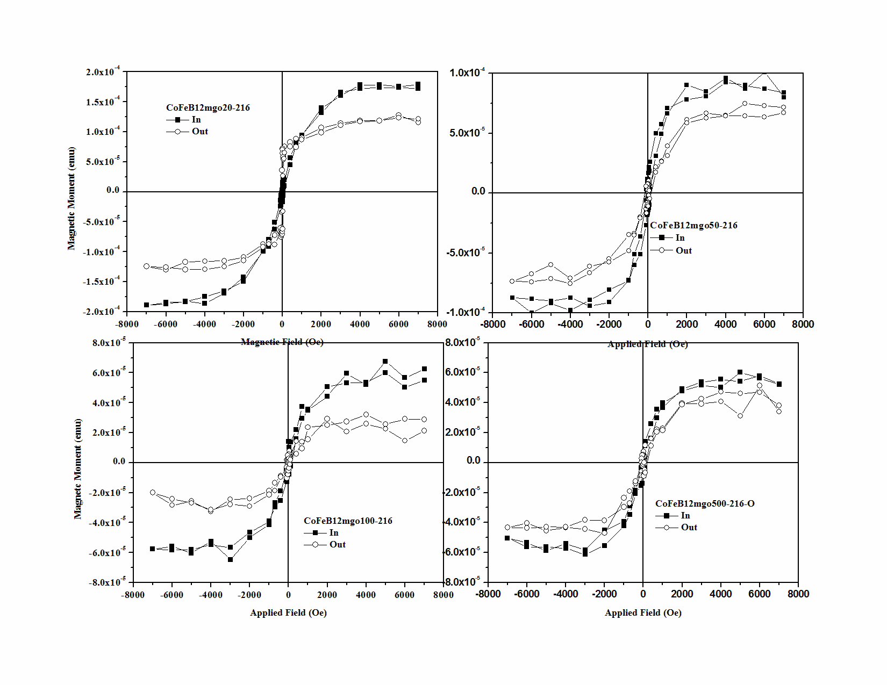

**Figure 2: Hysteresis loops of annealed Ta/CoFeB/MgO (x)**

From the values of out of plane magnetization and remanent magnetization, perpendicular squarness (Sperp) for as-deposited and annealed structures has been estimated and shown in Figure 2a. As deposited structures exhibit very low value of perpendicular squareness (~0.1) for all the stacks and has been attributed to the amorphous nature of CoFeB layer. The detailed investigation of absence of PMA in as-deposited bottom structures can be found elsewhere [13]. It is well established that annealing leads to improvement in crystallization of CoFeB. Amorphous CoFeB start to orient in along the direction of MgO after diffusing some of boron ions towards Ta layer. This leads to increased hybridization between Fe(3d)-O(2p) and Co(3d)-O(2p) orbitals favoring the enchancement in perpendicular squarness of the annealed structures.

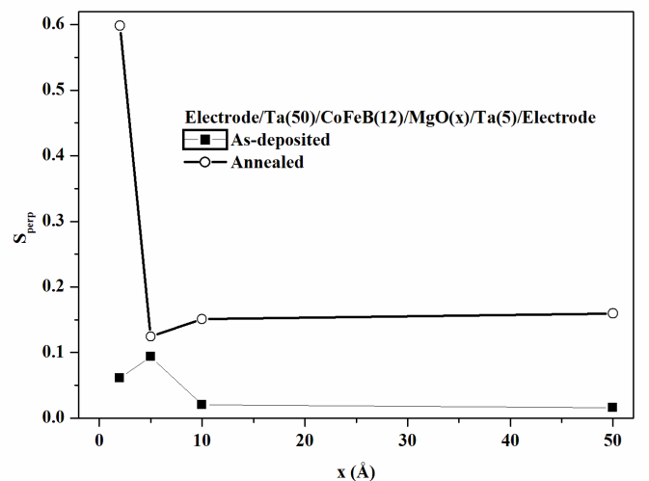

(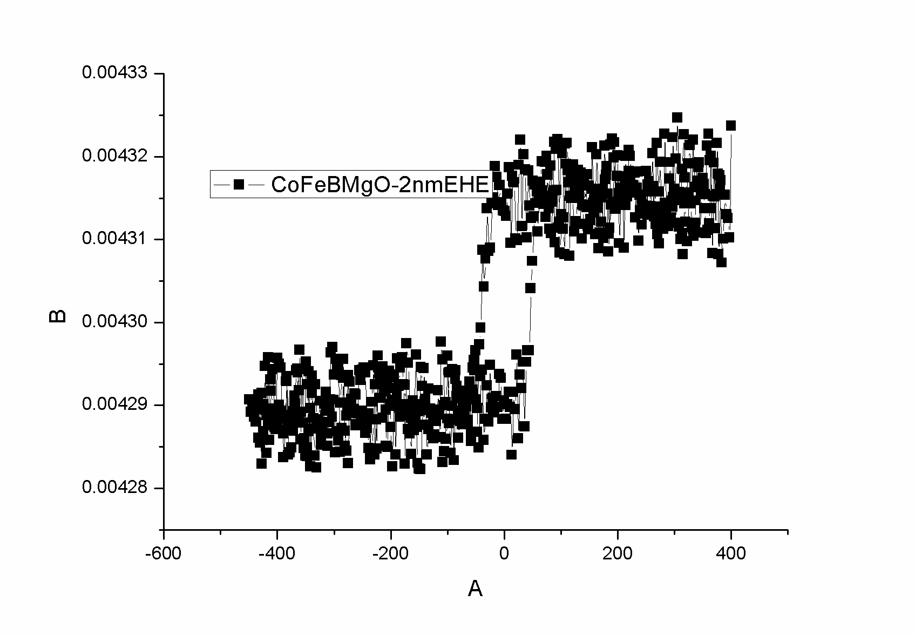

**Figure3:(a) Squarness (Sperp) and (b) EHE measurment of Ta/CoFeB/MgO(x) structures**

Regarding the origin of PMA some authors reported that it is affected by oxygen dynamics beside the improved crystallinity. With the perfect crystallization, PMA get strong only in those samples where the optimal numbers of oxygen atoms are available for hybridization. If these numbers are less or large than the PMA destroy. With increase MgO thickness, oxygen atoms are larger than the optimal concentration as thickness of CoFeb layers is constant for all stacks. Hence, perpendicular squareness decreases with MgO thickness.

In plane and out of plane magnetization of these stacks have been shown in Fig. 3. Behaviour of magnetization with MgO thickness is quite different for as deposited and annealed structure. In-plane magnetization increases with increase in MgO thickness of 10 nm, than decreases onwards. Increase of perpendicular magnetization of stack with 2 nm thickness is related with the improved crystallization with annealing [13APL, PMA]. As thickness of MgO layer is increased decrease in magnetization may be due to different reasons. One reason is related with the under annealing and other is related with oxygen dynamics. It may be contemplated that with increase of MgO thickness will lead to increase in oxygen content in the stack. Due to excess content of oxygen in the stack, metallic Co and Fe will try to from oxides. Formation of oxides in the stack will reduce the effective magnetization of the layers and huge reduction is observed in perpendicular and parallel component of magnetization for the stack with large thicknesses of MgO after annealing. Partial oxidation of Fe and Co atoms also corrobotes with reduction in PMA.

.

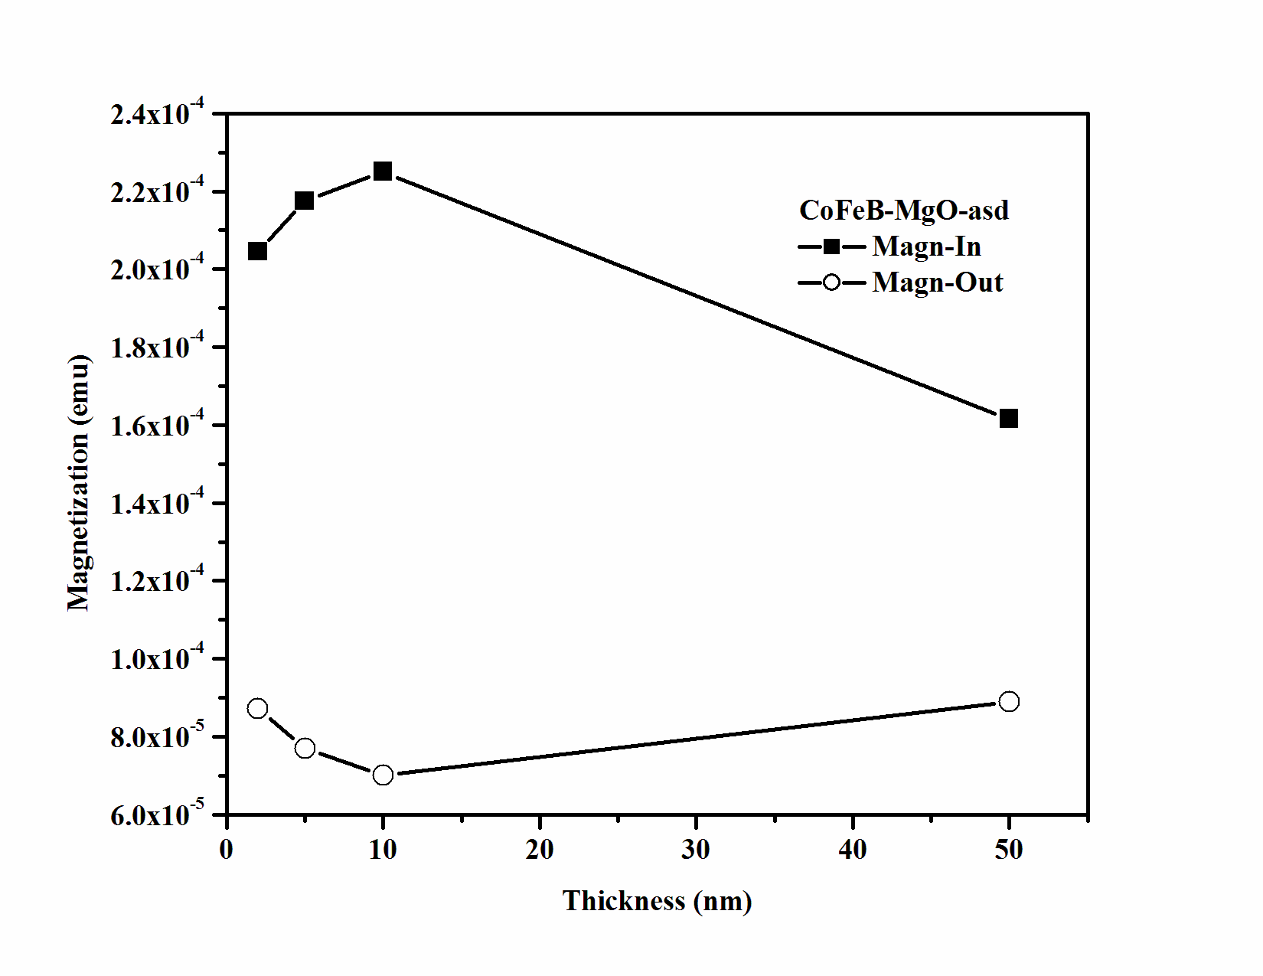

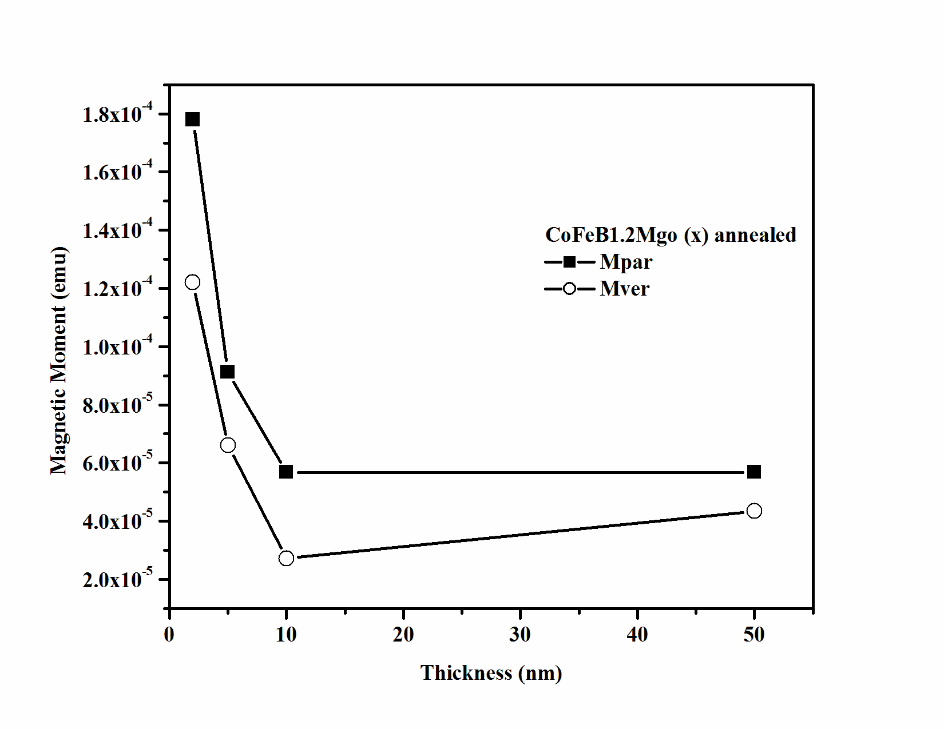

**Figure 4: Perpendicular and parallel magnetizations of as-deposited and annealed Ta/CoFeB/MgO (x) structures**

## Dielectric Properties

Figure 5 shows the variation of dielectric constant (k1), parallel resistance (Rp) and dielectric loss (D) as a function of frequency for as deposited structures. It is clear from this figure that stack with MgO thickness of 50 nm has value of k1~ 2.5 at 20 Hz. Rest of the stacks has value of k1 less than 1.0. The dielectric loss of these stack lie in the range 2.0-4.0. Stack with MgO thickness of 2.0 nm has higher resistivity compared to other stacks. It is surprising that why MgO has value less than 1.0.

Variation of parameters has been shown in Figure 6 for all stacks. It is clear from this figure that value of k1 increases with annealing. However dielectric loss lies in the same range. Values of parallel resistance for all stacks slightly decrease. Values of k1 at 20 Hz have been summarized in Figure 7 for as-deposited and annealed structures. Since, MgO is an insulator with dielectric constant of 9 and resistivity of the order of [14], Hence, variation of these properties will be affected by the properties of MgO at different thickness. Origin of dielectric constant in MgO is polarization of charge distribution [15]. An increase in resistivity of MgO thin films is mainly due to the incorporation of Mg hence widening the energy band gap. Mg incorporation increased the negative effective charge of oxygen ions resulting in the raise of conduction band and lowers the valence band edge. The reason that the resistivity of 0.4 M decrease with increasing molar concentration is maybe due to the imperfections in the atomic lattice structure such as vacancies, dislocation and impurity atoms [16]. Higher resistivity of as deposited stack with MgO thickness of 2 nm also favors this.

As stated by Gnade et.al, [17] the porosity of the structure will reduce capacitance value. Since capacitance value is directly proportional to the relative permittivity (dielectric constant) of the material, hence the decreased in the dielectric constant also due to the porous structure of MgO thin films.

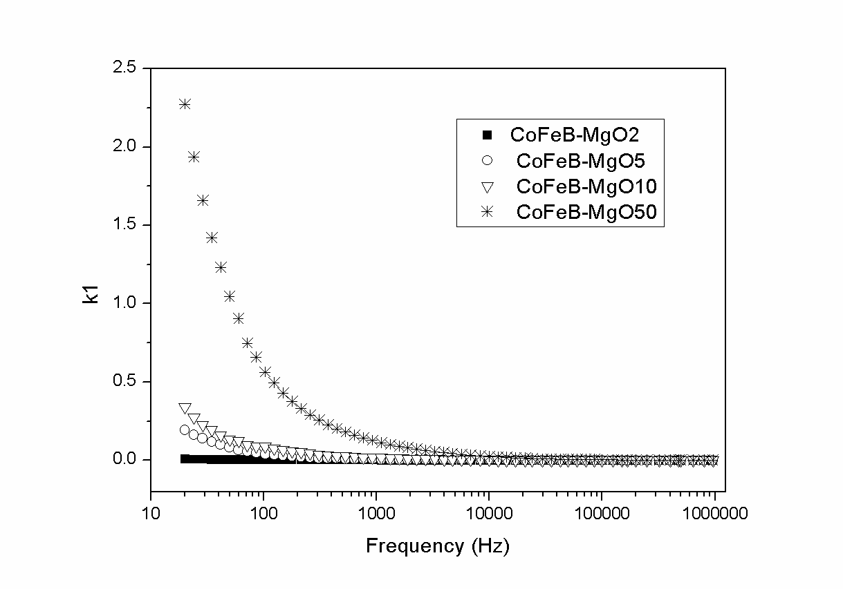

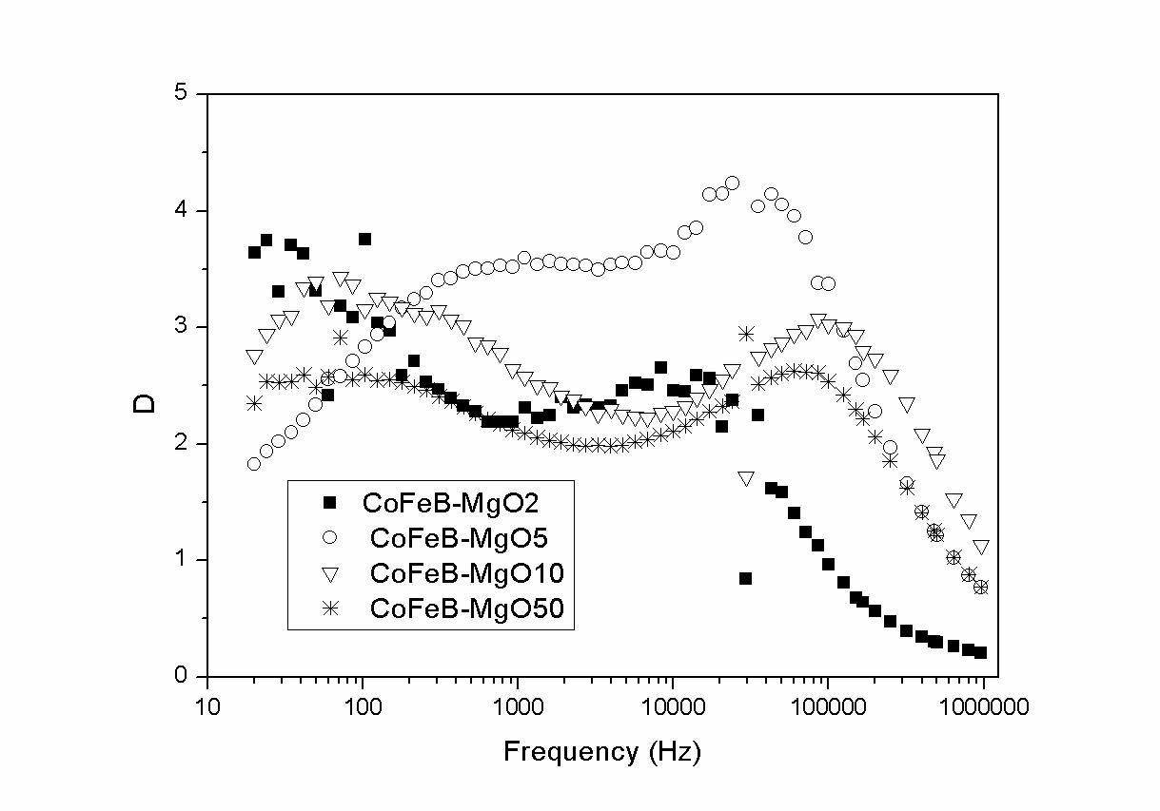

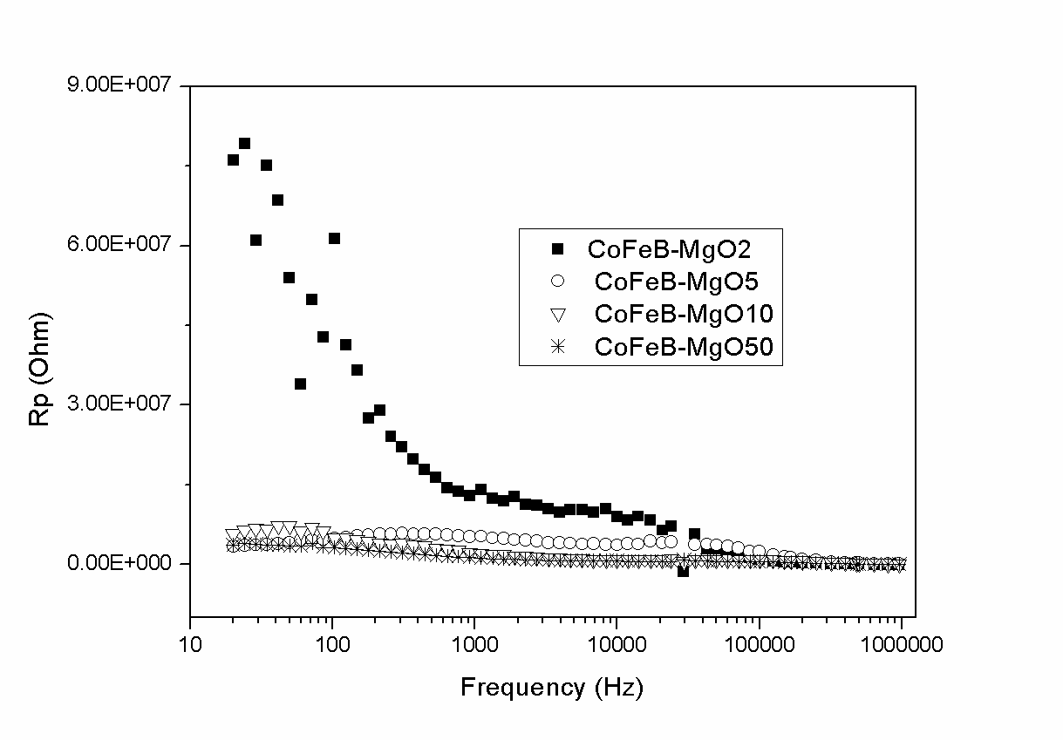

**Figure 5: Dielectric properties of as-deposited structures**

One reason for this deviation is related to an observed reduction in thin film density. Indeed, the XRR data (not shown here) have indicated a film density that is about 10% smaller compared to the bulk density. When less dipoles are present in the thin film, this can then lead to an apparent reduction of the dielectric constant.

Maxima in dielectric loss values appear at the hopping frequency and appears at comparatively lower values compared to other structures for structure with MgO thickness of 2 nm.

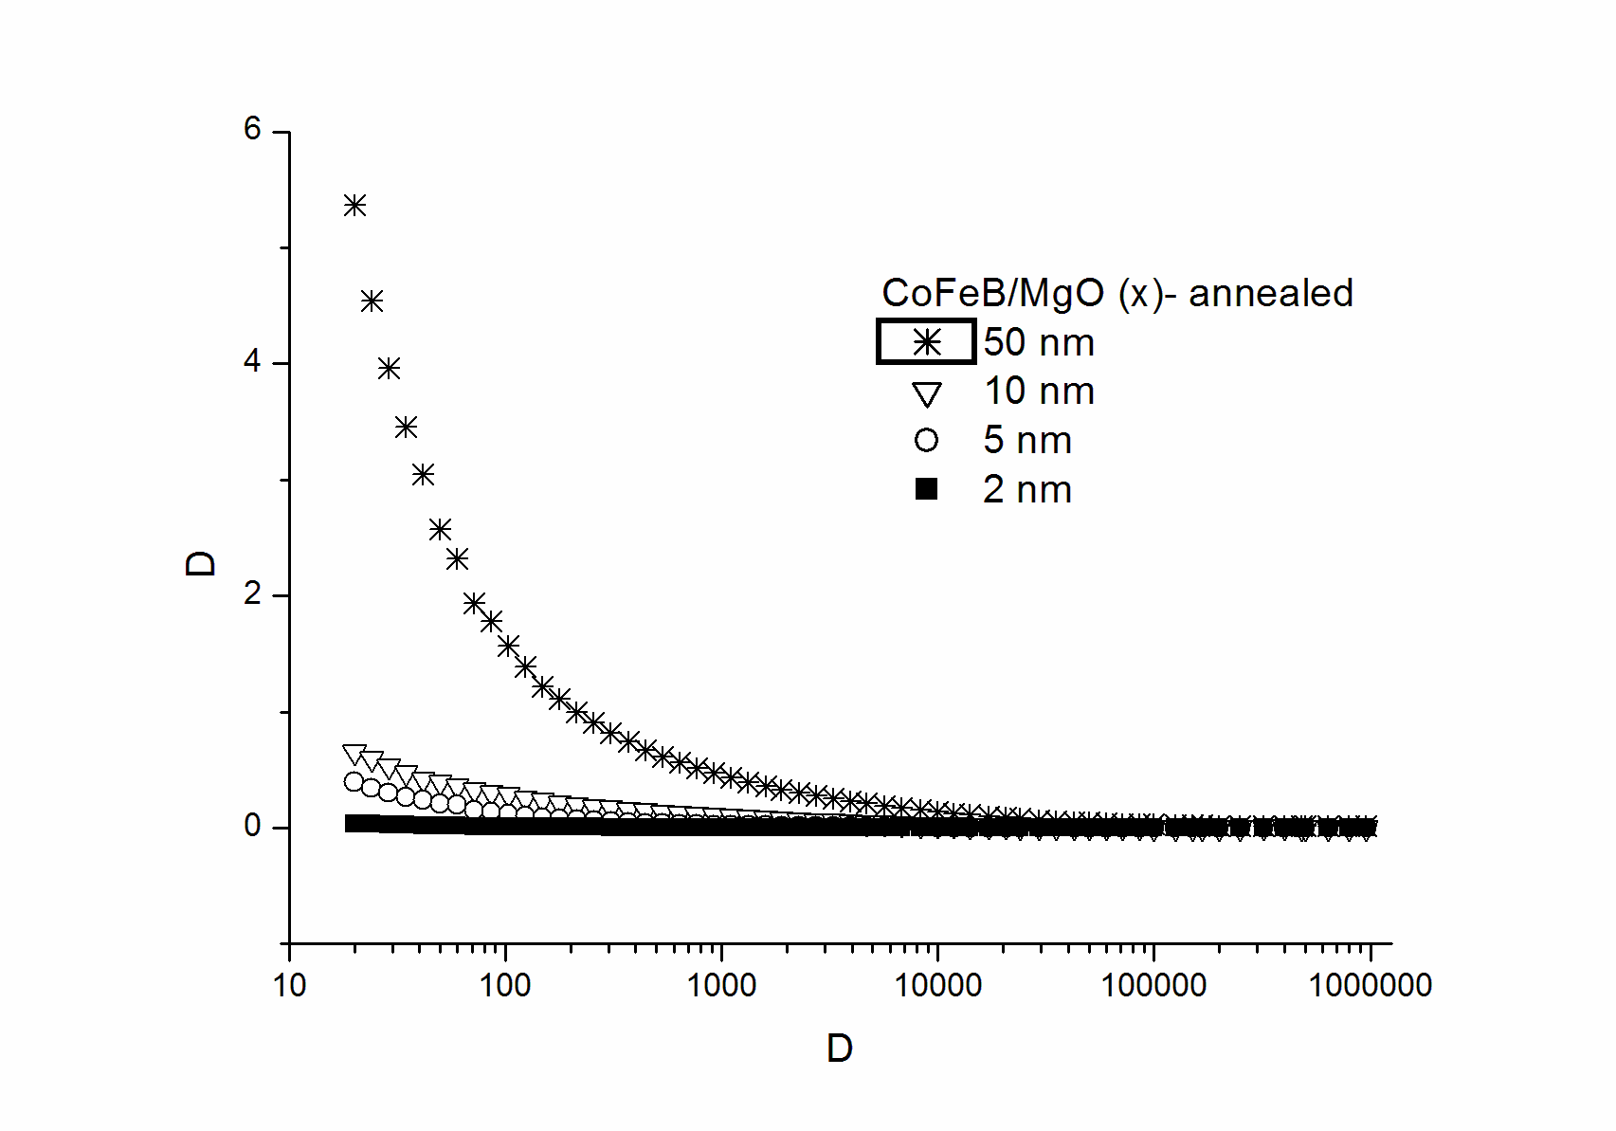

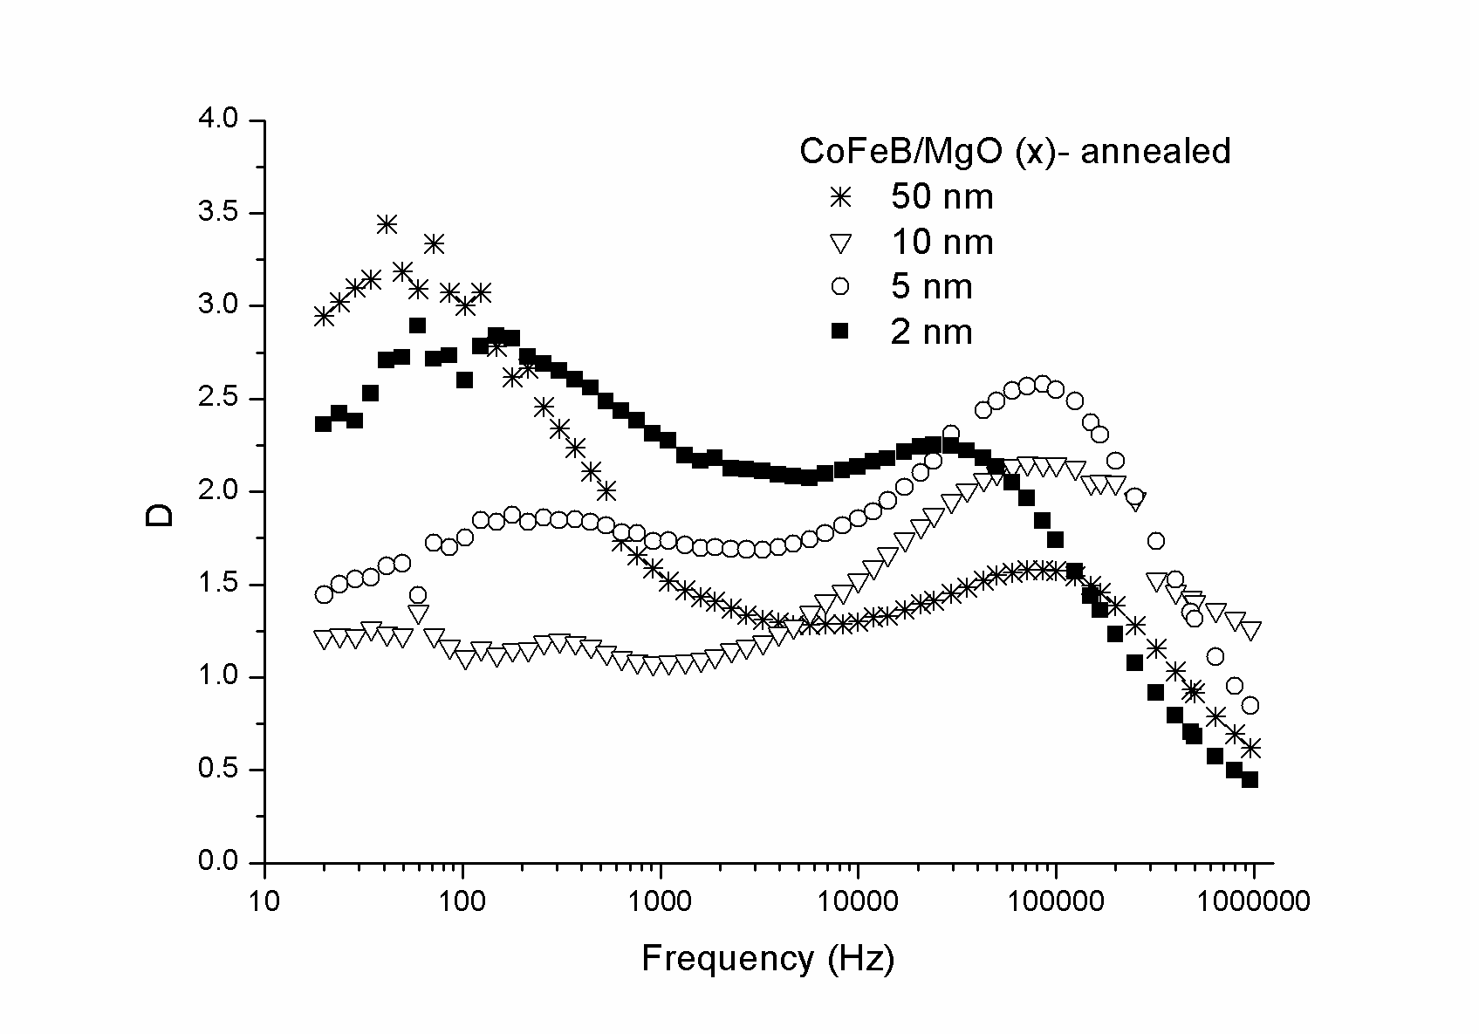

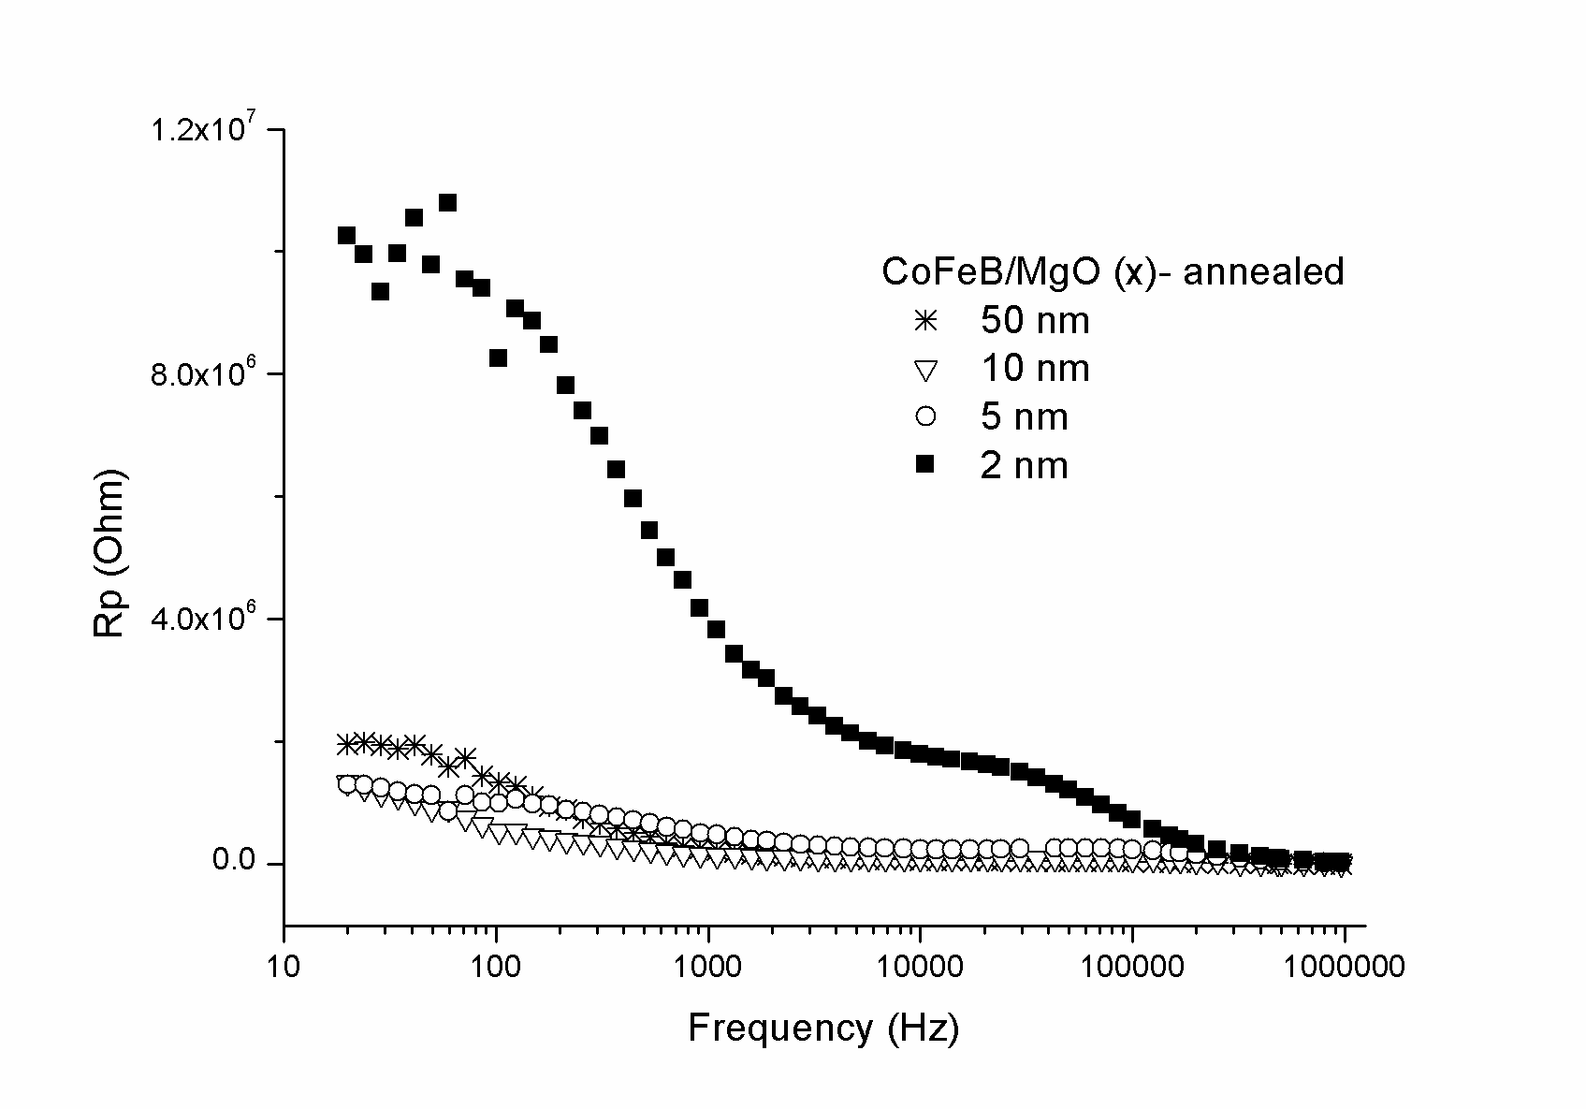

**Figure 6: Dielectric properties of annealed structures**

Hopping frequecy

# Table 1: Dielelctric constant (k1), dielectric loss (D) and parallel resistance (Rp) of as-deposited and annealed structures

# k-COMPARE

**Figure 7: Dielectric constant of annealed and as-deposited structures**

# Conclusion

Magnetic and dielectric properties of Ta/CoFeB/MgO/Ta with varying MgO thickness (2 nm -50 nm) deposited by rf sputtering method has been investigated. As deposited structures exhibit absence of perpendicular magnetic anisotropy and an increase of magnetization upto MgO thickness of 10 nm. Annealing leads to perpendicular alignment of magnetic moment in structure with MgO thickness of 2 nm, however no attributes of this behavior is observed in other structures. However, exponential decrease in magnetization was observed with increase of MgO thickness. Both these effects has been correlated with slight oxidation of Fe and Co atom with increase of oxygen content in structure.

Dielectric constant increases with MgO thickness for these structures and has maximum value ~2.5 and 4.2 for as deposited and annealed structures with MgO thickness of 50 nm. Decease in dielectric constant has been attributed to increase in porosity and interface roughness with decrease in MgO thickness. Comparatively, larger values of dielectric constant for annealed structures are related with improved crystallization and interface roughness. AC resistivity is higher for as deposited and annealed structure with MgO thickness of 2.0 nm. Also ac resistance values are lower for annealed structures. Dielectric loss values for all structures lie in the range 1.5-3.8.

References

1. M. Gajek, J. J. Nowak, J. Z. Sun, P. L. Trouilloud, E. J. O’Sullivan, D. W. Abraham, M. C. Gaidis, G. Hu, S. Brown, Y. Zhu, R. P. Robertazzi, W. J. Gallagher, and D. C. Worledge, App. Phys. Lett. 100, 132408 (2012)
2. S. Ikeda et al., Natr. Mat. (2010)
3. Wei-Gang Wang, S. Hageman, M. Li, S. Huang, X. Kou,X. Fan, J. Q. Xiao, and C. L. Chien, Appl. Phys. Lett. 99, 102502 (2011)
4. H. Meng, R. Sbiaa, M. A. K. Akhtar, R. S. Liu, V. B. Naik, and C. C. Wang Appl. Phys. Letter. 100, 122405 (2012)
5. W. W. Wang, M. Li, S. Hageman, and C. L. Chien, Nature Mater. 11, 64 (2012)
6. C Fowley, K Rode, K Oguz, H Kurt and J M D Coey, “Electric field induced changes in the coercivity of a thin-film ferromagnet” J. Phys D: App. Phys. . 44 305001
7. F. Bonell, S. Murakami, Y. Shiota1, T. Nozaki, T. Shinjo, and Y. Suzuki, “Large change in perpendicular magnetic anisotropy induced by an electric field in FePd ultrathin films” Appl. Phys. Lett. 98 (2011) 232510
8. M. Tsujikawa, S. Haraguchi, and T. Oda, “Effect of atomic monolayer insertions on electric-field-induced rotation of magnetic easy axis” J. Appl. Phys. 111, (2012) 083910
9. Lei Xu and Shufeng Zhang, “Electric field control of interface magnetic anisotropy” J. Appl. Phys. 111, (2012) 07C501
10. C A F Vaz, “Electric field control of magnetism in multiferroic heterostructures” J. Phys.: Condens. Matter 24 (2012) 333201
11. Koji Kita, David W. Abraham, Martin J. Gajek, and D. C. Worledge, “Electric-field-control of magnetic anisotropy of Co0.6Fe0.2B0.2/oxide stacks using reduced voltage” J. Appl. Phys. 112, 033919 (2012)
12. Chih-Wei Cheng et al., JAP (2011)
13. APL, PMA
14. J.-P. Locquet, C. Marchiori, M. Sousa, J. Fompeyrine, J. Appl. Phys. 100 (2006)

051610.

1. X. Fu, Z. Song, G. Wu, J. Huang, X. Duo, and C. Lin, "Preparation and Characterization of MgO Thin Films by a Novel Sol-GeMethod,"Journal Of Sol-Gel Science and Technology, vol. 16, pp.277-281,1999.
2. W.-K. Chen, Halim, A, Hashim, H., Rusop, M., Mamat, M.H. and Zoolfakar, A.S,“Study on electrical properties of zinc oxide thin film”, Innovative Technologies in Intelligent Systems and Industrial Applications, pp.123-126,2008.
3. Gnate et. al, “ Porous composites as a low dielectric constant material for electronic applications” U.S. Patent, 5,561,318, 1996.

1.