EMPLOYEE ATTRITION ANALYSIS
An Exploratory Data Analysis and Machine Learning Project

Project Report

Item | Details
Prepared by | Ritika Nanda
Project Area | Data Analytics / Machine Learning
Primary Tools | Python, Pandas, NumPy, Matplotlib, Scikit-learn, Tableau
Models | Logistic Regression + SMOTE; Random Forest + SMOTE
Dataset | IBM HR Employee Attrition dataset

2026

Abstract
Employee attrition is a major workforce analytics problem because unexpected employee departures can affect staffing, productivity, continuity and recruitment costs. This project analyzes employee data to identify patterns associated with attrition and develops classification models to distinguish employees who leave from those who remain. The workflow combines exploratory data analysis, visual analysis, class-imbalance handling with SMOTE, and supervised machine learning.
The analysis examines overtime, monthly income, job satisfaction, job role, age and job involvement. The visual results show substantial differences in attrition across several of these factors. Two SMOTE-based classifiers were evaluated using ROC-AUC and confusion matrices. The displayed ROC results report AUC values of 0.71 for Logistic Regression and 0.75 for Random Forest. The confusion matrices are also interpreted in terms of true positives, false positives, true negatives and false negatives.

Keywords
Employee Attrition, HR Analytics, Exploratory Data Analysis, SMOTE, Logistic Regression, Random Forest, ROC-AUC, Confusion Matrix, Python, Tableau

Executive Summary
- The project uses employee-level HR data to investigate factors associated with employee turnover.
- Exploratory analysis focuses on overtime, income, job satisfaction, job role, age and job involvement.
- The overtime visualization shows a substantially higher attrition rate for employees working overtime than for employees not working overtime.
- The monthly-income box plot shows different income distributions between employees who stayed and employees who left.
- Lower job satisfaction and lower job involvement categories show larger attrition shares in the displayed charts.
- The job-role visualization indicates that attrition varies considerably by role, with Sales Representative showing a particularly large attrition share in the plotted categories.
- SMOTE was used before model training to address class imbalance in the classification task.
- The displayed ROC curves report AUC = 0.71 for Logistic Regression + SMOTE and AUC = 0.75 for Random Forest + SMOTE.
- The confusion matrices show that both models identify many employees without attrition correctly, while detection of the positive attrition class remains more difficult.

1. Introduction

1.1 Background
Employee attrition refers to employees leaving an organization. From a data analytics perspective, attrition can be treated as a binary classification problem while also being studied through descriptive statistics and visualization. HR analytics can help organizations understand where attrition is concentrated and which employee characteristics are associated with turnover.

1.2 Problem Statement
The objective of this project is to analyze employee HR data, identify patterns related to attrition, visualize important workforce factors, and build machine learning models capable of predicting whether an employee belongs to the attrition class.

1.3 Objectives
- Perform exploratory data analysis on employee HR attributes.
- Study the relationship between attrition and selected demographic/job-related variables.
- Create clear visualizations for important attrition patterns.
- Prepare the data for supervised machine learning.
- Address class imbalance using SMOTE.
- Train and compare Logistic Regression and Random Forest classifiers.
- Evaluate the models using ROC-AUC and confusion matrices.
- Present findings in a reproducible Python-based project with Tableau visualization support.

1.4 Scope
The project is focused on analytical patterns in the supplied HR dataset. The findings indicate associations within the dataset and should not be interpreted as proof that any single factor causes an employee to leave.

2. Dataset and Technology

2.1 Dataset
The project uses the IBM HR Employee Attrition dataset, a structured employee-level dataset containing demographic, job, compensation, satisfaction and employment-related attributes. The target variable is Attrition, with values representing whether an employee left the organization.

2.2 Data Preparation
- The dataset is loaded into a Pandas DataFrame for analysis.
- Categorical variables are encoded so that they can be used by machine learning algorithms.
- The target variable is represented as a binary classification outcome.
- The data is split into training and testing subsets.
- SMOTE is applied to the training data to improve representation of the minority attrition class.

2.3 Technologies Used
Technology | Purpose
Python | Data processing, analysis and machine learning
Pandas | Data loading, cleaning and transformation
NumPy | Numerical operations
Matplotlib | Statistical and analytical plots
Scikit-learn | Model training and evaluation
SMOTE | Handling class imbalance
Tableau | Interactive HR analytics dashboard
Git/GitHub | Version control and project sharing

3. Exploratory Data Analysis
Exploratory data analysis was performed to understand how employee attrition varies across selected HR attributes. The following figures are the plots supplied with the project.

3.1 Attrition and Overtime
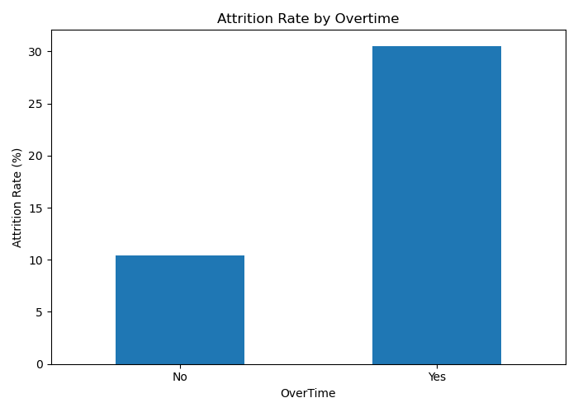
Figure 1. Attrition rate by overtime.
The chart shows a clear difference between employees who work overtime and those who do not. The displayed attrition rate is approximately 10.4% for the 'No' overtime group and approximately 30.5% for the 'Yes' group. This indicates that overtime status is strongly associated with attrition in this dataset. The result is descriptive and does not by itself establish causation.

3.2 Monthly Income and Attrition
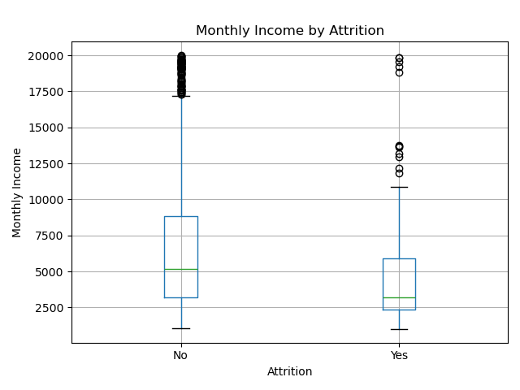
Figure 2. Monthly income distribution by attrition.
The box plot compares monthly income for employees who remained and employees who left. The central distribution for the attrition group is lower in the displayed plot, while the non-attrition group has a wider upper range and several high-income observations. The figure also contains outliers, showing that income varies substantially within the employee population.

3.3 Job Satisfaction and Attrition
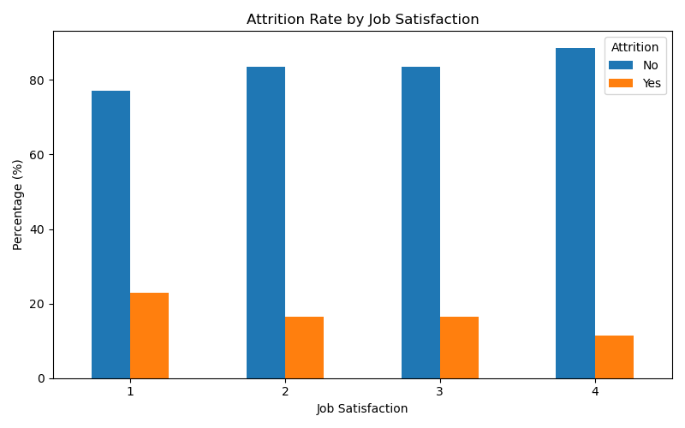
Figure 3. Attrition distribution by job satisfaction level.
Job satisfaction is represented on a four-level scale. The chart shows the largest attrition share at satisfaction level 1, followed by levels 2 and 3, while level 4 has the smallest attrition share among the displayed groups. This pattern suggests that satisfaction level is an important variable to examine when studying turnover.

3.4 Job Role and Attrition
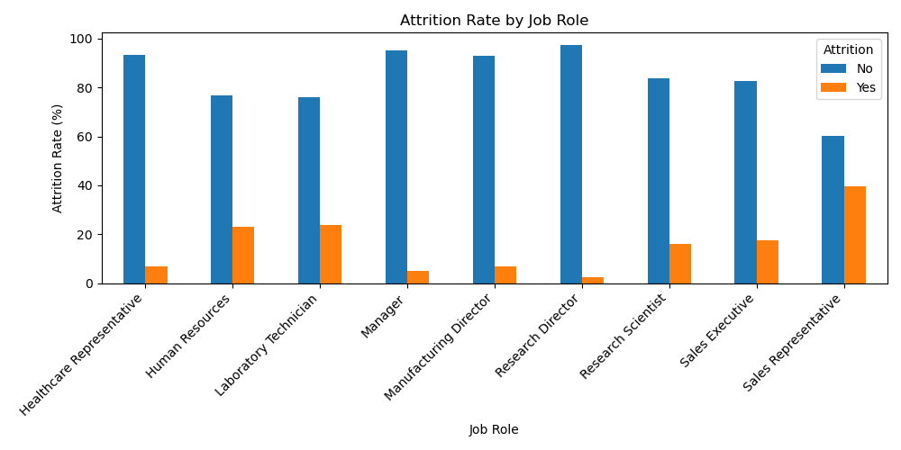
Figure 4. Attrition distribution by job role.
Attrition varies considerably across job roles. The displayed chart shows a particularly high attrition share for Sales Representatives, while Research Director and Manager show much smaller attrition shares. The differences demonstrate why job role should be included in workforce segmentation and predictive modeling.

3.5 Age and Attrition
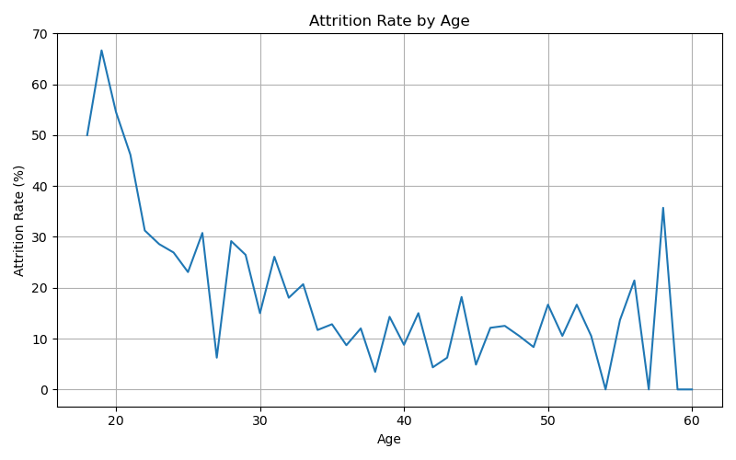
Figure 5. Attrition rate by age.
The line plot shows that attrition rates vary substantially across individual ages. The plotted series has relatively high values at younger ages and generally lower values across much of the later age range, although there are fluctuations. Because some individual ages may contain fewer observations, these values should be interpreted together with employee counts rather than as a standalone causal trend.

3.6 Job Involvement and Attrition
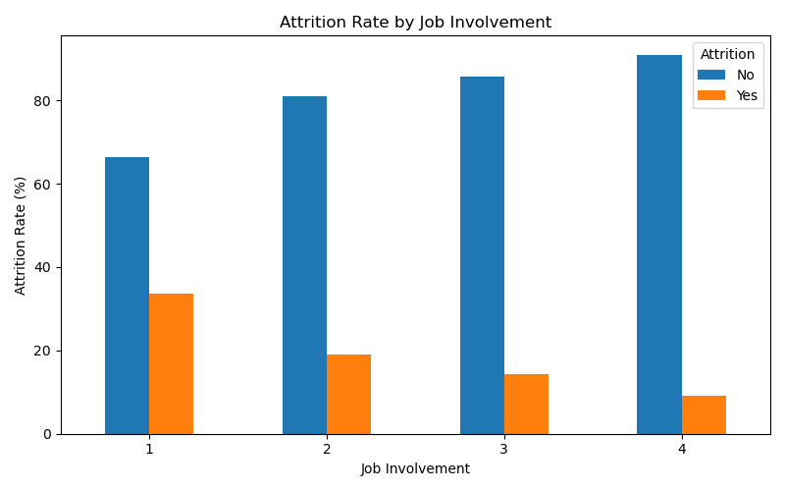
Figure 6. Attrition distribution by job involvement.
The chart shows a decreasing attrition share as job involvement increases from level 1 to level 4. The highest attrition share appears at involvement level 1, while level 4 has the lowest. This provides another workforce segmentation variable that can be explored by HR teams.

4. Machine Learning Methodology

4.1 Classification Problem
The predictive task is binary classification: predict whether an employee belongs to the Attrition = Yes class or the Attrition = No class. Because the dataset contains fewer attrition cases than non-attrition cases, class imbalance is an important modeling consideration.

4.2 SMOTE
Synthetic Minority Over-sampling Technique (SMOTE) is used on the training data to create synthetic examples of the minority class. The purpose is to give the classifier more balanced training information. SMOTE should be applied only to the training portion so that synthetic observations do not leak into the test set.

4.3 Logistic Regression
Logistic Regression provides a relatively interpretable baseline for binary classification. It estimates the probability of the positive class using a logistic function and can be useful for understanding the predictive signal present in the encoded HR variables.

4.4 Random Forest
Random Forest is an ensemble learning method that combines multiple decision trees. It can model nonlinear relationships and interactions between employee attributes and therefore provides a useful comparison with Logistic Regression.

4.5 Evaluation Metrics
Metric | Meaning
Accuracy | Proportion of all test observations classified correctly.
Precision | Among predicted attrition cases, proportion that are actual attrition cases.
Recall | Among actual attrition cases, proportion correctly detected by the model.
F1-score | Harmonic mean of precision and recall.
ROC-AUC | Measures ranking/discrimination ability across classification thresholds.
Confusion Matrix | Shows true/false positive and negative predictions.

5. Model Evaluation and Results

5.1 ROC Curve – Logistic Regression + SMOTE
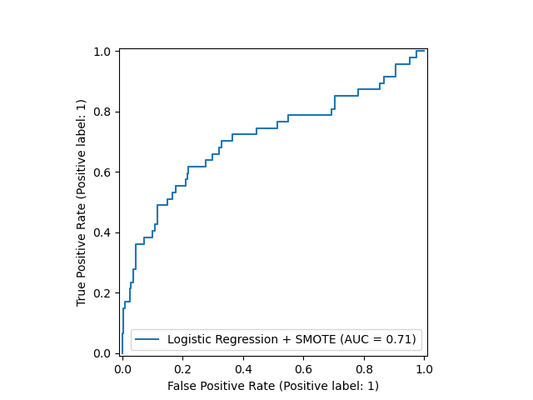
Figure 7. ROC curve for Logistic Regression + SMOTE (AUC = 0.71).
The ROC curve reports an AUC of 0.71. This indicates that the model has meaningful discriminatory ability above random ranking, while leaving substantial room for improvement.

5.2 ROC Curve – Random Forest + SMOTE
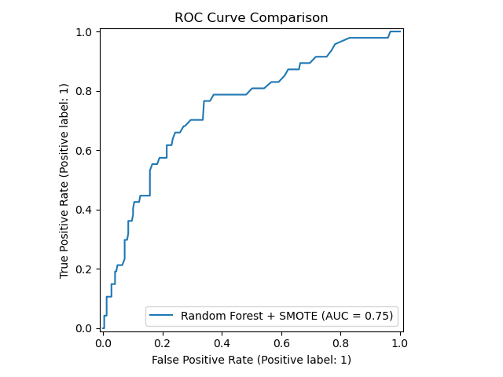
Figure 8. ROC curve for Random Forest + SMOTE (AUC = 0.75).
The Random Forest ROC curve reports an AUC of 0.75. The displayed AUC is higher than the Logistic Regression AUC of 0.71, indicating stronger ranking discrimination on this test split.

5.3 Confusion Matrix – Logistic Regression + SMOTE
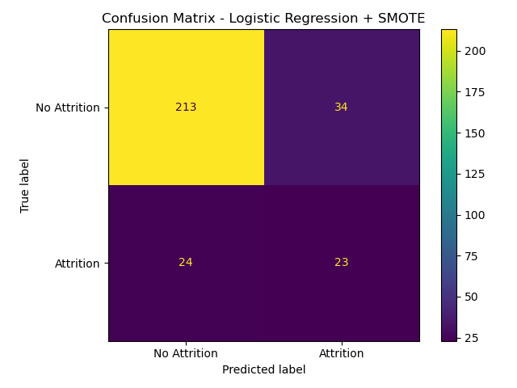
Figure 9. Confusion matrix for Logistic Regression + SMOTE.
The matrix contains 213 true negatives, 34 false positives, 24 false negatives and 23 true positives. From these displayed counts, accuracy is approximately 80.3%, precision for the attrition class is approximately 40.4%, recall is approximately 48.9%, and F1-score is approximately 44.2%.

5.4 Confusion Matrix – Random Forest + SMOTE
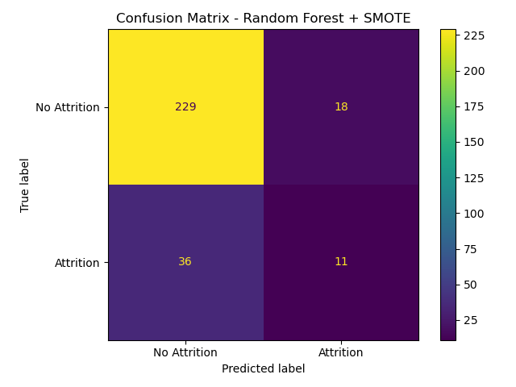
Figure 10. Confusion matrix for Random Forest + SMOTE.
The matrix contains 229 true negatives, 18 false positives, 36 false negatives and 11 true positives. From these displayed counts, accuracy is approximately 81.6%, precision for the attrition class is approximately 37.9%, recall is approximately 23.4%, and F1-score is approximately 29.1%.

5.5 Comparative Results
Model | AUC | TN | FP | FN | TP | Accuracy | Precision | Recall | F1
Logistic Regression + SMOTE | 0.71 | 213 | 34 | 24 | 23 | 80.3% | 40.4% | 48.9% | 44.2%
Random Forest + SMOTE | 0.75 | 229 | 18 | 36 | 11 | 81.6% | 37.9% | 23.4% | 29.1%
The displayed results show different trade-offs. Random Forest has the higher ROC-AUC and fewer false positives, whereas Logistic Regression detects more of the actual attrition cases in this test set. Therefore, model choice depends on the business objective and the relative cost of missed attrition cases versus false alarms.

6. Dashboard and Project Implementation

6.1 Tableau Dashboard
A Tableau dashboard was created to provide an interactive view of the attrition analysis. The dashboard includes key performance indicators and visual breakdowns such as overall attrition rate, attrition count, overtime, job satisfaction, job role and age group.
The dashboard complements the Python analysis: Python is used for reproducible data processing, statistical plots and machine learning, while Tableau provides an interactive presentation layer for HR-oriented exploration.

6.2 Project Repository
The project is maintained as a Git repository and includes the Python analysis script, README documentation, requirements file, Tableau workbook, generated plots and notebook-based project files. This structure supports reproducibility and makes the project suitable for portfolio presentation.

6.3 Reproducibility
- Keep the dataset and analysis script in the project directory.
- Install the dependencies listed in requirements.txt.
- Run the Python analysis script to reproduce the analysis and saved plots.
- Open the Tableau workbook for the interactive dashboard.
- Use Git commits to track changes to the project.

7. Key Findings
- Overtime is strongly associated with higher observed attrition in the plotted dataset.
- Employees who left show a lower central monthly-income distribution than employees who stayed in the displayed box plot.
- Lower job satisfaction levels have higher observed attrition shares than the highest satisfaction level.
- Attrition differs substantially across job roles.
- The age plot shows higher variation in attrition at younger ages and generally lower values across much of the later age range, with fluctuations.
- Lower job involvement levels show higher observed attrition shares.
- The Logistic Regression + SMOTE model reports AUC = 0.71.
- The Random Forest + SMOTE model reports AUC = 0.75.
- The confusion matrices show that identifying the minority attrition class remains more difficult than identifying employees without attrition.

7.1 Business Interpretation
From an HR analytics perspective, the patterns suggest that attrition monitoring can be segmented by workload, satisfaction, involvement, role and compensation. These variables can be used to prioritize further analysis, employee surveys and retention programs. The model outputs should be treated as decision-support information rather than automatic decisions about individual employees.

8. Limitations and Future Work

8.1 Limitations
- The analysis is based on one HR dataset and may not generalize to every organization.
- Observed associations do not establish causal relationships.
- Some age-specific rates may be unstable when the number of employees at an individual age is small.
- The model performance is evaluated on one test split shown in the project results.
- The confusion matrices show that positive-class recall can remain limited even after SMOTE.

8.2 Future Enhancements
- Tune Random Forest and Logistic Regression hyperparameters using cross-validation.
- Compare additional models such as Gradient Boosting, XGBoost or calibrated tree ensembles.
- Use precision-recall curves in addition to ROC-AUC because attrition is an imbalanced classification problem.
- Perform feature importance and explainability analysis using permutation importance or SHAP.
- Evaluate model stability using repeated stratified cross-validation.
- Add employee-level risk segmentation while protecting privacy and avoiding automated employment decisions.
- Add more interactive Tableau filters and drill-down views for HR stakeholders.

9. Conclusion
This project demonstrates an end-to-end employee attrition analytics workflow combining exploratory analysis, visualization, class-imbalance handling, machine learning and dashboard development. The exploratory plots reveal meaningful differences in attrition across overtime, income, job satisfaction, job role, age and job involvement.
The modeling results show that both evaluated approaches provide predictive signal. The displayed ROC-AUC values are 0.71 for Logistic Regression + SMOTE and 0.75 for Random Forest + SMOTE. At the selected classification threshold, the Logistic Regression confusion matrix identifies more actual attrition cases, while Random Forest produces fewer false positives and a slightly higher overall accuracy. These results illustrate why multiple evaluation metrics are needed for imbalanced HR classification problems.
Overall, the project provides a practical foundation for HR analytics and demonstrates skills in Python, data visualization, machine learning, Tableau, Git and reproducible project documentation.

References / Dataset
IBM HR Analytics Employee Attrition & Performance dataset (the dataset used in the project).
Project implementation: Python, Pandas, NumPy, Matplotlib and Scikit-learn; Tableau dashboard; Git/GitHub version control.

